TASK A

A production area in a factory measures 60 metres x 24 metres x 8 metres in height.
The factory’s work benches are set at a height of 1m above the floor level. 3
The area’s reflectance’s are 0.3 for the ceiling and 0.5 for the walls.
The Lighting design specifies Fluorescent lamps in recessed louvre with DLOR of 50%.
(The actual size for the luminaires is 1200mm (1.2m) in length and 200mm (0.2m) wide.)
A Lighting Design Lumen (LDL) output of 18,000 lumens is required.
The illumination required for the factory area is 200 lux at the working plane.
Light Loss Factor = 0.75

- Calculate
- Room index
Room index = (L x W)
(Hm (L + W))
- L = 60
- W = 24
- H = 8
For this exact equation, the “H” will be 7. The reason being is because we will be measuring from the work’s bench which is 1m above floor level. Given me 8 minus 1 equalling to 7.
Room index = (60 x 24)
(7m (60 + 24))
Room index = 2.45 (rounded up to 2 decimal places)
- The utilisation factor (from tables)
The utilisation factor I have calculated from the table was 0.46. As for the lighting design specifies fluorescent lamps in recessed louvre with DLOR of 50%, the area’s reflectance’s are 0.3 for the ceiling and 0.5 for the walls. I rounded up to 2.5 for room index on the utilisation factor table to find my results.

Table below shows my workings out.
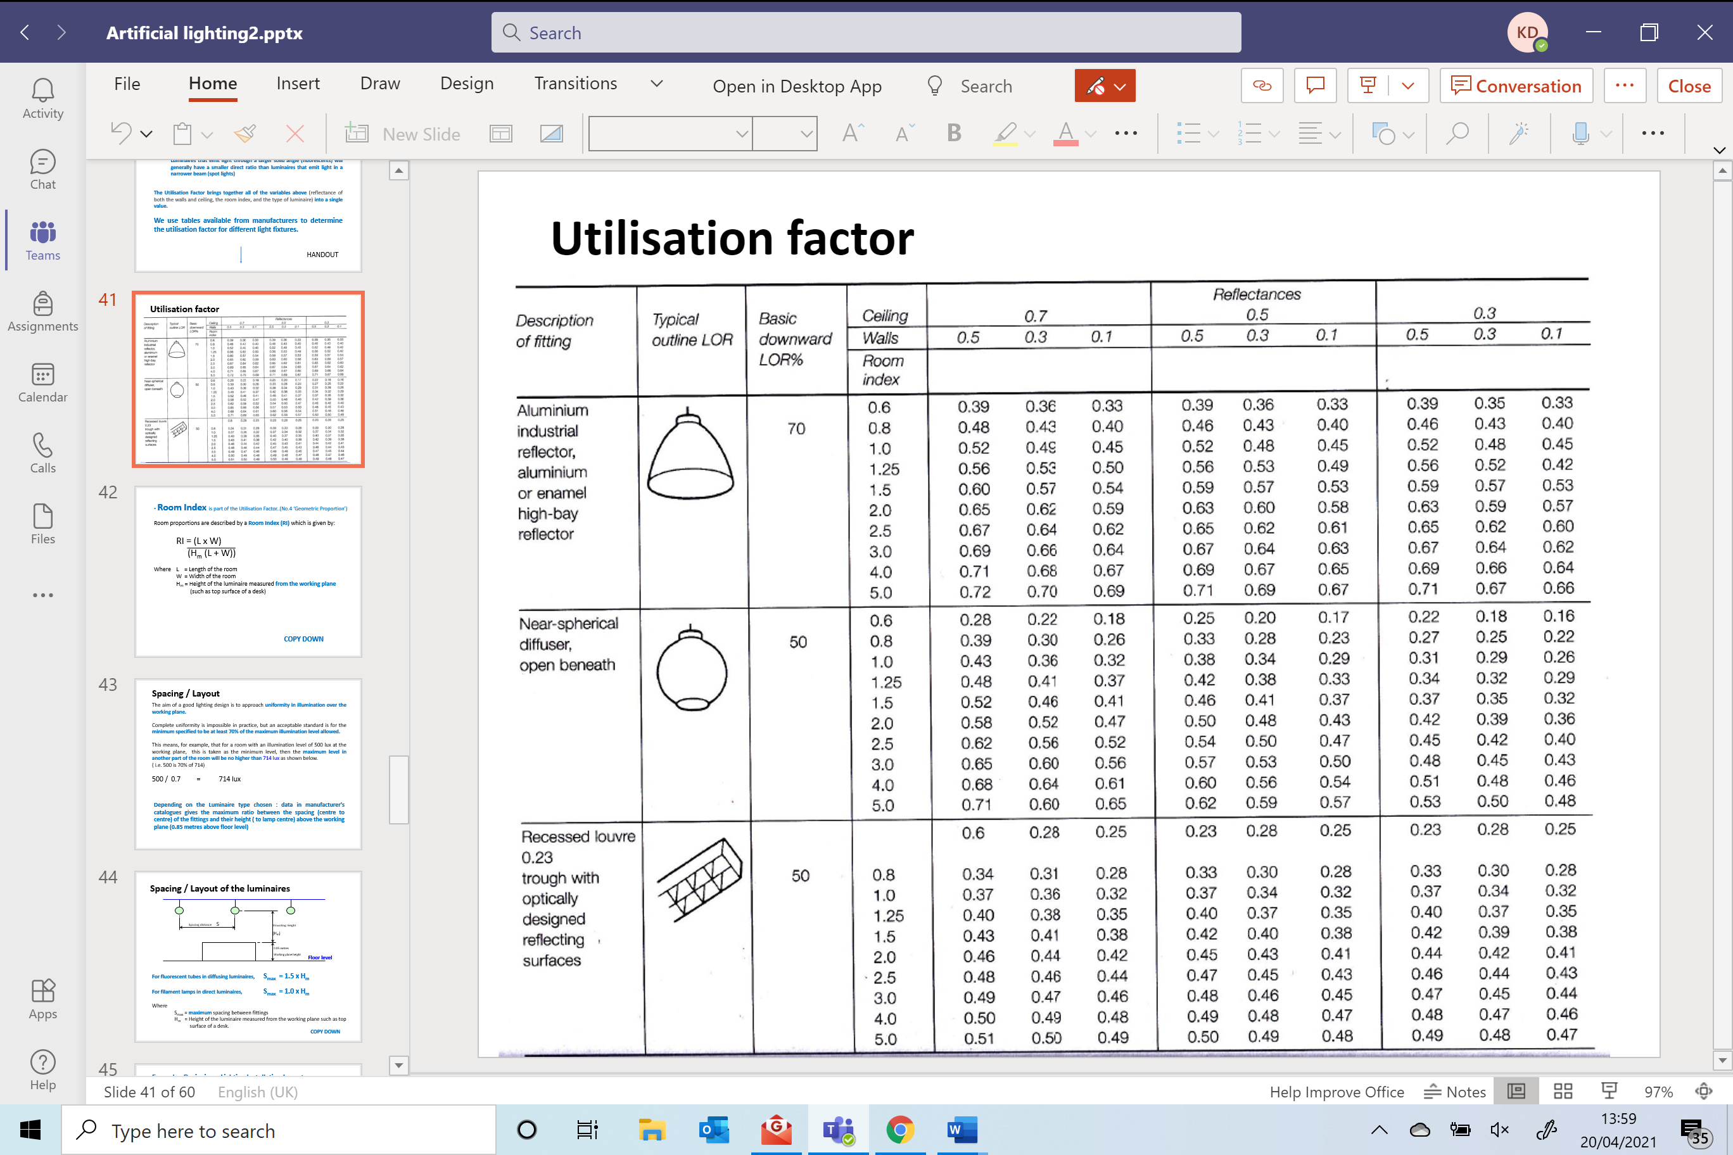
- Number of lamps required
The number of lamps is given by following formula shown below:
Number of lamps = E x A
F x UF x LLF
- E = illuminance level required (lux)
- A = area at working plane height (m2)
- F = average luminous flux from each lamp (lm)
- UF = utilisation factor
- LLF = light loss factor
Number of lamps = 200 x 1440
18000 x 0.46 x 0.75
Number of lamps = 46.38 (rounded up to 2 decimal places)

Number of lamps rounded up to 48 to make an even number of lights distributing the factory.
- A suitable layout (Value of S) for the lamp fittings
For fluorescent tubes
Smax = 1.5 x Hm
= 1.5 x 7
= 10.5m
- Draw the plan layout on a scale drawing of the factory floor indicating your “best fit” design for the luminaire installation.
Points on the row layout should indicate the position of the lamp centres.
60m
6m Spacing
6m Spacing
6m Spacing
3m Spacing
3m Spacing
24m
2.5m Spacing
2.5m Spacing
5m Spacing

Each centre of the cross indicates the lamp layout centres. Centres are indicated at 600mm in length and 100mm in width.

Task B
A brick wall of area 20m² contains a window of area 4m². The values of sound reduction indexes are:
50dB for the brickwork and 10dB for the window.
Calculate the overall sound reduction index for the entire wall.
Include the full arithmetic development of your answer.
Brickwork:
- T1 = ?
- A1 = 20-4= 16m2
- SRI = 50dB
Window:
- T2 = ?
- A2 = 4m2
- SRI = 10dB
SRI formula:
SRI = 10 x (log10(1/T))
Brickwork
SRI = 10 x (log10(1/T))
50 = 10 x (log10(1/T1))
5 = log10 x (1/T1)
1/T1 = 105
T1 = 10-5
= 0.000010
Transmission coeffienct for brick

Window
SRI = 10 x (log10(1/T))
10 = 10 x (log10(1/T2))
1 = log10 x (1/T2)
1/T2 = 101
T2 = 10-1`
= 0.10
Transmission coeffienct for window
Using averaging formula and subsituting for brickwork and window
= (T1 x A1) + (T2 x A2)
A1 + A2
= (10-5 x 16) + (10-1 x 4)
16 + 4
= 0.000016 + 0.4
20
average transmission coefficient = 0.0200008
Using SRI formula and subsituting
SRI = 10 x (log10(1/T))
= 10 x (log10(1/0.020008))
= 10 x (log10(49.980007))
= 10 x 1.69
SRI for the composite partition = 17dB

Discuss the implications of the factors of frequency and wavelength in:

1). Internal sound management
In April 2006, the Control of Noise at Work Regulations 2005 came into force, replacing the Noise at Work Regulations 1989. The regulations were established under the Health and Safety at Work etc. Act 1974 and implemented European Council directive 2003/10/EC. The regulations require employers to protect their employees from levels of noise that could cause them hearing damage
One of the more common complaints about buildings with poor build quality is noise transfer, both from outside sources but in particular between the rooms in the building itself. Poor acoustics is something that could, and should, be considered at the design stage of a project.
The Building Regulations for sound (Part E in England and Wales) are split into two sections: E1 and E2.
- E1 looks at protection from noise from adjoining buildings (flats, terraces, semi-detached)
- E2 deals with sound transmission within the home itself.

Part E was rewritten in 2003 and E1 in particular has proven to be very successful in reducing the number of noise complaints between neighbours. E1 party wall and party floor sound reduction levels were increased significantly in the revision. However, the improvement in E2 protection levels was limited and their current requirement for 40dB (decibels) of sound reduction in internal walls and floors is not very demanding.

2). Partition wall construction technique
Options for improving sound transmission reduction to existing partitions:
- Adding an additional layer of 10 mm plasterboard on both sides of a standard timber partition.
- Removing the lining from one side of a standard timber partition, adding sound-absorbing insulation and two layers of 10 mm plasterboard on one side and another layer of 10 mm plasterboard on the other side.
- Building an additional partition beside a standard timber partition that has had the lining removed on the face adjacent to the new partition, adding sound-absorbing insulation, two layers of 10 mm plasterboard on the external face of

the new partition and an additional layer of 10 mm plasterboard on the external face of the existing partition.

3). The Insulation material choice
Sound insulation describes the reduction in sound across a partition. The sound insulation across a good conventional, lightweight, office to office construction is typically in the order of 45 dB.
This means that if the sound level in the source room is around 65 dB (a typical level for speech), the sound level in the adjacent room, the receiver room, will be approximately 20 dB (barely audible).
If sound levels are increased in the source room to 75 dB (raised voice), sound levels within the adjacent room will also increase to around 30 dB (audible). Sound insulation therefore describes the level of sound lost across a partition and not the level of sound within a adjacent room.
Any masonry wall or concrete floor will meet Part E2 requirements, and timber or steel walls or floors only require the addition of some insulation and a slightly thicker plasterboard to be used.
Another form of material insulation is glass wool. Although glass wool is primarily used for thermal insulation, this material has got excellent soundproofing qualities as well. Thanks to the big mass, a lot of noise can be absorbed. Especially in case of roofs, glass wool is a better option than rigid insulation boards when it comes to sound insulation.
Glass wool insulation is usually supplied in the shape of semi-rigid insulation sheets. This way, they are easy to install, and they absorb a lot of sounds.
Polyethylene is another good form of sound proofing. It is used to build a soundproof floor. It is a strong and quite cheap plastic. Next to that, this material is resistant to moisture and very low or very high temperatures.

Next to glass wool and polyethylene, there are many other materials which can serve as sound insulation in your house or office. Cork and rock wool, for example, have good soundproof and sound-absorbing properties as well.
In order to avoid sound transmission as much as possible, a soft spring is advisable. This way, the sound can be absorbed better. A material like mineral wool is therefore more suitable than a solid sound insulation board.
The weight of the insulation material must be quite high. This way, it will be able to absorb the sound waves better. It goes without saying that a thick layer will absorb better than a thin layer of the same material.
First of all, the thickness of the wall is very important in order to exclude sound; the thicker the wall, the better the sound will be blocked.
However, it is not always possible to build a very thick wall. This is why one often applies the ‘mass-spring-mass principle’ when installing sound insulation. A so-called spring is placed between two masses (the inner and outer wall). This can be just air, or an insulation material can be put in place in order to reduce the sound better. One mostly leaves a layer of air between the insulation and the wall too.

Designing Buildings (2021), Designing Buildings Wiki (accessed 12 April 2021) Available at: https://www.designingbuildings.co.uk/wiki/Control_of_noise_at_work_regulations_2005
Future Publishing Ltd, Sound Proofing and Noise Control by Mark Brinkley (17 June 2020). Available at: https://www.homebuilding.co.uk/advice/soundproofing-and-noise-control-guide
Level (2017), Passive Design. Available at: http://www.level.org.nz/passive-design/controlling-noise/controlling-noise-through-design-and-layout/noise-control-in-interior-partitions/
Designing Buildings (2021), Designing Buildings Wiki (accessed 12 April 2021) Available at: https://www.designingbuildings.co.uk/wiki/Control_of_noise_at_work_regulations_2005
Future Publishing Ltd, Sound Proofing and Noise Control by Mark Brinkley (17 June 2020). Available at: https://www.homebuilding.co.uk/advice/soundproofing-and-noise-control-guide
Buildit Ltd 2021, Sound Insulation: possibilities and complications. Available at: https://www.insulation-info.co.uk/sound-insulation
Buildit Ltd 2021, Sound Insulation: possibilities and complications. Available at: https://www.insulation-info.co.uk/sound-insulation

