Contextual studies: Ways of perceiving

Student name: Joshua William Dodsley:
Student number: 1702608
Course: Automotive Design
Modular: M4X01559
Tutor: Scott Smith

Word count: 1,063
Word count with bibliography: 1,181

Exhibition space essay:

My proposed exhibition is to create a space which brings together two areas within Art and Design, showcasing a collection of art cars connecting the two disciplines of Fine Art and Automotive design. The concept is to use a collection of a mass-produced vehicle which will show a visual representation of the modern and postmodern art movements. Walking through the exhibition space you will get a sense of art history decorated on the most successful piece of automotive design. Its purpose is to show the connection between art and the automotive industry, visually showing how art has an influence design and challenging the perceived class system between the low class massed produced car and the high class fine art work.

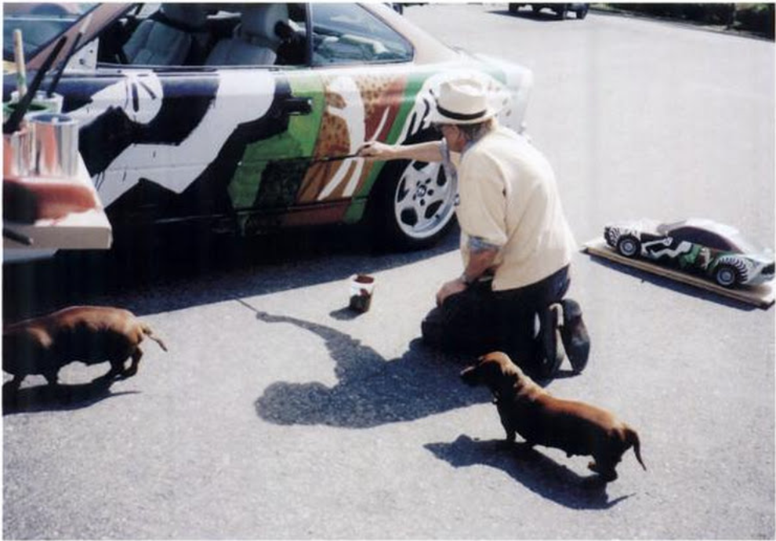
The concept of the exhibition signifies to a modernist approach, by taking a vehicle and applying a fine art decoration to the exterior follows the modernist idea, by changing an objects old and dated exterior to something contemporary. Rejecting the cars exterior by embellishing a design over the top fits with the philosophy of modernism stated in After The Great Divide: Modernism, Mass Culture, Postmodernism by Andreas Huyssen “modernism itself appropriates and transforms” (1968:20). He also states that modernism is an “alternative relationship between high and mass culture” (1968:8). I have interpreted this to what I am trying to communicate, the car itself is an object of mass culture and by altering the surface in an artistic approach to change its purpose to something purely aesthetic.

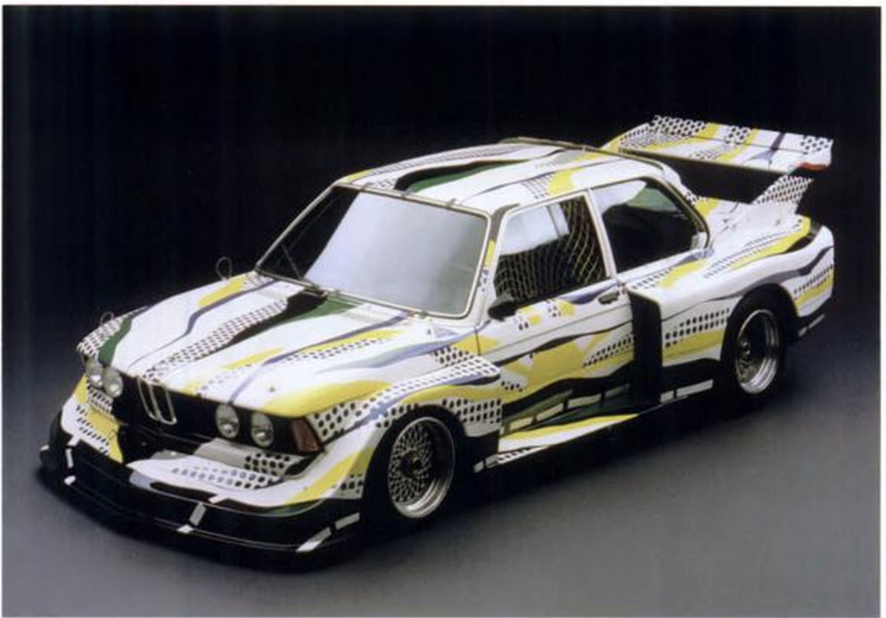
The idea is inspired by BMW with their series of BMW Art Cars, where the two differ is the BMW cars are made for the racing vehicles originally created for the Le Mans twenty-four-hour race. mine uses a perceived lower value base, using a car which will be available to the masses not the elite. Focusing on a modernist styles and artists. Stated in Autopia: Cars and Culture by Peter Wollen, Joe Kerr “BMW, the German automobile company were persuaded to commission the American artist Alexander Calder to decorate a BMW car”, “in the Le Mans 24-hour race” (2002:37), the artist that followed were Frank Stella, Roy Lichtenstein and Andy Warhol. I would envision a selection of current modern and post-modern artists’ works to decorate my collection, much like BMW did during their period of production.

Linking with the idea of the BMW art car and my concept to take a plain surface and by applying a design changing it purpose, from something designed to transport people to a fine art piece. The car I plan on using is something which is available to the masses which I will convert to something for the elitist. Taking the concept further breaking down the class values by having something seen as low class in an easily obtainable vehicle in a high society space, being viewed in a fine art exhibition with its fine art exterior. The car I plan on using is a Volkswagen Type One Beetle. The Volkswagen Type one is the highest produced single model car, producing twenty-one and a half million cars between the first car build in Germany in 1938 to the last made in Mexico in 2003. This success is reiterated in Bernhard Rieger’s The Peoples Car “The Volkswagen Beetle has been adopted as a national icon in countries as diverse as Germany, the United States and Mexico” (2003:326) labelled as a “a good bargin” (2003:5) and “to become the “people’s car”” (2003:1). This association with the lower class for those with smaller incomes makes it perfect for what I wish to communicate, turning this image for the lower-class to something viewed in an upper-class environment.

Due to my selected lower class vehicle, the work and exhibition could be considered as postmodern, with the challenge of class and the perceiving of a low valued functional object becoming something purely aesthetic and of a higher value. Focusing on what I am doing, taking a collection of type one Beetle’s altering their exteriors to something purely artistic and artificial to change the purpose of the object, representing a disruption between classes. Corresponding this to postmodernism “postmodernism work of art disruption” Simon Malpas The Postmodern (2005:29). “calling for a transformation” (2005:30), the transformation of the exterior of the vehicle and its newly allocated purpose, “focuses entirely on the stylistic features” (2005:31), which is what I am proposing not altering the overall mechanical functionality of the vehicle, working only with the exterior aesthetic to change the meaning.

Looking at a sense of place I need to consider the environment both for the exhibition space and theoretical sense of place, from being within the car to around the exterior of the vehicle, alongside walking around the exhibition to view the cars. Leading me to Making Sense of Place: Multidisciplinary Perspectives by Ian Convey, Gerrard Corsane, Peter Davis, relating with my concept by explain sense by “people should be allowed to themselves define place” (2014:4), how in cars the inside is our own personalised sense of place “For an individual” (2014:4), where the time is most spent when traveling and for most our experiences with cars are within vehicle. With my concept, I am challenging this by making the exterior the new sense of place. By doing this I am challenging the environment of what the purpose of the car is and the environment the car is situated, referring to “sense of place and the environmental” with how depending on my layout will affect the sense of place of the work and exhibition. This is what I will need to consider when placing the work within and around my space, ensuring that I am communicating the correct message through my sent of place.

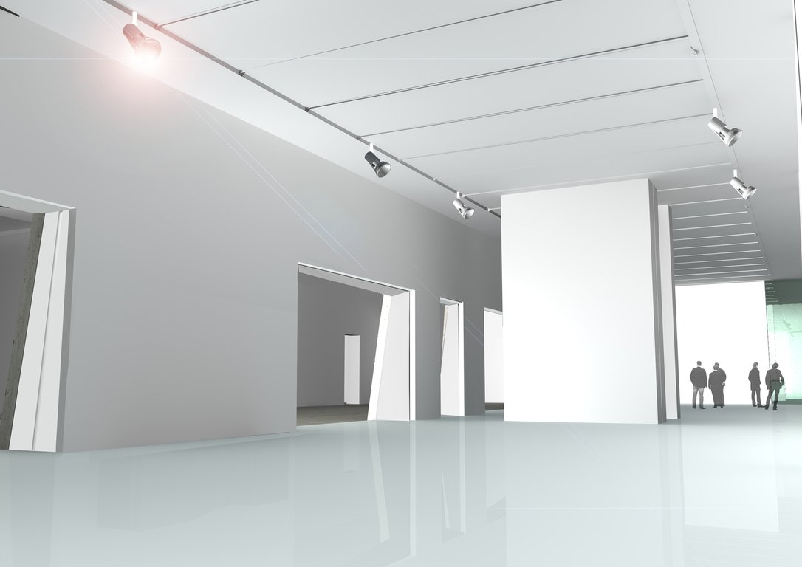
My proposition is to have a collection of type one Volkswagen Beetles, decorated in a modern and postmodern designs, visually representing the message of the separation of and perceived class system, shown by combining two art forms of Automotive Design and Fine Art. I plan to exhibit this in a confined space large enough to house a substantial collection of decorated Volkswagen Beetles in a style of modern and postmodern artworks, with plain white walls and floors and simple overhead lighting so not to distract from the exterior alterations to the Beetles. Placing the cars around the space to allow viewers to instinctively flow between cars starting with modern and organically leading to postmodern.

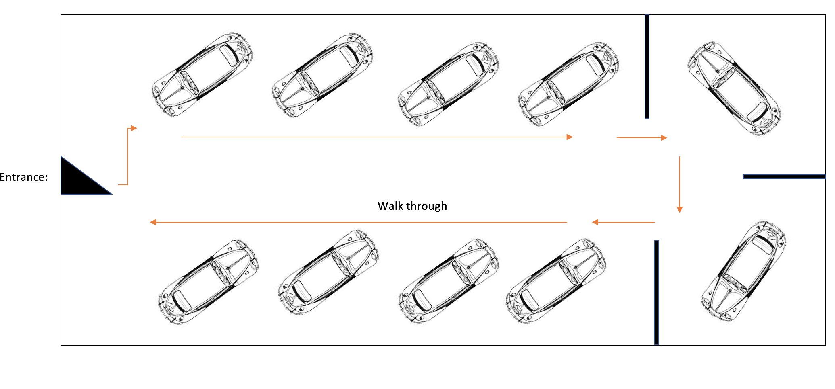

Bibliography

(A) Andreas Huyssen – After The Great Divide: Modernism, Mass Culture, Postmodernism (1968:8) – (1968:20) accessed on: [14.04.18] accessed from: https://books.google.co.uk/books?hl=en&lr=&id=WAkocqh61O0C&oi=fnd&pg=PR6&dq=modernism&ots=Ale6f2VZm-&sig=-eUcsTl6QPCvqXpeYVZSR0iVhEQ#v=onepage&q=modernism&f=false

(B) Bernhard Rieger – The Peoples Car (2003:1) – (2003:5) – (2003:326) accessed on: [15.04.18] accessed from: https://books.google.co.uk/books?hl=en&lr=&id=CwQ7hNxWvD0C&oi=fnd&pg=PP8&dq=people%27s+car+volkswagen+beetle&ots=p1teMuc0Rk&sig=UHLEA9BrpUvZ03JVdmj0uSOr1Ek#v=snippet&q=peoples%20car&f=false

(I) Ian Convey, Gerrard Corsane, Peter Davis – Making Sense of Place: Multidisciplinary Perspectives (2014:4) accessed on: [15.04.18] accessed from: https://books.google.co.uk/books?id=zszCAwAAQBAJ&printsec=frontcover&dq=sense+of+place&hl=en&sa=X&ved=0ahUKEwiYvJawiL3aAhUqLMAKHQZ-CE8Q6AEIMzAC#v=onepage&q=sense%20of%20place&f=false

(P) Peter Wollen, Joe Kerr – Autopia: Cars and Culture (2002:37) [image 1] [image 2] accessed on: [14.04.18] accessed from: https://books.google.co.uk/books?hl=en&lr=&id=705nF7ZUklkC&oi=fnd&pg=PR15&dq=david+hockney+bmw+art+car&ots=ihwXF38wtD&sig=vh5g78DxL_L25JWTa5Dq6BziMOU#v=onepage&q=art%20car&f=false
(P) PROPOSAL SPACE : EXHIBITION SPACE – PINTEREST [IMAGE] ACCESSED ON 24.04.18] ACCESSED FROM :https://www.pinterest.co.uk/pin/331647960038849430/?lp=true

(S) Simon Malpas – The Postmodern (2005:29) (2005:30) (2005:31) accessed on: [15.04.18] accessed on: https://books.google.co.uk/books?id=UYWYEXLYBNoC&dq=post+modern&source=gbs_navlinks_s

