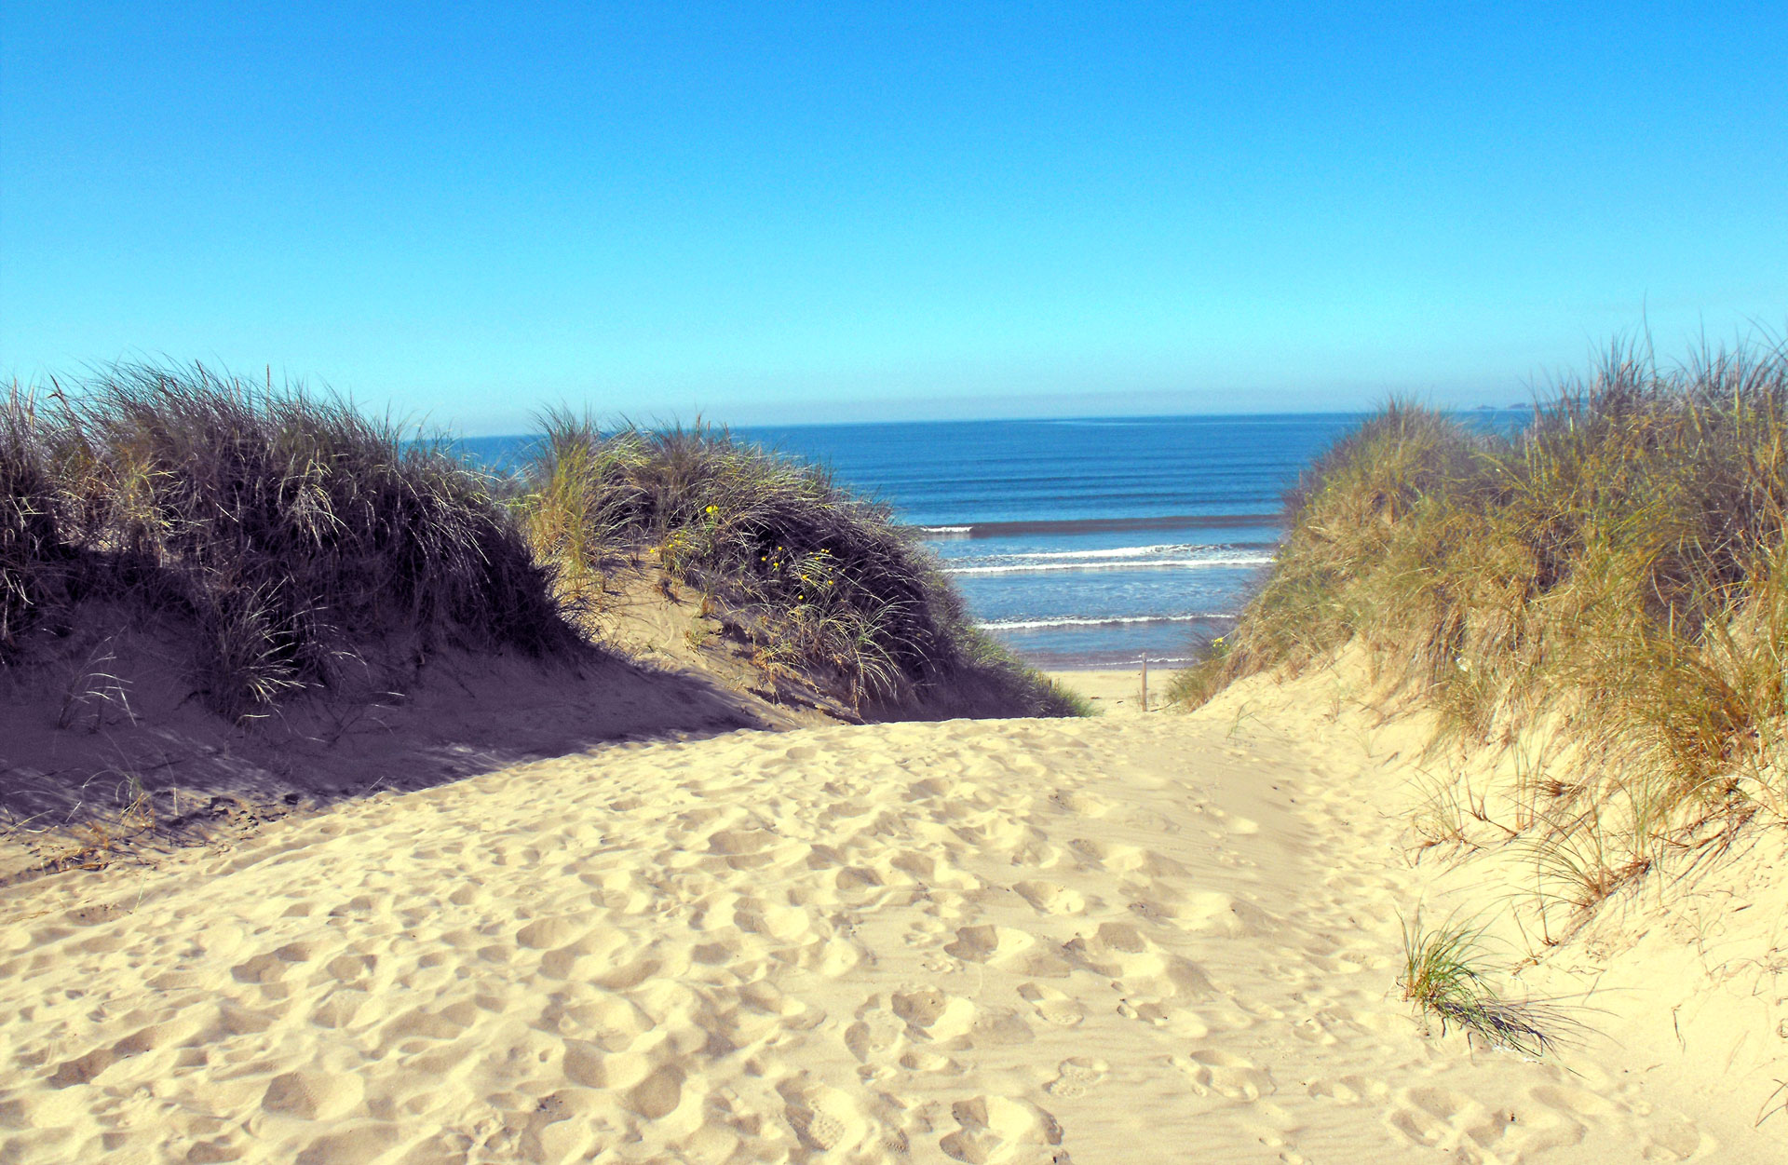
(NPTCBC 2012)

I have chosen to discuss this photo of the sand dunes down Aberavon seafront, as it is a place that we, as a setting, visit regularly as it provides many beneficial play and learning opportunities for children. White (2020) believes that one of the best environments for children to explore, experiment, build and imagine is the beach as there are various combinations and interaction of materials such as sand, shells, plants and water. When children play outside, they get to experience freedom and explore their surroundings, allowing them to learn about the world that they live in. The Welsh Governments (2022) Non-maintained setting curriculum allows children to be themselves and inspire awe and wonder in relaxed and open spaces, and the area above is a place where I believe is the best place for a child to experience this.
Alexandra (2020) explains how a recent study carried out in the UK concluded how children now spend half the amount of time playing outdoors in comparison to when their parents were children. A child’s overall learning and development is greatly impacted by outdoor play which have been proven by studies that showed results that children learn a lot from playing outside.

The National Curriculum for Wales (2022) states how play helps aid children to learn mathematics and numeracy in the early years by giving them the opportunity to solve problems, explore ideas, make connections, and work with others. It explains how mathematics is not only creative of itself and in its applications, but it is also necessary for advancement in other fields of knowledge, learning and experience such as Science. Nicholson 2021 states how Science and Mathematics inherently compliment one another. Data generated by science can be gathered, examined, and presented in a variety of ways. When conducting scientific research, children are required to look for patterns in the data they gather, analyse the data, and draw conclusions.

The photograph chosen provides many opportunities for children to explore and learn, especially in the areas on Science and Mathematics, with the need of some equipment such as magnifying glasses, buckets and spades, scavenger hunts, paper and crayons. The activities that could be carried out in this area are able to be carried out by the children as independent tasks but with adult supervision.
The Welsh Government’s (2022) non-maintained setting curriculum that recognises how each child is an individual with their own needs. It states how fundamental to a child's learning and development are five key developmental pathways with are child centered and interdependent. These developmental pathways are belonging, communication, exploration, physical development and well-being. I believe that my activities stated below have opportunities to build skills inside and across the five developmental pathways.

The tasks/activities that are planned to be carried out in this area are:
Playing on the Dunes
There are many activities that can be carried on using the slopes/hills of the dunes, which can help children to understand gravity and forces. The equipment needed for this activity will be various size/weight balls to roll down the hill. The children can experiment by rolling down the different size balls and record the timings of each one seeing if weight/size has an impact on how fast the ball will roll. This activity allows the children to explore the physics of how gravity is a force that brings everything towards the Earth. This outdoor activity will allow children to use their whole body movement, as they are free to run up and down the sand dunes, this will enhance their gross motor skills and physical development.
On the dunes there is long grass where there will be insects living, where they will be able to use their magnifying glasses to take a closer look. This area will encourage a lot of questions to be asked by the children, such as ‘What insects live here?’ ‘Are there more insects living in the grass at the beach compared to grass on a field?’ This area will allow the children to explore the wildlife and nature side of science. Before arriving at the area, the children can create their own scavenger hunt sheet where they write what sort of insects/objects they are expecting to see at the beach. This will encourage them to use their imagination as what they think they are going to find. As there are many disadvantages to scavenger hunts, such as children focusing on looking for what is on the sheet and not exploring or looking at other creatures/objects in the area, we have chosen to bring a blank sheet too so children can add on any extras that they have discovered themselves.
Shells
There are many activities that the children can carry out which will involve shells found on the sand. An enjoyable activity for the children would be seeing how many different shape and colour shells they can collect in their buckets. This will give the children a sense of freedom, boosting their confidence, as they are able to go and explore what is around them while searching. Once the children have collected all of their shells, there are various activities that are able to be carried out next, if relevant equipment has been brought on the trip. The children can use a magnifying glass to look up close at the shells and see how they vary in different patterns and detail. Children may start to ask scientific questions based on the physics of the magnifying glass such as ‘How does a magnifying glass make items appear bigger?’ Giving the chance for the children to explore with the magnifying glass such as with the shells or the grains of sand, allows children to think and wonder about new things, asking questions and gaining knowledge.
The shells can also be used in an activity looking at patterns where the children can place a piece of paper over the shell and colour over it with a crayon to see the pattern appear. These activities will promote a child’s critical thinking skills and their fine motor skills. The shells can then be taken back to the setting for the children to be able to carry on with new activities within the same topic, such as creating pictures out of the shells and carry out research on the shells, this will allow the children to be capable learners who can undertake research and evaluate critically what they have found.

Part 4

The Curriculum for a non-maintained setting (2020) states how in order to present a broad and balanced curriculum that takes into account both the children's current interests and prior knowledge and experiences, it is crucial that the adults effectively connect subjects across the curriculum. In order to better address the needs of all children, adults need to improve planning and the standard of provision. Adults have an important role to create environments that are emotionally safe which positively regulates children’s feelings and behaviours. Adults should set an example of learning with enjoyment, make the most of instructional moments that arise organically and support children’s natural curiosity. When adults are planning an activity outdoors it is essential that they choose an environment that will provide various opportunities and experiences for children to be able to safely express themselves as they experience a feeling of awe and wonder of the outdoors.

Penfold (2016) discusses that young children’s cultural participation, according to Nicholson, is facilitated by the availability of open-ended, loose part items that can be used in various ways. His theory disputes the notion that only a small number of people possess creativity. Nicholas argues against the fact that people have been misled to believe that creating artwork is only achievable by gifted people as everybody, including children have the ability to contribute to the creation of culture. Nicholson describes loose parts as being open-ended materials that are able to transformed and designed in to many different ways, such as blocks, rocks and clay. He believes that children are able to explore more with the loose parts depending on how much flexibility the loose part has. The beach has any loose parts available that adults can encourage the children to explore where they can enhance their mathematics and scientific development such the shells; there are many activities that can be encouraged with the shells as simple as counting them and creating them in to a pattern. There are also many other objects on the beach such as the sand, rocks, seaweed and water, which gives children experience of loose parts in a different environment.

Although learning outside has huge benefits, a study in … showed results of many reasons why working outside can be difficult. These reasons include the practitioners and/or children having a dislike of the outdoors, no personal experience of learning and educating outdoors, unsure of how to behave outside.

What is the theory that benefits their maths learning outdoors?

Wisbey (2018) highlights how the potential of the outside environment for promoting children's learning has recently attracted renewed interest in the UK, echoing the work of early years pioneers like Rousseau and Froebel as well as Montessori. Wisbey (2018) states how outdoor learning can hugely support a child’s mathematical development. This is because the outdoors provides many resources with its nature such as colour, symmetry, patterns and shapes. This is supported by Montessori’s Mathematical Mind description. Isaacs (2022) explains that the Mathematical Mind, according to Montessori, is a natural tendency for exactitude, orientation, and order that typically manifests in older children as the aptitude for logical, systematic reasoning. According to Pratt cited in Wisbey 2018 (2011), children need to have a "mathematical disposition" if they are to become proficient mathematicians. He contends that doing math outside can help children realise that math is present everywhere and help them draw connections between their classroom learning and real-world encounters with natural things. When children are learning outdoors they are able to become more creative and able to experience the natural environment such as shadows. Children will benefit and gain more knowledge learning about shadows outside where they can experience it first hand, than learn about it in a classroom room environment not being able to get the full experience. For example, a child could lie down on the floor and another child could use chalk to draw around the child and measure each other’s outlines. When children are developing their mathematical skills outdoors, they are also engaging in physical activity, which is greatly beneficial to the children.

Patet (2016) highlights how children are able to demonstrate an understanding of mathematics during play but need the aid and knowledge of an adult for mathematical proficiency. An example of this would be children playing with toy money and a toy till can give them the opportunity to gain knowledge of the concept of using money, however they need the adults support to be able to understand how to count out the money correctly.

It is important for adults to offer the right framework in order to empower a child’s young mathematical development; this can be done by the scaffolding technique. Rock (2022) describes the scaffolding technique as supporting a child to build on their own knowledge. It is providing guidance to the child and supporting them on the knowledge that they already have, such as probing questions, making suggestions and offering encouragement. However, some practitioners are wary about taking children outdoors to learn, as they fear that the children may be easily distracted in a new environment, causing them not to pay attention or listen. The weather is also another reason why adults refrain from taking the children outdoors to learn, however the weather is a great way for children to experience many scientific activities. For example, on a windy day children can carry out experiments involving flying kites. A rainy day will allow children to be able to carry out measure activities by measuring the depth of puddles, experimenting with the sound of raindrops on different materials such as windowsills, in a puddle of water and the ground. In snowy weather, the children will be able to learn about the scientific facts of freezing and melting, building different size and shapes snowballs and experiment with how long it takes them to melt.
Nicholson (2020) says that taking science outside of the primary classroom can allow children to gain knowledge of science in the real word, first hand. This gives them opportunity for brand-new, engaging learning activities while also integrating their science study into meaningful situations. It allows children to experience meaningful learning as they will be learning in context.

Children are encouraged to present their ideas in various forms such as art, drama, dance and music

