University of Wales Trinity Saint David
LONDON CAMPUS
Individual Report
Module Name: Digital Skills and Research Methods
Module Code: LCHS 4007
Student name: Martha de Leon Joson
Student ID:2508286
Lecturer’s Name; Dr. Patronella Ganza

Table of Contents
Research Topic: <NHS FUNDING 2
Introduction 2
Problem Statement 2
Justification 2
Information Sources and Justification 2
Task 2: Research Methodologies 2
Give a brief overview of quantitative and qualitative research. 2
What type of research methodology will you use for your research and why? 3
Task 3: Data Collection 3
Overview of primary and secondary data collection 3
What form of data will be used to address your research problem, and why? 3
Conclusion 3
References 3

Research Topic; Funding

Introduction
The NHS funding recently increase this large funding permitting this budget spending evriews , after another issue during winter the NHS has been subjected to intense , there are some fundamental questions about the system of health care in this situation of NHS
the spending plan announced the budget into the content of the history of the NHS, some important issue facing the health care systemin this country is assessed.one of o issue is surrounded the rationale for the system of NHS which the government are involved the finance of health care. The NHS funding increase the following budget reviews aimed at addressing on going challenges within the healthcare system then continues face significant pressures, particular in winter times this raise of fundamentals question about the sustainability and effectiveness of the current funding model, the government reflect the historical and principles of the NHS . the issue is workforce shortages rising demand from the aging population .an analysis in April 1949 to march 2004 and the recent budget contained the details of the government’s NHS spending plan till march 2004, the chancellor stated and plan that spending plan is the largest increase of NHS funding in the period of 50- year history in the year in terms of this increases the government of the NHS 1949, and share the National income that we now NHS ,
(Hansard, 2001)

Problem Statement
The problem of this issue is both social care and the patient this Problem in the UK reform to those are severe workforce crisis and shortage of demand from aging population and health needs. In NHS shortage of 10, 000 nurses compare to workforce target, also the doctors and health professional support staff and short supply leaving existing huge disparities in access and quality of care.
There are some problems the policy issue they increased alternative to the NHS for the last 20 years among higher increase household income. The implication on public medicine is important for public policy issue considering they buy and choose to buy the health insurance, those private medical insurances are not satisfied with The NHS without it (Calnan, Can’t and Gabe , 1996) There is evidence there is some waiting list for NHS treatment associate with the private health insurance. the wating list concern barometer for this performance (Besley, Hall, and Preston,1996 and 1999). The highlight of this of this waiting list surprising the media and political parties. the private facilities is the pressure of the NHS there’s a possibility the government encourage to take out the private medical insurance to reduce the demand of NHS at the age of 60 they receive the basic rate tax relief of private medical insurance . in 1997 removed the tax relief it cost of 135 MILLION IN 1999-2000 it finished in July 1997 this is regardless about over 60 years old they are qualified for taxpayer subsidy. From the policy its also aware the increases of NHS funding and the significant performance of NHS funding. It’s clearly possible that increase in NHS spending that were announce spending budget some individual not to renew .30 particularly waiting list to continue the demands of private medical insurance and the government stated the aim of reducing the lifetime of this parliament . this found is found by brook Hall and Preston (1997). Burchardt and proper (1999) they find the evidence in actual use of NHS.
THE WAITING LIST also the issue of NHS is the number of people in patient in order for a treated for a serious non-emergency condition it referred to his or her specialist GP OR outpatient appointment there are usually wait the patient require appointment to clinical intervention.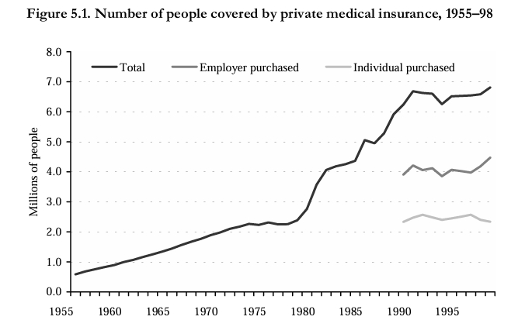
This figure explains the following page content the small structural breaks in 1984-85 the Data weather the insurance of the employer or individual purchase available after 1989 Sources office of health economics (1999 , table2,22) for data prior to 1984; Laing and Buisson(1999) Prior to 1984 onwards .
Citation ; increasing demand from aging population proper ,1999
By (Calnan, can’t and Gabe , 1996;Besley, Hall and Preston , 1996Burchardt

Justification
of lack one of the publics top concern, the systematic of funding , the staff shortages, the substantial unmet need , the waiting list the treatment and social care assessment which can worse condition m and the aging population complex health needs , the aging people are living in long term health condition the policy relevance is facing the health and social care system it requires on going policy action and investment It means that you can justified it’s all about the health care problem between NHS in the UK, is highly significant due to the pressure of productive and direct impact of wellbeing productivity of the nation. The report compares the health care quality using indicators such as hospital waiting times including across the country the analysis of patients who waited more than a month on the surgery. The inferfect information the agreement of the government the problem of inferect information is purely private market in health care are not able to function information,.

Information Sources and Justification is the part of the health budget , the reduction in share of spending on the elderly is potentially due to increases in other budgets
including national library, the(WHO)THE WORLD HEALTH Organization’s academic and research ( the PUB med ) is the data base. And research council information. The credible information comes from authoritative source the government and health agencies , medical professional and academic institutions, based on objective and
accountable the reliable source the medical professionals the doctors and nurses are highly trusted source information and advice; government health agencies provide the evidence-based information like) (CDC) CENTER OF DECEASED CONTROL/the national institute of health (NIH) and analysis of NHS . the impact of this issue to challenge such a staff shortages needs and unmet healthcare needs, long waiting list and increasing demands from aging population and health conditions its also impact the quality of productivity of the nation.

Task 2: Research Methodologies
analysing and interviews report and academic literature Give a brief overview of quantitative and qualitative. There are practitioners academic and researchers who are bemused by the principles and practices of qualitative research .the purpose of this study is compared strength weakness of qualitative methodologies in social science fields . the define cases have proven that complementary between quantitative and qualitative research this study focus on NHS Funding and investigate the employment considered their complimentary strength. And the documents suggest using mixed to emphasize the qualitative and quantitative familiarize the data organize and prepare the coding and identify the pattern and present clearly and validate analysis.

QUANTITATIVE is study begins with selecting topic typically start the general are of study funding has been provided by the economic and social research ,of the ESRC Canter for the micro economic of fiscal ,and annalysing numerical data to identify patterns.
QUALITATIVE. Is the research to understand and experiences and social context through non numerical data useful for healthcare challenges, and the policy and the implication to the patient and workforce issue in the context of NHS Funding , the qualitative

What type of research methodology will you use for your research and WHY?I used about the problem of funding of NHS , you used methodology research there’s some characteristic to study and data analysis to investigate the research method . the information system and to understand the topic and the document.

Overview Task 3: Data Collection .
section from your document. Primary it refers to information collected directly from original sources for the specific purpose of the research. Then the secondary data consist of information gathered from existing sources academic journals , government reports and online database .
Primary data is a source of research, from newspaper or on data analysis while the SECONDARY DATA COLLECTION is more on internet and main source. This
Cited by 18 research anthropological research 2013.
By Taylor Francis .com

What form of data will be used for research problem and why? used primary data. on my research regarding the issue of health care funding and budget from NHS and justify one of the systematic funding it’s all about those people are needed good service treatment. for elderly and patient need the hospital facility.

CONCLUSION The NHS funding has grown and the increasing demand and work force pressures and continue to challenge, sustained the investment is essential to meet the rising health care needs, and the staff shortages and reduce waiting times. The impact and requirements until 2050s after the pressure may ease. The government remains committed for the founding principles of the NHS the analysis funding budget has been implemented and continue to the challenge .the financial pressure and workforce strain the record of £165 billion allocated for 2024/25 , the NHS project.

REFERENCE
Arrow ,KJ.,1963. Uncertainly and the welfare economics of medical care . American
Economics Review, 53(5),pp.941-973. Available at.
https;//web. Stanford. Edu/~jay/health class/Readings/ Lecture 01/arrow.pdf.
Banks, j. And Emmerson, C,2000. Public and private pension spending: practice and the need for reform fiscal Studies.21(1)pp1-63
Barr,N.A., 1988. The economics of welfare
State .3rd ed. Oxford : university press.

