Student Name: Henri William

Student ID:2115861

Module Name: Financial Management

Module Code: LCMB7002

Lecturer’s Name: Dr shengfeng Mei

Work Count: 5000words
Term 1

Table of Contents
1.0 Financial Health Check 3
1.1 Overview of Financial statement of General Electronics 3
1.2 Ratio analysis for General Electronics 3
1.3 Identification of trends, strengths and threats of General Electronics 5
1.4 Applied corporate failure prediction models for risk assessment 6
2.0 Working Capital Management Analysis 7
2.1 Computation of cash operating cycle 7
2.2 Recommendation to business 8
2.3 Compare short-term vs long-term financing options 9
3.0 Strategic Financial Restructuring Plan 9
3.1 Recommendation for the financial restructuring option of business 9
According to the basic identified operating structure and the financial position of the business, the primary objective are mainly include; 9
3.2 Impact of Shareholders value, debt structure, and operational flexibility of business 11
3.3 International and ethical considerations associated with business 11
4.0 Investment Appraisal and Capital Budgeting 12
4.1 Computation of investment appraisal with different methods 12
4.2 Final investment recommendation with capital rationing 16
4.3 General recommendation regarding financial performances and risks characteristics 17
References 18
Appendix 20
Financial Ratios 20
Investment Appraisal 21

1.0 Financial Health Check

1.1 Overview of the Financial statement of General Electronics
The concept of Financial accounting provides relevance to the disclosure approach of financial details of business that represents financial insights during a specific period basis. The financial statement of business is recognised as the general disclosure approach with the consideration of which the overall positioning engagement of the business including the values are generally evaluated. A general analysis of financial position of business indicates a contemporary positioning support in general that brings the operating determination including the positioning approach of business operation in a detailed manner mainly.
According to the present financial details of General Electronics, it is fundamentally recognised that the revenue position of the business has basically declined steadily from the level of £614.7 billion (2020) to £394.9 billion (2024), which represents around 36% of the decreasing approach over the last five years. On the other hand, the position of business gross profit indicates a significant fall as well from the level of £176.3 billion (2020) to £114.0 billion (2024) however, the position of this earning roughly imposes a stable structure of 28% to 29% gradually. The net income position of the business on the other hand, represents a volatility approach that represents the positive earnings from £38.6 billion in 2020 to (£98.2) billion in 2023 and around a loss of (£24.0) billion in 2024. On the other hand the cash and cash equivalent position of the business also represents a certain declining approach from the level of £66.7 billion in 2022 to £26.8 billion in 2024. Even the processing of business balance sheet approach indicates the level of total assets position of the business have declined sharply from the level of £510.3 billion in 2021 to £323.4 billion in 2024, driven by reductions in PPE and current asset’s structure mainly (Atukalp, 2023).
The general identifications and the basic measurement approach, which is generally identified from the numeric present in the financial statement indicates the overall financial structure in the context of profitability, liquidity and also the other financial aspect mainly represents a comprehensive level of declining status for the business that probably occurred due to the reasons of incompetent business operations or probably due to the current economic pressure that facing every individual business of the United Kingdom.

1.2 Ratio analysis for General Electronics
The primary view of managerial accounting provides an effective level of significance to the application of the ratio analysis concept which is initiated as a form of strategic engagement under which the optimal evaluation of financial positions of the business are measured. Applicability of ratio can be recognised as a form of measurement under which a proper relations are mainly established between individual accounting elements in proportional level of the operation and values (Agrawal, 2023). In the present situation for the identification of financial position of this particular business operation over the five different financial period the following ratios are mainly measured which represent the result as follows;
(i) Profitability ratios
The initiated processing of this form of measurement mainly provides a focus on the earning potential approach which represents how efficiently the business is currently operating in respect of the market standard and position. The primary engagement of this formulation in relation to the gross profit margin of the business is mainly provided which represents a certain non-optimised positioning approach as the label of performances represent the 29% of returning capability during both the period without any kind of fluctuations (Fridson and Alvarez, 2022). The presence of this particular approach indicates the increased sale pricing including the reduced level of Costing structure in some contexts, which imposes the positive attribute to the business values. However, the operating profit margin represents a decline from the level of 6% in the year of 2020 to the level of (-4%) in 2024, which indicates a significant volume of operating loss consequences.
The excessive volume of expenses pressure, including the non-optimal market standard, imposes this type of consequences that ultimately initiate a challenging engagement to the business. The formulation of net profit margin also represents the same negative approach from the level of 6.3% of returning approach in the year of 2020 to the standard of (-6.1%) in the current period of 2024 that probably occurred due to the reasons of excessive financial issues including the current level of supply chain crisis that impacted over the UK in economy (Alomi et al., 2023). The measurements related to the level of return on equity indicating the standard position of decrease from the level of 12.3% in the year 2020 to the standard of (-15.7%) in the current period of 2024 that represents and excessive pressure of business costing engagement impose negative approach over the profit and which ultimately impacted incompetence initiation over the equity.
(ii) Liquidity ratios
Applied the formulation of this measurement is initiated to evaluate the cash flow processing or liquidity approach in a specific order basis that ultimately represents a comprehensive further investment opportunity. The measurement of current ratio level of the business indicating the position of 1.53 times approach from the previous level of 1.82 times in the year of 2020 that indicates overall stability formulations of current asset structure (Nasution and Yusleny, 2023). On the other hand the quick ratio measurement represents the general declining approach from 1.15 times to the level of 1.03 times in the current period of 2024. On the other hand the cash ratio position of the business indicates the standard of 0.17 times of returning initiations which is also declining from the previous level of 0.32 times mainly.
(iii) Efficiency ratios
The formulation structure of this particular ratio has been initiated to identify how efficiently the assets position of the business are impacting over the operating standard and depending on search the assets turnover position of the business can be evaluated which indicating the standard of 1.22 Times of returning support in the current year compared to the level of 1.20 times in 2020. On the other hand, the inventory turnover position of the business represents the level of 3.54 times that decreased from the level of 3.64 times in 2020 (Alarussi, 2021). The processing measurement related to accounting payable approach of the business presenting a level of 3.90 times of credit approach in the current period of 2024, that decreased from 5.27 represents non-optimised marketing demand structure in the current period of inflation under the UK economy.
(iv) Gearing ratios
Identified structure of these measurement has been initiated to realise the position of risks assessment approach over the capital processing level of business and the measurements of debt-to-equity processing of the business indicating the standard of 1.11 times of returning support while in the year of 2020 it was around 0.63 times which represents a high level of dependency approach over the borrowing capital (Oranefo and Egbunike, 2023). Following the same order the interest coverage ratio level of the business indicating the standard of (-4.55) Times of financial position in compared to the level of 26.21 times in 2020 that indicates in the presence situation the level of incompetent profit approach imposes a high level of negative initiation over this particular business operation.
(v) Investment ratio
A proper volume of initiation of this form of ratio mainly structure to realise how effectively the net profit approach is capable of providing returns supports to the investors with the processing of Earning per share structure which currently represents the results of (-1.85) times compared to the previous level of 2.72 times in the year of 2020.

1.3 Identification of trends, strengths and threats of General Electronics
Strengths: In the present positions of gross profit margin associated with the industrial standard including the operating cash flow generating position of the business represents a proper volume of stabilities and strength with optimised supply chain engagement which ultimately represents a comprehensive positioning approach to the business. Even inventory positions also represent a comprehensive value initiation support which is optimal for the business value development in upcoming years (Olayinka, 2022).
Threats: A huge volume of operating laws, including the loss of net income, imposes a huge level of crisis, which can be identified with the other return-oriented measurement perspective. Even the liquidity position in some prospects, including the leverage level of capital of the business, also imposes a huge level of borrowing capital dependencies that are non-optimal for the development in the upcoming period.

1.4 Applied corporate failure prediction models for risk assessment
According to the basic identified approach with the provided financial results for the current financial period of 2024 is mainly considered for the identified computations of Altman Z-Score, which can be applied for the purpose of identifying the risks assessment approach of the business in a detailed basis (Khan et al., 2021). The presence of this particular analysis formulated as;
Formula: Z_Score = (1.2A + 1.4B + 3.3C + 0.6D + 0.99E)
The primary involvement of this particular formula is structured with the following element basis that represents;
- A = “(Working capital / Total assets)”
- B = “(Retained earnings / Total assets)”
- C = “[Earnings before interest and taxes (EBIT) / Total assets]”
- D = (Market value of equity / Total liabilities)
- E = (Sales / Total assets)
With the support of the above formula, the primary financial details with the consideration of current financial details for the year of 2024 are mainly applied, which indicate
such values as;
A = “(Working capital / Total assets) = (84203 / 323354)” = 0.2605
B = “(Retained earnings / Total assets = 208431 / 323354)” = 0.6449
C = “[EBIT / Total assets = (Operating income) / Total assets]”
= (‑15297 / 323354) = (‑0.0473)
D = “(Book equity / Total liabilities) = (153105 / 170249) = 0.899
E = “(Sales / Total assets) = (394879 / 323354) = 1.221
Based on the above computation processing, the applied Z_Score value of the business will be; Z = [(1.2x0.2605) + (1.4x0.6449) + (3.3x(‑0.0473)) + (0.6x0.899) + (1.0x1.221)] = 2.82
According to the primary measurements the value of Z is around 2.82, which represents mainly the grey zone (1.8 - 3.0) that indicates the involvement of medium risk engagement of bankruptcy mainly.

2.0 Working Capital Management Analysis

2.1 Computation of cash operating cycle
According to the financial management approach applicability of cash operating cycle, which is also identified as the cash conversion cycle represents the time approach that generally the business takes to sell its inventory, collect its receivables, and pay its payables. The initiated involvement of this processing represents a proper optimised support including value progressive attributes also that manages the positioning level of operation in a systematic basis (Karim et al., 2024). Generally, this measurement indicates a shorter cash initiation is able to initiate a quickly selling approach of inventory and formulate a proper collection engagement from the receivable and also pay its payable, which generally develops and formulates the positioning level of liquidity with the reduction structure of working capital position.
In accordance with the positioning structure of these business values, the applied formulation of Cash operating cycle of the business is mainly provided as follows;
“Days Sales Outstanding (DSO)” = “(Accounting Receivable / Sales) x 365”
= “(114182 / 394879 x 365)” = 106 days.
It represents a slow receivable collection or the positioning engagement of lenient customer payment terms associated with the general operating position of the business.
“Days Inventory Outstanding (DIO)” = “(Inventory / Sales x 365)”
= “(79355 / 394879 x 365)” = 73 days.
The primary engagement of this analysis represents the slow inventory turnover position that probably occurred due to the possible product obsolescence risk associated with the consumer electronic requirement.
“Days Payable Outstanding (DPO)” = “(Accounts payable / COGS x 365)”
= “(72031 / 280885 x 365)” = 94 days
It represents the company extracting the long supplier payment terms including the initiations of partly offsetting structure of working capital associated with the requirements.
“Cash Conversion Cycle (CCC)” = [DSO + DIO − DPO] = (106 + 73 - 94) = 85 days
In accordance with the present level of operating structure the company requires nearly three months of working capital financing despite long supplier terms. Under the present operating structure with the falling cash and negative operating earnings, the positioning results of the business represents an optimised liquidity positioning approach including the receivable initiation that indicates the requisition of value positioning standard for the business liquidity in the upcoming.

2.2 Recommendation to business
According to the identified cash operating cycle computation, business importance to the short-term operation engagement are required to be initiated in a specified order basis. Some of the relevant strategic approaches that need to be structured in the business includes;
(i) Tighten Receivable management with the introduction of credit score threshold support and with the reactions of standard payment terms a proper volume of financial collections engagement including the involving approach can be implemented that represents an optimised opportunity for the business liquidity (Ahkam et al., 2021).
(ii) A proper volume of importance to the reduction of slow-moving inventory approach through the implementations of SKU rationalisations can be initiated which will be capable of managing the targeted promotions and conversion inventory into cash more accurately. The primary engagement of vendor management inventory for the core item were possible for the acceleration of operating progress and also write off the obsolescence can be initiated for the operating growth purpose (Efendigi and Cameron, 2021).
(iii) Application of repricing the product mix engagement with the maintenance structure of higher margin initiations can be optimised for the formulations of the product line which will be feasible for development of revenue generating support in this business more accurately.
(iv) A proper importance to the cash collections initiations including the reconciliations approach in respect of the unbalanced receivable and payable approach are required to be measured, with the presence of which the operating growth including the value development approach of the business will be formulated (Ab Shatar et al., 2021).
Along with the above recommendations approach the business also need to provide an equal volume of significance to some of the basics strategies in a specific order basis under which a proper receivable financing to convert the accounting receivable into immediate cache approach are required to be considered including the reserve factoring as well for initiating a proper financial cost initiations and low-cost maintenance support. A proper importance to the short-term commitment related to the credit line also needs to be initiated in a specified order basis which will be feasible for the recognition of the value proportion to the standard of this business. Additionally the management in a long term prospective is required to provide a proper importance to the inventory financing or assets-based lending approach against the inventory and receivable for free cash initiation purposes. The applications of cash pooling concept including the centralised treasury across in international units with the support of global liquidity formations, are required to be implemented in this business to manage the overall cash flow presence properly.

2.3 Compare short-term vs long-term financing options
According to the basic engagement, the short-term initiatives generally represent a quick liquidity relief, including the flexibility initiations however represents a higher volume of periodic cost engagement, which may require some frequent renewal approach that can be critically approached during the operational turnaround (Hempel et al., 2024). On the other hand the long-term initiation represents more expensive in absolute funding engagement or the involvement of diluted initiative however, capable of developing solvency metric with the reducing refinancing risk, which will be strategies the operating growth and optimised investment of opportunity.
According to the basic initiated processing implementation of the two-tier approach with the consideration of short-term working capital tools to stabilize the liquidity on an immediate basis, the combinations of medium funding packages can be initiated which will be feasible for the restoration of the structural solvency of this business on an accurate basis.

3.0 Strategic Financial Restructuring Plan

3.1 Recommendation for financial restructuring option of business

According to the basic identified operating structure and the financial position of the business the primary objective are mainly include;
- Restoration structure of business profitability and operations with a positive operating margin
- Formulation of a stable liquidity processing with revealed support of cash buffer
- Reducing the level of leverage along with improvement of interest coverage level.
- Preserve Global scheme and core competences with trimming approach of non-core Complexities.
In accordance with the primary initiation structure of the business position in engagement and operating level the general recommendations related to the restructuring approach of business operations mainly initiated with four different level bases, which will be accountable for the business’ operating development and performance progress purpose. Those includes;
(i) On immediate support (within the next 6 months); the fundamental applications of liquidity preservations and signalling approach are required to be initiated in this business operations, which will be accountable for the operating development and other progress effectively. A proper suspension of the share buyback initiative and also the discretionary approach regarding the dividend approach will be capable of conserving the cash and also improve the perceptions of governance more accurately which will be accountable for the business values (Kukushina and Vinogradova, 2021).
A proper volume of development structure related to the implementation of short-term Finance in package along with the extended structure of credit line processing will be convenient for the business values along with revised key performance indicator support which will be feasible for the business accountability. A proper amount of negotiations along with the supplier including the lease concession packager also required to be initiated in this business which will be feasible for the cash outflow controlling purpose.
(ii) Appearances of operational refracturing (Within the period of 3 to12 months); The initiative divest the low product line and underperforming regional operations are required to be initiated in the business operation with the presence of which the operating growth including the targeted approach of pay down on higher cost borrowings can be initiated with the rebuild structure of cash flows. The initiations of global manufacturing footprint with the consolidated support of overlapping capacity including invest savings associated with the automation process will be capable of supply development initiative support in the business which will be feasible for the liquidity (Pratama et al., 2022). A proper importance to the centralised procurement including the implementation of strategic Sourcing structure for reducing the cost of goods sold will be accountable for the business with the presence of which a proper gross profit margin variance can be eliminated. The applications of proper product portfolio support with focusing on the high margin initiations will be capable of managing the product development and revised product line initiation support which will be feasible also for the operating progress.
(iii) Restructuring financial presence (Within period of 6 to 24 months); Identification related to the maintenance structure of targeted equity injections with the involvement of proper strategic investors required to be initiated in this business with the formulation of which a proper volume of leverage capital engagement can be initiated. A proper volume of valuation related to the strategic partnership approach are also required to be initiated as well which will be compatible for financial Optimisation support purpose (Setyowati et al., 2021). A proper importance to the formulation of capital structure with the involvement for debt-to-equity approach are also required to be initiated with proper equity present which will be feasible for the maintenance of financial reformation. The presence of proper issuance of convertible bonds will be convenient for the protection and support of business financial positions in the form of both the debenture and equity which will be accountable for lowering the cash interest burden.
(iv) Corporate actions and other development: In according with the above processing structure of operations a proper importance to dispose of non-strategic subsidiaries are required to be initiated including a proper reduction of the net debt initiation need to be formulated in a properly order basis, which will be accountable and optimal for reveal the operating reserves more accurately. A proper strategic alliance, including the acquisitions approach, will be accountable for expansion support of operating progress including high margin product adoption’s purpose which will be operational in accordance with the targeted equity support (Gepner et al., 2022).

3.2 Impact of Shareholders value, debt structure, and operational flexibility of business
In accordance with the basic operating structure of this particular business operation the suspensions of buyback or dividend approach will be capable of reducing the near-term shareholder return in a comprehensive order basis however it will be capable of increasing the liquidity positions and credibility approach of the business in a more comprehensive order support. The presence of net positive for long term shareholder value will avoid the distress and also preserve the going concern approach of the business more accurately (Ritchken and Wu, 2021). A proper importance to the equity injection approach will dilute the existing shareholder however also decline the financial rays and also reduce the interest cost as well which will ultimately improve debt convenient approach with strong and sustainable business value prospective. The primary engagement related to the debt for equity swaps will be capable of reducing the fixed obligations and also for interest coverage pressure purposes which will be available to control and also maintain the stock market perceptions more precisely. The primary initiation structure of the divestitures generate cash and sharpen strategic focus will be accountable for the business however, it will reduce the revenue scale and be capable of providing a fair value initiation engagement related to product pricing.

3.3 International and ethical considerations associated with business
The primary engagement of the taxation approach is generally required to restructure the operations with proper tax implications bases which will avoid the aggressive tax avoidance scheme and prefer the transparent and complex approach of proper tax planning initiation benefit. The primary initiation set related to the currency risks can be avoided through the formulations of centralised currency hedging process with the treasury support which will reduce the forex volatility on the margin in a specified order and also capable of managing the financial stable component more accurately.
In the present situation inflation is one of the primary factors that imposes a huge level of economic crisis to the UK economy and a proper supplier contract including clear escalation clauses can be accountable to provide an opportunity for avoiding the inflation pressure in an accountable manner. The primary engagement related to CSR policies along with maintaining a proper stakeholder relations are accountable for the operational growth including the maintenance structure of the business values more accurately through the presence of which the regulatory compliances including the legislative engagement can be fruitfully balanced. Along with the above factors a proper volume of importance to the UK corporate governance code are also required to be initiated in this particular business with the maintenance of which a proper board significance including an optimal director’s engagement with a transparent and feasible approach can be initiated. The primary presence of this type of engagement is basically mandatory for every individual listed company incorporated with the company Act 2006 basis to provide a contemporary growth including the maintenance structure of business operating values in accordance with the market standard.

4.0 Investment Appraisal and Capital Budgeting

4.1 Computation of investment appraisal with different methods
The formulated appearance of the investment appraisal concept has been initiated to provide a systematic level of guidance regarding the evaluation of projects mainly that provides some comprehensive guidance for the business values and other development. Under the financial management the presence of this type of initiation is also formulated to identify the viability position of the business including some of the operating value initiation approach in a comprehensive order basis that ultimately brings the contemporary guidance for the business values. A proper volume of importance to the capital budgeting concept also brings the contemporary guidance structure in a more elaborated order basis which is ultimately optimised for the business positioning development.
The concept of Payback period is defined as a particular method under which how long a project generally takes for the completions of investment cost recovery initiation purpose are measured that represents a proper financial positioning support and contemporary benefit options. The concept of accounting rate of return generally provides relevance to the actual returning position of the business project in a specified order basis through the formulation of which the returning structure of the project approach can be identified. The primary engagement of net present value is defined as the differentiation between the present value initiations level of the project associated with the expected cash flow structure along with the initial cost presence so that the positioning growth of the project in an absolute order can be determined. The primary concept of profitability index is initiated as a ratio measurement with the formulation of which the present value of the investment expected cash flow related to the initial cost processing of the investment are measured. The applied formulations of internal rate of return on the other hand are initiated to identify the general discounting rate engagement with the time formulation bases through the recognitions of which the actual investment cost at what percentage will be equal to the level of zero are identified.
According to the primary identified approach the payback period, accounting rate of return, net present value, profitability index and the internal rate of return method are mainly used for three different project option bases with considerations of which the overall accountability level and other aspects of the business financial values can be identified.
Project A
Payback period
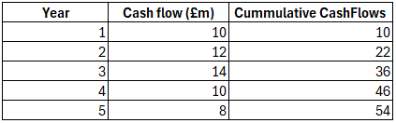
“Payback period = 3 years + (40 - 36) / 10 = 3.4 years”
Accounting rate of return
- “Depreciation (straight‑line) = (40 / 5) = £8.0 million (annually)”
- “Average cash inflow = (10+12+14+10+8) / 5 = £10.8 million”
- “Average accounting profit = (10.8 - 8.0) = £2.8 million”
- “Average investment = (Initial + Salvage value) / 2 = (40 / 2) = £20.0 million”
- “Accounting Rate of Return = (2.8 / 20.0) = 14.0%”
Net present value
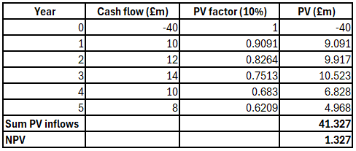
Profitability index
“Profitability Index (PI) = (PV inflows / Initial) = (41.327 / 40) = 1.033”
Internal rate of return
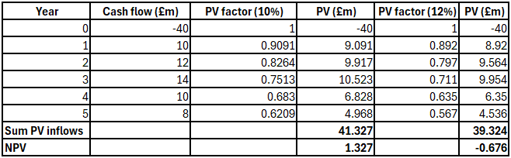
IRR = 10% + (1.327 / (1.327+ 0.676) x (12%- 10%)
= 10% + 0.6626 x 2.00% = 10% + 1.325% = 11.325%
Project B
Payback period
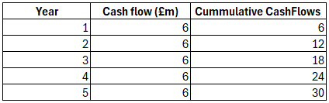
Payback period = 5 years
Accounting rate of return
- “Depreciation = (30 / 5) = £6.0 million annually”
- “Average cash inflow = 6.0”
- “Average accounting profit = (6.0 − 6.0) = £0.0 million”
- “Average investment = (30 / 2) = £15.0 million”
- “ARR = (0.0 / 15.0) = 0.0%”
Net present value
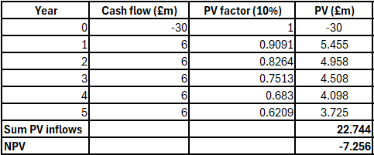
Profitability index
- “Profitability Index (PI) = (PV inflows / Initial) = (22.7448 / 30) = 0.758
Internal rate of return
- IRR = 0.0% (Under the present position of this project returns cash flows are mainly represents an equal to initial over life, and the processing of discounting makes NPV negative, therefore, IRR solves to 0%)
Project C
Payback period
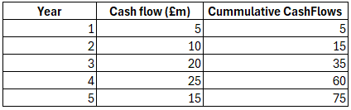
“Payback period = 3 years + (50 - 35) / 25 = 3.6 years”
Accounting rate of return
- “Depreciation = (50 / 5) = £10.0 million annually”
- “Average cash inflow = (5+10+20+25+15) / 5 = £15.0 million”
- “Average accounting profit = (15.0 − 10.0) = £5.0 million”
- “Average investment = (50 / 2) = £25.0 million”
- “Accounting rate of Return = (5.0 / 25.0) = 20.0%”
Net present value
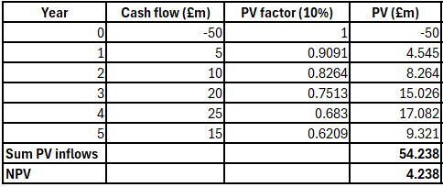
Profitability index
- “Profitability Index (PI) = (PV inflows / Initial) = (54.238 / 50) = 1.085
Internal rate of return
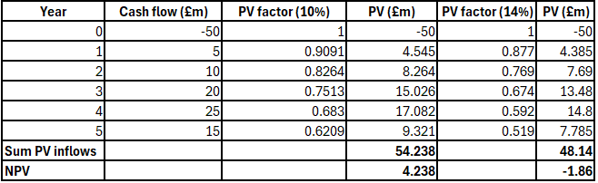
IRR = 10% + (4.238 / (4.238+ 1.86) x (14%- 10%)
= 10% + 0.6953 x 4.00% = 10% + 2.781% = 12.78%

4.2 Final investment recommendation with capital rationing
According to the general identified approach of capital budgeting measurements, a shorter payback period is fundamentally preferred, as it indicates that the investment will recover its initial cost more quickly. On the other hand, a higher ARR is supportive, as it indicates that the investment is generating a higher return. The positioning structure of positive and higher NPV is supportive as it is used to represent a proper financial returning approach associated with the cost of capital processing. Application of profitability index as greater than 1 represents a proper investment positioning benefit including an accountable attribute in respect of the cost of capital which is optimal for the business contemporary growth reason. Associated with the above approach a proper volume of higher IRR is optimal and accountable as it is used to indicate a proper investment process with generating higher returning support. In the present situation with the considerations level of the above factors the following analysis or ranking approach of the project are mainly provided.
Metric | Project A | Project B | Project C
Initial investment (£ in million) | 40 | 30 | 50
PV of inflows @10% (£ in million) | 41.327 | 22.745 | 54.238
NPV (£ in million) | 1.327 | −7.255 | 4.238
PI | 1.033 | 0.758 | 1.085
IRR | 11.20% | 0.00% | 12.38%
Payback period (years) | 3.4 | 5 | 3.6
ARR | 14.00% | 0.00% | 20.00%

In accordance with the above analysis structure of operation it can be recognise that at the presence situation initiating the investment over the project C will be accountable for the business operation as it is representing a higher volume of net present values support, positive and higher profitability index more than one, higher position of internal rate of return and also higher accounting rate of return approach mainly. However the level of Payback period for this particular project is around 3 years and 6 months however it is adjustable as it represents lower recovery time compared to the project life cycle.
Therefore initiating the investment over this particular project compared to any other project will be feasible and accountable for the business operations in the upcoming.

4.3 General recommendation regarding financial performances and risks characteristics
In accordance with the above operational approach the present financial standard including the generated liquidity positions which will be formulated with the support of project C will be accountable with a positive volume of ARR and IRR approach that indicates the comprehensive market positioning engagement also. Application of this particular initiation also represents a proper liquidity processing structure as well with the maintenance of which optimal progress including some of the stable operation compatibility level can be initiated.
The primary approach related to the liquidity initiation from the project C is also indicates a proper volume of cash flow volatility support including the optimised financial attribute in a specific basis that ultimately indicates the contingency approach for the project in a long term prospective.

References
Ab Shatar, W.N., Hanaysha, J.R. and Tahir, P.R., 2021. Determinants of cash waqf fund collection in Malaysian Islamic banking institutions: empirical insights from employees’ perspectives. ISRA International Journal of Islamic Finance, 13(2), pp.177-193.
Agrawal, S., 2023. The role of financial statements in understanding a company’s financial position and preparing and analyzing such statements. International Journal of Social Science & Economic Research, 8(07), pp.1833-1846.
Ahkam, S.N., Nahar, N. and Shorna, S.R., 2021. Management of receivables, financial distress, and profitability in bangladesh. Asian Economic and Financial Review, 11(9), p.710.
Alarussi, A.S.A., 2021. Financial ratios and efficiency in Malaysian listed companies. Asian Journal of Economics and Banking, 5(2), pp.116-135.
Alomi, Y.A., Aljumah, G.Z., Alohlie, N.R., Alamri, N.S., Alashban, R.M., Almadany, M.H., Almasoudi, A.H., AlHamdan, B.S. and Alanazi, G.T., 2023. Accounting and Financial in Pharmacy Practice: Financial Position Statement (Balance Sheet). International Journal of Pharmacology and Clinical Sciences, 12(1), pp.17-28.
Atukalp, M.E., 2023. The effect of financial statements on financial review results. Statement of financial position or income statement?. Gazi İktisat ve İşletme Dergisi, 9(1), pp.80-96.
Efendigi, E. and Cameron, K.K., 2021. Inventory management for slow moving and high volatility items.
Fridson, M.S. and Alvarez, F., 2022. Financial statement analysis: a practitioner's guide. John Wiley & Sons.
Gepner, P., Dao, M.T.H. and Minh, D.T., 2022. Analysis of business strategy of leading Vietnamese real estate developers using SWOT matrix. International journal of multidisciplinary research and growth evaluation, 3(1), pp.181-187.
Hempel, S., Li, Y. and Tibay, S., 2024. Firms' financing choice between short-term and long-term debts: Are they substitutes?.
Karim, R., Mamun, M.A.A. and Kamruzzaman, A.S.M., 2024. Cash conversion cycle and financial performance: evidence from manufacturing firms of Bangladesh. Asian Journal of Economics and Banking, 8(1), pp.67-82.
Khan, N., Malik, Q.A., Saghir, A., Rasheed, M.H. and Husnain, M., 2021. Does corporate social responsibility reduce financial distress? Evidence from emerging economy. Management Science Letters, 8(11), pp.2225-2232.
Kukushina, O.S. and Vinogradova, N.I., 2021, February. Improvement of Operational Management of Cash Flows as a Factor of the Growth of Business Activity of Agricultural Enterprises in the Region. In International Scientific and Practical Conference “Russia 2020-a new reality: economy and society”(ISPCR 2020) (pp. 404-407). Atlantis Press.
Nasution, Y.A. and Yusleny, Y., 2023, February. Financial Performance Measurement Using Profitability Ratios And Liquidity Ratios. In Proceeding Medan International Conference on Economic and Business (Vol. 1, pp. 1730-1741).
Olayinka, A.A., 2022. Financial statement analysis as a tool for investment decisions and assessment of companies’ performance. International Journal of Financial, Accounting, and Management, 4(1), pp.49-66.
Oranefo, P.C. and Egbunike, C.F., 2023. Gearing ratio and operating cash flow performance of quoted manufacturing firms in Nigeria. International Journal of Financial, Accounting, and Management, 4(4), pp.395-410.
Pratama, B.B., Ekasari, K. and Indrawan, A.K., 2022. Analysis of financial system modeling for integrated petty cash based on business process management. Journal of Applied Business, Taxation and Economics Research, 1(5), pp.427-438.
Ritchken, P. and Wu, Q., 2021. Capacity investment, production flexibility, and capital structure. Production and Operations Management, 30(12), pp.4593-4613.
Setyowati, W., Widayanti, R. and Supriyanti, D., 2021. Implementation of e-business information system in indonesia: Prospects and challenges. International Journal of Cyber and IT Service Management, 1(2), pp.180-188.

Appendix

Financial Ratios
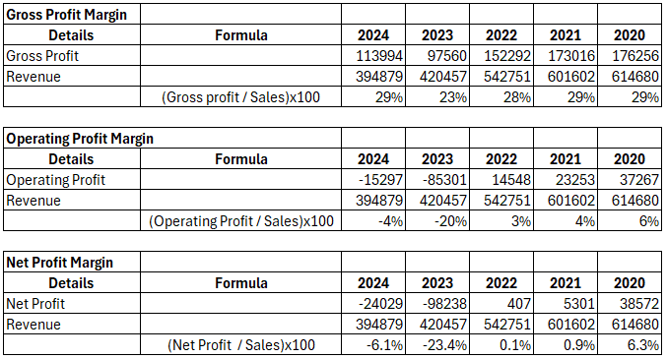
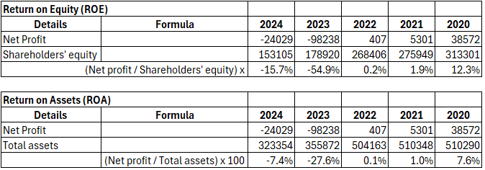
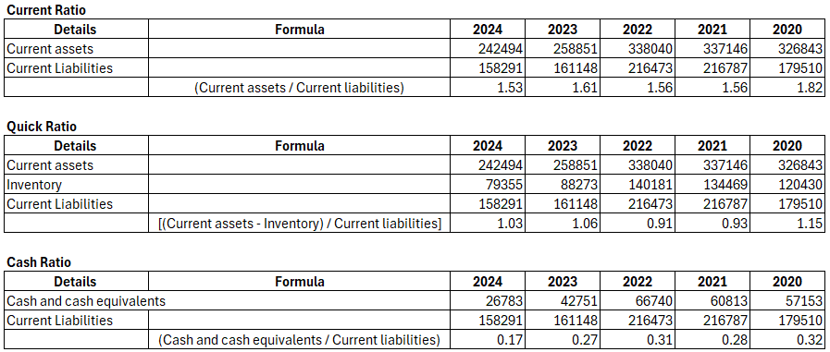

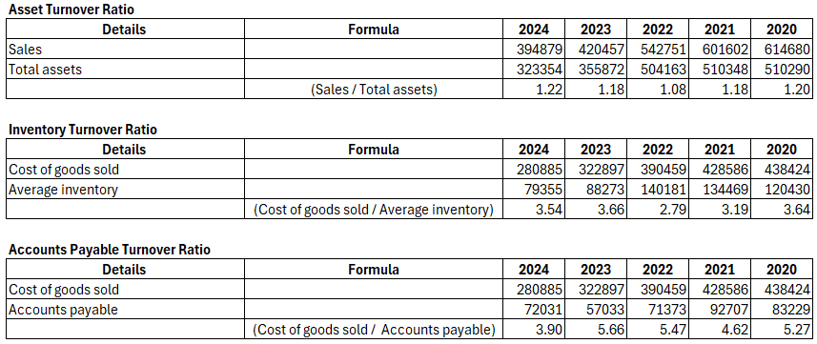
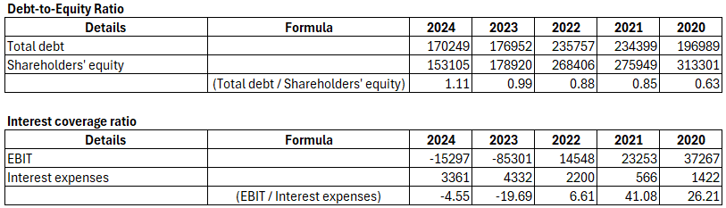
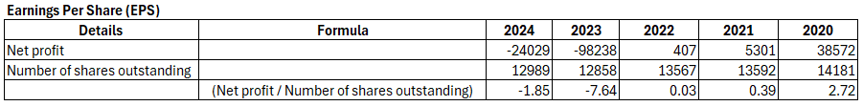

Investment Appraisal


