Student name: Bianca Petronela Lambrino​
Student ID: 2017447​
Module code: BMSW 4003
Assignment section: Digital Skills and Research Methods ​

Digital Skills and Research Methods

Table of Contents
Introduction 3
Research methods 3
Secondary research 3
CRAP Test 6
Primary research 6
Analysis 8
Concussion 10
Reference list and bibliography 11

Introduction
- The respective report is going to produce a script for a BBC TV news report based on the DIKW research.
- The report will first shed light on the different research methods like secondary and primary research methods to discuss Duckworth’s grit.
- CRAAP test is the analysis of secondary data based on its currency, relevancy, authority, accuracy and purpose.

The overall work will proceed by following Duckworth's Grit book. Therefore, the aim of the report is to conduct a CRAAP test for the DIKW research that is based on Grit perseverance and passion for long-term goals.
Duckworth's Grit is the current topic of self-help used by academic and business leaders. Duckworth is a professor at the University of Pennsylvania in the department of psychology as well as a leading researcher in some specific areas like the success and achievement of individuals. The professor and leader started to wonder what the differences between failure are and success is as well as what the differentiating factors are. Duckworth wanted to determine “if grit was a factor in defining why some cadets with innate talent are unsuccessful during basic cadet training generally referred to as Beast Barracks”.

Research methods

Secondary research

- As opined by Duckworth "grit is passion and perseverance and passion for the success of long-term goals.
- The concept of determining the factor of why some people are successful and why others are unsuccessful is a proper approach for the academic leaders in the universities or any institution of higher education.
- It is helpful for the leaders of higher educational institutes who are struggling with retaining the learners, especially with the students in the first year.
- The "Grit Scale" introduced by Duckworth focuses on the individual's willingness to approach challenges of life with determination.
- The researcher found the same result in the sales organisations among the students in the “Scripps National Spelling Bee”. Duckworth lastly stated that people with grit are more optimistic and intended to be more self-critical in the context of their performance.
- Moreover, the students possess a mindset that emphasises perseverance and rapid self-growth.
Here some studies raised their voice over whether grit is real or not. It just might be that the essentiality for passion and perseverance is more significant compared to the individual's mere talent. Just like other self-help books, Grit's concept is strong in the respect of circumstantial stories and light on quantitative evidence. For instance, Duckworth stated an argumentative statement in which she defined grit as a predictor of people's success in the context of long-term goals. According to this concept, there are two formulas;
“Talent x Effort = Skill”
“Skill x Effort = Achievement”
(Effort counts twice as much as skill)
Some of the benefits of possessing grit for people with depression are as follows:
- It helps reduce the severity of one's symptoms.
- It improves social and occupational functioning.
- It increases the chance of working through depressive episodes on one's own. This can be beneficial because it can reduce the length of depressive episodes, thereby leading to better self-management skills (Reysen et al., 2019).
- Grit can lead to greater confidence and positive feelings.
- It helps prevent the cycle that people with depression often go through, which is the inability to get started on a task, followed by hopelessness, then rumination and lastly relapse.
- It is beneficial in improving the overall health of an individual.
- It helps develop or maintain important social skills such as problem-solving, conflict resolution, building relationships and decision making. These are all essential skills that are important for everyone to have (Duckworth, 2016).
- Grit can be used as a coping mechanism for people with depression because it can help them face their problems head-on.
Duckworth offers no shortcut to achieving success in academic or business settings. Success is more likely to be related to determination and passion rather than the individual's talent. Passion and determination are closely focused on the premise of “Malcolm Gladwell in Outliers: The Story of Success that successful individuals often put in 10,000 hours to get good at anything” (Jachimowicz et al., 2018). With respect to Gladwell, Duckworth moreover argued that it takes determination and effort to attain success and not mere individual talent. According to Duckworth's opinion, talented individuals often become unsuccessful due to a shortage of grit and on the other hand, individuals with passion and perseverance are more likely to achieve success in a different way (Duckworth, 2016). Grit is neither fun nor glamorous, it requires sacrifice and personal commitment. Therefore to achieve success in life a student or learner needs to acquire stamina like a marathon runner. The individual with grit is also required to recognise that factors of unsuccessfulness are minor setbacks.
In this case, the individuals who faced problems or challenges or had setbacks, have two options. Option one is to quit the game and option two stays in the game to face adversity and challenges head-on (Park et al., 2020). There are two possibilities; one the individual who quit the game is unsuccessful or failed, and two keep trying by staying in the game until attaining the success.
However, Duckworth does not suggest a conceptual way to establish grit in people and does not even provide strong proof in support of her assertions. Therefore it can be stated that despite providing better evidence for grit, Duckworth is unsuccessful to provide an effective concept as there needs to conduct more research on grit.
Students who know to value effort are with a growth mindset. Also, the students with intelligence are inherent and unchangeable, do not need to give more effort to achieve success and have a constant mindset. The idea behind a growth mindset in the academic field relies on Duckworth's grit concept. In the colleges where online learning is applicable, students often give up or drop out sometimes even without warning (Buskirk-Cohen and Plants, 2019). For increasing the retention of the students, the faculties are required to create a growth-centric environment to foster a growth mindset and grit. In order to develop a grit and growth mindset, the faculty can adopt any strategies. On the contrary, the Grit scale was developed to measure the characteristics of grit. Grit is the characteristic that is introduced to help the higher education students change their concepts and perceptions and to fix intelligence (Direito et al., 2021).
Grit is the "tenacity and perseverance to pursue a specific goal against opposition." Grit is applicable in numerous areas, such as a life-long pursuit of personal goals, school, sports or work. This idea can be applied to people who suffer from depression as well. This topic could be expanded on further by discussing how people with depression can become gritty through different things that they need to do in order to overcome their depression (Priyohadi et al., 2019).

CRAP Test
- The above demonstrated secondary data mainly based on two authentic and relevant articles.
- The first article considers the potential impact of grit on the students' engagement in the context of online legal studies courses.
- The currency of the respective paper is in 2016 and is relevant to Duckworth's Grit concept.
- The authority of the paper goes to Duckworth; the primary aim of this paper is to explore the effect on higher educational students' engagement.
After analysing and using the data of the first article it can be stated that the accuracy level of the provided information is high. The main purpose of the paper was to provide a foundation for the additional empirical research focusing on the relevant significant topic. Analysis of this paper highlights the integration of grit which is the main focus of this respective script. The survey conducted in this paper suggests that the group of students who attend online learning may cultivate maximised effort and success in assignments and projects given by the instructor.
- The other article, on the other hand, the second paper from which the additional data has been collected has been published in 2021.
- Authors of this paper are Direito, I., Chance, S. and Malik, M.
- It is relevant to Duckworth's grit which is the main focus of this research.
The findings of the second article moreover hold relevance for the engineering academic research however the studies in this area are still scarce. The research has shed light on the current state of research regarding grit and the interlinked in engineering education research through a systematic review. To assess grit and use Duckworth's Grit scale most of the reviewed paper has implemented quantitative methodologies. The key findings of this research are inconsistent for both the engineering education research and the conceptualisation of grit research.

Primary research
Q 1. Have you understood the overall concept of Duckworth’s Grit?
Options | Total number of participants | Number of respondents | Percentage
Yes | 17 | 10 | 59
No | 17 | 7 | 41
Table 1: Concept of Duckworth
(Source: Created by the learner)
Q 2. Do you have any problems in the context of understanding grit?
Options | Total number of participants | Number of respondents | Percentage
Yes | 17 | 13 | 24
No | 17 | 4 | 76
Table 2: Problems
(Source: Created by the learner)
Q 3. Is the concept helpful for your academy in order to achieve success?
Options | Total number of participants | Number of respondents | Percentage
Yes | 17 | 9 | 53
No | 17 | 8 | 47
Table 3: Helpful in achieving success
(Source: Created by the learner)
Q 4. Do you think there needs to be more research on grit concepts?
Options | Total number of participants | Number of respondents | Percentage
Yes | 17 | 15 | 88
No | 17 | 2 | 12
Table 4: Research on grit
(Source: Created by the learner)

Analysis

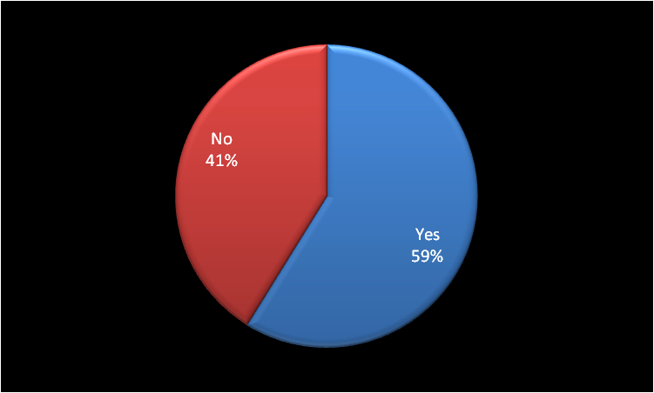
Figure 1: Concept of Duckworth
(Source: Created by the learner)
From the above figure, it has been observed that almost 59% of the students have a good understanding of Duckworth's grit while 41% still doubt terms of understanding grit. Therefore, the students require more depth knowledge of this topic and here the faculties need to conduct more classes for those particular students.
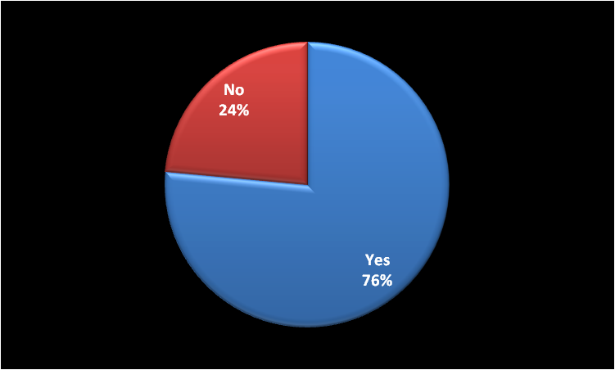
Figure 2: Problems
(Source: Created by the learner)
In response to this particular question, 76% of the students raised their hand for the "Yes" option. Therefore, only 24% of the total participating students understood the topic well and the rest of them have not yet gained a better knowledge of it. The faculties need to look into this factor to clear out the concept of that 76% of students.
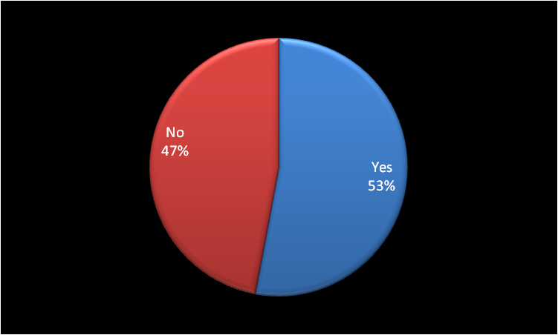
Figure 3: Helpful in achieving success
(Source: Created by the learner)
From this figure, it can be noticed that 53% of the participating students have benefited from the class where the grit concept was discussed. It means the rest of the students did not benefit from this class or did not implement this concept properly in their life.
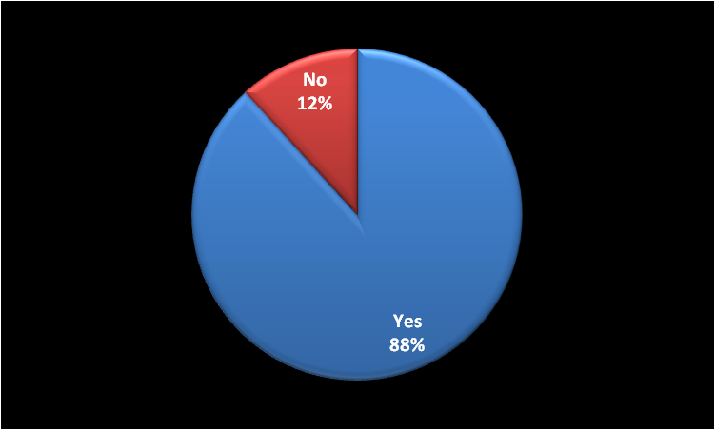
Figure 4: Research on grit
(Source: Created by the learner)
Here, the students were asked if they think that researchers need to do more in-depth research on grit. In response to this 88% of the participating students opined that they want more explanatory research on Duckworth's grit. However, 12% of them stated that they did not feel the requirement for more detailed research, the research will consider the perception of the majority.

Concussion
- From this overall discussion, it can be stated that Duckworth's Grit is the "tenacity and perseverance to pursue a specific goal against opposition."
- Grit is used in several areas, such as a lifelong pursuit of personal goals, school, higher education and sports or work.
- Through the CRAAP test, it has been known that both the papers are relevant to the current situation of implementing grit in the higher education context.
The primary research survey has been done on 17 students of the university. From the result of this research, it has been known that Although most of the students have understood grit well majority of the students have problems understanding the depth of grit. From this survey also it can be observed that the students want more exp[alnation on this particular concept. The secondary research focuses on the main two articles. Finally, it can be concluded that grit is a helpful framework for the students who are with a growth mindset. For better understanding, the faculties are required to conduct more classes on this particular topic.

Reference list and bibliography
Buskirk-Cohen, A.A. and Plants, A., 2019. Caring about Success: Students' Perceptions of Professors' Caring Matters More than Grit. International Journal of Teaching and Learning in Higher Education, 31(1), pp.108-114.
Cayley, W., 2021. Grit. Family Medicine, 53(1), pp.73-74.
Direito, I., Chance, S. and Malik, M., 2021. The study of grit in engineering education research: a systematic literature review. European Journal of Engineering Education, 46(2), pp.161-185.
Duckworth, A., 2016. Grit: The power of passion and perseverance (Vol. 234). New York, NY: Scribner.
Jachimowicz, J.M., Wihler, A., Bailey, E.R. and Galinsky, A.D., 2018. Why grit requires perseverance and passion to positively predict performance. Proceedings of the National Academy of Sciences, 115(40), pp.9980-9985.
Li, J., Zhao, Y., Kong, F., Du, S., Yang, S. and Wang, S., 2018. Psychometric assessment of the short grit scale among Chinese adolescents. Journal of Psychoeducational Assessment, 36(3), pp.291-296.
McKibben, S., 2018. Grit and the Greater Good: A Conversation with Angela Duckworth. Educational Leadership, 76(2), pp.40-45.
Oxford, R. and Khajavy, G.H., 2021. Exploring Grit:“Grit Linguistics” and Research on Domain-General Grit and L2 Grit. Journal for the Psychology of Language Learning, 3(2), pp.7-36.
Park, D., Tsukayama, E., Yu, A. and Duckworth, A.L., 2020. The development of grit and growth mindset during adolescence. Journal of Experimental Child Psychology, 198, p.104889.
Park, D., Yu, A., Baelen, R.N., Tsukayama, E. and Duckworth, A.L., 2018. Fostering grit: Perceived school goal-structure predicts growth in grit and grades. Contemporary Educational Psychology, 55, pp.120-128.
Priyohadi, N.D., Suhariadi, F. and Fajrianthi, F., 2019. Validity Test for Short Grit Scale (Grit-S) Duckworth on Indonesian Millennials. Journal of Educational, Health and Community Psychology, 8(3), p.375.
Reysen, R., Reysen, M., Perry, P. and Knight, R.D., 2019. Not so soft skills: The importance of grit to college student success. Journal of College Orientation, Transition, and Retention, 26(2).

