INTRODUCING THE MODERN WORKPLACE
Student’s name: Razvan Pavel Mocanu
Student number: 2131739
Module code: LCBB4003

Executive Summary
The article examines the intricate and diverse correlation between the composition, mindset, workforce, and productivity of an organisation. In this context, Aldi has been chosen to implement prime models for its comprehensive strategy in addressing these factors. This study has additionally delved into the fundamental characteristics of managerial strategy and the factors that influence successful guidance and direction to the employees. At the same time the factors for motivating the employees of the firm also have been assessed in order to manage the employee satisfaction to work in a modern workplace.

Table of Contents
Introduction 4
A. Discuss how organisational structure and culture related to its performance 5
i. Relationship between Structure, culture, people and organisational performance 5
ii. Identify the essential nature of managerial work 7
B. How are their employees motivated? 12
Conclusion 16
Reference list 18

Introduction
The goal of this report is to examine the influence of the structure and culture of Aldi’s overall performance, a significant worldwide discount supermarket brand. The concept of a workplace in the present age is constantly changing and comprises different structures, cultures, and tactics to motivate employees. The analysis will additionally examine the techniques utilised by the company to motivate their employees and evaluate their success in attaining their business objectives. This report will investigate how Aldi's efficiency and distinct retail strategies have played a pivotal role in the company's success.

A. Discuss how organisational structure and culture related to its performance

i. Relationship between Structure, culture, people and organisational performance
The interconnection of structure, culture, individuals, and organisational achievement is intricate and diverse. The interplay of these components greatly influences the overall achievement of a company, and alterations made to any single component may have a profound impact on the others. This report aims to examine how the interplay of structure, culture, people, and overall organisational performance are connected, with Aldi's business performance serving as a pertinent case example.
Structure
The arrangement of a company pertains to its organisation, encompassing its system of authority, subdivisions, and channels of communication. Having a properly planned and organised framework can enhance an organisation's proficiency and productivity, resulting in the accomplishment of its objectives (Naveed et al., 2022). In contrast, a structure that is inadequately planned may result in disarray, excessive red tape, and decreased productivity.
Aldi boasts of a well-structured organisation with a definite and lucid framework. It operates with a clear hierarchy, where reporting lines are well-established and each individual has clear roles and responsibilities (aldi, 2021). By using this framework, Aldi can operate with high levels of efficiency and effectiveness by ensuring that the appropriate personnel are engaged in suitable duties at optimal times. As a result, this has played a significant role in boosting Aldi's business accomplishments, facilitating its growth and market diversification.
Culture
The organisational culture pertains to the communal values, convictions, perspectives, and conducts that impact how the individuals operate in the organisation. An effective and optimistic culture can boost employee inspiration, encourage teamwork, and initiate progressive ideas (Imran et al., 2022). Conversely, when an organisation has a detrimental or poisonous environment, it can result in reduced motivation, frequent employee resignations, and a scarcity of active participation.
Aldi's culture is distinct and centres on effectiveness, excellence, and uncomplicatedness (aldi, 2021). The culture of the company is reflected in all facets of its operations, ranging from its efficient business structure to its simplified retail outlets and merchandise selection. The culture implemented has played a role in fostering a dedicated and enthusiastic staff, who strive to provide optimal customer service. Aldi's ability to surpass a number of its rivals has been bolstered as a result. This is largely attributable to the aforementioned factor.
People
The individuals constituting an establishment are its most priceless resource. Having the most suitable individuals onboard can actively contribute towards fostering innovation, enhancing procedures, and providing exceptional customer encounters (Fu et al., 2022). However, it can be a difficult task to locate and keep talented individuals, especially in the current cut-throat employment industry.
Aldi prioritises the importance of its employees, nurturing a culture that values them greatly (aldi, 2021). The company provides its staff with attractive compensation packages and perks, while also affording them chances to participate in educational programs and advance in their careers. As a result, a devoted and driven workforce has been established, consisting of staff members who are dedicated to providing the utmost customer satisfaction. Consequently, this has aided in Aldi's financial success by bolstering its ability to attain high levels of customer contentment and allegiance.
Organisational performance
The aptitude of an organisation to accomplish its aims and targets is recognized as organisational performance (Grover et al., 2022). There are several methods to assess this, encompassing the evaluation of fiscal accomplishments, the contentment of clients, the involvement of personnel, and the portion of the market acquired.
Aldi has demonstrated enduring success across various measures of performance. By adopting an efficient business structure and minimalistic store design, the brand has managed to provide excellent merchandise at affordable rates, which has resulted in the development of a devoted clientele and improved economic outcomes (aldi, 2021). The company's success is partly attributed to its emphasis on creating a pleasing customer experience supported by the principles of efficiency and simplicity.
The relationship between structure, culture, people, and performance affects an organisation's success. Altering one element can affect the others. Aldi's success is due to its strategic and coordinated approach with a clear structure, positive culture, commitment to employees, and strong organisational performance (aldi, 2021). It is one of the most successful and respected grocery retailers worldwide. By prioritising people and creating a positive culture, Aldi has built a loyal and engaged workforce committed to quality and efficiency, resulting in excellent customer experience (aldi, 2021). It highlights the importance of a holistic approach to organisational performance.

ii. Identify the essential nature of managerial work
Essential nature of managerial work
Managerial work is crucial for organisational success, encompassing planning, organising, staffing, directing, and controlling to achieve goals effectively. Managerial work involves decision-making, communication, problem-solving, and coordination, all requiring skill and expertise.
Role of leadership
Leadership is important in managerial work because leaders inspire and motivate others to achieve goals (Chmielewska et al., 2022). Aldi’s leaders communicate a clear vision and strategy, build strong team relationships, and provide direction and support. They can adapt, manage risks, innovate, and improve continuously.
Variables that determine effective management and leadership
Effective management and leadership are affected by factors like individual characteristics, situational elements, and organisational culture (Alshurideh et al., 2022). These include traits like personality, experience, and education that can influence a manager's or leader's effectiveness. Factors, such as challenges, competition, and the economy, can impact management effectiveness. Organisational culture affects goal achievement.
Aldi’s business performance
The successful performance of Aldi reflects the crucial role of competent management and leadership. The clear and well-defined organisational structure, efficient operations, and dedication to employees have been major contributors to the company's success. The company has demonstrated commendable leadership by exhibiting flexibility in adjusting to market fluctuations and predicting emerging trends (aldi, 2021). The company's peculiar way of doing things, which values productivity and straightforwardness, has played a key role in fostering a dedicated and committed staff, leading to impressive financial results and securing its bright prospects in the long run.
When managing and carrying out organisational functions, Aldi leaders and managers must use and adhere to several management tools for better management functions and processes.
Management Theory of Max Webber
In his Bureaucratic Theory of Management, Professor Max Weber described the strategy for organisational human resource management using six tiers or instruments. Max Weber's Bureaucratic Management Theory is being used to evaluate Aldi's line managers' and HR specialists' use of the following management techniques in light of the current scenario.
Hierarchy of Authority: As mentioned by Ismael et al, (2022), the organisational structure must include specialised authority for performance and monitoring according to position in the case of optimal human resource management. Lack of a structured infrastructure at Aldi makes it difficult for line managers to follow the hierarchy of power when it comes to monitoring business activities and human resource performance.
Division of Labour: In the institutional setting, corporate responsibility is distributed in accordance with certain talents. The Division of Labour tool cannot be used effectively because Aldi's HR personnel do not offer possibilities for skill development.
Formal Rules: As mentioned by Hajiali et al, (2022), through the application of suitable rules and regulations in the organisational setting, sustainability and corporate governance are maintained in the working environment. In Aldi's corporate environment, poor decision-making by line managers and HR specialists led to poor adherence to the formal rule-making instrument which must be considered for better management functions and processes.
Career Orientation: According to bureaucratic theory, employees should be given suitable training and development opportunities based on their interests and skills in order to improve corporate performance. Aldi's HR professionals have been able to identify flaws in the business context's formulation of appropriate growth programmes for employees for better management functions and processes.
Impersonality: As mentioned by Fahmi and Ali, (2022), in the organisational world, impersonal decision-making is prioritised when it comes to managing better management functions and processes. When analysing Aldi's current scenario, it can be concluded that the company's line managers rely too heavily on personal prejudice when making decisions, which is why in this instance they disregarded the impersonality tool.
Formal Selection Process: As mentioned by Saputra and Mahaputra, (2022), in order to hire human resources in the institutional sector, a formal selection procedure must be undertaken. However, in Aldi's recruiting practises needless outside hiring can be seen. As a result, Aldi's HR staff had issues using the official selection process tool effectively and this must be focused for better management functions and processes.
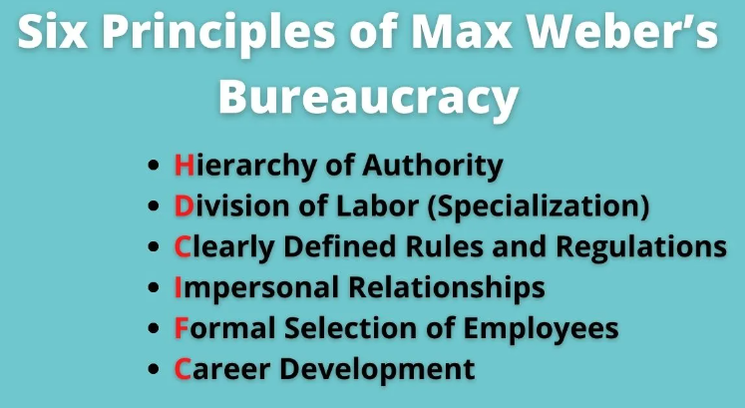
Figure 1: Management Theory of Max Webber
(Source: Saputra and Mahaputra, 2022)

B. How are their employees motivated?
As mentioned by Hajiali et al, (2022), the employees' unwillingness and carelessness in the Aldi corporate environment reflect their lethargy and dissatisfaction with their work. Here discussion has been made on how Aldi can work to improve employee relations and happiness while lowering the chance of absenteeism and staff turnover by utilising Frederick Herzberg's 2-factor theory and Abraham Maslow's Hierarchy of Needs.
The theory of Abraham Maslow's hierarchy of needs
Abraham Maslow's idea of the hierarchy of needs made it clear how to assist staff in boosting employee engagement in businesses by preserving job satisfaction. As mentioned by Fahmi and Ali, (2022), this idea focuses on increasing employee satisfaction by meeting five fundamental demands. The application of Maslow's Hierarchy of Needs theory by Aldi as a management tool to enhance worker relations and job happiness is covered in this section.
Psychological Needs: The satisfaction of employees' psychological needs is their top priority in an institutional context. By providing their psychological needs, such as food, clothing, drink, housing and so on Aldi may build relationships with its employees in an organisational setting.
Safety Needs: In the corporate sector after the pandemic, employees' needs for safety have grown to be one of their most pressing issues. Aldi can raise employee job satisfaction by providing for their safety needs through appropriate job security, an employment contract, and other means.
Love and Belonging Needs: this is necessary for Aldi to Identify need of love and care in strengthening the connection and comprehension between the organisation and its personnel. Aldi can prioritise their employee community through various social events and activities, which helps to boost employee job satisfaction by meeting their needs for benefits and a sense of community. Moreover, the firm need to show care for the specific requirements of its employees to better employee happiness.
Esteem Needs: As mentioned by Saputra and Mahaputra, (2022), finding resources that can be used to address employees' requirements for acknowledgement of their beliefs and duties is the major goal of organisation Esteem requirements. Through encouragement and awards, Aldi can helps its employees feel valued and can also help them be more satisfied at work.
Self-Actualization Needs: Employee development and skill acquisition demands are indicated by self-actualization needs. By enabling employees to create personal and professional development opportunities based on their interests and hobbies, Aldi can enhance workplace connections and employee happiness.
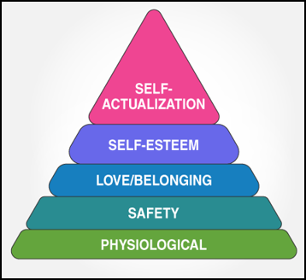
Figure 2: Maslow’s Hierarchy of Needs Theory
(Source: Saputra and Mahaputra, 2022)
Frederick Herzberg's 2-factor theory
As mentioned by Atapattu and Huybers, (2022), employee turnover and absenteeism can be decreased by raising employee interest in their jobs. Through Herzberg's Two Factor Theory, motivating and motivating factors are here identified in order to decrease the likelihood of employee absenteeism and staff turnover in the context of Aldi.
Hygiene Factors:
- The chance of employee absenteeism increases when there are insufficient opportunities for development and soft skill acquisition to carry out duties in a corporate setting.
- As mentioned by Afif et al, (2023), hiring people from outside the company rather than promoting current employees increases employee resistance and raises the possibility of workforce turnover.
Motivating Factors:
- By emphasising peer-to-peer learning, Aldi can give its associated staff opportunities for departmental training and growth.
- Through workshops and training activities, the organisation can provide its current employees opportunities to learn new skills and reduce the likelihood of staff turnover.
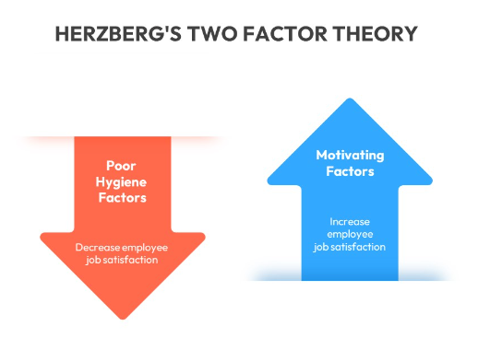
Figure 3: Frederick Herzberg’s 2-Factor Theory
(Source: Atapattu and Huybers, 2022)

Conclusion
Analysing the above study this can be concluded that, this is necessary for the modern workplace such as Aldi to maintain the organisational structure, cultural awareness, people and organisational performance. On the other hand, employee motivation enhances employees' engagement in the company's activities and lowers the likelihood of absenteeism, maintaining job satisfaction which is crucial for improving the performance of the firm. By determining the causes of unwillingness to work in the business environment, the business needs to analyse and adopt Maslow's theory and Professor Herzberg Two Factor Theory for better employee motivation. Thus, the firm can become more capable to manage the business culture and reputation as a modern workplace.

Reference list
Afif, M., Mariyanti, T., Septiani, N. and Dolan, E., (2023). Factor affecting employee motivation to increase performance of Sharia bank in Indonesia on Islamic perspective. APTISI Transactions on Management (ATM), 7(2), pp.131-142.
aldi (2021). Sustainability report. Available at https://www.aldi.nl/sustainability-report/2021/downloads.html Accessed on 18.4.23
Alshurideh, M., Kurdi, B., Alzoubi, H., Obeidat, B., Hamadneh, S., and Ahmad, A. (2022). The influence of supply chain partners’ integrations on organizational performance: The moderating role of trust. Uncertain Supply Chain Management, 10(4), 1191-1202.
Atapattu, M.M. and Huybers, T., (2022). Motivational antecedents, employee engagement and knowledge management performance. Journal of Knowledge Management, 26(3), pp.528-547.
Chmielewska, M., Stokwiszewski, J., Markowska, J., and Hermanowski, T. (2022). Evaluating Organizational Performance of Public Hospitals using the McKinsey 7-S Framework. BMC health services research, 22(1), 1-12.
Fahmi, I. and Ali, H., (2022). Determination of Career Planning and Decision Making: Analysis of Communication Skills, Motivation and Experience (Literature Review Human Resource Management). Dinasti International Journal of Management Science, 3(5), pp.823-835.
Fu, Q., Abdul Rahman, A. A., Jiang, H., Abbas, J., and Comite, U. (2022). Sustainable supply chain and business performance: The impact of strategy, network design, information systems, and organizational structure. Sustainability, 14(3), 1080.
Grover, V., Tseng, S. L., and Pu, W. (2022). A theoretical perspective on organizational culture and digitalization. Information and Management, 59(4), 103639.
Hajiali, I., Kessi, A.M.F., Budiandriani, B., Prihatin, E. and Sufri, M.M., (2022). Determination of Work Motivation, Leadership Style, Employee Competence on Job Satisfaction and Employee Performance. Golden Ratio of Human Resource Management, 2(1), pp.57-69.
Imran, M., Ismail, F., Arshad, I., Zeb, F., and Zahid, H. (2022). The mediating role of innovation in the relationship between organizational culture and organizational performance in Pakistan's banking sector. Journal of Public Affairs, 22, e2717.
Ismael, F., Hussein, B., Ibrahim, M.S. and Akoye, S., (2022). The mediation role of organization citizenship behaviour between employee motivation and productivity: Analysis of Pharmaceutical Industries in KRG. International Journal of Humanities and Education Development (IJHED), 4(1), pp.10-22.
Naveed, R. T., Alhaidan, H., Al Halbusi, H., and Al-Swidi, A. K. (2022). Do organizations really evolve? The critical link between organizational culture and organizational innovation toward organizational effectiveness: Pivotal role of organizational resistance. Journal of Innovation and Knowledge, 7(2), 100178.
Saputra, F. and Mahaputra, M.R., (2022). Effect of job satisfaction, employee loyalty and employee commitment on leadership style (human resource literature study). Dinasti International Journal of Management Science, 3(4), pp.762-772.

