Security Analysis Report
QuickMartRetailLtd.



Prepared by:

Student Name: Haci Babir
Student ID: 2524810

Word limit = 2000 words (Report)

Table of Contents

Contents
Introduction 4
1. Identification of Modern Threats 4
2. Modern Security Policies 5
3. Technical Mitigation Measures 5
4. Proactive Monitoring and Incident Response 5
5. Continuous Training and Awareness 5
Conclusion 6
References 6

Introduction

Computer security, also known as cybersecurity, is the practice of protecting computer systems, networking and data from unauthorised access, attacks and damage. It plays a vital role in safeguarding personal information and ensuring the reliable operation of digital services used by individuals, businesses and governments.

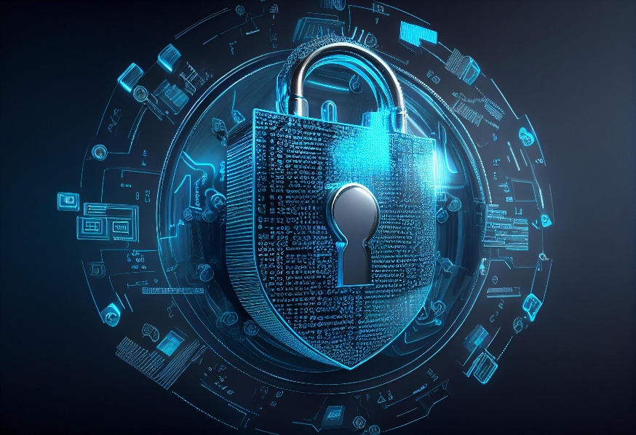

Figure 1. Security Challenges in Computers [1]

- Task
Make sure you do not exceed 2000 words.

1. Identification of Modern Threats

Organisations face many cybersecurity threats from both inside and outside the business. These threats can lead to data loss, financial damage and disruption to normal business operations. As technology develops, cybercriminals continue to find new ways to attack systems and steal information.

Internal threats come from people within organisation, such as employees, contractors or temporary staff. These threats may be deliberate or accidental. For example, an employee might use a weak password, click on a fake email link or share sensitive information with the wrong person. In some cases, unhappy employees may misuse their access to steal or damage company data. Human mistakes remain one of the biggest causes of cybersecurity incidents.

External threats come from outside the organisation and are usually carried by hackers, cybercriminals or organised crime groups common external threats include malware, phishing emails, hacking and data breaches. These attacks are often designed to steal information, demand money or interrupt business activities.

One of the fastest growing threats is Ransomware as a service (RaaS), RaaS is a service where cybercriminals create ransomware software and rent it to other attackers. This means people with little technical knowledge can launch ransomware attacks. Once a system is infected, files are locked or encrypted, and the victim is asked to pay money to regain access. RaaS has made ransomware attacks more common because it is easier for criminals to use [1].

Another threat is AI powered social engineering, including vishing (voice phishing). AI can create realistic voices that sound like real people. Criminals may use these fake voices to pretend to be managers, colleagues or bank representatives. They then try to trick people not sharing passwords, financial details or other confidential information. Because the voices sound genuine, these scams can be difficult to identify.

Supply chain attacks are also becoming more common. Instead of attacking a company directly, criminals targets suppliers, software providers or business partners, if a trusted supplier is compromised, attackers may gain access to several organisations at the same time. This can allow cybercriminals to spread malware or steal data from multiple business through a single weak point [2].

In conclusion, organisations must deal with both internal and external threats. Regular staff training, strong security policies, secure cloud systems and updated security software can help reduce risks. As cyber threats continue to evolve, businesses must remain alert and adapt their security measures to protect their data and systems.

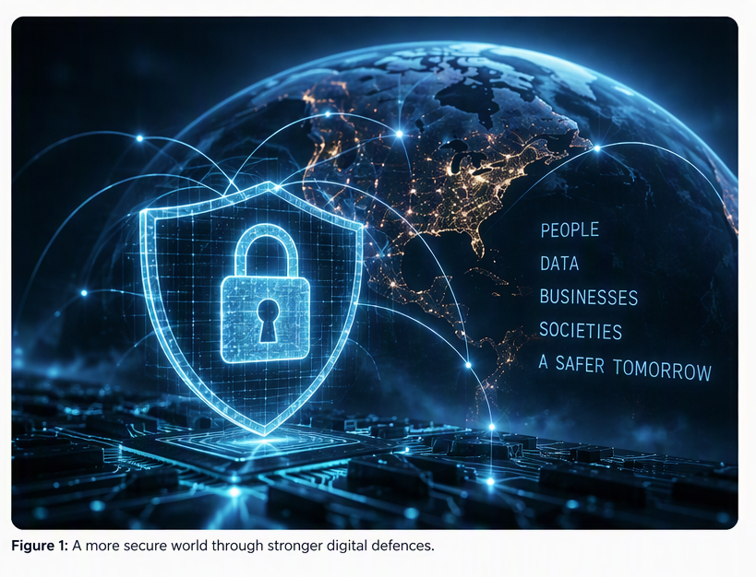

2. Modern Security Policies

Modern security needs strong security policies to protect systems, data and users from cyber threats. These policies are based on zero trust model, which means no user or device is trusted automatically and everyone must be checked before being given access.

Access Control Policy
All employees must use strong passwords and multi factor authentication. Staff should only have access to the files and systems they need to do their jobs.

Zero Trust: always verify users before giving access.

NIST and ISO 27001: support safe access to systems and data.

CIA Triad:
- Confidentially: stops unauthorised people from seeing information.
- Integrity: prevents unauthorised changed to data.

Data Protection Policy
Important data should be encrypted when stored and when sent online. Regular backups should be created and stored securely.

Zero Trust: protect data wherever it is stored.

NIST and ISO 27001: focus on protecting and recovering information

CIA Triad:
- Confidentially: encryption protects sensitive data.
- Integrity: data remains accurate.
- Availability: backups allow data to be restored if lost.

Device security policy
All company devices must have antivirus software, firewalls and the latest security updates installed. Any personal devices used for work also meet these requirements.

Zero Trust: devices must be checked before they can access company systems.

NIST and ISO 27001: help keep company devices secure.

CIA Triad:
- Integrity: protects devices from malware.
- Availability: reduces system downtime.

Security Awareness Policy
Employees should receive training on phishing, vishing, ransomware and password safety. Staff should know how to recognise and report suspicious activity.

Zero Trust: users must continually prove they are acting safely.

NIST and ISO 27001: encourage security awareness and training.

CIA Triad:
- Helps protect confidentially, integrity and availability by reducing human mistakes.

Incident Response Policy
Any security incident must be reported immediately. The organisation should have a clear plan for dealing with cyberattacks and testing its response procedures regularly.

Zero Trust: supports continuous monitoring and quick action.

NIST and ISO 27001: focus on responding to and recovering from security incidents.

CIA Triad:
- Availability: keeps services running during attacks.
- Integrity: limits damage to systems and data.

Evaluation of the Policies:
These security policies are easy to understand, useful and practical because employees can follow them without difficulty. They follow Zero Trust principles by checking users’ identities, limiting access to information and making sure devices are secure before access is allowed. The policies also follow recognised frameworks such as NIST Cybersecurity framework and ISO 27001, which provide guidance on keeping information and systems secure. In addition, the policies support the CIA Triad by helping to protect to protect the confidentially, integrity and availability of data. Together, these security measures help organisations reduce cyber threats and improve overall security.

3. Technical Mitigation Measures
Propose specific, feasible technical and administrative measures to mitigate identified threats, detailing how each measure will be implemented (e.g., MFA, SIEM, CSPM).

Are the mitigation measures realistic and achievable within the context of Vigilant Trust & Asset Management (VTAM)? Should be considered to meet the criteria of this section of the task.

Consider the latest trends in cyber threats, such as ransomware, insider threats, and social engineering tactics. Include references to relevant literature, case studies, or examples from other organizations to support your recommendations.

Are the mitigation measures (e.g., MFA, immutable backups, patch management based on CISA KEV) realistic, achievable, and reflective of current best practices?

4. Proactive Monitoring and Incident Response
Outline a plan for 24/7 monitoring, threat detection, and response, incorporating modern tools like SIEM and SOAR.

A flow chart or diagram is essential.

Is there a robust plan for ongoing monitoring and incident response? If yes, what and how?

Does the plan incorporate modern concepts like SIEM/SOAR and include specific procedures for current incident types like ransomware? A diagram is expected.

5. Continuous Training and Awareness
Describe an engaging, continuous training program focused on modern attack simulations (phishing/vishing) and promoting a culture of security awareness.

Include references to relevant literature, case studies, or examples from other organizations to support your recommendations. Does the training program effectively promote security awareness among staff? How?

Does the training program go beyond annual videos to include continuous, simulated attacks (phishing/vishing) and role-specific training to effectively promote a security-conscious culture?

Conclusion
Conclusion, recommendation and future work (From your findings what do you recommend, discuss or state these. What can be done in the future to improve on your findings will be the future work). (max 100 words). Word count is not included for this section.

References
The reference style should be IEEE kindly refer to the library website for details. Add all the references used in this report and make sure they are in-text citied. Word count not included.
Example:

- [1] National Cyber Security Centre, “Ransomware,” National Cyber Security Centre, UK. Available: https://www.ncsc.gov.uk/section/advice-guidance/all-topics/ransomware. Accessed: 19-Oct-2026.

- [2] National Institute of Standards and Technology, Cybersecurity Supply Chain Risk Management Practices for Systems and Organizations, NIST Special Publication 800-161 Rev. 1 Update 1, Nov. 2024. Available: https://www.nist.gov/publications/cybersecurity-supply-chain-risk-management-practices-systems-and-organizations. Accessed: 19-Oct-2026.

- [3] National Institute of Standards and Technology, “Cybersecurity Framework (CSF) 2.0,” 2024. Available: https://www.nist.gov/cyberframework. Accessed: 19-Oct-2026.

- [2] International Organization for Standardization, ISO/IEC 27001: Information Security, Cybersecurity and Privacy Protection Information Security Management Systems. Available: https://www.iso.org/isoiec-27001-information-security.html. Accessed: 19-Oct-2026.

