Student Name: Sara Dit Adama Camara
Student ID: 2541389


This is the Moodle page where you can see the course overview. This includes the certificate in higher education business files. Also includes the new academic skills files.

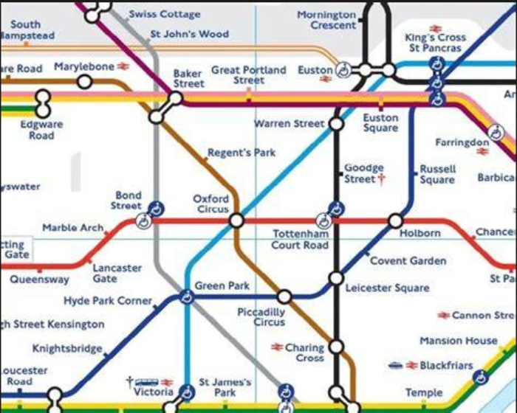
This is part of the London tube maps. Its more important for me because I have look at it every time I am going to a new place. Sometimes I just check it to familiarise myself with some names.

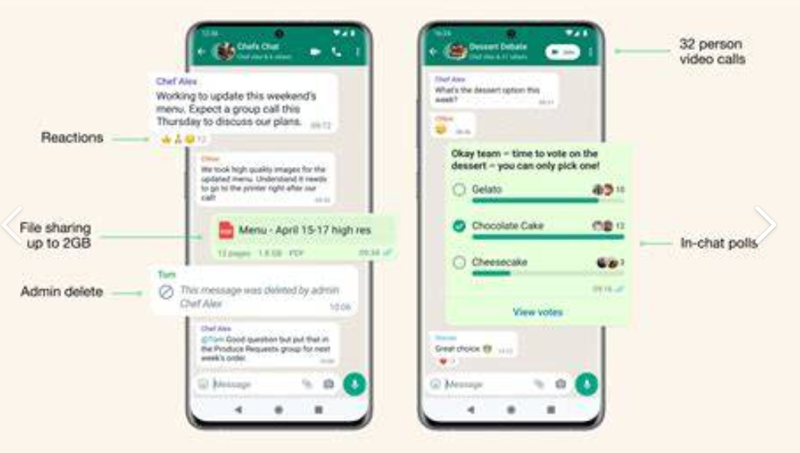
WhatsApp a magic tool for me. This is the connection between me and my family back home. You don’t feel like you are paying anything, but you communicate with a lot of people.

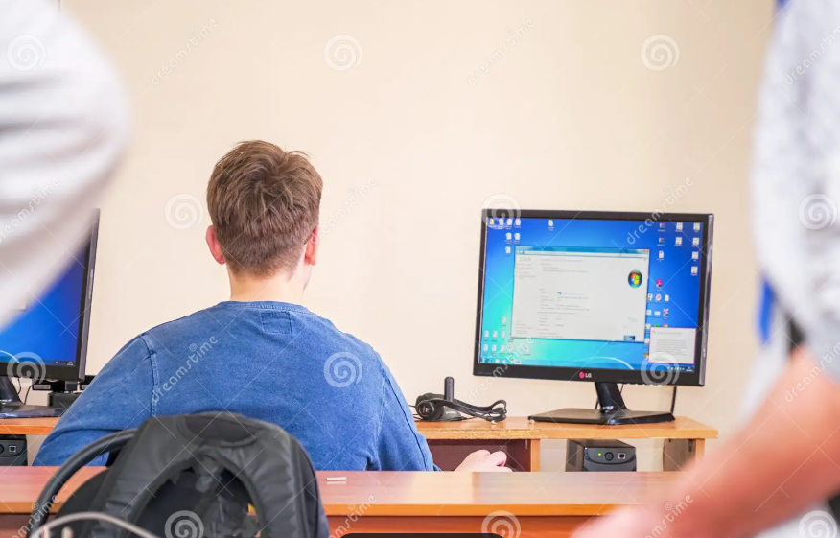
This screenshot represents me. It is about a student navigating the digital life. A lot of things nowadays are based on technology.

Online shopping. A simple way to buy items from any device from many parts of the world. Just use your internet connexion and go to some websites like Amazon, Temu, Asos, Shein, etc ….

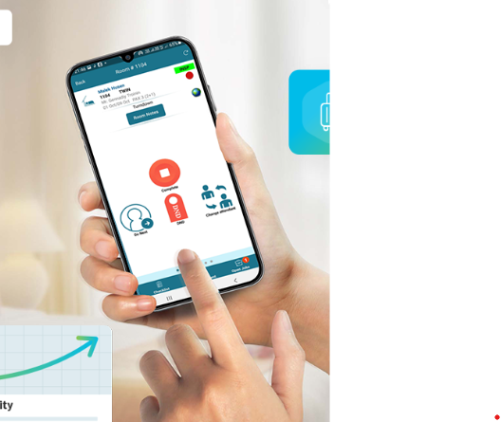
Know cross is the app I use at work. On this app I receive description of the job, their location and the time it is supposed to be done. This app is a good example of use of technology in the workplace.

My Short Reflection

I use digital tools to communicate. I feel confident when I use Know cross because it is an easy app to navigate. I want to improve in using tools like word as they can get complex if you are new to it. I often use these tools because in my journey of every day I cannot do without them I hope this module helps me improve in my digital skills. Digital skills are important for me because it is in my everyday life.

