

Qualification: CIPD Diploma in Applied Human Resources
Module Name: Using Research in Human Resources (activity 2)
Word Count: 2500
Student Name: Nia Williams
Student Number: 1806523
CIPD Membership Number: 53274221

By signing below, I confirm that the work/evidence presented is my own, unaided work. I understand the regulations pertaining to candidate malpractice and the action that may be taken as a result.

Signed: N.Williams
Date: 11th February 2019



Using Research in Human Resources
Issue: The Rise in Sickness Absence
Nia Wyn Williams

February 2019

Using Research in Human Resources
  - Executive Summary
This research report aims to ‘critically analyse sickness absence strategies to reduce short term sickness’ within Coleg Sir Gar (CSG). The identified stakeholders were the Corporate Board and the Principal, Faculty Directors, Line Managers and Employees. A literature review was undertaken to search for common themes in reducing short term sickness in the college. The themes identified were “promote wellbeing, effective return to work, training for line managers and a clear policy”. The literature review highlights both the strengths and the weaknesses of existing research it also highlights the gap in the research, this being that no research has been done specifically into a further education college. This justifies the reason for the next section in the report (Methodology and Findings) as these looked specifically into CSG.
To achieve objective one “To research current absence management policies and procedures and find out how it is being implemented”, research was made into the sickness policy. When comparing CSG policy and procures to the literature review, the policy includes everything mentioned by Simpson (2017), CIPD (2018), Parkin (2018) and Landau Law (2019) suggesting that CSG have an effective policy in place. To understand more into how the procedures are being implemented into the organisation a questionnaire was distributed to 1000 employees, and a focus group was conducted with 6 line managers.
To achieve objective two “to identify the current absence levels and trends against previous years”, research was made to identify the current absence levels of CSG against previous years. The result outlined that sickness absence rates within CSG are above the national average of 4.1 days per employee per annum. Results also show an increase in absence from academic year 2016/2017 from 4.5 days per employee to 5.1 days per employee in 2017/2018. With 1000 employees and an average of 5.1 days per employee in academic year 2016/2018, that totals £357,000 per annum.
To achieve objective three “to investigate how to improve the current procedures”, a comparison of the results from the questionnaire and the focus group were conducted. Results showed that there were some similarities in opinions on how to improve the current procedures to reduce sickness absence rates. The 6 ways identified to improve the procedures were:
- Line managers need to have regular contact with employees regardless if they are off for a short period of time. This will allow for a flow of communication and for the line manager to know what the problem is, how they can help the employee to get better and put in place measures/cover if needed.
- Training needs to be organised by HR for line managers to attend on a regular basis. This will address the average score given by employees with how effective the RTW was.
- Return to work needs to be conducted on the first day an employee returns to work to discuss everything that was highlighted by the literature review. This links back to training, as the importance of this can be reminded on a regular basis.
- Employee wellbeing also needs to be improved. Possible ideas could be to have more than one well being day a year for employees to team build and have fun together.
- Improvement to sickness system. This needs to be addressed as this may be one of the leading causes why line mangers leave it to the last minute to complete or not do it at all. This will need to be addressed by the IT department.
- It is clear that the Sickness policy needs to be made more aware of and encouraged to read by both employees and line managers. This will make it clear of the importance of regular contact with employees and the importance of an effective RTW on the first day back to work. Possible ideas could be to include it in the induction process for them to read in the first 21 days of employment.
These were presented to the corporate board to achieve objective 4 “to present findings to the corporate board”. These included, to give more time for participants to take part in primary research as only 156 out of 1000 responded which is not representative of the organisation as a whole. Another recommendation was to follow up the questionnaire with a focus group with employees in order for them to expand on some points.
The limitations to the study was that only 156 questionnaires were completed out of a possible 1000 meaning that it is not representative of all employees in the organisation. Another disadvantage was that only 6 line managers were interviewed, meaning that the sample size was only small and also not representative of all line managers. After conducting the primary research nothing was done from the corporate board point of view to tackle the short term absence levels in the organisation after it was presented to them. Doing nothing would mean that the issue will not be addressed and short term sickness levels will increase in the future which is costly for the organisation.

Gantt Chart – Research Project
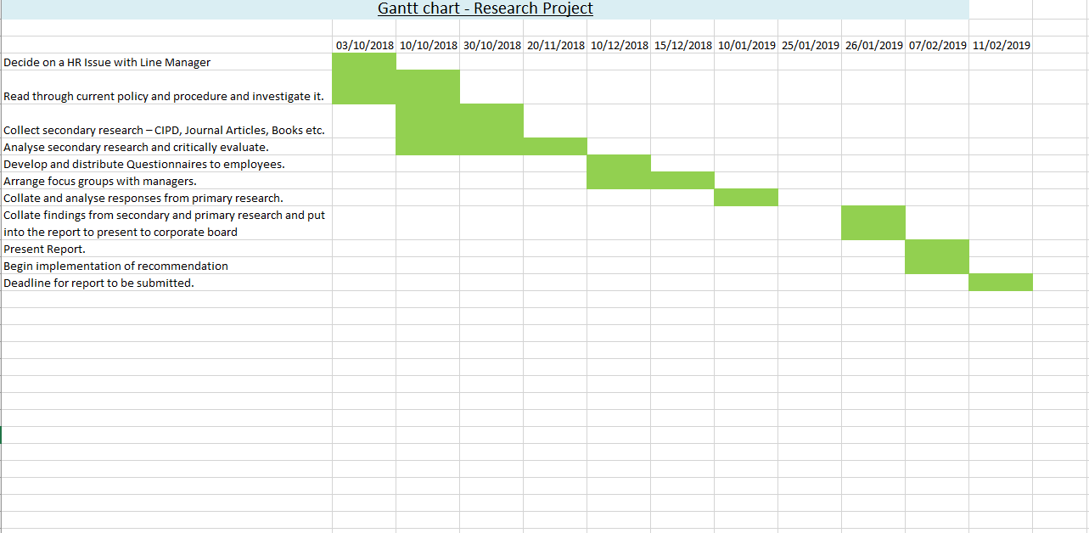
The below Gantt Chart is a plan of how long it will take to complete each part of the research project. It also helps to track and monitor progress.

  - Table of contents
Introduction ……………………………………………………………………….page 7-8
Literature Review………………………………………………………………….page 8-10
Methodology………………………………………………………………………..page 10-11
Findings/discussion…………………………………………………………………page 11-13
Conclusion…………………………………………………………………………page 13
Recommendations for change…………………………………………………….page13
Limitations…………………………………………………………………………page 13
References………………………………………………………………………….page 14
Appendices ………………………………………………………………………...page 16

- Introduction
This report will look at the rise of short term sickness absence within Coleg Sir Gar. It will include a brief background of the organisation, the HR issue in more detail, identified stakeholders and the aims and objectives of the report. A literature review will be undertaken to find ways of reducing sickness within the organisation. This report will also access a range of primary data sources. How data was collected and analysed will be explained along with a justification of the methodology adopted. Conclusions and recommendations will be made based on this data.
Organisation Name: | Coleg Sir Gar (CSG)
Organisation background: | CSG is a further and higher education college based in Carmarthenshire. There are five campuses including Graig, Ammanford, Pibwrlwyd, Gelli Aur and Jobswell.
Number of employees: | There are approximately 1000 employees, which are made up of lecturing, academic and support staff.
Title: | Assistant HR Officer.
Main HR functions of CSG/CC: | - Recruitment  - Absence management  - Employee relations  - Payroll  - Pensions  - Policies  - Contracts
HR department: | Includes seven employees:  - Executive Director of HR and Wellbeing  - Two HR Advisors  - HR Officer  - Assistant HR Officer  - Staff Development Officer  - Pensions Officer
HR Issue: | Rise in short term sickness absence figures.

Identifying the HR Issue:
The area of research I will choose is the convenient access strategy where I will select an area of research due to access I have to specific data (in this case, data such as sickness absence figures and employee/line managers views/opinions) (Horn, 2009, p. 90). This topic was also agreed by the Executive Director of HR and Wellbeing as well as the Principal.
This research project will look at the issue of short term sickness absence within the college. When comparing data from previous years, the level of sickness absence has increased. According to CIPD (2016), short term sickness is seen as the most costly in form of wages to any organisation.

Identifying stakeholders
According to Freeman (2009) it is important to understand who the readers are going to be and what they are going to be looking for. The most important stakeholders are the corporate board and the principal. They have the most interest in tackling the issue and lowering sickness and saving on the college costs.
Faculty Directors are also influential with their level of management but aren’t as influential as the above in making a decision. Faculty are important in implementing the decision down the organisation and convincing line managers to implement procedures.
Line Managers are important in implementing the policies with their staff. They need to be well trained in order to implement change successfully.
Employees are the ones who will be affected by the implementation of the policies. They need to understand the policies and processes and be communicated if there are any changes.
Aim and objectives
The aim of this report is to 'to critically analyse sickness absence strategies to reduce short term sickness’.
This aim will be achieved through four objectives. These objectives will be (Specific, measurable, achievable, realistic and time bound) (Mind Tools , 2019). Objectives are the steps you take to achieve your overall aim (CIPD, 2018c).
Objectives:
- To research current absence management policies and procedures and find out how it is being implemented.
- To identify the current absence levels and trends against previous years.
- To investigate how to improve the current procedures.
- To present findings to the corporate board and make recommendations.

- Literature Review
A literature review is a critical analysis of existing research in the field being explored. Literature includes professional associations, academic literature, media sources, online databases and Government information. It highlights both the strengths and weaknesses of existing research and it allows us to gain a critical understanding into a particular field. It is also an opportunity to see a gap in the research (Perkins & Woodhams, 2016).
Sickness absence according to NHS (2010) is defined as “when your employee is considered by themselves or their GP to be unfit to attend work due to illness”. From researching, there are common themes that have been identified to reduce short term sickness.
2.1 Promote Wellbeing
The following literature helps to understand the importance of promoting wellbeing in the organisation to reduce short term sickness. According to CIPD (2018b), The Telegraph (2011) and Office for National Statistics (2017) the main causes of short term sickness are minor illnesses such as colds and headaches, stress, musculoskelatal injuries, back pain, home/family responsibilities, mental ill health and asthma. The research has found that challenges are among older and part time workers. As the workforce ages, people are more likely to develop health conditions and/or disabilities and so it’s important that employers develop supportive workplaces that help people to manage their health and work. They suggest that promoting well-being for instance, on site fitness centre and mind/body classes can prevent problems from escalating and help create positive working environments. Research carried out by CIPD (2018b) in an organisation that had health and well being activities in place in 2017 found that 44% of respondents saw better employee morale and engagement. 35% saw a healthier and more inclusive culture and 31% saw lower sickness absence.
All sources used are recognised as credible by the university guide. Research outlined is fairly up to date apart from the Telegraph which was written in 2011. Although this was written eight years ago, the CIPD (2018b) and the Office for National Statistics still backs up the information outlined in the paper meaning that it is still correct. Statistics mentioned can’t be completely relied upon as it is uncertain how many respondents took part and in what company. It also doesn’t mention any absence figures in order to make comparison to what it was like before and after wellbeing programmes were introduced.

2.2 Effective Return to Work (RTW)
According to ACAS (2019), Simpson (2017), CIPD (2018a), Watt, (2018) and UNISON (2017) it is important to have an effective RTW in place to welcome the employee back and to check they are well enough to return to their every day duties. RTW meetings can also provide managers with an opportunity to start a dialogue about any underlying issues which might be causing the illness. This is important to find out whether the absence is work related, and finding ways of reducing it. All sources mention that an effective RTW will reduce sickness absence. Personnel today (2007) go one step further and surveyed 182 organisations, which employ 705,000 people, to see how effective they are. 64% saw that the introduction of return-to-work interviews reduced staff absences. 29% however didn’t see a difference in the organisation while 7% of HR practitioners saw an increase in absences.
All literature used are also credible according to the university guide. Apart from Personnel today (2007), all sources are also fairly up to date. The statistics used is over 12 years old, meaning that a lot can change in that time. The data also doesn’t provide us with statistics of how much sickness absence rates decreased from when RTW were introduced.

2.3 Clear policy
According to Simpson (2017), CIPD (2018a), Parkin (2018) and Landau Law (2019) organisations should have a clear policy in order to reduce absence. The policy must support business objectives and the culture and explain the rights and obligations of employees when absent due to sickness. This policy should provide staff with information on any terms and conditions relating to sickness such as provision for sick pay. The policy should also explain when and who employees should notify if they are not able to attend work, information regarding a self certificate form and details of when employees need to provide a fit note. The policy should also include provisions for return to work interviews and when they should be conducted. All sources used are credible according to the university guide, and are all up to date. The literature is useful in understanding what an effective policy should include, however no literature included statistics of how an effective policy can decrease sickness absence levels.

2.4 Training for line managers
According to CIPD (2018a), Paton (2016), Taylor & Wilkinson (2016 p. 25-26) and Personnel Today (2011) line managers have an important role to play in managing absence. According to this research, only around half of organisations train their line managers to manage absence effectively. The literature helps to understand the importance of training for line managers in the organisations absence policies and procedures. Line managers should be trained in the legal and disciplinary aspects of absence, maintaining absence record keeping and have return to work interview skills and the capabilities and confidence to raise and discuss potential issues. Research found that 20% of 178 people that took part in the survey saw a reduction in absence figures whilst 68% saw some reduction. The rest thought that absence management training was unsuccessful.
All sources used are credible sources according to the university guide. They are all relevantly up to date apart from Personnel Today which is eight years old. These sources are useful in understanding the impact training can have on absence however, it would have been more useful if absence level statistics were used before and after training was conducted to see whether training does reduce sickness absence.

From undertaking a literature review it is clear that no research has been done specifically into a further education college. The next section will focus specifically on CSG and ways employees think sickness absences can be reduced.

- (Methodology)
When conducting research projects, there are different types of data that can be used. These are, primary which is data collected first hand (questionnaires/interviews) or secondary which is data that is already published (journals/online databases). Data can also be qualitative where it is based around words/feelings, or it can be quantitative where data contains statistics (Perkins & Woodhams, 2016, p.92). The philosophical approach that will be taken is the interpretive approach. The point of this research is to gain an in depth insight into the lives of respondents, to gain an understanding of why they act in the way that they do (Iain Black, 2006).

Objective one and two is to identify what the current policy and procedure is and what the current levels and trends of absences are. Whilst the policies will inform me of what the policy and procedure is, I want to discover how this is being implemented. It is important to know how employees are using the procedures and how managers are enforcing this.
In order to gather data from employees of their experience of the absence management process a questionnaire will be used. According to Perkins & Woodhams, (2016, p.99) a questionnaire can be used to obtain quantitative data from a wide number of people. This data collection method is relatively cheap, fast to administer and it is more convenient for respondents as they can complete it when they have time. The disadvantage to this is that questionnaires must be properly designed, they do not allow for the researcher to prompt individuals to provide more information and response rates may be low.
In order to obtain information from the line managers on how they perceive/implement the policy and the issues associated with it, the a focus group will be used. According to Kilcullen, (2011) focus groups are good for allowing the respondents to develop and elaborate on themes. The disadvantage is that researchers need to be able to control discussions so that they get the information they need.
To address objective three, I will use information gathered from my findings above and also from my literature review to improve the current procedures.

Data collection methods must meet three basic criteria. These are reliable (are the results repeatable/data method collection consistent?), replicable (can another researcher replicate it the same/new setting?) and valid (conclusions drawn must be consistent with the data that has been collected) (Perkins & Woodhams, 2016 p. 96). The questionnaire will be sent out via email to all 1000 employees (appendix 1) and the focus group (appendix 2) will consist of six line managers.
In order for research to minimise risk of harm, it must be conducted ethically, therefore an ethical form has been approved prior to the research being conducted (appendix 3). All data collected will be confidential as employees can send the questionnaires back through internal mail to remain anonymous. All employees are over 18, meaning that data will only be collected from adults. Before any primary data was collected, permission was given by the Executive Director of HR and Wellbeing and the Principal.
Data will be analysed through pulling out common themes. Graphs created through excel will also be shown in order discuss the findings.

- Findings and Analysis

Objective 1 -What is the current policy/procedure and how is it being implemented?
The main purpose of CSG policy is to ensure that all sickness absence is responded to in a fair, caring and sympathetic manner. The policy it to provide support to staff when they are unable to work through ill health. When comparing the policy and procedure to the literature review, the policy/procedure includes everything mentioned by Simpson (2017), CIPD (2018), Parkin (2018) and Landau Law (2019) suggesting that CSG have an effective policy and procedure in place.
From analysing results from the 156 questionnaires that were completed there are some
results that stand out more than others in terms of how the policy is actually being implemented (Appendix 4).
The results confirmed that the most common sickness absence (37%) was colds, headaches and sickness bugs. Only 47% of employees admitted that they had contact with their line manager when they were off work. The importance of this is outlined in the sickness policy, however only 56% of people admitted they have read this and 53% of these people thought it was useful. The majority of people (28%) also scored their return to work as being below “average” by giving them a score of 4. This may be down to employees wanting line managers to be trained more effectively in this area as 56% of people would like their line manager to have more training in delivering return to work. It may also be down to the fact that 77% of people admitted that they weren’t given a return to work on the same day they returned to work with 37% of people saying that their return to work were conducted 3+ weeks after. 52% of people ranked employee wellbeing as average with a score of 5. Improving this score by introducing more wellbeing programmes may reduce sickness absence rates.

From analysing the results from six line managers in a focus group, there were also some results that stood out. Some problems were highlighted with regards to the sickness absence system, with all six experiencing technical problems when conducting a return to work with employees. Some problems consisted of difficulty saving the information, and return to work disappearing after it has been finalised. All line managers agreed that more training was needed around managing sickness with 4 admitting they were last trained 6+ years back when they were newly appointed to their line manager role. All 6 also admitted that conducting a return to work with employees on the same day they return to work is difficult as work commitments get in the way. Although they recognise they should be conducted the same day they return to work, they do try and conduct it within the first 3 weeks they return. All six line managers thought that they were supportive with their employees when they returned to work, offering them the option of phased return, help with the workload and supportive one to one meetings. All line managers admitted they felt they were hassling their employees when they were off absent for a short period of time, causing them not to phone them and relying on the employee to keep in touch with them.

Objective 2 - To identify the current absence levels and trends against previous years
Sickness Absence rates within CSG are above the national average rate of 4.1 days per employee per annum (Office for National Statistics 2018). Academic year 2016/2017 saw an average absence rate of 4.5 days per employee, which increased to 5.1 days per employee in academic year 2017/2018. The average daily cost is approximately £70 per employee. With 1000 employees and an average of 5.1 days per employee that totals £357,000 per annum. This is without taking into account the cost of absence cover.

Objective 3 - To investigate how to improve the current procedures
When comparing the results from the questionnaire and focus group there are some similarities in opinions on how to improve the current procedures to address sickness absence levels. All of these will be presented to the corporate board on February 4th 2019 to achieve the fourth objective “to present findings to the corporate board”.

Line managers need to have regular contact with employees regardless if they are off for a short period of time. This will allow for a flow of communication and for the line manager to know what the problem is, how they can help the employee to get better and put in place measures/cover if needed.
Training needs to be organised by HR for line managers to attend on a regular basis. This will address the average score given by employees with how effective the RTW was.
Return to work needs to be conducted on the first day an employee returns to work to discuss everything that was highlighted by the literature review. This links back to training, as the importance of this can be reminded on a regular basis.
Employee wellbeing also needs to be improved. Possible ideas could be to have more than one well being day a year for employees to team build and have fun together.
Improvement to sickness system. This needs to be addressed as this may be one of the leading causes why line mangers leave it to the last minute to complete or not do it at all. This will need to be addressed by the IT department.
It is clear that the Sickness policy needs to be made more aware of and encouraged to read by both employees and line managers. This will make it clear of the importance of regular contact with employees and the importance of an effective RTW on the first day back to work. Possible ideas could be to include it in the induction process for them to read in the first 21 days of employment.

- Conclusion
To conclude, the literature review helped to identify the common themes organisations should have in place in order to reduce sickness absence. These themes were to have wellbeing activities in place, training for line managers, an effective policy and RTW. The primary research undertaken helped to identify issues in the organisation that need improving from employees and line managers. The 6 issues identified above, were taken to the corporate board for them to implement changes throughout the organisation and address the issue to help achieve the aim of this report.

- Recommendations for change
Recommendations for change would be to give more time for participants to take part in the primary research as 156 results is not representative of the organisation as a whole. Another recommendation would be to follow up the questionnaires with a focus group with employees in order to expand on some points.
- Limitations
The disadvantage to the study was that only 156 questionnaires were completed out of a possible 1000 meaning that it is not representative of all employees in the organisation. This may be down to asking them to complete it in 1 month. Another disadvantage is that only 6 line managers were interviewed, meaning that the sample size was only small and also not representative of all line managers. After conducting the primary research nothing was done from the corporate board point of view to tackle the short term absence levels in the organisation after it was presented to them. Doing nothing will mean that the issue will not be addressed and short term sickness levels will continue to increase in the future which is costly for the organisation.

- Bibliography
ACAS, (2019). Managing staff absence: A step to step guide [Online]. Available at: http://www.acas.org.uk/index.aspx?articleid=4204 [Accessed 26 January 2019].
CIPD, (2016). Absence Management. [Online]. Available at: https://www.cipd.co.uk/Images/absence-management_2016_tcm18-16360.pdf [Accessed 7 January 2019].
CIPD A, (2018). Absence Measurement and Management. [Online]. Available at: https://www.cipd.co.uk/knowledge/fundamentals/relations/absence/factsheet [Accessed 26 January 2019].
CIPD B, (2018). Health and Wellbeing at Work. [Online]. Available at: https://www.cipd.co.uk/Images/health-and-well-being-at-work_tcm18-40863.pdf [Accessed 30 January 2019].
CIPD C, (2018). Performance Management: An Introduction. [Online]
Available at: https://www.cipd.co.uk/knowledge/fundamentals/people/performance/factsheet [Accessed 26 January 2019].
Freeman, R., (2009). What is stakeholder theory. [Online]
Available at: https://www.youtube.com/watch?v=bIRUaLcvPe8 [Accessed 26 January 2019].
Horn, R., (2009). Researching and writing dissertations: a complete guide for business students. 1st ed. London: Chartered Institute of Personnel and Development.
Iain Black, (2006) The presentation of interpretivist research, Qualitative Market Research: An International Journal, Vol. 9 Issue: 4, pp.319 324, https://doi.org/10.1108/13522750610689069
Kilcullen, T., (2011). Taking time out to listen: the benefits of focus groups. [Online]
Available at: https://www.theguardian.com/voluntary-sector-network/2011/jan/14/the-benefits-of-focus-groups [Accessed 7 January 2019].
Landau Law, (2019). Sickness rights at work. [Online] Available at: https://www.landaulaw.co.uk/sickness/ [Accessed 15 January 2019].
Mind Tools , (2019). SMART Goals. [Online] Available at: https://www.mindtools.com/pages/article/smart-goals.htm [Accessed 7 January 2019].
NHS , (2010). Sickness Absence - Definition. [Online] Available at: https://www.hefthr.co.uk/?q=node/48 [Accessed 26 January 2019].
Office For National Statistics , (2017). Sickness absence in the UK labour market 2016. [Online]. Available at: https://www.ons.gov.uk/employmentandlabourmarket/peopleinwork/labourproductivity/articles/sicknessabsenceinthelabourmarket/2016 [Accessed 26 January 2019].
Office for National Statistics , (2018). Sickness absence falls to the lowest rate on record. [Online] Available at: https://www.ons.gov.uk/employmentandlabourmarket/peopleinwork/employmentandemployeetypes/articles/sicknessabsencefallstothelowestratein24years/2018-07-30 [Accessed 30 January 2019].
Parkin, L., (2018). Getting your sickness policy right. [Online]
Available at: https://www.peoplemanagement.co.uk/experts/legal/creating-sickness-policy
[Accessed 26 January 2019].
Paton, N., (2016). Line Managers are key to return to work after sickness absence, survey finds. [Online] Available at: https://www.personneltoday.com/hr/line-managers-key-return-work-sickness-absence-survey-finds/ [Accessed 26 January 2019].
Perkins, G. & Woodhams, C., (2016). Using Information in Human Resources. In: 2nd, ed. Studying Human Resource Management. London: Chartered Institute of Personnel and Development, pp. 92-94.
Personnel Today, (2007). Return-to-work interviews do cut sickness absence rates. [Online]
Available at: https://www.personneltoday.com/hr/return-to-work-interviews-do-cut-sickness-absence-rates/ [Accessed 29 January 2019].
Personnel Today, (2011). Line manager training reduces absence rates. [Online]. Available at: https://www.personneltoday.com/hr/line-manager-training-reduces-absence-rates/ [Accessed 3 February 2019].
Simpson, S., (2017). Short Term sickness absence policy: a 15-step guide for HR. [Online]
Available at: https://www.personneltoday.com/hr/short-term-sickness-absence-policy-guide-hr/ [Accessed 16 January 2019].
Taylor, S & Wilkinson, K., (2016). Business Issues and the Context of Human Resources. In: S Taylor & C. Woodhams, eds. Studying Human Resource Management. London: Chartered Institute of Personnel Development.
The Telegraph, (2011). Top 10 Causes of absenteeism. [Online]
Available at: https://www.telegraph.co.uk/finance/jobs/8806388/Top-10-causes-of-absenteeism.html [Accessed 26 January 2019].
UNISON, (2017). UNISON toolkit on sickness absence. [Online] Available at: https://www.unison.org.uk/get-help/knowledge/leave/sick-leave/ [Accessed 26 January 2019].
Watt, C., (2018). How to manage and conduct return-to-work interviews. [Online]
Available at: https://www.xperthr.co.uk/how-to/how-to-manage-and-conduct-return-to-work-interviews/116769/ [Accessed 26 January 2019]

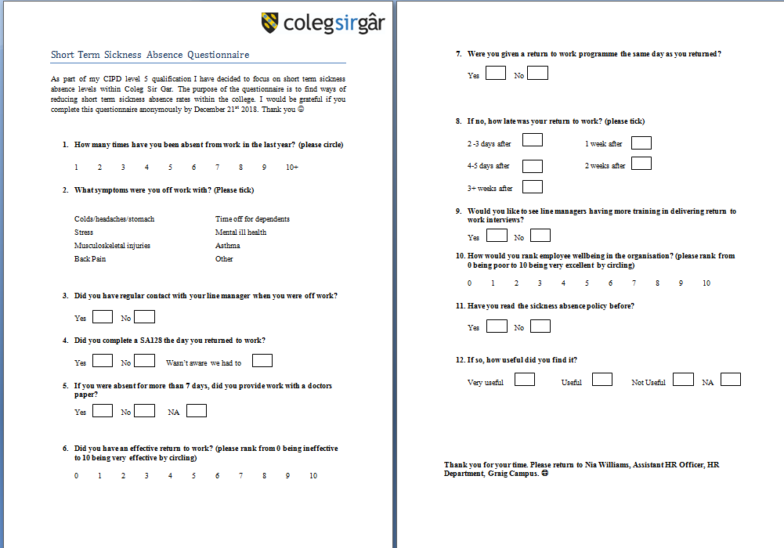
Questionnaire Questions (Appendix 1)
Focus Group Questions (Appendix 2)
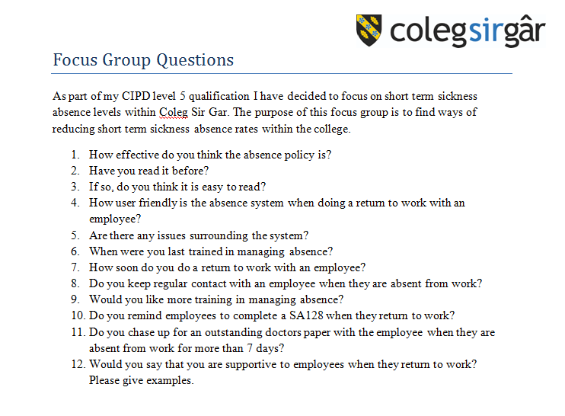

Ethical Form (Appendix 3)

Results from Questionnaire (Appendix 4)

