University of Wales Trinity Saint David
Wales institute of Science and Art



NWASP cracking due to Ni/Fe gamma prims solvus temperature relationships and cast chemistries.

Llewellyn Higgins

2237146

Undertaking a Green Belt Project

05/05/26

Six Sigma Green Belt (ACMA5005)

Contents
1.0 Introduction 5
2.0 Define 6
2.1 Process Map 6
Figure 2-1- Process Map 6
2.2 Voice of the Customer (VOC) and Critical to Quality (CTQs) 6
2.3 Project scope 7
Figure 2-3- Project Charter 7
3.0 Measure 7
3.1 Data type 7
3.2 Fishbone Diagram (Cause and Effect Analysis) 8
Figure 3-2- Fishbone Diagram (Author , 2025) 8
3.3 Data collection plan 9
Table 3-3- Data Collection (Author , 2025) 9
3.4 Graphical/Representation of Data 9
Figure 3-4-1- PRM rolling 10
Figure 3-4-2- 0.2%/UTS 10
Figure 3-4-3- Elong/R of A 10
Figure 3-4-4- Stress Rupture 11
Figure 3-4-5- Stress rupture Elong 11
Figure 3-4-6- Hardness 11
Figure 3-4-7- Grain Size 12
Figure 3-4-8- Sample 1 12
Figure 3-4-9- Sample 2 13
Figure 3-4-10- Initial Hardness 13
Figure 3-4-11- Initial Smooth Stress Rupture (SSR) 14
Figure 3-4-12- Initial SSR Elong 14
3.5 Measurement System Analysis CP/CPK 15
Figure 3-5- Standard Deviation 16
3.6 Inspection Reports/ additional data 18
Figure 3-6-1- NC 1 18
Figure 3-6-2- NC 2 18
Figure 3-6-3- Defective Batches 18
Figure 3-6-4- Example of Scrap Loss 1 19
Figure 3-6-5- Example of Scrap Loss 2 19
Figure 3-6-6- Example of complete Job 19
4.0 Analysis 20
4.1 Ni/Fe equilibrium phase diagram 21
Figure 4-1- Ni/Fe equilibrium diagram (E.A. Brocchi et al., 2013) 21
4.2 The 5 Whys 22
4.2.1 Why 1 22
4.2.2 Why 2 22
4.2.3 Why 3 22
4.2.4 Why 4 22
4.2.5 Why 5 22
5.0 Improve 23
5.1 Brainstorm Improvements 23
Table 5-1- Weighted Prioritisation Matrix Table for Improvement Options 23
5.2 Initial FMEA 24
Table 5-2-1- Key for FMEA 24
Table 5-2-2- FMEA Table 24
5.3 FMEA After Improvements and New Process Map 25
Table 5-3-1 FMEA Table Improved 25
Table 5-3-2 Process Map Improved (Author, n.d.) 26
5.4 Cost Benefit Analysis 26
5-4-1- Cost Benefit Analysis 26
5-4-2- Cost Benefit Analysis (Author, n.d.) 27
5.5 Heat Flow vs Temperature 27
6.0 Control Phase 28
6.1 Standard Operational Process (SOP) Updated 28
6.1.1 Material Melting Temperature 28
6.1.2 Forging 28
6.1.3 Cooling 28
6.1.4 Material Comp 28
6.1.5 Inspection 28
Figure 6-1-5-1- Forging Inspection Check Sheet(Author , n.d.) 28
6.1.6 Measurement 29
6.2 Process Monitoring 29
Figure 6-2-1- Witnessing Example 1 29
Figure 6-2-2- Witnessing Example 2 29
6.3 Training and Operator Experience 30
6.3 Process Sustainability 30
7.0 References 31

Introduction
Blaenavon - Forged Solutions Group (BFL), an aerospace forge dedicated to manufacturing engine mounts, IPC casings and fan blades. Using titanium, nickel and steel alloys weighing from 5kg to 3000kg. The product under observation is NWASP. Cracking within the forging occurs primarily on the edges due to the Ni(nickel)/Fe(iron) relations on gamma prime solvus temperature. Defective product must be reworked and is a waste and can cause both delays in production and an increase in cost for the manufacturer, this is why it is ideal for BFL to either minimize or erase any further occurrences of cracking within the NWASP forgings by improving process control and reducing product defect occurrence.

2.0 Define
The following products: A, B, C, D, are made of NWASP material which is a nickel-based superalloy. The most prominent issue that these three produce is cracking throughout the body of the rings/forgings. These cracks are often large and difficult to machine away due to various customer drawings and standards which result in several parts either requiring rework to try to minimise any cracks or simply must be scrapped. Attempting to salvage the parts will result in delays throughout the production line due to rework processes that operations must adhere to. Due to the delay in sale of the part and the increase in cost for reworking if the price of the part is not enough or too few parts are labelled as scrap then no rework will take place as it will be a loss to the business.

2.1 Process Map
Each individual part will have a different process map, since BFL manufactures parts from billets into almost finished parts there are many processes with sub-operations as well. Due to this a simplified process map covering the key stages of product A to D, is shown below.

Figure 2-1- Process Map
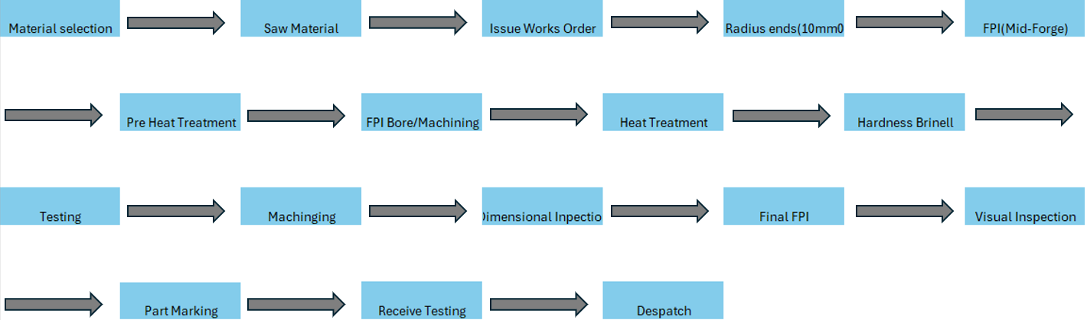

2.2 Voice of the Customer (VOC) and Critical to Quality (CTQs)
Voice of the Customer (VOC) is utilised within six sigma using customer expectations and feedback (Jordan, 2025). Requirements for manufacturing NWASP forgings for aerospace require high structural integrity, dimensional accuracy and no critical defects so avoid failure during the life of the part. These requirements are labelled as Critical to Quality or (CTQ). The CTQ will be listed below;
- Crack size
- Forging Dimensions (</= 3-4.0mm)
- Machine lines (</= 2.0mm)
- Surface finish
- Metallurgical analysis
- Testing (SCP data)
- Inspection charts
- SOP (Standard Operating Procedures)
Standards from both customer and industry standards apply and the relationship between the VOC and CTQs should be aligned for maximum operational quality output and customer satisfaction to be targeted and evaluated. The CTQs of machining lines </= 2.0mm (Kevin, 2026) is one example, that directly impacts the overall process capability analysis in section 3.5, therefore, reducing the variation in CTQs is imperative. The above forging dimensions were taken from BFL standards.

2.3 Project scope
Making unsuitable parts that end up as scrap or rework jobs is a waste for any manufacturing company. Minimising or eliminating any delays or scrap is also a key incentive in any business. By eradicating any forms of waste, BFL would be able to allocate its resources more efficiently which would only grow the business and its employee’s. This is why reducing the amount of cracking to at least machining standards is the focus of this investigation and is the result of identifying errors within stages of forging and cooling.

Figure 2-3- Project Charter
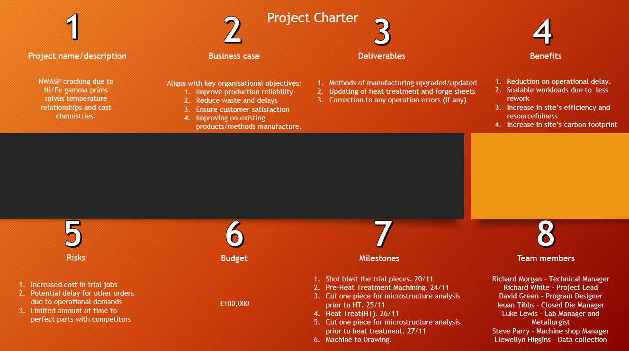

3.0 Measure
There are three stages in which measurements will occur during a process: The inputs, The outputs and the process itself. There are two forms of measurement which are attributes and variables, attributes are formed from qualitive data whereas, variable will form quantitative data. The inputs measure any contributions into the process; the output measurement will show customer satisfaction and if orders are being fulfilled and finally the process measurement itself will be taken at different points during the process which are critical to quality (CTQ).

3.1 Data type
Some variation within a process is acceptable providing there is no loss to value nor a loss in customer satisfaction with the product. A process will fluctuate due to external and internal factors. For example, people get sick and machines will break. This does not mean that the process cannot be improved further. However, to improve a process identifying the key causes of variation is critical, the main sources of variation are found in the following: Machines, materials, methods, measurements, mother nature and people. By condensing the entire process map into these six different key points of fluctuations data can be compared. Allowing unwanted data to be filtered out of the system due to the amount of extra efficiency improvements being negligible at this moment in time. It is good to keep note of this data for later use.
Not all projects are limited to the use of either variable or attribute data, due to the varying sets of data type a combination of the two will be used and analysed.

3.2 Fishbone Diagram (Cause and Effect Analysis)
A Fishbone Diagram, Cause and Effect Analysis diagrams or Ishikawa diagrams enable a form of identification of potential root causes and sources of variation (Shinde, Ahirrao and Prasad, 2018). This approach will allow an in-depth look into the key areas of concern shown in the below figure by grouping common occurrences of defects within the production line.

Figure 3-2- Fishbone Diagram (Author , 2025)
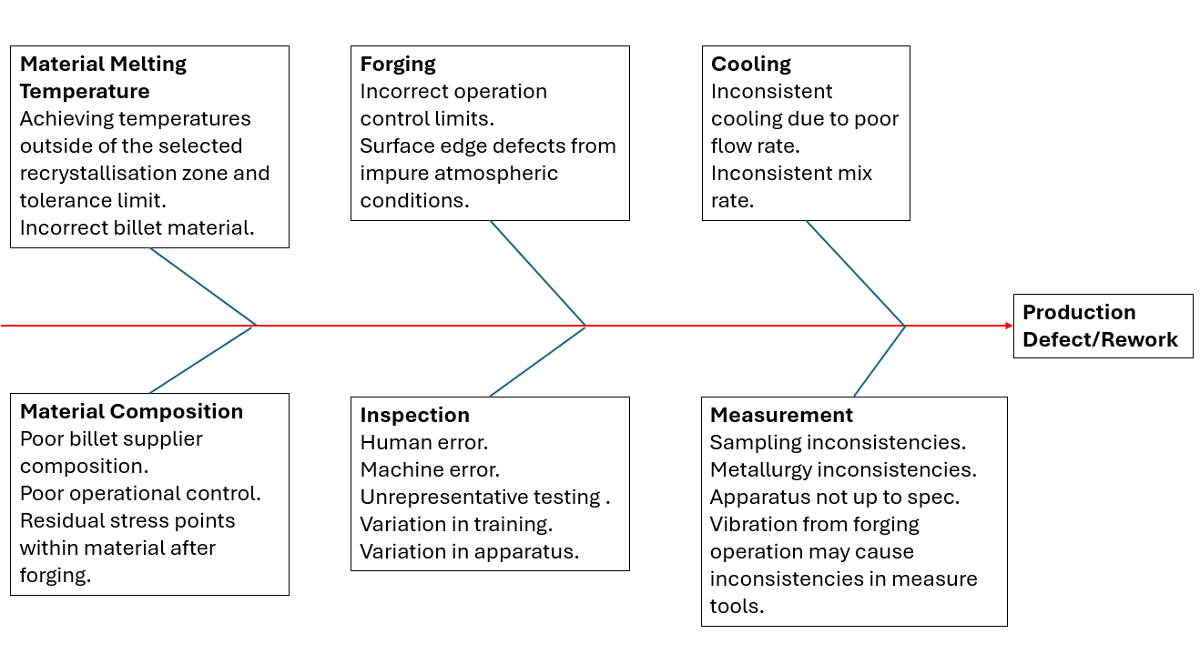
The above figure was used to gather key causes of concern within the operation, the causes were grouped into the six following boxes; Material Melting Temperature, Forging, Cooling, Material Composition, Inspection, Measurement. Each cause directly impacts the production defect and rework occurrence rate for BFL. The structured approach of the Fishbone diagram helps to visualise possible sources of variation and detection inconsistencies which support the root cause analysis investigations of the DMAIC methods (Ikeda, 2020).

3.3 Data collection plan
The initial collection of data needs to be broader to ensure that what is analysed is as accurate as possible. Step one will be to gather the following detailed in table below.

Table 3-3- Data Collection (Author , 2025)
 | BICs | NCRs | Excel check sheets | Process logs | Checklists | SPCs
Existing Data | Paperwork which follows the batch it is for through the length of the process. | Are raised when something happens to a part which is non-conforming to process. | Collection of information. | Detailed with when and how many parts went through what process. | Final checks before sale/other. | Collection of test results
Required Data | How many BICs were completed 100% without any faults in production. | What NCRs have been raised, how many, why. | Amount of value scrapping a part is. | How many should be expected to go through. | Any other reasons why parts were deemed unworthy. | Completion of SPCs

Within NWASP forgings variation is produced primarily by the melting point, material composition and thermal mechanical stresses applied during forging and cooling, this enables stages in which defects occur to be highlighted after the data collection plan is executed. NCRs, BICs and so on will demonstrate in detail where the issue has occurred allowing the prioritisation of improvements covered in section 5.2 FMEA which boost product quality and customer satisfaction.

3.4 Graphical/Representation of Data
The below Graphs illustrate the properties detailed within the heading for the same material composition batch heat treated and forged at specified different temperatures. The customer requirement lines which would be shows as red lines intersecting key points of the graphs have been removed. However, each graph demonstrates that the current process is failing to meet customer requirements and industry tolerances.

Figure 3-4-1- PRM rolling
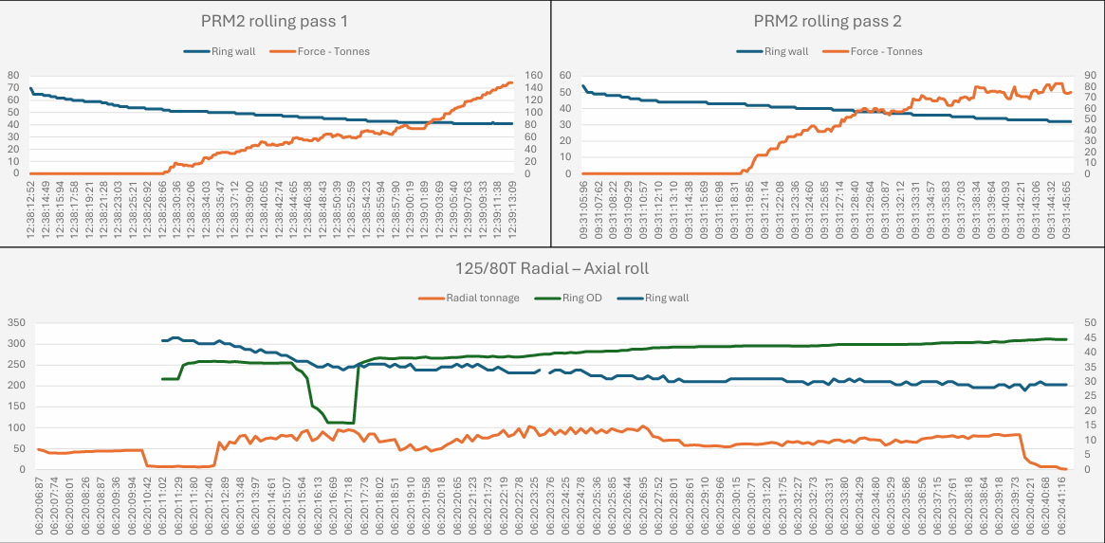

Figure 3-4-2- 0.2%/UTS
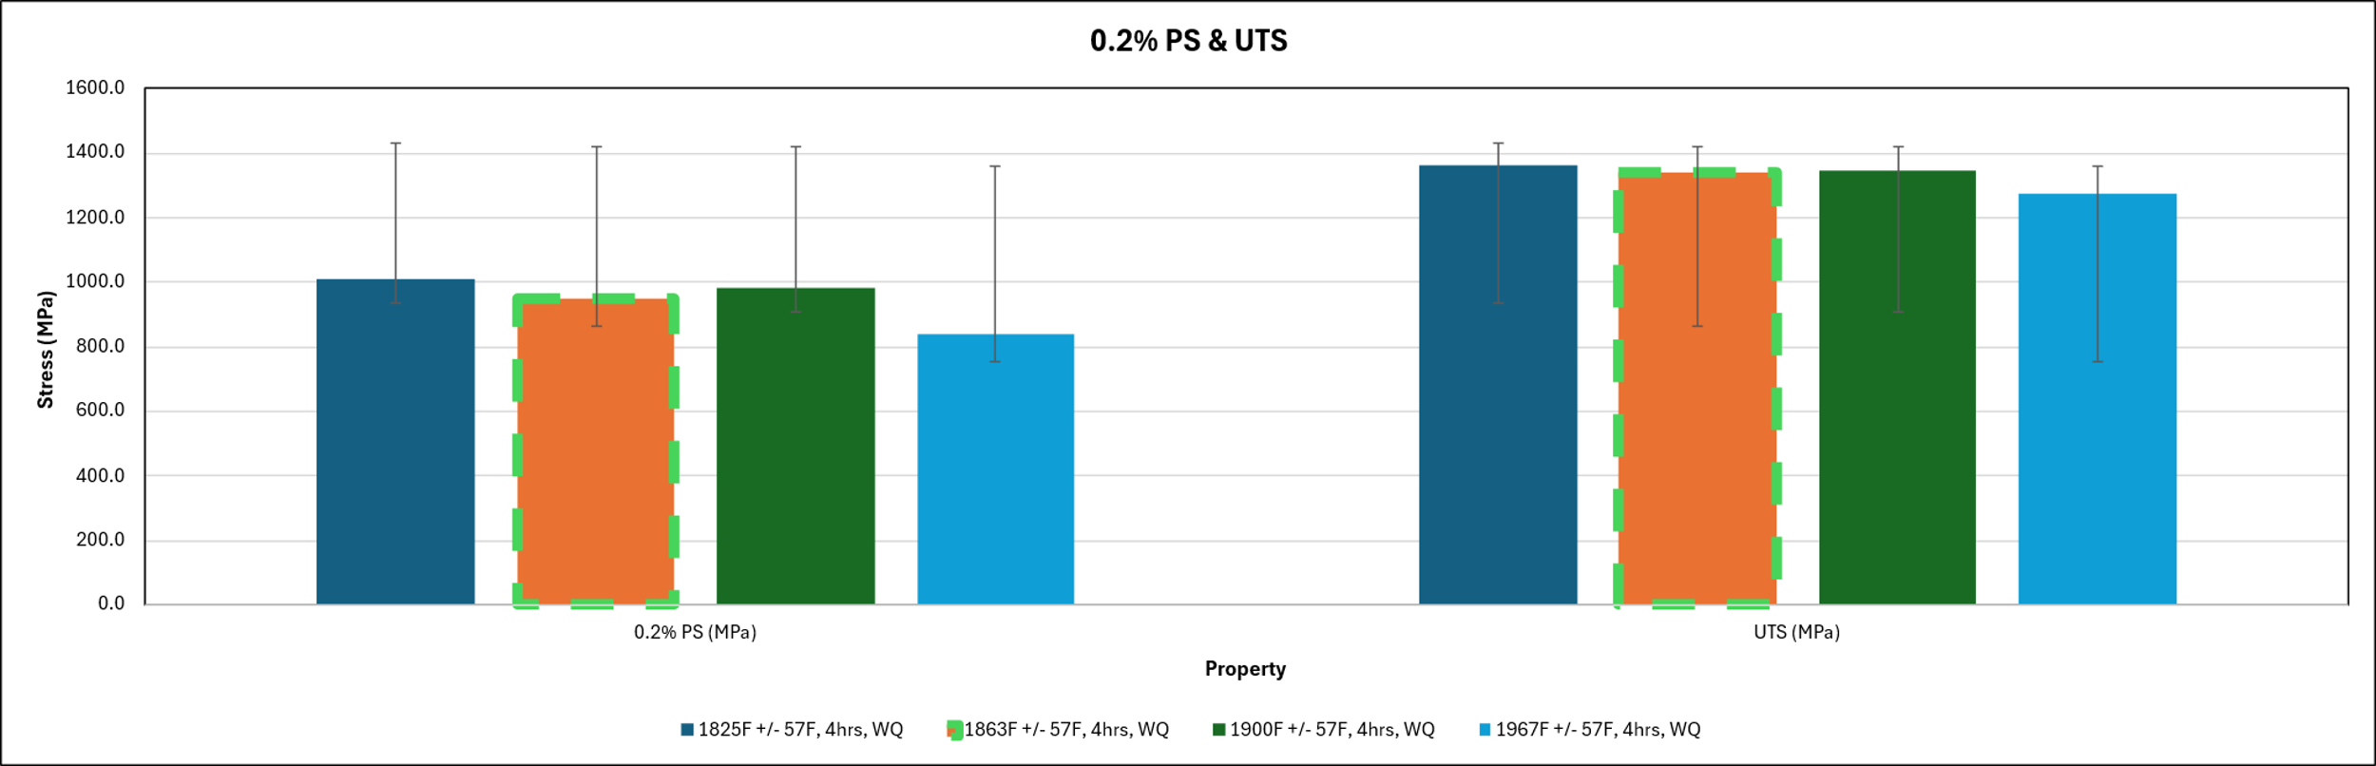

Figure 3-4-3- Elong/R of A
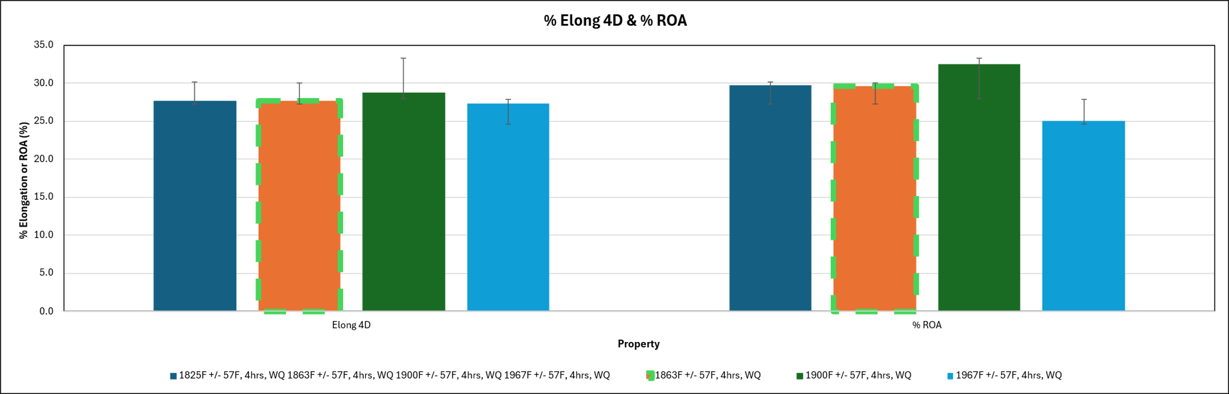

Figure 3-4-4- Stress Rupture
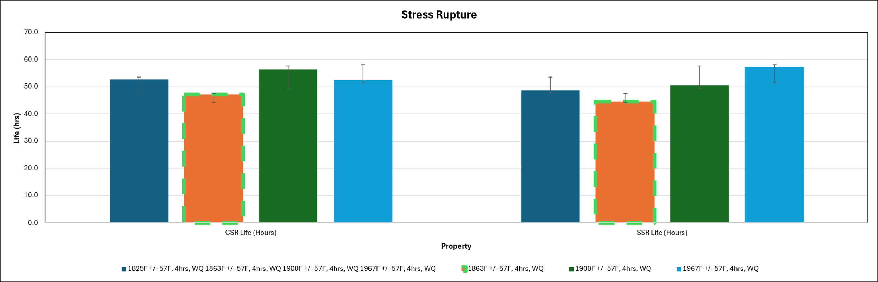

Figure 3-4-5- Stress rupture Elong
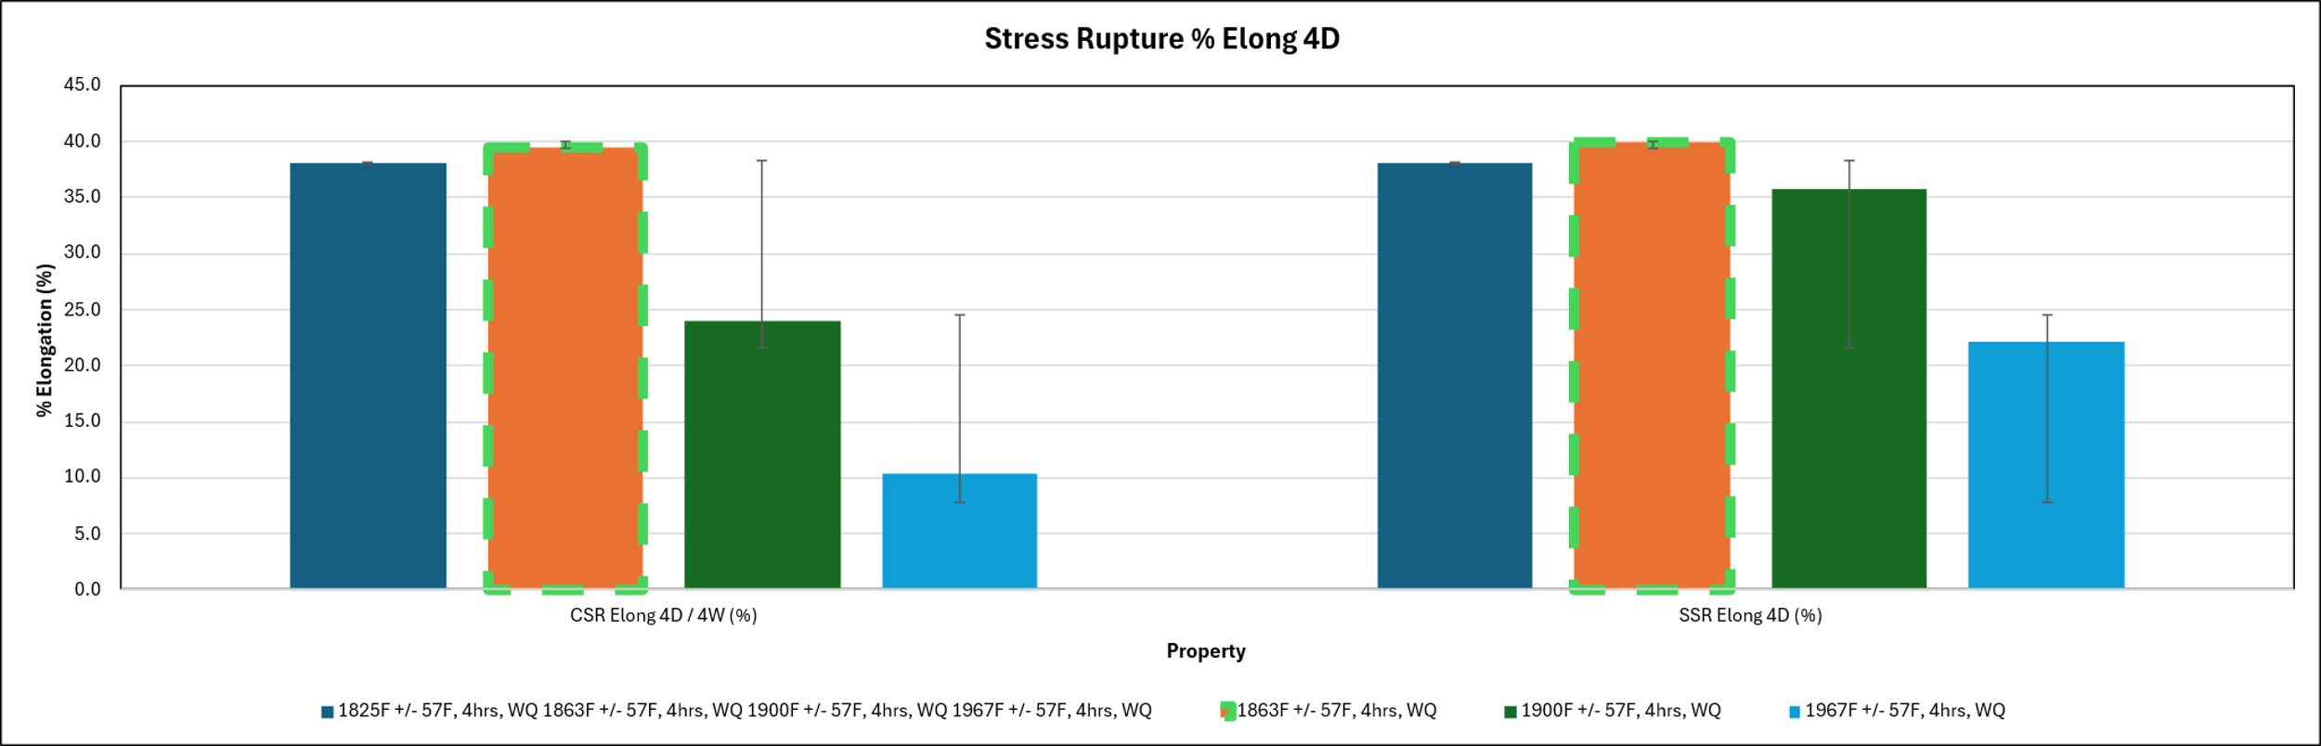

Figure 3-4-6- Hardness
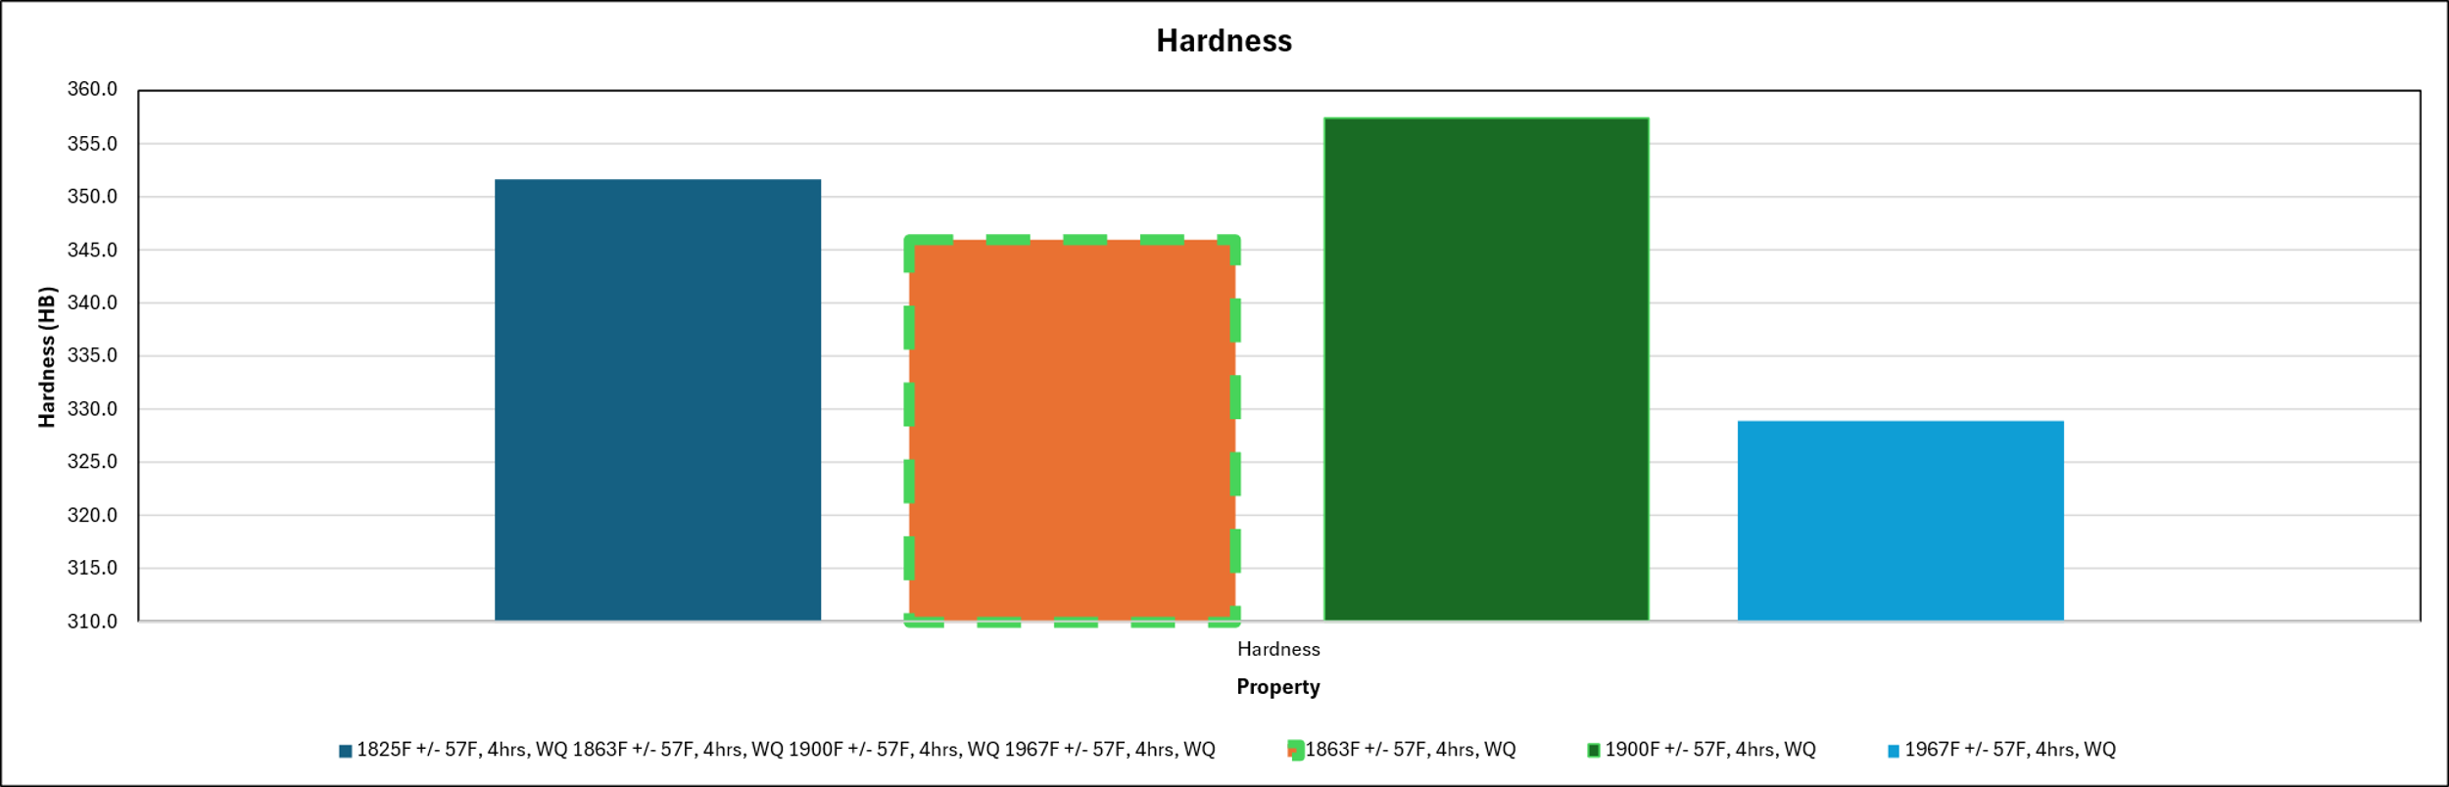

Figure 3-4-7- Grain Size
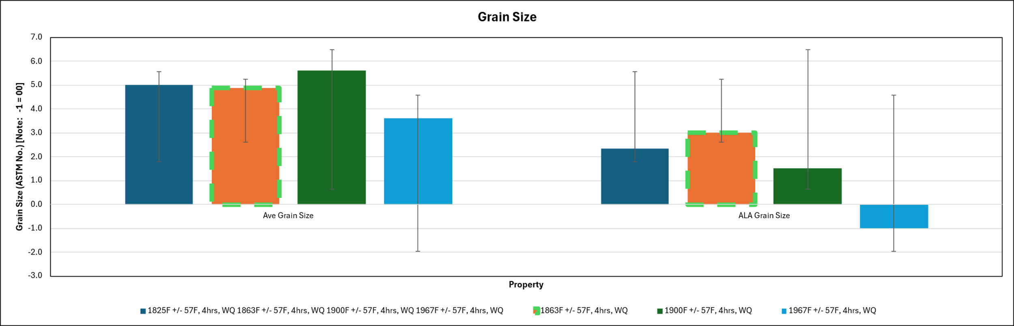
The below images show the microstrucre of the NWASP forgings at different heats and have to conform to governing spec MSRR 7197 which details the ASTM limits and range of eventaulites in which the grain structure can be assessed as to pass I.E. Unifrom grain structure.

Figure 3-4-8- Sample 1
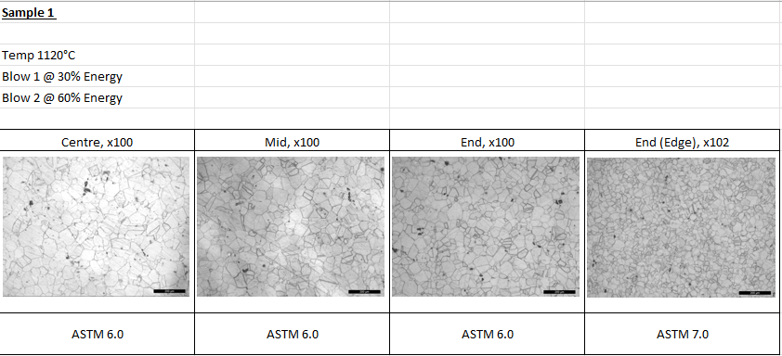

Figure 3-4-9- Sample 2
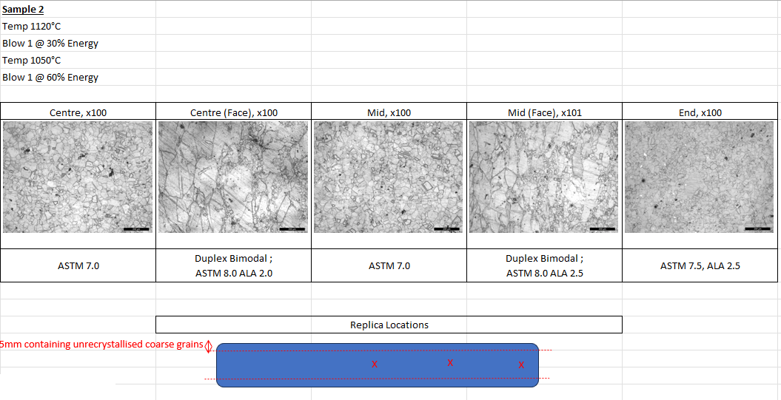
The below graphs represent the mechanical data of the original method of manufacturing and demonstrate the inefficiency within the forging process.

Figure 3-4-10- Initial Hardness
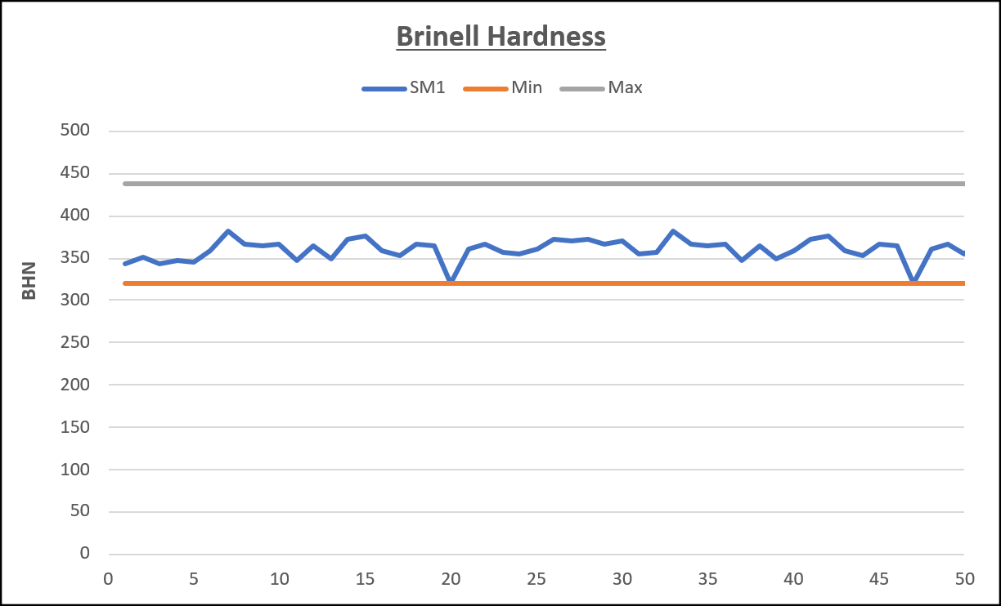

Figure 3-4-11- Initial Smooth Stress Rupture (SSR)
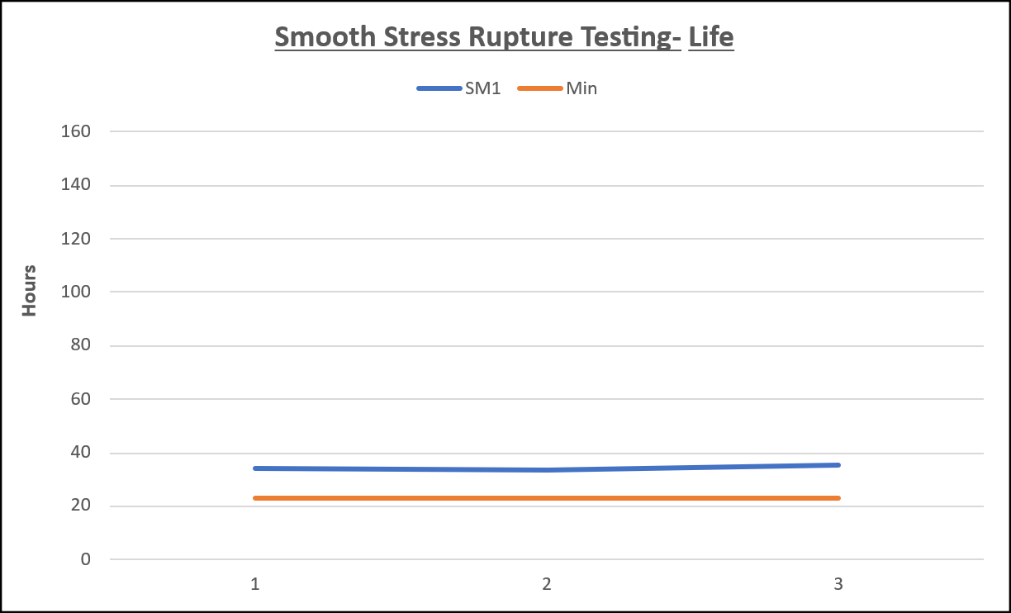

Figure 3-4-12- Initial SSR Elong
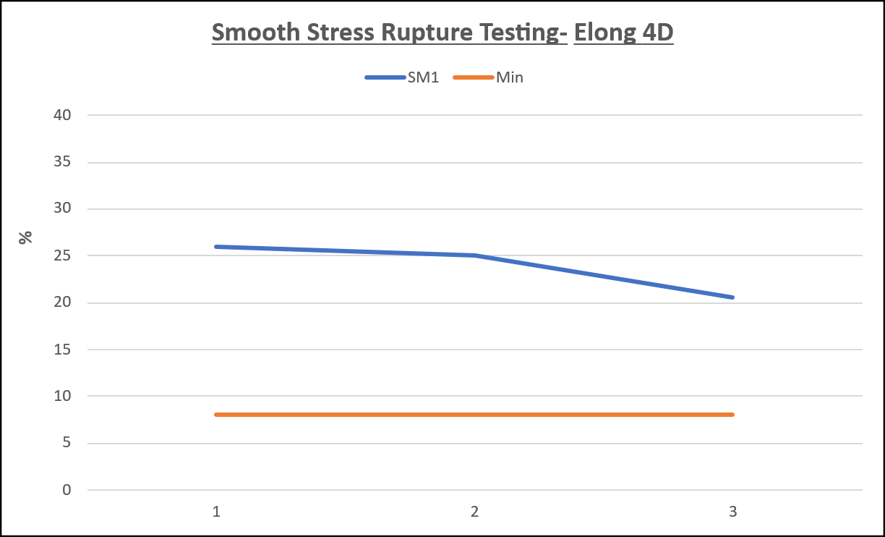

3.5 Measurement System Analysis CP/CPK
The first thing to note about these NWASP parts is that due to their dimensions, production is restricted to manufacturing batches of five otherwise representability of the batch would be uncertain in testing making the sample size. Process capability (CP) and index (CPK) is used to assess the forging operation is meeting customer and standard requirements.
The CP value is the process adhering to specification range:
Cp
=
USL - LSL6σ
Sample size = 24
Mean = 0.3,0.2,0.5,0.6,1.2,
0.5,1.3,0.8,0.8,0.7,
0.3,0.6,1.4,0.3,0.4,
1.0,0.9,1.3,0.2,0.3,
0.6,0.7,0.3,0.2
------------------------
24
= 15.4/24
= Mean_TOT
Mean_TOT = 0.7 mm
USL = 2.00 mm
LSL = 0 mm
σ = 0.37 mm

Figure 3-5- Standard Deviation
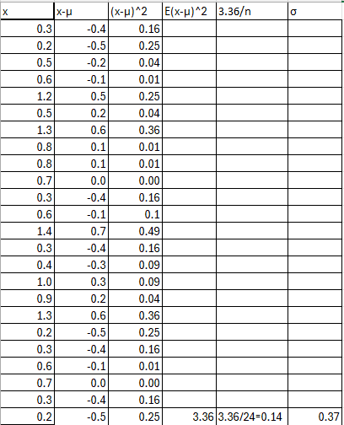

CP = 2/6 x 0.37 = 0.90

The CPK value will demonstrate if the process’ performance:
CPK = min
=
USL - μ3σ
μ - LSL3σ
Sample size = 24
Mean_TOT = 0.7 mm
USL = 2.00 mm
LSL = 0 mm
σ = 0.37 mm
CPK(USL) = (2.0 – 0.7/3 x 0.37) =
1.3/1.11 = 1.17
CPK(LSL) = (0.7 – 0/3 x 0.37) =
0.7/1.11 = 0.63
The CP value is <1 indicates the process capability is lacking, and the CPK value is <1 also which demonstrates the process in uncentred and failing to meet industry and customer standards. Both values present a level of variation within the process that will directly impact product quality by contributing to defect occurrence and falling below acceptable industry standards (Hessing, 2014).

3.6 Inspection Reports/ additional data

Figure 3-6-1- NC 1
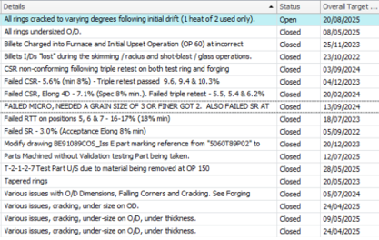

Figure 3-6-2- NC 2
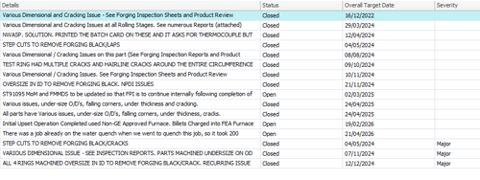

Figure 3-6-3- Defective Batches
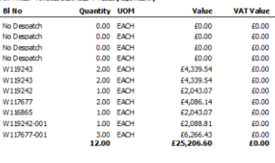

Figure 3-6-4- Example of Scrap Loss 1
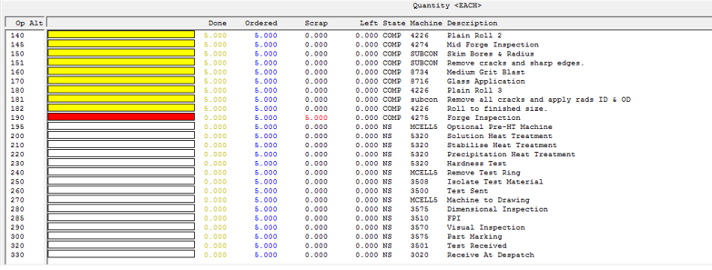

Figure 3-6-5- Example of Scrap Loss 2
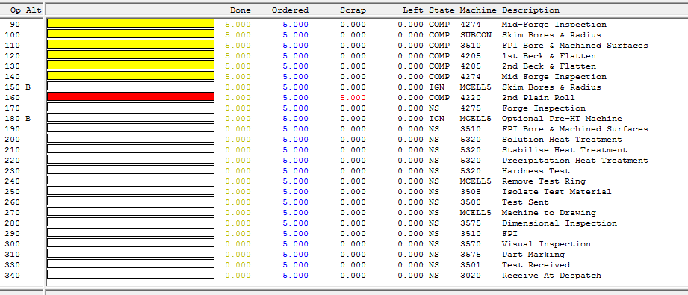

Figure 3-6-6- Example of complete Job
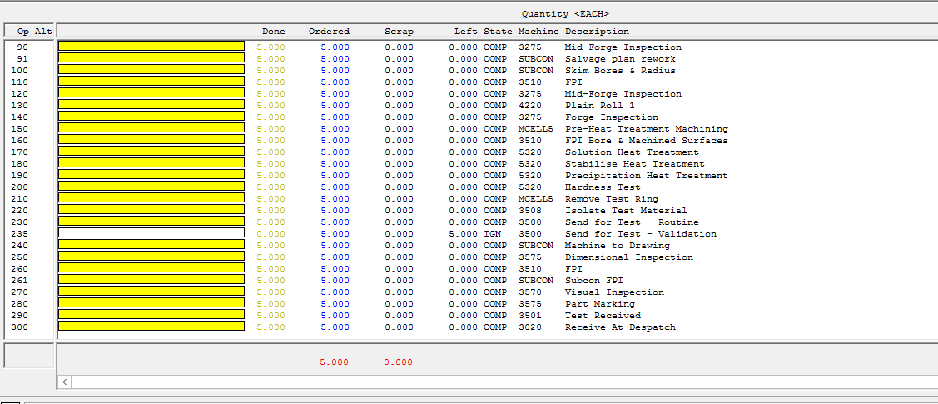

4.0 Analysis
Identifying the key cause of cracking and crack variation within the NWASP forgings will be measured via a combination of statistical and qualitative data produced by various tools.
Cracking may occur during many operations, and the majority will be briefly covered below with accompanying sources. This is due to the evidence covered in section 3.5 where the defects predominantly occur within the forging stages of manufacturing.
Material composition will directly impact both mechanical and metallurgical properties of any alloy and component. It is imperative that the Ni/Fe ratio and composition is calculated with precise temperature control during forging and heat treatment. This is due to a composition’s behaviour at different recrystallisation temperatures and solubility levels such as the gamma prime solvus temperature on the Ni/Fe equilibrium diagram. The Hume Rothery rules are an example of control limits where it is guided that an atomic radius of two elements should be similar to minimise lattice strain (Bohrium SciencePedia, 2026) which could cause cracking or dislocations if unmanaged. The data shown in section 3.4 is used to estimate the later FMEA S/O/D ratings which directly impact the RPN value impacting prioritisation of improvements.

4.1 Ni/Fe equilibrium phase diagram

Figure 4-1- Ni/Fe equilibrium diagram (E.A. Brocchi et al., 2013)

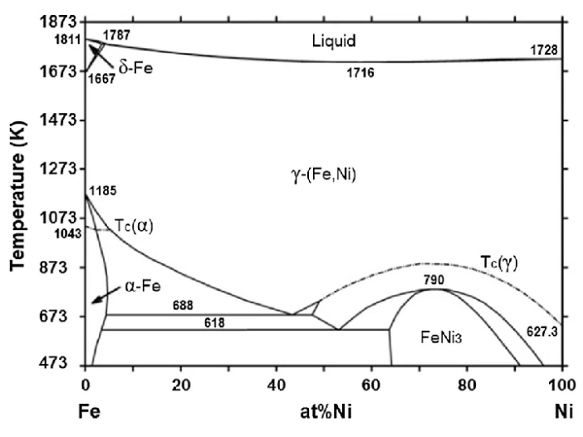
As stated, the method of forging and heat treatment can impact the cracking propagation due to inefficient handling by machinery or employees. A select composition and crystal lattice is desired and any fault within the process causes an inefficient cooling resulting in non-uniform microstructures. Forging is controlled at specific temperatures to achieve the desired crystal lattice structure to enhance the finished product (ALEKVS, 2025).
Temperature control is accompanied by precise atmospheric and pressure control to ensure product quality (Hao et al., 2025). The malleability and solubility of the solute and solvent elements of an alloy increase with temperature however, the machinery will experience more hostile working environments as limits are tested. If a tool is unable to function during the hostile working environment, then microcracks may form as a result from poor machining lines (Eggleton, 2025).
Human error is a major factor and consideration within any workplace. It is a recognised reoccurring error resulting from nothing or everything depending on personal situation and experience (Health and Safety Executive, 2025). This does not give a business a right to neglect pressuring efficiency. Human error should be recognised as a possibility and managed while implementing key changes within methods, training and processes to ensure it is minimised. (Clarity, 2026) A type of human error could be; inaccurate crack measurement, machining defects, inspection inconsistencies, operator error…

4.2 The 5 Whys
The 5 Whys is a root cause analysis technique used in the analyse phase of the six sigma DMAIC. It enables identification of the root cause of a fault and prevents its reoccurrence in the simplest format (Johnson, 2014). The concept is asking why repeatedly until the problem dissolves.

4.2.1 Why 1
Why does cracking occur? Cracking occurs during forging operations because the material is experiencing high thermal and mechanical stress during forging and cooling.

4.2.2 Why 2
Why does it experience high stress and temperatures? The microstructure is weakened during high temperatures enhanced during the solubility or recrystallisation zones on the phase diagram shown in section 4.1.

4.2.3 Why 3
Why is the structure weakened? The forging temperature exceeds the gamma solvus prime temperature which eases plastic deformation within the composition reducing the resistance to deformation. While producing precipitates during cooling which can strengthen mechanical properties while decreasing some such as ductility (Bendo et al., 2019).

4.2.4 Why 4
Why does the process exceed or achieve temperatures below the gamma solvus prime temperature? The temperature control and process parameters accompanied by operator error are not optimised efficiently for maximum product quality which suggests a systematic process control issue.

4.2.5 Why 5
Why are the process parameters and operators not optimised? Unstable process controls, environments and material composition can all have an impact on a standardised process control and may cause a product to fall outside the preferred standard.

5.0 Improve
Six sigma focuses on combining best practice, operation knowledge and quality management to improve processes (Pereira, 2022). Based on the analysis phase improvements will be considered to suit the key causes of operational defects and considered with tools such as FMEA below.

5.1 Brainstorm Improvements
A brainstorming session was carried out with the team members, operators and maintenance staff to suggest initial improvements to be considered where the potential of failure was the greatest.
The improvements are detailed below;
- Material Melting Temperature
- Forging
- Cooling
- Material Comp
- Inspection
- Measurement
The above list of improvements was used to create a Weighted Prioritisation Matrix Table for Improvement Options (LearnLeanSigma, 2023).

Table 5-1- Weighted Prioritisation Matrix Table for Improvement Options
Improvement Option | Impact  (1-10) | Occurrence  (1-10) | Cost to Rework  (1-10) | Cost to Scrap  (1-10) | Total Score  (40 Max)
Material Melting Temperature | 5 | 6 | 7 | 10 | 28
Forging | 5 | 5 | 8 | 10 | 28
Cooling | 5 | 5 | 9 | 10 | 29
Material Comp | 4 | 6 | 6 | 10 | 26
Inspection | 3 | 4 | 3 | 10 | 20
Measurement | 3 | 4 | 3 | 10 | 20

This approach offers a matrix in which each key cause is ranked by overall impact, occurrence and total cost, this ensures that decisions while ranking were made with data driven sources instead of inconsistent subjective ideas from single instances of data. The suggested improvements will be further exploited within section 5.2 FMEA for deeper analysis and improvement considerations.

5.2 Initial FMEA
One approach used to evaluate, identify and prioritise potential failure modes within a process is a Failure Mode and Effect Analysis (FMEA) table (Sartor, 2026). By weighing the failure effect on product quality enables customer satisfaction to be measured in terms of defects. An FMEA table for the NWASP products will be shown below along with a key;

Table 5-2-1- Key for FMEA
Name | Abbreviation | Description
Severity | S | Impact of failure
Occurrence | O | Frequency of failure
Detection | D | Likelihood of failure being identified before reaching customer (escape)
Risk Priority Number | RPN | Attempt to prioritise critical risks/areas needing improvement first to improve efficiency

Table 5-2-2- FMEA Table
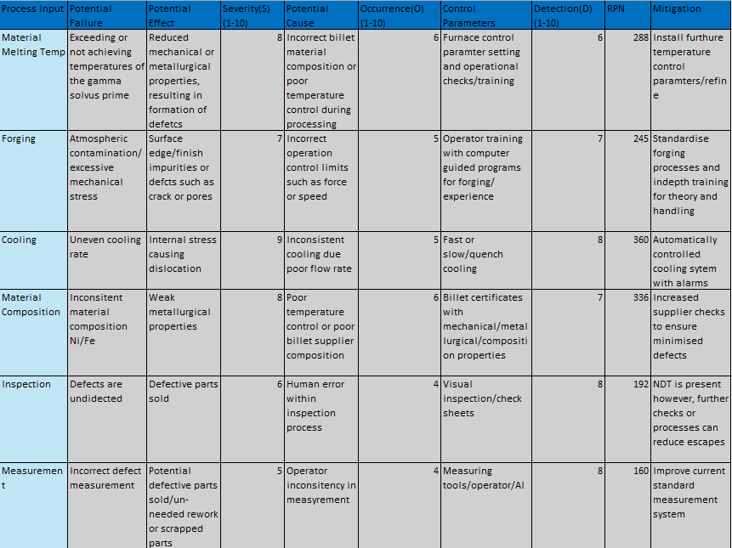
The FMEA table shows that the cooling inconsistencies and temperature variation from material composition within the process input have the highest RPN values. This identifies them as the primary contributors to cracking defects therefore, by prioritising improvement at these stages will offer the greatest improvement on process capability and potential detection of defects by having the largest impact on overall occurrence.

5.3 FMEA After Improvements and New Process Map

Table 5-3-1 FMEA Table Improved
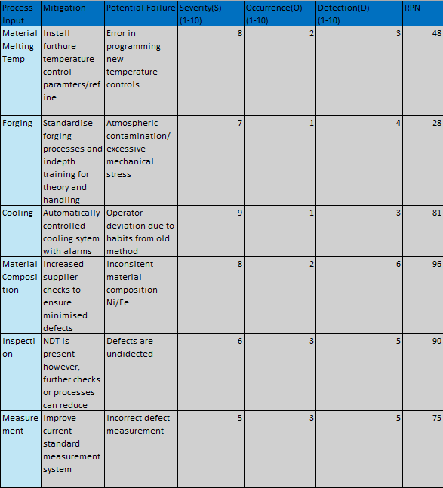
The Improved FMEA table shows the mitigation and potential failure mode after installation of the improvement. As shown in the RPN value adding these improvements significantly decrease the total RPN resulting in a better production quality predictability and customer satisfaction. However, the RPN values indicate that improvements are still necessary to achieve the 99.999% six sigma goal of efficiency. This approach aligns with six sigma ideals because no process involving humans can run at 100% efficiency due to human error but that should not impact the level of seriousness when action is needed to improve a process both for sustainability of the planet and resources.

Table 5-3-2 Process Map Improved (Author, n.d.)
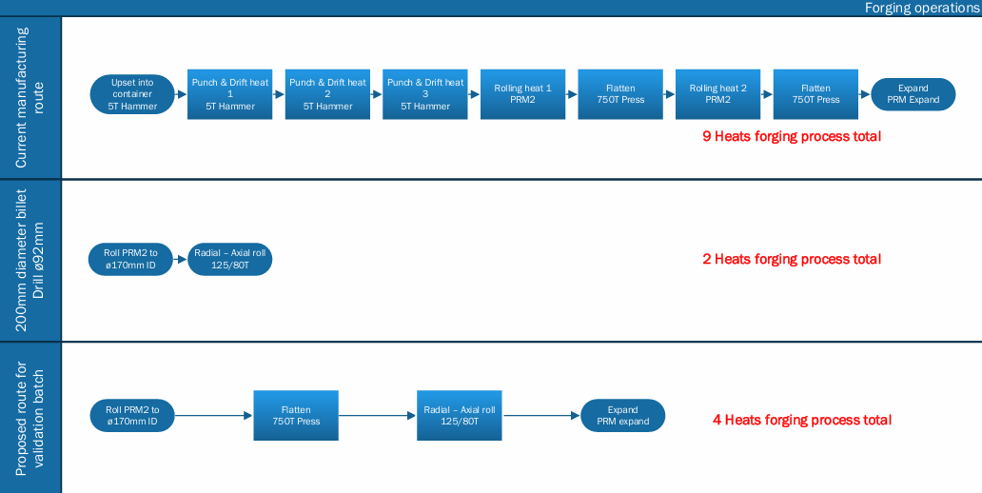
The above Process Map is the revised process Map for the forging operation, it identifies additional heats and operations to validate updated methods which will allow a reduction in metallurgical testing if requirements can be met.

5.4 Cost Benefit Analysis

5-4-1- Cost Benefit Analysis
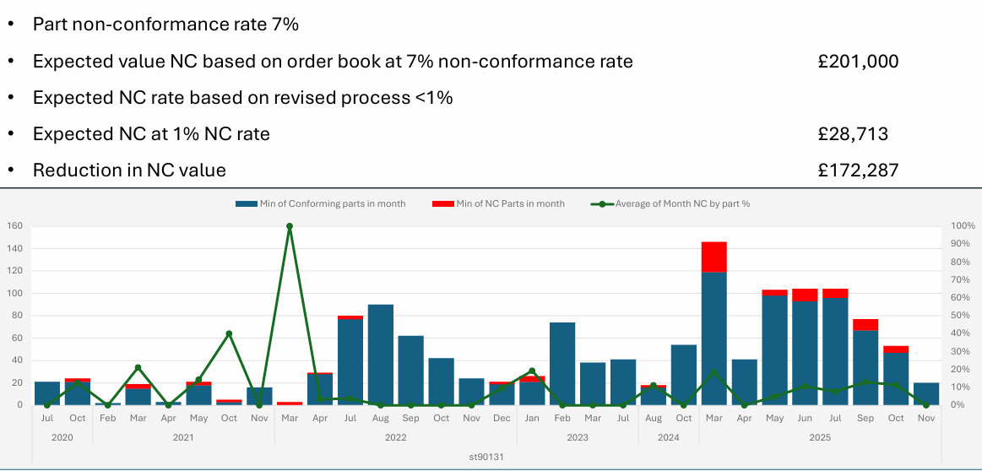
The above image shows the non-conforming (NC) rate and cost reduction dur to NC.

5-4-2- Cost Benefit Analysis (Author, n.d.)
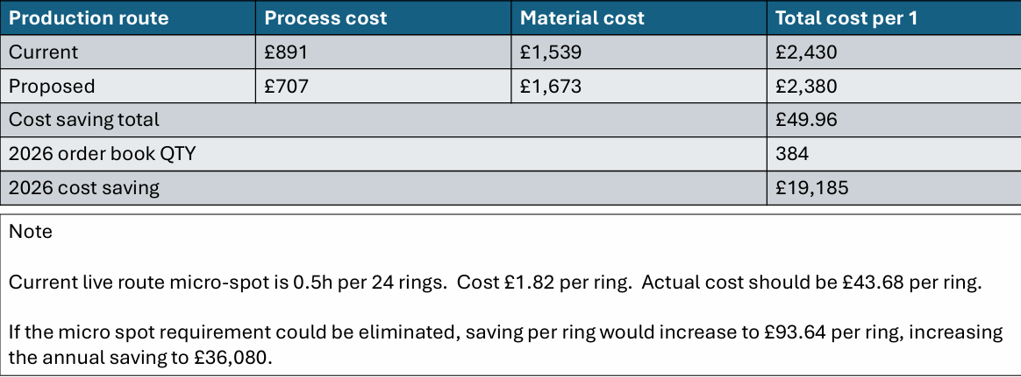
The cost benefit analysis demonstrates that the justification of eliminating all defects within the process map will greatly benefit the company. By producing repeatable and representable parts BFL can minimise the total number of verification operations carried out. For the governing spec for the NWASP parts, if a process can demonstrate repeatable and representable then the micro-spot evaluation is no longer required resulting in an overall £36,000 annual saving to BFL and £172,287 in operational costs due to defective products causing NC results.

5.5 Heat Flow vs Temperature
Due to the relationship between the gamma solvus prime and the cracking there are a few key areas which can be altered to improve the product’s capabilities. Adjusting the forging temperature or time, modifying the alloy composition and improving the cooling rate are the main solutions which can be used due to each one directly correlating with both the mechanical and metallurgical properties of the alloy. This is due to maintaining a temperature tolerance within the system to be around +/-10°C of the gamma solvus prime temp due to common variation with cooling rates during process. A closed loop temperature control system using thermocouples and automated computer feedback (Woolf, 2020) is implemented to control this range. This significantly reduces the effect on microstructure and crack formation while increasing the overall detection level of the operation by using alarms to sound faults.

6.0 Control Phase
Control parameters such as the standard processing, training, handling will be considered during the control phase utilising the previous improvement section to assess current and future control phases for production within BFL NWASP forgings. This stage will focus on the impurities left within the daily process that may not have been identified within the measurement and analytical methods used previously.

6.1 Standard Operational Process (SOP) Updated
The key causes of concern within section 3.0 Measure are reiterated below along with updates made to increase efficiency and customer satisfaction. The structure of represents expectations for process standardisation documentation control limits ISO 9001 (ISO, 2019).

6.1.1 Material Melting Temperature
Re-evaluated the recrystallisation temperature around the gamma solvus prime temperature.

6.1.2 Forging
Increased material weight by 0.4kg to bar diameter tolerances while rolling.

6.1.3 Cooling
Cooling is adjusted to account for the additional material within forging.

6.1.4 Material Comp
Validation testing requires more extensive metallurgical testing due to the elimination of said testing during routine batches.

6.1.5 Inspection

Figure 6-1-5-1- Forging Inspection Check Sheet(Author , n.d.)
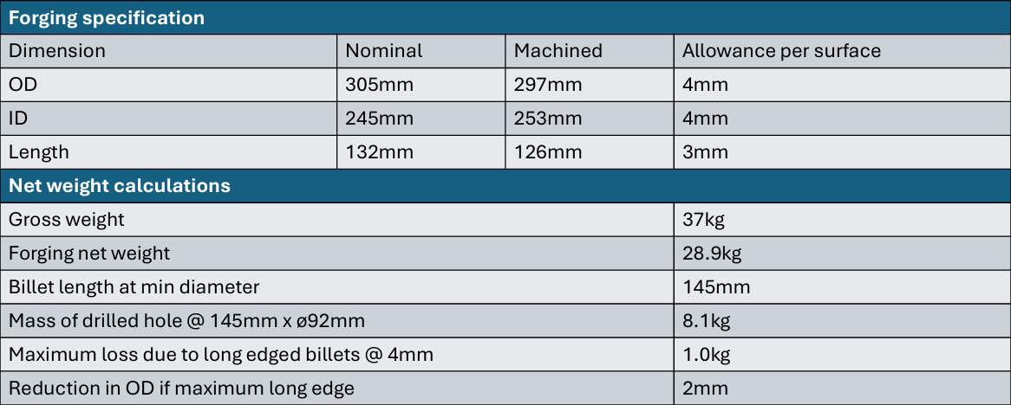
Training has been re-written to include dual measurements or signatory to prevent total number of escapes. The above image shows the new standards for the amended inspection details.

6.1.6 Measurement
Measurement tool and programs have been adjusted to fit new dimensions due to the added material in the forging process.

6.2 Process Monitoring
Programs and computer assisted programs have been updated to suit new process control requirements. However, in addition to this witnessing of the forging process has now been implemented within the SOP to ensure material flow, forging force and stress is all evenly distributed to achieve the correct solubility levels. This is done to achieve the desired mechanical and metallurgical properties as well as preventing any defects such as dislocation and slips from escaping and being sold. Witnessing will be validated via a photographic storage sheet containing images of correctly forged parts shown below along with WO which has been removed for information purposes.

Figure 6-2-1- Witnessing Example 1
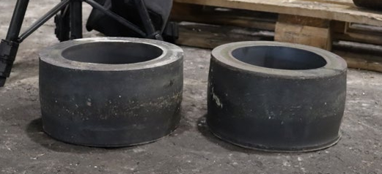

Figure 6-2-2- Witnessing Example 2
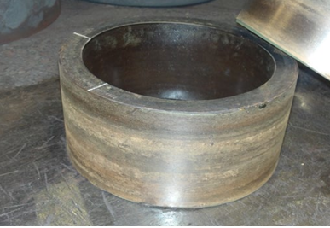

6.3 Training and Operator Experience
Methods such as toolbox talks and check list have been revised and re-issued to all relevant employees in which after completion of the training or check list will require a identifying stamp to show co-operation with both industry and customer standards, while providing management with the ability to ensure training is absorbed throughout all possible outlets within the process of NWAPS forgings and more which is the result and a key focus of six sigma projects.
Toolbox talks are in person team meeting governed by method of manufacturing (MOM), SOP, health and safety or any other critical operational changes and are presented to teams via managers or team leaders. If BFL identifies that a toolbox talk is ineffective then personal training is started which requires a more in-depth process in which individuals are trained to complete a task however, this comes with training costs for BFL.

6.3 Process Sustainability
The improvements made to the DMAIC methodology in this report have created a more predictable and sustainable method of manufacturing the NWASP forgings within BFL. By revising control methods and procedures brought an annual £36,000 reduction in micro-spot evaluation possibility providing, BFL can continue to maintain adequate performance and cleanliness while manufacturing critical aerospace parts. Current methods like SOPs have been updated to suit the revised methods, and this ensures the longevity of the production by maintaining temperature and material flow at consistent levels producing a more predictable life of machinery which could cause defects by forging or machining outside of tolerance limits due to system malfunction from wear and tear.
Monthly and weekly meeting have been implemented within the operations. Depending on the RPN priority level from section 5.2 FMEA departments now are required to hold a meeting either once a month or weekly, for example those who witness the forging operations must meet weekly to discuss any problems that arise during manufacturing or concerns for future production. Whereas the LAB in which the micro-spot evaluation has been reduced to only validation testing will only be required to show occasional findings within SPC format if there is any due to production demands at the given time.
The improved FMEA table demonstrates BFLs ability to identify ongoing issues and causes for concern and using critical analysis tools such as FMEA and fishbone diagram allow for a clearer insight into understanding how a process currently functions and what the issues are. Which enable key mitigations to be installed and critical documentation such as SOPs are updated to reflect the new MOM. In doing so will father BFL to reduce operational costs and reduce overall manufacturing waste from defective products.

7.0 References
ALEKVS. (2025). Forging Process Explained: Types and Techniques. [online] Available at: https://www.alekvs.com/forging-process-explained-types-and-techniques/ [Accessed 6 Apr. 2026].
Author (n.d.). Cost Benefit Analysis. BFL.
Author (2025). Fishbone Diagram (Cause and Effect Analysis). Materials.
Author (n.d.). Process Map revised. BFL.
Bendo, A., Maeda, T., Matsuda, K., Lervik, A., Holmestad, R., Marioara, C.D., Nishimura, K., Nunomura, N., Toda, H., Yamaguchi, M., Ikeda, K. and Homma, T. (2019). Characterisation of structural similarities of precipitates in Mg–Zn and Al–Zn–Mg alloys systems. Philosophical Magazine, 99(21), pp.2619–2635. doi:https://doi.org/10.1080/14786435.2019.1637032.
Birkie, S.E., Trucco, P. and Kaulio, M. (2017). Sustaining performance under operational turbulence. International Journal of Lean Six Sigma, 8(4), pp.457–481. doi:https://doi.org/10.1108/ijlss-12-2016-0077.
Bohrium SciencePedia (2026). Hume-rothery Rules. [online] Bohrium SciencePedia. Available at: https://www.bohrium.com/en/sciencepedia/feynman/solid_state_physics_undergraduate-Hume-Rothery_rules [Accessed 5 Apr. 2026].
Caa.co.uk. (2026). GM1 CAT.POL.H.420 Helicopter operations over a hostile environment located outside a congested area. [online] Available at: https://regulatorylibrary.caa.co.uk/air-operations-pre-30-october-2025/Content/Document%20Structure/04%20CAT/4%20GM/GM1%20CAT%20POL%20H%20420%20Helicopter.htm [Accessed 7 Apr. 2026].
Clarity, S. (2026). HSG48: Reducing Error and Influencing Behaviour. [online] Safetyclarity.co.uk. Available at: https://safetyclarity.co.uk/articles/workplace-safety/hsg48-human-factors-guide [Accessed 7 Apr. 2026].
E.A. Brocchi, Moura, F.J., Cortez, O.A., Siqueira, R.N.C. and Souza, R.F.M. (2013). Synthesis by hydrogen reduction and characterization of iron nickel alloys. [online] Available at: https://www.researchgate.net/publication/286807012_Synthesis_by_hydrogen_reduction_and_characterization_of_iron_nickel_alloys [Accessed 6 Apr. 2026].
Eggleton, J. (2025). How Manufacturing Affects the Mechanical Properties of Materials - iLearn Engineering®. [online] iLearn Engineering®. Available at: https://www.ilearnengineering.com/manufacturing-industrial/how-manufacturing-affects-the-mechanical-properties-of-materials [Accessed 7 Apr. 2026].
Hao, Y., Rui, L., Xinqi, N., Hanlin, W., Ce, Z. and Xin, L. (2025). Effect of hot-rolling temperature on strength–plasticity synergy and multi-scale plastic deformation mechanism of Ti-55531 titanium alloy. Journal of Materials Science, 60(44), pp.22307–22325. doi:https://doi.org/10.1007/s10853-025-11664-1.
Health and Safety Executive (2025). Human factors/ergonomics – Managing human failures. [online] Hse.gov.uk. Available at: https://www.hse.gov.uk/humanfactors/topics/humanfail.htm [Accessed 7 Apr. 2026].
Hessing, T. (2014). Process Capability (Cp & Cpk) | Six Sigma Study Guide. [online] Six Sigma Study Guide. Available at: https://sixsigmastudyguide.com/process-capability-cp-cpk/ [Accessed 9 Apr. 2026].
Ikeda, I. (2020). Le début de la faim. BoD - Books on Demand.
ISO, 9001 (2019). International Organization for Standardization. [online] ISO. Available at: https://www.iso.org [Accessed 1 Jan. 2023].
Johnson, S. (2014). 5 Whys | What you need to know to pass your Six Sigma certification exam. [online] Six Sigma Study Guide. Available at: https://sixsigmastudyguide.com/5-whys/ [Accessed 7 Apr. 2026].
Jordan, L. (2025). Voice of Customer (VOC) Tools: Translating Needs into Action - Lean Outside the Box. [online] Lean Outside the Box. Available at: https://leanoutsidethebox.com/voice-of-customer/ [Accessed 23 Dec. 2025].
Kevin (2026). Forging Tolerance: Limits, Machining, and Cost. [online] Quanzhou Weforging Machinery Manufacturing Co., Ltd. Available at: https://www.weforging.com/forging-tolerance-guide/ [Accessed 22 Dec. 2025].
LearnLeanSigma (2023). Prioritization Matrix Template - Learn Lean Sigma. [online] www.learnleansigma.com. Available at: https://www.learnleansigma.com/template/prioritization-matrix-template/ [Accessed 11 Apr. 2026].
Pereira, P. (2022). Six Sigma and Quality Management. IntechOpen eBooks. IntechOpen. doi:https://doi.org/10.5772/intechopen.100753.
Sartor, M. (2026). Shibboleth Authentication Request. [online] Oclc.org. Available at: https://www-vlebooks-com.uwtsd.idm.oclc.org/Product/Index/2033534?page=0&startBookmarkId=-1 [Accessed 8 Apr. 2026].
Shinde, D.D., Ahirrao, S. and Prasad, R. (2018). Fishbone Diagram: Application to Identify the Root Causes of Student–Staff Problems in Technical Education. Wireless Personal Communications, [online] 100(2), pp.653–664. doi:https://doi.org/10.1007/s11277-018-5344-y.
Woolf, P. (2020). 11.6: Common Control Loops and Model for Temperature Control. [online] Engineering LibreTexts. Available at: https://eng.libretexts.org/Bookshelves/Industrial_and_Systems_Engineering/Chemical_Process_Dynamics_and_Controls_(Woolf)/11%3A_Control_Architectures/11.06%3A_Common_control_loops_and_model_for_temperature_control [Accessed 19 Apr. 2026].

