COMPONENT 1 REPORT WORD COUNT EFFECTIVE TEAM WORKING FOR EQUIVALENT TEAM SUCCESS

Executive Summary
The study has evaluated the performance of the Abdul team and it has provided the various methods for creating an effective team for taking better results. It has also analysed the Tuckman and Belbin model for creating an effective team.
Table of Contents
Introduction 4
The ways in which Abdul can create an efficient team 4
The theoretical model which can be utilised 5
Types of roles that are needed for developing an effective team 6
Impact of team working can have on the success 7
Barriers to effective team working 8
Conclusion 9
Reference List 10

Introduction
The study will give significance to the case of Abdul and it will evaluate the various issues which are arising at the beginning of the project which is not favourable for further growth. The study will be providing the various ways using which the concerned individual will be able to create a very efficient team and the study will be discussing the theory which can be incorporated for the same. Also, the assignment will be analysing the various types of roles which are necessary for developing an effective team and it will be analysing the impact of the team working on the success of the project. At last, the several barriers which arise while working in a team will be analysed.

The ways in which Abdul can create an efficient team
It is not very easy for adult to manage the new project of Vodafone wherein he has to handle the group of 18 employees which are assigned to him for delivering a community event. However, there are several ways by which Abdul can create a very effective and efficient team which are discussed as follows:
Development of clear team goal
It was witnessed that the team members put their own individual goals first which makes the team lose their sense of direction. Therefore, the team leader has to create project-wide, high-level goals to unite the disparate teams.
Enhancing Team Communication
A formal training session for enhancing communication has to be developed so that the team members are able to learn the effective ways of communicating with their colleagues for enhancing productivity. Also, developing an open communication platform could also help the members of the team to communicate their issues openly with the team leader and the other members of the team. Even in the absence of the team leader, the members of the team should be communicating effectively in an open atmosphere that encourages communication (Krizanova et al. 2019).
Build Trust and Respect
The concerned individual will have to create an environment of trust and respect which will be very essential for the successful growth in their work. The uncertainty in the team that has been developed in the environment can be balanced by the trust which would allow the members to work together in a very efficient manner.
Organising meetings for the employees
For enhancing communication and teamwork, the concerned individual has to make sure that the members are able to get to know each other in a better way. Therefore, organising the in-person meetings for all the various workers at least once a week. The information conversations and interactions help in bringing the team members together and warm up the team relationships. It would help in creating an effective team as the quantity and quality of interactions are impacted by pre-existing relations (Jean et al. 2018).

The theoretical model which can be utilised
In order to create an effective team, the Tuckman model can be utilised by Abdul which is as follows:
Forming
In the forming stage, Abdul is required to establish basic expectations amongst the members of the team regarding the kind of output required to be invested by each of them when it comes to teamwork. Moreover, the identification of the similarities of common goals would also be very necessary. In addition to this, such an effort develops trust amongst the members which would help them to depend on their leader.
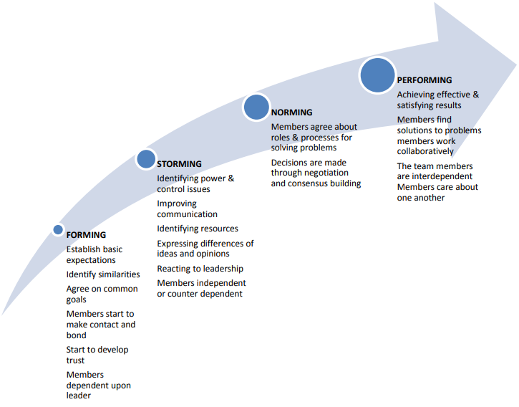
Figure 1: Tuckman Model
(Source: Gla.ac.uk. 2022)
Storming
Identifying the control and powers issues are the main agenda of the storming stage. However, it would help in enhancing the communication strategies and finding the resources which are available for executing operations. It would help the members of the team in expressing the differences of opinions and ideas and react to the changes incorporated by the leader.
Norming
Members would accept and agree about the various procedures and roles that they want to choose for solving the various issues regarding the work in this stage. Also, this stage would help Abdul in making the members of the team to make decisions by consensus building and negotiation (Gla.ac.uk. 2022).
Performing
This stage would help the members of the team in attaining effective and desirable outcomes which would further enhance their trust in themselves and improve communication in the team. This stage would also help Abdul in enabling the various members of the group to work in collaboration while finding the solutions to the issue. At last, this stage would make sure that all the members of the team are interdependent on each other and are under the guidance of Abdul alongside they care for the members of the group.

Types of roles that are needed for developing an effective team
The Belbin model is being utilised to determine the various roles which are required for creating an effective team:
Resource Investigator
According to Belbin, the resource investigator utilises their inquisitive nature to find plans to bring back to the team. Thus, this specific role could help the members of the team in fulfilling the requirements of the project and being in line with the deadlines. These changes would be made by this role as it is seen that the resource investigator is outgoing, has a very enthusiastic nature and has the ability to develop contacts.
Teamwork
This role chosen from the Belbin model supports and helps the members of the team to gel in with each other. As it is seen in Abdul’s team that no help is available when an individual team member asks for help, therefore the team member would be present for all the other members of the team and provide help whenever it is needed. This would be possible as the team member is able to provide support utilising their versatility to find the work which is needed and complete it for the entire team. To face these issues, it is significant to create competencies and provide training (Gutiérrez et al. 2019)
Implementer
The implementer will plan and create a doable and workable strategy and execute it as efficiently as possible. Abdul was facing issues as the members of the team were failing to complete the projects. Therefore, the implementer would analyse the potential of the members and make the relevant strategies according to the work assigned so that the members are able to do their work easily.
Shaper
This chosen role from the Belbin model would help in providing the essential drive to make sure that the team keeps ongoing and that they are not affected by any distraction and are able to maintain their momentum and focus. This role would make sure that Abdul's team is not losing focus and would push the various members of the team to work with their maximum potential. This would be possible as the Shapers of an organisation have to be challenging, dynamic and capable of thriving through pressure.
Completer Finisher
It was seen that the members of the team were failing to complete the project tasks and thus this role selected from the Belbin model would be utilised in such a way that it would be the quality checker end of every work. It would be possible as the completer would make sure that the work is scrutinised and polished, removing the scope of any error, which subjects it to the highest levels and standards of quality control.

Impact of team working can have on the success
The impact of teamwork on the success of the team is as follows:
Teamwork enhances Productivity
While working in a team, the load of the work is divided and shared between the various members of the team that have separate and unique expertise and skillsets. The members of the team combine their power together for performing a better job in a shorter time frame than a single person ever could which eventually provides team success. The team members have different and unique approaches towards solving issues and therefore they are able to create fresh ideas and solutions which would be difficult for a single individual. The members are able to give brainstorming sessions to each other which support them in their quest to innovate. Team working also allows the individuals to find solutions by building on each other's ideas prominently influencing team success. A team that works together in an effective way will create a successful team culture which incorporates loyalty and synergy along with the respect for each other. Resilience has been mostly studied at the individual level, team resilience has recently been given more theoretical and empirical consideration (Hartwig et al. 2020).
Teamwork provides learning opportunities
Teamwork is very effective as having different people that have separate skills, levels of experience and abilities working together will be working faster and in a successful way. Also, it is seen that while communicating over the various problems in the work the members of the team share their knowledge amongst each other which provides an effective learning opportunity. This is a reason that all the members of the team grow together and enhance their abilities and skills towards effective team success. They learn from the experience of their teammates and they keep finding fresh methods of executing their work. The individuals that are working in a team become more confident and proficient at the same time the employer is attaining the productivity of more knowledgeable employees without any additional costs. Knowledge workers produce most goods and services with their minds (Xu et al. 2018).

Barriers to effective team working
The aim of this segment is to describe barriers to effective team workings follows:
Poor communication
According to Kapur (2018) communication is a very general concept in everyday life and has to take place in every organisational setting. Therefore, poor communication is a significant barrier to efficient and effective team working as it was seen that the members of Abdul's team were not able to maintain effective communication. It is clearly seen that the productivity of the members was decreasing as they were not able to communicate the issues that they were facing to the team leader or the other members of their team. Also, it was seen that there was no communication in the form of an apology when a staff member was not able to attend a significant meeting with the local MP and community groups. This shows that this communication gap has been the main reason for the inefficiency of the members.
Non-supportive team members
The most prominent advantage of working is that members are able to attain help from their colleagues regarding every issue. In the case of Akbar's team, it was seen that the communication and collaboration between the employees were very bad. It is clearly shown that the members do not support each other and neither do they revert to the email communications. This is a significant drawback for the team as it would never allow the members of the team to perform with their maximum potential as the non-collaborative behaviour is creating a very negative environment. The popularity of several communication platforms has been found to be effective in communication and teamwork (Darics and Cristina Gatti, 2019).
Poor performance of Team members
Research demonstrates that the people working in teams have to handle the poor performers using various ways on the basis of the members' perception regarding the reasons for bad performance. In the given scenario, the members failed in fulfilling the requirements of the projects. Due to this, the members with bad performance are perceived as lacking in ability, the team is more likely to shape and train the member. Whereas in the situation where the members feel that the individual is just not motivated enough then they try to motivate or reject the performer.

Conclusion
The study has given significance to the case of Abdul's team and it has analysed the ways which can be utilised to create an efficient team like the development of a clear team goal, enhancing team communication, building respect and trust and organising meetings for the employees. The study has also utilised the Tuckman model to choose Forming, Storming, Norming and Performing as the stages for creating an effective team. Then, the study has utilised the Belbin model to form the several roles which are needed for developing an effective team. It has also discussed the ways in which team working impacts success like it enhances productivity and gives learning opportunities. At last, the study has discussed the several barriers to effective team working.

Reference List
Darics, E. and Cristina Gatti, M., 2019. Talking a team into being in online workplace collaborations: The discourse of virtual work. Discourse Studies, 21(3), pp.237-257
Gla.ac.uk. 2022. Tuckman’s Team Development Model. [online] Available at: <https://www.gla.ac.uk/media/Media_358180_smxx.pdf> [Accessed 2 March 2022].
Gutiérrez, L., Flores, V., Keith, B. and Quelopana, A., 2019. Using the Belbin method and models for predicting the academic performance of engineering students. Computer Applications in Engineering Education, 27(2), pp.500-509.
Hartwig, A., Clarke, S., Johnson, S. and Willis, S., 2020. Workplace team resilience: A systematic review and conceptual development. Organizational Psychology Review, 10(3-4), pp.169-200.
Jean, S., Medema, W., Adamowski, J., Chew, C., Delaney, P. and Wales, A., 2018. Serious games as a catalyst for boundary crossing, collaboration and knowledge co-creation in a watershed governance context. Journal of environmental management, 223, pp.1010-1022.
Kapur, R., 2018. Barriers to effective communication. Delhi University.
Krizanova, A., Lăzăroiu, G., Gajanova, L., Kliestikova, J., Nadanyiova, M. and Moravcikova, D., 2019. The effectiveness of marketing communication and the importance of its evaluation in an online environment. Sustainability, 11(24), p.7016.
Xu, M., David, J.M. and Kim, S.H., 2018. The fourth industrial revolution: Opportunities and challenges. International journal of financial research, 9(2), pp.90-95.

