Student Name: Lois James
P Number: 1700345
Programme of Study: Graphic Design
Module: Creative Research (M5X01599)

Lousie Burston and Sarah Tombs

Final Word Count - 1965 /2000 Words.

Within a given time period, select examples of what could be considered high and low cultural artefacts. Discuss these, taking into consideration the surrounding social, political and historical context.

As humans it is in our nature to analyse and categorise the multitude of information we are exposed to everyday whether it be relating to people, art, politics, religion etc. It is through this process of categorisation that we developed the idea of ‘Culture’ and the formation of boundaries and stereotypes associated with these different cultures started to form. In today’s society it is common to find that products of our creativity cross over these boundaries and are appreciated by people from all kinds of cultural backgrounds. This idea of manipulating what we view as attributes from high cultures and low cultures and mixing them together became prominent during the mid 19th century. With the rise of artists such as Andy Warhol, Jean-Michel Basquiat and Richard Hamilton society began to question what culture really meant and explored the social constructs of the time.

The term ‘Culture’, by definition, has two meanings. It either refers to “The arts and other manifestations of human intellectual achievement regarded collectively” or “The ideas, customs, and social behaviour of a particular group of people” according to the Cambridge Dictionary (1995). A ‘high culture’ refers to items that are viewed as belonging to a higher social class and often have links with intelligence and aristocracy. Comparatively, a ‘low culture’ artefact, also known as ‘pop culture’, makes reference to the masses and is frequently used as a form of protest against the elitist culture. This essay will take into account all of these perspectives when discussing artists prominent in the mid 19th and 20th centuries and their associations to culture.

The 1950’s saw the start of the ‘Pop Art’ movement with artists like Andy Warhol, Richard Hamilton and Robert Rauschenberg rising in both fame and popularity. The term ‘Pop Art’ refers to works that are, in the words of Richard Hamilton (1957), “Transient, low cost, mass produced, witty, glamourous, popular, expendable, young, gimmicky, big business”. He is considered to be of the ‘fathers’ of ‘Pop Art’ and created many famous pieces including his ‘Swinging London’ series in 1967- 1972 to his work on The Beatles’ ‘White Album’. Due to their content, composition and construction, the works created by Hamilton are difficult to categorise. This lends them to be a part of both a high and low culture and, depending on what the individual viewing them associates with each culture, it influences where on the scales they sit.

Whilst America was stuck in an age of prosperity and economic struggle, artists began to reject the elitism displayed in art of the time by taking from the everyday, resulting in their works having a stronger relationship with their culture. Work was being created by the people for the people, reflecting their personal feelings. The appropriation of everyday objects being turned into artwork for galleries started with the DADA movement and is clear within the piece ‘Fountain’ by Marcel Duchamp, (1917,1964).

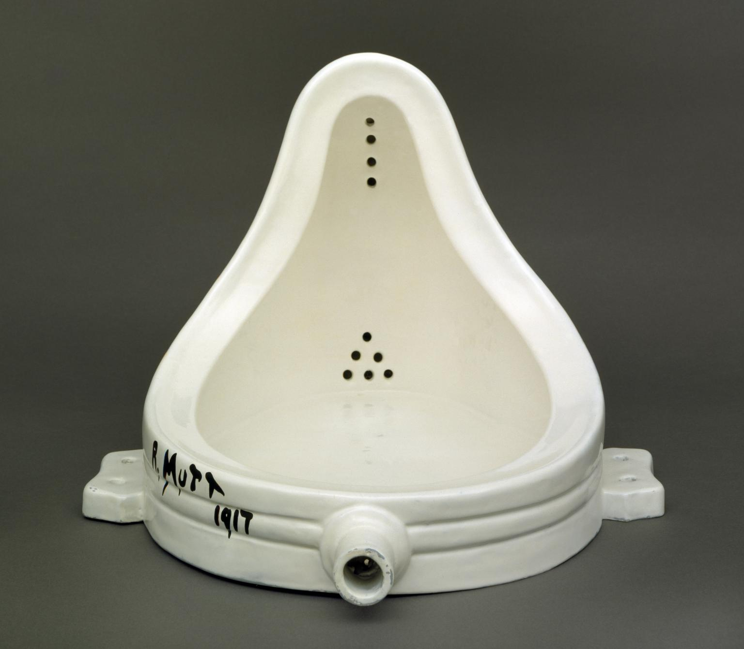

‘Fountain’ by Marcel Duchamp, (1917,1964).
However, through displaying this everyday object in a gallery, it now starts to blur the lines between high and low culture as its uniqueness lends itself to be appreciated by those who have access to the galleries themselves. Marcel’s relationship with the generation of art was a “defensive move against the dominance of Parisian Cubism” (Stephen Koch, 1991, pg.8) and despite its interesting and quirky qualities, it lacked power.

One artist who managed to find and somewhat harness this power was Andy Warhol. Everything about the type of artwork he created was ‘low culture’ from its commercial appearance, to its lack of uniqueness through uniformity and production, he achieved great distance between himself and middle-class Americans and their perceptions of art. Andy’s studio earnt itself the title ‘Factory’ and was moved across three different locations in New York City between 1962 and 1984. It was the place where many artists, musicians and creators of all kinds would get together and help with the creation of Andy’s artwork. This division of labour between such a wide mix of people resulted in pieces that lacked both personality and originality. Mass production of artwork at this time was uncommon and as a process it was similar to that of the production of consumer goods. A great example of these techniques can be found is his piece ‘Brillo Box (Soap Pads)’ from 1964.
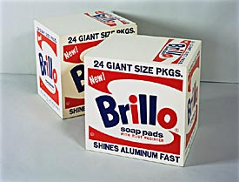

Warhol, Andy (1964) “Brillo Box”
This sculpture optimises what artists at the time were trying to do and Warhol’s piece was accompanied with its fair share of controversy. It was indifferent to its counterpart that was being sold to consumers at various supermarkets every day, and its simplicity is something the critics disliked. Despite this, many argued that this qualifies as an artwork due to its overall understanding and conveying of the theory of art, which is why many consider Warhol one of arts great philosophers.
Consumerism in art was slowly beginning to form through the likes of this piece and alongside it the world of what was considered to be ‘low culture’ was growing. This is the evident in the quote from art critic and close friend of Warhol’s, Arthur Danto (2010) who stated that “My theory is that when there is a period of deep cultural change, it shows up first in art.” in his book ‘Andy Warhol (Icons of America)’. Art was starting to become more accessible to the masses through things such as the ‘The Picture Post’ newspaper as it was filled with artworks that reflected the views and opinions of this changing culture, moving it away from being something exclusive to that of the people.

Whilst the likes of Andy Warhol were making a name for themselves in the galleries, art began to move into the streets in the form of graffiti. It first entered the arena of art as political protest. It was a demonstration of individual expressionism at the times of the 1960’s counter culture, when the masses felt ignored in regard to race, education, gender, war, etc. Although it originated at this time, graffiti wasn’t a widely known art form until around 1971 when street artist Taki 183 was interviewed by the New York times and youths started to copy him, which led to an explosion in the world of graffiti. Mostly, people would write their names/nicknames/initials on any surface they could find including subway carriages, monuments and billboards with spray paint as seen in the BBC documentary “Watching my name go by” (1967).

One of graffiti’s biggest names is Jean- Michel Basquiat, an African-American artist who rose to fame in the 1980’s and moved graffiti into the world of high culture. Despite his works appearance and its low cultural background, Basquiat himself was well educated up to the age of 17 and took his artistic influence from many visits he made to museums and galleries with his mother. At the age of 20 he started to sell work and gained fame within the New York Community, before being supported by galleries to produce works on canvas. It is for these reasons that many argue that his work has always belonged to the higher culture and that he had a hidden agenda to manipulate societies associations of culture in order to gain fame and fortune.
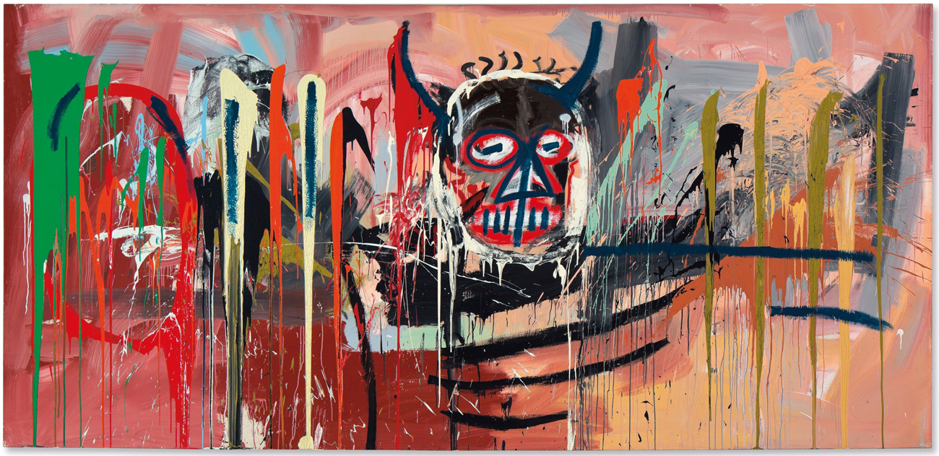

‘Untitled (1982) by Jean- Michel Basquiat

Many of his paintings expressed the weird and wonderful culture of New York combined with patterns and imagery from African, Aztec and Hispanic heritages. This resulted in a very abstract final image full of expression and personality which is what earnt him his acclaim. From looking at his piece “Untitled (1982)” we can see that the way the piece is constructed using broad and messy strokes, lends itself to low cultural influences of urban street art. However, making a successful piece of street art is more difficult than it appears, and it requires a level of technique and skill as discussed in the short film “Capturing a culture” by Henry Chalfant, which means that by having a skill that’s hard to replicate their work becomes more unique and a part of the high culture art scene.

Despite his works low cultural appearance, Basquiat was given his own solo exhibition in 1982 and this piece broke auction records, selling at a whopping $57.3 million in 2016, proving just how influential his artwork was to the history of art itself. It also shows his links to the world of high culture through the means in which it was sold and the price it was sold for.
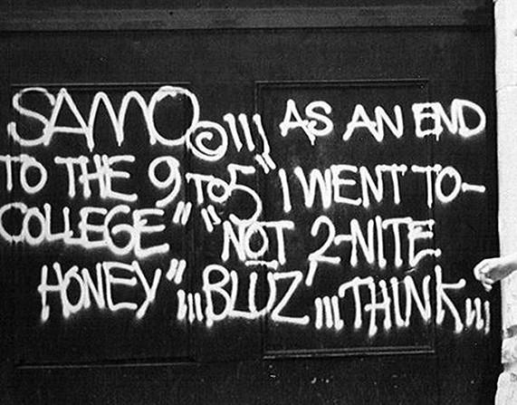

“SAMO” Original Ink

Before becoming a self-proclaimed artist, Basquiat was a key member in the art group SAMO. Alongside artist Al Diaz, they went along and created an identity that challenged the views held by society. It gave individuals like them a chance to establish a reputation without having to have an education. In regard to why he started to create graffiti, Al Diaz stated that “Before people would go around writing gang names, such as ‘Sharks’ or ‘Jets’, but this was all about ‘you’. And I was looking for an identity.” SAMO was initially introduced to the world in the form of a comic style magazine, appealing to the low cultured members of the population, until it gained interest from a wider, higher cultured audience who viewed it as a form of artistic expression. In an interview for the ‘Village Voice’ in 1978, Basquiat stated that they “Can’t stand on the sidewalk all day screaming at people to clean up their acts, so we write on walls.” They were fed up of being ignored by the people who could combat the issues they faced and used art to express this.

The statements they were making about the cultural divide in both New York and across the states in their artwork resulted in it crossing the boundaries between what is considered a piece of high or low culture art. The messages and medium in which it is constructed fit with that of a low culture, but the value and uniqueness it holds are associated with the more elitist world of art. This style and approach to creating art has gone on to influence many artists including the likes of the illusive Banksy, who has made his career commenting on issues regarding politics, religion and gender through the use of the humble spray can.
Art itself has been built upon the foundations of expression, individuality and emotion. It also retains the ability to capture significant moments in time, whilst still managing to convey all of this to the viewer in a seamless manner. It can show strong links to history, religion, and gender, but most artwork is influenced by culture. After looking at examples of work from a range of different artists that were prominent in the mid 19th century, it is clear that this is when the perceptions of high and low culture in art began to change. Society started to view what used to be considered a low art form as having a level of skill in its creation and it was appreciated and considered as an artwork.

However, as the world of art started to grow to include these previously outcast artworks, they became less accessible to the public through gallery placement and many artists started to gain fame and fortune, leaving behind their true intentions for creating art in the first place for a place within high culture. From this exploration, what was once two clear sides of a fence, has merged into what we consider to be culture today.

This short but ever important period of time helped establish that fact that nothing is fixed, culture can be defined in a number of different ways, and artwork can have a place in both a high and low culture when it is looked at with the consideration of a plethora of different contexts.

Bibliography

- Cambridge University Press (1995), Cambridge Dictionary, Cambridge, Cambridge University Press
- Wordpress, (2018), High Culture Vs Low Culture. [Online] Available at: https://irdefense22012.wordpress.com/2014/07/11/high-culture-vs-low-culture/ . [Accessed 26 November 2018]
- Duchamp, Marcel (1917,1964) ‘Fountain’
- Koch, Stephen (1991), Stargazer: The life, World and Films of Andy Warhol, Marion Boyars Publishers Ltd; 3rd Revised Edition
- Wikipedia, (2018). ‘Appropriation (art’). [Online] Available at : https://en.wikipedia.org/wiki/Appropriation_(art). [Accessed 13 November 2018]
- The Guardian (2016), ‘Factory Records: Andy Warhol’s 1960’s captured by Stephen Shore – in pictures.’ [Online] Available at: https://www.theguardian.com/artanddesign/gallery/2016/dec/23/andy-warhol-factory-1960s-stephen-shore-photographs. [Accessed 21 November 2018]
- Warhol, Andy (1964), “Brillo Box (Soap Pads)’
- Danto, Arthur (2010), ‘Andy Warhol (Icons of America)’, Yale University Press
- Warhol.org (2018), ‘Brillo: Is it Art?’ [Online] Available at: https://www.warhol.org/lessons/brillo-is-it-art/. [Accessed 27 November 2018)
- Hamilton, Richard (1957), ‘Quote of the day – Richard Hamilton’, [Online] Available at: https://brookoverfinearts.wordpress.com/2013/10/01/quote-of-the-week-richard-hamilton/. [Accessed on 27 November 2018]
- Basquiat, Jean-Michel (1982), “Untitled (1982)”
- BBC, (1976), “Watching my name go by”
- Diaz, Al (2017), ‘Dazed Digital: The story of SAMO, Basquiat’s first art project’ [Online] Available at : http://www.dazeddigital.com/art-photography/article/37058/1/al-diaz-on-samo-and-basquiat. [Accessed on 3 December 2018]
- Flaflick, Phillip (1978), ‘Village Voice – SAMO Graffiti: BOOSH-WAH or CIA?’
- Artnet.com (2018), ‘Jean-Michel Basquiat’, [Online] Available at: http://www.artnet.com/artists/jean-michel-basquiat/biography. [Accessed on 3 December 2018]

