
A critical evaluation of the role of digital innovation in professional practice
Digital Innovation and Professional Practice
Elanor Alun | 30 May 2023 | 4612 Words

Contents
1 Introduction 1
2 Literature Review 1
2.1 Successful Learning 1
2.2 Technology-Enhanced Learning (TEL) 3
2.3 Quality and Efficacy 5
2.4 Ethics 6
2.5 Online Learning 6
3 Tool Development 8
3.1 Selection 8
3.2 Practical Application 11
3.3 Evaluation 12
4 Conclusion 16
5 References 18

Figure 1. Top learning tools in 2022 (Hart, 2022) 3
Figure 2. The TPACK Framework applied to the tool 10
Figure 3. Screenshots of the MDK in development. 11
Figure 4. Student opinions on the MDK 14
Figure 5. Students' self-reported learning outcomes 15

Table 1. Links to resources 12
Table 2. Professional Standards included in the session 13

Introduction
In 2020, the global COVID-19 pandemic forced the entire field of education online, with varied results (Caldarulo, Mossberger and Howell, 2023; Fütterer et al., 2023). This highlighted numerous elements of blending digital innovation with professional practice; sometimes good (e.g. widening provision to those unable to access traditional education), and sometimes bad (e.g. reducing access via uneven technology provision) (Horrigan, 2020; Li and Lalani, 2020; Caldarulo, Mossberger and Howell, 2023). Researchers are still exploring these impacts, but it has arguably brought the relationship between digital innovation and pedagogy into the limelight more strongly than ever before.
However, this is a vast and long-studied field beyond the pandemic, with huge variety in educational digital tools (Hart (2022); also enshrined in professional standard K4, on the use and value of learning technologies; Higher Education Academy (HEA) (2011)). It has been recognised for years that technology-enhanced learning (TEL) offers pedagogical opportunities that were previously limited or impossible – computer models that can explore real-world research questions, for example, or tools for distance collaboration (Beetham, 2019). By now, simple substitution of analogue tools for technology has become common globally (Mishra, Koehler and Harris, 2009; Sung, Chang and Liu, 2016; Hillmayr et al., 2020), but teachers rarely exploit the full potential of a specific technology (Mishra, Koehler and Harris, 2009; Backfisch et al., 2021). However, fundamentally, the purpose of education is learning; this means that, whatever tool is selected and used, it may be considered successful as long as it supports this learning (Gebre, Saroyan and Bracewell, 2014; Beetham, 2019; Fütterer et al., 2022).
This paper will critically examine the role of digital innovation in educational practice, with a particular focus on supporting learning and some ethical considerations. It will also seek to develop and deploy a digital tool, and evaluate its efficacy in a genuine lesson using the ERA framework (Jasper, 2013).

Literature Review

Successful Learning
To establish the impact of digital innovation on pedagogy, it is first necessary to lay out a definition for what is considered “good pedagogy”. Research in this field is extensive, but of particular use here may be the ICAP (Interactive, Constructive, Active, Passive) hypothesis, which describes a descending scale of student engagement with learning materials; the higher on the scale, the more learning takes place (Chi and Wylie, 2014). ICAP has proven viable in classroom settings, not just laboratory studies, and is presently assumed to apply to both technology-enhanced and analogue learning (Fütterer et al., 2022; Wekerle, Daumiller and Kollar, 2022).
This engagement is important, because a crucial element of successful learning is cognitive activation: the extent to which a student is motivated to engage with deep processing during learning (Seidel and Shavelson, 2007; Baumert et al., 2010; Fütterer et al., 2022, 2023). Learning activities that promote this are those that encourage reflection, problem-solving, decision-making or knowledge integration, and by using these, students develop a sustainable learning process (Klieme, Pauli and Reusser, 2009; Lipowsky et al., 2009; Baumert et al., 2010; Kunter et al., 2013). This is also supported by professional standards A1, A4 and K2, all of which are concerned with developing and delivering appropriate learning activities and methods (HEA, 2011). In principle, ICAP therefore explains well why technology enhances learning: in the literature there is an attested increase in short-term (and possible long-term) engagement when novel technologies are used (Ainley, Enger and Searle, 2008; Blumenfeld, Kempler and Krajcik, 2012; Zhu and Urhahne, 2018; Mayer, 2019; Fütterer et al., 2022), which triggers cognitive activation.
A handful of analytical frameworks supplement this. SAMR (Substitution, Augmentation, Modification, Redefinition; an increasing scale of innovation) (Puentedura, 2006) assesses how well a technology is applied to learning activities to enhance these deep-level learning processes (Hughes, Thomas and Scharber, 2006; Hamilton, Rosenberg and Akcaoglu, 2016; Hilton, 2016; Geer et al., 2017; Choi and Lam, 2018), though it is important to remember the benchmark used. This should never be whether the technology has been employed to its fullest unique potential, but whether or not it induced cognitive learning (Fütterer et al., 2022).
A more practice-focused framework is TPACK (Technological, Pedagogical and Content Knowledge); if a teacher must focus on how to use technology to support and enhance students’ learning processes, they need competent technological-pedagogical knowledge (Mishra and Koehler, 2006; Koehler, Shin and Mishra, 2011; Lachner, Backfisch and Stürmer, 2019; Hillmayr et al., 2020). As such, the promotion of technological skills training should be a priority for institutions (Fütterer et al., 2022), which also aligns with professional standard A5 on continuing professional development (HEA, 2011).

Technology-Enhanced Learning
Available tools for TEL are extensive and diverse. The Top Tools for Learning Survey has been running since the mid-2000s, and annually collates data from educators to produce yearly lists of most-used EdTech (Hart, 2023). At its peak in the COVID-19 pandemic it recorded 300 separate tools; in 2022, however, this was reduced to 100 (see Fig. 1), as educators appeared to consolidate their preferred tools after a COVID-iniced period of experimentation (Hart, 2022). There are numerous ways to categorise EdTech tools (Kharbach, 2022; TeachThought Staff, 2022), but Hart (2023) uses five groups: Office tools and suites, content development, learning tools and platforms, social and collaboration platforms, and web tools and platforms. This range in applications illustrates well the variety of practices under the EdTech umbrella. Many tools may fall into more than one; Mentimeter, for example, is a learning tool thanks to its quizzes, and a social/collaborative tool thanks to its live engagement abilities (Mentimeter, 2023).
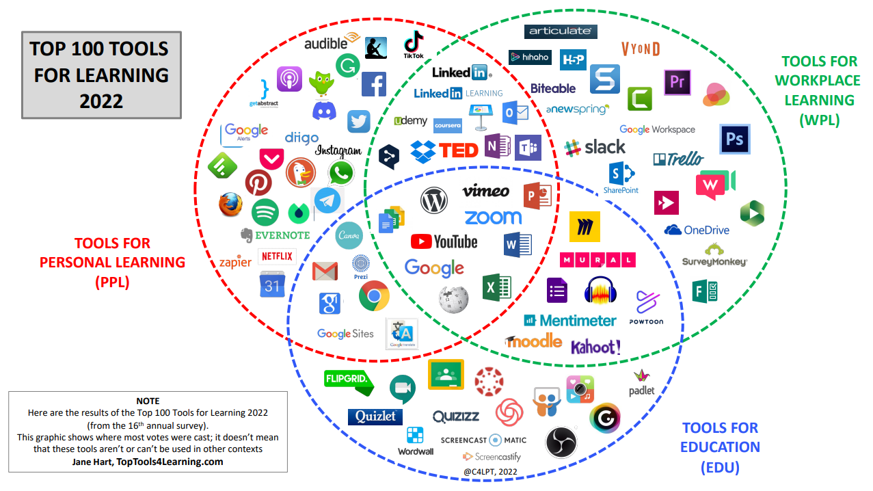
Figure 1. Top learning tools in 2022; note those contained in the education circle (blue) (Hart, 2022)
Institutions are increasingly offering digital literacy as a graduate attribute (ECORYS, 2016; Sharpe and Armellini, 2019), so logically, there is increasing demand for these digital tools and resources to be used in learning activities where possible and relevant (Beetham, 2019); additionally, professional standard K4 encourages the use of appropriate learning technology (HEA, 2011). The Insights Survey was carried out in 2018, which asked some 37,000 students to name digital activities they had found “really helpful” (Newman and Beetham, 2018). This resulted in the authors suggesting Bloom’s taxonomy – traditionally focused on individual cognition, and so ignoring collaborative outcomes – should be expanded into two broad areas:
- “Preparing to Learn”: the ability that stems from digital tools to learn flexibly, track grades, manage notes and references, etc
- “Learning with others”: the ability that stems from digital tools to learn and work collaboratively
This suggests, however, that TEL is particularly well-suited to developing collaborative learning in a way that traditional analogue learning can’t match. Other areas found to be enhanced by digital tools are curating materials, and writing/production; if students are connected, this could be either individual or collective (Newman and Beetham, 2018; Beetham, 2019).
Finally, the use of mobile devices for TEL has risen; the technology was initially expensive and fragile, but over the last two decades it has become cheap, robust and ubiquitous (Kukulska-Hulme and Traxler, 2019). Learning design used to be focused around procuring and deploying devices by institutions (Cuban, Kirkpatrick and Peck, 2001; Hennessy, Ruthven and Brindley, 2005; Hew and Brush, 2007; Hall, 2010; Cheung and Slavin, 2013; Hsu and Kuan, 2013; Kim et al., 2013; Ifenthaler and Schweinbenz, 2016; Sung, Chang and Liu, 2016; Hu et al., 2018; Bergdahl et al., 2020); now, it focuses on exploiting the plethora of (often free) online resources available (Kukulska-Hulme and Traxler, 2019). The technology has, in fact, evolved faster than the research into its pedagogical application, so design for its use in learning activities currently has few stable reference points (Kukulska-Hulme and Traxler, 2019).
However, it does seem to offer a wealth of advantages. Mobile learning is learner-focused, good for situated, practice-based settings (e.g. problem solving, learning “in the field”, etc), and has good applications to accessibility as it can accommodate preferred learning approaches, diversity of needs/experiences, etc (Naismith et al., 2004; Rodríguez- Fórtiz, Fernández-López and Rodríguez, 2011; Kukulska-Hulme and Traxler, 2019; this also chimes with professional standard V2, promoting equality of opportunity for learners (HEA, 2011)). They also aid in communication and data-sharing for collaborative learning; but, it should be noted that they have a less illustrious side. For one, teachers are less able to police mobile networks if interpersonal struggles arise between learners (Kukulska-Hulme and Traxler, 2019); for another, they offer accessibility challenges as well as solutions (see Section 2.4 below.)

Quality and Efficacy
So how effective is this digital innovation in practice?
The answer is not straightforward. Professional standard V3 requires evidence-based approaches (HEA, 2011), but credible research in this field is in fact limited – a huge amount of studies found have design flaws (e.g. no control groups, cross-sectional designs, short study periods, etc), and results between educational fields (or indeed between studies) are often thusly incomparable (Fütterer et al., 2022). Of those there are, there has been a focus on frequency of technology use as a benchmark, rather than quality (Cuban, Kirkpatrick and Peck, 2001; Hennessy, Ruthven and Brindley, 2005; Hew and Brush, 2007; Hall, 2010; Cheung and Slavin, 2013; Hsu and Kuan, 2013; Kim et al., 2013; Ifenthaler and Schweinbenz, 2016; Sung, Chang and Liu, 2016; Hu et al., 2018; Bergdahl et al., 2020). These studies have revealed large variation in effect sizes if not outright contradictions; sometimes technology use is positively associated with learning outcomes (Cheung and Slavin, 2013; Sung, Chang and Liu, 2016; Zheng et al., 2016; Hillmayr et al., 2020), sometimes not (Campuzano et al., 2009; Drijvers et al., 2014; Perry and Steck, 2015), and sometimes a mix (Haßler, Major and Hennessy, 2016; Major, Haßler and Hennessy, 2017).
These mixed results suggest that frequency alone is not an indicator of technological impact. It is increasingly assumed that the quality of technology use is more important than frequency or any other metric (Mayer, 2003; Lei and Zhao, 2007; Schmid et al., 2009; Tamim et al., 2011; Kim et al., 2013; Petko, Cantieni and Prasse, 2017; Hu et al., 2018; Hillmayr et al., 2020; Backfisch et al., 2021). Some authors take “quality” to mean the method of integration (Lei and Zhao, 2007; Petko, Cantieni and Prasse, 2017), and frameworks like SAMR do indicate that higher level technology integration is associated with increased learning; but this has not been directly tested (Hamilton, Rosenberg and Akcaoglu, 2016; Fütterer et al., 2022). However, as outlined above, a more valuable metric is arguably whether or not the technology induced cognitive activation, such as according to the ICAP framework (Chi, 2009; Chi and Wylie, 2014; Fütterer et al., 2022). ICAP also offers a plausible explanation for why higher technology use seems to be associated with higher cognitive processing; TEL aids with setting open-ended tasks that encourage students to think, and thus induce cognitive learning (Fütterer et al., 2022; Wekerle, Daumiller and Kollar, 2022; Wong and Liem, 2022).
These same results, however, can often be achieved through analogue means (Daumiller and Kollar, 2022; Wong and Liem, 2022); Baker et al. (2018)’s meta-analysis of 48 studies assessing use of PowerPoint vs traditional chalk-and-talk found no difference regarding cognitive learning outcomes (e.g., grades, test scores) between the methods. This illustrates again that the technology itself should not be the benchmark; the learning should.

Ethics
While technology offers many opportunities to increase accessibility, this can be a double-edged sword. Millions of students being transitioned into distance learning during covid highlighted concerns over the digital accessibility gap (Horrigan, 2020; Li and Lalani, 2020); for example, geographic broadband disparities in the US are stratified along historic and present-day racial and socio-economic lines, which affects long term educational attainment and opportunity (DiMaggio and Bonikowski, 2008; Hampton et al., 2021; Mossberger, Tolbert and LaCombe, 2021). A study that examined learning outcomes after free broadband provision found broadband adoption was associated with higher academic results in maths and reading/language arts at US county levels (though not equally), and the results were higher for Black, Latino and low-income students than they are for their white or more affluent counterparts (Caldarulo, Mossberger and Howell, 2023).
Meanwhile, mobile phones may now seem ubiquitous, and offer superb opportunities for collaborative, interactive elements in class – but not all students will necessarily have a compatible device, thanks to income disparities (Naismith et al., 2004). There are clear potential issues to requesting mobile use from a class, if this forces a disadvantaged student to disclose their income status (Naismith et al., 2004; Rodríguez-Fórtiz, Fernández-López and Rodríguez, 2011; Kukulska-Hulme and Traxler, 2019). This potentially clashes with professional standard V2, as it inhibits equality of opportunity for learners without careful planning (HEA, 2011).
Student familiarity with technology would seem to be an important consideration also, but Fütterer et al. (2023) found it had no effect on student outcomes after the pandemic. However, this is an understudied area.

Online Learning
Finally, any discussion of technology and education should include online learning. Online and blended learning are, of course, not technology-enhanced as much as technology-enabled; as was seen during the pandemic, the education could not take place without it. However, it has different requirements from the analogue classroom, both in terms of the behavioural management of teachers and students, the methods of delivery, and the integration of additional digital tools (Edwards, Perry and Janzen, 2011; Xu, Chen and Chen, 2020; Young, 2020; Mahmood, 2021).
Crucial to a course (both for learning and for behavioural management) is the sense of belonging that learners have; the community they form, that makes them feel safe to participate, and to collaborate to solve problems (Edwards, Perry and Janzen, 2011; Bennett et al., 2019; Cleveland-Innes, 2020; Xu, Chen and Chen, 2020; Mahmood, 2021). Online, opportunities for student interaction must be a priority (Bennett et al., 2019). This is not a new concept, in fact. As early as the late 90s, educators were applying the Community of Inquiry (CoI) framework – the formation of a group of learners, who are collaboratively seeking solutions to an inquiry – to online and blended learning (Cleveland-Innes, 2020). In practice, this means making particular use of interactive tools. A true CoI can only be formed with commitment from the participants; the most important element for an online community is a space for text-based discussions (Garrison, Anderson and Archer, 2010). Cognitive – and metacognitive - activity can be significantly fostered by forums, which can be used to facilitate thoughtful and reflective online communication between students (Clark Green, 2005; Akyol and Garrison, 2011). Participants in online courses were surveyed to identify exemplary online educators, and described such teachers as challengers, affirmers and influencers (Edwards, Perry and Janzen, 2011). The CoI process provides a good “influencer” teaching template (Cleveland-Innes, 2020).
As a final point, the ubiquity of the internet itself should be considered. Daoud et al. (2020)’s meta-analysis found that home internet access has a positive effect on educational outcomes for children, although this is correlational and dependent on use; some studies found that internet can distract students from schoolwork (Choi et al., 2009; Kirschner and Karpinski, 2010; Malamud, Pop-Eleches and Research, 2010; Feng et al., 2019). However, many are increasingly finding that even non-educational use increases reading, language and cognitive skills, thus providing educational benefit (Jackson et al., 2011; Silber-Varod, Eshet-Alkalai and Geri, 2019; Hampton et al., 2021).

Tool Development

Selection
I teach on the BSc Environment, Sustainability and Climate Change course in University of Wales, Trinity St David (UWTSD). As part of this course, students learn key skills in ecological surveying, and one of these is basic tree species identification.
This can be a difficult area for the students to learn, as it requires a lot of technical information about ID features that needs to be married to practical field experience (Kirchoff, 2014). Traditionally, this is achieved in taxonomic courses by means of a formal lecture giving key ID information on each target species, followed by a practical trip into the field to attempt identification; this initial lecture is often dry and non-interactive, making it difficult to maintain engagement (Vizard, 2012; Dixon et al., 2019; Babik and Luther, 2020; Knowles et al., 2020) and clashing with how students learn best (professional standard K3; HEA, 2011). One option to “get to the practical bit quicker” is providing students with dichotomous keys (DKs) and encouraging their use against example branches or in the field (Krasna, 2010; Stagg and Donkin, 2013; Anđić et al., 2021; Nagwa, 2023). However, commercially available DKs are jargon-heavy and list a high amount of information for each species; what I want to provide the L4 students with is something much simpler, with beginner-friendly terminology, that uses ID tips and tricks that I personally have gathered over the years in my own industry practice. This will make the learning more appropriate to their level and subject area, in accordance with standard K2 (HEA, 2011).
In terms of pedagogy, this is a field that requires a constructivist approach, as it requires learners to build knowledge (ID skills) based upon experience (correctly identifying organisms) (Anđić et al., 2021); constructivism has been shown to be effective at adopting and linking acquired knowledge (Muis and Duffy, 2013; Beerenwinkel and von Arx, 2017; Barger et al., 2018). Technology-enhanced constructivist learning has also been successfully demonstrated in biological education (Ananiadou and Claro, 2009; Mouza and Barrett-Greenly, 2015; Anđić et al., 2021), and there is evidence that university students acquire more knowledge from mobile constructivist learning, foster better cooperation skills, and increase their competence (Al Hamdani, 2014; Anđić et al., 2019).
Mobile dichotomous keys (MDKs), too, have a positive track record of use over their printed counterparts (PDKs). The SAMR framework, at first glance, seems to position them as simple substitution, but research suggests they better fit the augmentation bracket; while providing the same mechanism and information as a PDK, MDKs increase student motivation (Jeno, Grytnes and Vandvik, 2017), provide better and longer-lasting knowledge acquisition (Anđić et al., 2019), and can be used in both the classroom and the field (Campbell et al., 2011).
In the name of designing a successful learning activity, in accordance with how students learn, using an an evidence-based approach to select an appropriate technology (professional standards A1, K3, V3 and K4 respectively; HEA, (2011)) I therefore opted to create an MDK of my own. The aim was to develop a tool that could be used in both the lab against example branches and in the field against living trees, so I primarily needed a smartphone-compatible platform (as previously discussed (Section 2.2), mobile technology suits practical learning (Kukulska-Hulme and Traxler, 2019)); with that said, however, given potential accessibility issues (see Section 2.4), I wanted something that could be used on a computer or tablet if necessary as well. I reasoned that I needed something like a digital survey or questionnaire, which could be manipulated to direct to specific questions based on the answers the user gave. I therefore chose Google Forms, as it was free, easy to set up and access from a phone or computer, and could be formatted to suit these needs. It can also support photographs, to make identification easier.
Figure 2 shows how the MDK fits into the TPACK framework, and its three fundamental areas of knowledge.
As mentioned (see Section 2), the benchmark for successful technology integration is not the technology itself, but the quality of the learning – the cognitive activation – that takes place. The ICAP framework holds that deep cognitive activation is best achieved through interactivity and problem-solving; the act of applying knowledge to a novel situation to find the solution (Chi and Wylie, 2014; Fütterer et al., 2022). By providing the students with a tool that allows them to immediately investigate a branch or tree to find their own solution, I believe I am achieving this. This is particularly true as the MDK will only ever take a student so far; sooner or later a learner will encounter a specimen that seems to fit into several brackets. The tool allows them to explore these different potential options and ultimately make an educated judgement call, which I can then provide feedback on (professional standard A3; HEA, 2011).

TPK: The MDK allows more interactivity, and lets the students problem-solve
TCK: The MDK allows the students to practice ID for themselves quickly and easily
PCK: DKs encourage interactivity and increase knowledge acquisition

Figure 2. The TPACK Framework applied to the tool

Practical Application
The MDK was used as part of a taught session on tree identification on the 15th May 2023. Figure 3 displays screenshots of its development; Table 1 contains links to the developed resources, and the lesson plan of the session.

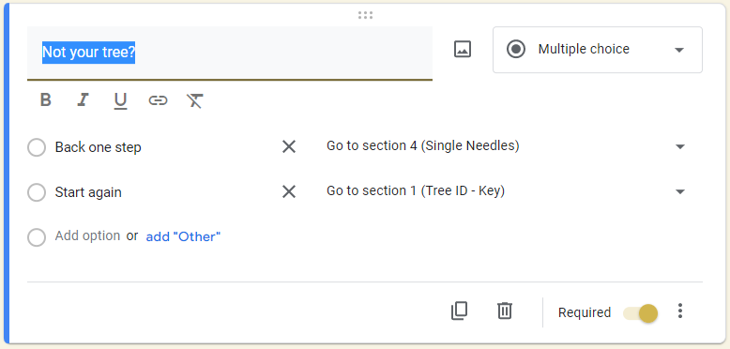
Figure 3. Screenshots of the MDK in development. Crucial to its suitability was the ability to direct learners to specific questions based on answers (top), and to ensure each question was 'required' (bottom)

Table 1. Links to resources
Resource | Link
Lesson Plan
MDK | https://forms.gle/pWiLX3ne5URfeFTv5
Prezi Slides | https://prezi.com/view/QrCPbY9flgP0bD7GmT63/

Evaluation
The following is evaluated using the ERA reflective model (Jasper, 2013).
The session worked well (see Table 1 for the lesson plan) with all learning outcomes being met, and encompassed multiple professional standards (HEA, 2011). See Table 2 for a list of these.
The tool will ultimately be used with level 4 (L4) students studying BSc Environment, Sustainability and Climate Change, but owing to timing issues with the academic year, the session was delivered to L6 education students. While their botanical expertise matched the target demographic, it should be noted that their predisposition to analyse pedagogic tools and techniques may have influenced the results.
However, the feedback from the students was unanimously positive. All reported that they enjoyed using the app, found it easy to use and navigate, and would want to use it again (see Figure 4); one student requested permission to use it in her personal life! This is in line with previous findings in the literature, which consistently report that MDKs significantly increase student motivation and attitudes, including for acquiring botanical knowledge specifically (Huang, Lin and Cheng, 2010; Silva et al., 2011; Al Hamdani, 2014; Jeno, Grytnes and Vandvik, 2017; Laganis, Prosen and Torkar, 2017; Anđić et al., 2021).

Table 2. Professional Standards included in the session
Standard(s) | Application
A3: assess and give feedback to learners | Throughout the session I gave learners feedback on if their identification was correct or not, and helping them see where they mis-stepped.
A5: engage in CPD in subjects and their pedagogy  K2: appropriate methods for learning in the subject area  K4: the use and value of appropriate learning technologies | This is a brand new tool I made myself, designed to better teach identification skills.
V3: use evidence-informed approaches from research and scholarship | Research has shown digital keys promote learning AND student attitudes and engagement
V4: acknowledge the wider context in which HE operates recognising the implications for professional practice | At the start of the session, I explained that there is a lack of ID skills among environmental workers currently, so this is a vital area to fill.

The eventual lesson the MDK will be used in will be much longer than the session carried out here, and will involve a lengthy trip into the field to try out the tool on whole trees. This will allow me to better assess how well the students acquire the knowledge without using the MDK each time, something I was less able to do here (in opposition to professional standard A3, on assessing and feeding back to learners (HEA, 2011). However, there were positive indicators for its pedagogical results. Students swiftly learned the use of the tool and were able to rapidly identify the branches given, with a very high success rate; the overwhelming majority were correctly identified, and my guidance was extremely minimal. In feedback, students reported that by the end of the session, short though it was, they could all distinguish the relevant ID features, and several had learned at least one species without any need for the MDK (see Figure 5).

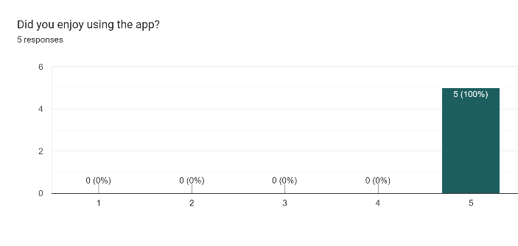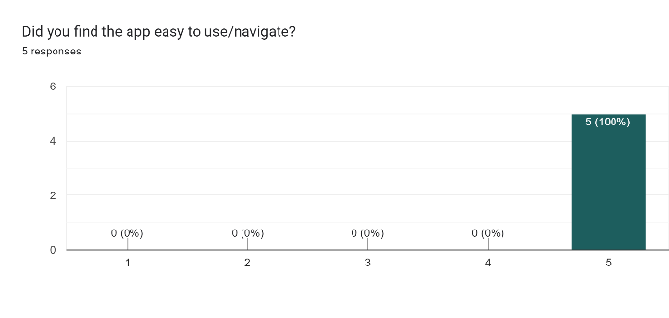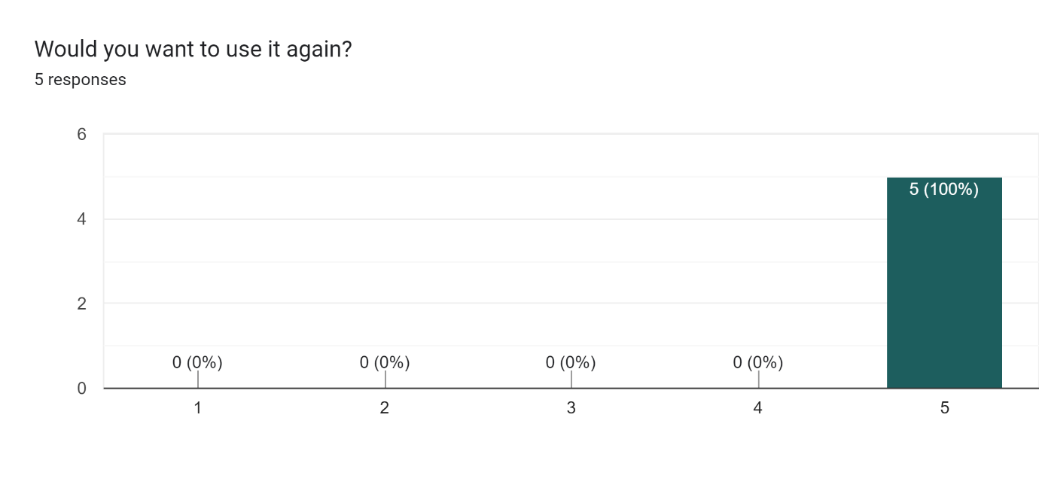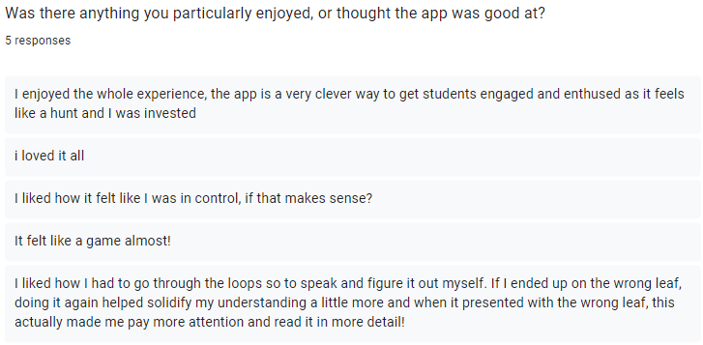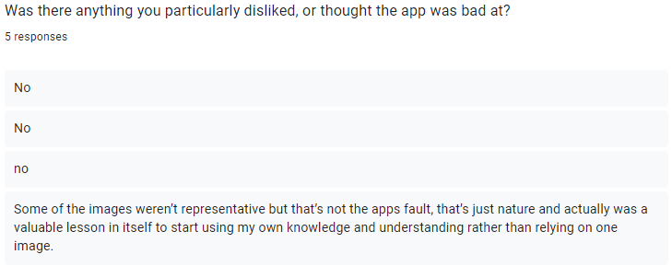
Figure 4. Student opinions on the MDK

This is encouraging news; as previously discussed, the measurement for success is not the tool itself, but the learning (see Sections 2.1 and 2.3). In this case, the ultimate learning aim is for the students to adopt new botanical knowledge and be able to link it to each new branch or tree, something greatly aided by the constructivist approach I chose (Muis and Duffy, 2013; Beerenwinkel and von Arx, 2017; Barger et al., 2018); although, the eventual longer session the tool is destined for will be redesigned to lean into this more (supported by professional standard A1, to design and plan learning activities (HEA, 2011)). In particular, there are five main constructivist principles: eliciting prior knowledge, exploring new content, creating cognitive dissonance, applying knowledge from feedback, and reflecting on learning (Windschitl, 2002; Baviskar, Todd Hartle and Whitney, 2009; Anđić et al., 2021). Future sessions will be structured to offer a small selection of branches first, followed by a feedback period of revealing the identified branches, followed by a new larger phase of identification to put the learners’ new experiences into practice, in order to better capitalise on point 4. This will then be taken into the field.
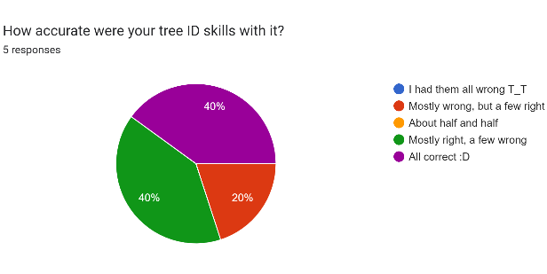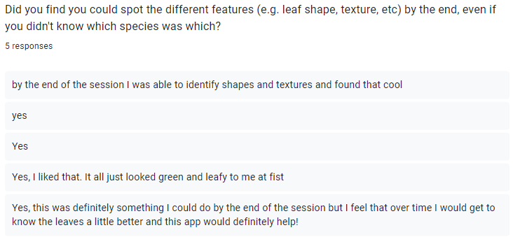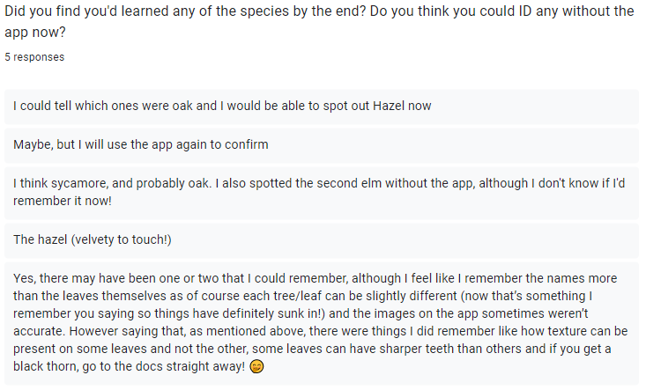
Figure 5. Students' self-reported learning outcomes

Regardless, the tool – and session – did encourage suitable cognitive activation, as espoused by the ICAP framework. ICAP uses several underlying assumptions: that invisible cognitive learning is linked to visible learning activities (here, the use of the MDK); that the scale from passive to interactive also reflects increasing student learning effort (seemingly borne out by the feedback); and that higher levels subsume lower levels (e.g. a constructive activity is therefore ALSO both active and passive) (Chi and Wylie, 2014; Fütterer et al., 2023). Here, the session was highly interactive, as the students were identifying the branches themselves and recording their comprehension. It was also passive, as they were receiving information from the MDK; active, as they were acting on that information; and constructive, as they were comparing new information (features on the branches) with established knowledge (information from the MDK). Overall, the session encouraged knowledge integration and problem-solving, thus activating the deep processing that is crucial to learning (Seidel and Shavelson, 2007; Baumert et al., 2010; Fütterer et al., 2022, 2023). One student also described how they enjoyed the way that getting a wrong ID meant they could go back and properly re-assess the information to “solidify their understanding” (see Figure 4). This is interesting, as it taps into a long-studied aspect of deep learning: the ability to safely make mistakes, and learn from them (Ellis and Davidi, 2005; Ellis, Mendel and Nir, 2006; Forrest, 2013; Light, 2017).
There was one student whose smartphone was unable to open the MDK, owing to its age. Thanks to the size of the class, I simply lent my own phone to her; however, this needs consideration for future use, as requesting students use their own phones runs the risk of forcing them to disclose income disparity to the class (Naismith et al., 2004; Rodríguez-Fórtiz, Fernández-López and Rodríguez, 2011; Kukulska-Hulme and Traxler, 2019). I believe the answer to this will likely be to inform all students ahead of time over email that they will need to bring a suitable device to the session, and to alert me if theirs is incompatible. In this event, I could simply arrange the class so the students identify in pairs, meaning only one device is necessary; this will also incorporate more collaboration between learners, which can itself boost learning (Newman and Beetham, 2018; Bennett et al., 2019; Dixon et al., 2019; Kukulska-Hulme and Traxler, 2019; Race, 2020).

Conclusion
Overall, this was a highly successful venture. Digital tools possess enormous potential for enhancing pedagogy, and in the current climate are rapidly becoming ubiquitous; but, educators must ensure they are included to support learning, rather than for their own sake. In particular, the benchmark for quality should be whether or not the tool encourages deep cognition, as a crucial aspect of learning.
The tool developed performed exceptionally, and was extremely well-received by students. It allowed for a nigh-immediate interactivity that traditional methods do not, increased engagement and enthusiasm, and helped the students acquire the necessary knowledge and skills. With only minor tweaks to session structure, it is suitable for use in standard future curriculum.

References
Ainley, J., Enger, L. and Searle, D. (2008) ‘Students in a Digital Age: Implications of ICT for Teaching and Learning’, in International Handbook of Information Technology in Primary and Secondary Education. Available at: https://doi.org/10.1007/978-0-387-73315-9_4.
Akyol, Z. and Garrison, D. (2011) ‘Assessing metacognition in an online community of inquiry’, The Internet and Higher Education, 14(3), pp. 183–190.
Analytics Insight (2021) ‘EdTech’. Available at: https://www.analyticsinsight.net/wp-content/uploads/2021/01/EdTech.jpg (Accessed: 25 April 2023).
Ananiadou, K. and Claro, M. (2009) ‘21st century skills and competences for new millennium learners in OECD countries’, OECD Education Working Papers [Preprint], (41).
Anđić, B. et al. (2019) ‘The contribution of dichotomous keys to the quality of biological-botanical knowledge of eighth grade students’, Journal of Biological Education, 53(3). Available at: https://doi.org/10.1080/00219266.2018.1469540.
Anđić, B. et al. (2021) ‘Mobile and printed dichotomous keys in constructivist learning of biology in primary school’, Research in Science and Technological Education, 39(4). Available at: https://doi.org/10.1080/02635143.2020.1763290.
Babik, J.M. and Luther, V.P. (2020) ‘Creating and Presenting an Effective Lecture’, Journal of Continuing Education in the Health Professions, 40(1). Available at: https://academy.idsociety.org/sites/default/files/Creating_and_Presenting_an_Effective_Lecture.pdf (Accessed: 1 February 2023).
Backfisch, I. et al. (2021) ‘Variability of teachers’ technology integration in the classroom: A matter of utility!’, Computers and Education, 166. Available at: https://doi.org/10.1016/j.compedu.2021.104159.
Baker, J.P. et al. (2018) ‘Does teaching with PowerPoint increase students’ learning? A meta-analysis’, Computers and Education, 126. Available at: https://doi.org/10.1016/j.compedu.2018.08.003.
Barger, M.M. et al. (2018) ‘Constructivism and personal epistemology development in undergraduate chemistry students’, Learning and Individual Differences, 63. Available at: https://doi.org/10.1016/j.lindif.2018.03.006.
Baumert, J. et al. (2010) ‘Teachers’ mathematical knowledge, cognitive activation in the classroom, and student progress’, American Educational Research Journal, 47(1). Available at: https://doi.org/10.3102/0002831209345157.
Baviskar, S.N., Todd Hartle, R. and Whitney, T. (2009) ‘Essential criteria to characterize constructivist teaching: Derived from a review of the literature and applied to five constructivist-teaching method articles’, International Journal of Science Education, 31(4). Available at: https://doi.org/10.1080/09500690701731121.
Beerenwinkel, A. and von Arx, M. (2017) ‘Constructivism in Practice: an Exploratory Study of Teaching Patterns and Student Motivation in Physics Classrooms in Finland, Germany and Switzerland’, Research in Science Education, 47(2). Available at: https://doi.org/10.1007/s11165-015-9497-3.
Beetham, H. (2019) ‘Learning Activities and Activity Systems’, in H. Beetham and R. Sharpe (eds) Rethinking pedagogy for a digital age: principles and practices of design. 3rd edn. Oxon: Routledge.
Bennett, L. et al. (2019) ‘Learning and teaching with technology’, in J. Avis, R. Fisher, and R. Thompson (eds) Teaching in lifelong learning: a guide to theory and practice. 3rd edn. London: Open University Press, pp. 165–180.
Bergdahl, N. et al. (2020) ‘Engagement, disengagement and performance when learning with technologies in upper secondary school’, Computers and Education, 149. Available at: https://doi.org/10.1016/j.compedu.2019.103783.
Blumenfeld, P.C., Kempler, T.M. and Krajcik, J.S. (2012) ‘Motivation and Cognitive Engagement in Learning Environments’, in The Cambridge Handbook of the Learning Sciences. Available at: https://doi.org/10.1017/cbo9780511816833.029.
Caldarulo, M., Mossberger, K. and Howell, A. (2023) ‘Community-wide broadband adoption and student academic achievement’, Telecommunications Policy, 47(1). Available at: https://doi.org/10.1016/j.telpol.2022.102445.
Campbell, K.R. et al. (2011) ‘Interactive online tools for teaching plant identification’, HortTechnology. Available at: https://doi.org/10.21273/horttech.21.4.504.
Campuzano, L. et al. (2009) ‘Effectiveness of Reading and Mathematics Software Products: Findings From Two Student Cohorts. NCEE 2009-4041.’, National Center for Education Evaluation and Regional Assistance [Preprint].
Cheung, A.C.K. and Slavin, R.E. (2013) ‘The effectiveness of educational technology applications for enhancing mathematics achievement in K-12 classrooms: A meta-analysis’, Educational Research Review. Available at: https://doi.org/10.1016/j.edurev.2013.01.001.
Chi, M.T.H. (2009) ‘Active-Constructive-Interactive: A Conceptual Framework for Differentiating Learning Activities’, Topics in Cognitive Science, 1(1). Available at: https://doi.org/10.1111/j.1756-8765.2008.01005.x.
Chi, M.T.H. and Wylie, R. (2014) ‘The ICAP Framework: Linking Cognitive Engagement to Active Learning Outcomes’, Educational Psychologist, 49(4). Available at: https://doi.org/10.1080/00461520.2014.965823.
Choi, K. et al. (2009) ‘Internet overuse and excessive daytime sleepiness in adolescents: Regular article’, Psychiatry and Clinical Neurosciences, 63(4). Available at: https://doi.org/10.1111/j.1440-1819.2009.01925.x.
Choi, P.M.S. and Lam, S.S. (2018) ‘A hierarchical model for developing e-textbook to transform teaching and learning’, Interactive Technology and Smart Education, 15(2). Available at: https://doi.org/10.1108/ITSE-12-2017-0063.
Clark Green, M. (2005) Factors influencing the process of critical thinking among health professional during computer conferencing: A case study . Athabasca University. Available at: https://auspace.athabascau.ca/handle/2149/527 (Accessed: 9 May 2023).
Cleveland-Innes, M. (2020) ‘The Community of Inquiry Framework: Designing Collaborative Online and Blended Learning’, Rethinking Pedagogy for a Digital Age: Principles and Practices of Design [Preprint].
Cuban, L., Kirkpatrick, H. and Peck, C. (2001) ‘High access and low use of technologies in high school classrooms: Explaining an apparent paradox’, American Educational Research Journal, 38(4). Available at: https://doi.org/10.3102/00028312038004813.
Daoud, R. et al. (2020) ‘The educational value of internet use in the home for school children: A systematic review of literature’, Journal of Research on Technology in Education, 53(4). Available at: https://doi.org/10.1080/15391523.2020.1783402.
DiMaggio, P. and Bonikowski, B. (2008) ‘Make money surfing the web? The impact of internet use on the earnings of U.S. workers’, American Sociological Review, 73(2). Available at: https://doi.org/10.1177/000312240807300203.
Dixon, L. et al. (2019) ‘Practical Teaching’, in J. Avis, R. Fisher, and R. Thompson (eds) Teaching in lifelong learning: a guide to theory and practice. 3rd edn. London: Open University Press, pp. 136–164.
Drijvers, P. et al. (2014) ‘The effect of online tasks for algebra on student achievement in grade 8’, Technology, Knowledge and Learning, 19(1–2). Available at: https://doi.org/10.1007/s10758-014-9217-5.
ECORYS (2016) Digital skills for the UK economy, Department for Business Innovation & Skills.
Edwards, M., Perry, B. and Janzen, K. (2011) ‘The making of an exemplary online educator’, Distance Education, 32(1), pp. 101–118.
Ellis, S. and Davidi, I. (2005) ‘After-event reviews: Drawing lessons from successful and failed experience’, Journal of Applied Psychology, 90(5). Available at: https://doi.org/10.1037/0021-9010.90.5.857.
Ellis, S., Mendel, R. and Nir, M. (2006) ‘Learning from successful and failed experience: The moderating role of kind of after-event review’, Journal of Applied Psychology, 91(3). Available at: https://doi.org/10.1037/0021-9010.91.3.669.
Feng, S. et al. (2019) ‘The Internet and Facebook Usage on Academic Distraction of College Students’, Computers and Education, 134. Available at: https://doi.org/10.1016/j.compedu.2019.02.005.
Forrest, G. (2013) ‘Questions and answers: Understanding the connection between questioning and knowledge in game-centred approaches’, in Contemporary Developments in Games Teaching. Available at: https://doi.org/10.4324/9780203797730.
Fütterer, T. et al. (2022) ‘Quality beats frequency? Investigating students’ effort in learning when introducing technology in classrooms’, Contemporary Educational Psychology, 69. Available at: https://doi.org/10.1016/j.cedpsych.2022.102042.
Fütterer, T. et al. (2023) ‘High-quality digital distance teaching during COVID-19 school closures: Does familiarity with technology matter?’, Computers & Education, 199. Available at: https://www-sciencedirect-com.ezproxy.uwtsd.ac.uk/science/article/pii/S0360131523000659#sec2 (Accessed: 3 May 2023).
Garrison, D., Anderson, T. and Archer, W. (2010) ‘The first decade of the community of inquiry framework: A retrospective’, The Internet and Higher Education, 13(1–2), pp. 5–9.
Gebre, E., Saroyan, A. and Bracewell, R. (2014) ‘Students’ engagement in technology rich classrooms and its relationship to professors’ conceptions of effective teaching’, British Journal of Educational Technology, 45(1). Available at: https://doi.org/10.1111/bjet.12001.
Geer, R. et al. (2017) ‘Emerging pedagogies for the use of iPads in schools’, British Journal of Educational Technology, 48(2). Available at: https://doi.org/10.1111/bjet.12381.
Hall, G.E. (2010) ‘Technology’s achilles heel: Achieving high-quality implementation’, Journal of Research on Technology in Education, 42(3). Available at: https://doi.org/10.1080/15391523.2010.10782550.
Al Hamdani, S.D. (2014) ‘A Constructivist Approach to a Mobile Learning Environment’, International Journal of Computer Applications, 93(4), pp. 41–61. Available at: https://doi.org/10.5120/16206-5500.
Hamilton, E.R., Rosenberg, J.M. and Akcaoglu, M. (2016) ‘The Substitution Augmentation Modification Redefinition (SAMR) Model: a Critical Review and Suggestions for its Use’, TechTrends, 60(5). Available at: https://doi.org/10.1007/s11528-016-0091-y.
Hampton, K.N. et al. (2021) ‘How variation in internet access, digital skills, and media use are related to rural student outcomes: GPA, SAT, and educational aspirations’, Telematics and Informatics, 63. Available at: https://doi.org/10.1016/j.tele.2021.101666.
Hart, J. (2022) Top 100 Tools for Learning 2022, Top Tools for Learning. Available at: https://toptools4learning.com/ (Accessed: 10 May 2023).
Hart, J. (2023) About, Top Tools for Learning. Available at: http://toptools4learning.com/about/ (Accessed: 11 May 2023).
Haßler, B., Major, L. and Hennessy, S. (2016) ‘Tablet use in schools: A critical review of the evidence for learning outcomes’, Journal of Computer Assisted Learning, 32(2). Available at: https://doi.org/10.1111/jcal.12123.
Hennessy, S., Ruthven, K. and Brindley, S. (2005) ‘Teacher perspectives on integrating ICT into subject teaching: Commitment, constraints, caution, and change’, Journal of Curriculum Studies, 37(2). Available at: https://doi.org/10.1080/0022027032000276961.
Hew, K.F. and Brush, T. (2007) ‘Integrating technology into K-12 teaching and learning: Current knowledge gaps and recommendations for future research’, Educational Technology Research and Development, 55(3). Available at: https://doi.org/10.1007/s11423-006-9022-5.
Hillmayr, D. et al. (2020) ‘The potential of digital tools to enhance mathematics and science learning in secondary schools: A context-specific meta-analysis’, Computers and Education, 153. Available at: https://doi.org/10.1016/j.compedu.2020.103897.
Hilton, J.T. (2016) ‘A Case Study of the Application of SAMR and TPACK for Reflection on Technology Integration into Two Social Studies Classrooms’, The Social Studies, 107(2). Available at: https://doi.org/10.1080/00377996.2015.1124376.
Horrigan, J.B. (2020) Students of color caught in the homework gap, Alliance for Excellent Education. Available at: https://futureready.org/wp-content/uploads/2020/07/HomeworkGap_FINAL7.20.2020.pdf (Accessed: 3 May 2023).
Hsu, S. and Kuan, P.Y. (2013) ‘The impact of multilevel factors on technology integration: The case of Taiwanese grade 1-9 teachers and schools’, Educational Technology Research and Development, 61(1). Available at: https://doi.org/10.1007/s11423-012-9269-y.
Hu, X. et al. (2018) ‘The relationship between ICT and student literacy in mathematics, reading, and science across 44 countries: A multilevel analysis’, Computers and Education, 125. Available at: https://doi.org/10.1016/j.compedu.2018.05.021.
Huang, Y.M., Lin, Y.T. and Cheng, S.C. (2010) ‘Effectiveness of a Mobile Plant Learning System in a science curriculum in Taiwanese elementary education’, Computers and Education, 54(1). Available at: https://doi.org/10.1016/j.compedu.2009.07.006.
Hughes, J., Thomas, R. and Scharber, C. (2006) ‘Assessing Technology Integration: The RAT – Replacement, Amplification, and Transformation - Framework’, in Society for Information Technology & Teacher Education International Conference 2006.
Ifenthaler, D. and Schweinbenz, V. (2016) ‘Students’ Acceptance of Tablet PCs in the Classroom’, Journal of Research on Technology in Education, 48(4). Available at: https://doi.org/10.1080/15391523.2016.1215172.
Jackson, L.A. et al. (2011) ‘A longitudinal study of the effects of Internet use and videogame playing on academic performance and the roles of gender, race and income in these relationships’, Computers in Human Behavior, 27(1). Available at: https://doi.org/10.1016/j.chb.2010.08.001.
Jasper, Melanie. (2013) Beginning reflective practice, Hampshire: Cengage learning. Andover: Cengage Learning.
Jeno, L.M., Grytnes, J.A. and Vandvik, V. (2017) ‘The effect of a mobile-application tool on biology students’ motivation and achievement in species identification: A Self-Determination Theory perspective’, Computers and Education, 107. Available at: https://doi.org/10.1016/j.compedu.2016.12.011.
Kharbach, M. (2022) 38 EdTech Tools for a Productive New School Year (2021-2022), Educators Technology. Available at: https://www.educatorstechnology.com/2021/08/38-edtech-tools-for-productive-new.html (Accessed: 11 May 2023).
Kim, C.M. et al. (2013) ‘Teacher beliefs and technology integration’, Teaching and Teacher Education, 29(1). Available at: https://doi.org/10.1016/j.tate.2012.08.005.
Kirchoff, B. (2014) Plant Identification, UNC Greensboro. Available at: https://kirchoff.wp.uncg.edu/plant-identification/ (Accessed: 12 May 2023).
Kirschner, P.A. and Karpinski, A.C. (2010) ‘Facebook and academic performance’, Computers in Human Behaviour, 26(6), pp. 1237–1245.
Klieme, E., Pauli, C. and Reusser, K. (2009) ‘The Pythagoras Study: Investigating Effects of Teaching and Learning in Swiss and German Mathematics Classrooms’, The Power of Video Studies in InvestigatingTeaching and Learning in the Classroom [Preprint].
Knowles, M.S. et al. (2020) The Adult Learner: The Definitive Classic in Adult Education and Human Resource Development. 9th edn, Industrial and Commercial Training. 9th edn. Oxon: Routledge.
Koehler, M.J., Shin, T.S. and Mishra, P. (2011) ‘How do we measure TPACK? Let me count the ways’, in Educational Technology, Teacher Knowledge, and Classroom Impact: A Research Handbook on Frameworks and Approaches. Available at: https://doi.org/10.4018/978-1-60960-750-0.ch002.
Krasna, I.K. (2010) ‘Use of Key to Nature Identification Tools in the Schools of Slovenia’, in P.L. Nimis and R. Vignes Lebbe (eds) Tools for Identifying Biodiversity: Progress and Problems. Trieste: EUT Edizioni Universita` di Trieste., pp. 379–381.
Kukulska-Hulme, A. and Traxler, J. (2019) ‘Design Principles for Learning with Mobile Devices’, in Rethinking Pedagogy for a Digital Age. Available at: https://doi.org/10.4324/9781351252805-12.
Kunter, M. et al. (2013) ‘Professional competence of teachers: Effects on instructional quality and student development’, Journal of Educational Psychology, 105(3). Available at: https://doi.org/10.1037/a0032583.
Lachner, A., Backfisch, I. and Stürmer, K. (2019) ‘A test-based approach of Modeling and Measuring Technological Pedagogical Knowledge’, Computers and Education, 142. Available at: https://doi.org/10.1016/j.compedu.2019.103645.
Laganis, J., Prosen, K. and Torkar, G. (2017) ‘Classroom versus Outdoor Biology Education Using a Woody Species Identification Digital Dichotomous Key’, Natural Sciences Education, 46(1). Available at: https://doi.org/10.4195/nse2016.11.0032.
Lei, J. and Zhao, Y. (2007) ‘Technology uses and student achievement: A longitudinal study’, Computers and Education, 49(2). Available at: https://doi.org/10.1016/j.compedu.2005.06.013.
Li, C. and Lalani, F. (2020) ‘The COVID-19 pandemic has changed education forever. This is how’, World Economic Forum [Preprint].
Light, R. (2017) ‘Positive Pedagogy for Sports Coaching: the influence of positive psychology’, Positive psychology in sport and physical activity [Preprint].
Lipowsky, F. et al. (2009) ‘Quality of geometry instruction and its short-term impact on students’ understanding of the Pythagorean Theorem’, Learning and Instruction, 19(6). Available at: https://doi.org/10.1016/j.learninstruc.2008.11.001.
Mahmood, S. (2021) ‘Instructional Strategies for Online Teaching in COVID-19 Pandemic’, Human Behavior and Emerging Technologies, 3(1). Available at: https://onlinelibrary.wiley.com/doi/full/10.1002/hbe2.218 (Accessed: 1 February 2023).
Major, L., Haßler, B. and Hennessy, S. (2017) ‘Tablet Use in Schools: Impact, Affordances and Considerations’, in Handbook on Digital Learning for K-12 Schools. Available at: https://doi.org/10.1007/978-3-319-33808-8_8.
Malamud, O., Pop-Eleches, C. and Research, N.B. of E. (2010) Home Computer Use and the Development of Human Capital. NBER Working Paper No. 15814, National Bureau of Economic Research.
Mayer, R.E. (2003) ‘The promise of multimedia learning: Using the same instructional design methods across different media’, Learning and Instruction, 13(2). Available at: https://doi.org/10.1016/S0959-47520200016-6.
Mayer, R.E. (2019) ‘Computer Games in Education’, Annual Review of Psychology. Available at: https://doi.org/10.1146/annurev-psych-010418-102744.
Mentimeter (2023) Mentimeter, Mentimeter. Available at: https://www.mentimeter.com/ (Accessed: 11 May 2023).
Mishra, P., Koehler, M. and Harris, J. (2009) ‘Teachers ’ Technological Pedagogical Content Knowledge and Learning Activity Types : Curriculum-based Technology Integration Reframed’, Journal of Research on Technology in Education, 41(4).
Mishra, P. and Koehler, M.J. (2006) ‘Technological Pedagogical Content Knowledge: A Framework for Teacher Knowledge’, Teachers College Record: The Voice of Scholarship in Education, 108(6). Available at: https://doi.org/10.1177/016146810610800610.
Mossberger, K., Tolbert, C.J. and LaCombe, S. (2021) Choosing the future: Technology and opportunity in communities. Oxford: Oxford University Press.
Mouza, C. and Barrett-Greenly, T. (2015) ‘Bridging the app gap: An examination of a professional development initiative on mobile learning in urban schools’, Computers and Education, 88. Available at: https://doi.org/10.1016/j.compedu.2015.04.009.
Muis, K.R. and Duffy, M.C. (2013) ‘Epistemic climate and epistemic change: Instruction designed to change students’ beliefs and learning strategies and improve achievement’, Journal of Educational Psychology, 105(1). Available at: https://doi.org/10.1037/a0029690.
Nagwa (2023) Lesson Explainer: Dichotomous Keys, Nagwa. Available at: https://www.nagwa.com/en/explainers/842173734891/ (Accessed: 12 May 2023).
Naismith, L. et al. (2004) Literature Review in Mobile Technologies and Learning: Report 11, Educational Technology.
Newman, T. and Beetham, H. (2018) Digital experience insights survey: Findings from students in UK Further and Higher Education. Bristol.
Perry, D.R. and Steck, A.K. (2015) ‘Increasing Student Engagement, Self-Efficacy, and Meta-Cognitive Self-Regulation in the High School Geometry Classroom: Do iPads Help?’, Computers in the Schools, 32(2). Available at: https://doi.org/10.1080/07380569.2015.1036650.
Petko, D., Cantieni, A. and Prasse, D. (2017) ‘Perceived Quality of Educational Technology Matters: A Secondary Analysis of Students ICT Use, ICT-Related Attitudes, and PISA 2012 Test Scores’, Journal of Educational Computing Research, 54(8). Available at: https://doi.org/10.1177/0735633116649373.
Puentedura, R. (2006) ‘Transformation, Technology, and Education’, Strengthening Your District Through Technology [Preprint].
Race, P. (2020) The lecturer’s toolkit: A practical guide to assessment, learning and teaching. 5th edn, Routledge. 5th edn. Oxon: Routledge.
Rodríguez-Fórtiz, M.J., Fernández-López, A. and Rodríguez, L. (2011) ‘Mobile communication and learning applications for autistic people’, in T. Williams (ed.) Autism spectrum disorders: From genes to environment. London: InTech Open Access Publishing, pp. 349–362.
Schmid, R.F. et al. (2009) ‘Technology’s effect on achievement in higher education: A Stage I meta-analysis of classroom applications’, Journal of Computing in Higher Education, 21(2). Available at: https://doi.org/10.1007/s12528-009-9021-8.
Seidel, T. and Shavelson, R.J. (2007) ‘Teaching effectiveness research in the past decade: The role of theory and research design in disentangling meta-analysis results’, Review of Educational Research, 77(4). Available at: https://doi.org/10.3102/0034654307310317.
Sharpe, R. and Armellini, A. (2019) ‘Designing for Learning within an Organisational Context’, in Rethinking Pedagogy for a Digital Age. Available at: https://doi.org/10.4324/9781351252805-9.
Silber-Varod, V., Eshet-Alkalai, Y. and Geri, N. (2019) ‘Tracing research trends of 21st-century learning skills’, British Journal of Educational Technology. Available at: https://doi.org/10.1111/bjet.12753.
Silva, H. et al. (2011) ‘Illustrated plant identification keys: An interactive tool to learn botany’, Computers and Education, 56(4). Available at: https://doi.org/10.1016/j.compedu.2010.11.011.
Stagg, B.C. and Donkin, M. (2013) ‘Teaching botanical identification to adults: Experiences of the UK participatory science project Open Air Laboratories’, Journal of Biological Education, 47(2). Available at: https://doi.org/10.1080/00219266.2013.764341.
Sung, Y.T., Chang, K.E. and Liu, T.C. (2016) ‘The effects of integrating mobile devices with teaching and learning on students’ learning performance: A meta-analysis and research synthesis’, Computers and Education, 94. Available at: https://doi.org/10.1016/j.compedu.2015.11.008.
Tamim, R.M. et al. (2011) ‘What forty years of research says about the impact of technology on learning: A second-order meta-analysis and validation study’, Review of Educational Research. Available at: https://doi.org/10.3102/0034654310393361.
TeachThought Staff (2022) 100 Essential EdTech Tools By Category [Updated 2022], TeachThought. Available at: https://www.teachthought.com/technology/essential-edtech-tools/ (Accessed: 11 May 2023).
The Higher Education Academy (2011) ‘The UK Professional Standards Framework for teaching and supporting learning in higher education’, Learning [Preprint].
Vizard, D. (2012) How to Manage Behaviour in Further Education, How to Manage Behaviour in Further Education. London: Sage.
Wekerle, C., Daumiller, M. and Kollar, I. (2022) ‘Using digital technology to promote higher education learning: The importance of different learning activities and their relations to learning outcomes’, Journal of Research on Technology in Education, 54(1). Available at: https://doi.org/10.1080/15391523.2020.1799455.
Windschitl, M. (2002) ‘Framing constructivism in practice as the negotiation of dilemmas: An analysis of the conceptual, pedagogical, cultural, and political challenges facing teachers’, Review of Educational Research, 72(2). Available at: https://doi.org/10.3102/00346543072002131.
Wong, Z.Y. and Liem, G.A.D. (2022) ‘Student Engagement: Current State of the Construct, Conceptual Refinement, and Future Research Directions’, Educational Psychology Review. Available at: https://doi.org/10.1007/s10648-021-09628-3.
Xu, B., Chen, N.S. and Chen, G. (2020) ‘Effects of teacher role on student engagement in WeChat-Based online discussion learning’, Computers and Education, 157. Available at: https://www.sciencedirect.com/science/article/pii/S0360131520301548 (Accessed: 1 February 2023).
Young, C. (2020) Moving activities online – as easy as ABC?, UCL. Available at: https://blogs.ucl.ac.uk/abc-ld/moving-activities-online-as-easy-as-abc/ (Accessed: 1 February 2023).
Zheng, B. et al. (2016) ‘Learning in One-to-One Laptop Environments: A Meta-Analysis and Research Synthesis’, Review of Educational Research, 86(4). Available at: https://doi.org/10.3102/0034654316628645.
Zhu, C. and Urhahne, D. (2018) ‘The use of learner response systems in the classroom enhances teachers’ judgment accuracy’, Learning and Instruction, 58. Available at: https://doi.org/10.1016/j.learninstruc.2018.07.011.

