Linguistic Prejudice in Racialized ELT: A Qualitative Study on Accent Discrimination Against Peripheral-Circle Non-Native English Teachers in Tutoring Institutions
An Empirical Research Proposal Based on World Englishes Theory

1 Research Background and Significance
1.1 Theoretical Background: Paradigm Shift in World Englishes
The global spread of English has transcended its monolingual, monocultural origins, giving rise to diverse linguistic varieties shaped by local contexts, cultures, and identities (Kachru & Smith, 2008). Kachru’s (1985) Three-Circle Model laid the foundational framework for understanding this diversity by categorizing global Englishes into the Inner Circle (English as a Native Language/ENL: e.g., UK, US), Outer Circle (English as a Second Language/ESL: e.g., India, Nigeria), and Expanding Circle (English as a Foreign Language/EFL: e.g., China, Vietnam). However, this model has faced critical scrutiny for its implicit hierarchical structure, which centers Inner Circle varieties as “standard” and marginalizes non-Inner Circle Englishes as “peripheral” or “inferior” (Kachru, 2005).
Contemporary WE research has witnessed a paradigm shift from “standard worship” to “intelligibility priority” (Jenkins, 2003). Jenkins’ ELF theory challenges the dominance of native-speaker norms by emphasizing that cross-cultural communication prioritizes meaning transmission over adherence to Inner Circle accents. Her Lingua Franca Core (LFC) concept identifies a set of phonological features essential for intelligibility, demonstrating that non-native accents do not hinder effective communication—thus validating the legitimacy of peripheral-circle varieties (Jenkins, 2003). Complementary theoretical perspectives, such as Critical Applied Linguistics (CAL) and Raciolinguistics, further highlight how language and race intersect to shape social power dynamics, exposing “raciolinguistic essentialism”—the problematic belief that racial identity determines linguistic competence (Kubota & Lin, 2006). Together, these theories provide a critical lens to re-examine accent discrimination in English Language Teaching (ELT), particularly in market-driven contexts where linguistic and racial biases are amplified.

1.2 Practical Dilemma: Racialized ELT and Native Speakerism in Tutoring Institutions
Tutoring institutions, as profit-driven educational entities, operate under unique market logics that reinforce traditional ELT hierarchies (Jenks, 2019). Despite the paradigm shift in WE research, these institutions remain entrenched in the dual constraints of Native Speakerism and Racialized ELT. Native Speakerism, defined as an essentialist prejudice that constructs Inner Circle native speakers (NSs) as “ideal teachers” (Holliday, 2005), manifests in explicit preferences for American (GA) or British (RP) English and white racial identities in recruitment, marketing, and remuneration. Racialized ELT, meanwhile, intersects linguistic bias with racial prejudice, creating “double discrimination” against peripheral-circle NNETs (Kubota, 2021).
Xu’s (2025) study on African English teachers in China provides empirical evidence: Black teachers face systemic disadvantages, including lower salaries, exclusion from promotional materials, and implicit recruitment screening, and are undervalued in evaluations despite meeting teaching and communication standards, solely due to “non-standard accents”. This discrimination is further exacerbated by parental consumption preferences for “white native speakers,” as tutoring institutions prioritize market appeal over educational equity (Jenks, 2019). Consequently, autonomous varieties such as Chinese English and Indian English are marginalized, while the hegemony of Inner Circle Englishes is reinforced through commercialization (Philipson, 1992).

1.3 Research Significance
1.3.1 Theoretical Significance
This study addresses three key theoretical gaps. First, it extends WE theory to private tutoring contexts—a under-researched domain dominated by market logics, complementing existing studies focused on universities and public schools (Seo & Kubota, 2023). Second, it enriches micro-empirical research on Racialized ELT by exploring how linguistic hegemony and racial bias interact at the institutional, interpersonal, and classroom levels. Third, it bridges CAL with tutoring institution practices, testing theories such as Linguistic Racism (Dovchin, 2020a) in non-Anglophone, market-oriented settings. By comparing the experiences of Outer and Expanding Circle teachers, the study also contributes to debates on the autonomy and legitimacy of non-Inner Circle varieties (Wang et al., 2025).

1.3.2 Practical Significance
The findings will provide actionable insights for tutoring institutions to promote equity and inclusion. Specifically, the research will: (1) inform the development of fair teacher evaluation systems that prioritize teaching effectiveness and intelligibility over native-like accents; (2) support curriculum reform integrating WE and ELF principles, fostering students’ awareness of linguistic diversity; (3) guide recruitment and marketing practices to eliminate racial and accent biases; and (4) empower peripheral-circle teachers with evidence-based coping strategies. Aligning with global calls for anti-racist ELT (Kubota, 2023), this study responds to the fairness demands of market-oriented education and contributes to eliminating linguistic discrimination in ELT.

2 Research Objectives and Core Questions
2.1 Research Objectives
To start with, this study aims to systematically identify the specific manifestations of accent discrimination faced by peripheral-circle NNETs in tutoring institutions, including recruitment, performance evaluation, classroom interaction, and home-school communication. Next, it seeks to analyze the underlying mechanisms of such discrimination, focusing on the interplay between Native Speakerism, linguistic hegemony, market interests, and the language attitudes of administrators, students, and parents. Additionally, the research intends to explore the coping strategies adopted by peripheral-circle teachers and how these strategies connect to their perceptions of the autonomy and legitimacy of their own English varieties. Finally, it endeavors to propose inclusive and anti-racist institutional practices (e.g., teacher evaluation, curriculum design, marketing) grounded in WE theory and ELF’s intelligibility principle.

2.2 Core Research Questions
There are four research questions: Fist, what specific accent-related discriminatory behaviors do peripheral-circle NNETs (from Outer/Expanding Circles) encounter in recruitment, performance evaluation, classroom teaching, and interactions with students/parents in tutoring institutions? Second, how do the language attitudes (e.g., perceptions of “standard accents”) of institutional administrators, students, and parents influence their professional evaluations of peripheral-circle teachers? Third, what strategies do peripheral-circle teachers use to cope with accent discrimination, and how are these strategies associated with their recognition of the legitimacy of their own English varieties? Fourth, How can tutoring institutions integrate anti-racist and inclusive principles into teacher evaluation, curriculum design, and marketing to address accent-race double discrimination?

3 Literature Review
3.1 World Englishes Theory and Linguistic Diversity
Kachru’s (1985) Three-Circle Model revolutionized the study of English globalization by acknowledging the diversity of non-Inner Circle varieties. However, its static hierarchy and Inner Circle centrality have been criticized for perpetuating linguistic inequality (Pennycook, 2017).
Jenkins’ (2003) ELF theory transcends the limitations of the Three-Circle Model by shifting the focus from “native-likeness” to “intelligibility.” Her LFC framework identifies 15 phonological features critical for mutual understanding among ELF users, demonstrating that non-native accents do not impede communication—challenging the myth that Inner Circle accents are “superior” (Jenkins, 2003). Complementing these perspectives, Linguistic Imperialism Theory (Philipson, 1992) explains how Inner Circle countries maintain dominance by exporting ELT standards, framing Anglo-American expertise as “global norms” and marginalizing local varieties.

3.2 Accent Discrimination and Native Speakerism
Native Speakerism is an essentialist ideology that constructs Inner Circle NSs as “ideal teachers” based on the belief that racial identity and linguistic origin determine teaching competence (Holliday, 2005). This prejudice is amplified in market-oriented contexts: tutoring institutions strategically promote “native teachers from the UK/US” to attract parents, reinforcing negative perceptions of peripheral-circle accents (Jenks, 2019). Wilkinson’s (2019) semi-ethnographic study found that students hold implicit biases against NNETs’ accents.
Quinto et al. (2024) further confirmed that accents deviating from Inner Circle standards face “double devaluation”: they are judged as less socially attractive and linguistically competent, even though NNETs often bring unique pedagogical strengths (Braine, 2010). This discrimination not only limits teachers’ career opportunities but also perpetuates the myth that only Inner Circle varieties are “valid” for teaching.

3.3 Racialized ELT and Peripheral-Circle Teachers’ Experiences
Racialized ELT refers to the intersection of language and race in English teaching, where white identity and Inner Circle accents are privileged (Kubota, 2021). Xu’s (2025) study on African English teachers in China documents explicit racial bias: institutions prioritize white candidates, offer lower salaries to Black teachers, and exclude them from marketing materials to appeal to parental preferences for “white native speakers.”
Taj Eddin and Rajabi (2025) demonstrate that addressing linguistic diversity in ELT curricula can reduce accent bias: students exposed to WE theory and non-Inner Circle varieties develop more positive attitudes toward peripheral-circle accents. However, such inclusive practices remain rare in tutoring institutions, where market logics prioritize “standard” accents over educational equity (Jenks, 2019). Braine (2010) argues that NNETs’ cultural and linguistic backgrounds are valuable resources for global ELT, but systemic bias prevents these resources from being fully utilized.

3.4 Research Gaps
Despite growing attention to accent discrimination and Racialized ELT, four critical gaps remain: first and foremost, there is a contextual limitation. most studies focus on universities, public schools, or generalized ELT markets (Xu, 2025), neglecting tutoring institutions—profit-driven entities with unique logics (e.g., parental consumption demands, competitive marketing) that intensify accent-race discrimination. demands, competitive marketing) that intensify accent-race discrimination.
Secondly, the participant scope of prior research is narrow. It prioritizes Outer Circle teachers (e.g., African educators in Xu, 2025) or single linguistic groups, overlooking Expanding Circle teachers (e.g., China, Vietnam) whose English is positioned as “foreign” rather than “second language,” and no study has systematically compared discrimination experiences between these two groups of teachers in tutoring contexts. Furthermore, there exists a theoretical disconnection. Few studies integrate accent discrimination with critiques of the Three-Circle Model’s power structure (Pennycook, 2017) or the autonomy of non-Inner Circle varieties (Li, 2024), which obscures how linguistic hegemony shapes discrimination and how teachers’ recognition of their variety’s legitimacy influences their coping strategies.
Lastly, existing research suffers from insufficient data triangulation. Most qualitative studies rely heavily on interviews (Xu, 2025) but lack complementary data from classroom observations, institutional documents, or teaching materials—this limitation hinders a comprehensive understanding of how structural discrimination interacts with micro-level practices. This study addresses these gaps by focusing on tutoring institutions, including both Outer and Expanding Circle teachers, integrating WE theory with CAL, and using triangulated data collection methods.

4 Research Methodology
4.1 Research Design
This study adopts a qualitative research approach, which is well-suited for exploring subjective experiences, social dynamics, and contextual complexity (Braun & Clarke, 2006). Guided by Wilkinson’s (2019) semi-ethnographic framework, the research centers on semi-structured interviews, supplemented by short-term classroom observations and document analysis. Data triangulation—combining subjective interview narratives, objective classroom observations, and institutional documents—ensures research reliability and validity by cross-verifying findings across multiple sources (Xu, 2025).

4.2 Research Participants
4.2.1 Sample Size and Background
The study will recruit 6-8 peripheral-circle NNETs from tutoring institutions in China, with balanced representation from two distinct groups. First, the Outer Circle group will consist of teachers from India and Nigeria—nations where English functions as an official language and is extensively used in educational settings. Second, the Expanding Circle group will include teachers from China and Vietnam, where English is primarily taught and learned as a foreign language rather than a native or second language.

4.2.2 Inclusion Criteria
Firstly, participants must have at least 1 year of full-time teaching experience in Chinese tutoring institutions, which is designed to ensure their familiarity with institutional practices and potential discrimination experiences. Secondly, their mother tongue should be a non-Inner Circle English variety—meaning they are not from the UK, US, Canada, Australia, or New Zealand. Additionally, participants need to have the ability to communicate clearly in English, as this will allow them to articulate their experiences and perspectives comprehensively during interviews.

4.2.3 Recruitment Method
Snowball sampling will be used via professional networks, including ELT teacher communities, social media groups, and partnerships with tutoring institutions. This method ensures trust and access to participants who may be hesitant to discuss discrimination publicly (Xu, 2025).

4.3 Data Collection
Data will be collected over 5 weeks (Weeks 4-8) using three complementary methods:

4.3.1 Semi-Structured Interviews
Interviews will be the primary data source, lasting 45-60 minutes per participant. The interview protocol covers 6 thematic dimensions (derived from literature and research questions: 1) Recruitment/Onboarding: Explicit/implicit accent/race preferences; 2) Evaluation/Remuneration: Salary disparities and biased assessments; 3) Curriculum/Language Constraints: Pressure to adopt GA/RP, restrictions on non-Inner Circle varieties, and marginalizing curricula; 4) Teacher-Student Interaction: Biased feedback from students/parents, replacement requests; 5) Coping Strategies: Actions to navigate discrimination, multicultural pedagogy; 6) World Englishes Cognition: Perceptions of own variety’s legitimacy and attitudes toward linguistic diversity.

4.3.2 Classroom Observations
Each participant will be observed twice (45 minutes per observation) to document several key dimensions of their teaching contexts and interactions. First and foremost, the observations will focus on the teacher’s linguistic practices—such as their accent, vocabulary, and syntax—as well as instances of self-censorship, including the deliberate avoidance of variety-specific expressions that reflect their own English variant. In addition, student reactions will be carefully recorded. To cross-verify claims shared during interviews, field notes with timestamps and video clips will be collected as complementary data.

4.3.3 Supplementary Documents
With participant permission, several types of documents will be collected to enrich the research data. First, institutional documents will be gathered, these materials are crucial for identifying structural biases embedded in the institutions’ policies and practices. Additionally, teaching materials such as textbooks and lesson plans will be collected to analyze how closely these resources adhere to Inner Circle English standards, shedding light on curriculum-related linguistic hegemony.

4.4 Data Analysis
Data analysis will follow Braun and Clarke’s (2006) Thematic Analysis, with NVivo employed to ensure systematic coding and rigorous theme development. The process unfolds through three sequential steps designed to unpack and organize the collected data comprehensively. First, open coding will entail extracting key events, attitudes, and behaviors from interview transcripts, observation notes, and supplementary documents—for example, codes may include “salary disparity,” “accent criticism from parents,” or “multicultural teaching strategies” to capture critical insights. Next, axial coding will involve grouping these discrete open codes into three cohesive core categories: “Forms of Discrimination,” “Driving Factors,” and “Coping Strategies,” which helps transform fragmented data into meaningful, interconnected clusters. Finally, selective coding will focus on identifying overarching themes (e.g., “market-driven accent bias,” “agentic resistance through WE pedagogy”) while establishing explicit links between these themes and the study’s theoretical underpinnings, including WE theory, ELF principles, and Critical Applied Linguistics (CAL). To enhance the trustworthiness of the findings, two validation strategies will be implemented: member checking,(sharing transcriptions and themes with participants) and peer debriefing (discussing codes with a colleague to reduce bias).

5 Ethical Considerations
This study adheres to rigorous ethical standards to protect participants’ rights and well-being, with specific measures implemented across four key areas. First and foremost, informed consent will be prioritized: consent will be formally obtained before any interviews or observations commence. Secondly, strict privacy protection will be enforced: all participants and involved institutions will be anonymized (e.g., through the use of pseudonyms), while identifiable information such as geographical locations and unique institutional features will be redacted from transcripts and collected documents. Furthermore, audio recordings, transcripts and documents will be used exclusively for research, and permanent destroyed post-study per ethical guidelines. Lastly, to ensure research objectivity, the researcher maintains no personal or commercial affiliations with the participating institutions or teachers, eliminating any potential conflicts of interest.
Ethical approval will be obtained from the researcher’s university before data collection begins.

6 Work Plan
The preparation phase will span Weeks 1 to 3, during which an intensive literature review focusing on critiques of the Three-Circle Model and English as a Lingua Franca (ELF) theory will be completed, a semi-structured interview outline will be designed, and an ethical approval application will be submitted to ensure compliance with research regulations.
The data collection phase will take place from Weeks 4 to 8. During this period, efforts will be made to contact 2-3 tutoring institutions of varying sizes to establish cooperation, conduct semi-structured interviews and short-term classroom observations with selected research participants, and collect supplementary materials such as teaching materials, and personal teaching artifacts with the participants’ permission.
The data analysis phase will run from Weeks 9 to 12. First, the audio recordings of the interviews will be transcribed. Then, NVivo software will be used to code and organize the transcribed texts, classroom observation records, and collected documents. Core themes will be extracted through systematic analysis, and theoretical connections will be established between these themes and World Englishes theory, ELF’s intelligibility principle, and critiques of linguistic hegemony.
The report writing phase will cover Weeks 13 to 16. The first draft of the research proposal will be completed initially, followed by multiple rounds of revision and refinement to enhance the quality and rigor of the document. Finally, the final version of the research proposal will be finalized, and supporting materials for academic presentation will be prepared simultaneously.

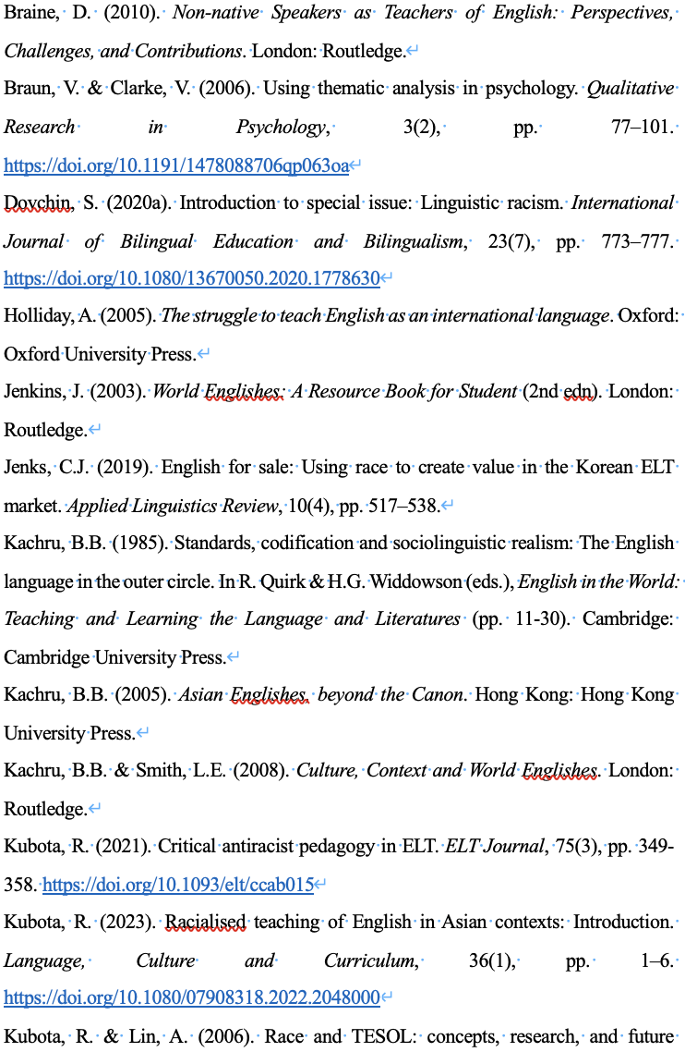
7 References


