Student name: Cherrelle Melissa Sutherland

Student ID: 2010942
Module Code: BMHP5015_BIRM
Assignment section: Changemakers: Building your Personal Brand for Sustainability
employment
Lecturer name: Dr Mark Gallagher-Read

Task 1

January 05th 2022

Sue Smith
Clinical Nurse Manager
Southwest Building
22 Hillview Avenue
Birmingham
B22 3PN

Dear Ms Smith:

This letter is in response to the full-time healthcare assistant advertise on Marie Curie website with a closing date 1st March 2022. As of February 18^{th,} I will complete my BSc Hons Health and Social Care I have previously gained a level Skills for the Workplace health and social (CertHE) in 2021 at University of Wales Trinity Saint David. I am very passionate about health and social care and I particularly love being in the position to help people I have also previously worked with vulnerable young children and adults who have complex needs your organisation is one of the best in the U.K it would be a privilege to contribute to its already stellar reputation.

I am highly motivated my skills and experience coupled with my passion for patient care make me a great fit for your organisation. Working with vulnerable people I have met various types of patients I believe listening and communicating effectively with patients having empathy and understanding this is what drives my passion has we all need someone to rely on I have always had a kind and caring nature. I also have good time management skills and I have a great work ethic. Prior to pursuing my BSc Hons in Health and Social Care, I spent three years working in a school with children with learning disabilities, and it has always been my passion to assist children and young adults. I can adapt to any rapid changes by making them feel accepted and loved, as well as teaching and nurturing them. Working with children with learning disabilities can be unpredictably unexpected, but I have the expertise and experience to recognise the positive and negative aspects of people's changes.

One of the factors that contribute to the success of healthcare assistants is their willingness to learn. Being flexible is one of my many strengths on any given day I was asked to perform minor medical producers, cleaning task, or use any software to manage patients’ data. I’m willing and ready to complete any task given to me I feel that I’m very hardworking and methodical in my approach I’m knee to gain more experience. I’ve read Marie Curie became the first woman to receive a Nobel Prize in any category. She was the first woman to win a Nobel Prize in Physics I find this achievement inspirational and relatable I believe working for a passion and supporting people within the community is the first steps to making our world a better place and it’s invigorating to see a healthcare organisation as large as Marie Currie thriving for so many years.

Thank you for your consideration, I would be grateful for the opportunity to speak with you in person regarding my qualification for this position please let me know if I can provide you with any additional information.

Sincerely,

Cherrelle Melissa Sutherland

Task 2

Cherrelle Sutherland

Walsall, Birmingham Ws1 3jn | 07769630643 | cherrelle.sutherland@yahoo.co.uk
Professional Summary
I am an approachable, helpful, and patient individual with the ability to learn quickly and communicate effectively. I am passionate about achieving high standards and demonstrating my bright and professional approach. I have a genuine interest in helping clients and representing my employer in a positive way I have good people skills and I can offer an employer reliability and commitment. Caring teaching assistant with teaching abilities and assessment skills to help students of diverse backgrounds and abilities. Focused on meeting students at personal skill levels to encourage development and increase academic performance dedicated to maintaining positive environment
Experience
Hospice Care Assistant 22/2021 to Current
Mary House (NHS)

- To undertake assessments of patient/carer needs and include patients‟ families and volunteers to develop their caring skills.
- Co-ordinate patient discharge plans from the hospice in-patient unit.
- Work with registered health professionals to plan and deliver rehabilitation program for patients (Independent Living).
- To act within the limits of your competence and authority
- To support and direct clinical care assistant volunteers
- Contribute to the effectiveness of teams by participating in inter-disciplinary team working to support individuals both in the hospice and the community.

Senior mentor 07/2016 to Current
NCS National Citizen Service

- Empower each team member to develop new skills
- Responsible for team 14 children
- Lead visit to community partners and charities
- Overseeing the health and safety and behavior management
- Deliver curriculum sessions to the team

Teaching Assistant
03/2019 to 03/2020
- Maintained student safety inside and outside classrooms in line with school safeguarding policies.
- Helped students master learning concepts through one-on-one and small group tutoring.
- Established positive relationships with students, leading by example and responding appropriately to classroom needs.
- Used teacher assessment data to customize interventions and best help children with learning difficulties.
- Organized classroom spaces and materials to help teacher prepare for lessons.

Mayfield School 09/2016 to 11/2019
Birmingham City Council
Birmingham, west midlands
- Helped teachers manage classroom crises effectively to reduce child stress and manage behavior without difficulty.
- Proactivity supported pupil emotional and educational development.
- Helped classroom teacher adapt resources and materials for use with SEND students.
- Worked with students requiring more complex needs by delivering an adapted curriculum to meet individual children's needs.
- Proactivity helped students when required both on a one-to-one and group basis.
- Gained experience working with children with Autism, MLD, SLD, PLMD and other complex needs.

English Language Teacher 09/2015 to 07/2016
Eveli Bilingual
France, Paris
- Teaching Basic Principles in language Science
- Teaching Safety methods and knowledge
- Setting and completing task
- Communicating with children emotional needs
- Health and safety awareness
- Teaching English language
- Planned, designed, and produced high-quality teaching materials, increasing student productivity.
- Carried out teacher support functions, performing coaching and counselling to achieve optimum
- student outcomes.

Core Qualifications
- Confident in liaising with customers via phone, email, or face to face  - Able to relay information clearly and assist in problem solving  - Fifteen years' experience in delivering customer care  - Patient, professional, and focused manner  - Ability to meet and exceed targets  - Able to handle complaints sensitively | - Child Skills experience  - First Aid  - Math  - Problem solving  - Teaching  - Behavior strategy knowledge
Education
Bachelor of Science 2023
University of Wales Trinity Saint David Birmingham
Certificate of Higher Education Level 4 2021
University of Wales
NCFE Level 2 in 2013
Birmingham Metropolitan College
Travel Services (Leisure and business
Level 2 Award in Food Safety Catering 2007
Open College
- Parent Craft
- Alcohol Drug Misuse
- Heart Start (First Aid)
2004
St John Wall Secondary RC School
References
References available upon request
Interests
I maintain a physically active and healthy lifestyle. I go to the gym on a regular basis to do classes like aqua aerobics or aero fit. To unwind, I also enjoy reading and watching movies. To decompress, I also do yoga. In my leisure time, I help the homeless as a volunteer. Spirituality and meditation are two of my favorite things. I practice meditation on a regular basis.

Task 3

“Episode 1 A little more care a little more awareness and understanding mental health in young people during the global pandemic covid-19”

During the coronavirus outbreak, there was a significant increase in the number of young people seeking hospital care for mental health issues. Early research suggests that the epidemic and its aftermath are having a significant impact on the mental health of children and teenagers. Why has mental health in young people increased? With worries about the virus and their future. research shows that the COVID-19 pandemic has continued to have a devastating impact on many young people with a history of mental health needs. Thomas (2021) was a useful source of information. Feelings of Isolation and changes to routine became a major issue particularly in young people Mental Health Foundation (2021) states young people, people who are unemployed, full-time students and single parents are all more likely to be lonely. Young people who are starting out new job prospect in life where suddenly had to revaluate their dreams and ambitions.

Single parents had to start rationing and turning to organisations to provide the necessities food, gas, electric during a global lockdown government around the world decided to close schools leaving children without a school meal which some children depend on due low family income as sated by UNICEF (2020) Approximately 150 million additional children are living in multidimensional poverty. It is critical that we educate young people about mental health risks and vulnerabilities, as well as how to recognise mental health issues. how to talk to children and teenagers about mental health and where they may get help. I have spoken to a few young people within the community to see their perspective I asked a question “How has the pandemic affected your mental health here are some responses.
I feel lonelier more than ever I miss my family and friends and I must do my studies alone.
I’m Naturally introverted, and I found school gave me anxiety because I had only a few friends online learning is
enjoyable

Amelia, 18

Hari, 16

It was an honour meeting and discussing issues with young people within the community according to (Winter and Lavis, 2022, p. 5) In relation to the virus itself, young people primarily spoke of fear and being “anxious”. statements, such as these elucidated this “I got COVID and now I’m panicking”. (Creswell et al., 2021) states “the majority of pre-adolescents (but not adolescents) were reported by parents to be cut off from their peers at times of peak restrictions stress (assessed with the Depression Anxiety and Stress” According to Office of National Statistics (2021) early 2021, adults aged 16 to 29 years were most likely to experience some form of depression (34%). Sleeping problems, insomnia, feeling down, hopeless, loss of appetite, and suicidal thoughts are all symptoms of deteriorating mental health.

While having a discussion with Amelia and Hari due to the stigma surrounding mental health stigmas, such as being misunderstood by older individuals, I saw Amelia was hesitant to seek help It is critical for young people to be heard and understood and feel comfortable with building relationships with other young people who are suffering challenges during the pandemic, ensuring they have an advocate, and knowing their rights. According to Mind (2020) Talking therapies, Medication, Creative therapies,
You do this with a trained therapist in a safe environment. You may need to try a few different things until you find what works for you. It is also critical for young people to follow a healthy lifestyle that includes eating healthily and exercising to maintain mental health has sated by Kamara (2020) According to UK government guidelines, each week we should all aim to do at least 150 minutes of moderate activity. Getting outside to boost serotonin and to reduce screentime and hours spent on social media.

The World Health Organization (2020) confirmed on the 31st of December 2019 that there was a coronavirus outbreak, a global pandemic that would have a terrible impact on the world. The outbreak sickened 80 million people, and many people were left with uncertainty about their future, particularly young adults who had just begun to build a life. It was a pleasure to walk out into the community and chat with young people, and I'd like to thank Amelia and Hari for taking the time to convey how the epidemic has affected them.

Cherrelle Sutherland reporting from UWTSD

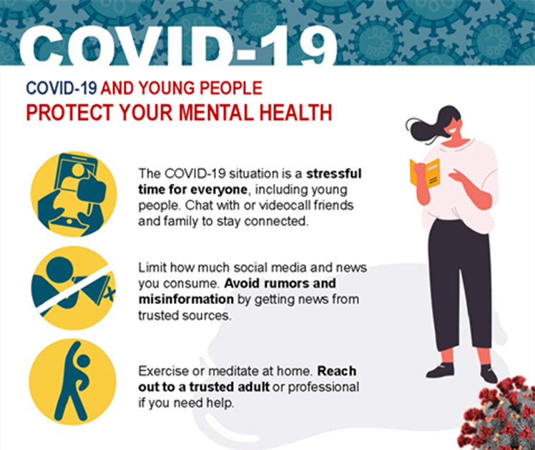

Figure 1, Covid 19 and young people protect mental health (W.H.O, 2020)

Creswell, C. et al. (2020) Young people's mental health during the COVID-19 pandemic. Available at Young people's mental health during the COVID-19 pandemic - The Lancet Child & Adolescent Health (Accessed: 12 February 2022).

Kamara, F. (2020) Feel Exercise and mental health. Available at Exercise and mental health (bupa.co.uk) (Accessed: 18 February 2022).

Mental Health Foundation (2021) Loneliness during coronavirus. Available at: Loneliness during coronavirus | Mental Health Foundation (Accessed: 12 February 2022).

Mind (2020) Understanding mental health – for young people. Available at Information for young people on mental health - Mind (Accessed: 18 February 2022).

Office of National Statistics (2021) Coronavirus and depression in adults, Great Britain: January to March 2021. Available at Coronavirus and depression in adults, Great Britain - Office for National Statistics (ons.gov.uk) (Accessed: 12 February 2022).

Thomas, E. (2021) Coronavirus: Impact on young people with mental health needs. Available at: https://www.youngminds.org.uk/media/esifqn3z/youngminds-coronavirus-report-jan-2021.pdf (Accessed: 12 February 2022).

UNICEF (2020) Impact of COVID-19 on multidimensional child poverty. Available at: Impact of COVID-19 on multidimensional child poverty - UNICEF DATA (Accessed: 12 February 2022).

W.H.O (2020). Covid 19 and young people protect mental health. [Online]. Available at adolescents-and-covid-19-page-3.png (1048×1044) (who.int) (Accessed: 12 February 2022).

WHO (2020) Coronavirus disease 2019 (COVID-19) Situation Report – 94. Available at 20200423-sitrep-94-covid-19.pdf (who.int) (Accessed: 18 February 2022).

Winter, R. and Lavis, A. (2022) The Impact of COVID-19 on Young People’s Mental Health in the UK: Key Insights from Social Media Using Online Ethnography, pp. 5. Available at The Impact of COVID-19 on Young People’s Mental Health in the UK: Key Insights from Social Media Using Online Ethnography - ProQuest (Accessed: 12 February 2022).

