Internet Technology and Security

Report on HTML & CSS Web Development

Author: Kallum Gordon
Prepared for: Dr Kemi Ademoye

15th December 2019

Table of Contents
1.0 Abstract 3
2.0 Requirements 3
3.0 Implementation 3
3.1 Navigational diagram 3
3.2 Style sheet 4
3.3 Webpage screenshots 5
3.4 Validation 8
4.0 Evaluation 11
4.1 Usefulness (suability and utility) 11
4.2 SEO 12
4.3 Accessibility 12
5.0 References 13
6.0 Appendix 14

Figure 1Navigational diagram 3
Figure 2 Index screenshot 5
Figure 3 Part 1 screenshot 5
Figure 4 Part 2 screenshot 6
Figure 5 Part 3 screenshot 6
Figure 6 Part 4 screenshot 7
Figure 7 Part 5 screenshot 7
Figure 8 Accessibility page screenshot 8
Figure 9 - Validation errors 1 8
Figure 10 Validation errors 2 9
Figure 11 Validation errors 3 9
Figure 12 Validation errors 4 9
Figure 13 Validation errors 5 10
Figure 14 Validation errors fixed 10
Figure 15 CSS errors fixed 1 11
Figure 16 CSS errors fixed 2 11

1.0 Abstract
The website that was decided upon is based around the fictitious organization known as ‘The Speedwagon Foundation’ that exists as part of the ‘JoJo’s Bizarre Adventure’ cartoon universe. The website covers each part of the cartoon and was decided upon as a personal interest. It is designed to display the knowledge gained through the unit and showcases different techniques such as the bootstrap grid system, the box model, and organizing a website to display text and images to a formatted and professional standard.

2.0 Requirements
The design and coding of a responsive website comprised of a minimum of five pages was requested, these pages must be relevant and related, and the website must use web standards. The purpose of this website is to not only promote a hobby, but also act as a fictitious institution guiding the viewer through each part of the animated cartoon known as ‘JoJo’s Bizarre Adventure’.

3.0 Implementation
To begin development of a website, documentation must be produced to outline what the website will look like to aid visualization. These documents include a navigation diagram, and a style sheet containing information such as typography, colour palette, imagery, and paragraph spacing.

3.1 Navigational diagram

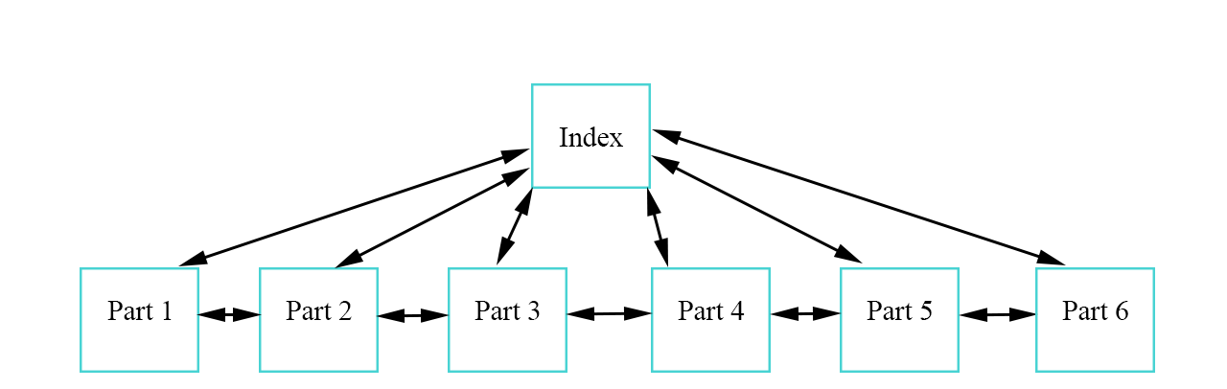
Figure 1Navigational diagram
This navigational diagram shows the website is interconnected and any one page can be reached from any other page, as shown by the two-way arrows between every page.

3.2 Style sheet
A style sheet is critical in the process of designing a website as it allows the developer to plan out the minute but important details.
Brand:
The brand this website is created for is ‘JoJo’s Bizarre Adventure’ and as such features plot synopsis’, images, and facts from the show.
Typography:
The font type used for this website is Arial. Arial has been shown to be very accessible font as it is a commonly used sans serif font. [1] Sans serif means ‘without serif’ so missing the ‘flicks’. The sans serif font type appears more informal, but improving accessibility on a website makes up for this so eyes do not have to focus on the ‘flicks’.
Colour palette:
The font colour will be black throughout the website, with the exception of the white text on the navigation bar so it doesn’t blend into the background. Black text contrasts well against the white background of the main body of the page. This colouring scheme is easy on the eyes and should aid those with specific disabilities.
The primary background colour will be white, this is the dominant colour of the website as it blends well with black text and a deep pink header. Using the WebAIM contrast checker, a black foreground and a white background pass the WCAG 2.0 contrast ratio. [2]
The header background colour will be deep pink due to the ‘JoJo’ logo being pink, this achieves consistency as the background is the same colour as the one people associate with the show. Using the WebAIM contrast checker, a white foreground and a deep pink background pass the WCAG 2.0 contrast ratio. Therefore, the navigational bar works well on the deep pink header. [3]
Imagery:
Images will be plentiful on the index page to help the user find the specific webpage they are looking for, but will be used sparingly on the subpages. The images represent the media the website is focused on to provide a sense of consistency.
Spacing:
Each paragraph and image will be strategically placed as to achieve a consistency. Spacing information far enough apart so they don’t blend together can help the readability of the site, but care must be taken to not space information too far apart so eyes don’t have a hard time tracking back and forth between paragraphs.

3.3 Webpage screenshots
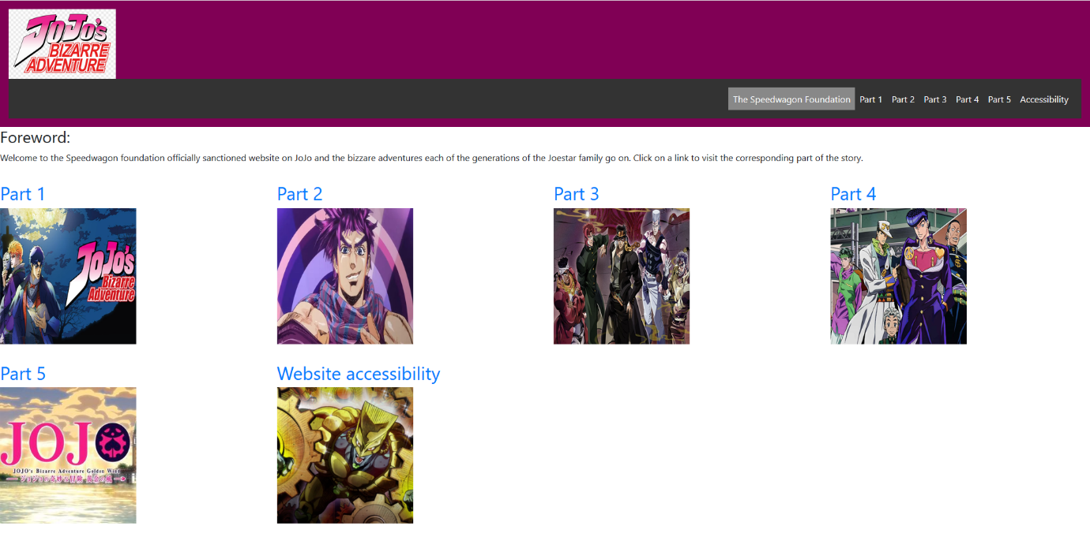
Index/homepage:
Figure 2 Index screenshot

Part 1:
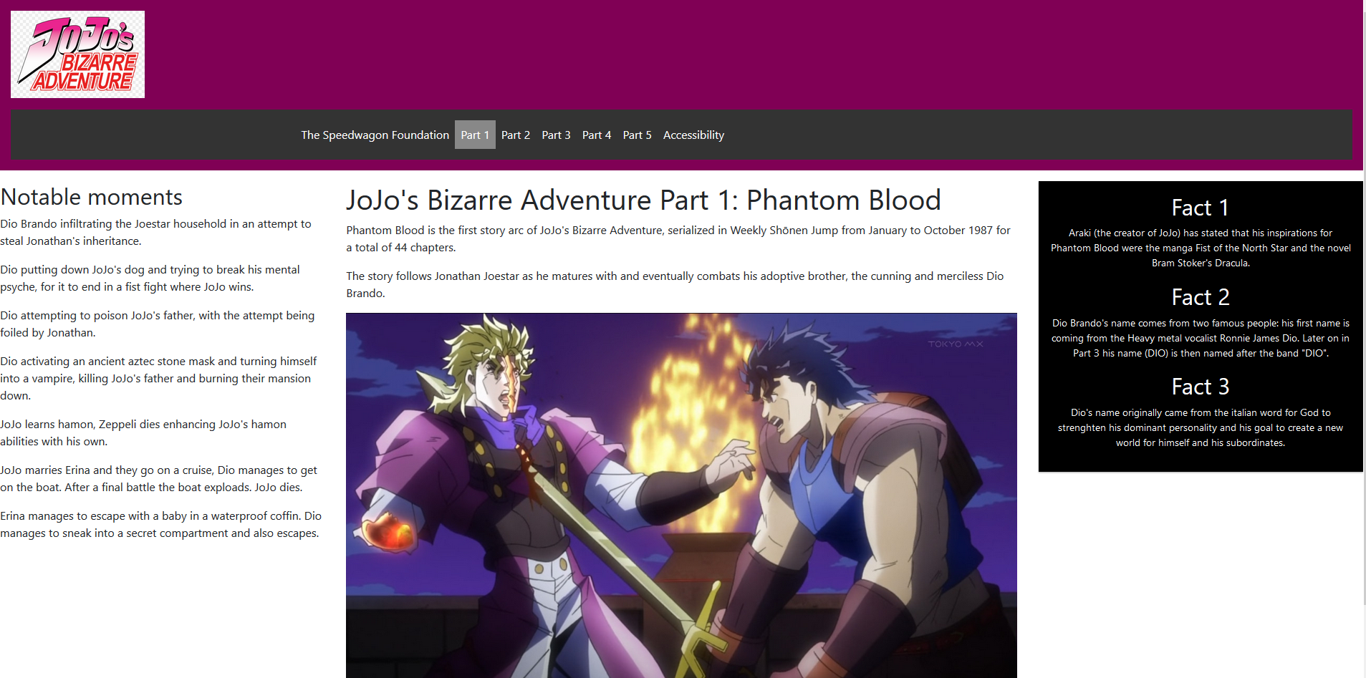
Figure 3 Part 1 screenshot

Part 2:
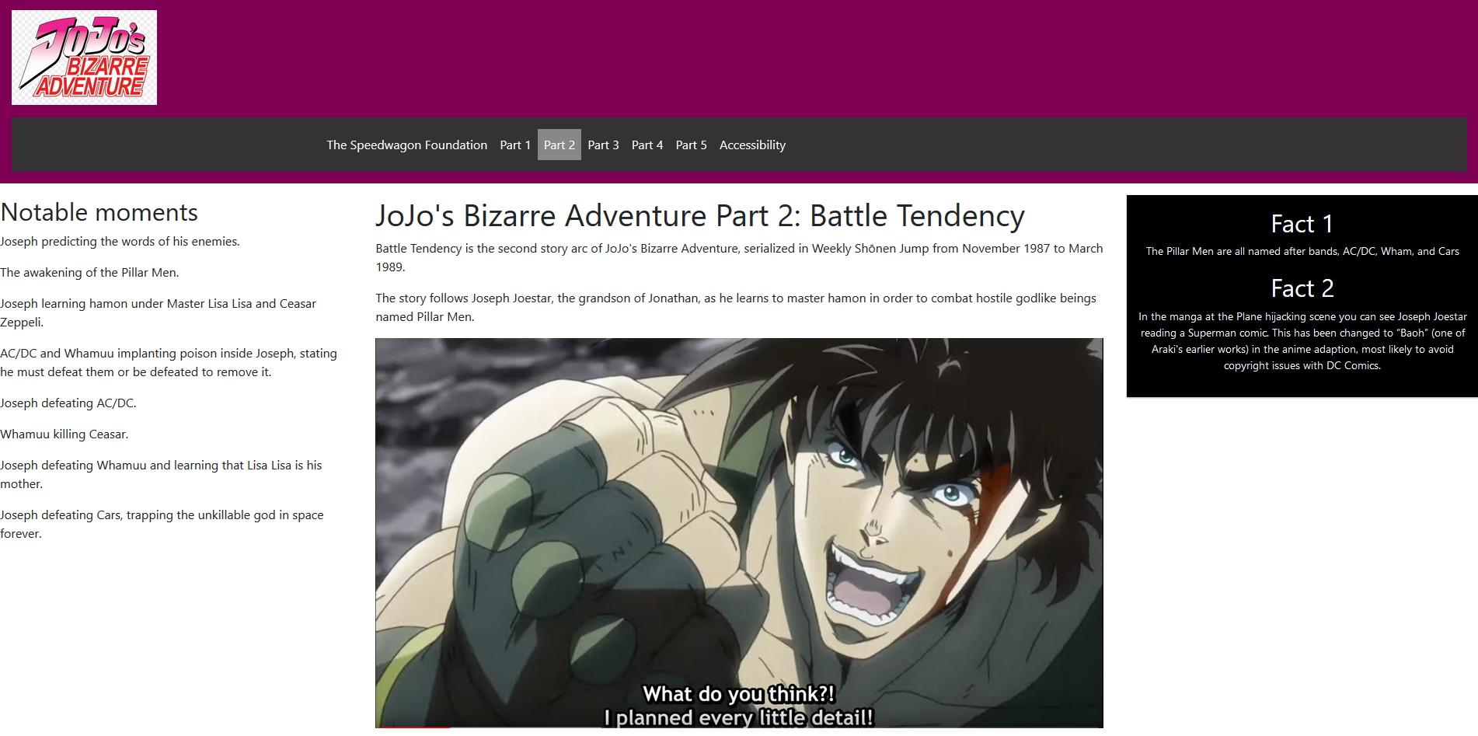
Figure 4 Part 2 screenshot

Part 3:
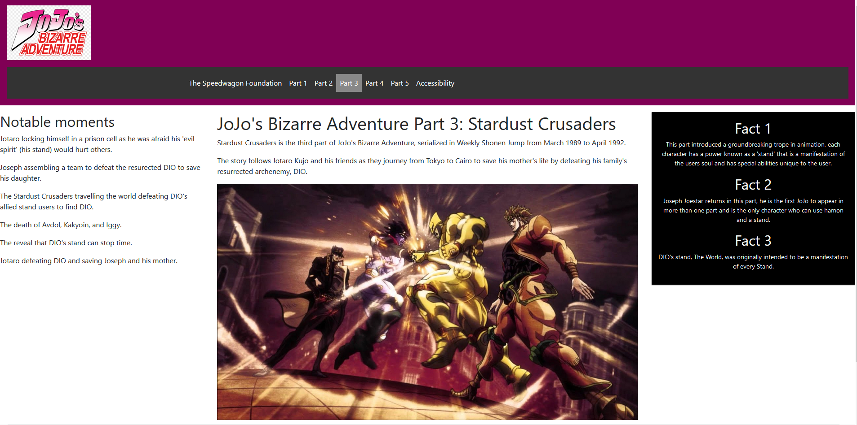
Figure 5 Part 3 screenshot

Part 4:
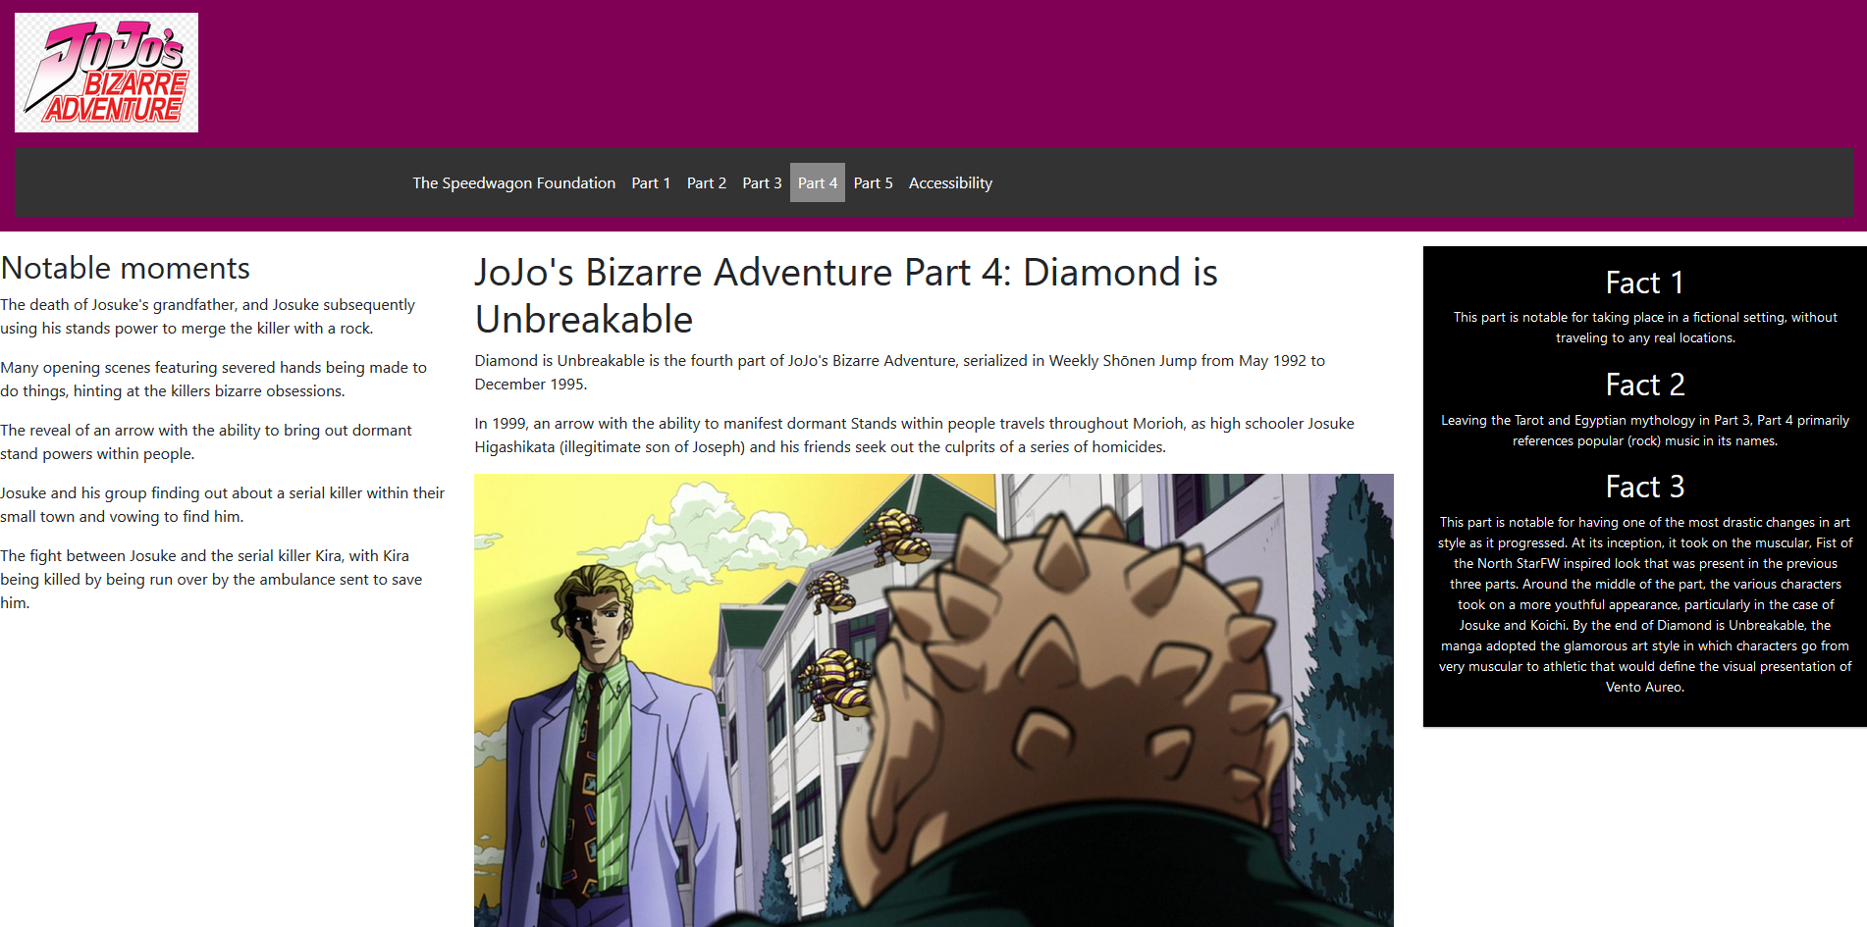
Figure 6 Part 4 screenshot

Part 5:
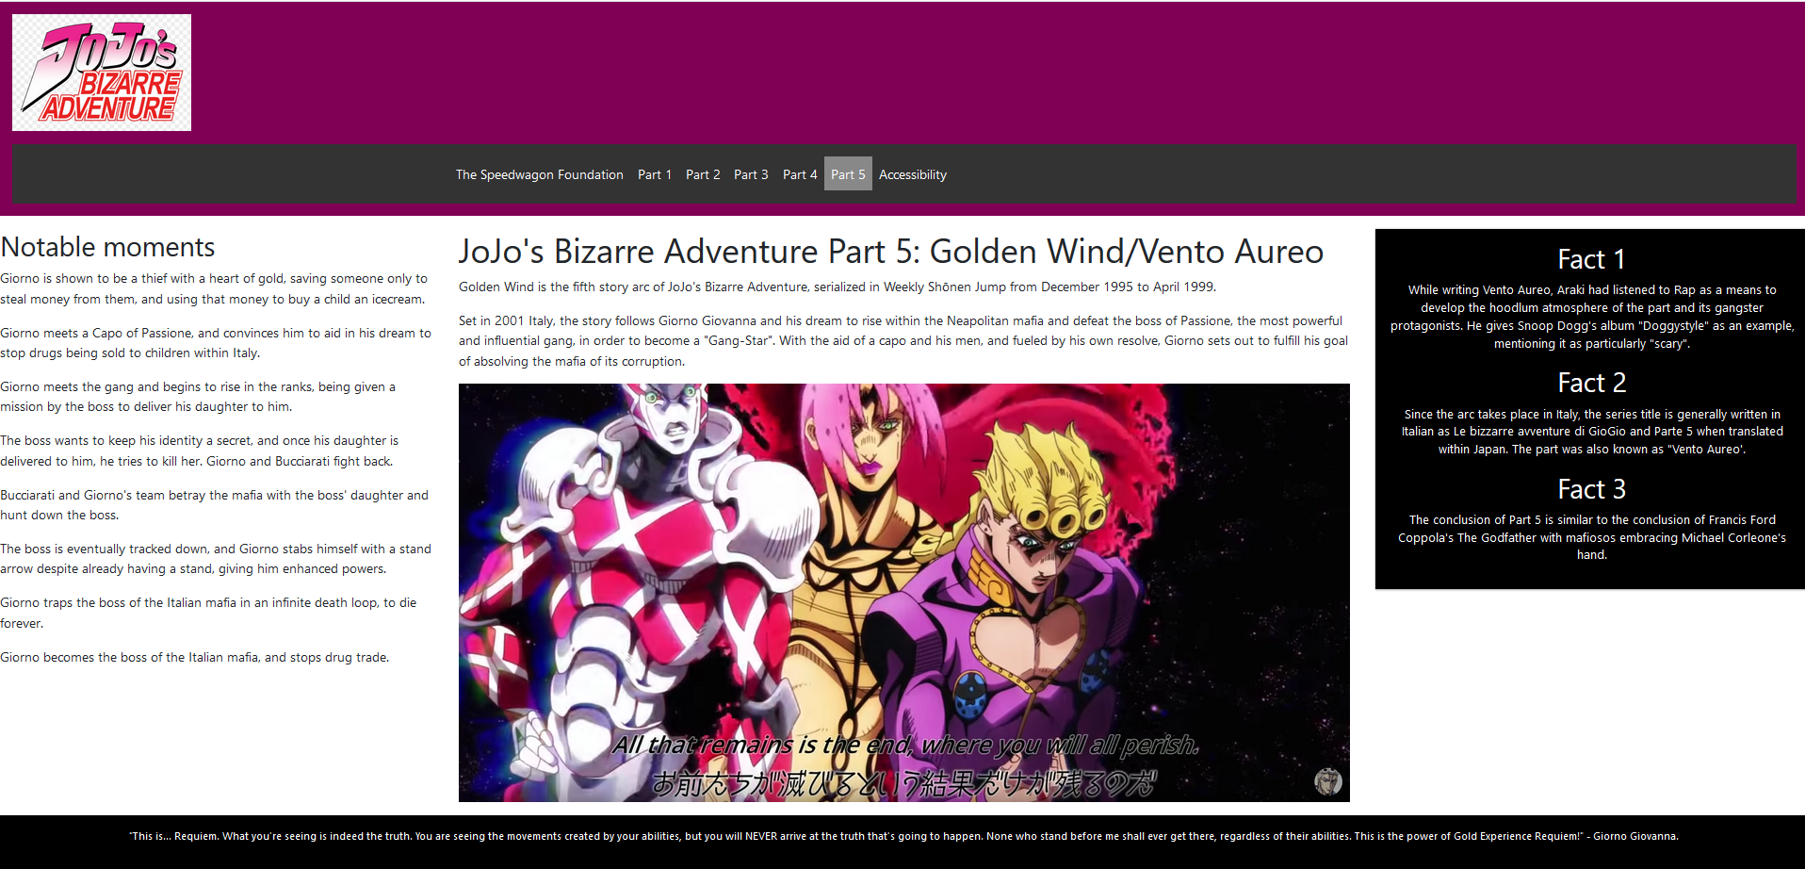
Figure 7 Part 5 screenshot

Website accessibility:
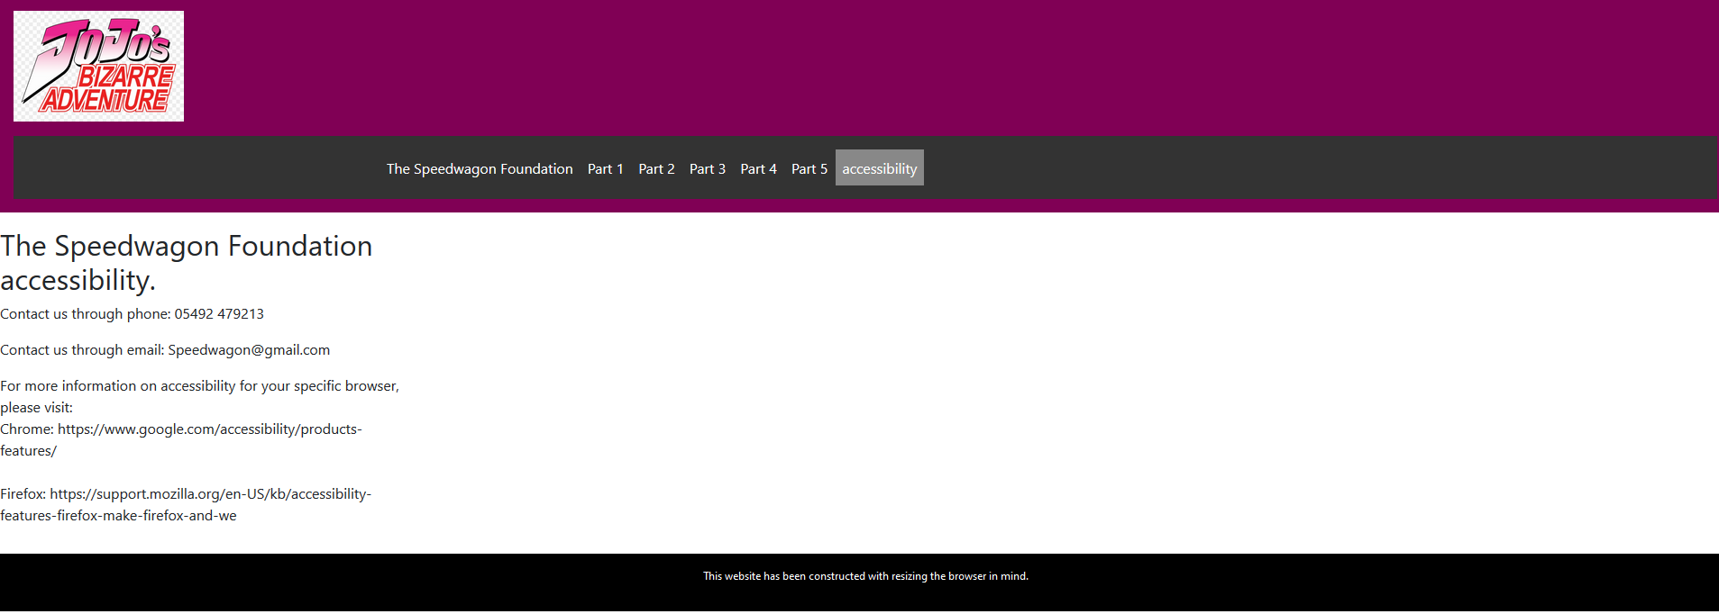
Figure 8 Accessibility page screenshot

3.4 Validation
The index page was inserted in the w3 validator to ensure errors were promptly rectified. [4] There were five total errors in the index page and each will be fixed. Three errors were caused by the same semicolon which was intended as part of CSS.
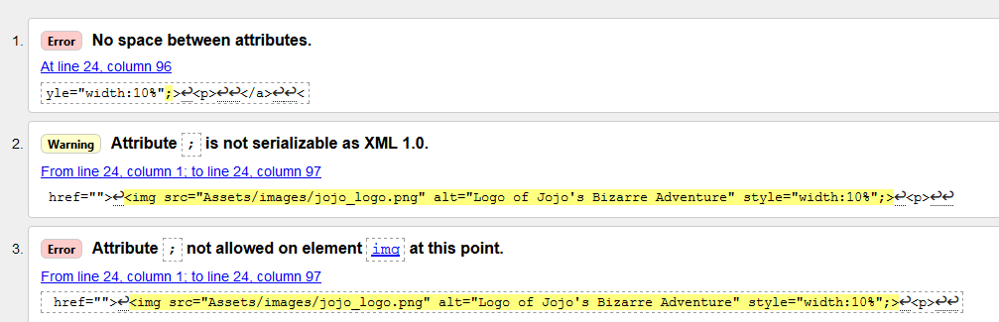
Figure 9 - Validation errors 1

The first error is due to the validator thinking the semicolon was an attribute and detecting no space between it and the previous attribute. The second error was due to semicolons not being valid in HTML. The third error was because the validator thought it was an attribute, and that attribute is not recognized as being valid for image tags. To fix this error, the semicolon was moved inside the quotes to become part of the inline CSS.

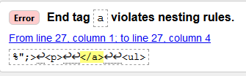
Figure 10 Validation errors 2

There was an open <p> tag with no close tag causing the above error. Because of this, the </a> tag wasn’t nested properly. This was fixed by removing the <p> tag. A fatal error was reported after this error, reporting that it could not recover. This was also due to the open <p> tag and was fixed by removing the tag. After fixing the fatal error, the validation scan needed to be done again to show the remaining errors.

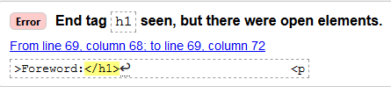
Figure 11 Validation errors 3
A <h3> tag was opened, but it had mistakenly been closed as </h1>. This error was rectified by closing with </h3>.

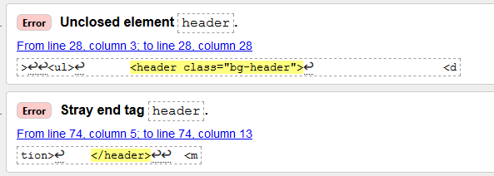
Figure 12 Validation errors 4
The close </header> was nested incorrectly within its own opening tag which caused the two errors above. This was fixed by rearranging the close tag, moving it outside of the opening tag.

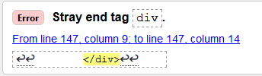
Figure 13 Validation errors 5
This error was caused by an extra closing </div> tab, removing this fixed the error. This was the final error and the validator shows no further errors.

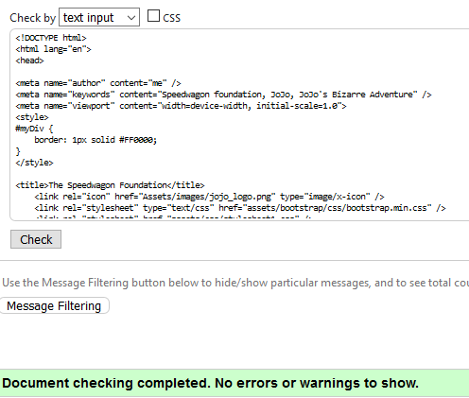

Figure 14 Validation errors fixed

The CSS was also validated using the W3 CSS validator. [5] The W3 validator displayed no errors found, so it was validated within Visual Studio instead.

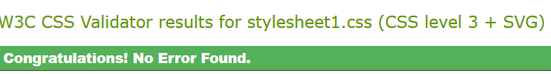
Figure 15 CSS errors fixed 1

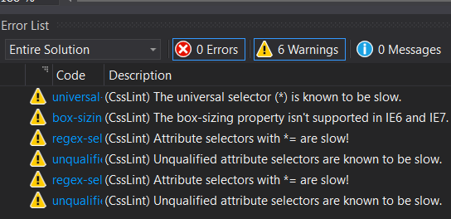
Figure 16 CSS errors fixed 2

These errors were fixed by using the online autoprefixer [6] to allow IE6 and IE7 to function properly using the CSS file. The slow issues cannot be fixed at present, but fixes could be included in future work where the CSS is written in a better, more optimized way.

4.0 Evaluation

4.1 Usefulness (suability and utility)
The website follows a scheme of using a grid system on the main page, and each subsequent page following the same style as to retain a feel of continuity. The main page has a header to easily switch between pages, a brief introduction, and four square grids on the top, and two square grids below them. These function as a way to not only introduce a part, but also provide a feel for the part with an image, and each image has a hyperlinks that takes the user to a respective part if they like the look of it. Therefore the functionality includes hyperlinks within grids with images, a navigation bar at the top of the page, the page resizing when shrunk, and alt tags for every image.
The usability is pleasant as the colour scheme of dark pink, black and white go together well as shown by the contrast checker below. The site is also easy to use as it’s small and has a navigation bar at the top of every page which uses the current class and highlights which page a user is on.
The content is relevant as it covers the topic of the show ‘JoJo’s Bizarre Adventure’. All of the information present on the site apart from the accessibility page is centered around the topic of JoJo.
Future improvements could include adding more pages to expand the websites content, adding php elements to create a functional JoJo merchandise store, and further expanding accessibility capabilities by including ways within the site for a user to edit the font size, font colours, and providing alternative interchangeable background colours.

4.2 SEO
The title tag helps with SEO as it’s used by the search engine to determine the subject of a page and display it in SERPs. [7]
The meta tag helps with SEO as it’s a short paragraph of text displayed in a SERP snippet after a websites title and URL.
Header tags help with SEO as they help a search engine read content in a more efficient way. The order of heading shows the importance of each section.
Alt tags help with SEO as it aids in image optimization. It makes an image more accessible to search engines by telling them what an image means, and to people by displaying an alternative text incase an image can’t be loaded or helping screen readers describe an image.

4.3 Accessibility
The website follows the Web Content Accessibility Guidelines 2.1 (WCAG 2.1) guidelines and as such:
- Ensures the website provides alt text over every image used, which provides text where an image would be if the image fails to load or a user would prefer to disable images for purposes such as using less Wi-Fi.
- Using a font that is generally agreed to be accessible. Sans-serif fonts are considered to be the most accessible for use on a website, and Arial was chosen for this reason. [1]
- The correct use of titles and headings. Headings should be used as actual headings and not to make text larger. This is so screen readers can differentiate between normal text and headings. Doing so makes the site more accessible to users that have the content read aloud to them. [8]
- The tab order matches the flow of the content, aiding those with cognitive impairments.
- The website is not reliant on audio.
- The website is responsive, it adapts to different screen layouts. Though more work could be done to improve the website on mobile, such as ensuring the navigation bar works on every screen size.
Additional steps that could be taken to improve accessibility given more time include:
- Adding subtitles to each video provided on the website if any.
- Providing settings on the accessibility page to change the colour layout of the website with one click.
- Perfecting the colour combinations to ensure colour blind users can see the content without having to manually adjust settings.
- Allowing for the user to choose from font colour and text size presets would make the content on the site more accessible as it can be altered by the user to meet their individual needs.

5.0 References

[1] | Recite Me, “Choosing an Accessible Font,” Recite Me, [Online]. Available: https://reciteme.com/uploads/articles/accessible_fonts_guide.pdf. [Accessed 2 January 2019].
[2] | WebAIM, “Contrast Checker,” WebAIM, [Online]. Available: https://webaim.org/resources/contrastchecker/. [Accessed 3 January 2020].
[3] | WebAIM, “WebAIM,” Contrast Checker, [Online]. Available: https://webaim.org/resources/contrastchecker/. [Accessed 3 January 2020].
[4] | W3, “Nu Html Checker,” W3, [Online]. Available: https://validator.w3.org/nu/#textarea. [Accessed 3 January 2020].
[5] | W3, “The W3C CSS Validation Service,” W3, [Online]. Available: http://jigsaw.w3.org/css-validator/validator. [Accessed 3 January 2020].
[6] | Autoprefixer, “Autoprefixer CSS online,” Autoprefixer, 2017. [Online]. Available: https://autoprefixer.github.io/. [Accessed 3 January 2020].
[7] | V. Niechai, “HTML Tags for SEO: to use or not to use?,” SEO PowerSuite, 26 February 2019. [Online]. Available: https://www.link-assistant.com/news/html-tags-for-seo.html. [Accessed 3 January 2020].
[8] | World Wide Web Consortium (W3C), “Web Content Accessibility Guidelines (WCAG) 2.1,” W3C, 5 June 2018. [Online]. Available: https://www.w3.org/TR/WCAG21/#section-headings. [Accessed 2 January 2020].

6.0 Appendix
Appendix A: Image Copyrights
Image: | Link:
JoJo’s Bizarre Adventure | Hirohiko Araki, Warner Bros. Japan LLC
Jojo logo | https://www.pinclipart.com/pindetail/ibRJoo_jojos-bizarre-adventure-jojo-bizarre-adventure-logo-clipart/
Jojo part 1 logo | https://i.ytimg.com/vi/icEF0TBE2SU/maxresdefault.jpg
Jojo part 2 logo | https://i.ytimg.com/vi/Kwc-ihGrldc/maxresdefault.jpg
Jojo part 3 logo | https://cynicscapeblog.files.wordpress.com/2015/10/crusaders.png?w=594&h=375&crop=1
Jojo part 4 logo | http://goinjapanesque.com/wpos/wp-content/uploads/2017/01/JoJo-Diamond-Is-Unbreakable.jpg
Jojo part 5 logo | https://i.ytimg.com/vi/So54Khf7bB8/maxresdefault.jpg
Jojo part 6 logo | https://www.pngitem.com/middle/oJibJb_jojos-bizarre-adventure-stone-ocean-logo-hd-png/
The World (DIO’s stand) | https://i.ytimg.com/vi/mn_PqjntMcU/maxresdefault.jpg
Part 1 image | https://jojo.fandom.com/wiki/Fire_and_Ice,_Jonathan_and_Dio_(story_arc)?file=Dio_cuted_by_Jonathan.jpg
Part 2 image | https://youtu.be/TJ57rRkBdZ0?t=18
Part 3 image | https://i.ytimg.com/vi/bR0N2eguwb8/maxresdefault.jpg
Part 4 image | https://pbs.twimg.com/media/EKzorUSWoAAiu4Y.jpg
Part 5 image | https://youtu.be/psQt50Uwc6Y?t=73

