ECGE6001Q Assignment 1
Skills for Life: employability and future pathways
The purpose of doing a degree was to enable a career change. The academic study I have done has provided underpinning knowledge which supports the practical knowledge I have gained from my working life.
Realising that I will need to upgrade my employability skills I was particularly looking forward to the elements of the module which would help me successfully get a new job. In particular I thought that the elements of effective interview and presentation techniques, job searching, and the application process would be the most helpful to me (James, 2019).
The reflective piece that I completed in Year 2 about my work as a carer with a vulnerable adult suffering from Locked-in syndrome changed my life. It really was a lightbulb moment. When I did the Journal in Year 2 it gave me a boost of self-confidence and awareness. Up until then it was just my job. Reflecting on what I did in my job using Gibbs Model of Reflective Practice (Brookes, 2019) it enabled me to recognise that I was competent working both on my own work and as part of a team. I was decisive working under pressure despite being sleep deprived. Using Gibbs allowed me to recognise the skills that I had developed, the practical knowledge I gained and how this high-pressured job had affected me emotionally (James, 2019). Before this moment of clarity, it was, as previously stated, just my job. Reflective practice was probably one of the most important skills I have learned during my academic studies which has enabled me to recognise what I have to offer to any future employer. In addition, it has helped me recognise that I need to change my career. Underlying this is the realisation that the skills I have acquired in my working life are in fact transferable skills. These include and are not limited to teamwork ability, communication skills, problem solving, leadership and team management and work ethic (Cambridge- Community, 2019). Giving further consideration to the subject of transferable skills I would consider that from working in a practical setting I have unique knowledge and experience of; equality, social inclusion, advocacy, safeguarding, problem solving, exploitation in the workplace, minority groups, vulnerable people​ and gender. Knowledge of these issues form a major part of the degree course and if I were to become a lecturer would allow me to transfer my practical knowledge to the academic setting (Skillsyouneed, 2011).
Before my lightbulb moment it probably would have been that this module was just another academic exercise. However, I now recognise that this module would give me the tools to make a more polished and professional response to a job application. Going back to Gibbs theory I recognised that I really need to showcase my skills and experience that up until recently I had not identified that I had. This improved my personal resiliency as I addressed my negative work situation and work life balance. Therefore this ‘Skills for Life’ module has built on last year’s light bulb moment so has been equally life changing (Ed, 2019).
In order to showcase my skills, and experience I upgraded my CV. It was only through reflective practice that I understand the need to upgrade this document. Applying for a job and preparing for a mock interview was also very important and enjoyable. It gave me more confidence and allowed me to realise abilities and skills that I never knew I had (Cambridge- Community, 2019). Researching the role of lecturer made me aware that in addition to getting the academic qualifications of a degree I had the added knowledge and skills from my job. I would go as far to say that I had a unique advantage from the work-based learning that I have. For example, if I were to lecture students about safeguarding, I would be able to give real life situations and experiences from my work and the underpinning theory from my academic studies on the degree course. This work knowledge and experience is backed up as I completed essential in-house training about safeguarding of vulnerable adults. As evidence a copy of the certificate is included in the portfolio (Raelin, 2008).
As a result of the degree course in general and this ‘Skills for Life’ module in particular I have identified a new career pathway and I have further identified that I will need to get a postgraduate qualification in order to achieve this new career pathway. Due to subsequent research I have identified that I could achieve this post graduate qualification while working as a lecturer. So, this research has proved invaluable in making me realise that I can achieve this career change and that the graduate employability that studying a degree has given me (Graduateemployability.com, 2019).
I now recognise the importance of reflective practice because it been life changing for me. Therefore, this is a skill which I would think essential in my future working life. I really cannot emphasise enough how important I think reflective practice is and believe it would help me to become a more effective educator.
Reflective practice has also uncovered the negative situation that I was in. Working night shifts and studying full time took its toll and my health and well-being and was probably instrumental in me not fully appreciating how the degree course was going to help me change my career. When I looked ahead at some of the modules, I did not see them as opportunities and essential to change but just as more work and pressure. This would likely have been true of the ‘Skills for Life’ module had I not had my light bulb moment at the end of Year 2 (Koshy, 2017).

APPENDIX 1
Selection of work- related training.
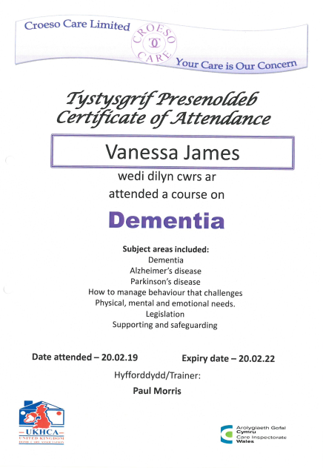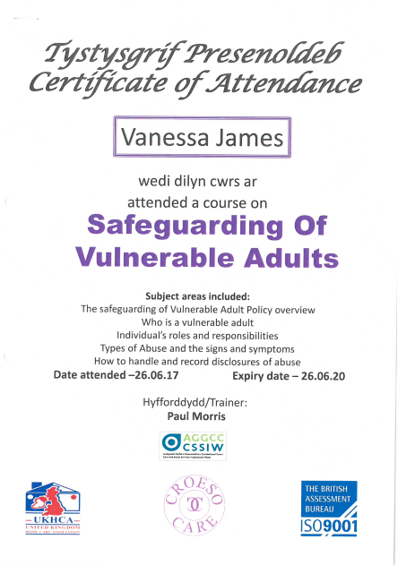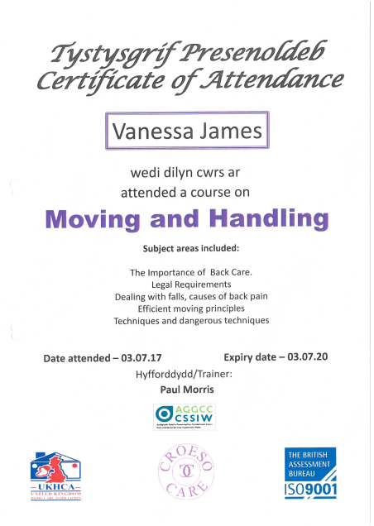

APPENDIX 2
Evidence of progression to final year.
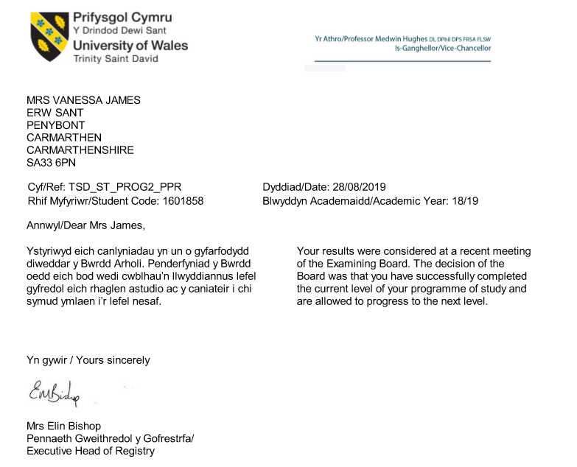

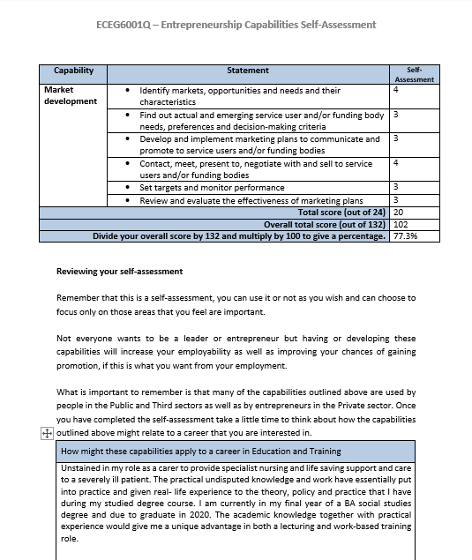
APPENDIX 3
Capabilities self- assessment and personal statement
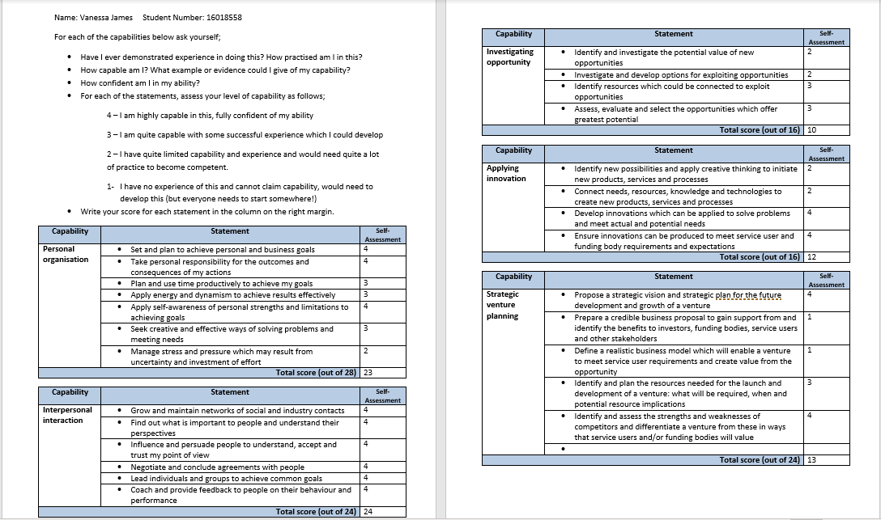

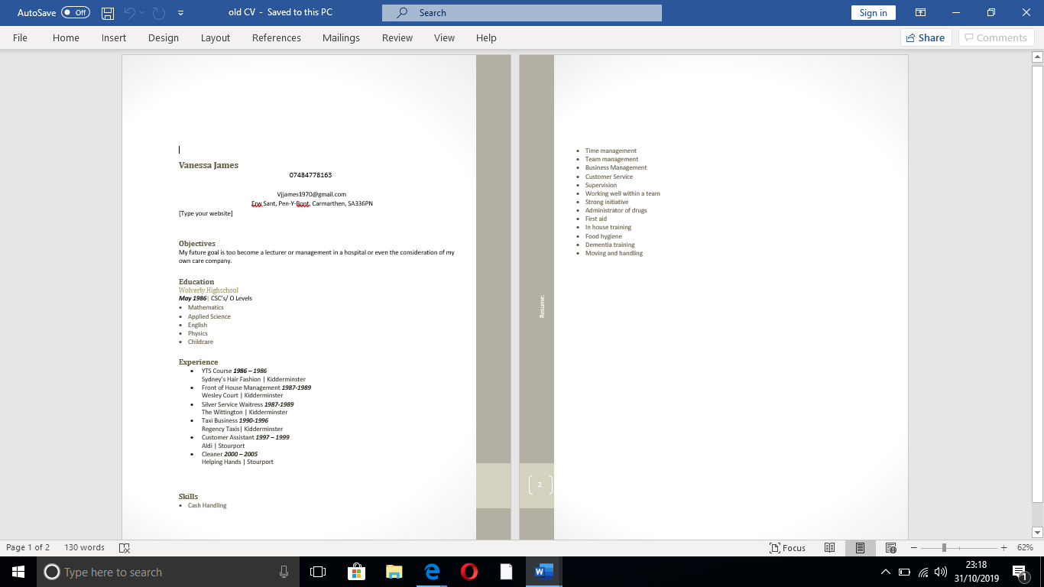
Old CV

Old CV

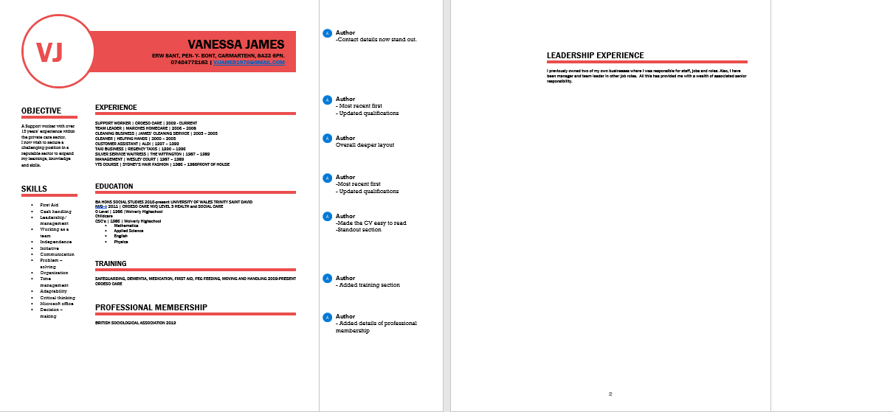
New CV

