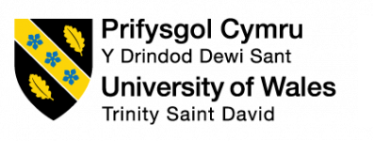

Module name: Professional career development
Module code: BMSW4005
Lecturer: Gulnar Ali

Student name: Bozica Katic
Student ID: 2008115

TABLE OF CONTENT

- Introduction ………………………………………………………………..1
- Personal and professional background …………………………………...1
- SWOT analyses………………………………………………………………2
- Learning styles ……………………………………………………………….3
  - Kolb’s style of learning …………………………………3
  - Honey and Mumford style of learning ………………..3
  - VAK style of learning …………………………………..4
  - My style of learning …………………………………….4
- Johari window ………………………………………………………………..5
- PDP ……………………………………………………………………………6
- Reflection on task1 …………………………………………………………..6
- Conclusion ……………………………………………………………………7
- References ……………………………………………………………………8
- Appendix 1 …………………………………………………………………..10
Appendix 2 …………………………………………………………………..13

- Introduction

In this report, I will present my professional development plan, and also personal and professional self-reflection. I assessed my knowledge, skills and experience to be more aware of the areas I need to develop to be better employable as in my future profession. It also includes different approaches to assessing personal and professional skills that are important for employment. I will also conduct a personal assessment of my skills, my SWOT analysis, my style of learning, Johari window. l reflected on Task 1 ¨In Class Role Play¨ using Gibb's model of reflection.

- Personal and professional background

I entered my 50 years but the desire to learn and achieve new knowledge and skills in me never stopped. I worked in various jobs: from working in the laboratory on an IR spectrophotometer and analyse quality of water, to working on the UNEP-GEF project "Development of the National Biosafety Framework in the Republic of Croatia" in the Ministry of Environmental Protection, to running production and a restaurant. Through different business positions, I have acquired many different skills that can adapt to other types of work. Doing my professional part of the job I always found time to help others who needed my help. That's why I volunteered at a home for the elderly and on a project for the protection of children's rights in an Zagreb association. In my spare time, I also worked on my personal development. I attended some workshops and courses for self-development. I danced one spiritual dance and also I wanted to promote that dance because of its value. Therefore, I designed and implemented a large project in which I included and connected some important institutions in the city of Zagreb. The feedback was great. The project was also covered by state television. But most of the time the idea of ​​doing something useful for the community, especially for the children, lived in me.
At the time I came to live in England, England had special conditions for the employment of immigrants from Croatia so my professional career started from the beginning. I worked as a self-employed in a hotel, after that I worked for a hospitality agency and finally, now I am a full-time employee in a restaurant. I am a mother of two independent adults so I have more time for myself. I have a feeling that the time has finally come to fulfil my long-held aspiration to help the society in which I live. Therefore I enrolled in the study of Health and Social Care to gain the necessary knowledge and skills. Now I'm a full-time employee and full-time student. I will soon finish the fourth level for Health and Social Care worker and I will get a Certificate for that. I would like to become an independent social worker and for that, I need to study for two more years and finish the sixth level and get a Diploma.
In five years I see myself as a person with a Diploma of 6 degrees in the Health and Social Care field, and experience in working with children. I see myself as a person who holds inspirational workshops for children on the topic of self-development. A person who cooperates with schools and institutions that deal with childcare and proper child development, especially for disabled children. That is my professional vision for the future.

- SWOT analyses

While writing the SWOT analysis, I noticed my weaknesses that I need to remove so that they could harm me in my personal professional development and help me achieve my personal goal (MindTools, n.y.).
Strengths: I'm very creative and innovative and I have excellent organizational skills. I designed and realized my big project. I like teamwork and communicate well in the team and with clients. I have developed self-compassion and empathic skills. I have a strong desire to do something for the benefit of all children, and especially children who suffer in any way- they are my main motivation. I am responsible and confidential.
Weaknesses: My biggest weakness is the language barrier, in speaking and writing, especially professional academic language in that area of ​​science. One of my weaknesses is that I have no previous professional experience in the field of Health and Social Care and I have never before worked with children in the community.
Opportunities: I have the opportunity to improve my English, with an emphasis on the language of the profession, by attending additional courses and reading professional literature. Once I get a Certificate for level 4 in Health and Social Care I will be able to look for a job with children in the community. Through further studies, I will gain the necessary knowledge in the field of Health and Social Care
Threats: In the new situation, given the coronavirus epidemic, the only threat I see could be health (given my age), but I hope it doesn’t materialize.

- Learning styles
We develop skills and aptitudes through learning. Different learning styles seek to enrich teaching methods and explain differences in how individuals learn (Brew, 2002).

  - Kolb's style of learning
Learning consists of four interdependent phases. (1) Concrete experience - involves the use of direct experience, feelings and emotions. (2) Reflective observation - review of existing experience, remembering details and obtaining new information about the experience.(3) Abstract conceptualization - creating a sense of experience and plans for future actions. (4) Active experimentation - testing of planned implementation (Kayes, 2005).

  - Honey and Mumford style of learning
Honey and Mumford identified four different learning styles: Activists (Kolb's active experimentation): They experience new things without bias, with enthusiasm to embark on new tasks and under high pressure. The most appropriate learning activities for activists are teamwork, role-playing, and participation in skills. Theorists (Kolb's abstract conceptualisation): they think carefully and logically about situations, do not make any assumptions without conducting in-depth research and analysis. Theorists avoid creativity, preferring to work logically and practically. Their learning topics on established concepts, theories and methods. Pragmatists (Kolb's concrete experience): they prefer to apply their knowledge and theories practically and literally in the world around them. They learn by testing and experiencing their ideas, also take the opportunity to experiment and apply what they have learned practically. Reflectors (Kolb's reflective observation) (Cassidy, 2010): they like to deviate from situations, learn by observing instead of jumping into action. They don’t make quick decisions but give themselves time to think about the content before concluding. They learn best through questionnaires, interviews, comments, observations and prefer to participate in activities that allow them to think before they act.

  - VAK style of learning

The most common and simplest way to recognize different learning styles is based on senses. This method consists of three types of learning processes: Visual types need to see the teacher and his body language and facial expression. They are happy to take notes at the lecture to help absorb information. They learn best from visual representations such as diagrams, charts, illustrated textbooks, videos. Auditory types learn best through oral lectures, discussions, debates, and listening to others. Auditory interpret the fundamental meanings of speech through listening to the voice, pitch and speed, music, storytelling. Kinesthetic types learn best by direct contact with the environment, they learn by moving, doing and touching; acting, role-play, clay modelling (Intel Corporation, 2007). They need activity and research so they can’t sit in one place for long.

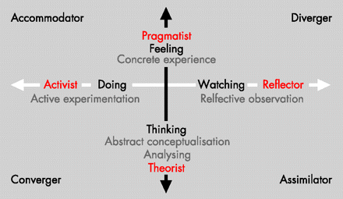
(Jennings, 2007)

  - My style of learning
I partially use all styles in my learning because when I learn I like to listen and watch, consider new ideas, follow my feelings and try to do it. But, I prefer Kolb’s style because it leaves me space for my new ideas.

- Johari Window

Communication is a very important skill in life and the business world. It is the key to success for a successful organisation (Saxena, 2015). Joseph- Harry window helps us understand how to improve trust in a team as in personal development. The Johari window is a structure that helps us understand our relationships with ourselves and with other people. There are two kinds of interpersonal communication, i.e., self-disclosure and feedback.

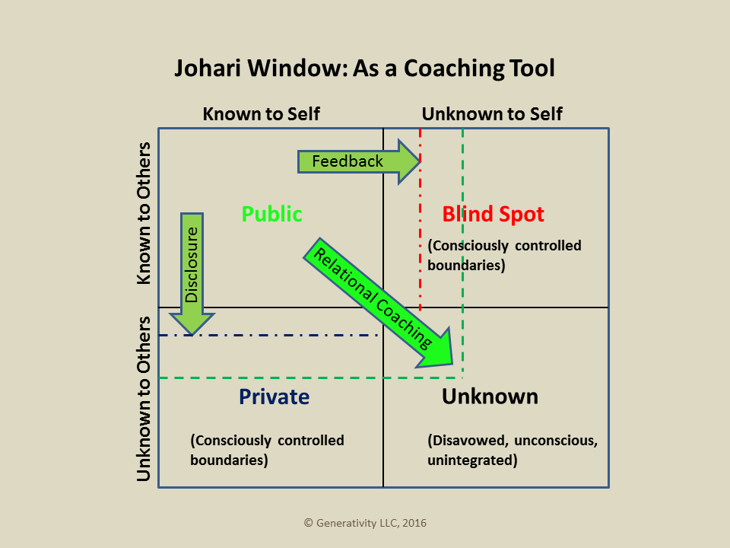
(Macaux, 2016)
The size of the windows can vary depending on where the information is located, how well our colleagues know us, and how well we know ourselves. The goal of the Johari window is to create an open culture of organisation increasing the open area and improve trust between people in the workplace.

PDP- A Personal Development Plan

- Get Certificate of Higher Education for level 4 in Health and Social Care (October 2021.)
- Continue study for Diploma in Health and Social Care (from October 2021- October 2023)
- Looking for a part-time job in Health and Social Care (After I receive the Certificate or from the beginning of 2022)
- Start working in the Children’s Social Care field to get experience working with children (2022)
- Improve language by attending online courses (Septembar 2021)
For the realization of my PDP, I expect support from my; employer who will help me because I will work in parallel for the whole time of studying, a loan from Student Finance England who will be my financial support in realizing my PDP, and a faculty where I will get the necessary professional knowledge, which makes me very happy.
Measuring progress: I will soon be able to put the first + under point 1. of PDP (Spruce, 2020) and point 2.

- Reflection on task 1

Role-play is a learning technique that helps participants try out real-life situations to develop experiences and trying out different strategies (Clapper, 2010). In task 1 ¨Role Play¨, in which an student and I worked in pairs, we played the roles of interviewer and interviewee (both of us) in an interview for the desired job position. I applied for a job position: support worker in a children's residential home and my partner for a child support assistant. We did it using an MS team meeting and in front of our lecturer. During that meeting, I felt very natural and satisfied. The atmosphere was relaxed and positive. No matter what role I played, I always felt support from the interlocutor. I think my interlocutor felt the same way. When I was in the role of interviewer, I felt that this role helped me to see the situation from the opposite side. When I was in the role of the interviewee and presented my strengths, skills and experience, this role helped me to gain experience for future situations. In that moments I experienced myself from a different perspective and realized that I was always too self-critical. Through my answers to the questions, I became more aware of my good professional skills and previous experience.
This interview prompted me to start thinking more intensely about career development and my real future interview. There was open and positive communication (verbal and non-verbal) between both parties. Mostly, everything went good and I see a lot of advantages in that experience. The experience helps reduce or even eliminate the fear of presenting ourselves to a stranger, from whom we expect positive feedback. Also, it certainly, help me feel more confident and relaxed for a future job interview. One of the possibilities of this experience is a live interview when the meaning of this task would be even more productive. This event makes sense to me because it helps me become aware of my strengths, increases self-confidence in my abilities, and encourages action. The event was going in a good direction because my partner and I had a good collaboration before and looked critically at our performance. We suggested to each other what needed to change to make the performance as good as possible. I learned something new about myself from that experience. I also learned that I need to improve my presentation skills and that I need to better prepare for the presentation, to make it look as natural and interesting as possible to the audience. I know that my previous jobs experiences and my acquired professional skills and strengths will help me in further professional development and achieving my future professional long-term goal, to become a good independent social worker.

- Conclusion
A professional career refers to everything a person does, not just a job and an occupation. It also includes education, family roles and all activities that an individual engages in his spare time. The career development strategy implies anticipating the plan (PDP) of activities and the manner of eliminating the identified shortcomings, ie the use of advantages (SWOT), to achieve goals. To develop a career, it is important to be aware of our learning style by which we acquire new knowledge and skills as well as the policy of good interpersonal relationships in the organization.

- References:

Brew, C.R. (2002), 'Kolb's learning style instrument: sensitive to gender', Educational and Psychological Measurement, 2nd April, Available at: https://journals-sagepub-com.ezproxy.uwtsd.ac.uk/doi/pdf/10.1177/0013164402062002011, (Accessed: 22 August 2021)
Cassidy, S., (2010), Learning Styles: An overview of theories, models, and measures, An International Journal of Experimental Educational Psychology, October 2010, Available at: https://www.tandfonline.com/doi/full/10.1080/0144341042000228834, (Accessed:22 August 2010)
Clapper, T.C., (2010), Role Play and Simulation Returning to Teaching for Understanding, April 2010, Available at: https://www.researchgate.net/profile/Timothy-Clapper/publication/234567370_Role_Play_and_Simulation_Returning_to_Teaching_for_Understanding/links/00b4952cb9a268deae000000/Role-Play-and-Simulation-Returning-to-Teaching-for-Understanding.pdf, (Accesses: 23 August 2021)
Intel Corporation, (2007), Designing Effective Projects: Thinking Skills Frameworks Learning Styles, Designing Effective Projects, Available at: https://acdowddesigns.com/sfsu_860_11/Styles.pdf, (Accessed: 22 August 2021)
Jennings, S.F., (2007), Personal development plans and self-directed learning for healthcare professionals: are they evidence-based? Postgraduate Medical Journal, 2007, Available at: https://pmj.bmj.com/content/83/982/518.full, (Accessed: 23 August 2021)
Kayes, D.C., (2005), Internal validity and reliability of Kolb’s learning style inventory, Journal of Business and Psychology, Winter 2005, Available at: https://link-springer-com.ezproxy.uwtsd.ac.uk/content/pdf/10.1007/s10869-005-8262-4.pdf, (Accessed: 22 August 2021)

Macaux, W.P., (2016), Something Old, Something New: The Johari Window in Relational Coaching, Generativity llc (blog), 29 June. Available at: https://macauxinc.com/blog/2016/6/29/something-old-something-new-the-johari-window-in-relational-coaching, (Accessed: 23 August 2021)
Mind Tools, (n.y.), Personal SWOT Analysis, Available at: https://www.mindtools.com/pages/article/newTMC_05_1.htm, (Accessed: 17 August 2021)
Saxena, P., (2015), Johari window: An Effective Model for Improving Interpersonal Communication and Managerial Effectiveness, SIT Journal of Management, December 2015, Available at: https://d1wqtxts1xzle7.cloudfront.net/57905519/journal13-with-cover-page-v2.pdf?Expires=1629676779&Signature=RNbNYZ-UlsnN0vFlbkxWpu4ey0IQPlFuucIgQ7MYv6uMTNYPAz5st0k4wKIBU~5uKh~dC-mH2wyOsvqYGBZItSfXcSOJQfz7Hiw2JXsnkzMCIo8SO1JcrFDmwrZINo~M7pTEj6Udh1o7tnxG5o9BaQfBr9FMv6Ae6GnV0IhDfItvYeYzlX3YPzMlD9nB6~IjHz-Z~1~8d2u-4kiwbWhXNhmvcK1s5TfkSgOODzMq8PSIiUTHorrNlp8JATAjKAkjPY41AP-GxIqtRc~tNqwthcMB1EOW9j7fSbwIohtmbWwZkSsaVihYpotRrRGQAyBa07-kBeFs5ftCuJRoa9QRtw__&Key-Pair-Id=APKAJLOHF5GGSLRBV4ZA, (Accessed: 23 August 2021)
Spruce, H., (2020), A Personal Development Plan (PDP) Guide & Template, Available at:
https://www.highspeedtraining.co.uk/hub/personal-development-plan-template, (Accessed: 17 August 2021)

- Appendixes

APPENDIX 1:
Questions that my interviewer ask me, and my answers:
JOB POSITION: support worker in child residential home
- WHAT IS YOUR MAIN MOTIVATION FOR WORK IN OUR ORGANIZATION?
My main motivation to work for your organization is to help children have happier, healthier, and as much as possible, normal childhood; take care of them and improve their physical, emotional, social, and intellectual needs; guide them to become physically and mentally healthy adults who will work for their well-being, the well-being of whole society, and well-being of planet earth.

- WHAT CAN YOU DO FOR US THAT SOMEONE ELSE CAN’T?

Good question!
According to my previous life and professional experiences I know I can offer much more than you expect of a person for this position.
Eg. as a mother of two successful adults (male and female), and 2 years of experience as a nanny, I am familiar with all stages of a child’s development and the child’s needs related to specific stages. I can more easily recognize and understand their needs. I have a pronounced maternal instinct. I can easily establish close contact with the child, full of trust.
As a nutritionist, what is my previous profession, I can help create a healthy menu for children and thus affect their physical and mental health. I can organize workshops for children about the ¨meaning of healthy eating¨ or how to eat consciously and other topics about food and feeding. I have experience in the kitchen so I can help in any position in the kitchen.
As a dancer, I can create interesting dance workshops adapted to their age and thus contribute to their physical and mental health in a fun way.
For children in puberty and adolescents, I can organize interesting active workshops on certain topics, such as the harmfulness of any kind of dependency and influence on their awareness. And a lot of other interesting things depending on your needs.

- WHAT ARE YOUR STRENGTHS?

I love working in a team, but also and individually.
I am a creative, empathic, organized, loyal, communicative and enthusiastic person who loves changes and achieving goals (especially challenging goals that seem unattainable).
I have a great desire to influence positive changes in children.
I have a strong passion for children and a willingness to try a new experience for them.
I want to improve the daily life of children or young persons. I love seeing positive changes in the community (and I can tell that, about ten years ago, I volunteered for a Zagreb’s association on a project that addressed the protection of children's rights in Croatia).
I am resilient and love to inspire, engage and stimulate others, especially children (what I already did on my project).
I am adaptable to the needs of the organization, so I can use my transferable skills.

- WHAT IS YOUR GREATEST ACHIEVEMENT?
My greatest achievement is the independent creation, development, and realisation of a project for the UNESCO competition. The competition was published on the website of the Ministry of Culture in Zagreb, Croatia. UNESCO has sought projects to declare the unmaterial cultural heritage. In that competition, I saw an opportunity to try to present an unknown spiritual dance¸ which have roots in Croatian tradition. In this project, I cooperated with institutions such as the Archaeological Museum in Zagreb, Cultural Centers in Zagreb, libraries of the city of Zagreb ...
My project was accompanied by a report on national television in the show "Good Morning Croatia".
Also, I organised a presentation of the dance in the "Museum Night" where a dance was seen by 11 thousand people in one night. The feedback was great.
I organized everything by myself, from idea to realisation. In my opinion, it was my greatest achievement!

- HOW DO YOU SEE YOURSELF IN 5 YEARS?
In 5 years, I see myself as a person with a diploma of 6 degrees in Health and Social Care, and experience in working with children.
I see myself as a person who holds inspirational workshops for children on the topic of self-development.
A person who cooperates with schools and institutions that deal with childcare and proper child development, especially for disabled children.

My question for the employer: What are my duties for that job position?
Will I have the opportunity to progress in your company?

APPENDIX 2:
Questions which I (as interviewer) ask interviewee:
JOB POSITION: children support assistant
- What experience do you have concerned this particular job position?
- Tell me about yourself.
- What are your strengths?
- I like your answers, but we have got a tone of great candidates. Why should we hire you?
- Do you have any questions?

