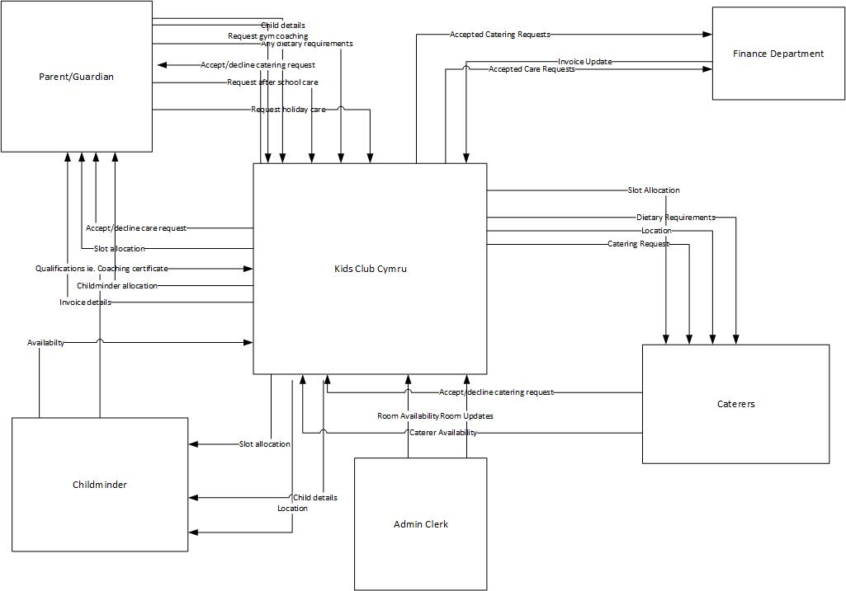
Context Diagram: shows data flowing to and from external entities for Kids Club Cymru.

Level 0 DFD: shows all major processes of the Kid Club Cymru system and how they relate and store data.
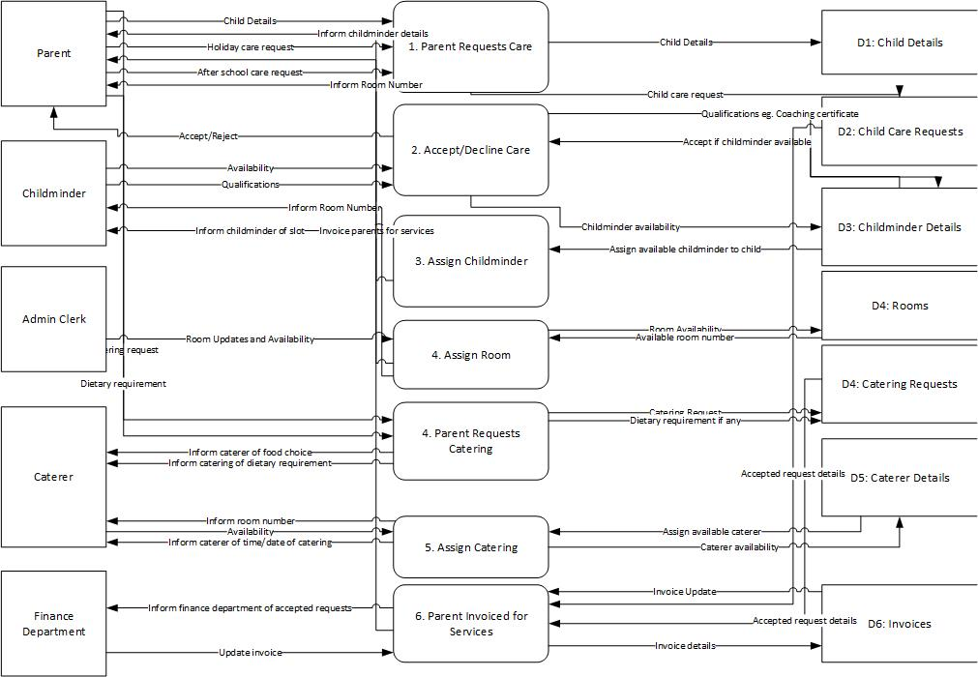

Level 1 DFD: shows how Kids Club Cymru operates in greater detail. The below level 1 DFD looks at process 2. Accept/Decline Care.
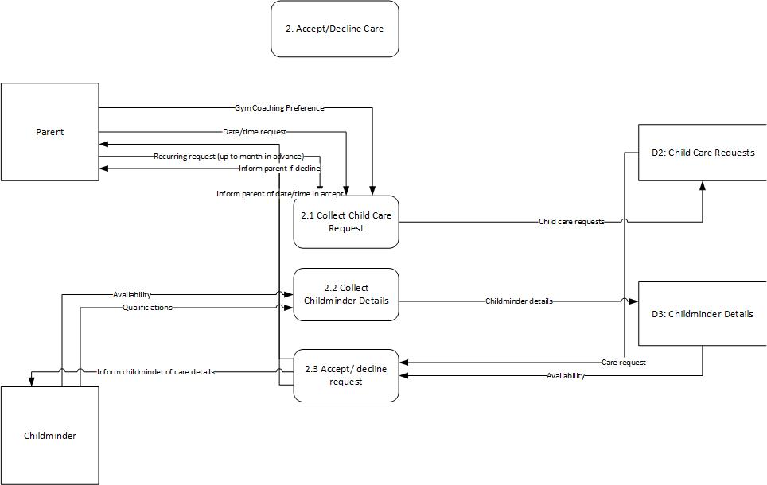

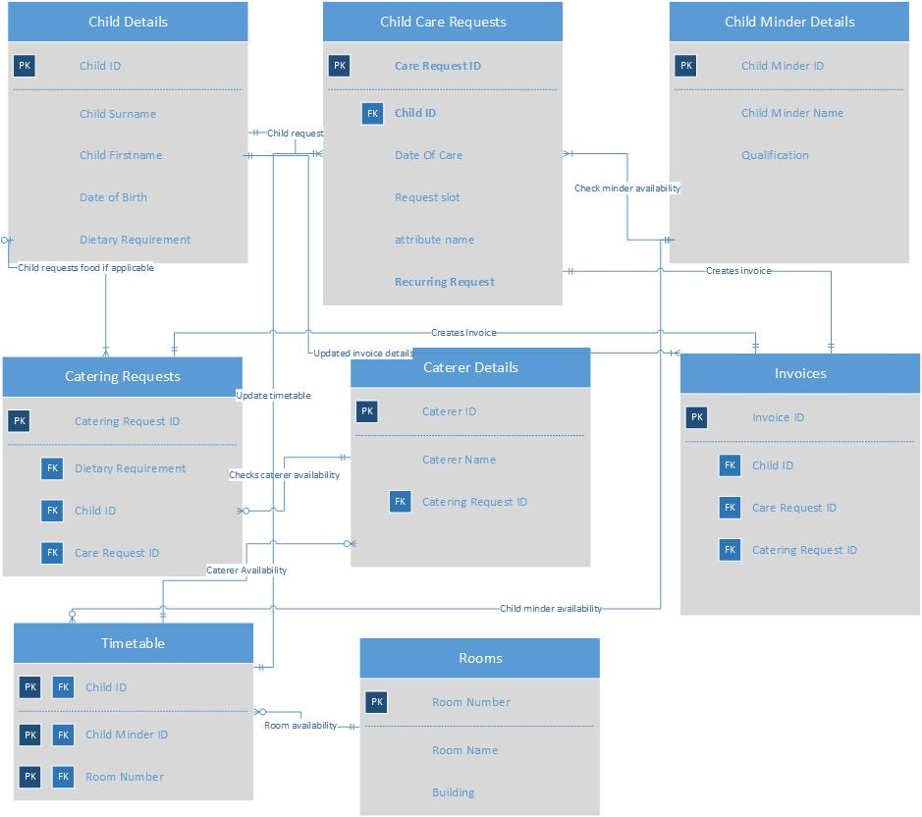
Entity Relationship Diagram: shows the relationship of the entity sets stored in Kids Club Cymru database.

