Research in Action
(ECP5006)
1,000-word reflective essay + portfolio of competencies

Reflective log
At the start of the research in action module I was extremely nervous. The expectations that we had to meet as part of the module was overwhelming and hard for me to understand in the beginning. However, I was determined to excel in this module and was looking forward to the challenges ahead as well as further developing my knowledge in the area of practical research. It was explained by Katie and Paul that we would be tasked with designing two small-scale research studies which were based upon the topic area of the psychology of gender bias. It was further explained that these studies were going to be groups of three/ four individuals per group. Within our groups it was decided that we would be conducting one qualitative and one quantitative study. I was a bit hesitant at first about working in groups as I tend to prefer working alone. However, I’m aware that having the ability to work with others is pivotal when looking at future career environments (chapman et al, 2006; Liden et al, 2004). Hence why I made sure not to let my personal feeling interfere with my learning and the task head.
The first task we had to all do was conduct a systematic literature search (SLS). This was done so we would become familiar with the research topic as well as for us to identify key journal articles and scales that could potentially be applied to our research studies. our principal investigators (PIs) Katie and Paul advised all of us to use different databases for our SLS so that we could use a wide range of databases as well as making sure out searchers didn’t overlap with one another which allowed us to have a ranged of different literature. From our SLS we managed to come up with two research questions for our studies. The next step was to begin designing our studies. To do this we had to create proposal forms for out PIs as well as ethics forms for the school research ethics committee. This was going to be a daunting task however I was determined to be successful.
As we were a group of four, we collectively decided to split the group into two sub-groups for the creation of the proposal forms. With clear communication between each sub-group members, it was easy to divide the workload into fare shares. Stephan (1952) states that communication between group members is essential for effective work production. We all looked though the mock example of the proposal forma and came to a unanimous decision on how the document would be divided. Though communication with each other we based this decision on skills and preference for the task. I was extremely happy with how effectively we all worked together, we all worked as equals and there didn’t feel as if there was a hierarchy amongst members. As a group we tackled the challenge of completing both proposal forms, we then focused out attention on the next task which was the ethics form. When I fist looked at the document, I was taken aback by the shear amount that had to be done, especially with our restricted time fame. Furthermore, knowing that there where only doing to be two people working on each form further grew my nervousness.
Me and my other sub-group member took charge of the qualitative (focus group) ethics form. After individually looking through the ethics form and the different sections we had to decide who would take each section. This was a very hard task for me as writing is not one of my biggest strengths. Maiden et al, (2010) and Strong et al, (1990) mentions the concept of free riding which refers to one individual benefiting off others’ hard work. However, this isn’t the case for me as I refused to let my shortcomings burden my partner. We collectively decided on our section based on writing ability, knowledge, understanding, and ability to perform. I took sections B, D, F, I, and J. We set a fixed date for us to know when out sections should be completed by. It was decided that we should be done a week before the forms needed to be sent out to the ethics committee as we needed one of our PIs to looks thought the forms to see if any changes needed to be made. It was hard for me to stay motivated as I did the bulk of the work during the holidays, furthermore as I was working on it alone, I was constantly worried if I was making mistakes. But with proper time management and voicing my worries to the other members as well as being assured I was on task I completed my sections in the allotted time frame. Macan et al, (1990) stated that students who have proper time management skills are more likely to be successful in their work performance with little negative behavioral attitudes such as stress. Additionally, Shepherd et al, (2017) sates that individuals not voicing there concerns when completing groupwork can lead to the buildup of flaws which can later on cause bigger problems for the group as a whole.
I learnt that when working in a group it’s important to discuss each member’s strengths and weakness to have a base understanding of everyone’s abilities as well as being able to work efficiently in a team. As this is something that was done within this task and have seen fist hand how effective it can be I will make sure to use this strategy in future group work tasks. Lastly, I have learnt that it’s okay to rely on other team members when you’ve come across a problem, and that’s it better for it to be voices so that problems don’t arise further down the project as supported by Shepherd et al, (2017). I’m confident that this experience of working on a research study as a group will benefit me on how I approach future research and group tasks. Furthermore, this experience has allowed me to test myself and prove that I’m capable of succeeding in task that go against my preferred areas of work and that it shouldn’t deter me from trying.

Competence one:
Research in Action – Completion of Systematic Literature Search

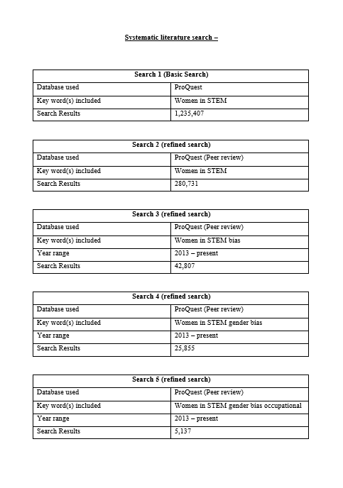

This is one of the systematic literature searches I produced which was around the topic area of women in STEM.

We took the advice from our principal investigators and choose different database for our search. For my first search I decided on ProQuest.

With every search I used key words and terminology to get a more results around my topic area. I first started out with 1,235,407 results. after using key word and dates around the time frame I was looking at I brought it down to 1,241.

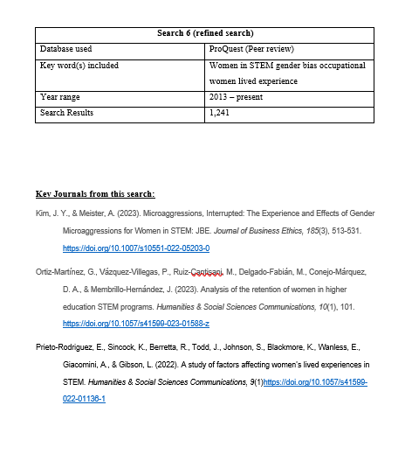

These where some of the key journals I found that related to out topic area. Using the database was very useful as we got focused results.

Competency two:
Research in Action – Applied research
Completion of research proposal

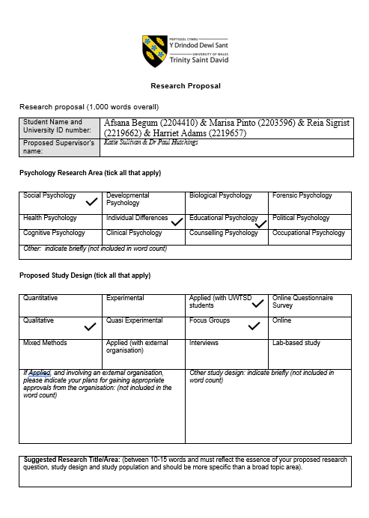

Me and my sub-team member carefully selected the applicable boxes. We took out time selecting the correct boxes as this would give the ethics committee key information which will be needed as well as a base understanding on how this study will be crated.

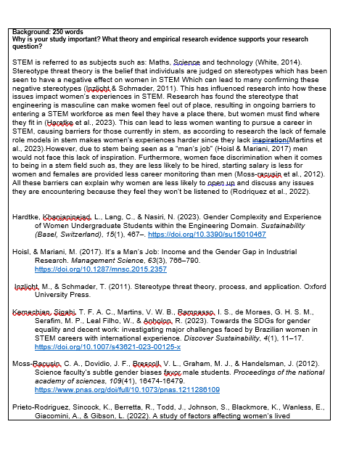

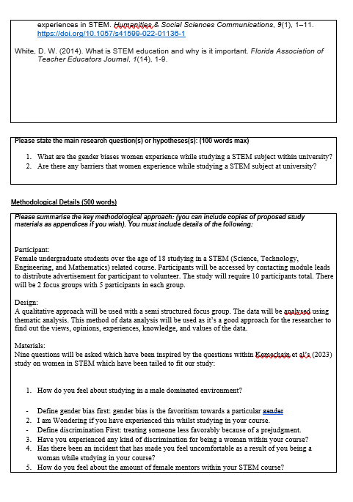
I initially had issues with the wording of the question. But will guidance from the PI I managed to come to more suitable questions for the study. furthermore, from the help of the PI and discussions within the team we deemed it more suitable to focus of just student experience in STEM as it would be more suitable for us to carry out considering our skill set at the time.

From readying key literature and discussing details about the study with my group it was easy for me to come up with the participants and design of the study.

I created the questions for our focus group with inspiration from Kemechain et al’s (2023) study.

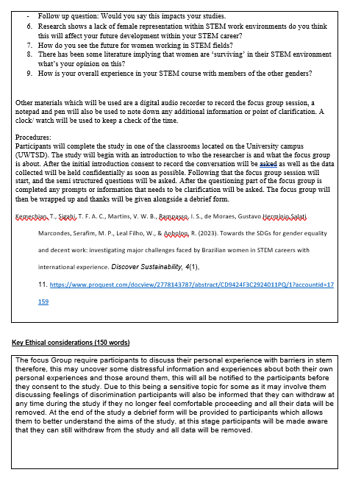

After having out PIs look at our initial proposal form it became evident that the question that I had initial came up with where poor and not up to the standard they need to be for an ethically sound set of questions. But with help from our PIs and team members we cam up with a set of acceptable questions for the study.

Competency three:
Research in Action – Applied research
Ethical Considerations - Ethics Form Completion

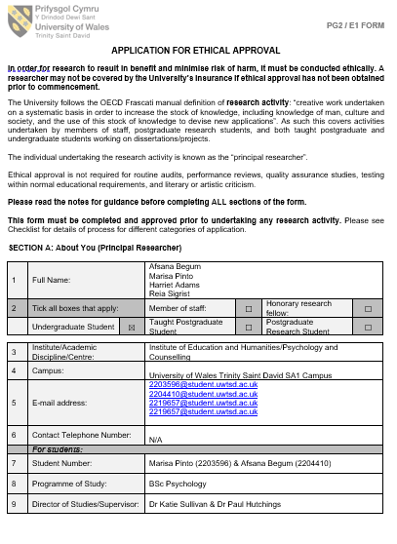

It was helpful to have guidance from the PIs as there were bits of information which would have been filed out incorrectly.

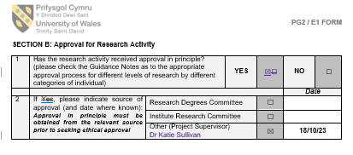

Once again with help from the PIs Katie and Paul it was easy for me to correctly tick the right boxes.

Halfway through section D I was a bit confused on one of the boxes and asked for assistance from Katie I was told this section was not applicable for my study. After re reading the section title I realised that it was very important for me to take my time reading and understanding my section in order to not mess up.

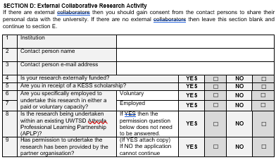

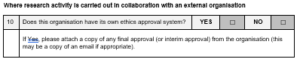

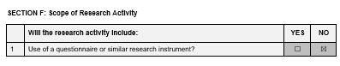

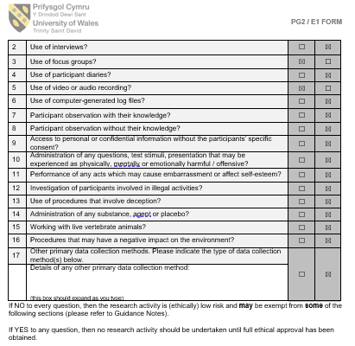

Ticking these boxes may seen like a simple task but tis important for me to make sure I selected the correct boxes.

Although our study was approved by the ethics committee. There where somethings that needed to be changed hence why all the section in red are things that had to be changed or reworded.
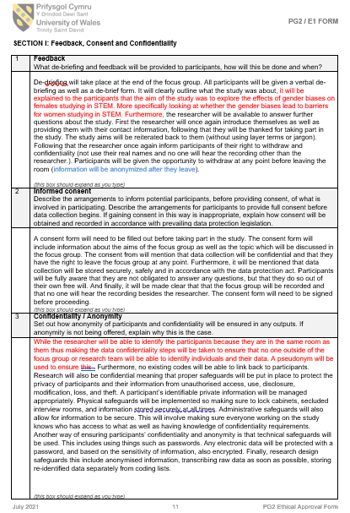

From my prior knowledge I was able to fill in these section with a bit more confidence however as you can see there where still bits where I needed help.

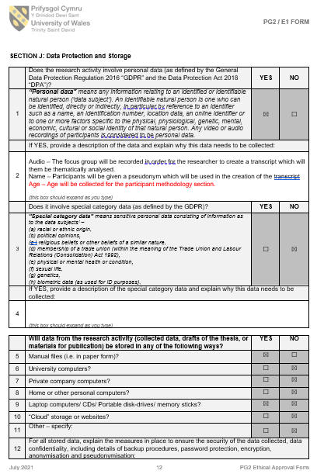

From feedback it was clear to me that there are things that I need to consider when filling out these sections such as age.

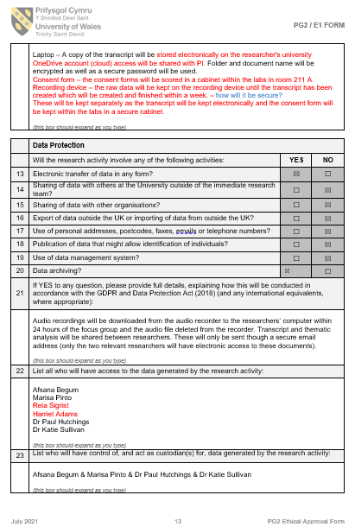

In the process of me changed things that where commented by the ethics committee it was clear to see that I needed to go more in depth in sections.

As we and my sub teammate worked on this ethics form in the moment, I failed to mention my other team members. Although they weren’t working on this ethics form, they are still apart of the study as whole.

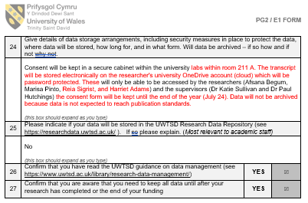

References

Chapman, K. J., Meuter, M., Toy, D., & Wright, L. (2006). Can’t we pick our own groups? The influence group selection method on group dynamics and outcomes. Journal of Management Education, 30(4), 557-569. https://doi.org/10.1177/1052562905284872
Liden, R. C., Wayne, S. J., Jaworski, R. A., & Bennett, N. (2004). Social loafing: A field investigation. Journal of Management, 30(2), 285-304. https://doi.org/10.1016/j.jm.2003.02.002
Macan, T. H., Shahani, C., Dipboye, R.L., & Phillips, A. P. (1990). College students’ time management: correlations with academic performance and stress. Journal of Educational Psychology, 82(4), 760-768. https://psycnet.apa.org/doi/10.1037/0022-0663.82.4.760
Maiden, B., & Perry, B. (2010). Dealing with free-riders in assessed group work: results from a study at a UK university. Assessment & Evaluation in Higher Education, 36(4), 451-464. https://doi.org/10.1080/02602930903429302
Shepherd, D. A., Patzelt, H., & Berry, C. M. (2017). Why didn’t you tell me? Voicing concerns over objective information about a project’s flaws. Journal of Management, 45(3), 1087-1113. https://doi.org/10.1177/0149206316688942
Stephan, F. F. (1952). The relative rate of communication between members of small groups. American Sociological Review, 17(4), 482-486. https://doi.org/10.2307/2088006
Strong, J. T., & Anderson, R. E. (1990). Free-riding in group projects: control Mechanisms and preliminary data. Journal of Marketing Education, 12(2), 61-67. https://doi.org/10.1177/027347539001200208

