Music, Memory and
Photography

By Marina Lennon
P151686
3rd Year.
Research Practises.
Dissertation.

Word count. 5.198.

Table of Contents.

1. Introduction.
2. Music.
3. Memory.
4. Photography.
5. Conclusion.

List of Illustrations.

Fig 1- Diagram showing the brains reaction when listening to a familiar song.
Fig 2. The Sonic Boom book cover by Joel Beckerman. 2014.
Fig 3. A portrait of Joel Beckerman.
Fig 4. The three key stages of the memory process.
Fig 5. Diagram showing the steps involved in the memory process.
Fig 6. Portrait of Niecephore Niepce.
Fig 7. A Daguerreotype.
Fig 8. Portrait of William Henry Fox Talbot.
Fig 9. Portrait of John Herschell.
Fig 10. An image showing Abel Niepce de Saint-Victor using glass for him portraits.
Fig 11. A portrait of George Eastman.
Fig 12. Portrait of the Lumiere brother.
Fig 13. An image of the Kodachrome.
Fig 14-19. Images created for the Cities and Memories project.
Music, Memory and Photography are three keywords that I will explore within this dissertation. By researching these keywords, I will answer the following questions, what do these three keywords mean? Do they work in relation with each other? Can one of the keywords be used to help with the others?

Introduction.
This dissertation will focus on the investigation of the following three keywords; Music, Memory and Photography. These keywords are essential for the understanding and the progression of this dissertation and the conclusion of how music, memory and photography relate with each other.
The first section will be an expansion on the definition of music and how it can affect society in many different ways. The Sonic Boom is a book by Joel Beckerman in which he describes in detail the affect that music can have on various aspects of our everyday life. Beckerman also talks about how we can change our thoughts, feelings and emotions with the use of music.
The second section will be an in-depth detail on how the memory works scientifically as well as how with the use of music, patients with illnesses such as Dementia can be helped with the retrieval of memories.
The third section will be focussed on photography. The history of how photography first came about and how it has progressed and changed over the years. The reason why photographs are kept and cherished over the course of a lifetime will also be discussed. The conclusion will bring the three keywords together. The question of how music, memory and photography relate to one another and why they are important to each other will be answered in the conclusion. The three keywords are all subjects that can work independently but they can have a greater impact on society when they work together. The question that should be answered therefore is do Music, Memory and Photography work together and can they improve our ability to live a happier and healthier life?

Music.
Music tends to have a connection to our emotions. Different styles of music can induce different moods or emotions. The more upbeat the music, the more feelings of happiness and joy are invoked, whereas, the slower the song, emotions of melancholy and sadness are evoked. As our emotions are affected by music, it is possible to change the way in which we are feeling simply by changing the music that is being listened to. This can be a very useful in helping a person fulfil certain tasks or chores. To help complete activities such as exercise or household chores, we usually listen to music that is upbeat as it has the ability to provide a felling of happiness and therefore, more energetic. Music can make a chore feel less like hard work and a little more enjoyable. An action that demands more concentration definitely benefits more from listening to music that is less upbeat and those songs without lyrics can aid in the concentration without any distractions.
Managing day to day troubles are made easier when using music as an emotional outlet, especially when a person feels it to be impossible to approach others with their troubles. Music has the potential to connect with people on an emotional level and therefore it has the ability to help us confront our feeling in a healthy way.
“The beautiful this is, music can be like a time machine. One song- the lyrics, the melody, the mood- can take you back to a moment in time like nothing else can.” – Lisa Schroeder.
Specific songs that are connected to a specific memory helps in evoking the memory and therefore equally evoking the emotion that is associated with that memory and song. While studying, students will often listen to music to help them concentrate more. Listening to a specific genre of music can assist is creating the right mood for relaxation which can result in positive results in the subject matter that is being studied. Whether or not music can really help with concentration while studying depends on variable factors. The personality trait of the individual is important for determining the results of this study but the genre of music is also very important. Upbeat music with lyrics can be a distraction whereas music that is slower and missing the lyrics are less of a distraction and therefore more suited to the aid of studying.
Relationships and friendships are usually formed when the individuals involved have certain commonalities. Most listen to music of some kind and this has the ability to be a starting point for creating a friendship or a relationship as it can bridge the gap between individuals. As social situations prove to be difficult for many and music can be an effective tool to break the ice.
Music is all around us, we listen to music while driving, working and running errands. This makes it more enjoyable when doing things that are found to be boring or hard. Music is also heard in many public places such as shopping centre and restaurants as a way of creating a more pleasing atmosphere and a relaxing experience.
Television shows and movies use music as a way to induce and emotional connection between the viewer and what is being viewed. The addition of a soundtrack connects the scene that is being watched with the correct corresponding emotion which makes for more enjoyable viewing. Without any musical soundtrack to accompany a movie or television show, no emotional connection can be formed and this can take away the true meaning of what is being viewed. A horror movie for example is usually paired with dark, ominous music which can create a feeling of anxiousness about what us about to happen or is happening during a scene in the movie. An action movie would most likely be accompanied by dramatic and upbeat music which has the tendency to get the viewers heart pumping with excitement. Sadness can be evoked during a heart-breaking scene with the use of melancholy music. The emotional connection between the scenes and characters in a movie or show with the viewer would not be possible if there was no music or soundtrack to accompany the scenes.
In tests, researchers have gained the ability to display how familiar songs can cause the brain to react. The green areas show the brains reaction to music.
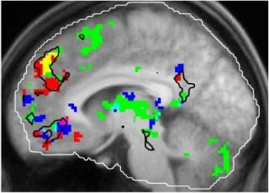 (Fig 1)
In his book ‘The Sonic Boom’, Author and music maker, Joel Beckerman discusses how music has the ability to change how we think and feel. Music can also change the way in which we buy and what we buy. ‘Companies, brands and individuals can strategically use sound to get to the core of their mission, influence how they are perceived by their audiences and gain a competitive advantage.’ -Joel Beckerman, 2014. Beckerman discuss ‘The Boom Moment’ in his book. The boom moment, according to Beckerman, is the moment in which a sound can transform emotions and experiences suddenly without even knowing what sound it was that had triggered the sudden reaction. Beckerman wrote a section in the book that teaches the reader how they can create their own boom moments to enable more opportunities to generate soundtrack to help make their lives less stressful and therefore easier to manage. In relation to movies, television shows and advertisements, Beckerman mentions that the music that is composed to accompany the scenes being viewed is very important for creating the corresponding emotional connection. If the scene being watched and the music accompanying it do not correspond, this would result in the incorrect emotion being felt by the viewer and so a disconnect between the viewer and the scene. Beckerman refers to this disconnection as ‘Sonic Trash’.
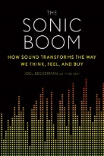(fig 2 & 3)
Music influences our daily lives, impacts our experiences, decisions, emotions and our health. Although music plays a very large part of daily living, it is often taken for granted.
“What seems to happen is that a piece of familiar music serves as a soundtrack for a mental movie that starts playing in our head. It calls back memories of a person or place and you might all of a sudden see that persons face in our minds eye. Now we can see the association between these two things- The music and the memories.” -P Janata.

“The past which is not recoverable in any other way is embedded, as if in amber, in the music and people can regain a sense of identity.” -Oliver Sacks.

Memory.
“Memory is the process of maintaining information over time.” – Matlin, 2005.
Living a happy and fulfilled life requires an important element. That element is memory. It is an impossible to function in everyday life, learn new things or plan for the future without the ability to retain memories. The memory processes vast amounts of information in forms such as images, sound and meaning and works in very much the same way as a computer.
“The human brain has a vast memory storage. It made us curious and very creative. Those were the characteristics that gave us an advantage – curiosity, creativity and memory. And the brain did something very special, it invented an idea called the future.” -David Suzuki.
The process for processing information consists of three major factors which are; Memory Encoding, memory Storage and Memory Retrieval. – Campos, TF. 2010.
(Fig 4)
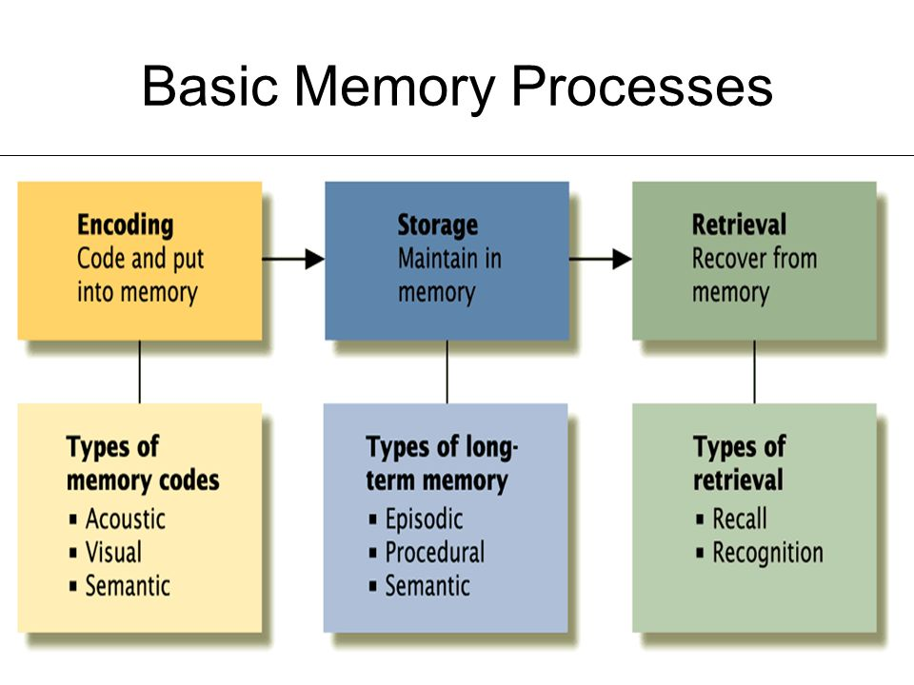(Fig 5)
Memory encoding involves the conversion of information into a format that is manageable for the memory system enabling the information to be stored. Acoustic or sound, visual or image and semantic or meaning, are the three types of memory codes. Memory encoding works by memorising words or a list of numbers by repeating them verbally, would enable the words or numbers to be stored as a sound or meaning. The memory is then saved in storage. The memory is later retrieved by either a conscious attempt to remember the memory or by a trigger with could be sound, music and images.
“Memory is the means by which we draw on our past experiences in order to use this information in the present.” -Sternberg, 1999.
The short-term memory and the long-term memory store information using different coding. Acoustic or sound coding is used to store information in the short-term memory, whereas the long-term memory stores information using primarily semantic coding, but visual and acoustic can also store memory in the long-term memory. According to American psychologist, Miller, G.A. 1956, An adult can store up to nine pieces of information in the short-term memory at any one time but, the information can only be stores for up to thirty seconds. The long-term memory storage however, is believed to be able to store information that last for the duration of a lifetime and is limitless. Memory retrieval is as it states. It is the retrieving of a memory by pulling the information out of storage. How the information is retrieved differs with long-term and short-term memories depending on how the information was stored. Due to the information in the short-term memory being stored systematically, they have to be retrieved in the same way. Long-term memories are stored in relation to a place, subject or object and therefore these memories are usually retrieved when they are triggered by something that is affiliated with the memory that is stored.
There are two different categories that the memory can be divided into. The explicit memory and the implicit memory. An explicit memory is considered the deliberate retrieval of the past. This means that when posed with a question such as where did I go last week? And who was I with? The memory of that time is retrieved. The implicit memory is the unexpected and unintentional retrieval of a memory which is often triggered by something. Separate areas of the brain are involved with explicit and implicit and it is the explicit memory system that can become damaged by either illness, accidents or the degeneration over time in elderly people. Scientists are continually conducting experiments on the human brain and more specifically the memory system. They are always gaining more knowledge of how the memory works. This will continue to aid in the understanding of how those suffering with memory loss illnesses can be treated. In these scientific experiments it is found that both music and images by way of photographs, are important factors when attempting to trigger specific memories.

Photography.
In the beginning of the 1820’s, Nicephore Niepce invented the first photographic process, Heliography. Niepce created images using bitumen of Judea which was spread over a silver plate and was then exposed over a period of several days. Louis Jacques Mande Daguerre became an associate to Niepce’s research in 1829 and in 1832 they introduced the use of a residue of lavender oil as a way of a second process which reduced the exposure time to just one day. Niepce died in 1833 but Daguerre continued with the work and in 1838 the Daguerreotype was invented. This process involved coating a silver plate with a thin layer of silver iodide and then exposing it using a camera obscura. This was then exposed to mercury vapours to induce the invisible image into visibility. The exposure to the light caused the chemicals to react resulting in an image. The amplification of the light and chemicals meant that only a thirty-minute exposure time was needed. The image was then fixed by immersing it into salted sea water.
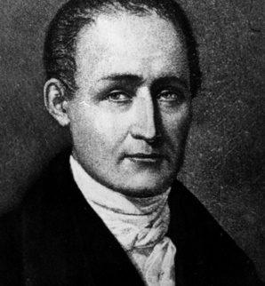(Fig 6)
(fig 7)
Other artists followed suit over the following years, each creating new ways of processing. Henry Fox Talbot made a name for himself when he patented the Calotype in 1841. The calotype was the first negative-positive process which made it possible to multiply the same image. John Herschell discovered a way of fixing his images by dipping them in a solution of sodium hyposulfite which is a process that is still used in photography in the present. In 1841 a physicist by the name of Hippolyte Fizeau discovered that by replacing the use of silver iodide with silver bromide, only a few second of exposure time was required to make a Daguerreotype as it had a superior sensibility to the light. This made it possible to create portraits. In 1847, Abel Niepce de Saint-Victor decided to replace the use of paper with glass as the silver bromide mixed with albumen (egg whites) would adhere to the glass in a way that it would not with paper. This created sharper images, but they were a little bit too contrasted which led to the need for creating higher definition lenses. Due to the plates being highly sensitive, it became a necessity to design mechanisms that would let light into the camera for 1/100th and even 1/1000th of a second. This mechanism was the shutter which began just before 1880. As this meant that the light intensity would need to be evaluated, the light metre was used to measure the light.
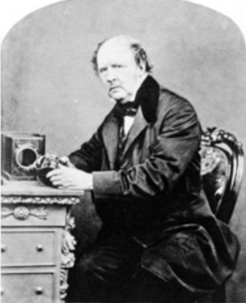(Fig 8)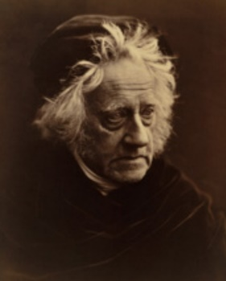(Fig 9)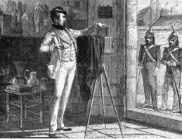(Fig 10)
During 1888, the founder of Kodak, George Eastman conceived the idea of using a supple base by replacing the glass plates with celluloid rolls.
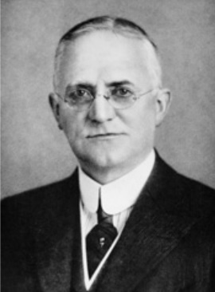(Fig 11)
Although other artists had experimented with colour in their image making, it was brothers Auguste and Louis Lumiere who invented the Autochrome plate. They had used a mosaic of microfilters in primary colours on one plate to achieve colour in their images. 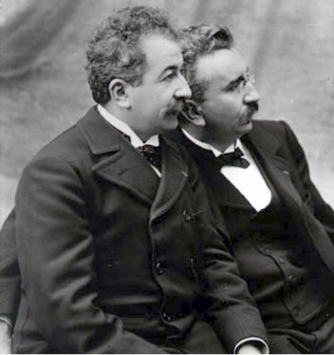(Fig 12)
This was later improved on in 1911 by R. Fisher when he developed the Chromogene and was then further improved on by Agfa in 1936 with the inventio of Agfacolor films which superimposed layers using blue, green and red. Throughout the years methods of image making have been constantly improved upon. Whenever a new process of processing is conceived, lenses would need to be improved to gain accurate colours on film. In 1935 the process was yet again improved by L. Mannes and L. Godowsky with their invention that was then bought by Kodak and named the Kodachrome. In todays photography, the use of the principles of the Agfacolor and the Kodachrome as well as the use of silver bromide and gelatin are still very much used.
(Fig 13)
Technology has brought the art of photography so much further than the idea of capturing an image as it is in that moment. The capturing and the storage of photographs using digital technologies started in the late 1980’s with the introduction of the first digital cameras being available to the everyday consumer. The conception of a computer programme names Adobe Photoshop was realised in 1990, allowing for the manipulation and adjustments made to the digital files that had been captured using a digital camera. Photographers then had the ability to change the structure and content of an image. This led to the questioning as to the truth behind the final changed photograph. Newspaper and magazine companies continued to use film images right up to the 2000’s but because digital images are faster to edit and transmit, it became much more beneficial and effective to transition over to using digital technologies including digital cameras that where used by the photographers and designed specifically for professionals. The use of digital technology in the news has come under scrutiny due to the ease of manipulation. Although image manipulation dates back to before computers, it was during the first decade of the 21st century that several digitally altered news photographs caused an uproar as these images were not fact. Ultimately this led to the drawing up of the codes of ethics being established to regulate the manipulation done to images. Many photojournalists lost their jobs due to the discovery that photographs that they had published had in fact been doctored. Unlike photojournalist who have had to remain cautious with digital imaging, photo artists approached the possibilities of digital imaging with enthusiasm. The idea of what is believable about manipulated images intrigued artists and opened a whole new avenue for them to explore. Photoshopped images of models and celebrities appear on magazines but not as they would appear face to face. Digital retouchers are commissioned to remove any unsightly blemishes or transform the body’s shape and size. This has made for a world where so much is possible with image making but what is the truth and what is false?
Due to the continues improvements and progress throughout the years, photography and the sharing of photographs has become available to everyone, not just artists and the rich. Today, photography is becoming a way of life since the introduction of smartphones with built in cameras giving people the ability to capture images with their camera phones whenever and wherever the mood strikes us. Access to the world wide web makes it possible to upload and share photographs within a matter of seconds with the use of applications such as Instagram and Facebook. We take photos of everything. Holidays, birthdays, celebrations or everyday things that capture our attention. We are constantly sharing many aspects of our lives through imagery and social media.
There are mixed reactions to the use of digital technology. While some artists have embraced it such as Trevor Paglen who captures the trail of light made by spy satellites, others have chosen to journey back and continue creating their images using more traditional photographic processes.
Images, along with digital technology are utilised by the government and military by way of surveillance, digital fingerprints, identification and face-recognition which have caused debates about the impact that the camera has on civil liberties.

Conclusion.
Is there a parallel between music and photography? Both music and photography are an art form that require passion, experimentation, flexibility, persistence, determination and no small degree of patience. To achieve a piece of music that is to the desired standard by a musician or musicians, many hours of work, trial and error and refinement are needed and the same can be said for photography. The photographer can spend hours and sometimes days to be able to capture the image that is wanted, and then additional time is required to refine the image or images to produce then final result. Music and photography are very much parallel in many ways. The musicians and photographers are always learning new techniques and processes that will improve their craft. There is always the potential to learn new things whether it is a sound that has been changed to create a new sound or a new way of creating images. Creativity is always kept alive as the challenge of exploring something new and the incentive of the finished piece of work, is inspiring. Photography and music both appeal to many people because of their artistic expression. Creativity blends music and photography together and in fact many photographers have been known to have some type of musical background. Ansel Adams was a concert pianist and Robert Valenzuela was a guitarist. These two artists are just an example of artist who are both photographers and musicians.
Whether by a song or by a photograph, the artist is in some way telling a story. When a musician is performing a song of composition, they are not thinking about the performance rather they are feeling the music evoke emotions. Photography is much the same in that owning a camera is not simply enough to create art, practice and more practice is a necessity but also the images need to tell and story that has the ability to evoke emotion and the more personal the story, the it ties to the viewers emotions. The viewing of a photograph should be able to reach the audience on an emotional level, a feeling, not the thought of an idea.
Musical composer, Stuart Fowkes, embarked on a major project in 2014 which was titled ‘Cities and Memory’. It was a global collaborative sound project that at this present time expands over more than seventy-five countries and has contributions from more than five hundred artists. One part of Cities and Memory is ‘Sound Photography’ for which Fowkes had asked volunteers from all around the world send him photos and then using a sound map of a variety of normal everyday sounds from all over the world, artists would compose sounds and music inspired by a chosen photograph based on the way that the photo made the artist feel. Fowkes stated in an interview with The Verge that sound is limitless, and the musical inspiration does not come from simply the raw sounds but the way in which the sound can be manipulated to create music. The sounds collected for this project were everyday real-life and sometimes boring sounds that were then made remarkable. This was Fowkes way of trying to encourage people into thinking and listening to the world around them in a new and different way. One image that was chosen this project was called ‘Gratitude’ and was contributed by Fowkes himself. The image was of the sun rising behind a tree and the sunlight that broke through the branches of the tree created and beautiful picture that induced feeling of thankfulness in Fowkes. To share this feeling of gratitude, the images was paired with the sound of the words, thankyou in various languages from around the world. Cities and Memory was in part inspired by Roland Barthes and his concept of the punctum. Barthes describe a punctum as the thing in the image that is eye-catching to the individual, not if the image is good or what the viewer should be seeing, but the thing that draws the viewer in.
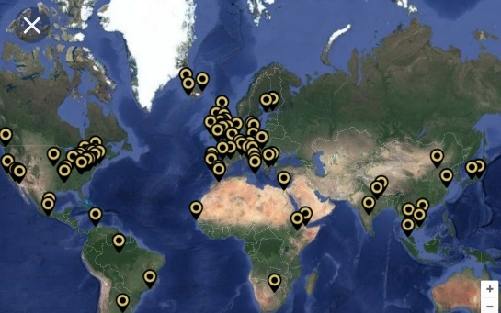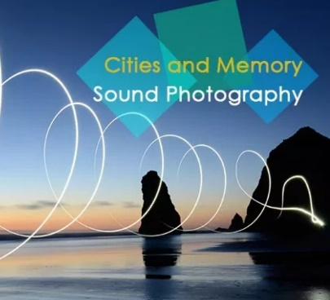(Fig 14-19)
Is there a relationship between music and memory? Unlike music and photography that tends to run parallel with each other, music and memory are two areas that can be used in conjunction to each other to help people. Songs from days, months and even years past can evoke emotions so powerful that if even for a moment, we are transported to the specific time that holds meaning in relation to the song being listened to. It conjures up emotions that were experienced during a time when the song was first hears or when it was playing during a particular moment when something of importance occurred. There is a powerful connection between music and memory and researchers are always searching for ways the memory system works and gaining more knowledge that could potentially help patients suffering with memory loss. This research is already helping patients that suffer with dementia. Music is often used to help those that have suffered brain injuries or memory loss as listening to music from earlier years can trigger vivid memories from those earlier years.
Music is a mnemonic device that had been used to past on stories long before the stories could be written down and documented. By adding melody and rhythm to the words, the stories could be memorised and passed on to following generations.
There are two large areas of the brain that are connected to the memory that are known as the hippocampus and the frontal cortex. Retrieving information from the memory can be difficult as there is so much information taken in on a daily basis so using music can provide the brain with clues. The melody and the structure of a song helps us to remember as it provokes the memory to come to the surface. Neuroscientists have carried out tests on the brain and have discovered that when attempting to memorise words, they are much easier to remember when set to music as this converts the words in a way that is understandable to the memory system. The power to recall a memory is much stronger when it is set to music. Music and memory have a connection to each other but why are strong emotions felt when hearing a particular song? This is because often the particular song we are listening to is associated with a specific time and the memory of that time is retrieved. It can bring back the emotions that were felt at the time the memory was first created as well as creating new emotions that relate to that memory such as happiness or sadness or even nostalgia for the days long past. Music can help retrieve memories from as far back as our childhood.
As music is often heard in many places, including in the car or at home, it has become so much more likely that we can retrieve more memories and create many more new memories.
The author of ‘The Proust Effect: The Senses as Doorways to Lost Memories’, Cretien Van Campen, discussed the ways in which different senses act, for example, eating something that was loved as a child can evoke memories based on taste, colour and smell. This is a memory that is very personal as it is something that others can’t relate to and so they are unable to retrieve or create memories based on another individuals’ senses. Many times, however, we listen to music collectively and therefore we can create a shared memory which unlike the sense of smell that is personal to us, music has the social aspect to it. Social memories can be very meaningful, especially if the experience of creating the memory is shared by those we love or significant people in our lives.
“People worry a lot today about forgetting and the problems with memory. But the beauty is today we are beginning to help with remembering.” – Campen.
How do photography and memory relate to each other? Our memories encode and store our memories to be retrieved at a later date. Photographs are recorded images of a memory so both the memory and photography capture and store specific memories that we can later retrieve or view. The difference between them is that the memory can also capture the emotion of that moment in time. Photography however, speaks of a specific moment in time, the place, and certain details. The photograph itself may not be able to evoke the emotion that was felt during the time the image was captured but, it can bring the memory of that time to the surface, so we can feel the emotion from the memory. A photograph can evoke certain emotions when looking back at them such as the feeling of happiness when looking at an image of a happy time or sadness when seeing an image of times that have passed never to be lived again. The raw emotion felt however, can only be felt when the photograph triggers the memory of the time and place in the image. Photographer have been referred to as ‘Agents of death’ by Roland Barthes as he thinks of the clicking of the shutter represents the passing of that moment as if it has died. We can look back at the photograph and remember that moment, but the photograph is just a reminder on a flat surface. If we really want to experience the true emotions of the moment that had passed, we must evoke the memory from our storage which can keep the moment alive in our memory system. This does not take away from the power of the photograph to capture and record memories as the images can act as a trigger to retrieve memories. We can relive those memories in a more vivid way when both the visual aspects of the moment of the captured image and the memory work together.
When capturing images with a camera, For the most part, we are able to recount more details about that moment than if we had simply lived that moment. Psychologists refer to this as ‘cognitive offloading’. It means that the brain has less work to do when a visual aid to help. Tests on this however, shows that this is not the case for everyone. Sometimes, especially in this age where we capture hundreds and thousands of images of everything, we can close down the ability to store what we are capturing in our memory as the image has become the main focus.
Music and photography both have the ability to create and evoke a memory. Music can accompany photography to create a more powerful and emotional piece of art work. Music is used as a tool to help the memory and photography gives us the ability to capture a still of a moment in time so that along with the memory of that time, we also have a visual aid. After researching the three keywords and how they relate it is my conclusion that although music, memory and photography can be separate entities that all work well on their own, they have a much bigger in pact on our lives when they are all working together harmoniously and this is important in many aspects of our lives. Music, memory and photography can help us relax, concentrate better and be able to intake information easier to improve our lives but it is also very important for helping those with memory loss to be able to live more fulfilled lives. With the help of music and photography, we can improve our memory and therefore we can function in life, learn new things and plan for the future.

Bibliography.

Beckerman, J. and Gray, T. (2014). The sonic boom. 1st ed. Boston, Mass.: Mariner Books.
Blackmon, T. (2014). Cognitive PsychologyFINAL PAPER - 724 Words | Bartleby. [online] Bartleby.com. Available at: https://www.bartleby.com/essay/Cognitive-PsychologyFINAL-PAPER-F365W3JVJ [Accessed 14 Apr. 2018].
Campos TF, e. (2010). Encoding, storage and retrieval processes of the memory and the implications for motor practice in stroke patients. - PubMed - NCBI. [online] Ncbi.nlm.nih.gov. Available at: https://www.ncbi.nlm.nih.gov/pubmed/20203379 [Accessed 9 Apr. 2018].
Crouse, A. (2015). How Does Music Affect Our Lives?. [online] The Express. Available at: https://www.blhsnews.com/opinion/2015/09/29/how-does-music-affect-our-lives/ [Accessed 8 Apr. 2018].
Divine, S. (2014). How Music Impacts Our Lives in Ways We Don't Even Notice. [online] www.ascap.com. Available at: https://www.ascap.com/playback/2014/11/radar-report/joel-beckerman-sonic-boom [Accessed 8 Apr. 2018].
Hamons, M., Jenkins, T. and Befi-Hensel, C. (2017). Music, memory, and meaning. 1st ed. USA: Whelk and Waters Publishing.
Jenkins, T. (2014). Why does music evoke memories?. [online] Bbc.com. Available at: http://www.bbc.com/culture/story/20140417-why-does-music-evoke-memories [Accessed 8 Apr. 2018].
Levitin, D. (2008). This is your brain on music. 1st ed. London: Atlantic.
Miendlarzewska, E. and Trost, W. (2014). How musical training affects cognitive development: rhythm, reward and other modulating variables. [online] Frontiers. Available at: https://www.frontiersin.org/articles/10.3389/fnins.2013.00279/full [Accessed 8 Apr. 2018].
Razon, R. (2017). 3 Ways Music Impacts My Life. [online] The Odyssey Online. Available at: https://www.theodysseyonline.com/3-ways-music-impacts-life [Accessed 8 Apr. 2018].
Sacks, O. (2013). Musicophilia. [London]: Picador.
Snyder, B. (2000). Music and memory. Cambridge: The MIT Press.

References.

Barthes, R. (1968). The Death of the Author. [online] artsites.ucsc.edu. Available at: http://artsites.ucsc.edu/faculty/Gustafson/FILM%20162.W10/readings/barthes.death.pdf [Accessed 8 Apr. 2018].
Baumgartner T, Willi M, Jäncke L. Modulation of corticospinal activity by strong emotions evoked by pictures and classical music: a transcranial magnetic stimulation study. Neuroreport. 2007;18:261–265. doi: 10.1097/WNR.0b013e328012272e. [PubMed] [Cross Ref]
Beckerman, J. and Gray, T. (2014). The sonic boom. 1st ed. Boston, Mass.: Mariner Books.
Buchanan TW. Retrieval of emotional memories. Psychol Bull. 2007;133:761–779. doi: 10.1037/0033-2909.133.5.761. [PMC free article] [PubMed] [Cross Ref]
Campos TF, e. (2010). Encoding, storage and retrieval processes of the memory and the implications for motor practice in stroke patients. - PubMed - NCBI. [online] Ncbi.nlm.nih.gov. Available at: https://www.ncbi.nlm.nih.gov/pubmed/20203379 [Accessed 9 Apr. 2018].
Chan AS, Ho YC, Cheung MC. Music training improves verbal memory. Nature. 1998;396:128. doi: 10.1038/24075. [PubMed] [Cross Ref]
Crouse, A. (2015). How Does Music Affect Our Lives? [online] The Express. Available at: https://www.blhsnews.com/opinion/2015/09/29/how-does-music-affect-our-lives/ [Accessed 8 Apr. 2018].
Divine, S. (2014). How Music Impacts Our Lives in Ways We Don't Even Notice. [online] www.ascap.com. Available at: https://www.ascap.com/playback/2014/11/radar-report/joel-beckerman-sonic-boom [Accessed 8 Apr. 2018].
Eschrich S, Münte TF, Altenmüller EO. Unforgettable film music: the role of emotion in episodic long-term memory for music. BMC Neurosci. 2008;9:48. doi: 10.1186/1471-2202-9-48. [PMC free article] [PubMed] [Cross Ref]
Hamons, M., Jenkins, T. and Befi-Hensel, C. (2017). Music, memory, and meaning. 1st ed. USA: Whelk and Waters Publishing.
Janata P, Tomic ST, Rakowski SK. Characterization of music-evoked autobiographical memories. Memory. 2007;15:845–860. doi: 10.1080/09658210701734593. [PubMed] [Cross Ref]
Jäncke, L. (2008). Music, memory and emotion. [online] BMC Miology. Journal of Biology. Available at: https://www.ncbi.nlm.nih.gov/pmc/articles/PMC2776393/
Jenkins, T. (2014). Why does music evoke memories? [online] Bbc.com. Available at: http://www.bbc.com/culture/story/20140417-why-does-music-evoke-memories [Accessed 8 Apr. 2018].
Koelsch S, Kasper E, Sammler D, Schulze K, Gunter T, Friederici AD. Music, language and meaning: brain signatures of semantic processing. Nat Neurosci. 2004;7:302–307. doi: 10.1038/nn1197. [PubMed] [Cross Ref]
Levitin, D. (2008). This is your brain on music. 1st ed. London: Atlantic.
Matlin, M. W. (2005). Cognition. Crawfordsville: John Wiley & Sons, Inc.
Miendlarzewska, E. and Trost, W. (2014). How musical training affects cognitive development: rhythm, reward and other modulating variables. [online] Frontiers. Available at: https://www.frontiersin.org/articles/10.3389/fnins.2013.00279/full [Accessed 8 Apr. 2018].
Miller, G. A. (1956). The magical number seven, plus or minus two: Some limits on our capacity for processing information. Psychological Review, 63 (2): 81–97.
Mizuno T, Sugishita M. Neural correlates underlying perception of tonality-related emotional contents. Neuroreport. 2007;18:1651–1655. [PubMed]
Peretz I, Coltheart M. Modularity of music processing. Nat Neurosci. 2003;6:688–691. doi: 10.1038/nn1083. [PubMed] [Cross Ref]
Platel H, Baron JC, Desgranges B, Bernard F, Eustache F. Semantic and episodic memory of music are subserved by distinct neural networks. Neuroimage. 2003;20:244–256. doi: 10.1016/S1053-8119(03)00287-8. [PubMed] [Cross Ref]
Platel H. Functional neuroimaging of semantic and episodic musical memory. Ann NY Acad Sci. 2005;1060:136–147. doi: 10.1196/annals.1360.010. [PubMed] [Cross Ref]

Publications, H. (2011). Music and health - Harvard Health. [online] Harvard Health. Available at: http://www.health.harvard.edu/staying-healthy/music-and-health [Accessed 9Apr. 2018].
Razon, R. (2017). 3 Ways Music Impacts My Life. [online] The Odyssey Online. Available at: https://www.theodysseyonline.com/3-ways-music-impacts-life [Accessed 8 Apr. 2018].
Sacks, O. (2013). Musicophilia. [London]: Picador.
Schendel ZA, Palmer C. Suppression effects on musical and verbal memory. Mem Cognit. 2007;35:640–650. [PubMed]
Simplypsychology.org. (2013). Memory, Encoding Storage and Retrieval | Simply Psychology. [online] Available at: https://www.simplypsychology.org/memory.html [Accessed 8 Apr. 2018].
Snyder, B. (2000). Music and memory. Cambridge: The MIT Press.
Snyder, B. (2001). Music and Memory. Cambridge: MIT Press. Website
Sternberg, R. J. (1999). Cognitive psychology (2 nd ed.). Fort Worth, TX: Harcourt Brace College Publishers.

