What is the Digestive System?
The digestive system consists of a group of organs, working together to break down food and absorb the nutrients. These nutrients are then used as fuel for the body, in order to keep its body systems working efficiently. The food that cannot be broken down, and is therefore left over, is then excreted as bowel movements (Svihus, 2014)
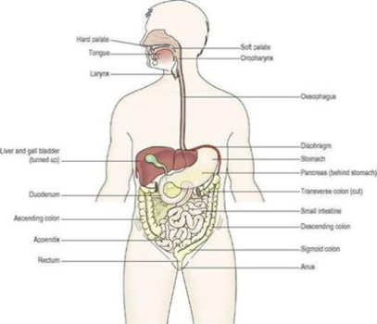
Organisation of the Digestive System
The system is made up of the gastrointestinal tract (GI tract), the pancreas, gallbladder and the liver. The GI tract is a series of organs joined in a long tube from the mouth to the anus. The organs that make up the GI tract are the mouth, oesophagus, stomach, small and large intestines and the anus. The small intestine consists of 3 parts. The first being called the duodenum, the second being called the jejunum and the ileum at the end. The large intestine includes the cecum, colon, appendix and the rectum. The cecum is the first part of the large intestine, followed by the colon, finally followed by the rectum. The appendix is a 4-inch-long tube that projects out from the colon.
How Does Food Move Through the GI Tract
Mouth: When we swallow, the tongue pushes food into our throat, allowing it to move through the GI tract. Small tissue (epiglottis) folds over the windpipe to prevent choking, allowing food to pass into the oesophagus.
Oesophagus: The process then becomes automatic when you begin to swallow. The muscles of the oesophagus are signalled by the brain, allowing peristalsis to start.
Lower Oesophageal Sphincter: Food is then relaxed, allowing it to pass into the stomach. The sphincter usually stays closed, in order to keep food in the stomach from flowing back
Stomach: Stomach muscles mix the food with gastric juices, slowly emptying everything into the small intestine.
Small Intestine: The walls of the small intestine make enzymes, that work the liver and pancreas’ enzymes, to mix the food and push it forward for more digestion. Water and nutrients are absorbed into the bloodstream, and peristalsis continues, products move into the large intestine.
Large Intestine: Water is absorbed to change waste products from liquid to solid stool, using peristalsis to move the stool to the rectum.
Rectum: Stool is stored until it is pushed out of the anus during a bowel movement

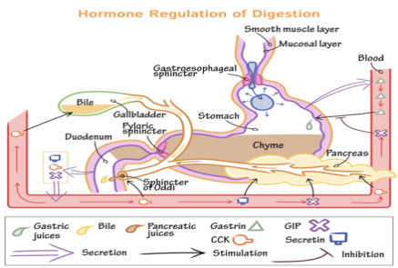
Controlling the Digestive System
Hormone Regulators
- Cells lining the stomach and small intestine make and release hormones that control how your digestive system works.
- The hormones tell your body to make digestive juices, and send signals to your brain to regulate your appetite (Khan and Ghia, 2010)

Nerve Regulators
- There are nerves that are connected the CNS (Central Nervous System), which consists of the brain and the spinal cord, to your digestive system and control some digestive functions.
E.G: When food is seen or smelt, the brain sends a signal which prepares your salivary
glands to eat, by ‘making your mouth water’.
- There are also nerves connected to the ENS (Enteric Nervous System), within the GI tract. When food stretches the walls of the GI tract, the nerves release substances that speed up or even delay the movement of food.
- Nerves send signals to control the muscles of the gut. Muscles contract and relax, in order to push the food through the small and large intestines.

2 Types of Nerves in the Digestive System
Extrinsic Nerves: Connect the organs to the CNS
- Releases different chemicals that cause the muscle layer of the GI tract to relax or contract
Intrinsic Nerves: Used when food stretches walls of organs
- Releases substances that speed up or slow down the movement of food, as well as the production of juices.

Digestive Diseases: Irritable Bowel Syndrome

Definition:
Collection of symptoms that happen together, for example: irregular bowel movements, like constipation or diarrhoea, as well as repeated pain in the abdomen. Sometimes people have these symptoms, without any visible, clear signs or disease in the digestive tract (Chey et al, 2015).
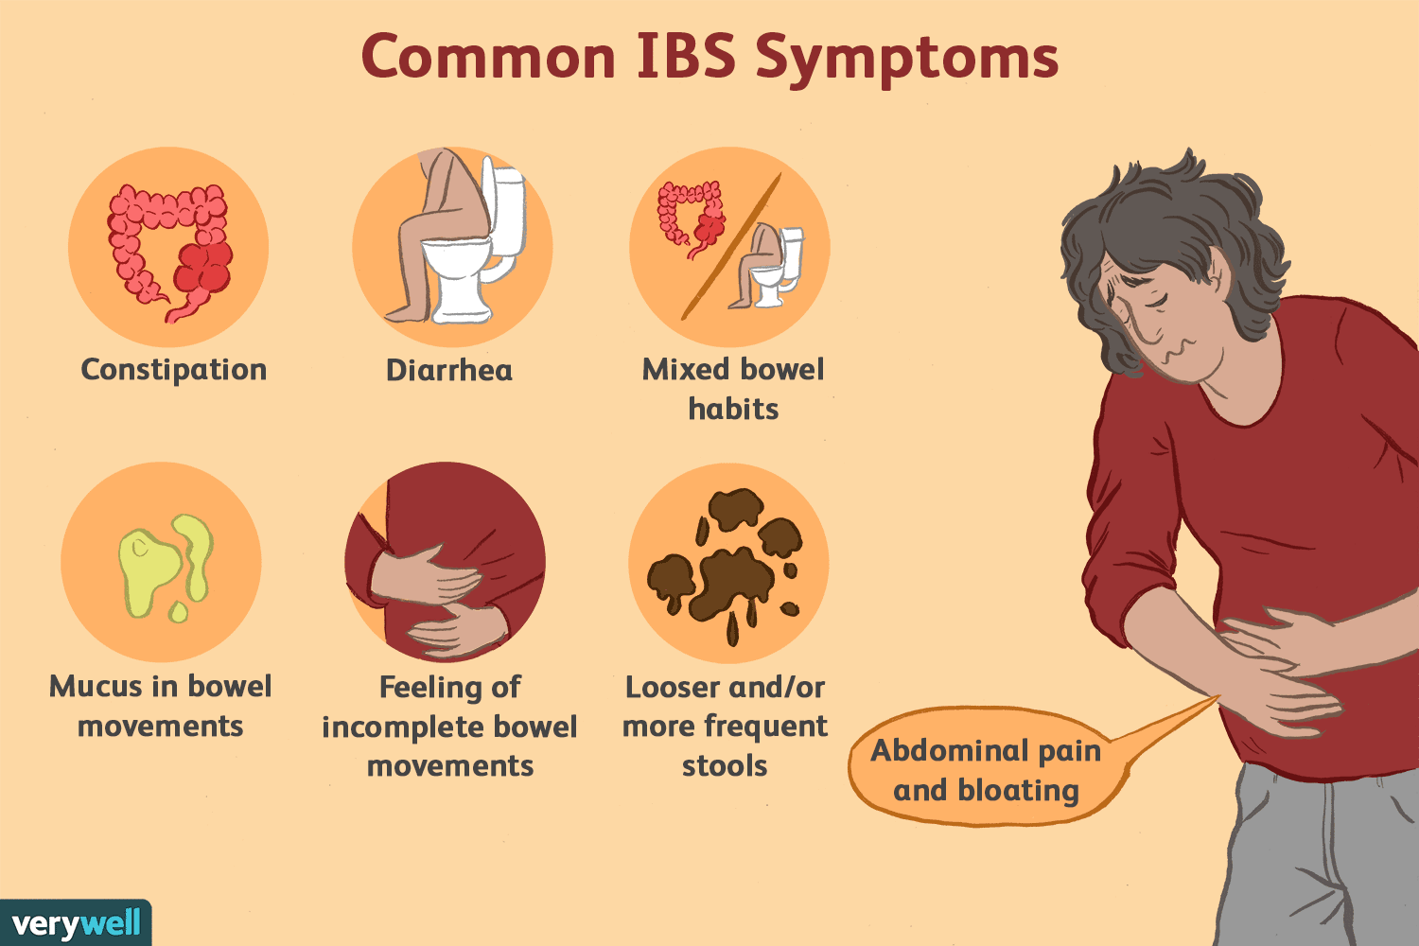
Symptoms and Causes:
One of the most common of all the symptoms is severe pain in the abdomen, which is very normally associated with a change in an individual’s bowel movements. The most often occurring symptoms depend on which IBS you have, but mainly diarrhoea and constipation.

Treatments:
Doctors usually treat IBS by recommending beneficial changes to the individual’s lifestyle. These changes include dietary restrictions, medicines, therapy for mental health, as well as probiotics. Individuals usually have to try a series of different treatments to find the most favourable one for them.
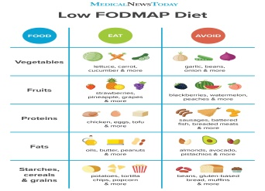
Eating and Dietary Changes:
As previously stated, changes to nutrition is key to seeing positive results in relation to IBS. These changes include, avoiding certain ingredients like gluten, eating more fibre, or following stricter diets like the FODMAP (fermentable oligo-, di-, mono saccharides and polyols) diet. Some popular foods that trigger IBS include: apple, chocolate, caffeine, nuts and margarine (health.harvard, 2010).

Digestive Diseases: Acid Reflux

Definition:
Acid reflux, or gastroesophageal reflux, occurs when the contents in the stomach return into the oesophagus, causing a long term, severe condition, in which the over bearing symptoms cause an increase in complications over time.

Symptoms and Causes:
One of the main reasons for acid reflux is when the lower oesophageal sphincter becomes weak or it begins to relax when it shouldn’t. The symptoms include regurgitation and severe heartburn.

Treatment:
Treatment, like many other digestive diseases, includes massive change to your lifestyle. This includes taking over the counter medicines, changes to nutrition, as well as surgery in some severe cases.
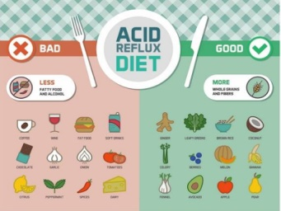
Eating and Dietary Changes:
To minimise the symptoms, doctors usually tell patients to keep an eye on their weight, if the individual is overweight, through recommending weight loss. Doctors also advise patients to eat meals 2 to 3 hours before lying down, as well as avoiding certain food or drink in order to reduce the symptoms. Some of these foods include: cheese, ice cream, garlic, onions, as well as anything spicy.

References

Chey, W.D., Kurlander, J. and Eswaran, S., 2015. Irritable bowel syndrome: a clinical review. Jama, 313(9), pp.949-958.

Khan, W.I. and Ghia, J.E., 2010. Gut hormones: emerging role in immune activation and inflammation. Clinical & Experimental Immunology, 161(1), pp.19-27.

Svihus, B., 2014. Function of the digestive system. Journal of Applied Poultry Research, 23(2), pp.306-314.

file:///C:/Users/ADMIN/Downloads/AnatomyandPhysiology.pdf

https://www.drawittoknowit.com/course/physiology/glossary/physiological-process/hormone-regulation-of-digestion
https://www.verywellhealth.com/ibs-pain-locations-1945305

http://skynewswire.com/7-foods-to-help-your-acid-reflux

https://www.health.harvard.edu/diet-and-weight-loss/a-new-diet-to-manage-irritable-bowel-syndrome

