

Data Handling and Business Intelligence

Student Name: Vasile Murgu
Student Id: 2019287
Lecturer Name: Anupam Mazumdar
Table of Contents
Part 1 3
Part 2 5
k mean clustering 7
Initial Cluster Centers 7
Iteration Historyª 7
Data mining methods 18
Text mining methods 19
Advantages and disadvantages of Excel and SPSS 19
References 21

Part 1
MS Excel is considered as the most powerful visualization of data software, for this purpose spreadsheets are used. With the use of spreadsheets data can be track, store and organize. Accountants, marketers and data analytics are efficiently use MS Excel. Budgets, balance sheets are considered as the examples o f excel. Excel is primarily utilized by the financial departments due to it’s strong analysis powers. The formulas of excel offer users to solve any statistical problems at a quicker rates just by the use of excel formulas and functions. Excel is a method for data preparation and management. Both Windows and Mac users can use it. With the use of Microsoft Excel's tools and methods, data structure may be polished up by making more valuable. Alternatively, the user can interact with the spreadsheets data using Excel's pivot table feature. When evaluating similar data from different angles, no mathematics or efforts are needed because the information is similar in each situation. A user can categories data, partition it into months and years, filter it, and then even graph it to create a unique perspective.
Crime rates vs. Northern youth
The available data provide the data of crime rate according to the northern youth. The table below will define the sum of youth numbers of northern region and crime rates.
CrimeRate | Youth
45.5 | 135
52.3 | 140
64.2 | 126
67.6 | 128
70.5 | 130
73.2 | 143
75 | 141
78.1 | 133
82.3 | 123
83.1 | 135
84.9 | 121
88 | 140
92.3 | 126
94.3 | 130
95.3 | 125
104.3 | 134
105.9 | 130
107.2 | 148
108.3 | 126
115.1 | 131
117.2 | 136
119.7 | 119
127.2 | 132
132.4 | 152
135.5 | 125
137.8 | 141
140.8 | 150
149.3 | 143
154.3 | 124
157.7 | 136
161.8 | 131
total | 4134

The figure define the crime rates over the youths in northern region
Crime rates vs. youth (southern region)
56.6 | 157
60.3 | 139
79.8 | 142
85.6 | 166
96.8 | 151
97.4 | 152
98.7 | 162
99.9 | 149
103 | 177
106.6 | 157
109.4 | 135
112.1 | 142
114.3 | 127
121.6 | 147
123.4 | 145
145.4 | 131
total | 2379
IF function
IF function in Microsoft Excel is considered as the most often used function. Users can utilize IF functions to make logical comparisons between values. The function was used to make the reasonable compression among the crime statistics for the given data.
The IF function has been applied to the data set to make the logical compression between the values of crime rates as seen in the table below
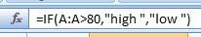
Logic compression in terms of "HIGH" "LOW" has been made possible by the usage of the IF function. If the crime rate is less than 80, the function displays the result as low; however, if the crime rate is greater than 80, the function displays the result as high.
Crime Rate | Youth | Region | State Size | Youth Unemployment | Crime severity
45.5 | 135 | 0 | 6 | 80 | low
52.3 | 140 | 0 | 6 | 135 | low
64.2 | 126 | 0 | 40 | 78 | low
67.6 | 128 | 0 | 28 | 77 | low
70.5 | 130 | 0 | 14 | 70 | low
73.2 | 143 | 0 | 10 | 114 | low
75 | 141 | 0 | 4 | 107 | low
78.1 | 133 | 0 | 7 | 99 | low
82.3 | 123 | 0 | 113 | 124 | High
83.1 | 135 | 0 | 22 | 77 | High
84.9 | 121 | 0 | 25 | 84 | High
88 | 140 | 0 | 7 | 100 | High
92.3 | 126 | 0 | 34 | 102 | High
94.3 | 130 | 0 | 51 | 78 | High
95.3 | 125 | 0 | 97 | 105 | High
104.3 | 134 | 0 | 47 | 83 | High
105.9 | 130 | 0 | 3 | 113 | High
107.2 | 148 | 0 | 9 | 84 | High
108.3 | 126 | 0 | 18 | 102 | High
115.1 | 131 | 0 | 7 | 142 | High
117.2 | 136 | 0 | 29 | 111 | High
119.7 | 119 | 0 | 168 | 92 | High
127.2 | 132 | 0 | 43 | 83 | High
132.4 | 152 | 0 | 10 | 103 | High
135.5 | 125 | 0 | 78 | 130 | High
137.8 | 141 | 0 | 18 | 91 | High
140.8 | 150 | 0 | 9 | 87 | High
149.3 | 143 | 0 | 13 | 96 | High
154.3 | 124 | 0 | 101 | 77 | High
157.7 | 136 | 0 | 157 | 102 | High
161.8 | 131 | 0 | 3 | 102 | High
56.6 | 157 | 1 | 22 | 97 | low
60.3 | 139 | 1 | 19 | 135 | low
79.8 | 142 | 1 | 18 | 94 | low
85.6 | 166 | 1 | 46 | 72 | High
96.8 | 151 | 1 | 33 | 108 | High
97.4 | 152 | 1 | 30 | 92 | High
98.7 | 162 | 1 | 40 | 73 | High
99.9 | 149 | 1 | 36 | 86 | High
103 | 177 | 1 | 24 | 76 | High
106.6 | 157 | 1 | 39 | 81 | High
109.4 | 135 | 1 | 31 | 89 | High
112.1 | 142 | 1 | 33 | 116 | High
114.3 | 127 | 1 | 4 | 97 | High
121.6 | 147 | 1 | 23 | 76 | High
123.4 | 145 | 1 | 96 | 88 | High
145.4 | 131 | 1 | 50 | 79 | High

Crime rate vs. education
The table below will show the crime rates and education
Crime Rate | Education
45.5 | 12.4
52.3 | 10.9
64.2 | 12.2
67.6 | 13.5
70.5 | 14.1
73.2 | 12.9
75 | 12.9
78.1 | 11.4
82.3 | 12.5
83.1 | 13.6
84.9 | 13.2
88 | 12.9
92.3 | 12.7
94.3 | 13.3
95.3 | 12
104.3 | 12.5
105.9 | 13.4
107.2 | 13.7
108.3 | 13.8
115.1 | 13.7
117.2 | 12.9
119.7 | 11.9
127.2 | 10.4
132.4 | 12
135.5 | 12.5
137.8 | 14.2
140.8 | 12
149.3 | 12.3
154.3 | 12.3
157.7 | 15.1
161.8 | 13.2
56.6 | 11.2
60.3 | 11.9
79.8 | 12.9
85.6 | 11.4
96.8 | 10
97.4 | 10.8
98.7 | 12.1
99.9 | 10.7
103 | 11
106.6 | 11.1
109.4 | 11.4
112.1 | 10.9
114.3 | 12.8
121.6 | 13.9
123.4 | 11.7
145.4 | 12.2
Crime rate vs. sate size
The table below show the sum of state size and crime rates.
Crime Rate | Sum of State Size
45.5 | 6
52.3 | 6
64.2 | 40
67.6 | 28
70.5 | 14
73.2 | 10
75 | 4
78.1 | 7
82.3 | 113
83.1 | 22
84.9 | 25
88 | 7
92.3 | 34
94.3 | 51
95.3 | 97
104.3 | 47
105.9 | 3
107.2 | 9
108.3 | 18
115.1 | 7
117.2 | 29
119.7 | 168
127.2 | 43
132.4 | 10
135.5 | 78
137.8 | 18
140.8 | 9
149.3 | 13
154.3 | 101
157.7 | 157
161.8 | 3
56.6 | 22
60.3 | 19
79.8 | 18
85.6 | 46
96.8 | 33
97.4 | 30
98.7 | 40
99.9 | 36
103 | 24
106.6 | 39
109.4 | 31
112.1 | 33
114.3 | 4
121.6 | 23
123.4 | 96
145.4 | 50
 | 1721
Region vs. youth unemployment
The table below shows the rate of unemployment of northern region
The name of region is denoted by the code as

Region
Northern | 0
Southern | 1

Region | sum of Youth Unemployment
0 | 80
0 | 135
0 | 78
0 | 77
0 | 70
0 | 114
0 | 107
0 | 99
0 | 124
0 | 77
0 | 84
0 | 100
0 | 102
0 | 78
0 | 105
0 | 83
0 | 113
0 | 84
0 | 102
0 | 142
0 | 111
0 | 92
0 | 83
0 | 103
0 | 130
0 | 91
0 | 87
0 | 96
0 | 77
0 | 102
0 | 102
 | 3028
the table below shows the sum of youth Unemployment of southern region
Region | sum of Youth Unemployment
1 | 97
1 | 135
1 | 94
1 | 72
1 | 108
1 | 92
1 | 73
1 | 86
1 | 76
1 | 81
1 | 89
1 | 116
1 | 97
1 | 76
1 | 88
1 | 79
Region vs. education
The table below shows the education rate according to the region
As per northern region
Region | Education
0 | 12.4
0 | 10.9
0 | 12.2
0 | 13.5
0 | 14.1
0 | 12.9
0 | 12.9
0 | 11.4
0 | 12.5
0 | 13.6
0 | 13.2
0 | 12.9
0 | 12.7
0 | 13.3
0 | 12
0 | 12.5
0 | 13.4
0 | 13.7
0 | 13.8
0 | 13.7
0 | 12.9
0 | 11.9
0 | 10.4
0 | 12
0 | 12.5
0 | 14.2
0 | 12
0 | 12.3
0 | 12.3
0 | 15.1
0 | 13.2

As per southern region
1 | 11.2
1 | 11.9
1 | 12.9
1 | 11.4
1 | 10
1 | 10.8
1 | 12.1
1 | 10.7
1 | 11
1 | 11.1
1 | 11.4
1 | 10.9
1 | 12.8
1 | 13.9
1 | 11.7
1 | 12.2

Crime rate vs. males
The graph below represents the sum of males and crime rates
Crime Rate | Males
45.5 | 965
52.3 | 1045
64.2 | 989
67.6 | 972
70.5 | 984
73.2 | 977
75 | 968
78.1 | 1024
82.3 | 948
83.1 | 986
84.9 | 964
88 | 1029
92.3 | 984
94.3 | 934
95.3 | 964
104.3 | 972
105.9 | 1049
107.2 | 998
108.3 | 990
115.1 | 1038
117.2 | 1012
119.7 | 938
127.2 | 953
132.4 | 1018
135.5 | 985
137.8 | 985
140.8 | 964
149.3 | 1012
154.3 | 966
157.7 | 994
161.8 | 1071
56.6 | 962
60.3 | 968
79.8 | 969
85.6 | 973
96.8 | 950
97.4 | 986
98.7 | 996
99.9 | 953
103 | 974
106.6 | 955
109.4 | 978
112.1 | 956
114.3 | 982
121.6 | 972
123.4 | 981
145.4 | 969
 | 46202

Wage vs. below wage
The graph below represents the sum of below wage
Wage | sum of Below Wage
564 | 139
453 | 200
593 | 171
507 | 206
486 | 196
487 | 166
489 | 170
425 | 225
572 | 158
529 | 190
689 | 126
526 | 174
557 | 195
627 | 135
617 | 163
580 | 172
588 | 160
590 | 144
589 | 166
540 | 176
622 | 162
637 | 154
513 | 227
537 | 215
626 | 166
578 | 174
559 | 153
557 | 194
657 | 170
673 | 167
674 | 152
288 | 276
457 | 249
318 | 250
396 | 237
394 | 261
405 | 264
496 | 224
395 | 251
382 | 254
421 | 239
631 | 165
427 | 247
620 | 168
462 | 233
488 | 228
472 | 206
 | 9118
Labor force vs. males
The table below shows the sum of labor force
sum of Labour Force | Males
540 | 965
535 | 1045
599 | 989
624 | 972
641 | 984
537 | 977
523 | 968
599 | 1024
526 | 948
595 | 986
547 | 964
632 | 1029
602 | 984
536 | 934
586 | 964
595 | 972
623 | 1049
601 | 998
542 | 990
574 | 1038
574 | 1012
521 | 938
564 | 953
571 | 1018
567 | 985
591 | 985
531 | 964
583 | 1012
580 | 966
577 | 994
631 | 1071
512 | 962
480 | 968
533 | 969
521 | 973
510 | 950
530 | 986
522 | 996
515 | 953
638 | 974
553 | 955
537 | 978
497 | 956
519 | 982
560 | 972
560 | 981
542 | 969
26376

Crime rate vs. labor force
Crime Rate | Labour Force
45.5 | 540
52.3 | 535
64.2 | 599
67.6 | 624
70.5 | 641
73.2 | 537
75 | 523
78.1 | 599
82.3 | 526
83.1 | 595
84.9 | 547
88 | 632
92.3 | 602
94.3 | 536
95.3 | 586
104.3 | 595
105.9 | 623
107.2 | 601
108.3 | 542
115.1 | 574
117.2 | 574
119.7 | 521
127.2 | 564
132.4 | 571
135.5 | 567
137.8 | 591
140.8 | 531
149.3 | 583
154.3 | 580
157.7 | 577
161.8 | 631
56.6 | 512
60.3 | 480
79.8 | 533
85.6 | 521
96.8 | 510
97.4 | 530
98.7 | 522
99.9 | 515
103 | 638
106.6 | 553
109.4 | 537
112.1 | 497
114.3 | 519
121.6 | 560
123.4 | 560
145.4 | 542

Labour force vs. below wage
the table below shows the sum of below wage
Labour Force | sum of Below Wage
540 | 139
535 | 200
599 | 171
624 | 206
641 | 196
537 | 166
523 | 170
599 | 225
526 | 158
595 | 190
547 | 126
632 | 174
602 | 195
536 | 135
586 | 163
595 | 172
623 | 160
601 | 144
542 | 166
574 | 176
574 | 162
521 | 154
564 | 227
571 | 215
567 | 166
591 | 174
531 | 153
583 | 194
580 | 170
577 | 167
631 | 152
512 | 276
480 | 249
533 | 250
521 | 237
510 | 261
530 | 264
522 | 224
515 | 251
638 | 254
553 | 239
537 | 165
497 | 247
519 | 168
560 | 233
560 | 228
542 | 206
 | 9118

Pivot table
Values
Sum of Crime Rate | 4832
Sum of Youth | 6513
Sum of ExpenditureYear0 | 3995
Sum of Males | 46202
Sum of State Size | 1721
Sum of YouthUnemployment | 4487
Sum of Mature Unemployment | 1597
Sum of High Youth Unemploy | 15
Sum of Below Wage | 9118
Sum of Wage | 24693
Sum of LabourForce | 26376
Sum of Region | 16
Sum of Education | 582.4

Figure 1 Part 1: Pivot Table and Graphs
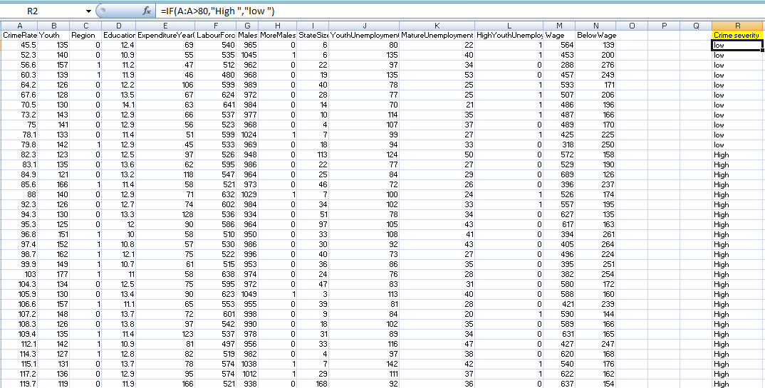
Figure 2 Part 1: IF Statement

Part 2
- Number of students who like Vanilla flavor i.e. flavor code: 1 = 95
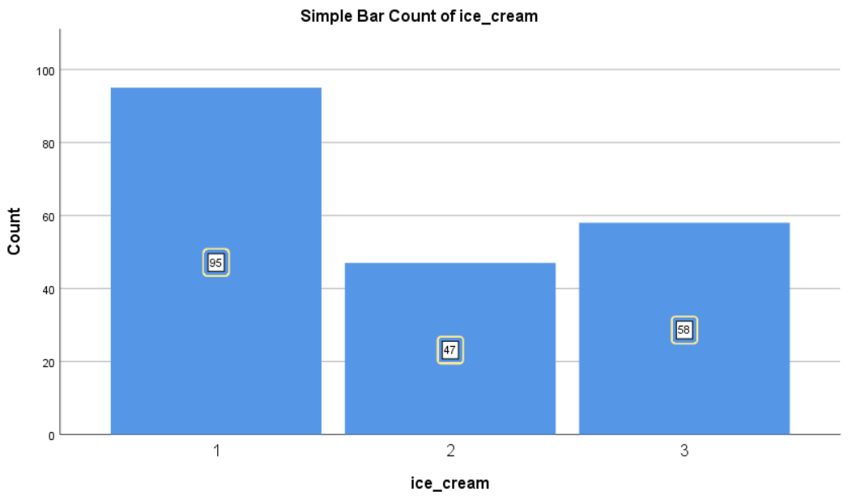
Figure 3 Flavor 1 is Vanilla
- Number of male and female students=
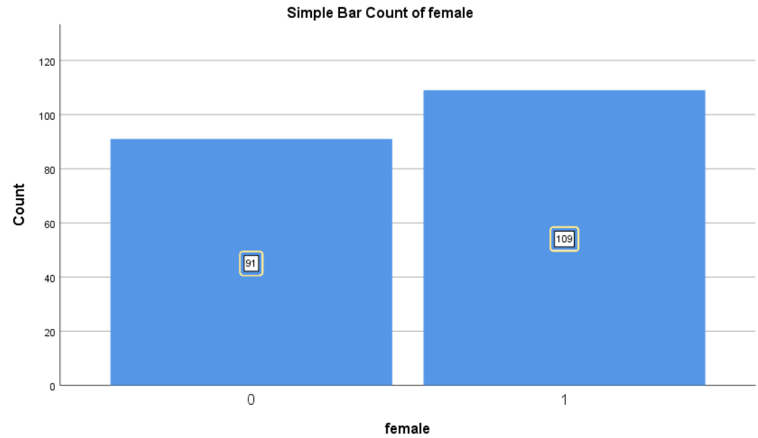
Male= 91
Female= 109
3. Mean and Median of participants who like strawberry and chocolate flavor:
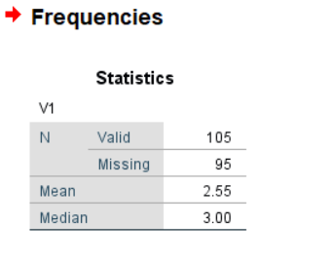
Figure 4 Statistics of Chocolate and Strawberry Flavors
Mean: 2.55
Median: 3.00

a).

k means clustering

Initial Cluster Centers
 | Cluster
 | 1 | 2
id | 1 | 200
female | 1 | 0
ice_cream | 2 | 1

Iteration Historyª
Iteration | Change in Cluster Centers
Iteration | 1 | 2
1 | 49.502 | 49.508
2 | .000 | .000
a. Convergence achieved due to no or small change in cluster centers. The maximum absolute coordinate change for any center is .000. The current iteration is 2. The minimum distance between initial centers is 199.005.

Cluster Membership
Case Number Cluster Distance
1 1 19.510
2 2 29.514
3 1 35.523
4 2 9.593
5 2 21.519
6 2 37.511
7 1 1.169
8 1 39.514
9 1 33.517
10 1 2.714
11 1 24.523
12 1 9.559
13 1 44.518
14 2 46.519
15 1 12.515
16 2 35.504
17 1 25.532
18 2 44.509
19 2 36.524
20 1 34.516
21 2 16.525
22 2 7.554
23 1 9.559
24 1 30.527
25 1 38.515
26 1 2.714
27 2 3.745
28 2 27.515
29 2 45.520
30 1 21.509
31 2 24.517
32 2 47.519
33 2 41.521
34 2 1.033
35 2 48.518
36 2 6.635
37 2 49.508
38 1 29.528
39 1 34.505
40 2 2.659
41 2 25.516
42 2 26.515
43 2 17.523
44 1 10.518
45 1 11.571
46 2 18.508
47 1 1.972
48 2 14.528
49 2 38.511
50 1 43.513
51 1 23.524
52 2 22.539
53 1 29.519
54 2 32.513
55 2 18.522
56 1 35.523
57 1 16.511
58 1 28.520
59 2 34.512
60 1 41.513
61 2 30.513
62 2 19.546
63 2 16.509
64 2 42.510
65 2 46.519
66 2 10.539
67 2 20.520
68 2 43.503
69 1 30.506
70 1 32.517
71 2 4.590
72 1 46.518
73 1 17.532
74 2 6.563
75 1 5.601
76 1 45.504
77 2 8.604
78 2 27.532
79 2 13.530
80 1 36.522
81 2 23.538
82 2 14.510
83 2 23.517
84 1 47.504
85 1 7.574
86 2 4.693
87 2 48.518
88 2 33.527
89 2 17.523
90 1 43.519
91 1 26.521
92 2 1.596
93 1 31.523
94 1 42.502
95 2 21.507
96 2 22.507
97 1 6.570
98 1 49.515
99 1 49.502
100 2 43.521
101 1 37.519
102 1 48.515
103 1 3.525
104 2 30.529
105 2 15.527
106 1 14.532
107 2 49.518
108 1 38.502
109 1 3.525
110 2 29.530
111 2 11.536
112 1 46.502
113 2 19.546
114 2 25.506
115 1 16.543
116 2 44.509
117 2 20.544
118 1 42.517
119 2 12.513
120 1 13.507
121 1 15.506
122 1 36.513
123 1 22.520
124 2 1.043
125 1 6.514
126 2 2.012
127 2 45.509
128 1 22.520
129 1 40.518
130 1 5.516
131 2 34.512
132 1 17.505
133 1 15.530
134 1 21.521
135 1 26.503
136 1 10.568
137 2 39.511
138 1 8.554
139 1 48.509
140 1 4.601
141 1 31.503
142 1 39.518
143 2 8.549
144 1 33.514
145 2 28.515
146 2 40.522
147 1 32.514
148 2 31.513
149 1 44.502
150 1 4.520
151 1 7.512
152 1 45.516
153 2 12.533
154 1 40.511
155 1 20.522
156 2 11.536
157 2 40.510
158 2 2.662
159 2 41.510
160 1 11.562
161 2 3.545
162 1 23.520
163 2 47.519
164 2 10.515
165 2 38.511
166 1 18.505
167 2 5.576
168 2 39.504
169 2 35.512
170 1 47.502
171 2 31.505
172 1 37.512
173 1 1.299
174 1 24.529
175 1 14.506
176 2 15.510
177 1 8.554
178 1 27.517
179 1 13.553
180 1 12.507
181 1 28.516
182 2 42.510
183 1 41.517
184 2 9.544
185 1 18.539
186 1 27.503
187 2 7.556
188 1 25.518
189 2 37.524
190 1 1.558
191 2 26.506
192 2 24.537
193 2 33.513
194 1 20.535
195 2 28.515
196 1 19.523
197 2 5.576
198 2 36.511
199 2 32.513
200 2 13.566

Final Cluster Centers
 | Cluster
 | 1 | 2
id | 51 | 151
female | 1 | 0
ice_cream | 2 | 2

Distances between Final Cluster Centers
Cluster | 1 | 2
1 |  | 100.000
2 | 100.000

ANOVA
 | Cluster |  | Error |  | F | Sig.
 | Mean Square | df | Mean Square | df | F | Sig.
id | 500000.000 | 1 | 841.667 | 198 | 594.059 | .000
female | .605 | 1 | .247 | 198 | 2.445 | .119
ice_cream | .605 | 1 | .735 | 198 | .823 | .365
The F tests should be used only for descriptive purposes because the clusters have been chosen to maximize the differences among cases in different clusters. The observed significance levels are not corrected for this and thus cannot be interpreted as tests of the hypothesis that the cluster means are equal.

Number of Cases in each Cluster
Cluster | 1 | 100.000
Cluster | 2 | 100.000
Valid |  | 200.000
Missing |  | .000

b).

Data mining methods
Classification: in this method of data mining attributes are used to move the data into discernable categories. With the help of categories classification, the information of customers can be stored more frequently and provide better understandings of customers to businesses
Clustering: in this method of data mining similar data sets are classified and provide the simplest form of data to businesses
Regression analysis: this technique is used to make a plan and model, identify the specific variables. With the help of regression analysis relationship between the sets can be determined
For example, mobile service providers can use data mining to design their campaign marketing and to retain their customers from shifting to other vendors

Text mining methods
Information extraction: This technique is considered the most common text mining technique of businesses which is based on information exchange. In this technique, meaningful data is collected from a variety of datasets.
Categorization: categorization or rather NLP (Natural Language Processing) is a procedure of meeting text documents and processing and analyzing them to discover the right indexes or topics for each document.
For example, text mining is used in customer care services to provide rapid responses for customers, the entire responses processes are based on automated patterns.
C)

Advantages and disadvantages of Excel and SPSS

Advantages of Excel | Disadvantages of Excel
- Organizing data: for data collection and organizing Excel used spreadsheets by which the entire data set is to manage in a well-defined format and provide quick understandings to users (Blanaey, et. al., 2019).  - Access of multiple users: it is considered as the top advantage of Excel, multiple users can get access tothe same file in a single time  - For example, Excel is used for data entry and storage in businesses for both operations it is a vital tool (Becker, et. al., 2019). | - User bias: in data analysis processes decision-making approach can be excluded  - Lack of security: it is another disadvantage of spreadsheets in which data corruption and mismanagement issues can be generated

Advantages of SPSS | Disadvantages of SPSS
- SPSS is considered as the comprehensive statistical software that provides multiple benefits to users in terms of data management (Stehik, et. al., 2017)  - SPSS has multiple complex statistical tests, this feature of SPSS makes it different from its competitors (McCormick, et. al., 2017).  - The interpretation of the result is relatively easy  - It can display the data tables with quicker rates  - For example, SPSS is widely used by multiple researchers for the analysis of complex data sets. | - For students, the rate of purchase is very expensive  - To take the advantage of its features users need training  - The feature of the graph is not simple as of Excel

References
Salo, F., Injadat, M., Nassif, A.B., Shami, A. and Essex, A., 2018. Data mining techniques in intrusion detection systems: A systematic literature review. IEEE Access, 6, pp.56046-56058.
Support.microsoft.com. 2022. Excel functions (alphabetical). [online] Available at: <https://support.microsoft.com/en-us/office/excel-functions-alphabetical-b3944572-255d-4efb-bb96-c6d90033e188> [Accessed 22 March 2022].
Stehlik-Barry, K. and Babinec, A.J., 2017. Data analysis with IBM SPSS statistics. Packt Publishing Ltd.
McCormick, K. and Salcedo, J., 2017. SPSS statistics for data analysis and visualization. John Wiley & Sons.
Blayney, P.J. and Sun, Z., 2019. Using Excel and Excel VBA for preliminary analysis in big data research. In Managerial Perspectives on Intelligent Big Data Analytics (pp. 110-136). IGI Global.
Becker, L.T. and Gould, E.M., 2019. Microsoft power BI: extending excel to manipulate, analyze, and visualize diverse data. Serials Review, 45(3), pp.184-188.

