

1 Digital Skills and Research Methods [BMS4003 LON]

Student name | Japhet Nwaeke
Module name | DSR
Student ID | 1810253
Lecturer | Balendran Kandasamy

Table of Contents
Introduction 3

Modern Technology is the collection of techniques, Skills, Methods, and processes used in the production of goods or services or in accomplishment of objectives, such as scientific investigation for examples of technology – it includes machines [like computers chips] but also techniques and processes [like the way we produce computer chips] it might seem like all technology is only electronic, but that is just most modern technology. In fact, a hammer and the wheel are two examples of early human.

Cloud Storage is a service model in which data is maintained, managed, backed up remotely and made available to users over a network [typically the internet] users generally pay for their cloud data storage on a per- consumption, monthly rate. Although the pre – gigabyte cost has been radically driven down, cloud storage providers have added operating expenses that can make the technology more expensive than users bargained for. Cloud security continues to be concern among users providers have tried to deal with those fears by building security capabilities, such as encryption and authentication, into the service .There are three main cloud- based storage architecture models, Public, Private, and Hybrid.
Public Cloud Storage Services provide a multi – tenant storage environment that is most suited for unstructured data. Data is stored in global data centers with storage data spread across multiple regions or continents, customers generally pay on a per- use basis similar to the utility payment model.
Hybrid Cloud is a mix of private cloud and third – party public cloud services with orchestration between the platforms for management. The model offers businesses flexibility and more data deployment options. In recent years , most customers have accepted the hybrid cloud model. Despite its benefits, a hybrid cloud presents technical business and management challenges, for example private workloads must access and interact with public cloud storage providers, so compatibility and solid network connectivity are very import factors.
Google Drive VS Dropbox
Two of the main providers are Google Drive and Dropbox -Both offer the same basic features and are very comparable .Dropbox came out few years before Google Drive so it has a large market share, however Google Drive still is a cloud competitor with any competing product. Google Drive is a cloud storage service and like any cloud storage service its main function is to expand your ability to store files beyond the limits of your hard drive while Dropbox keep every thing organised with out breaking your flow ,Dropbox brings your files together in one central place. They are easy to find and safely synced across all of your devices -so you can access them any time any where .Dropbox is built for creative collaboration, share a big file -power point ,photoshop and sketch.
Price V.S storage space ,each service offer a certain amount of free storage space for their users an additional storage can be purchased .Google Drive starts users off with 5GB of storage where as Dropbox only starts with 2GB of storage. Google Drive offers 25 GB for $2.49 a month, 100 GB for $4.99 month ,if users need more storage space why Dropbox rates on the other hand start at $9.99 a month for 50 GB or $19.99 a month for 100 GB over all ,Google Drive sale the space more cheaper.
The ability to share files is a key aspect when analysing both Google Drive and Dropbox. The main different here is that Google Drive share files through the web app why Dropbox share files from its desktop.
Deleting of files and old versions, both Google Drive and Dropbox have their different way to deal with version control which allows you to go back and recover old files that you deleted or older versions of a file. The way Google Drive deals version control it is that it stores up to 100 reversions of a document or 30 days of versions per document, which counts towards your total storage allowance. The trash folder is used to store deleted files and if the trash folder is deleted the files can not be recovered again. Dropbox keeps unlimited versions of your document for 30 days and it does not count towards the total storage space you are all owed.
Google Drive comes with a standard, with 15 GB of free space, which is far more than Dropbox initial free storage offering of just 2GB … it is good that Dropbox Drive has that option, but ultimately Google Drive s free storage is simply better.

Pros and Cons of Cloud Storage.
Disaster Recovery, when you use cloud storage , data is at a reduced risk of system failure since all the data is stored and backed- up on an external devise often thousands of miles away from your own location ,this means that you avoid expensive data retrieval that follows an all -too-common hard -drive malfunctioning .Cloud providers automate the back up process for yon. There is no need for you to back up your data on an external devise your self , you save time and stress.
Access Your Data Anywhere, since your data is stored remotely you can access it whether you are in London or Spain ,this is especially helpful if your work requires frequent travel or if your team is located in different time zones. Cloud Storage also help the collaborative process when your team is spread out across the globe. Cloud Storage makes it easy for employees to login and access other team members. When you use cloud storage you are not restricted by place or medium and your employees are able to work from home or abroad as a result .
Low Cost -Cloud Storage eliminates the need to pay for software licences and updates since all this is included in one global monthly price .Cloud Storage also avoids the need to invest in expensive server infrastructure since the cloud company provides this off site for you. You eliminate the need to pay a dedicated storage professional in -house employment, you do not need to pay the cloud storage company sick pay or holiday.
Scalability – you only pay for amount of storage you need, If your business experiences growth, the cloud storage operator is able to accommodate your corresponding growth in data storage need, you simply extend the amount of available storage by varying how much you pay ,likewise, if your business shrinks, you can then opt for less storage space at a reduce rate. Scalable payment plans such as pay as you go are commonly available .Thus cloud storage caters for all business size sand needs.
Security –professional cloud storage firms habitually offer a better data security than is other wise available to small businesses through effort of there own. Cloud Storage companies offer password protected data storage .Data is then sent over the internet using encryption technology ,this ensures the highest standards of security are upheld.

Cons Of Cloud Storage.
Lack of total control, since data is held offsite by a company you do not control, you lack the power to control and customise your data storage set up. This is a big risk to businesses who have complicated storage needs. This typically requires a level of customisation that cloud data storage companies are unfortunately unable to accommodate.
Difficult To Migrate—Once you have signed up started using one particular Cloud Storage provider, it is difficult to migrate data to another Cloud provider later on. This is a phenomena known as vendor lock- in. Vendor lock -in is particularly a problem for medium-to -large size businesses who store massive amounts of data with one Cloud provider ,if you run into problems with that provider it may problematic to switch to another provider due to the sheer size of data and related complexities of making a move.
Requires Internet –If your internet connection fails so does your access to remotely stored data. Internet failure thus leads to costly downtime when your business heavily relies on Cloud Storage ,further more if your internet connection is slow you will need to wait a long time in order to access your remotely store data. No Cloud provider, offers an outage free service. By way of example, in 2014 Dropbox ,a major Cloud Storage provider experienced an outage lasting two days ,This caused a lot of inconvenience for many of Dropbox customers.
Security And Privacy have been an issue,--Cloud Storage means handing over the control of confidential information to a third party company. Before you transfer data to a cloud storage provider you must have utter faith this company is capable of keeping your data secure. In the past things have been known to go wrong with cloud storage companies, for instance during 2014 Dropbox leaked its customers confidential data because of a security glitch in its systems, leaked data included tax returns and mortgage application. A major Cloud data storage company close completely after a hacker deleted all of its customers data. Another example was Celebrate ,this occurred during 2014 when a hacker leaked celebrities photos from apple i-cloud service.

Compare Skype And Zoom
Skype for business has of the same features as Zoom, how ever Skype for business excels as on office communication solution, Skype for business allows the user to connect easily and quickly with co workers using instant messaging screen and document sharing and informal audio / video calls.
Zoom is a desk top video conferencing tool similar to Skype, it allows a group of people to interact in real time through audio, video and text messages.. The advantage of Zoom over Skype is that participants do not need to share contact information with each other or create accounts.
Skype – you can download two different versions of Skype; the free version and Skype for business, Skype for business cost either $2 per user per month with the online plan 1 or $5:50 per month with the online plan 2.
Zoom—Offers a wide variety of different plan and price points, if you want to keep things on a budget, you can sign up for Zooms free plan which allows you to host up to 100 participants in a video call, along with other basic communication features. The nest tire costs $14:99 per user month ,this tier allows you host up to 100 participants. The highest tier cost $19:99 user per month it allow you to host up to 100 participants.
Ease of use—Both are easy to be use ,when it comes to using the software both Zoom and Skype are simple and user friendly, setting up calls, creating new contacts, and getting set up are all easy for both solutions are crisp.
Customer Support—Both Zoom and Skype offer excellent support teams. How ever , since Skype is officially part of Microsoft you might find more power behind its support team but longer wait times.
Zoom you can get support from Zooms team through a variety of different means. The company provides a comprehensive online support page that includes video tutorials, FAQs and comprehensive help articles. If you prefer live help you can call the support team directly, initiate a live online chat or submit a ticket online.
Skype was founded in 2003.
Zoom was founded in 2011.
Recommendation – In my own opinion l will recommend Skype than Zoom .

FACEBOOK
Facebook is a social networking site that makes it easy for you to connect and share with family and friends online, Facebook was created in 2014 by Zuckerberg while he was enrolled at Harvard university Facebook also supports interactive online chat and the ability to comment on your friends profile pages to keep in touch share information. Facebook supports group pages, fan pages and Business pages that let businesses use Facebook as a vehicle for social media market
Tips For Successful Marketing Through Facebook
Post regularly
Create a human voice for your business
Have a clear goal and strategy
Encourage comments and reply quickly
Use Pictures and Videos
Nurture your relationship
Don’t use Facebook for the hard sell
To market your business successfully on Facebook, you need to understand Facebooks golden opportunities ,and how it differ from other media.
Do not use Facebook for the hard sell. People regard Facebook as fun social space where they chat to friends check out photos and videos and relax you need join conversations and become part of a community, rather than being a business outsider who tries to sell confrontational. Hard sell tactics such as using advertising slogans, posting repeatedly about a particular product or service or providing lists of products and prices in isolation from any related conversation will result in other users unfriend you. T
Have a clear goal and strategy
Creating a post every morning featuring a special of the day, using a coupon code so that the sale can be tracked to Facebook
Encouraging users to post their own photos of them enjoying
Create a human voice for your business
Facebook page must be able to write in a voice that sounds real and likeable, using a style that suits your business. They also need permission to express things in their own words, not in the company s jargon or official line.
Post Regularly
Unlike traditional media [such as magazines or television] or other online media [such as web pages] social media are built around frequent updates. Facebook users check their page more than 25 times per week, and they need to see that you are regularly posting new material, but the core principles are to post when you have interesting content.
Encourage Comments And Reply Quickly.
Encourage other Facebook users to respond to your posts or to post their own comments about your business or a topic that’s of interest to them and you, when they do post, respond quickly within 24 hours is best. Failing to respond will weaken your Facebook friends willingness to engage with you and gradually drift away.
Use Pictures and Videos.
Pictures and videos are major element of Facebook appeal, use them regularly to keep your friends busy and entertained ,For example a shoe retailer could post photos of new stock as it arrives.
Nurture Your Relationships.
It takes time to build good relationships with other Facebook users, so be patient engage sincerely in conversations, provide useful content, and develop the heart of appreciation to loyal customers to help encourage positive relationship
Promote Your Facebook Page.
On your Facebook page promote it through out your business so that your social media works hand in hand with more convention marketing technique. Provide your Facebook address on your letter head, business card and website in store, in advertisements, and in your trademark.
Use Facebook Insights To Learn About Your Customers.
Facebook insights can tell you more about people who choose to like your page, once you know your Facebook friends attribute you can tailor your posts and offers to meet their needs and interests.

BENEFIITS OF FACEBOOK FOR BUSINESS.
Facebook is a low cost marketing strategy, marketing activities that would cost thousands of dollars through other channels can be used on Facebook for a fraction of the cost. This makes it ideal for small to medium businesses with limited marketing budget.
Share basic information about your business.
Your Facebook is a place you advertise your business name, address and contact details and briefly describe your products and services, or any other aspect of your business that is likely to attract other Facebook users.
Provide Customer Support.
Customers can post after sales questions on your Facebook wall, and your staff can answer them there. This is more efficient than staff answering phone calls.
Share Pictures And Videos From Your Business.
Facebook lets you upload pictures and videos from your business. This can be a powerful way to communicate with customers and potential customers allowing them to see your product or service without having to visit your premises.
Raise Brand Awareness And Promote Positive Word Of Month.
You can increase your business profile on Facebook by encouraging existing and potential customers to click and like button on your Facebook page, once they like your page, your customers will receive your updates on their wall where their friends will also see them .

Facebook page [ Japhet Jeff Nweke]
Twitter Page [Japhet Jeff Nweke]
Linkedin page [Japhet Jeff Nweke]
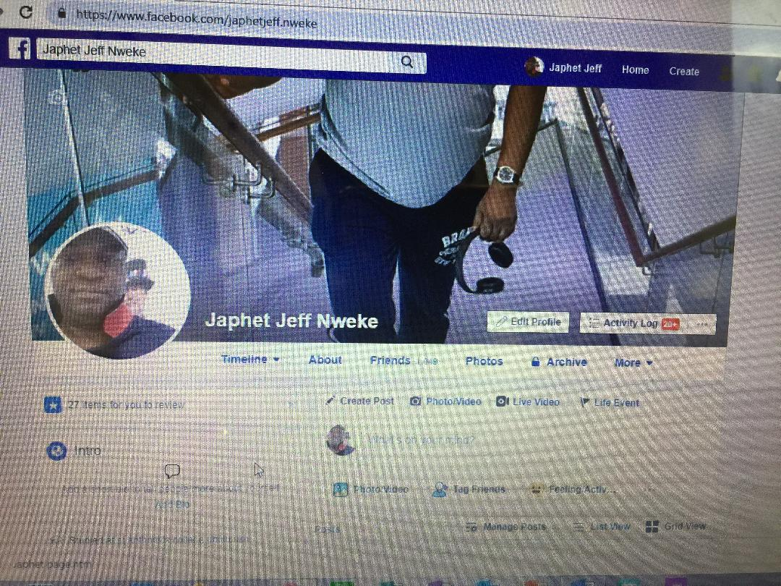

Referencing
Christopher Alghini
Google Cloud Consultant [October 23/2013]
Mark Zuckerberg [February 4/2004]

