Swansea Coastal Hotel

Buildability and Sustainability Report

Student: Jac Roberts
Student Number: 2404313
Module: Construction Technology
Tutor: Rhodri Thomas
Date: 05-05-2026

Table of Contents
- Introduction
- Environmental Impact
2.1 Orientation
2.2 Life Cycle
2.3 Aesthetics
- Façade Greening and Sustainable Urban Drainage Systems (SUDS)
3.1 Façade Greening
3.2 Sustainable Urban Drainage Systems (SUDS)
- Buildability
4.1 Construction Practicality and Methods
4.2 Site Logistics
4.3 Structural Complexity and Build Sequence
4.4 Safe and Sustainable Construction Processes
- Construction Sequence / Storyboard
- Conclusion
- References

1. Introduction
This report looks at the sustainability and buildability of the proposed Swansea Coastal Hotel development located near Singleton Hospital along Swansea Bay.
The project is designed as a medium–high-rise hotel using a reinforced concrete structural frame with a reinforced concrete core and glazed facade systems. Due to the coastal location, the design has to consider environmental conditions such as wind exposure, salt spray, heavy rainfall and long-term durability of materials.
The report evaluates how the building design responds to environmental impact, sustainability requirements and practical construction considerations. It also looks at the potential use of façade greening and Sustainable Urban Drainage Systems (SUDS), while assessing the buildability of the design from a construction point of view.
The overall aim is to create a durable, sustainable and practical building suitable for the Swansea coastline.

2. Environmental Impact

2.1 Orientation
The orientation of the building has a major impact on the environmental performance of the development. Positioning the hotel correctly can improve natural daylight, ventilation and energy efficiency while reducing environmental impact.
The proposed design aims to maximise south-facing glazing where possible to increase natural daylight into hotel rooms and communal areas. This reduces the need for artificial lighting during the day and can also improve passive solar gain during winter months.
Swansea’s coastline experiences strong south-westerly winds throughout the year. The building orientation can help use these winds for natural ventilation while also protecting exposed elevations from excessive wind pressure and wind-driven rain.
The coastal location also means the building must resist salt spray and harsh weather conditions. More exposed elevations would therefore use durable rainscreen cladding and marine-grade materials.
The stepped design of the hotel also helps reduce the visual mass of the building while improving sunlight around the site.
Attached below is a copy of annual windspeeds, Wind direction, Humidity and Rainfall in Swansea Bay area:

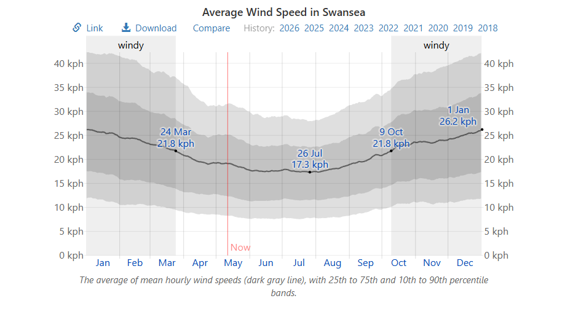

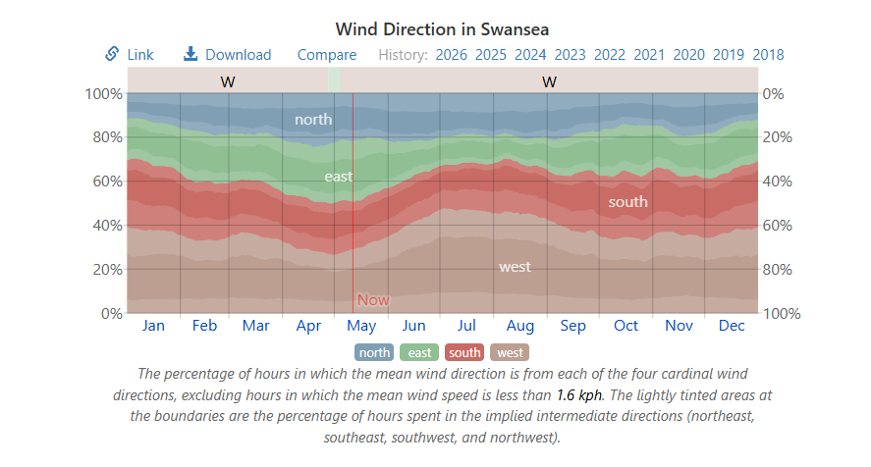
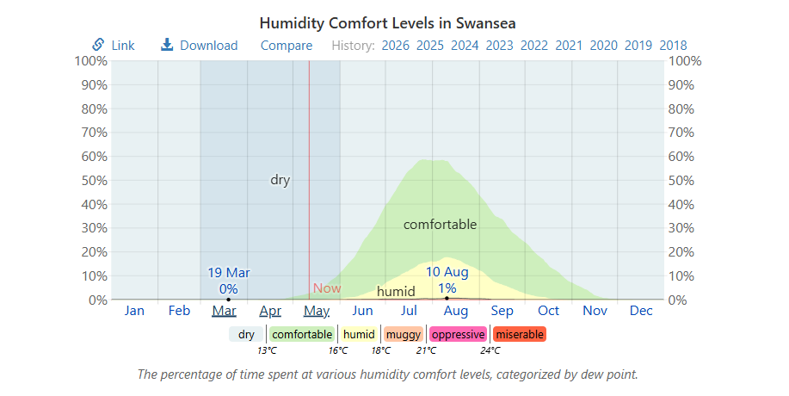
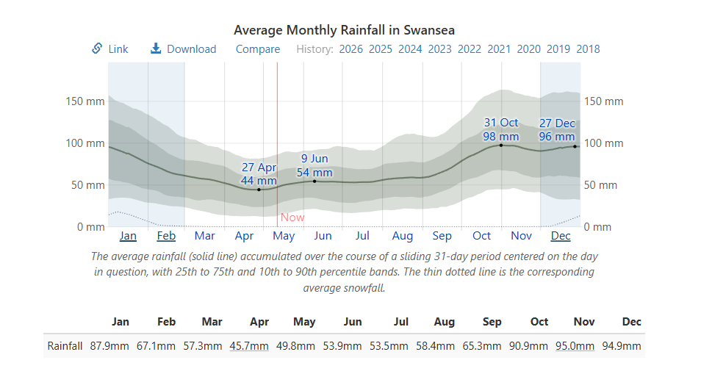
(“Average Weather in Swansea, United Kingdom, Year Round - Weather Spark”)

2.2 Life Cycle
The proposed hotel has been designed with long-term durability in mind. Reinforced concrete has been selected as the main structural material due to its strength, fire resistance and suitability for a coastal environment.
A reinforced concrete frame can typically last over 60 years if maintained correctly. Compared to exposed steel structures, reinforced concrete generally requires less maintenance in marine environments due to reduced corrosion risks.
Concrete does however have a high embodied carbon value during construction. To reduce this impact, lower-carbon concrete mixes and recycled materials could be used where possible.
The project also includes prefabricated elements such as bathroom pods, precast stairs and panelised façade systems. Prefabrication reduces material waste, improves quality control and shortens construction time.
Durable materials and marine-grade finishes also reduce future maintenance requirements and improve the building’s long-term sustainability.

2.3 Aesthetics
The aesthetic design of the Swansea Coastal Hotel aims to fit in with the surrounding Swansea Bay environment while still creating a modern seafront appearance.
The use of glazing, light-coloured cladding and stepped building forms reflects modern coastal developments while maintaining views towards the coastline.
The tiered upper levels help reduce the visual scale of the building and stop it appearing too overpowering from surrounding areas.
Ground-level landscaping and pedestrian access routes would also improve the appearance of the public realm around the development.

3. Facade Greening and Sustainable Urban Drainage Systems (SUDS)

3.1 Facade Greening
Façade greening could improve both the sustainability and appearance of the proposed development.
Green facades could be introduced through climbing plants, planted terrace areas and green wall systems on sheltered parts of the building.
The main benefits of façade greening include:
- Improved biodiversity.
- Better air quality.
- Reduced heat gain.
- Improved rainwater absorption.
- Better visual appearance.
Because the building is located on the coastline, facade greening would need to be positioned carefully due to strong winds and salt exposure. Lower podium levels and sheltered terraces would likely be the most suitable locations.
Maintenance access and irrigation systems would also need to be considered during the design stage.
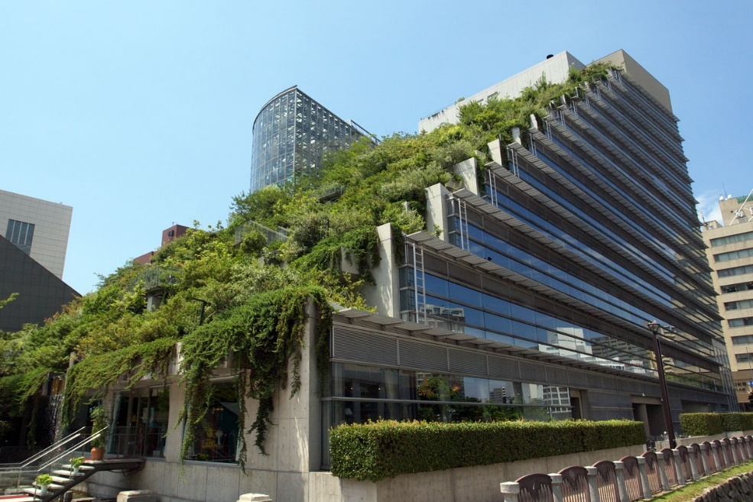
Due to the desired shape of the building with its stepped design it allows the designer to integrate a tiered green roof design. I am using this building as an example as it has similar characteristics:
(Somvichian-Clausen)

3.2 Sustainable Urban Drainage Systems (SUDS)
Sustainable Urban Drainage Systems (SUDS) are an important part of the proposed development due to the amount of impermeable surfaces created by the hotel.
Without proper drainage systems, surface water runoff from roofs, roads and paved areas could place pressure on surrounding drainage infrastructure.
The proposed SUDS strategy could include:
- Permeable paving.
- Attenuation tanks.
- Green roof drainage.
- Rainwater harvesting systems.
- Controlled discharge systems.
Permeable paving allows water to drain naturally into the ground while reducing surface runoff.
Green roof systems can also help absorb rainfall while improving biodiversity and thermal performance.
Rainwater harvesting could allow roof runoff to be reused for irrigation and non-potable water systems.
A basic attenuation calculation can be used to estimate how much surface water runoff may need to be stored during heavy rainfall conditions.
Assuming:
- Roof area = 2000m²
- Rainfall = 50mm (0.05m)
2000 × 0.05 = 100m³
This shows the approximate volume of runoff that may need to be controlled during storm conditions.

4. Buildability

4.1 Construction Practicality and Methods
The proposed hotel has been designed with buildability and construction efficiency in mind.
A reinforced concrete frame has been selected due to its durability, fire resistance and suitability for coastal conditions. Reinforced concrete also provides good acoustic performance which is important for hotel buildings.
The reinforced concrete core would likely be constructed first using slipform or jumpform construction methods. This would allow the main structural stability system to progress quickly while floor slabs follow behind.
A hybrid construction approach is recommended throughout the project. Prefabricated bathroom pods, precast stairs and panelised façade systems would improve programme efficiency and reduce onsite labour.
Bathroom pods are particularly useful due to the repetitive hotel room layouts. Factory-built pods improve quality control and reduce clashes between trades onsite.
Panelised façade systems would also reduce working-at-height activities and improve installation speed.
Overall, the use of prefabrication would reduce waste, improve safety and shorten the construction programme.

4.2 Site Logistics
Site logistics are a major consideration due to the project being located near Singleton Hospital.
Construction activities must minimise disruption to surrounding roads, pedestrians and hospital operations. Deliveries may need to be scheduled outside peak traffic hours to reduce congestion.
Storage space onsite is expected to be limited, meaning a just-in-time delivery system may be required.
Tower crane positioning would also need careful planning to maintain safe lifting operations and efficient material movement around the site.
Temporary site setup would likely include:
- Secure hoarding.
- Welfare facilities.
- Material storage areas.
- Temporary drainage.
- Concrete pumping zones.
- Pedestrian segregation.
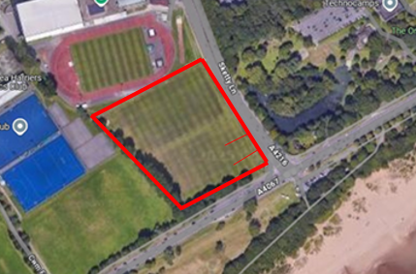
Noise and vibration would need to be controlled throughout the project. Continuous flight auger piling is likely the preferred option due to lower vibration levels compared to driven piles.

Logistics Drawing Key:
- Site access – ##
- Welfare and parking – ##
- Storage / Laydown area – ##
- Crane Pad locations – ##
- Site boundary - ##

4.3 Structural Complexity and Build Sequence
The proposed hotel includes several buildability challenges associated with coastal high-rise construction.
Construction would begin with site setup, excavation and piling works. Due to the likely ground conditions and groundwater levels, piled foundations are considered the most suitable option.
Once foundations are complete, the reinforced concrete core would be constructed followed by floor slabs and perimeter columns.
The repetitive hotel layout improves buildability and supports the use of prefabricated elements.
Several practical challenges would still need to be managed throughout construction, including:
- Coastal wind affecting crane operations.
- Working at height.
- Weather delays.
- Concrete curing conditions.
- Coordination between structural and M&E trades.
Careful sequencing and coordination would therefore be important to maintain programme efficiency.

4.4 Safe and Sustainable Construction Processes
The construction strategy aims to support safe and sustainable construction methods throughout the project.
Prefabrication improves safety by reducing onsite labour and limiting working-at-height activities. Factory manufacturing also improves quality control and reduces material waste.
Shorter construction programmes also reduce temporary energy use, transport emissions and site disturbance.
Additional sustainable construction measures could include:
- Low-carbon concrete mixes.
- Waste recycling.
- Sustainable sourcing of materials.
- Reduced transportation emissions.
- Efficient site energy management.
Safe access routes, lifting plans and edge protection systems would also be required throughout the build process.
Overall, the proposed strategy attempts to balance safety, sustainability and construction efficiency.

5. Construction Sequence / Storyboard
The proposed construction sequence for the Swansea Coastal Hotel development is shown below:
Stage | Construction Activity
1 | Site setup and temporary works
2 | Excavation and piling works
3 | Foundation construction
4 | Reinforced concrete core construction
5 | Structural frame and floor slabs
6 | Installation of precast stairs and bathroom pods
7 | Façade and glazing installation
8 | Roofing and waterproofing
9 | Internal fit-out and M&E installation
10 | Landscaping and SUDS installation
11 | Testing and final completion
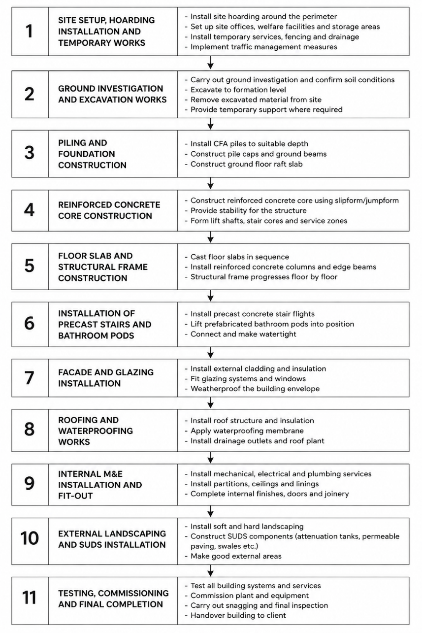
The use of repetitive floor layouts and prefabricated elements allows multiple activities to take place at the same time, improving efficiency and reducing program length.
Construction Story Board

The use of repetitive floor layouts and prefabricated components allows multiple construction activities to occur simultaneously, improving programme efficiency.
Critical construction stages include core construction, façade weatherproofing and M&E coordination.

6. Conclusion
The proposed Swansea Coastal Hotel has been designed with sustainability, durability and buildability as key considerations.
The reinforced concrete structural system provides a strong and durable solution suitable for the harsh coastal environment while also improving fire resistance and acoustic performance.
Environmental considerations such as building orientation, façade greening and Sustainable Urban Drainage Systems help reduce the overall environmental impact of the development.
The use of prefabricated construction methods also improves programme efficiency, reduces waste and improves health and safety onsite.
Buildability factors such as site logistics, sequencing and construction methods have also been considered due to the project’s location near Singleton Hospital.
Overall, the proposed strategy provides a practical and sustainable solution suitable for a modern coastal hotel development in Swansea.

7. References
Council, S. (2016). SWANSEA TALL BUILDINGS STRATEGY Contents Page. [online] Available at: https://www.swansea.gov.uk/media/2879/Swansea-Tall-Buildings-Strategy/pdf/eaTall_Buildings_Strategy.pdf?m=1634631798457.
Council, S. (2021). Building regulations guidance - Swansea. [online] Swansea. Available at: https://www.swansea.gov.uk/buildingregulationsguidance.
Gov.Wales (2021). Approved Document B: fire safety | GOV.WALES. [online] GOV.WALES. Available at: https://www.gov.wales/approved-document-b-fire-safety.
MBA (2006). A guide to design and construction Concrete Framed Buildings CONCRETE FRAMED BUILDINGS 2. [online] Available at: https://www.mpaprecast.org/Precast/media/BPMediaLibrary/Publications/MB_Concrete_Framed_Buildings_Feb16_1.pdf?ext=.pdf.
MBA (2025). Slipform. [online] www.concretecentre.com. Available at: https://www.concretecentre.com/Structural-design/Building-Elements/Formwork/Slip-form.aspx.
Mining Remediation Authority (2021). The Coal Authority Map Viewer. [online] Arcgis.com. Available at: https://datamine-cauk.hub.arcgis.com/.
Norris, P. (2022). Storm Eunice wind gusts of 92mph recorded. [online] Wales Online. Available at: https://www.walesonline.co.uk/news/uk-news/storm-eunice-wind-gusts-92mph-23139538.
Tarmac (2024). Innovative Low Carbon Concrete Solutions by Tarmac. [online] Tarmac. Available at: https://www.tarmac.com/low-carbon-concrete/.
team, E. (2023). Online calculations for Eurocode 1: Actions on structures. [online] EurocodeApplied.com. Available at: https://eurocodeapplied.com/design/en1991.
Somvichian-Clausen, Austa. “Impressive Green Roofs around the World.” American Forests, 15 Mar. 2016, www.americanforests.org/article/impressive-green-roofs-around-the-world/.
“Average Weather in Swansea, United Kingdom, Year Round - Weather Spark.” Weatherspark.com, weatherspark.com/y/37763/Average-Weather-in-Swansea-United-Kingdom-Year-Round.

