

PROGRAMME: Master of Business Administration
MODULE: Marketing Management
MODULE CODE: LCMB7024
STUDENT NAME: Karan Prasad Kajale
STUDENT ID: 2428129
WORD COUNT: 2544
NAME OF THE LECTURER: Hoaran Liu
SUBMISSION DATE: 28/03/2025
MODULE CODE – LCMB7024

Table of Contents
INTRODUCTION 2
Definition: 2
Advantages of Pioneer: 2
Advantages of Follower company: 4
Successful pioneer companies 6
Successful Follower companies 7
Introduction 8
Graph of Product Life Cycle 8
Product Life Cycle Strategies: Pioneer and Follower Companies. 9
Introduction Stage Strategies (Product Launch) Long Before the Product Launch 9
2. Strategies Utilized by Follower Companies that have Succeeded 13
Introduction Phase Strategies (Building Market Share at the Initial Stage) 13
Strategies for the Stage of Growth (Increasing Market Share) 15
Measures for a maturity stage (competition with market leaders) 15
Decline Stage Strategies (Sustaining or Pivoting) 16
Conclusion 16
REFERENCES: - 17
Other references 17

Q-1 What are the advantages of being a pioneer and a follower company? Provide an example of a successful pioneer and follower company.

INTRODUCTION
- A pioneer and a follower company have different strategies, as to be verified in the market. They differentiate each other through innovation, risk management, and competitive phases in the market, there are specific factors affecting the pioneer and the follower company, like psychological, cultural, political, and legal. A follower company is dependent on the market of the pioneer to establish itself. In a follower company, there are fewer chances of market failure due to experience, and in a pioneer company, there are high chances of deflation as there are new concepts of ideas in the business and they have less experience in market strategies.
The war between the pioneers and followers of the company leads to success in the automobile and raising the bar for the trends. Some of the companies are successors and predecessors and have an effectual cycle for market modification.

Definition:
- Pioneer – A Pioneer is an individual or organization that is the first to introduce a new product or an individual who desires to start a new venture in a new area by analyzing specific gaps and requirements.
- Follower company - A Follower Company is a company that is not the company leading the market, but has the option of maintaining the position of the company and chooses to work on the existing market shares of the company instead
of competing with other companies.

Advantages of Pioneer:
- Creating an Own Brand: There are many options for expanding and building a brand, as the company can implement strategies that enhance its brand image while also improving company recognition.
- Initiator Advantage: Pioneers are the first person or the organization to introduce, as they are the initiators, they probably have a high chance of succeeding, as they create brand curiosity.
- Barrier for the participants: Being an initiative company, it creates a scarcity for the company as they have controlling and original resources that can’t be copied so there is less scope for entering as a participant and creating a competition.
- Shaping Taste and Preference: Pioneers shape the requirements based on the factors that influence consumer behavior buying, they can be genetics, age, shape, color, marketing, etc.
- Continues Learning: They have a golden chance to learn from their failures and explore new strategies to evolve a useful innovation of their product.

Advantage | Description
Creating a Strong Brand | Pioneers get the first opportunity to establish a unique brand identity. They can shape consumer perception and loyalty by introducing a new product, making it easier to expand and strengthen their brand over time.
First-Mover Advantage | Being the first to introduce a product gives pioneers a head start. They create brand curiosity and often capture a loyal customer base before competitors even enter the market.
Building Barriers for Competitors | Pioneers secure essential resources, patents, and distribution channels that make it difficult for followers to compete. This creates a high barrier for new entrants and limits competition.
Shaping Consumer Preferences | Since they’re first to market, pioneers influence customer preferences by setting trends and defining the standards for what the product should look and feel like. Factors like design, features, and usability are often aligned with consumer expectations.
Continuous Learning and Innovation | Pioneers gain valuable insights from early successes and failures. This continuous learning allows them to refine their strategies and improve their products, leading to ongoing innovation.

Advantages of the Follower company:

- Decreasing the cost: The company mainly focuses on the campaigns to reach the audience instead of using other social media platforms which increases the cost of the company.
- Spending less on Research and Development: The company already has pre-determined research of the organization, which makes it easier for the following company to develop the required means.
- Acknowledged Market: Follower company already has an existing market, which creates less cost because there is no need for market advertisement and attracting clients.
- Improvement in products: Improvement in products can be accurately done as the turnover ratio increases in a short period as well as there is an equivalent reduction in costs; therefore, it is more accessible to adapt the changes for the products.
- Resource Appropriation: Resource appropriation is helpful it evolves limits in resources so there is no overallocation, and also is effective in avoiding project delays and enables the company to analyze the priorities of projects based on the strategies and investment.

- Build-on Achievement: Motivated employee contributes more to productivity and are very innovative in their field as the company is at its peak of achievement, they equally feel motivated as the achievement of the company creates a positive workplace culture for the employees to contribute more evenly in their specific area.

Advantage | Description
Lower Costs and Spending | Followers can save significantly by focusing on targeted marketing campaigns rather than investing heavily in expensive, broad-scale promotions. This cost-effective approach allows them to reach their audience efficiently.
Reduced R&D Investment | Since followers build on the groundwork laid by pioneers, they benefit from existing research and market data. This minimizes the need for extensive research and development, saving both time and resources.
Established Market Awareness | Followers enter a market where consumer awareness already exists, eliminating the need for costly educational marketing. They can capitalize on existing demand without having to invest heavily in brand introduction.
Improved Product Offerings | With customer feedback from pioneer products, followers can refine and enhance their versions. These improvements often lead to better products at lower prices, increasing turnover and customer satisfaction.
Resource Optimization | Followers effectively allocate resources by focusing on high-priority projects. They avoid overallocation, prevent delays, and strategically invest where it matters most, leading to smoother project execution.
Leveraging Established Success | Followers benefit from the success of pioneers, creating a positive work culture that motivates employees. When employees see the company thriving, they’re more engaged, innovative, and driven to contribute towards continued growth.

Successful pioneer companies
- DeepMind Technologies Ltd: It is a British American artificial intelligence research laboratory that serves as a Subsidiary of Alphabet Inc., merged with Google AI and Google Brain division to become Google DeepMind in April 2023.
- Headquarters: London
- Research Centre: United States, Canada, France, and Germany.
- DeepMind introduced neural Turing machines and created neural network models for video games and board games.

- Darktrace: It is a British Cybersecurity company that was established in 2013, and it has the power to use unsupervised machine learning techniques so that it can detect potential threats as they emerge in real-time.
- Headquarters: Cambridge, UK
- Global Office Location: San Francisco, Singapore

- Revolut: A financial technology company allowing banking, currency exchange, and investment services, which provides free subscription-based digital bank services, proclaimed with domestic and international bank transfers, and also with an advantage of cryptocurrency exchanges.
- Headquarters: London, England

- Wise: Wise is a company co-developed by one of the employees of SKYPE, it is a financial company concentrated on global money transfer. However, it doesn’t allow customers money to others but helps the customer to hold the money while sending receiving, and spending.
- Headquarters: UK

Successful Follower companies

- Tesco: Tesco is a multinational grocery market and merchandise retailer the third largest retailer in the world measured by gross revenue and the ninth largest in the world by revenues.
- Stores: Czechia, Ireland, Slovakia, and Hungary

- Sainsbury’s – It is a large E-Commerce store entering into kitchens through online grocery shopping like Ocado as pioneers who already have a very strong market ratio presence.
- Headquarters: London, UK

- Barclays – In the source of mobile banking Barclays followed the lead of fintech startups like Monzo and Revolut who pioneered the digital-only banking experience. Over the decade Barclays followed to become a global bank. In 1967 Barclays introduced the world’s first cash dispenser.
- Headquarters – Lombard Street, London

- Vauxhall: Vauxhall is a large automotive manufacturer in the UK in developing new designs, technologies, and efficiencies after having a competitor like Ford.
- Founded in 1857

Conclusion - For the specified research, it concludes that whether it is a pioneer or a follower company, both are equally important for the market to have growth, as it shows the current representation or actual phase of the company. Pioneers create a great source of opportunity for marketers to explore, and for a follower company, it forms a phase for them to generate the lost revenue through different strategies to have a booming comeback in the market. As a follower company, they have less performance pressure because they already have an impression about the company, so it doesn’t form a burden to uproot the company from the market.

Q.2 What product life cycle strategies do a successful pioneer and a follower company implement to increase growth and maintain a strong competitive advantage? Provide an example of companies to support the statement made.

Introduction
- Product life cycle strategy is the progression of the item or a product which passes through the four stages of its time of the market. The stages of the product life cycle are Introduction, Growth, Maturity, and Decline. Every product life cycle strategy has a life cycle and time spent at each stage differs from product to product.

- Introduction Stage – This stage is known as the intense marketing efforts of the firm to promote the newly introduced product in the target market, and the customer purchases the new product on a trial basis.
- Growth Stage - The customers are aware of the product and the intense promotional measures adopted by the firm. The sale of the product gradually increases and competition also develops. Products become more profitable during this stage.
- Maturity stage – The market attains saturation during this stage. At this stage, the sales reach their maximum point and maintain a steady state there is no way to grow further. Some companies leave the market after the maturity phase due to low profit margins. Price wars and intense competition are the highlights of their market.
- Decline Stage – It is the continuous decline in the sales volume, Economic and production conditions become unfavorable. Profit can be improved by reducing marketing and other expenses. Heavy decline in the sales volume price and profitability are the important features of the decline stage.

Graph of Product Life Cycle

Product

Introduction Growth Maturity Decline

Product Life Cycle Strategies: Pioneer and Follower Companies.

Product Life Cycle (PLC) consists of four basic stages: Introduction, Growth, Maturity, and Decline. Successful Pioneer and Follower companies use different strategies at each of these stages to achieve maximum growth and preserve a strong competitive advantage.

Strategies Used by Successful Pioneer Companies

Pioneers are initial organizations to introduce the product to the market. They aim to become the leaders in the market, to gain name recognition, and to sustain long-term growth.

Introduction Stage Strategies (Product Launch) Long Before the Product Launch

1. Market Creation Strategy
Pioneers create demand by educating the customers about the new product.
- Apple introduced the iPhone in 2007 and showed the world how to use a phone without a keyboard.
2. High Promotional Spending
Intensive advertising and promotional campaigns could be implemented to catch the attention of early adopters.
- Tesla, for example, invested in marketing to push electric vehicles as an alternative in the future.
3. Penetration or Skimming Pricing
Penetration Pricing: Keeping prices low to attract a large customer base.
Pricing by skimming: Assigning an elevated price to cover the R&D expenses.
- Intensive Advertising and Sales Promotion
- Employing markdowns, sponsorships, and social media campaigns to perpetuate purchase habits.

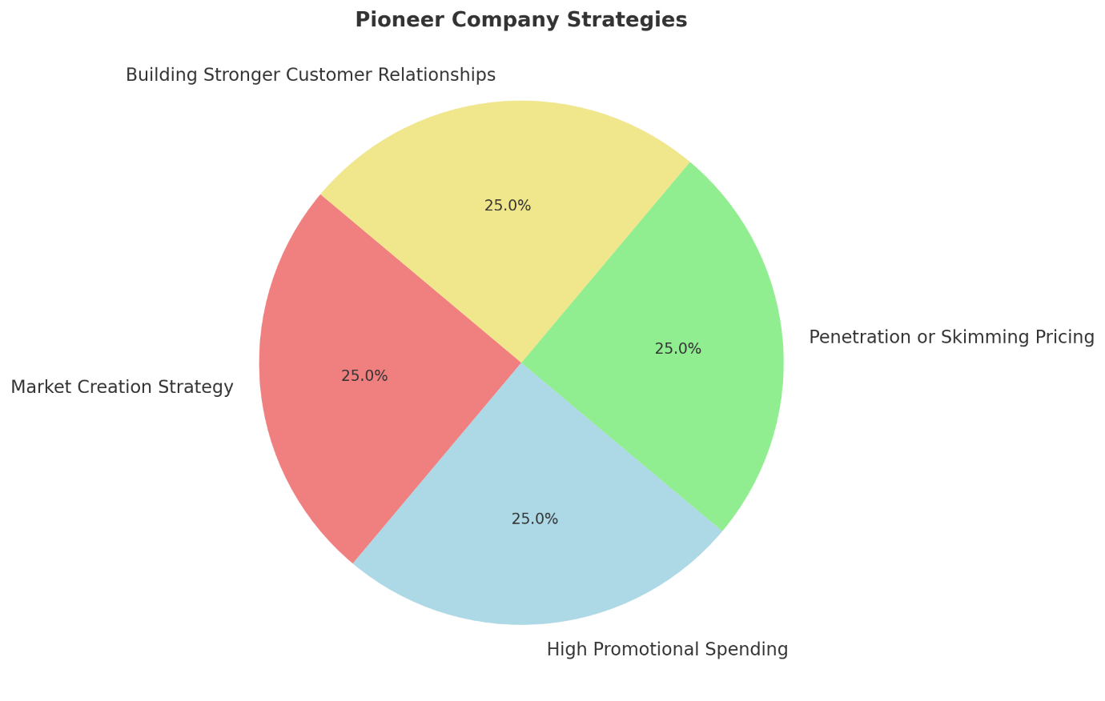

Decline Stage Strategies (Extending the Product Life)

1. Product Revitalization
Revamping the item with new features or a new design.
- Nokia has re-introduced its classic 3310 model with modern features.

2. Targeting Niche Markets
Focusing on small but loyal customer groups.
- The emphasis of Kodak switched from general photography to professional cameras and printing.
  - Selling to New Markets (Repositioning the Product)
Product launch in less competitive markets or those that are emerging is an option.
- BlackBerry shifted from the specter of doom in the consumer market, to a renewed focus on its core business - enterprise and government

3. Mergers and Acquisitions
Selling a business to a larger firm to keep it running.
- Motorola was acquired by Lenovo to stay in the mobile phone industry.

Growth Stage Strategies (Expanding the Market)

1. Product Improvement and Innovation
This is about adding new features improving quality and fixing customer feedback issues.
- Samsung Galaxy smartphones always move ahead, no matter how great the camera or how powerful the core Samsung is already offering.

2. Expanding Market Reach (Geographical Expansion)
To enter new cities states and countries to increase sales.
- McDonald's has grown to become a global brand by offering menus that are tailored to individual

3. Brand Differentiation and Positioning
Creating a unique brand image through quality technology or service.
- Tesla placed its brand as eco-premium in electric cars.

Growth Stage Strategies (Expanding the Market)
1. Product Improvement and Innovation
Adding new features. Improving quality. Fixing issues based on customer feedback.
- Samsung permanently improves Galaxy smartphones by providing more powerful cameras and higher performance.
2. Expanding Market Reach (Geographical Expansion)
To enter into new cities states and countries for sales expansion.
Exploring new cities, new states, and new countries to achieve more sales.
- Example: (McDonald's has also expanded its operations to different countries by having
3. Brand Differentiation and Positioning
Developing a unique brand identity based on superior quality, technology.
Example: Tesla has branded itself as a premium electric car company.

Maturity Stage Strategies (Maximizing Profits)

1. Cost Reduction and Process Efficiency
Reforming supply chains to lower production expenses.
- Example: Toyota applies lean manufacturing to minimize wastage and enhance competence

2. Product Diversification
Vary the products by adding new colors, sizes, or special editions.
- Example: Coca-Cola introduced Diet Coke and Coke Zero. Diet Coke and Coke Zero was designed to meet the needs of customers who were

3. Market Segmentation
Targeting new customer segments, such as a different age group, income level, or occupation.
- For example, Nike provides various types of shoes for athletes, casual wearers, and children.

Decline Stage Strategies (Extending Product Life)

1. Product Revitalization
Upgrading the product with new features or design.
- Instance: With the modern features, Nokia re-introduced the classic 3310.
2. Targeting Niche Markets
Focusing on small but loyal customer groups.
- Example: Kodak changed its focus from common photography to professional cameras as well as printing.
3. Selling to New Markets (Reposition of the Product)
The second strategy is to launch the product in low-competitive or emerging markets.
- For instance, BlackBerry targeted the use by enterprise and government clients after it lost the consumer market.

2. Strategies Utilized by Follower Companies that have Succeeded

Follower Companies: Follower companies enter the market after the pioneers. The follower companies aim to gain market share by providing innovative, cost-effective, and improved alternatives to the existing companies.

Introduction Phase Strategies (Building Market Share at the Initial Stage)

1. Reverse Engineering and Fast Adaptation
Our efforts are placed on studying the pioneering products, and then making them better or cheaper.
- Xiaomi surpassed Apple and Samsung in the production of smartphones.

2. Aggressive Pricing (Lower Cost Strategy)
Selling at prices lower than those initially set by the first movers to carve a niche of cost-sensitive
- The telecom market was disturbed by Reliance Jio with free data inexpensive plans.

3. Targeting Underserved Markets
Identifying customer needs that the pioneer ignored.
- Vivo and Oppo, for example, concentrated on selfie cameras to lure the young client.

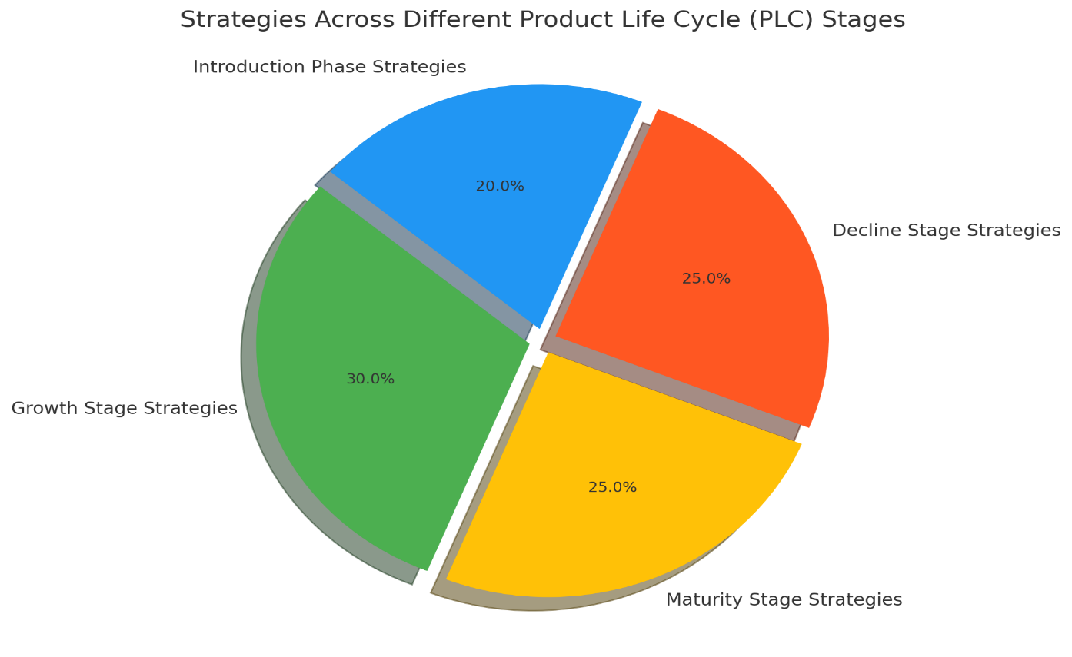

Strategies for the Stage of Growth (Increasing Market Share)

1. Better Customer Service and After-Sales Support
Superior customer service for gaining customer trust
- Dell used to offer laptops that were customizable by configuration, and the services of support 7 days a

2. Intense Digital Marketing Campaigns and Influencer Endorsements
- Using social media YouTube and influencers to gain.

3. Expanding Distribution Channels
Providing for convenient access to products in retail stores internet shops and remote points of sale.
- Flipkart moved onto the smaller towns. Amazon wasn’t able to access such areas.

Measures for a maturity stage (competition with market leaders)
1. Creating a Strong Brand Identity
Spending on branding, packaging and emotional bonds.
- Pepsi founded youth-oriented branding to rival Coca-Cola.

2. Acquiring Smaller Brands for Expansion
Buying niche companies to expand market presence.
- Facebook has purchased WhatsApp and Instagram. They wish to dominate the social media space.

3. Entering New Product Categories
Expanding business by launching related products.
- For example, Xiaomi transitioned from smartphones to smart TVs and home appliances.

Decline Stage Strategies (Sustaining or Pivoting)

1. Rebranding or Repackaging the Product
Changing the brand image to attract new buyers.
- Maggi redesigned its packaging after a temporary ban in India.

2. Expanding to Developing Markets
Selling in countries with growing demand.
- Nokia had turned its attention to Africa and Asia after it lost its European and U.S. markets.

3. Shifting to New Business Models
Transitioning from product-driven to service-driven income.
- Adobe has transformed its business. From selling software in a traditional way (perpetual licenses

Conclusion
Each Pioneer and Follower leverages varied strategies to triumph in the production life cycle. Pioneers emphasize innovation, brand positioning, and market expansion. Followers, on the other hand, focus on cost leadership, improved features, and aggressive marketing. By applying suitable approaches at each stage, companies can maintain growth, profits, and long-term competitive benefits.

REFERENCES: -
- Prior knowledge of Pioneer and Follower company - :
- https://www.researchgate.net/publication/47367708_A_question_of_strategy_To_be_a_pioneer_or_a_follower

- Brief Introduction about the pioneer and follower company
- https://www.sciencedirect.com/science/article/abs/pii/S0883902698000159

- Advantage of Pioneer company
- https://link.springer.com/chapter/10.1007/978-3-8349-9679-4_6

- Advantage of Follower company:-
- https://journals.sagepub.com/doi/10.1509/jmkg.70.1.015.qxd

- Successful pioneer company
- https://find-and-update.company-information.service.gov.uk/company/07386350
- https://www.revolut.com/
- https://wise.com/in/?utm_source=google&matchtype=e&device=m&userlocation=9145952&keyword=wise&campaignid=21842513458&adgroupid=176102742944&utm_campaign=21842513458___176102742944&gad_source=1&gclid=Cj0KCQjwhYS_BhD2ARIsAJTMMQbrYC9yfCgAO3kmw_7aIQbakjFGvCwIUDWXrHCtkgL6XQmIoKdf73EaArEMEALw_wcB
- https://www.asos.com/
- successful follower company
- https://www.tesco.com/?srsltid=AfmBOor5IWcxX53fqlJIPOAcA581-O9TQ5m2OcF7jwci-LcK23ZGgYLY
- https://www.sainsburys.co.uk/
- https://home.barclays/
- https://www.vauxhall.co.uk/

other references
- https://www.researchgate.net/publication/47367708_A_question_of_strategy_To_be_a_pioneer_or_a_follower
- https://www.semanticscholar.org/paper/A-QUESTION-OF-STRATEGY%3ATO-BE-A-PIONEER-OR-A-Kali%C4%8Danin/26270056dbc4ca41ba9b3dadcf83908fa4222f3b
- https://www.academicmentoronline.com/2017/05/pioneering-versus-following-strategies/
- https://www.eria.org/uploads/media/discussion-papers/FY21/Export-Market-Survival-of-Pioneers-and-Followers.pdf

