Awe and Wonder- science, mathematics, and the outdoors.

Task 1: Photograph

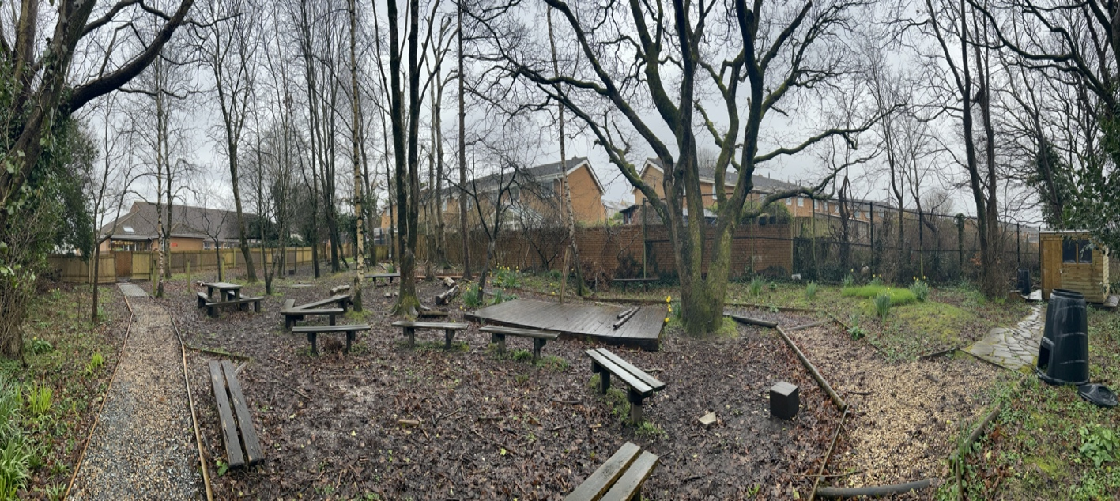
(Source: Lovell, 2023 a)

Task 2:
Learning Journey
A spring trip to the woodlands on a sunny day

(Source: Lovell, 2023 a)

Name: Child A

Age: 4 years old

Setting: Primary school however the child attends a day nursery in the afternoons.

Date: 1st April 2023

9:15am

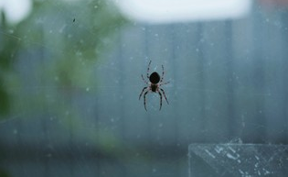
A small spider crawling across the window captured the attention of child A. Child A exclaimed “it’s a spider!” a small crowed of children began to gather around to have a closer look. Child A used his ‘pointy finger’ to count the spiders’ legs “1,2,3,4,5,6,7,8” other children joined in. Child A then began to sing the nursery rhyme incy wincy spider whilst carrying out the actions and pointing to the spider. Suddenly child A turned to the small group of children and said, “I want to find more bugs”. I then took charge asking if they would like to look for more bugs in the woodlands, the children replied “yes!” unanimously. The children then put their wellingtons and coats on to ensure that they were dressed appropriately.
(Source: Shutter stock,2023)
9:30am


We headed to the woodlands whilst on our walk we came across a hill. Child A began to roll down the hill with other children. Experiencing both force and speed this is found in progression step two of the science and technology curriculum it states that “I can communicate the effect forces have on myself and on objects”. Child A has completed this by stating “I can go faster than” ‘Child B’. (Welsh Government ,2020 a) Child A also stated “miss, look at me!” in excitement. This shows confidence and fulfilment. When child A got to the bottom of the hill, he noticed a worm in the mud. I observed him picking the worm up gently and placing it on a leaf to put in a “safe spot”. This shows that the child is an ethical citizen and cares for wildlife. On our way to the woodland the weather changed drastically from blue skies to light rain this sparked the interest of the children and child A stated that a “rainbow might come” I asked why he thought this, and he replied, “sun and rain makes a rainbow”. I gave child A verbal praise. The rainbow appeared in the sky I then discussed colours with child A and told him about the colours in Welsh. Child A repeated the colours back to me promoting multilingualism.
(Source: Flickr ,2018)

9:45

We arrived at the woodlands and found ourselves surrounded by fresh spring flowers, green leaves, tall trees, spikey grass, pathways made up of different terrains, platforms of different heights, monkey bar apparatus and endless amounts of sticks and stones in a verity of sizes and shapes. There were many pockets of spaces to explore within the woodlands child A firstly gravitated towards the sticks, which he found on the ground these are a loose part. He began to collect them until he found the perfect stick whilst he was picking them up, he was saying to himself “too big” “too small” and then “this is a good one”. This shows that he is recognising the difference in size for function and using early signs of measurement. Progression step two of the mathematics and numeracy curriculum states “I can make estimates and comparisons with measures, such as ‘shorter than’, ‘bigger than”. Child A has fulfilled this step by comparing the sticks. (Welsh Government, 2020 b) He then moved on to use the stick as a wand casting spells on myself and the other children. Child A was saying “abracadabra” in excitement. This is symbolic representation it is a skill that allows children to develop coding. I also observed the child A using the same stick to write numbers in the mud I took pictures of this as evidence on the iPad. This shows that the woodlands can be used by young children to develop mathematic concepts. In order to further child A’s development, I asked him “how old are you?” “Can you write the number 4?”. I also asked him “how does it feel writing in the mud?” he replied “wet and slimy” this shows knowledge of textures.

10:00

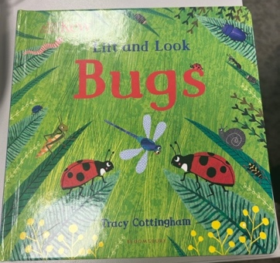
As child A has found real interest in bugs and insects throughout the day in order to support curiosity, I provided extra resources such as magnifying glasses and bug pots to encourage child A to explore and discover. The magnifying glasses and bug pot allow child A to get a closer look at the insects. Child A found an unidentified insect He came up to me and asked me “what is this bug called?” I replied with a question and asked, “what do you think it is?” I was also unsure, so I replied, “let’s explore that together”. I had brought a book with me, so we looked in that together comparing the images to the insect that he had found we concluded together that it was a green shield bug. Whilst comparing and looking back and forth between the image and the bug in the bug pot Child A pointed to the image and yelled “it’s that one!”. Child A then returned the insect to its previous position. Whilst in the woodland’s child A stumbled across a caterpillar on a tree he shouted, “I’ve found a caterpillar!” this show recognition to what the creature is called. (Sedgwick, 2012).
(Source: Lovell, 2023 b)

10:15

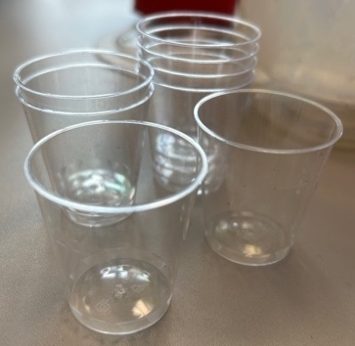
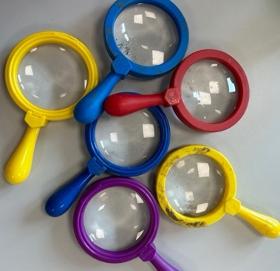
Child A very genetically placed the caterpillar into his bug pot using a small paint brush to guide the creature. This uses both fine and gross motor skills. Using the magnifying glass, I had a conversation with child A regarding the features of the caterpillar. I asked him “what colour is the caterpillar?” he replied, “bright green!” this shows differentiation in shades of colour. We also discussed how the caterpillar feels to touch child A replied “smooth and soft” this helps child A gain more knowledge on texture. I asked child A “can you see a pattern on the caterpillar?” he replied “I see black spots” this helps to build an understanding of different patterns and symmetry. To further the child's development, I asked “what shape are the spots?” curious if he would know, he confidently replied “small circles” this tells me that he is aware of both shapes and size in different formats not just in the classroom. To round off I asked child A did he notice anything in particular about the caterpillar, whilst looking through the magnifying glass he told me “It has lots of legs, but I don’t have lots” this shows me that he is aware of his body and the differences. Child A then skipped off into the distance stating that he was going to make caterpillar a “nice house”. Using the bug pot I observed child A gathering small twigs, leaves, and grass to make the perfect house for the caterpillar. I questioned child A to see if he had named the caterpillar, he stated that “he’s called, Curley!” this shows alliteration even though the child maybe unaware of this, this also shows me that the child has formed an attachment to the caterpillar by naming it Maslow’s theory supports this. (Waite, 2011).
(Source: Lovell, 2023 d)

(Source: Lovell, 2023 c)

10:30 am

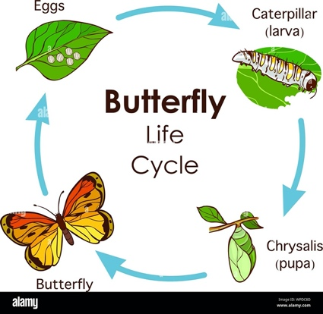
Child A was eager to show everyone the caterpillar he had found so we gathered the children around to carry out a short circle time on the outdoor seating area. Child A passed the caterpillar around to every child ensuring that no one was missed out, this shows amazing sharing skills and care for others. We discussed the lifecycle of a butterfly and what will happen to the caterpillar next. The children learnt new vocabulary that they had not heard before such as chrysalis. All of the children were very interactive and had lots of questions. Child A asked, “how long will it take for Curley to be a butterfly?” I replied, “around five weeks!”. Child A suggested that we keep ‘Curley’ and look after him until he turns into a butterfly and then we can let him go. I agreed that we can monitor the caterpillar’s growth in a dedicated area of the classroom. We discussed how we can look after Curley and what he requires to turn into a butterfly. I asked the children “what do you think Curley likes to eat?” child B said “grass!” with confidence and child A stated “twigs!” both being correct. To further child A development, I asked “why do you think he likes twigs?” he replied, “because I found him on a tree”. We then moved on to the habitat that caterpillars live in I told the children that caterpillars like it somewhere that’s not too bright or too dark, too hot, or too cold. I asked, “where should we put him in our classroom?” child A replied “in the shade” this shows that he has listened and considered what I have said.
(Source: Alamy, 2019)

10:45 am

It was almost time to go, and Child A volunteered to carry the caterpillar back to school very carefully. Whilst in the woodlands I have observed many mathematical and scientific concepts. The children were extremely stimulated by their surroundings and all of their senses were being used outdoors. A holistic approach was taken, and every aspect of the children's development was considered. I have found it is important to take a balanced approach to promote both children's play and leisure. (Welsh Government ,2022).

(Task 3)

Collecting Materials. | Children can explore properties of different materials and select materials for a particular use for example when den building selecting strong sturdy sticks.  Collecting materials links directly to some schemas. It also supports mathematical development when counting and looking at patterns and colours. | Children could potentially pick up sharp objects. They may put something in their mouth. When collecting twigs, the child may get a splinter or cut. | Children. | Discuss with the children what is safe to pick up and what is not so that they gain an understanding. Create a golden rule that nothing is to go in their mouths. Ensure that a first aid kit is close by to be able to get a splinter out efficiently. Before the children enter the woodlands have a brief look around for unsafe objects and dispose of them. | L
Playing with soil and water. | Children can observe what happens when the two materials are mixed together. They can problem solve for example when making a mud pie they may add too much water the first time so the second time they add less. It is also a multisensory experience for them. | The soil could contain Sharp objects that the children may cut themselves on. Animal faeces may also be found in the soil resulting in the child potentially becoming unwell. There is also risk of the children downing in the water. | Children. | To ensure that there are no sharp objects in the soil an adult will rake through it briefly also observing if there are any animal faeces. Only a small amount of water will be given to the children, and they will be monitored closely to decrease the risk of drowning. | L
Children exploring the woods independently. | It provides children with a sense of freedom and independence that they can explore what they want too and are not restricted by others. Promotes their brain development and allows them to make mistakes on their own. | A member of the public could enter the school settings ground through a gate connecting the woodlands to a public field. The children may wonder off to an area where they are not visible to an adult. | Children. | Ensure that the gate is closed over and locked so that no one can get in or out. Observe beforehand that the fence around the woodlands is secure and has not been vandalized. Have a conversation with the children making them aware of strangers and what to do if they are on the school grounds. Make boundaries with the children so that they know where they are allowed to go and where they are not. Adults can wear a high-vis jacket so that they are seen straight away by the children if there is a problem. | L
Children exploring things they see such as rocks, sticks, trees, flowers, and insects | Children have the opportunity to learn and ask questions about living things. Children are able to explore animals’ habitats and their life cycles. It enhances children's physical development, gross and fine motor skills when bending, stretching, and using small brushes or tweezers to pick up insects. Allows children to become aware of how we treat living things such as plants and animals by being kind and gentle. Resulting in them becoming ethical citizens. | Branches at eye level could cause injury, scratches, or an infection. Bites or from insects could cause discomfort or spark an allergic reaction. It is important to be aware of poisonous and irritant plants such as brambles and nettles. Deadly nightshade and lords-and-ladies can cause illness.  Children may collect litter that they have found. | Children and Adults. | Discuss that children may see things that are new and exciting. Make sure that the children are aware of their surrounding and to look where they are going. Be prepared and keep epi-pens close by encase a child was to have a reaction. Create a golden rule of nothing is to go in your mouth. Consider boundaries make the children aware of things that are not nice to collect and to wash their hands when they come back inside. | L
The stage and monkey bars. | Children have the opportunity to perform shows on the stage increasing their confidence and self-esteem. It allows the children to use their imagination and storytelling abilities, also gross motor skills when dancing and moving around. The monkey bars also develop children's gross motor skills as they learn how strong they are and what they are able and unable to do. The monkey bars also develop children's maths skills as they can count how long they can hold on for or how many they complete.  It gives children the opportunity to view the world from different perspectives. | Children could slip on the stage especially if it is wet due to the moss. Children could fall off the monkey bars if they are unable to hold their own weight. | Children and Adults. | Ensure that the children are wearing appropriate shoes with grip or wellingtons. Have an adult monitoring the monkey bars encase a child requires support. Ensure that the children’s emergency contact forms are up to date encase of an injury where the parents may need to be informed immediately. | L
Magnifying glass and bug pots. | Magnifying glasses allow the children to have a closer look at living things gaining more knowledge and insight. By using the bug pots children are able to observe patterns, colours and how the animals move. Magnifying glasses can teach children perception and distance. | The glass in the magnifier could break if the item is being used incorrectly along with the bug pots made out of plastic. If they glass or plastic shatters, then children could cut themselves. Children could hit each other with the magnifier causing a head injury and harm. | Children and Adults. | Communicate the purpose of the magnifying glass and bug pots with the children so that they know how to use them correctly and efficiently. Monitor the children closely so that they do not cause harm to each other. Keep a first aid kit nearby just encase it is needed. | L

Task 4: Academic Evaluation

McElroy (2013) states that children as young as five months old are able to carry out basic addition and subtraction skills this shows that skills are inherited and then developed over time by children gaining more knowledge. Vygotsky believes that children learn from a more knowledgeable other this can be a practitioner or another child. Scientific concepts are also developed in the womb as baby is aware of themselves moving and turning around, this acknowledges force, and the baby becomes aware of surroundings. (NHS, 2021) Science and maths is everywhere in the world and it is important children understand these concepts in order to be in awe of science and maths. Maths and science are not just carried out in the classroom, core subjects can also be taken outdoors. There is a stigma around science and maths however, practitioners are here to break it and make it fun. (Bergen, 2009) Children are able to meet the same progression steps in the curriculum through open-ended and child-led play it does not have to consist of structured adult-led activities. The purpose of this assignment is to observe and promote investigating, experimenting and curiosity in an outdoor environment such as the woodlands.

Mathematics and science are both subjects that interlink and work closely together, mathematics is an important element of science, and this is reciprocated. Furthermore, maths and science both also stimulate one another. (Rogers et tal, 2007) Research shows that maths and science activities and be creative and messy and taken out of the classroom so that the children get some fresh air. (Dancer, 2023) Fresh air has a positive impact on a child's wellbeing as when more oxygen is taken in, serotonin levels are boosted resulting in feeling happy. This helps to improve children's concentration and allows them to absorb more knowledge. (Kumon,2012) (Kinsner, 2019).

Bruner believed that children learn through self-exploration, discovery, and curiosity. Furthermore, with Hands on experiences including real world applications. He also believed that children have to show an interest first independently before extending their knowledge. (Olson, 2007) This shows that children carry out science and maths actives outdoors without being aware, when practitioners are then completing maths or science in the classroom practitioners can link back to a pacific event outside to re-spark the child’s, knowledge and interest and use it to form memorable connections. Similarly, Piaget agrees and suggest that children are ‘little scientists’ implying that children create their own theories. Piaget values children's learning and use of exploration, shining light on that practitioners may need to step back on occasions and allow the children to find things out for themselves. (Egan, 2012) Piaget believes…

Einstein stated that

However…

Why is outdoor play good for children?
Regular time outdoors playing allows the children the space to observe and reflect on their constantly changing surroundings.

How should the children feel ?
Happy
Excited- interest
High energy
Curious
Creative- einstien
Imagination is more important than knowledge
Confident- regio
Safe-maslow ,
Inquisitive – questions and explore
Supportive – helping each other
Eager
Critical thinker
Challenger - allow them to be stuck, solve problems .
Scemas no limit when outdoors , (transporters, skilled adult)

How adults sould be
The more knowledgeable other, modelling , zone of proximal development ,Vygotsky.
Bruner scaffolding
What makes a good practitioner ?
Encourage
Supportive- resources opportunity
Challenging
High energy- animated , enthusiastic
Questioning
Dedicated – passionate , time , vauled
Responsive to cues
Nurturer holistic wellbeing
Role models – bandura
Affectionate- professional love
Communication
Observers
Interactive

Role of the practitioner
General role of the adult in children's outdoor learning and how they can promote learning for maths and science.
Use froybel – role of they adult is to facilitate and guide but to step back and not take over.
You see they real child in play . children learn from nature.
Pics of theorists on phone
Refernce to theory and research evaluate how adults working with early years children's support and encourage children engage with mathimatial and scientific concepts in an outdoor environment.

Froeble

Malaguzi

Loose parts
Reggio loose parts mirrors, light boxes, to see children as competent, natural environment “the environment is the third teacher” not being to risk adverse.

Affordance
imagination a stick is not just a stick

Challenges for practitioners
How to break through the barriers , provide work shops
Why some practitioners might not take the children outside, battle with lack ofaduquate outdoor space , preventing young children to develop outdoor
What might prevent adults using they outdoors or supporting science and maths =. Time training weather.

Albert Einstein
Leonardo da vinci
Sustained shared thinking
Observation curiosity and discovery outside

1795 words

To conclude, it has been discovered that babies are exploring science and maths concepts in the firsts months on being born and even in the womb. Children explore new concepts

every day
Life cycles,
Outdoors is essential
Natures resources
Moving , width, length , shape
Imagination
Practitioners must value
Training
Observations

Reference List

Shutter stock (2023) Available at: https://www.shutterstock.com/search/spider-crawling [Digital Photograph].

Flickr (2018) Available at: https://www.flickr.com/photos/omnitrigger/25047367997
[Digital photograph].

Alamy (2019) Available at: https://www.alamy.com/vector-illustration-of-life-cycle-of-butterfly-diagram-image271972973.html?imageid=40EBC456-7987-4915-AD84-C980E24B8C2B&p=404053&pn=1&searchId=4fcd9290c6de91e86ca00a66b48d15d3&searchtype=0 [Digital photograph].

Waite, S. (2011) Children learning outside the classroom: from birth to eleven. London, England; Thousand Oaks, California: SAGE Publications.

Sedgwick, F. (2012) Learning Outside the Primary Classroom. Hoboken, Taylor, and Francis.

Welsh Government (2020 a) Science and technology. Available at: https://hwb.gov.wales/curriculum-for-wales/science-and-technology/descriptions-of-learning/ (Accessed: 27th March 2023).

Welsh Government (2020 b) Mathematics and numeracy. Available at : https://hwb.gov.wales/curriculum-for-wales/mathematics-and-numeracy/descriptions-of-learning/ (Accessed: 27th March 2023).

Welsh Government (2022) A curriculum for funded non-maintained nursey settings. Available at: https://hwb.gov.wales/api/storage/b1801d78-38c3-4320-9818-d9996c21aef8/220914-a-curriculum-for-funded-non-maintained-nursery-settings.pdf (Accessed: 27th March 2023).

Lovell, H. (2023 a) [Personal Photograph].

Lovell, H. (2023 b) [Personal Photograph].

Lovell, H. (2023 c) [Personal Photograph].

Lovell, H. (2023 d) [Personal Photograph].

McElroy, M. (2013) While in they womb, babies begin learning language from their mothers. Available at: https://www.washington.edu/news/2013/01/02/while-in-womb-babies-begin-learning-language-from-their-mothers/ (Accessed: 29th March 2023).

NHS. (2021) Your baby’s movements. Available at: https://www.nhs.uk/pregnancy/keeping-well/your-babys-movements/ (Accessed: 29th March 2023).

Bergen, D. (2009) Play as the learning medium for future scientists, mathematicians, and engineers. American Journal of play, 1(4), pp.413-428.

Dancer, J. (2023) Maths outdoors EYFS. Available at: https://www.teachearlyyears.com/learning-and-development/view/taking-maths-outdoors (Accessed: 29th March 2023).

Rogers, P et tal. (2007) Science and mathematics. Available at: https://eric.ed.gov/?id=EJ776751 (Accessed: 27th March 2023).

Kumon (2012) Why is fresh air important for children? Available at: https://www.kumon.co.uk/blog/why-fresh-air-is-important-for-children/ (Accessed: 27th March 2023).

Kinsner, K. (2019) Fresh Air, Fun, and Exploration. YC Young Children, 74(2), pp.90-93.

Olson, D.R. (2007) Jerome Bruner : the cognitive revolution in educational theory. London ;: Continuum. Available at: https://doi.org/10.5040/9781472541369.

Egan, K. (2012) Education and psychology : Plato, Piaget and scientific psychology. Abingdon, Oxon ;: Routledge. Available at: https://doi.org/10.4324/9780203807422.

