BMHP5014
CHANGEMAKERS: CREATIVITY AND VALUE CREATION PROFESSIONS

LECTURER: CAROLINE SALAMI

STUDENT: SOBIA HUSSAIN
ID: 2409460

COMPONENT 1
ONLINE PORTFOLIO

Declaration of Originality
I confirm that this assignment is entirely my own work and has been completed in accordance with the academic integrity requirements of the University of Wales Trinity Saint David (UWTSD). I have not used artificial intelligence (AI) tools to generate or write any part of this submission.
I declare that I have used Canva to support the design of visual materials in the mind map, and the Read&Write application to assist with proofreading and improving clarity. These tools were used solely for presentation and accessibility purposes and did not contribute to the generation of academic content.
All sources have been acknowledged and referenced in accordance with UWTSD Harvard referencing guidelines.

Table of Contents
Introduction……………………………………………………………………….Page 4
Task 1: Defining Key Concepts in Practice……………………………………Page 4-6
Task 2: Mind Map………………………………………………………………..Page 6-7
Task 3: Self-Reflection of Group Activity ……………………………………...Page 7-8
Task 4: Case Study Analysis of UK Innovation………………………………..Page 8-9
Task 5: Research Task…………………………………………………………..Page 9
Task 6: Exploring Digital Innovation in Health and Social Care…………….Page 10-11
Task 7: Understanding the NHS Leadership Framework
Reflective Journal…………………………………………………………Page 11-12
Conclusion………………………………………………………………………….Page 12
References……………………………………………………………………….Page 13-15

Introduction
Innovation, creativity, value creation and effective change management are important concepts in modern health and social care practice. These concepts help organisations improve service quality, address complex healthcare challenges, and enhance outcomes for patients and service users. This assignment explores these concepts, examines their application in health and social care, and reflects on innovation, digital technology and leadership within the NHS.
Task 1
Innovation
Innovation refers to the process of developing and implementing new ideas, technologies, or practices that improve services or outcomes (Greenhalgh et al., 2004). In health and social care, innovation is essential because systems must continuously adapt to increasing demand, ageing populations and complex health conditions. Innovative practices can improve efficiency, enhance patient care and support better health outcomes.
Rogers’ Diffusion of Innovation Theory explains how new ideas and technologies spread within organisations and are gradually adopted by individuals and teams over time (Rogers, 2003). In healthcare, innovations often begin with early adopters before becoming widely implemented across services.
Innovation is particularly important in health and social care because it allows organisations to respond to changing needs and improve service delivery. For example, the introduction of telemedicine consultations within the NHS enables patients to speak with healthcare professionals remotely, reducing travel barriers and improving access to care (NHS England, 2023). This innovation has helped increase efficiency and improve patient experiences.

Creativity
Creativity refers to the ability to generate new ideas or approaches that are both original and useful in solving problems (Amabile, 1996). In health and social care, creativity allows professionals to design new solutions to complex care challenges and improve services for patients and service users.
Amabile’s Componential Theory of Creativity states that creativity occurs when individuals combine knowledge, creative thinking skills and motivation to produce innovative ideas (Amabile, 1996). This theory highlights the importance of supportive environments where staff feel encouraged to share ideas.
Creativity is important in healthcare settings because many problems require flexible and innovative thinking. For example, healthcare teams may creatively redesign patient pathways to reduce waiting times or improve discharge planning. During the COVID-19 pandemic, many hospitals introduced virtual wards, allowing patients to receive monitoring at home while freeing hospital beds (NHS England, 2022). This demonstrates how creative thinking can improve patient care and system efficiency.
Value Creation
Value creation refers to the process of improving outcomes for patients while ensuring resources are used effectively. In healthcare, value is created when services deliver better health outcomes relative to the cost of providing care (Porter, 2010).
Porter’s Value-Based Healthcare Framework explains that healthcare systems should focus on improving patient outcomes rather than simply increasing service activity (Porter, 2010). This model emphasises measuring patient outcomes and designing services that maximise value for both patients and healthcare organisations.
Value creation is essential in health and social care because resources are limited and services must ensure that care provides meaningful benefits to patients. For example, preventative care programmes such as community diabetes education services help patients manage their condition and reduce hospital admissions, creating long-term value for both individuals and healthcare systems (World Health Organization, 2020).

Change
Change refers to the process of transforming existing practices, systems or behaviours to improve organisational performance or outcomes (Burnes, 2017). In health and social care, change is necessary to implement improvements, respond to policy developments and meet the evolving needs of patients.
Lewin’s Change Management Model suggests that organisational change occurs through three stages: unfreezing existing practices, implementing new behaviours and refreezing these improvements into routine practice (Burnes, 2017).
Change is important in healthcare because systems must constantly evolve to improve patient safety and quality of care. For example, the implementation of electronic prescribing systems in hospitals has changed traditional medication management processes and helped reduce medication errors, improving patient safety (Greenhalgh et al., 2017).
Task 2
Mind Map: Addressing Long NHS Waiting Times Using a Systems Thinking Approach
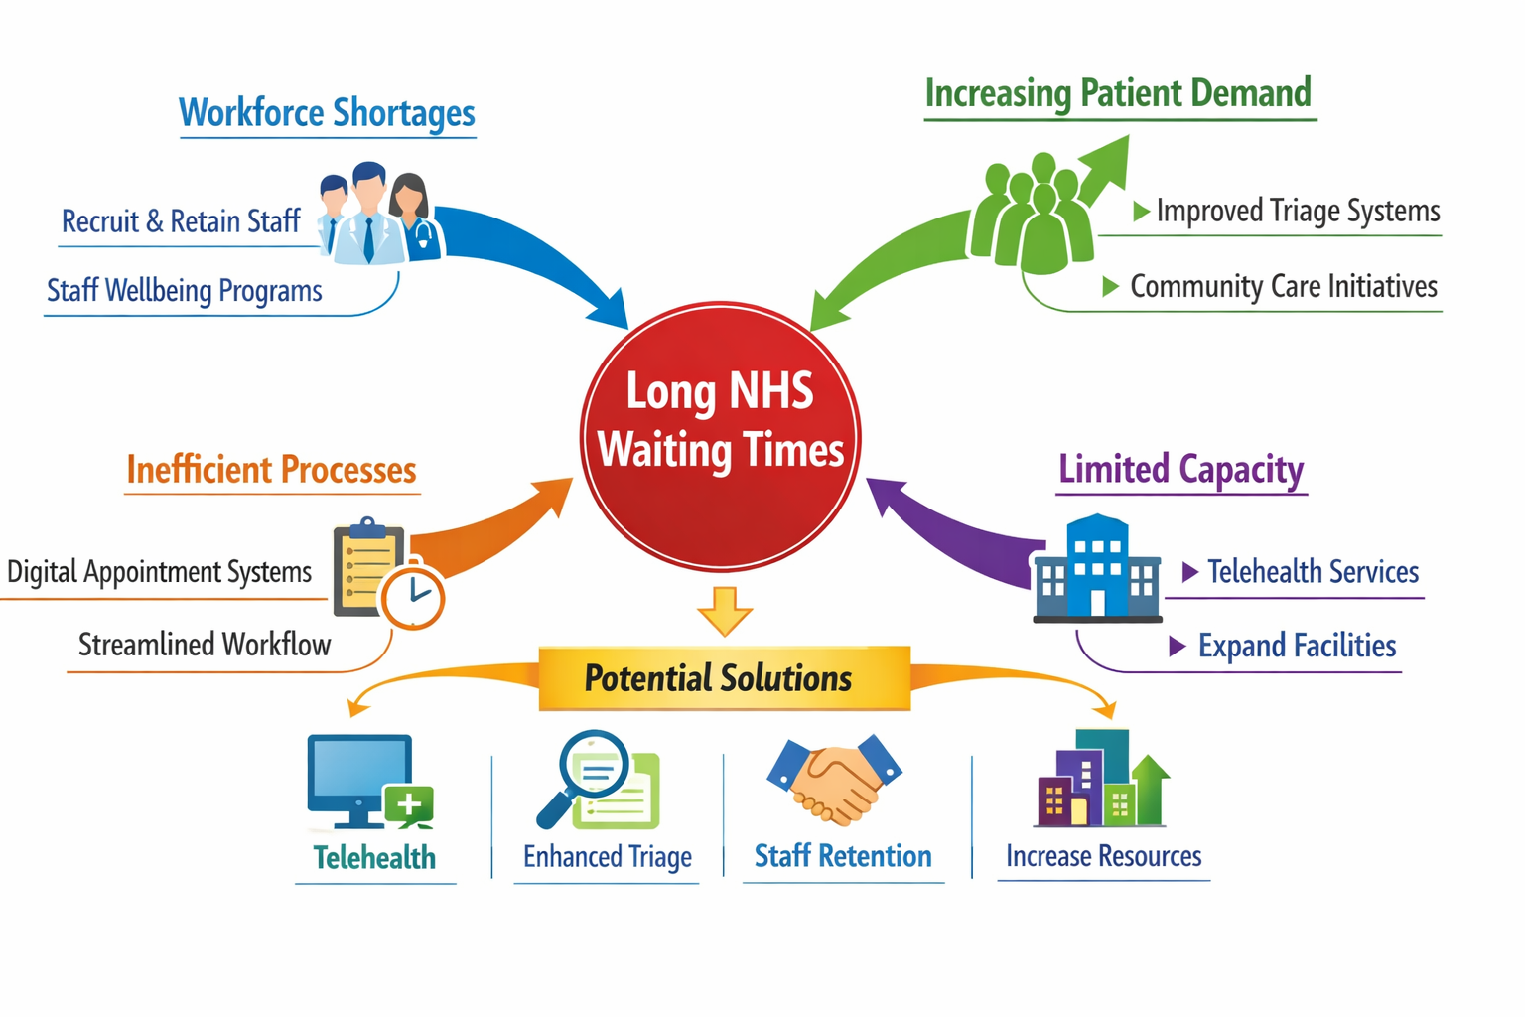
A mind map helps visualise complex health and social care problems by identifying multiple interconnected causes and potential solutions. In this example, the central issue is long NHS waiting times, which is influenced by several factors including workforce shortages, increasing patient demand, inefficient processes and limited healthcare capacity.
Using a systems-thinking approach, health problems are viewed as part of a wider system of interconnected elements rather than as a single cause (Meadows, 2008). This approach helps healthcare organisations understand how different factors influence each other.
The mind map identifies possible solutions such as telehealth services, improved triage systems, staff recruitment and retention strategies, and better use of digital appointment systems. By examining the wider system, healthcare leaders can develop more effective strategies to improve service efficiency and reduce waiting times.
Reference: Meadows, D. (2008) Thinking in Systems: A Primer. Vermont: Chelsea Green.
Task 3
Self-Reflection of Group Activity
Convergent and divergent thinking are two distinct approaches to problem-solving and idea generation. Divergent thinking involves generating many different ideas or possible solutions to a problem, while convergent thinking focuses on analysing those ideas to identify the most effective solution (Cropley, 2006).
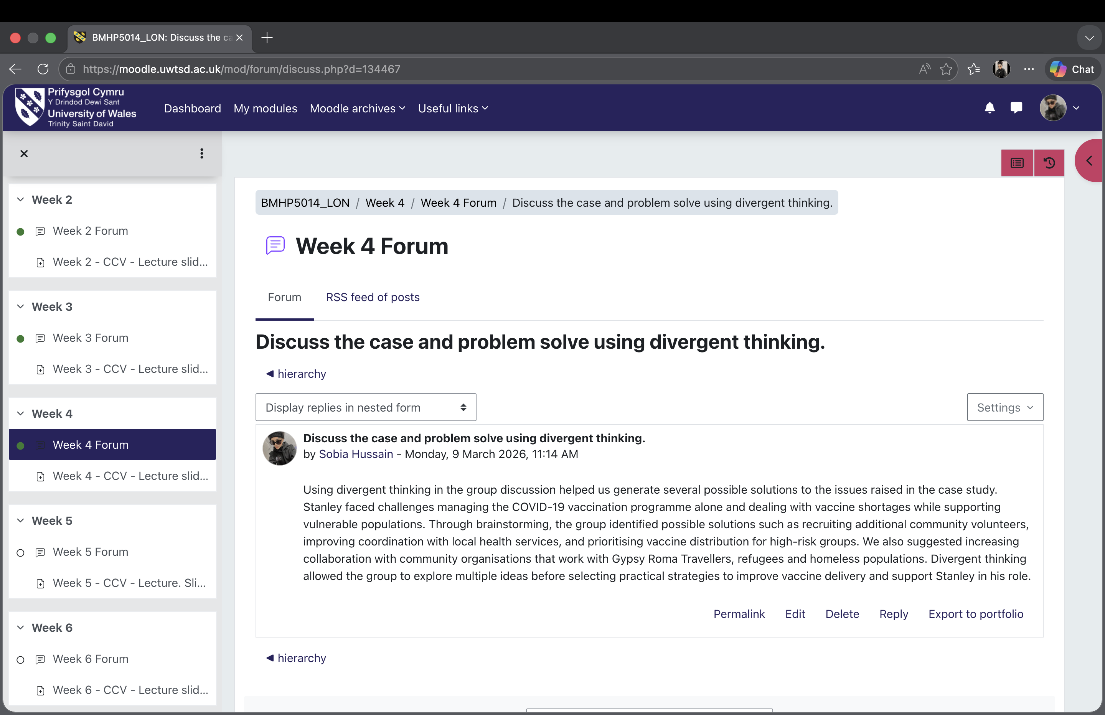
During the group activity, we used divergent thinking to brainstorm a wide range of ideas to improve healthcare services. Each group member contributed different perspectives, which helped us generate multiple possible solutions. Convergent thinking was then used to evaluate the ideas and select the most practical and effective solution for our project.
Using Kolb’s Experiential Learning Cycle, reflection is an important part of learning because it allows individuals to evaluate their experiences and improve future performance (Kolb, 1984). Reflecting on the activity helped me recognize the importance of listening to different viewpoints within a team.
One key learning outcome from the activity was the value of collaboration in generating innovative ideas. Working with others encouraged more creative thinking than working individually. I also realised that I tend to focus more on practical solutions, which reflects convergent thinking. In the future, I would like to develop stronger divergent thinking skills to generate more creative ideas when solving complex health and social care problems.
Task 4
Case Study Analysis of a UK Innovation
One significant innovation within the NHS is the introduction of the NHS App, a digital platform that allows patients to access healthcare services online. The app enables users to book GP appointments, order repeat prescriptions and view medical records through their smartphones (NHS England, 2023).
Creativity played an important role in the development of the NHS App, introducing a new digital approach to delivering healthcare services. Instead of relying solely on traditional face-to-face interactions, the app provides patients with convenient access to healthcare information and services.
The main problem addressed by this innovation was limited access to healthcare services and administrative inefficiencies within the NHS. Patients often experienced difficulties booking appointments or accessing their health information.
According to Rogers’ Diffusion of Innovation Theory, new technologies are more likely to be adopted when they are perceived as useful and easy to use (Rogers, 2003). The NHS App has been widely adopted because it simplifies access to healthcare and reduces staff administrative workload.
The value created by this innovation includes improved patient convenience, better communication between patients and healthcare providers, and reduced pressure on healthcare services. Reports suggest millions of patients now use the NHS App to manage their healthcare needs more efficiently (NHS England, 2023).
Another innovation is Telemedicine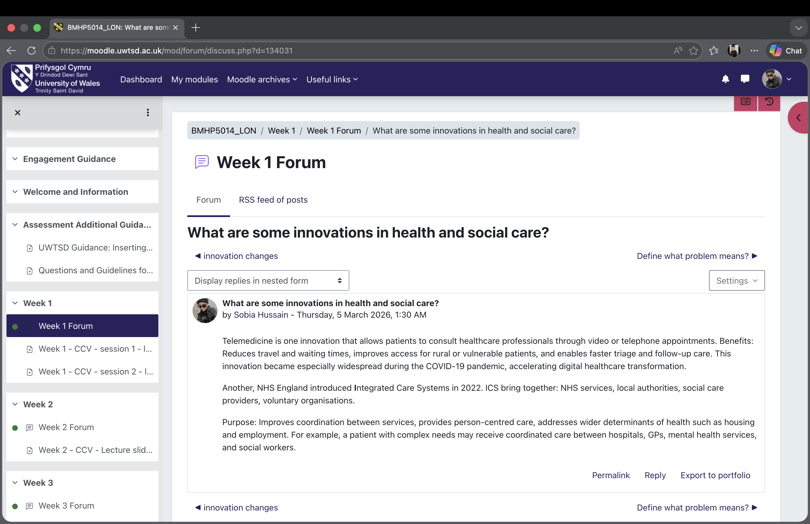
Task 5
One significant issue currently affecting health and social care is staff burnout among healthcare professionals. Burnout refers to emotional exhaustion, stress and reduced professional effectiveness caused by high workloads and workplace pressures.
A study by West et al. (2018) found that healthcare staff in the NHS experience high levels of burnout due to heavy workloads, staff shortages and long working hours. The study concluded that burnout negatively affects both staff wellbeing and patient care, as exhausted healthcare professionals may struggle to maintain high levels of performance.
Similarly, research conducted by Dyrbye et al. (2017) found that burnout among healthcare professionals is linked to organisational factors such as lack of support, high job demands and limited resources. The authors suggested that improving workplace conditions and organisational support could significantly reduce burnout levels.
These studies demonstrate that burnout is not simply an individual problem but is strongly influenced by organisational factors. Addressing staff burnout therefore requires systemic changes, including improved staffing levels, better support systems and policies that promote work-life balance within healthcare organisations.
Task 6
Wearable Health Technologies
Wearable health technologies such as smartwatches and fitness trackers are increasingly used to support the management of chronic health conditions. These devices can monitor health indicators such as heart rate, physical activity levels and sleep patterns, allowing individuals and healthcare professionals to track health data in real time.
One major benefit of wearable technologies is that they enable continuous monitoring of health conditions outside traditional healthcare settings. This can help patients manage conditions such as diabetes, heart disease and hypertension more effectively.
The Technology Acceptance Model explains that people are more likely to adopt digital technologies when they perceive them as useful and easy to use (Davis, 1989). Wearable technologies are widely adopted because they provide accessible and convenient ways for individuals to monitor their health.
For example, patients with heart conditions may use smartwatches that detect irregular heart rhythms and alert healthcare providers if abnormalities occur. Research shows that wearable devices can support early detection of health issues and encourage healthier behaviours (Piwek et al., 2016).
Electronic Health Records (EHRs)
Electronic Health Records (EHRs) are digital systems used to store and manage patient information. EHRs allow healthcare professionals to access patient records quickly and securely, improving communication and coordination between healthcare providers.
One key benefit of EHR systems is that they allow multiple healthcare professionals to access the same patient information simultaneously. This improves collaboration between doctors, nurses and other healthcare providers, leading to more coordinated care.
The Technology Acceptance Model suggests that healthcare professionals are more likely to adopt digital systems when they improve efficiency and ease of use (Davis, 1989). EHRs support this by reducing paperwork and improving access to patient data.
For example, hospitals using integrated EHR systems can quickly share patient information between departments, which helps reduce medical errors and improves decision-making (Health Foundation, 2022).
Digital Technology for Preventative Care
Digital technology also plays an important role in supporting preventative care and health promotion. Preventative care focuses on reducing the risk of illness by encouraging healthy behaviours and early detection of health problems.
Mobile health applications can help individuals track diet, exercise and health indicators. These tools encourage users to adopt healthier lifestyles and prevent long-term health conditions.
The Technology Acceptance Model explains that individuals are more likely to use digital health tools when they believe the technology provides useful health benefits (Davis, 1989).
For example, digital health apps that support smoking cessation provide reminders, progress tracking and motivational messages. Research suggests that digital interventions can improve health behaviours and support disease prevention (World Health Organization, 2020).
Task 7
Summary of the NHS Leadership Framework
The NHS Leadership Framework outlines essential behaviours and competencies needed for effective leadership within health and social care organisations. The framework emphasises promoting high-quality patient care, collaboration, and ongoing improvement in healthcare services (NHS Leadership Academy, 2013). It identifies several leadership behaviours, including inspiring shared purpose, leading with care, evaluating information, engaging the team, and influencing outcomes. These behaviours help leaders support staff, foster innovation, and enhance service delivery. Leadership is especially vital in healthcare because leaders shape organisational culture, motivate staff, and impact the quality of patient care. Effective leadership ensures healthcare teams collaborate to achieve common goals and uphold high standards of care. The framework also promotes the development of leadership skills among healthcare professionals at all levels, enabling individuals to contribute to service enhancement and innovation.
Leadership Behavior Example
One key leadership behaviour within the NHS Leadership Framework is inspiring shared purpose. This involves motivating healthcare teams to work towards a common goal of improving patient care. Leaders can encourage creativity by supporting staff in developing new ideas and innovative solutions to healthcare challenges. According to Transformational Leadership Theory, leaders inspire and motivate staff by communicating a clear vision and fostering collaboration (Bass and Avolio, 1994). For instance, a healthcare leader might encourage staff to develop new approaches to enhancing patient experiences or reducing waiting times. By supporting creativity and teamwork, leaders can assist healthcare organisations in delivering better outcomes for patients.
Reflective Journal
Throughout this module, my understanding of creativity and innovation in health and social care has greatly expanded. At first, I saw creativity mainly as artistic thinking, but I now realise that creativity is also vital for solving complex healthcare challenges.
Activities like mind mapping and group discussions helped me understand how innovative ideas can enhance healthcare services and patient outcomes. I also learned that value creation centres on improving patient outcomes while efficiently using resources.
Transformational leadership theory emphasises the importance of fostering innovation within healthcare teams (Bass and Avolio, 1994). In the future, I hope to apply these principles in my professional practice by contributing ideas that enhance healthcare services and support improved patient care.
Conclusion
In conclusion, innovation, creativity, value creation and effective change are vital for improving health and social care services. These concepts help organisations respond to complex challenges, enhance patient outcomes and use resources more efficiently. The tasks in this assignment show how innovative thinking, digital technologies and strong leadership can contribute to service improvement within the NHS and broader health and social care systems. Developing an understanding of these concepts is important for future professionals, as it allows them to support continuous improvement and deliver high-quality, person-centred care.
References
Amabile, T.M. (1996) Creativity in context: Update to the social psychology of creativity. Boulder: Westview Press. https://books.google.com/books?id=VvBzQgAACAAJ (Accessed: March 2026).

Bass, B.M. and Avolio, B.J. (1994) Improving organizational effectiveness through transformational leadership. Thousand Oaks: Sage Publications. https://psycnet.apa.org/record/1994-98606-000
(Accessed: March 2026).

Burnes, B. (2017) Managing change. 7th edn. Harlow: Pearson Education. https://www.pearson.com/en-gb/subject-catalog/p/managing-change/P200000003295
(Accessed: March 2026).

Cropley, A. (2006) ‘In praise of convergent thinking’, Creativity Research Journal, 18(3), pp. 391–404. https://doi.org/10.1207/s15326934crj1803_13
(Accessed: March 2026).

Davis, F.D. (1989) ‘Perceived usefulness, perceived ease of use and user acceptance of information technology’, MIS Quarterly, 13(3), pp. 319–340. https://doi.org/10.2307/249008
(Accessed: March 2026).

Dyrbye, L.N. et al. (2017) ‘Burnout among health care professionals: A call to explore and address this underrecognised threat to safe, high-quality care’, Journal of Internal Medicine, 283(6), pp. 516–529. https://doi.org/10.1111/joim.12752
(Accessed: March 2026).

Greenhalgh, T., Robert, G., Macfarlane, F., Bate, P. and Kyriakidou, O. (2004) ‘Diffusion of innovations in service organisations: Systematic review and recommendations’, Milbank Quarterly, 82(4), pp. 581–629. https://doi.org/10.1111/j.0887-378X.2004.00325.x
(Accessed: March 2026).

Health Foundation (2022) Electronic health records: Improving patient care. https://www.health.org.uk
(Accessed: March 2026).

Kolb, D.A. (1984) Experiential learning: Experience as the source of learning and development. New Jersey: Prentice Hall. https://learningfromexperience.com/downloads/research-library/theory-of-experiential-learning.pdf
(Accessed: March 2026).

Meadows, D.H. (2008) Thinking in systems: A primer. Vermont: Chelsea Green Publishing. https://donellameadows.org/archives/thinking-in-systems/
(Accessed: March 2026).

NHS England (2022) Virtual wards including hospital at home. https://www.england.nhs.uk/virtual-wards/
(Accessed: March 2026).

NHS England (2023) The NHS App. https://www.nhs.uk/nhs-app/
(Accessed: 9 March 2026).

Porter, M.E. (2010) ‘What is value in health care?’, New England Journal of Medicine, 363(26), pp. 2477–2481. https://doi.org/10.1056/NEJMp1011024
(Accessed: 9 March 2026).

Rogers, E.M. (2003) Diffusion of innovations. 5th edn. New York: Free Press. https://books.google.com/books?id=9U1K5LjUOwEC
(Accessed: March 2026).

West, M., Coia, D. and The King’s Fund (2018) Caring for doctors, caring for patients. London: General Medical Council. https://www.gmc-uk.org/-/media/documents/caring-for-doctors-caring-for-patients_pdf-80706341.pdf
(Accessed: March 2026).

World Health Organization (2020) Digital health interventions for health system strengthening. https://www.who.int/publications/i/item/9789241550505
(Accessed: 9 March 2026).

