Assessment Form

Module: Preparing for Professional Policing
Student Name: Saffron Simon
Module Tutor (s): Kelly Andrews
Question | 1  Situation | 2  Task | 3.  Action | 4.  Result |  | Total Mark
1 | 2/5 | 5/5 | 8/15 | 2/5 |  | 17/30
2 | 2/5 | 2/5 | 8/15 | 2/5 |  | 14/30
3 | 4/5 | 2/5 | 10/15 | 3/5 |  | 19/30
 |  |  |  |  |  | Total Mark 50/90
Key
No Reference | Minimum | Satisfactory | Exceptional
0 | 0-4 | 5-10 | 11-15

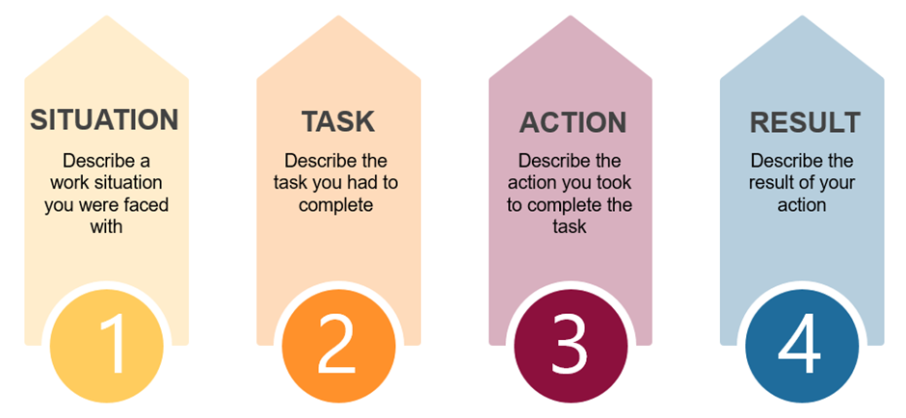

Question | Comments
1 | Q1:  Job example – working with children with needs- work with children, parents, school.  Task: Main goal is to get what the child needs.  One of the children is not very good at sitting in the car, needed to add more detail around what the child was doing.  Managed to get the child a seat belt that she couldn’t undo.  Needed a prompt for what you did – remember to provide detail.  Remember to use STAR - this was not done clearly,  Try to use just one example so not to confuse.
2 | Q3:  Situation working with challenging children. They use different communication. Use I not we.  One of the children uses an Ipad to communicate- you must reward him when he uses this correctly. Inspire him to use this correctly and communicate.  Result – Getting the children to communicate with staff.  Think of an example before you start to answer so it is clear in your mind.  Use STAR model to help you.
3 | Q5  Situation: Given 3 children to work with – all three children are autistic – only one can speak. The youngest is in a buggy and cannot walk.  We were outside in the car park – two of the children were having melt downs – another child in the buggy was having a seizure.  I took control of the child in the buggy – timing the seizure.  Explained to the other children what was happening.  Result – Good outcome – reported back to explain what had happened.  Remember to explain in detail what you did and why –  Good example but needed more detail around decision making.  .

.

.

