

Student Name : Riddham Mangukiya
Student ID : 2520876
Master of Business Administration (MBA)
Module name : Financial Management
Module code : LCMB7002
Assignment component : Financial performance and management
Lecture’s name : MD KALAM
Submission Date : 24th April, 2026
Word Count : Approx.5000

Term 1

Table of Contents
Introduction 4
Financial Health Check 5
Financial Ratio Analysis 5
Working Capital Management Analysis 10
Cash Operating Cycle 10
Recommended Strategies 11
Comparison of short-term and long-term financing 11
Strategic Financial Restructuring Plan 13
Investment Appraisal and Capital Budgeting 17
References 21
Appendices 25
Appendix 1: Profitability Ratios 25
Appendix 2: Liquidity Ratios 26
Appendix 3: Efficiency Ratios 27
Appendix 4: Gearing Ratios 28
Appendix 5: Investment Ratios 28
Appendix 6: Cash Flows Ratios 29
Appendix 7: Cash Operating Cycle 30
Appendix 8: Investment Appraisal 31

Introduction
Hyundai Motor Company is a South Korean-based multinational automotive company and one of the biggest market participants in the electric vehicle and general mobility sector. The company provides financial, governance and sustainability information to the stakeholders through its official global site and investor relations site (Hyundai, 2026). Hyundai boasts of scale and global presence, as in 2024, it registered annual revenue of KRW 175.2 trillion, net profit of KRW 13.23 trillion and global vehicle sales of 4.14 million vehicles. These numbers reflect the good performance of Hyundai in the market, as well as the economic pressures and strategic issues that the business faces in a competitive and capital-intensive environment (Hyundai, 2026).
This report is aimed at assessing the financial performance and strategic financial position of Hyundai Motor Company in the eyes of the Chief Financial Officer. It evaluates the performance of the company in terms of profitability, liquidity, efficiency, gearing, investment, and cash flow over the last five years through the ratio analysis of the financial statements of the company. The working capital management of Hyundai is also reviewed, restructuring options suggested that are financially viable, and future investment ideas are also analysed using capital budgeting techniques. It is on this basis that this report is intended to make recommendations that increase shareholder value, enable global scalability, financial resilience, and continue to be ethically responsible in the ever-changing EV business.

Financial Health Check

Financial Ratio Analysis
Financial health of a firm can be effectively analysed using the key tool that is financial ratios useful in evaluating the firm’s financial health, operational efficiency, as well as overall performance over the period of time (Schmidt, 2020). Through examining the relationships between the figures in the income statement, cash flow statement, and balance sheet, the ratios are useful in providing meaningful insights regarding liquidity, efficiency, profitability, investment potential, leverage, and cash flow management. Considering the context of Hyundai Motor Company, ratio analysis is useful in enabling a systematic assessment of effectively generating profits, utilising assets, managing short-term obligations, and financing operations Blessing and Sakouvogui, 2023). The analysis of these ratios over various years leads to identifying strengths, financial trends, as well as potential risks, and hence supports informed financial and strategic decision-making. Thus, the financial ratio analysis from 2020 to 2024 for Hyundai Motor Company is calculated and analysed below.
Profitability Ratios: These ratios help in determining the income generation capacity of a firm using the revenues, costs, assets, and income (Rashid, 2021). The Hyundai’s profitability ratios determine a strong improvement between 2020 and 2024 considering increased operational efficiency and profit generation. The operating profit ratio of the firm increased from 2.3% in 2020 to 8.1% in 2024 with a peak of 9.3% in 2023 before slightly declining in 2024 (Hyundai, 2020; Hyundai, 2024). This upward trend is concerned with the firm’s focus on strong global demand, higher-margin vehicles and increased sales of electric and hybrid models. The global electrified vehicle sales involving commercial vehicles from October to December 2024 have increased 21% concerned with sales growth in the North American region (Hyundai, 2025). However, the declining margin reflects increased cost of sales, and selling and admin expenses.
Similarly, the net profit ratio significantly improved from 1.85% in 2020 to 7.55% in 2024 reflecting the firm’s increased profitability and financial performance (Hyundai, 2020; Hyundai, 2024). This is concerned with favourable exchange rates, higher vehicle sales, and efficient production strategies. A key strength is Hyundai’s increasing profits, benefiting investors through improved returns and enhancing the firm’s financial stability. However, due to intense competition in the EV markets, global economic uncertainty, and rising raw material costs, the firm faces potential threats. Thus, for stakeholders like creditors and investors, improving profitability leads to stronger financial resilience and long-term growth prospects.
Liquidity Ratios: To analyse the short-term position of a firm in terms of current assets and liabilities, liquidity ratios are considered useful (Gunawan, 2023). The liquidity position of Hyundai is stable in a five-year period indicating the capability of the company to cover short-term financial obligations. The current ratio was moderate, varying between 1.407:1 in 2020 and 1.456:1 in 2024 which means that the current assets were always greater than the current liabilities (Hyundai, 2020; Hyundai, 2024). This implies proper management of working capital even when the scale of operations and global expansion increase. The minor decline to 1.298:1 in 2022 indicates increased short-term liabilities in the form of increased production and supply chain changes as a result of recovering from the pandemic.
Similarly, the acid-test (quick) ratio dropped a little but above 1:1 within the period reflecting 1.217:1 in 2020 to 1.207:1 in 2024, though it is lower than 2020 indicating excellent short-term solvency in the absence of inventories (Hyundai, 2020; Hyundai, 2024). The progressive decline can be attributed to rising inventory because of larger vehicle production and EV demand. Thus, it reflects that Hyundai is providing a strong liquidity buffer and hence reassuring suppliers and creditors of timely payments. For stakeholders, mainly the suppliers and lenders, the stable liquidity helps in reflecting their low short-term financial risk of the firm.
Efficiency Ratios: These ratios are also known as operating or activity ratios and are useful in effectively measuring the firm’s utilisation of assets and management of liabilities for generating income (Kurniani, 2021). An effective control of receivables but a slow growth in holding of inventory during the 5-year period has been seen in the efficiency ratios of Hyundai. The days of receivables turnover were relatively constant in 10 days to 12 days from 2020 to 2024 which indicated effective collection of credit and good management of the dealer network (Hyundai, 2020; Hyundai, 2022; Hyundai, 2024). This is concerned with the sales of the majority of vehicles provided through authorised global distributors and financing subsidiaries that helps in providing quick access to receivable collection and controlled credit risk.
However, the inventory turnover days have increased to 44 days in 2021 and 52 days in 2024 (Hyundai, 2022; Hyundai, 2024). This is attributed to financial disclosures of Hyundai to increased volumes of production, increased electric vehicle production, and supply chain changes due to semiconductor shortages that necessitated increased safety stocks in plants across the world. This reflects the firm’s position in effectively managing its receivables with high cash inflows and low credit risk. Whereas increasing inventory results in increased storage expenses and higher inventory capital. Thus, the investors and management need to focus on improving inventory to sustain operational efficiency considering the expansion of production.
Gearing Ratios: These ratios are useful in measuring the financial leverage that reflects the degree to which the operations of an organisation are funded by debt or equity capital. (Odhiambo, et al., 2025) The gearing ratios involving the debt-equity ratio and interest coverage ratio reflected Hyundai’s moderate use of debt financing and a high ability to service debt. The debt equity ratio grew to 1.164 in 2024 as compared to 0.963 in 2020 indicating a slow increase in long-term borrowing in comparison to equity (Hyundai, 2020; Hyundai, 2024). The financial statements of Hyundai indicate that total liabilities increased when the company engaged in big investments in electric vehicles, mobility technology, and global production capacity. This growth indicates that leverage was used more to fund strategic growth.
However, despite the rise in the leverage, Hyundai is able to maintain a strong interest coverage ratio which has improved significantly from 2.5 times in 2020 to 9.3 times in 2022, and 15.85 times in 2024 respectively (Hyundai, 2020; Hyundai, 2022; Hyundai, 2024). This means that operating profits are adequate to meet interest liabilities mainly because of increasing operating income and increasing vehicle sales around the world. Thus, effective gearing position reassures creditors and investors with a strong ability to service debt signalling strong financial stability.
Investment Ratios: These ratios are used to assess a firm’s financial health and stock valuation for guiding investment decisions. It has been seen that shareholder returns of Hyundai are effective considering the investment ratios comparison from 2020 to 2024. The return on equity (ROE) has increased 2.52% in 2020 to 11.00% in 2024 which demonstrates the better profitability of Hyundai and the efficient use of the funds of shareholders (Hyundai, 2020; Hyundai, 2024). Considering the firm’s financial statements, net profit has grown significantly with an increase from KW 1.92 trillion in 2020 to KW 13.23 trillion in 2024 with an expansion of equity to KW 120.3 trillion reflecting capital growth and stronger financial performance (Hyundai, 2020; Hyundai, 2024).
Similarly, the EPS (Earnings Per Share) of the firm increased sharply from KW 5,454 in 2020 to KW 28,521 in 2022, and KW 47,615 in 2024 determining higher net earnings along with improved returns for investors (Hyundai, 2020; Hyundai, 2022; Hyundai, 2024). This performance is attributed to Hyundai through strong global vehicle demand, improved operating margins across major markets, and growth in electric and SUV vehicle sales. This results in reflecting the firm’s increasing shareholder value that benefits investors through higher profitability. However, it has been seen that economic uncertainty and global competition are considered potential risks impacting future earnings and returns.
Cash Flow Ratios: Cash flow ratios are useful in assessing a firm’s solvency, liquidity, and operational efficiency by measuring the ability to pay off debts and generating cash from operations (Blessing and Sakouvogui, 2023). It has been seen that Hyundai’s cash flow ratios reflect that their cash generation operating activity has been fluctuating even though the revenues of the company have been continuously rising. The operating cash flow ratio was negative in the majority of years with -0.007 in 2020, -0.034 in 2023, and -0.071 in 2024 with a positive outlier of 0.143 in 2022 (Hyundai, 2020; Hyundai, 2022; Hyundai, 2024). Similarly, the cash flow margin also determined the same trend with -0.39% in 2020, -1.55% in 2023, and -3.23% in 2024 with a positive margin of 7.46% in 2022 respectively (Hyundai, 2020; Hyundai, 2022; Hyundai, 2024). These ratios are mainly because of the increased working capital needs, the increased inventories, and heavy investments in the development and technological capabilities of electric vehicles.
It has been seen that while the firm has achieved a substantial revenue growth from KW 103.9 trillion in 2020 to KW 175.2 trillion in 2024, the operating cash flows are impacted by increased inventories and financial services receivables supporting vehicle sales (Hyundai, 2020; Hyundai, 2024). This determines that despite Hyundai generating strong sales and profits, the higher operational investments of the firm can temporarily pressure the cash flows leading to the importance of working capital management for sustaining financial stability and liquidity.

Working Capital Management Analysis

Cash Operating Cycle
Working capital management is concerned with the management of short-term assets and liabilities in order to ensure that the organisation is able to maintain sufficient liquidity for meeting its operational needs along with maximising profitability (Islam, 2025). An effective working capital management focuses on controlling receivables, inventory, and payables for maintaining an optimal cash conversion cycle (CCC). As per the corporate finance theory mainly the working capital efficiency framework, it has been seen that a shorter CCC helps in indicating more efficient utilisation of short-term resources because of quicker recovery of cash invested in operations (Asman, et al., 2022). The working capital efficiency of Hyundai is assessed through its cash operating cycle (COC).
In consideration of the calculations, the COC of the firm increased from 22 days and 19 days in 2020 and 2021 to 29 days and 31 days in 2023 and 2024 respectively (Hyundai, 2020; Hyundai, 2022; Hyundai, 2024). This change is mainly due to the increased outstanding inventory days from 48 days and 44 days to 49 days and 52 days determining higher production volumes along with the need to maintain a larger inventory of electric vehicle parts and components during semiconductor shortages and supply chain disruptions. At the same time, the days' sales outstanding have remained stable with 12 days in 2020 and 2024 determining efficient credit collection through the firm’s financing networks and its global dealer (Hyundai, 2020; Hyundai, 2024). However, the days payable outstanding of Hyundai have decreased from 38 days in 2020, 35 days in 2021 to 31 days in 2023 and 33 days in 2024 demonstrating faster payment to suppliers (Hyundai, 2020; Hyundai, 2022; Hyundai, 2024). Despite helping in strengthening supplier relationships, the COC also result in enhancing short-term cash pressure. Therefore, the rising COC indicate greater working capital associated with operations and hence requires improved payment strategies and inventory management.

Recommended Strategies
For strengthening liquidity, Hyundai can focus on adopting various working capital reforms aiming at improving the efficiency of receivables, inventory, and payables management.
- Hyundai can focus on enhancing inventory optimisation through demand forecasting technologies and digital supply chain systems. The integration of real-time production monitoring and AI-based demand planning can help the firm to minimise excess inventory levels along with maintaining production stability and hence shortening inventory holding periods (Nweje and Taiwo, 2025).
- The firm can also consider expansion of dealer financing and receivable management systems by undertaking subsidiaries of financial services in order to accelerate cash inflows. The implementation of dynamic discount policies and automated credit monitoring for early payments could help in further minimising receivable collection periods.
- Moreover, it has also been recommended to Hyundai to focus on improving liquidity by strategically extending supplier payment terms with the usage of collaborative supply chain financing programmes (Chen, et al., 2020). This approach will allow suppliers to undertake early payments through financial institutions along with enabling Hyundai to maintain longer payable periods without damaging supplier relationships.
Therefore, these reforms would help in shortening the cash operating cycle, improve liquidity, and release trapped working capital along with supporting the global production expansion of Hyundai.

Comparison of short-term and long-term financing
Hyundai can use both short and long-term financing to finance the working capital, although the purpose of the financing varies. Bank overdrafts, trade credit, short-term loans and commercial paper are all covered by short-term financing (Xilong, 2025). Such sources come in handy to manage the temporary cash flow situations, seasonal inventory requirements, and temporary receivables. They are also typically more readily available and flexible, but they have refinancing risk, and can be costly in the event interest rates increase (Lin, et al., 2022). Excessive dependence on short-term financing can also undermine liquidity in case the market situation becomes tight.
On the contrary, long-term financing incorporates long-term bank loans, bonds, lease finance and equity funds. These are more applicable sources of funding for permanent working capital and further general stability in operations (Krinichansky, 2025). However, as much as long-term finance can be expensive to arrange and less flexible, it is more certain, with less refinancing pressure, and better aligned funding with long-term business needs (Kostyna, 2025). In the case of a company like Hyundai, which has to operate in the capital-intensive and highly competitive EV market on a global scale, long-term financing is typically more adequate to ensure the financial sustainability.
In general, Hyundai needs to pursue a moderate course. Temporary operating requirements should be financed at a low rate by short-term sources, whereas the permanent working capital requirements should be financed by long-term sources. This would minimise the liquidity risk, enhance stability and sustainable growth.

Strategic Financial Restructuring Plan
Financial restructuring of Hyundai Motor Company must be aimed at a selective strengthening strategy and not a distress rescue strategy. The corporation is still large and profitable in terms of finances; however, recent statistics demonstrate that the company is facing pressure in terms of margins and growing liability pool, as well as being subjected to increased exposure to international uncertainty. Hyundai realised KRW 175.2 trillion in revenue, KRW 14.24 trillion operating profit, and KRW 13.23 trillion net profit in 2024 and sold 4.14 million vehicles worldwide (Hyundai, 2025). However, total liabilities as at the end of 2025 are already KRW 241.2 trillion as compared to KRW 219.5 trillion in 2024, and total assets are KRW 368.8 trillion, and total equity is KRW 127.6 trillion. In the identical 2025 statements, Hyundai announced KRW 10.39 trillion short-term debentures that were short term, KRW 33.76 trillion current portion of long-term debt and KRW 106.90 trillion long-term debt (Hyundai, 2025). These numbers can be used to conclude that Hyundai remains resilient, yet a heavier and less flexible capital structure is emerging in an EV transition period, tariff risk, and a highly competitive global market.
Portfolio divestiture and asset rationalisation are the first of the restructuring recommendations (Potharla, 2025). Non-core or low-return assets, especially operations, joint ventures, or model lines that dilute return on capital and do not support EV leadership, should be reviewed by Hyundai. This is not a sale of strategically important EV, battery and software holdings. Hyundai should instead sell poorly performing internal-combustion-related properties in low-growth markets, cut superfluous inventories and duplicate regional capacity, and reuse capital in electrification, software-defined automobiles, and premium mobility services. This would enhance shareholder value through increasing future expected returns on invested capital and an indication of disciplined use of capital. It would also enhance flexibility in operations since the management focus and funding would be channelled into segments that have a stronger potential for growth in the world. Hyundai already predicts KRW 16.9 trillion of total investment by 2025; divestiture would allow it to fund priority projects without excessive use of debt (Hyundai, 2025).
The second suggestion is a specific equity-based capital injection, but only on strategic areas of growth and not on overall repair of the balance sheet (Nagy, 2025). Hyundai does not find itself in a situation where a significant emergency rights issue is required. Nevertheless, limited equity issues, or hybrid notes, or attracting strategic collaborators to EV platforms, battery supply, charging infrastructure or autonomous technology may distribute risk and ease the pressure of financing. This is particularly pertinent since the liabilities of Hyundai have increased drastically in 2025, and the obligations concerning debts were also high. An enhanced gearing pressure would be mitigated by a measured equity injection, and would maintain credit quality and would enhance borrowing capacity in future projects (Hyundai, 2025). This would cause a short-term dilution effect to the shareholders; however, in case the capital is ring-fenced to invest in high-return EV and digital investments, long-term value creation should neutralise this cost. It is better to finance all the expansion with the help of additional debentures only when there is uncertainty about interest rates, tariffs, and geopolitical risks.
The third suggestion is debt restructuring by maturity extension and refinancing (Friewald, et al., 2022). Finally, Hyundai ought to mitigate the refinancing risk by transforming part of the short-term and current debt liability into instruments with longer maturities, particularly green bonds or sustainability-linked bonds. By the end of 2025, Hyundai had over KRW 44 trillion in short-term borrowings and current amounts of long-term debt and debentures, both of which may limit the liquidity in downturns of the cycle. The extension of the maturities would enhance the cash planning and operational flexibility, whereas the green financing would potentially reduce the effective cost of capital in case it is linked to realistic sustainability goals. Since Hyundai already has a commitment towards becoming a public carbon-neutral company by 2045 and has instituted governance mechanisms, including the Carbon Neutrality Committee and the Group Carbon Neutrality Council, it has an authoritative basis of sustainable financing (Hyundai, 2025). This would not only increase the debt structure but also investor confidence in ESG-oriented funds, which would help shareholder value.
The fourth restructuring alternative is selective alliance or merger activity, although only in those areas where the scale is required. There is no need to have a complete merger of the corporations, and this would kill the flexibility. However, the intensity of capital and speed to market can be decreased with selective mergers, platform-sharing deals, or regional EV manufacturing-based cross-border joint ventures in batteries, semiconductors, software, or regional EV manufacturing. Hyundai is already in a very international situation and thus reorganising should be aware of the fact that the competitive edge is no longer based on the sheer size of manufacturing capacity, but on the control of its ecosystem. The strategic combinations would enhance the flexibility of operations, whereby they will share the fixed costs and the risk of technology (Shuaibu, et al., 2025). They might also defend shareholder value by ensuring that they do not spend much on duplication of R&D in a highly electrified and software-investment-need market.
The restructuring plan is based on international considerations. To begin with, taxation is important due to the fact that Hyundai is a company that operates in different jurisdictions and may have different corporate taxation, EV subsidies, and tariffs. The reorganisation should thus be inclined towards the transparent tax-efficient supply chain rather than the aggressive, though reputation-damaging avoidance schemes. Second, there is a critical currency risk. According to Hyundai, the Group is affected by foreign exchange, interest rate, price, credit and liquidity risk. The revenues and costs are distributed all over the world, and hence a weak or volatile Korean won would translate to revenues and warranty costs as well as the prices of imported inputs. Hyundai ought to thus combine restructuring and more powerful natural hedging, local sourcing and foreign-currency debt matching (Hyundai, 2025). Third, inflation increases labour, battery, logistics and financing costs (Suraharta and Hendrasti, 2025). This endorses the argument of unloading lower margin businesses and joint ventures that would save overlapping capital investment.
On the ethical front, the restructuring of Hyundai should be in line with the stakeholders' responsibilities. Massive layoffs, unfriendly tax transfers or termination of obligations with its suppliers may make short-term ratios better and the long-term value worse. Official sustainability reports indicate that Hyundai has implemented clear governance on carbon neutrality and climate-risk measures, and its carbon-neutrality goal is 2045. Consequently, CSR should be backed up with financial restructuring to the extent of safeguarding employment by retraining where feasible, focusing on responsible sourcing, and allocating capital to low-emission technologies (Hyundai, 2025). This renders the restructuring more plausible, global in nature and morally upright.
In general, the most effective restructuring strategy to use at Hyundai is the balanced one, which combines non-core divestiture, selective equity-based funding, optimisation in debt maturity, and strategic alliances. The package would enhance the shareholder value due to improved capital allocation, pressure on the capital structure would be reduced due to the low refinancing risk, and flexibility in conducting operations would be facilitated in a highly dynamic international EV market (Hyundai, 2025). Hyundai is not a financially feeble company; however, the figures are clear that a proactive restructuring plan is required in case it desires to continue generating profits and to stay competitive in the world of EVs at the next stage of its growth.

Investment Appraisal and Capital Budgeting
This section will analyse the three proposed investment projects of Hyundai Motor Company by using the results of the appraisal that have already been computed in the spreadsheet. There are five standard methods that were used in the analysis: Payback Period, Accounting rate of return, Net Present Value, Profitability index and Internal rate of return.
Payback Period is used to calculate the duration of time it takes a project to break even with net cash inflows. It is helpful since rapid recovery enhances liquidity and eliminates vulnerability to unpredictability (Sinaga, et al., 2023). Accounting Rate of Return is used to evaluate the average annual accounting profit as a percentage of average investment. It suggests profitability within accounting, however, without taking into account the time value of money (Dai, et al., 2022). The Net Present Value is the difference between the present value of the cash inflows (future) and the initial amount of the outlay at the discount rate that is necessary. When NPV is positive, the project is value-creating to shareholders, whereas when NPV is negative, the project is value-destroying (Focacci, 2022). Profitability Index gives the evaluated value of what is available as a result of every pound investment; hence, a value above one denotes acceptance (Ogunbiyi, 2023). The discount rate that causes NPV to equal zero is called the internal rate of return. When the IRR exceeds the amount of the required rate of return, the project is viable.
The final results reveal that Project C is the most robust one. It is also the shortest payback period of the three projects, with a payback period of 3.60 years. It is the highest in ARR of 60.0, highest in NPV at 4.23 million pounds, highest PI at 1.08 and highest IRR at 10.82. The payback period of Project A is 4.50 years, ARR is 43.2, NPV is negative, which is -8.68 million pounds, PI is 0.83, and IRR is 2.84. Project B has a payback period of 4.55 years, ARR of 44.0, NPV of negative 8.30 million pounds sterling, PI of 0.83, as well as IRR of 3.30. These results demonstrate that Project C only succeeds in the primary discounted cash flow examinations.
In such an environment, projects that break even sooner enjoy favour since they have less risk and secure liquidity. Project C takes 3.60 years to recover the initial amount of 50 million pounds, as compared to Projects A and B, which will take over 4.5 years. It implies that the cash would be generated back by Project C earlier, and Hyundai will either reinvest it or maintain flexibility.
The same ranking is supported by ARR. As long as straight-line depreciation to zero is made, the ARR represents the average accounting profit per year, compared to the average investment. Project C is generating the best accounting payoff, and therefore, it would have the greatest contribution to the reported profit performance of Hyundai. The ARR figures in projects A and B are lower. Nonetheless, ARR is not to be employed in isolation since it does not take timing and discounting into account.
The most vital method of appraisal is NPV, as it directly evaluates the value of the current after considering the time value of money and the required return of 10% by Hyundai. It is based on this that the decision is easy. Project C is advisable since its NPV is positive at 4.23 million pounds, implying that it has the capacity to increase the business. Projects A and B are not to be accepted since they have negative NPVs, i.e. making them less profitable than the cost of capital of Hyundai and decreasing the wealth of shareholders.
This conclusion is verified by the Profitability Index. The PI of project C of 1.08 indicates that every 1 given to the project is likely to yield 1.08 in terms of present value. Conversely, the PI of 0.83 of Projects A and B implies that one pound of investment in the project only produces 83 pence of present value, which is lower than the acceptance level.
IRR supports Project C. As the IRR of Project C stands at 10.82, it is somewhat higher than the cost of capital of the company, which is 10% and is thus acceptable in terms of the cost. Project A and Project B have an IRR of 2.84 and 3.30, which is much lower than the hurdle rate, hence not financially smart. Even though IRR is handy in the sense that it gives a percentage value of the return, NPV must still be given the highest weight.
On the whole, all five techniques are directed in the same way. Project C is the most successful regarding cash recovery, accounting profitably, value creation, capital efficiency, and anticipated return. Project A and Project B might appear rational since they recover their cost of projects in the project life and give reasonable accounting returns; however, when discounted, both projects fail to satisfy the required return of Hyundai. Hence, the single-project recommendation that is optimal is Project C acceptance and Project A and B rejection.
The same suggestion would also suit the overall financial stance of Hyundai. Hyundai is a huge and profitable company, but it must be disciplined in allocating capital since EV conversion involves high costs on battery, software, research and development, and global production capacity. To that end, Hyundai must not commit to projects that do not generate value at a desired rate of return. Project C is more appropriate for a company that has to be flexible as well as compete in the market characterised by a high rate of change, because it offers a good return, and the cash will be collected sooner.
There are other risks, which are non-financial and contribute to the selection of Project C. First, there are political and regulatory risks. The tariffs, changes in subsidies, localisation needs, and environmental standards influence EV manufacturers. Such factors are capable of changing the project results within a short period of time, hence a shorter payback and a positive NPV project is more secure. Second, it is customer loyalty and the risk in the market demand. The EV market is price sensitive, which is why consumers are interested in its reliability, convenience in charging, design, and brand name. In case of a decline in demand, less valuable generation projects will be exposed. Third, it has a technology risk. Automation, autonomous functions, and battery systems change at an extremely fast pace, and thus, the returns become more unpredictable. Project C would be in a better position since it generates value even with such risks.
Hyundai has the capacity to invest up to 100 million under the capital rationing. The company is able to select not more than two projects because every project will demand the same amount of 50 million pounds. The combinations are possible: A plus B, A plus C and B plus C. Since NPV is additive, the combination that has the most outcomes in terms of total NPV will be the best combination. According to the calculations done, A + B will result in a combined NPV of negative £16.98 million, A + C will result in negative 4.45 million, and B + C will result in negative 4.07 million. As such, in the event of Hyundai having to select two projects, B and C are the most optimal, given that they yield the least negative total NPV.
The result, however, should be interpreted with caution. Capital rationing does not imply that Hyundai will need to invest the entire amount of the funds amounting to 100 million pounds. When the management has the option to invest at will with less than the maximum budget, the option that is the strongest financially is to invest in Project C only and leave the other £50 million. This is because only Project C has a positive NPV, and the addition of either Project A or Project B would decrease the total value.
To sum up, the final suggestion is supported by the meaning and outcomes of all five variables of appraisals. Payback Period reveals that Project C recovers the cash within the shortest time. ARR demonstrates that it experiences the best accounting profitability. It is clear that NPV indicates that it is the only project that generates shareholder value. PI reveals that it is the only project that is creating greater present value than cost. IRR demonstrates that it is the only project that makes more than the obligatory 10% return of Hyundai. As such, Hyundai ought to accept Project C as the optimal one-off investment. Under capital rationing, the combination of the two projects B and C is the optimal, although the stronger suggestion is still Project C simply because it is the only option that evidently maximises the value.

References
Asman, F.N., Fernandez, D., Jamaludin, N.A., Omar Zaki, H. and Ghazali, A.W. (2022) Cash conversion cycle and firm’s performance. International Journal of Academic Research in Business and Social Sciences, 12(11), pp.2682-2692.
Blessing, H. and Sakouvogui, G. (2023) Impact of liquidity and solvency ratios on financial performance: a comprehensive analysis. Indonesia Auditing Research Journal, 12(3), pp.102-115.
Chen, J., Cai, T., He, W., Chen, L., Zhao, G., Zou, W. and Guo, L. (2020) A blockchain-driven supply chain finance application for auto retail industry. Entropy, 22(1), p.95.
Dai, H., Li, N., Wang, Y. and Zhao, X. (2022, March) The analysis of three main investment criteria: NPV IRR and payback period. In 2022 7th International Conference on Financial Innovation and Economic Development (ICFIED 2022) (pp. 185-189). Atlantis Press.
Focacci, A. (2022) The investment rate of return at the end of the period: A future worth approach to capital budgeting. International Journal of Revenue Management, 13(1-2), pp.79-98.
Friewald, N., Nagler, F. and Wagner, C. (2022) Debt refinancing and equity returns. The Journal of Finance, 77(4), pp.2287-2329.
Gunawan, E. (2023) Liquidity Ratio Analysis in Financing Short Term Liabilities. International Journal of Health, Economics, and Social Sciences (IJHESS), 5(2), pp.157-162.
Hyundai. (2020) CONSOLIDATED FINANCIAL STATEMENTS AS OF AND FOR THE YEARS ENDED December 31, 2020 AND 2019. [Online]. Available at: https://www.annualreports.com/HostedData/AnnualReportArchive/h/OTC_HYMTF_2020.pdf [Accessed on: 14.03.2026].
Hyundai. (2022) CONSOLIDATED FINANCIAL STATEMENTS AS OF AND FOR THE YEARS ENDED DECEMBER 31, 2022 AND 2021. [Online]. Available at: https://www.annualreports.com/HostedData/AnnualReportArchive/h/OTC_HYMTF_2022.pdf [Accessed on: 14.03.2026].
Hyundai. (2024) CONSOLIDATED FINANCIAL STATEMENTS FOR EACH OF THE TWO YEARS IN THE PERIOD ENDED DECEMBER 31, 2024. [Online]. Available at: https://www.annualreports.com/HostedData/AnnualReports/PDF/OTC_HYMTF_2024.pdf [Accessed on: 14.03.2026].
Hyundai. (2025) Corporate Information. [Online]. Available at: https://www.hyundai.com/worldwide/en/newsroom/detail/hyundai-motor-announces-2024-annual-and-q4-business-results-0000000897 [Accessed on: 14.03.2026].
Hyundai. (2025) Hyundai Motor Announces 2024 Annual and Q4 Business Results. [Online]. Available at: https://www.hyundai.com/worldwide/en/newsroom/detail/hyundai-motor-announces-2024-annual-and-q4-business-results-0000000897 [Accessed on: 14.3.2026].
Hyundai. (2025) HYUNDAI MOTOR COMPANY AND ITS SUBSIDIARIES. [Online]. Available at: https://www.hyundai.com/content/dam/hyundai/ww/en/images/company/investor-relations/financial-Information/report-en/2025/2025-q4-consolidated-audit-report-en.pdf [Accessed on: 14.3.2026].
Hyundai. (2025) Sustainability Report. [Online]. Available at: https://www.hyundai.com/content/dam/hyundai/ww/en/images/company/sustainability/about-sustainability/2025/hmc-2025-sustainability-report-en-v12.pdf [Accessed on: 14.3.2026].
Hyundai. (2026) Company. [Online]. Available at: https://www.hyundai.com/pacific/en/company/about-hyundai [Accessed on: 14.3.2026].
Hyundai. (2026) Worldwide. [Online]. Available at: https://www.hyundai.com/worldwide/en [Accessed on: 14.3.2026].
Islam, I.M.M. (2025) Linking working capital efficiency to profit maximisation: A conceptual analysis. In Economic Forum (Vol. 15, No. 1, pp. 93-102).
Kostyna, V. (2025) THE IMPACT OF INVESTMENT STRATEGIES ON LONG-TERM FINANCIAL STABILITY. Collection of scientific papers «SCIENTIA», (October 3, 2025; Berlin, Germany), pp.35-42.
Krinichansky, K.V. (2025) The Theoretical Foundations and Problematic Areas of the Contemporary Long-Term Financing Theory. FINANCE: THEORY AND PRACTICE, p.112.
Kurniani, N.T. (2021) The effect of liquidity ratio, activity ratio, and profitability ratio on accounting profit with firm size as a mediation. Journal of Economics and Business Letters, 1(3), pp.18-26.
Lin, J.Y., Yang, Z., Li, Y. and Zhang, Y. (2022) Development strategy and the MSMEs finance gap. Journal of Government and Economics, 5, p.100034.
Nagy, M. (2025) The Paradox of Performance: Profit Growth amid Structural Financial Instability. Ekonomicko-Manazerske Spektrum, 19(2), pp.1-11.
Nweje, U. and Taiwo, M. (2025) Leveraging Artificial Intelligence for predictive supply chain management, focus on how AI-driven tools are revolutionizing demand forecasting and inventory optimization. International Journal of Science and Research Archive, 14(1), pp.230-250.
Odhiambo, J.D., Murori, C.K. and Aringo, C.E. (2025) Financial leverage and firm performance: An empirical review and analysis. East African Finance Journal, 4(1), pp.25-35.
Ogunbiyi, J.O. (2023) Practical Demonstrations of the Use of Select Property Investment Viability Appraisal Models: Net Present Value, Profitability Index and Net Terminal Value. Urban Economics & Regional Studies eJournal, 16(82).
Potharla, S. (2025) From Debt to Divestiture: How Indian and Global Firms Reshaped through Corporate Restructuring. Available at SSRN 5348941.
Rashid, C.A. (2021) The efficiency of financial ratios analysis to evaluate company’s profitability. Journal of Global Economics and Business, 2(4), pp.119-132.
Schmidt, J. (2020) Financial Ratios: Definition, Types, and Examples. [Online]. Available at: https://corporatefinanceinstitute.com/resources/accounting/financial-ratios/ [Accessed on: 14.03.2026].
Shuaibu, A.S., Mahmoud, A.S. and Sheltami, T.R. (2025) A review of last-mile delivery optimization: Strategies, technologies, drone integration, and future trends. Drones, 9(3), p.158.
Sinaga, A.S., Sari, M.M., Hutasuhut, A.A., Zahara, S.T., Amanda, A., Fitri, A. and Caesario, M.A. (2023) Comparison of capital budgeting methods: NPV, IRR, PAYBACK PERIOD. World Journal of Advanced Research and Reviews, 19(2), pp.1078-1081.
Suraharta, I.M. and Hendrasti, A. (2025) The Effects of Rising Fuel Prices on Logistic Costs in Emerging Markets. The Journal of Academic Science, 2(6), pp.1678-1687.
Xilong, P. (2025) Enterprise Short-Term Commercial Paper. In Dictionary of Contemporary Chinese Economics (pp. 1770-1771). Singapore: Springer Nature Singapore.

Appendices

Appendix 1: Profitability Ratios
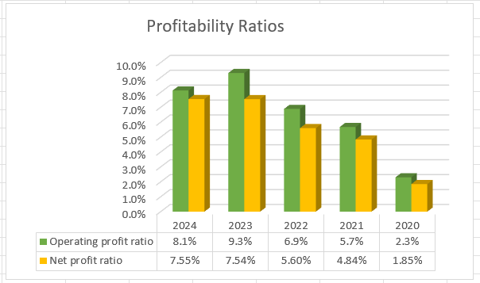
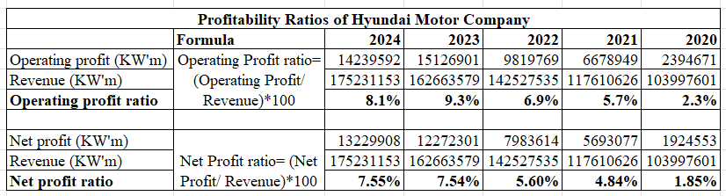

Appendix 2: Liquidity Ratios
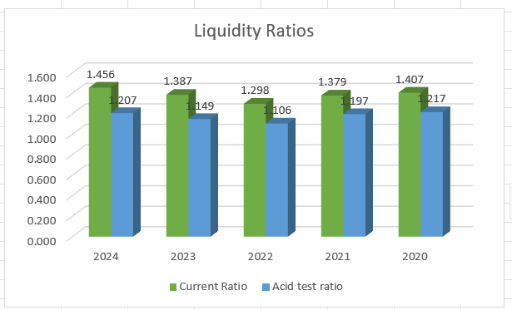
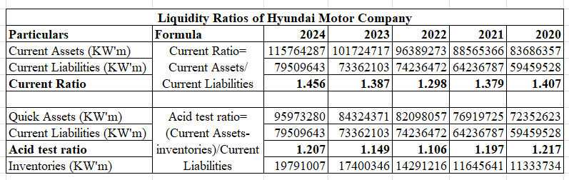

Appendix 3: Efficiency Ratios
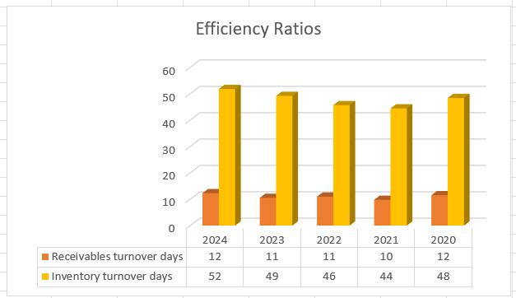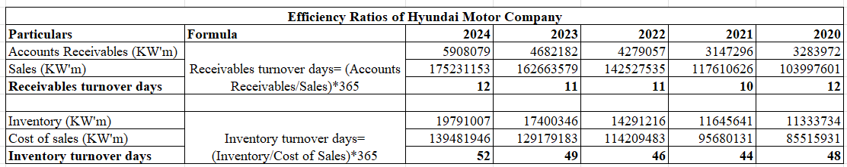

Appendix 4: Gearing Ratios
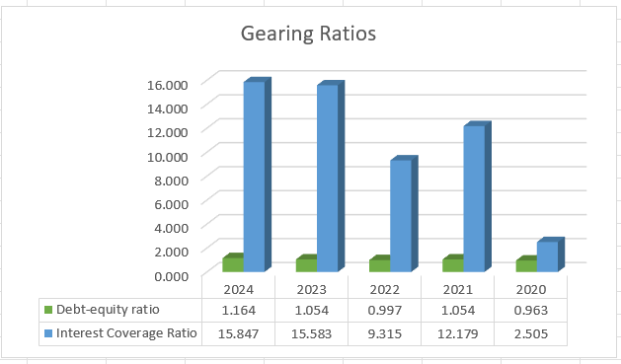
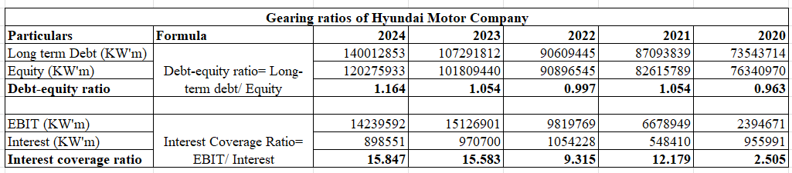

Appendix 5: Investment Ratios
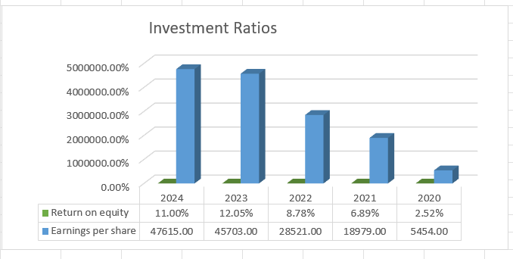
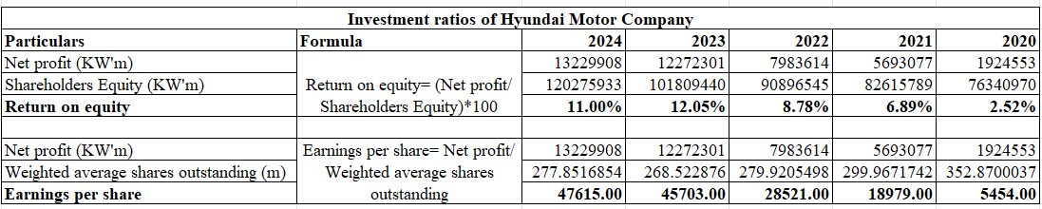

Appendix 6: Cash Flows Ratios
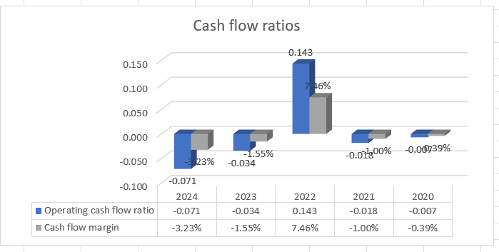
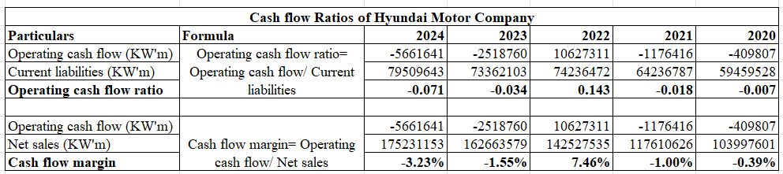

Appendix 7: Cash Operating Cycle
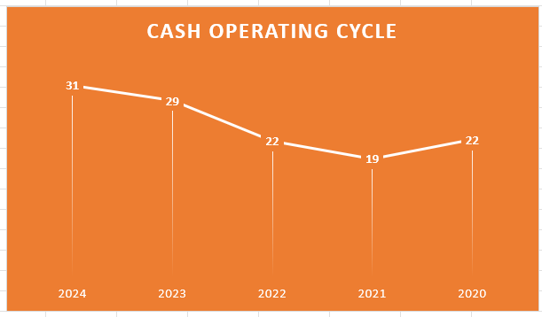
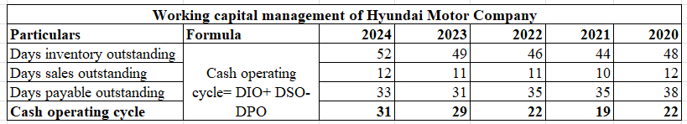
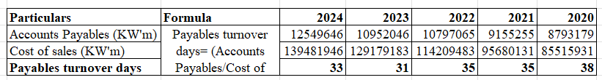

Appendix 8: Investment Appraisal


