Marketing Management Assignment

Programme : Masters in General Management

Module : Marketing Management
Module code : LCMB 7001

Assignment Title : 2
Student Name : Payyauvla Saikishan
Student Number : 2126308

Lecturer Name : Tushara Balendran

Executive summary
Marketing management is an important aspect of every business and this has been illustrated through the analysis of marketing analysis of Tesco. The report begins with a background study of the company along with information on its market share and annual revenue. Further, the report indulges in the analysis of macro environment with PESTLE analysis and microenvironment with SWOT analysis. The competitive analysis has been done through Porter's five forces. The report concludes with the discussion of the segmentation, targeting and positioning of Tesco and the marketing mix of 4ps as well. The report is replete with relevant recommendations for Tesco.

Table of Contents
Introduction 4
Analysis of macro environment 5
Porter’s five forces 6
Analysis of microenvironment 7
Segmentation, targeting and positioning 7
Marketing mix of Tesco 9
Conclusion 9
Recommendation 9
References 10

Programme : MBA

Module : Marketing Management
Module code : LCMB 7001

Assignment Title : 1
Student Name : Payyauvla Saikishan
Student Number : 2126308

Lecturer Name : Tushara Balendran

Introduction
The report is based on the analysis of the marketing management of one of the top retail companies in the UK, Tesco. Tesco is the leading company in the retail industry of the UK and it deals primarily in groceries and general merchandise. The company diversified its products involving books, clothing, electronics, furniture, toys, petrol, software, financial services, telecoms and internet services (Tesco, 2022). The company has gradually expanded to 11 other countries other than the UK. The market share of Tesco is 27.3% (Statista, 2022). The annual revenue of the company is 56 billion pounds in 2022. The employee strength of the company is 354000 workers globally and it has 5000 retail stores in the countries that the company serves and 2797 stores are alone situated in the UK (Statista, 2022). The company relies majorly on print media to promote its products and services and recently its online sales of the company increased by 15% in Ireland and South Korea (Tesco, 2022).
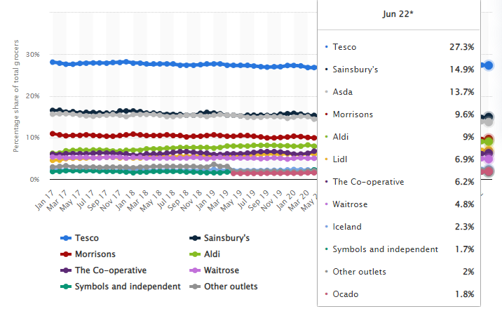
Figure 1: Market share of Tesco
(Source: Statista, 2022)
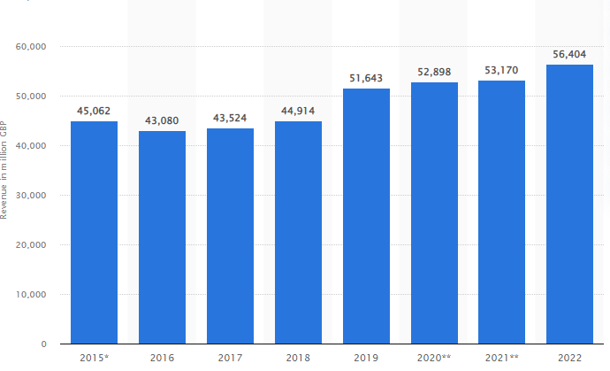
Figure 2: Annual Revenue of Tesco
(Source: Statista, 2022)

Analysis of macro environment
The macro environment of Tesco will be analysed by the use of PESTLE analysis
Political
The company, Tesco, majorly thrives in the UK and the market of the UK is quite favourable for the company as it has experienced stable growth in the UK. However, the company is present in other 10 countries and the tax rate, political stability and other political aspects can affect the operations of the company (Adamyk, 2019). The corruption rank of the UK is 11 and the score is 78 which indicates that corruption is quite low in the UK and that would provide the company to operate without any external pressure on the business operations (James, and Cooper, 2018).
Economic
One of the economic factors that can affect Tesco is the labour costs in the UK. The annual wages for the company can be 4.5 billion pounds and the minimum wage rate has been increasing in the country the current rate is 8.21 pounds for workers who are of age 25 and above. This might affect the profits and the finance of Tesco (Foabeh, and Achaleke, 2020).
Social
The shopping trends and the demands of the population of the UK have been drastically changing with time. The people in the country prefer one-stop shopping and fast deliveries or online shopping because of their busy lives (Adamyk, 2019). Therefore Tesco has indulged in online sales and is making efforts to fast-pace the deliveries further. Moreover, 65% of the population are loyal customers which would direct Tesco to build close ties with its customers (Adamyk, 2019).
Technological
The population of the UK is technologically advanced and because Tesco lacked technological advancement it faced customer relationship issues. However, the company has indulged in technology through online retailing and has also involved RFID technology to enhance the in-store experience of the customers (James, and Cooper, 2018). The company has also indulged in online payment systems for its customers.
Legal
The employment laws in the UK are quite robust and etched under the Employment Rights Act 1996. The guidelines for the Equal pay Act 1970 are quite strong as well and the employees of Tesco had taken legal action against the company regarding gender discrimination in the company (James, and Cooper, 2018).
Environmental
The UK has been striving with the environmental issues and therefore Tesco and other companies are facing pressure from the government to manage the issues and follow the environmental guidelines. The Environmental Act, of 2021 of the UK reflects a framework of the guidelines relevant to the protection of the environment (Foabeh, and Achaleke, 2020). Therefore Tesco has adopted strategies like the Tesco van drivers will use fuel-saving routes and also collect plastic bags and recycle them from the customers they visit.

Porter’s five forces
Threat of new entrants
The threat of new entrants is low regarding Tesco. Tesco is the largest player in the retail industry, therefore for the new entrants, the financial resources are high along with the best strategies to compete with the largest players in the industry which is quite impossible (Adelakun, 2020).
Threat of substitutes
The threat of substitutes for the products Tesco is low because the products that the company deal in are the basic needs of the customers who use them all year round. The products are generally groceries and general merchandise (Haucap, 2019). Moreover, the products are replenished and restored once the stocks in the retail outlets are exhausted.
Bargaining power of customers
The bargaining power of the customers is high because the retail industry in the UK has multiple players who are close competitors of Tesco. As the products are similar in every company in the industry and the customers have so many options of companies or retailers to choose from that the bargaining power of the customers is high for Tesco (Tesco Plc, 2019).
Bargaining power of the suppliers
The bargaining power of the suppliers of Tesco is low as the retail industry has many companies that procure the supplies from an array of suppliers which is huge in number (Veszelszki, 2018). Therefore the companies like Tesco can easily switch from one supplier to another.
Competitive rivalry
The competitive rivalry of Tesco is high as the company faces stiff competition in the market from other competitors of the same level like Walmart, Asda, and Sainsbury and so on. These competitors are strong in terms of supply chain and logistics networks as well as robust strategies (Veszelszki, 2018).

Analysis of microenvironment
The microenvironment of Tesco will be analysed through a SWOT analysis of the company.
SWOT analysis

Strengths | Weaknesses
- Tesco has a robust supply chain and logistics network  - Tesco has a strong global presence and it has diversified its products in several other countries  - It has the largest market share in the UK of 27.3%.  - Tesco has opted for efficient online sales and gained 15% sales through online platforms | - The operations of Tesco failed in Japan and the USA  - The company has faced many legal troubles from the employees of the company.  - Tesco operates in multiple segments and that is the reason for its inefficiency  - Tesco has faced a decline in operating profits.
Opportunities | Threats
- Tesco can expand to more potential markets like South Korea, Indonesia and Turkey.  - The company can make strategic alliances with other brands as well  - Tesco has the potential to expand on online channels and capitalise on the same. | - Low-price supermarkets that offer non-expensive products and huge discounts  - Tesco faces stiff competition from the large players in the industry  - Consequences that Tesco faced due to Brexit in terms of taxes, changes in tariffs and export and imports.
Table 1: SWOT analysis
(Source: Rosnizam et al., 2020)

Segmentation, targeting and positioning
Segmentation
The segmentation of Tesco has been done based on the attributes like geographic, demographic, behavioural and psychographic. According to the geographic segmentation, Tesco has segmented the customers that are based in the UK and other 13 countries (Van Berten, 2020). Further, the demographic segmentation of Tesco has been done in terms of age, gender, income, occupation, education, social status, and family size of the customers. Tesco has segmented the customers of all age categories and genders, the social class segmented by the company includes the middle class, lower middle class, skilled working class and working class (Kartajaya, Setiawan, and Kotler, 2021). The family size segmented are extended families, single individuals and nuclear families. The products of the company can serve individuals of all ages and gender and nuclear families as that will increase the sales for the company as disintegrated families and households purchase increased quantities of goods like groceries.
Targeting
Although the company, Tesco, has multiple segments of customers, the company adopts a mass marketing strategy so that the company can target the customers that have middle income capacity as the products are low priced and the products are varied so the company targets both the genders of men and women. The most important strategy of Tesco is low prices and high quality and the strategy regarding the targeting of Tesco determines that the company makes efforts to serve as many customers as they can as the needs of the customers are most common regarding groceries and general merchandise (DURU, 2019).
Positioning
The positioning strategy of Tesco has been quite robust as the company maintains the prices of the products to be low so that the company can register the brand with the kinds of customers. The company has also strategized to provide good quality products to the customers along with the advertisement message, "cheapest price every day" (Lamey et al., 2018). The positioning strategy of Tesco is quite successful as it has garnered many customers and a substantial increase in sales. The positioning of the company is quite effective than the competitions like Sainsbury, Boots, Walmart, Lidl and so on as the company has always maintained the quality of the products that increases its customer loyalty (Mahadevan, 2020).
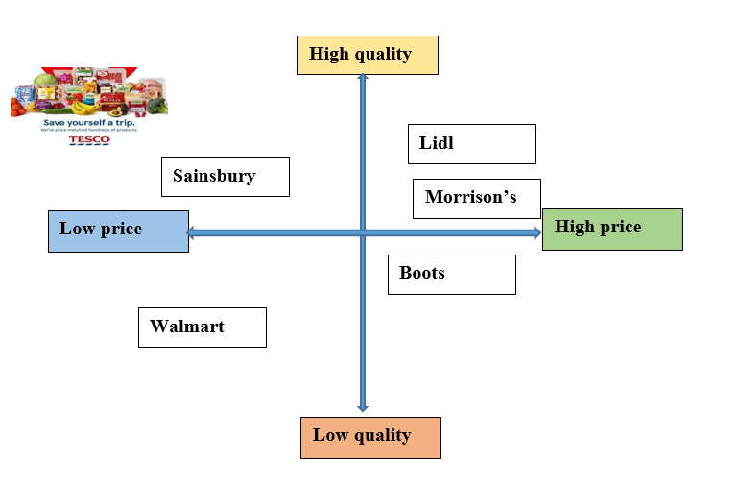
Figure 3: Positioning map
(Source: Self-developed)

Marketing mix of Tesco
The marketing mixes of 4ps analysed in the section are product, price, places and promotion.
Product
The strategy of Tesco regarding the products of the company suggests that the company indulges in including a wide variety of products like groceries, electronics, apparel, home decor, books, jewellery, baby products and so on (Tuten, 2019). These products cater to all segments of customers. Moreover, the company has brands for all the products as well.
Price
Tesco has an effective supply chain that enables the company to identify economies of scale and offer products at low prices to customers. The company maintains superior quality at a low price for the products (Tuten, 2019). The company follows the strategy of cost leadership. Moreover, the company gains feedback from the customers and works on it in terms of the quality and prices of the products.
Place
Tesco has its stores and the number of stores is around 6500 they are situated in the UK, Hungary, Ireland and many other countries (Tuten, 2019). The stores are located at prime locations so that the customers can have full and easy accessibility to the stores. The company is also present online with the products.
Promotion
Tesco relies majorly on print advertisements and media advertisements as the primary promotion channels. Moreover, the company highlights the low prices of the products as one of the promotional strategies (Tuten, 2019). The company provides promotional offers on the products to the customers as a promotional strategy.

Conclusion
The report is based on the analysis of marketing management and the assessment of the market for Tesco. The report highlights the macro environment through the PESTLE analysis and the microenvironment through the SWOT analysis. Further, the report illustrates the competitive analysis through Porter’s five forces and the marketing strategies of Tesco through 4ps of the marketing mix including price, product, place and promotion. The report concludes with recommendations relevant to the overall analysis.

Recommendation
- Tesco should ensure that the employees in the company are receiving ethical and legal treatments and there is equality among the employees as well to prevent legal troubles and liabilities.
- Tesco should implement technical error free online orders and efficient and fast deliveries to serve the customers effectively and increase revenue in the process. As currently the online website User Interface is lagging along with technical difficulties. The company should also indulge in easy payment and cancel options to enhance the customer experience. However, through fast deliveries and enhancement of marketing strategies the company should also ensure that the strategies and the actions do not have negative effect on the environment by increasing the carbon footprint.
- Tesco should expand its brand in many other potential markets to experience further growth. The company should innovate new options for robust promotional strategy through digital mediums like increasing its visibility through social media advertising and influencer marketing. As the company deals in daily products influencer marketing will be effective as the influencers have a wide reach.

References
Adamyk, K., 2019. PESTLE Analysis on Tesco PLC. http://dspace.wunu.edu.ua/bitstream/316497/35536/1/10.pdf
Adelakun, A., 2020. Should Porter's Five Forces have value in Businesses today? Computing for Business (BSC) Aston University Birmingham. https://www.researchgate.net/profile/Andrew-Adelakun/publication/340771629_Should_Porters_Five_Forces_have_value_in_Businesses_today/links/5e9c998ca6fdcca78928352e/Should-Porters-Five-Forces-have-value-in-Businesses-today.pdf
DURU, C.E., 2019. THE IMPACT OF HUMAN CAPITAL DEVELOPMENT ON THE PROMOTIONS OF CONSUMER GOODS OF EIGHT SELECTED STORES IN FOUR NATIONS. https://www.researchgate.net/profile/Emmanuel-Olaolu/publication/351776021_Effect_of_Government_Borrowing_on_Economic_Output_in_Nigeria/links/60a90488a6fdcc6d6267c0b9/Effect-of-Government-Borrowing-on-Economic-Output-in-Nigeria.pdf#page=62
Foabeh, P.A. and Achaleke, H.F., 2020. ATTITUDES AND PERCEPTIONS OF SHOPPERS GROCERY SUPERMARKET CHOICES: A COMPARATIVE ANALYSIS BETWEEN BIG C AND TESCO LOTUS. https://pdfs.semanticscholar.org/2c0a/93893464555ab21f04d3a9b02efbf7329b57.pdf
Haucap, J., 2019. Competition and competition policy in a data-driven economy. Intereconomics, 54(4), pp.201-208. https://link.springer.com/article/10.1007/s10272-019-0825-0
James, A. and Cooper, B., 2018. The Impact of Relationship Marketing On Customer Loyalty At Tesco Plc, UK. https://www.academia.edu/download/57746526/The_Impact_of_Relationship_Marketing_On_Customer_Loyalty_AtTesco_Plc_UK.pdf
Kartajaya, H., Setiawan, I. and Kotler, P., 2021. Marketing 5.0: Technology for humanity. John Wiley & Sons. https://books.google.com/books?hl=en&lr=&id=lgAXEAAAQBAJ&oi=fnd&pg=PA1&dq=segmentation,+targeting+and+positioning+of+tesco,+UK&ots=XMLDDgsN7P&sig=0MgfMhfELnoUft4SwWgYfjtV5AQ
Lamey, L., Deleersnyder, B., Steenkamp, J.B.E. and Dekimpe, M.G., 2018. New product success in the consumer packaged goods industry: A shopper marketing approach. International Journal of Research in Marketing, 35(3), pp.432-452. https://www.sciencedirect.com/science/article/pii/S0167811618300132
Mahadevan, K., 2020. TLP for Strategic Management 2020-2021. http://dspace.vnbrims.org:13000/jspui/bitstream/123456789/4520/1/Strategic%20Management.pdf
Rosnizam, M.R.A.B., Kee, D.M.H., Akhir, M.E.H.B.M., Shahqira, M., Yusoff, M.A.H.B.M., Budiman, R.S. and Alajmi, A.M., 2020. Market opportunities and challenges: A case study of Tesco. Journal of the Community Development in Asia (JCDA), 3(2), pp.18-27. http://ejournal.aibpm.org/index.php/JCDA/article/view/807
Statista, 2022. Great Britain: Grocery market share 2022 | Statista. [online] Statista. Available at: <https://www.statista.com/statistics/280208/grocery-market-share-in-the-united-kingdom-uk/> [Accessed 25 August 2022].
Statista, 2022. Tesco financial revenue the United Kingdom 2015-2022 | Statista. [online] Statista. Available at: <https://www.statista.com/statistics/490931/tesco-group-finance-revenue-united-kingdom-uk/#:~:text=In%20its%202021%2F2022%20financial,to%20the%20prior%20financial%20year.> [Accessed 25 August 2022].
Tesco Plc, U.K., Impact of Social media marketing on consumer Perception: A Case Study on. https://infoharvardresearchuk.com/wp-content/uploads/2020/08/Impact-of-Social-Media-Marketing-on-Consumer-Perception-A-Case-Study-on-Tesco-Plc-UK..pdf
Tesco, 2022. [online] Tesco. Available at: <https://www.tesco.com/> [Accessed 25 August 2022].
Tuten, T.L., 2019. Principles of Marketing for a Digital Age. SAGE. https://books.google.com/books?hl=en&lr=&id=YPG-DwAAQBAJ&oi=fnd&pg=PP1&dq=marketing+4ps+of+tesco,+UK&ots=oNfKRV8WK_&sig=sY3px88zvdEOxJVhhSF0gfhjyeM
Van Berten, P., 2020. A SYSTEMIC MODEL OF THE LATEST TACTICS IN MARKETING. National Association of Business, Economics and Technology, p.271. http://www.nabet.us/proceedings-archive/NABET-Proceedings-2020.pdf#page=271
Veszelszki, Á., 2018. Like economy: What is the economic value of likes? Society and Economy, 40(3), pp.417-429. https://akjournals.com/view/journals/204/40/3/article-p417.xml

