Assignment Title | Assignment 2:  Report entitled –  Hotel standards, reputation management, building and retaining customer loyalty
Programme Name | International Hotel Management
Student Name | Muhammed Karim
Student Number | 2208392
Module Code | BMIH4003
Module Title | Hospitality and Guest Services
Lecturer Name | Lisa Bassler,  Kathryn Flynn,  Melissa John,  Charlotte Joyner,  Muhammad Cassamo
Assignment Wordcount | 1500

Executive Summary
Because of the intense competition in the hospitality sector, it is necessary for businesses to remain current with the most recent advancements in their field in order to ensure that they do not fall behind their rivals. Additionally, staying current with the state of the industry as a whole is one of the most effective strategies for ensuring that your company will deliver the type of customer service that your customers want and anticipate receiving from your company. This is one of the most important ways to guarantee that your company will meet the expectations of your customers. In light of hotel management and the level of service offered, the purpose of this research is to concentrate on the numerous strategies that may be used to win the trust of customers (Alketbi et al., 2020).

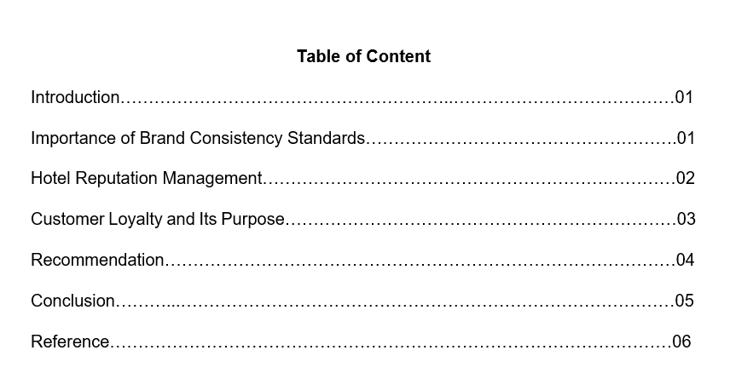

Introduction
In order for managers to achieve market success, it is not sufficient for them to focus on gaining new customers; rather, they must concentrate on retaining existing customers by implementing effective customer satisfaction and loyalty programs. When it comes to the hospitality industry, customer satisfaction is mostly determined by the caliber of service rendered (O'Neill, and Mattila, 2010). A management plan that prioritizes customer satisfaction has the ability to build customer loyalty, hence enhancing the good image of the tourism destination. Hence, it is necessary to analyze the significance, from the standpoint of customers, of various hotel attributes in the selection process. For the success of the hospitality industry, visitor satisfaction research is crucial (Erdem, and Jiang, 2016). This study addresses whether or not consumers will return to a hotel or suggest it to other tourists. If a hotel fails to pay adequate attention to the aspects that consumers appreciate the most, it faces the danger of receiving negative feedback from its guests, which in turn diminishes the possibility of those guests returning in the future.

Importance of Brand Consistency Standards
Brand consistency is the process of ensuring that the way a company is presented and what it stands for are consistent across all marketing platforms, thereby unifying the image and message that your current and potential customers see. Consistency of a brand involves being recognizable, establishing trust, and expressing personality. Increasing client faith and loyalty through good branding adds individuality, encouraging consumers to engage with your company (Lee, and Jeong, 2014). Consistency of a brand is characterized by
Increase consumer trust and loyalty: Effective branding provides a business with a personality that compels people to interact with it.
Stand out from competitors: It distinguishes from the competition and provides consumers with an emotional reason to choose the hotel.
Boost brand authority: The brand can become an industry leader by increasing its authority (O'Neill, and Mattila, 2010).
Hotel / Resort Brand Names and Brand Guidelines can play a significant influence in the marketing of any type of hospitality organization. Branding has always been a subject of debate. A franchise agreement or membership is necessary, or a separate brand must be developed. A brand establishes recognition and uniformity. Focusing on expectations, market analysis, and all deliverables, including the Brand manual, enables the creation of a brand. A brand is the identity of a product, as well as the service delivery and consistency of that offering. Brand Standards distinguish facilities from their rivals in order to cultivate client preference. Due to their distinguished Brand Standards, consumers are more likely to choose well-known Hotel / Resort Brands over generic products designed to reduce R&D and risk (O'Neill, and Mattila, 2010).

Hotel Reputation Management
Management of a hotel's reputation involves monitoring and altering internet perceptions. It includes monitoring review sites, publishing on social media, and optimizing your website for search results, among other tasks. Some ways to improve the hotel’s reputation are given below.
- Social media allows businesses to promote their company and communicate with their followers. Consistency is essential for expanding and retaining your planning community and target audience, given the abundance of material on all social media platforms. Keep a consistent voice across all platforms. Also, social media can link planners and guests. Use your profiles to persuade guests that the residence is secure. As the hotel's expert, keep visitors informed on local activities and changes to the property.
- Keeping up with the ever-changing digital landscape will prevent slipping behind. During this economic downturn, emphasize how you are assisting customers and employees, preserving cleanliness, and, if applicable, planning for when the economy recovers. Digital marketing strategy for group organizations must combine many channels and content types to be effective.
- People enjoy being recognized and respected. Hence, address them by name and include their comments in response. This demonstrates that owners value their opinions. Individualized responses are required.
- After a stay, clients forget to offer online reviews; therefore, it is necessary to request them. Send emails to guests requesting reviews, or create a page for comments and reviews on the website. Asking for feedback at the point of sale is a second approach for obtaining reviews more quickly, personally, and directly.
Ultimately, online and offline reviews are a vital component of the hotel industry. That is the first thing someone sees while searching for a hotel name. These will enhance traffic and bookings, as well as customers' confidence in their decision to stay at the facility. So, if the hotel authority is seeking strategies to boost the hotel's business, they should prioritize obtaining good online reviews (So et al., 2016).
Bad reviews have the potential to influence the booking decisions of your hotel. However, this criticism can also be utilized to address any flaws that you were unaware of. Consumers are hesitant to buy from businesses with unfavorable evaluations. This will ultimately harm the hotel's website traffic and income (Schuckert et al., 2015).

Customer Loyalty and Its Purpose
Every successful business pursues two objectives: retaining existing customers and acquiring new ones. The same holds true for hotels (Lai, 2019).
Hotel loyalty programs reward customers for spending money at their properties. Typically, members gain perks in the form of points for booked nights or money spent. These points are redeemable for future stays, room upgrades, dining discounts, and other perks. Some hotel loyalty programs reward members for shopping at partner establishments or using credit cards with which they have a partnership (Campbell 2021).
Hotels that wish to increase customer loyalty or retain guests should focus on enhancing hotel service, visitor perception, and the guest experience. By exceeding their guests' expectations and providing great customer service, hotels may increase customer loyalty. Positively responding to visitor evaluations and feedback (Lai. 2019). Consistently committing to development while cultivating relationships with repeat travelers. Understanding what guests anticipate from a hotel and providing a customized experience (Poku et al., 2013).
Hoteliers should constantly prioritize guest loyalty because it fosters an environment that is conducive to long-term success. When guests frequent a hotel on a regular basis, not only does the hotel benefit from an increase in occupancy and revenue, but it also allows hotel staff to develop relationships with guests. This aids staff in anticipating client needs and can help a resort deliver a superior guest experience (Campbell, 2021). Exceptional service results in customer loyalty. It is the outcome of guests consistently receiving excellent service and understanding that when they book with their reputable brand, their needs will always be met. When the hotel begins to see people frequently at the resort and they become identifiable, they have likely become loyal consumers (Kandampully, 2011).

Recommendation
The primary factor that makes it more difficult to achieve better levels of customer satisfaction is the tendency toward standardization of services, which reduces the possibility of tailoring the offer to the specific needs of each guest. This is due to the fact that increasing customization of the service is required to meet rising client expectations (Erdem, and Jiang, 2016). During informal chats with the hotel's management, it became clear that the business utilizes marketing techniques. This discovery was facilitated by interviews. The administration determines the types of tourism services to be offered without first asking clients what they want or attempting to meet their specific requirements. And services are not differentiated depending on client satisfaction ratings (Luck, and Lancaster, 2013). The absence of a well-defined Customer Relationship Management (CRM) system is one of the constraints of the hotel's approach to customer satisfaction management. If a client database does not exist, data collecting is not organized, and the results are not immediately accessible or usable by top management for the formulation of marketing strategies. In the lack of benchmarking data on customer satisfaction, management is unaware of the strategies adopted by the competitors. The hospitality business has a great deal of untapped customer happiness and competitive success potential, but in order to compete at a higher level, management will need to implement creative CRM tactics. Accounting and cost data alone are insufficient to make decisions about the most fundamental aspects of customer satisfaction; a customer database must be constructed on the go (Erdem, and Jiang, 2016).

Conclusion
The hotel industry is one of the areas within the hospitality sector that places a significant emphasis on developing its brand and reputation (Lai, 2019). When it comes to hotel sales, the worth of a customer who stays at the establishment more than once cannot be understated. Several studies have found that the cost of acquiring a new client can be anywhere from five to eight times higher than the cost of maintaining an existing one. Developing a customer base that is devoted and profitable, lowering the costs associated with acquiring new customers, and establishing a robust network of promoters are some of the key benefits that can be gained from focusing on the guest retention strategy rather than the guest acquisition strategy when formulating the hotels' guest retention strategy (Al-Msallam, 2015).

Reference
Campbell, K. (2021) “The Complete Guide to Hotel Customer Loyalty,” CVENT, 6 August. Available at: https://www.cvent.com/en/blog/hospitality/hotel-customer-loyalty (Accessed: February 26, 2023).
Lai, I.K.W., 2019. Hotel image and reputation on building customer loyalty: An empirical study in Macau. Journal of Hospitality and Tourism Management, 38, pp.111-121.
Alketbi, S., Alshurideh, M. and Al Kurdi, B., 2020. The Influence of Service Quality on Customers' Retention and Loyalty in the UAE Hotel Sector: A Qualitative Study. PalArch's Journal of Archaeology of Egypt/Egyptology, 17(4), pp.541-561.
Al-Msallam, S., 2015. Customer satisfaction and brand loyalty in the hotel industry. International Journal of Management Sciences and Business Research, 4.
Poku, K., Zakari, M. and Soali, A., 2013. Impact of service quality on customer loyalty in the hotel industry: An empirical study from Ghana. International Review of Management and Business Research, 2(2), pp.600-609.
Kandampully, J., Juwaheer, T.D. and Hu, H.H., 2011. The influence of a hotel firm's quality of service and image and its effect on tourism customer loyalty. International Journal of Hospitality & Tourism Administration, 12(1), pp.21-42.
So, K.K.F., King, C., Sparks, B.A. and Wang, Y., 2016. The role of customer engagement in building consumer loyalty to tourism brands. Journal of Travel Research, 55(1), pp.64-78.
Schuckert, M., Liu, X. and Law, R., 2015. Hospitality and tourism online reviews: Recent trends and future directions. Journal of Travel & Tourism Marketing, 32(5), pp.608-621.
Luck, D. and Lancaster, G., 2013. The significance of CRM to the strategies of hotel companies. Worldwide hospitality and tourism themes.
Erdem, M. and Jiang, L., 2016. An overview of hotel revenue management research and emerging key patterns in the third millennium. Journal of Hospitality and Tourism Technology.
Lee, S.A. and Jeong, M., 2014. Enhancing online brand experiences: An application of congruity theory. International Journal of Hospitality Management, 40, pp.49-58.
O'Neill, J.W. and Mattila, A.S., 2010. Hotel brand strategy. Cornell hospitality quarterly, 51(1), pp.27-34.

