

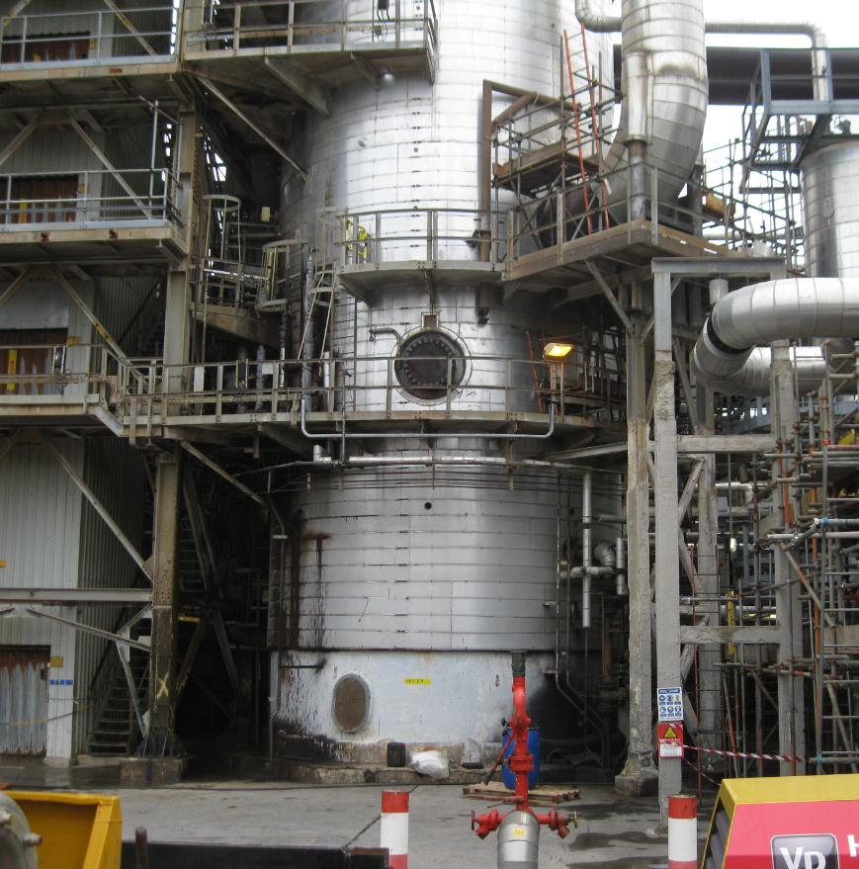  Project Report  SGDM5024 | Tom Ferguson  Mechanical Engineering HNC Year 2

(Page intentionally left blank)

Summary
This successful project was conducted on Valero Pembroke Refinery over the 4th quarter of 2019. The problem, investigated by a project team put together, was the reduction of Heavy Cycle Gas Oil flow from the bottom of the Main Fractionator (02-F-201).
Upon investigating, the project team found that there is a build-up of “Coke” in the bottom of the vessel which is blocking the outlet lines. The economic impact of this blockage is a loss of around $540,000 per week. HCGO is mainly shipping oil and this is a highly demanded product. From a safety perspective, this has the potential to block lines further down the system and could possibly cause damage to the plant and injury to personnel.
The aim of this project was to provide a solution that will either accommodate the future improvement of the HCGO flow from 02-F-201 (FCCU Main Fractionator) to the outlet suction pumps or remove the blockage entirely. Three solutions were discussed in depth and a criteria analysis was conducted. The outcome from this was that shutting down the vessel is not an option due to its economic impact, because of this, the option to keep the vessel online and install a new outlet nozzle from which a temporary line can be installed to the outlet suction pumps was selected.
The author then discussed the steps in which the project takes to get this solution executed. All of which are included on the project plan. The project plan was followed closely by all personnel working on this project, with a few exceptions making the actual total duration grow by 9 days.
A trail was implemented in a workshop environment to give empirical data for the procedure drafting and risk assessment.
After all the pre-planning was complete the execution phase was initiated and the hot tap drilling commenced. This drilling took longer than first thought due to the cutting blade blunting at a higher rate than planned. Also the hot tap contractor did not have sufficient stock of drill bits to meet the project plan targets. Nonetheless, the project was completed. The main aim of providing the opportunity to install a new drain line to the vessel was made available for the next stages of this project.
The author recommends for future reference to utilize chemical cleaning techniques as observed in the Crude unit cleaning in 2018.

Table of Contents
1.0. Acknowledgements 4
2.0. Introduction 5
3.0. Background 6
3.1. Problem investigation 6
3.2. Problem economic impact 8
3.3. Safety impact 8
4.0. Experimental procedure / methodology 9
4.1. Project aim 9
4.2. Initial Actions 9
4.3. Conceptual resolutions & selection 9
4.3.1. Hot Tapping 10
4.4. Initial Engineering/construction schedule & AFE 10
4.5. Engineering drawings 11
4.6. Hazard Review 12
4.7. Material procurement 13
4.8. Hot tap trial run 13
4.9. Procedure drafting 15
4.10. Construction 15
5.0. Analysis and discussion of results 15
6.0. Conclusion 16
6.1. Recommendations 17
7.0. References 18
8.0. Bibliography 18
9.0. Appendices 19
Appendix 1 – CSB Williams Case Study (U.S. Chemical Safety and Hazard Investigation Board, 2013). 19
Appendix 2 – Criteria Analysis 20
Appendix 3 – Initial Project Plan (Ferguson, 2019) 21
Appendix 4 – Engineering drawings (Valero Engineering Drawing Office, 2019) 22
Appendix 5 – Hazard review, Risk assessment form. (James, 2019) 23
Appendix 6 – Project Plan Rev. 1 (Ferguson, 2019) 24
Appendix 7 – Specific Procedure (Bagley, 2019) 25

List of figures
Image 1 - 2014 outlet screen 6
Image 2 - 2014 removal of coke 7
Image 3 - 2014 clean outlet screen 7
Image 4 - Hot tap assembly 11
Image 5 - Trial blank plate with cladding 13
Image 6 - Hot tap trial run 13

List of tables
Table 1 - Planned costs 12
Table 2 - Major hazards from review 14
Table 3 - Planned and Actual project costs 16
List of tables
Graph 1 - Crude unit feed rate from 2018 17

Nomenclature
FCCU - Fluid Catalytic Cracking Unit
HCGO - Heavy Cycle Gas Oil
LPG - Liquid Petroleum Gas
DRB - Decision Review Board
AFE - Approval for Expenditure
CDU - Crude Distillation Unit
TAR - Turnaround

Acknowledgements
Neil James – Fixed Equipment Manager (Valero Energy)
George Bagley – Fixed Equipment Superintendent (Valero Energy)
Kevin James – Fixed Equipment Coordinator (Valero Energy)
Stuart Evans – Fixed Equipment Coordinator (Valero Energy)
Daniel Chesmer – Reliability Engineer (Valero Energy)
Gerald Thomas – Lead Piping Engineer (Valero Energy)
Gareth Philips – Contract Manager (Ledwood Mechanical Engineering)
Frank Nunnery – FCCU Operations Maintenance Coordinator (Valero Energy)
Phillip Allison – Procurement (Valero Energy)
Craig Lewis – Hot Tap Specialist (TEAM Inc.)

Introduction
Pembroke Refinery was first opened in 1964 as a hydro skimmer with cat-cracking capacity added in 1982. This refinery is one of the largest and most complex refineries in Western Europe. Valero Energy acquired the refinery in 2011 from Chevron and today it makes products such as diesel fuel, gasoline, LPG, and petrochemical feedstocks. The total throughput capacity is 270,000 barrels of crude oil per day, with 10.5 million barrels of storage.
Pembroke refinery is comprised of various units. This report is focusing on the Fluid Catalytic Cracking Unit (FCCU) and this is one of the most important units on the refinery. The FCCU main fractionator tower (equipment number 02-F-201) separates the product hydrocarbons such as Heavy Cycle Gas Oil (HCGO), which forms a major component in shipping fuel oil. Shipping fuel oil is a highly demanded consumer product.
With most other companies in the petrochemical industry, profit margins are tight and pressure from the market competition to keep up with demand is at an all-time high. Therefore, making sure the refinery has output of shipping fuel oil (HCGO) is very important for Pembroke refinery.
During the course of this project a problem with the flow of HCGO from the FCCU main fractionator will be investigated, solutions will be compared and one chosen from conceptual designs. The chosen solution will be planned and executed in 3 stages; 1. Engineering design, 2. Pre-installation work, 3. Installation. This project will be looking primarily at the first 2 stages.
Discussions of the outcome and a conclusion to follow with recommendations.

Background
In this section, the author will focus on the main problem, its causes and the impacts.

Problem investigation
On the 10th of July 2019 Valero Pembroke refinery suffered the effects of a nation-wide power cut which forced certain units to be shut down due to the electrical pumps failing and the backup steam turbines not coping with the demand.
The FCCU main fractionator bottom suction pumps were off line for a period of 7 days. This lack of flow through the vessel resulted with the increase of heavy oil residency in the bottom dome. The cooling down of the product has an adverse effect on the HCGO in the bottom of the main fractionator, turning it solid. The problem was identified by the unit operators when commissioning the suction pumps. The pumps were suffering mechanical stress through low head pressure.
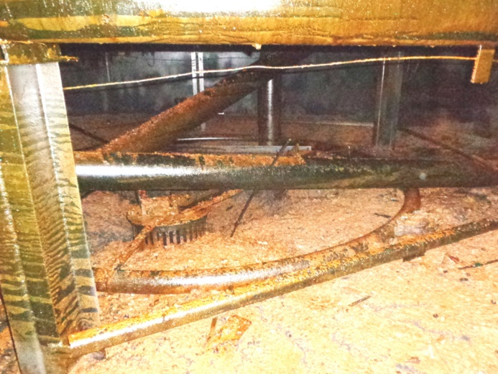
Historically when this vessel is taken off line for its statutory inspection periodically (usually every 6-8 years), there is a buildup of solidified heavy oil or in other words coke. This vessel’s next statutory inspection date is in 2021 and the last time was 2014. In 2014 it was noted that the level of buildup was nearly over the three bottom outlet screens as shown in image 1 (right).
Outlet screen
Image 1 - 2014 outlet screen
These screens act as a filter to stop any solids from entering the outlet pipework to the suction pumps. This will have a huge effect on the HCGO flow rates and consequentially impacts on the refinery’s profit, if the buildup level is over the top of these screens.

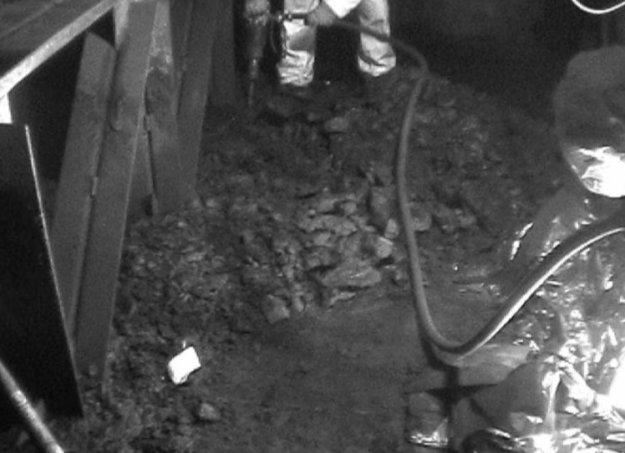
When this vessel is due for a statutory inspection it is drained, opened up, cleaned, inspected internally and subsequently repaired. This would almost certainly be pre-planned well in advance and costs allocated to carrying out this work alongside other equipment associated with the main fractionator.
Image 2 - 2014 removal of coke
In recent years, cleaning the build-up in the bottom of the FCCU main fractionator has been labour intensive, this is due to the confined space conditions, the lack of space for heavy machinery and the safety of personnel inside the vessel to remove the solid HCGO. In 2014 a gang of 6 civil technicians with pneumatic jack hammers took around 4 weeks, working days and nights, to remove enough solid HCGO to accommodate the inspection of the internal vessel walls and internal pipework (see Image 2 & Image 3).
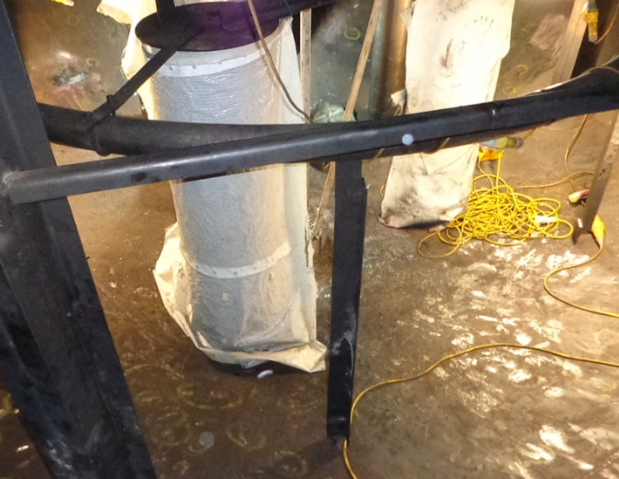
Image 3 - 2014 clean outlet screen
As (Dahlman, 2011) states, “HCGO product consists of heavy (polyaromatic) hydrocarbons” and the heavier hydrocarbons are called asphaltenes. Dahlman goes on to say, “Asphaltenes can form larger hydrocarbon structures which can precipitate on the surface of filtering media. HCGO product also often contains fine coke particles which, on penetrating filter media, might cause plugging and poses a big threat for reliable operation.” This explains the issue of the product plugging the filter screens.
Outlet screen

Problem economic impact
During the period the FCCU main fractionator bottom suction pumps were off line for of 7 days the flow indication for 6th of July states an 80% flow utilisation (43 cubic meters per hour), a period of outage with an erratic week of starting back up. Then when it plateaus we see a measurable drop in flow rate for HCGO to 23.2 cubic meters per hour. This drop has resulted in a financial loss of around $540,000 per week. 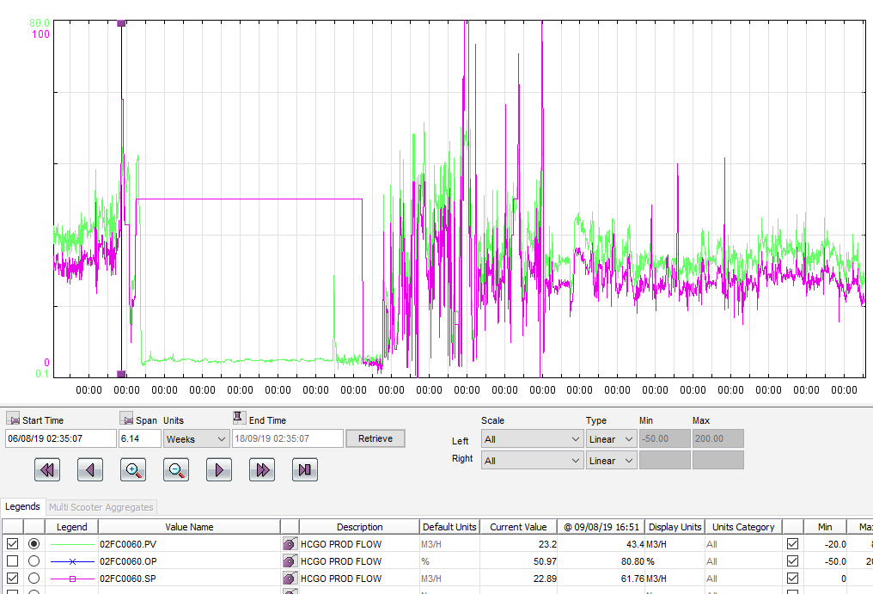
The figure of over $540,000 loss per week was calculated using the average shipping oil prices per M³ So the loss of 20m³/hour production, minus the recirculated amount of approximately ¾ volume, accumulated to a loss of 840m³/week multiplied by the average price per m³ of $643 (Shipping and bunker, 2020).

Safety impact
The level in this vessel could potentially become critical and start flooding the trays above the bottom dome. This poses a problem for mixing processes and a chemical reaction could occur. If left, this has the potential to block further pipe routes and result in over pressuring the connected heat exchangers. A similar occurrence was recorded in Williams Geismar Olefins Plant. Appendix 1 is a case study showing the catastrophic effects of over pressuring a heat exchanger.

Experimental procedure / methodology
This section will review all the main steps to the project, conceptual resolutions, the selection criteria and reason why one was selected. It will also run through how this resolution is going to be implemented.

Project aim
The aim of this project is to provide a solution that will either accommodate the future improvement of the HCGO flow from 02-F-201 (FCCU Main Fractionator) to the suction pumps or remove the blockage entirely. Then implement the project in the field safely, on time and within budget.

Initial Actions
Once a problem is identified, a work order is inputted into the Computerized Maintenance Management System (CMMS) namely SAP. This is then picked up by the maintenance team for that plant section and discussed in the morning maintenance meeting. This flow problem for HCGO was of high priority, due to the significant financial impact and a team was set up immediately.
The team consisted of a broad range of different disciplines which included; Mechanical Engineers, Inspection Engineers, Operations, Maintenance Supervisors and Maintenance Planners. In this initial meeting the problem was discussed and the ideal outcome was identified. The ideal outcome was to revert the flow rate back to normal by removing the blockage completely. This outcome was unlikely to be achieved due to cost and time issues, so three proposals were put together for the Decision Review Board (DRB).

Conceptual resolutions & selection
Referring to Appendix 2, criteria analysis lists three different resolution proposals that were put together by a cross discipline team for the DRB.
The first proposal (A), to shut down the unit and remove the blockage or coke manually. This proposal measured the lowest on cost and time, which means that it would take the longest and cost the most. But from a durability and reliability standpoint scored the highest due to the long term sustainability of removing the coke, thus removing the problem.
Proposal (B), to install a new nozzle above the blockage level in the vessel to facilitate the drainage of HCGO. This proposal measured lowest for safety due to the nature of live line welding onto the outer wall of the vessel being an extremely high risk task. Upon investigating this proposal, it was found that the vessel would have to be offline and drained to complete this task. This is due to the fact that the welds would have to be post weld heat treated as stated by the materials engineer. The only way to achieve this would be to isolate the vessel and when this happens they might as well go with proposal A.
Proposal (C), to install a new nozzle on to an existing man way. This proposal was chosen to go ahead due to it being the least complicated and lowest cost. But this proposal comes with high risk due to the task not being done before on Pembroke Refinery. From the DRB a few mitigating actions had to be completed before carrying out the hot tap these were, a thorough risk assessment, step by step procedure and a trail run done in a workshop environment.

Hot Tapping
By implementing proposal (C) means that a “Hot Tap” would be required. Fundamentally, Hot tapping or under pressure drilling is a method of providing controlled entry into live piping, vessels and tanks operating as pressure or vacuum without losing product or interrupting process operations.

Hot Tapping Method
As (Allied Pipefreezing Services Limited, 2019) states “The hot tapping process begins with fitting a new branch to the host pipeline/system. The new hot tapping fittings can be attached by welding or by using mechanical (clamp)”. In this instance the branch is already in place (manway nozzle M4). Allied Pipefreezing goes on to say “a full bore isolation valve is then installed, the branch and valve is then pressure tested and a sealed drill rig attached to the valve. The pipe is then drilled while the valve is in the open position, the drill is then withdrawn and the valve closed. The drill is then removed from the valve and a blanking flange or plug fitted.” This method is for installing a new branch onto a pipe so, for this project it would be following the same type of method for a flat blank plate instead of a pipe.

Initial Engineering/construction schedule & AFE
Referring to Appendix 3. The initial engineering and construction schedule was drafted by the Maintenance Planner with input from various sources which included historical plans, contractor company’s contribution and the maintenance teams. This initial plan shows 99 days duration.
From this initial schedule an AFE was drafted. An AFE is approval for expenditure against the maintenance budget for the related year. To develop a budget figure for a project of this scale there is a number of different areas of contribution to this figure. Table 1 shows these planned costs.

Planned
Cost description | Cost (£)
Engineering Labour | £ 9,415.92
Pre-execution Labour | £ 52,441.25
Execution Labour | £ 10,932.83
Post execution Labour | £ 4,670.31
Materials | £ 39,912.88
Misc. Stress engineer | £ 3,150.00
Misc. Machining Contractors | £ 2,640.00
Misc. TEAM Inc. Contractors (hot tap) | £ 18,350.00
Misc. Fabrication Costs | £ 3,212.74
Misc. Engineered Scaffold drawing | £ 450.00
Total | £ 145,175.93
Table 1 - Planned costs
This planned cost of £145,175.93 was submitted to the cost controllers then approved by the site manager & maintenance director to be funded from the 2019 maintenance budget which was £13million.
The planned cost of has an allowable deviation before a funding review is set at +/- 10%.

Engineering drawings
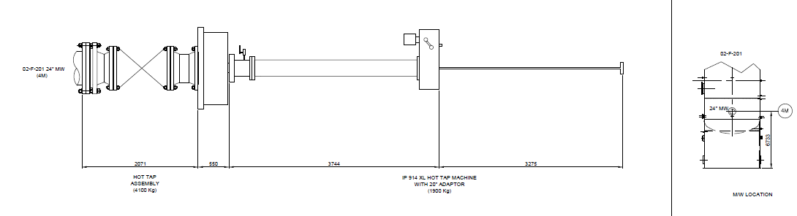
The engineering drawings are a vital part of this project, they will support the hazard review, enable the planner to order the correct materials and also the fabrication contractor will be capable to manufacture the required pipe spools within stated tolerances. Refer to Appendix 4 and Image 4.
Hot tap machine with cobalt drill bits
Adaptor flange
Special flange
20” full bore gate valve
Existing manway (M4)
Image 4 - Hot tap assembly

Hazard Review
Before starting any high risk tasks a formal hazard review meeting is required and documented. This hazard review is initiated by the maintenance coordinator and personnel included are a selection of different disciplines. Appendix 5 shows the documented hazard review.
Due to the complexity of this project, the document is split up into 7 separate steps and one general section for the risk assessment. Table ** shows the major hazards of each task identified from the hazard review and the mitigating actions. The main aim of this hazard review is to make sure the risks of all hazards that are identified are reduced and safeguards/controls are noted for implementation.
Step | Description | Major Hazard Identified | Mitigating Action
1 | Carry out hot bolting of Manway 4M | Minor gasket leak | Down to tolerable risk by:  Gain Mechanical Design/Reliability Engineer approval for the operating envelope at which hot bolting can take place.
2 | Install engineered scaffold to support hot-tap assembly | Minor | N/A
3 | Machine 4M face for gramophone finish | Negligible | N/A
4 | Install special adaptor flange & pressure test, prove gasket integrity | Major gasket leak | Down to tolerable risk by:  Engineering to provide special torque value for non-standard flange
5 | Install 20” valve to special spool | Major gasket/nozzle failure | Down to tolerable risk by:  Valero Engineering department to review scaffold design is acceptable. Ensure load test of scaffolding is completed
6 | Install hot tap machine and secure to scaffolding | Major gasket/nozzle failure | Down to level 1 risk by:  Valero Engineering department to review scaffold design is acceptable
7 | Carry out hot tap drilling and coupon retraction. Replacing cutter at specified drill depths | Inherent hot-tap hazards as disc. | Down to broadly acceptable:  Team engineering department to prove equipment is fit for service (to include evidence of prolonged service in the event machine has to remain in-situ until next TAR)
Table 2 - Major hazards from review

Material procurement
The current European Union situation has disrupted the supply chains at Valero Pembroke refinery. Upon sending out for quotes for certain materials, the suppliers required a longer amount of time than usual to source and supply. This affected the critical path of the project plan due to an extra 9 days lead time on material required. The project plan was updated with this set back and due to the activity of material ordering being critical path, the completion date was moved out 9 days. The total duration was then 108 days. Appendix 6 shows the revised project plan.

Hot tap trial run
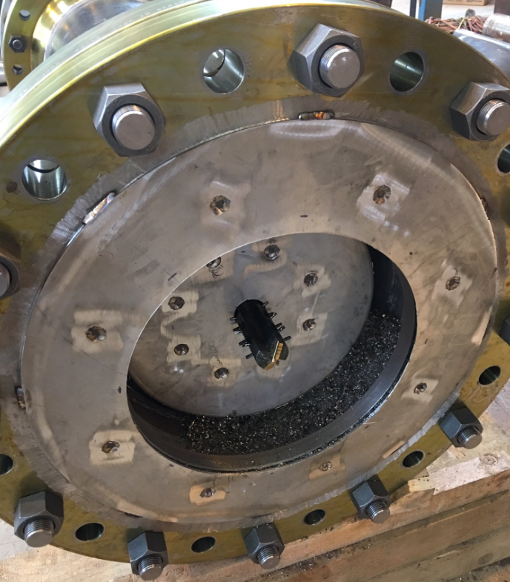
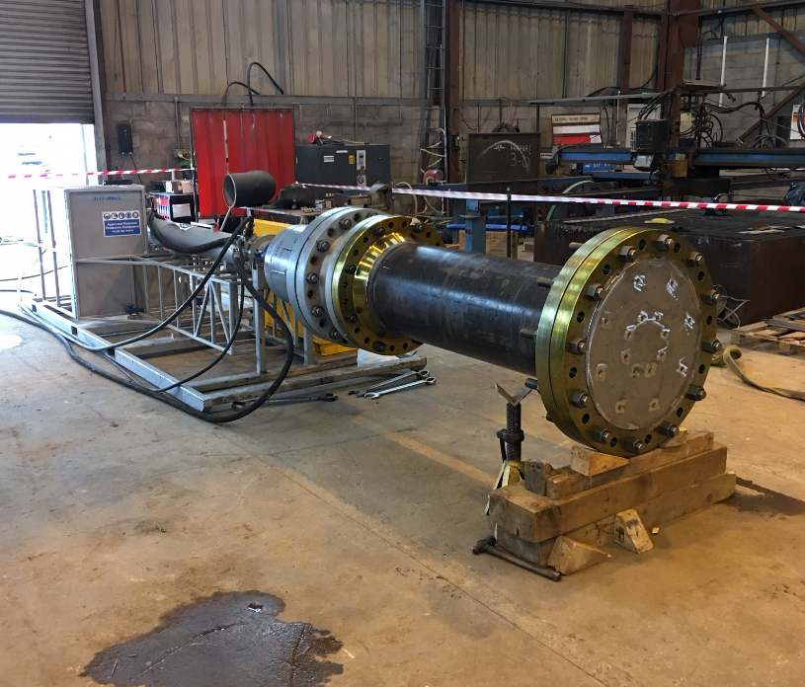
Due to the complexity of the task and the fact that this type of hot tap has not been done at Valero Pembroke before, a decision came from the DRB was to carry out a trial run in a workshop setting for empirical data. This was carried out in Ledwood Engineering’s workshop with the assistance of TEAM industrial services.
Image 5 - Trial blank plate with cladding
Image 6 - Hot tap trial run
To make the trial run as close in similarity as possible, the trial run manway cover had a 316 stainless steel cladding plate welded to the inside. The original vessel has internal lining of the same grade steel.

Procedure drafting
Along with the generic contractor’s procedures, the DRB instructed that a specific procedure for this project must be drafted to control the activities related to the Hot Tap of the M4 manway on 02-F-201 Main Fractionator. This document (Appendix 7) was put together using the job tasks identified in the initial project plan and specifies the critical steps that must be completed in sequence to mitigate hazards identified in the hazard review.

Construction
With all of the pre-requisites complete, materials delivered and fabrication finished. The execution stage was initiated.
During the execution of the project, the plan was followed closely by the maintenance team and contractors. A weekly progress update meeting was set up and the planner sent out weekly progress reports to make sure the planned milestones were being hit.
The execution stage was going well up until when the actual hot tap commenced. The contingency of replacing the drill bit 2 times was not enough. During the cut it came apparent to the hot tapping contractor that the drill bit was being worn quicker than anticipated. This resulted in a 24 hour delay to source/deliver 3 more drill bits and an extra 8.5 hours to change the drill bits 2 more times.

Analysis and discussion of results
Upon completion of this project, the main aim of providing the opportunity to run a line to drain 02-F-201 in the future and in turn increasing the volume of HCGO draining was achieved. Upon completing this project, the next phase of installing the temporary line from this new nozzle off the M4 manway to the bottoms suction pumps can now commence.
There is no data available to show if this vessel can now be drained at a higher volume due to the fact that this is an ongoing project. Once the next phase is complete the volume can be measured.
This project was done safely and without leaks. Although the finish date changed from an original date of 10th December 2019 to 19th December 2019 due to the two setbacks. The budget of +/- 10% of planned costs was met. Table 3 shows the planned vs actual cost calculations. If the actual costs ended up over the -/+ 10%, then a request for additional funds will have to be sent to the site manager for approval.
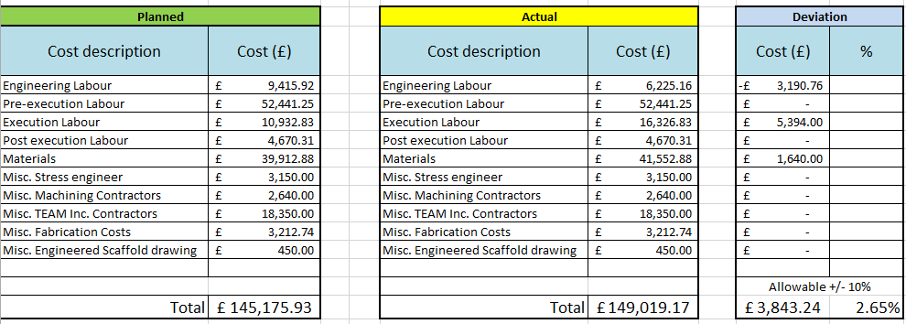
Table 3 - Planned and Actual project costs
The first set back was the material suppliers adding on 7 days due to complications around Britain’s exit from the European Union. This could have been foreseen with more communication to the suppliers and some contingency could have been built into the project plan to suit.
The second set back was the wearing of the drill bits. This also could have been foreseen due to the incapacity to use lubrication when drilling. The 20” Cobalt drill bits wore faster than they did in the trial run.
As shown on Table **, there was a saving from Engineering Labour of £3190.76. This was due to the Stress engineer’s costs being included twice.

Conclusion
This project was a success due to a number of pre-planning techniques and the input of a vast amount of different personnel. With a diverse team, nearly all possible problems were identified prior to execution. The project plan is likely the most important document in this project as it increases transparency, structure and gives key information during the planning phase for budgetary requirements.
The trial run was good practice but it did have limitations, the vessel was under pressure and the trial run does not provide that conditional factor. Also the vessels manway was more than likely heat treated during fabrication and in turn making the steel harder. If the hot tap contractor was made aware of this, they could have had more drill bits available and planned more time for changing them more often. The trial run was successful in proving that the hot tap machine can be utilized in this situation. The primary concern was the retrieval of the coupon cut out which the trial accomplished this.
As this initial stage of the project as a whole is completed, the next stage of installing a temporary line from this new nozzle can now commence. It is recommended that new instruments are installed to keep level visibility in the bottom of the Main Fractionator because the new outlet nozzle is now higher up.

Recommendations
Going forward, to minimize the return of fouling in the outlet lines from this vessel a large variety of anti-fouling additives are commercially available. As Shell Global Solutions state there is an additive that can be used which turns the coke/asphaltenes into liquid, “Additives that act as a (high temperature) dispersant - These additives keep the asphaltenes in the liquid phase and are applied in CDUs and FCCUs. These additives minimize deposition of potential inorganic or organic particulates in streams” (Shell Global Solutions, 2007). This type of chemical cleaning has been utilized on Valero Pembroke refinery recently, during the CDU Maintenance outage in 2018 with remarkable effect. See graph 1 below.
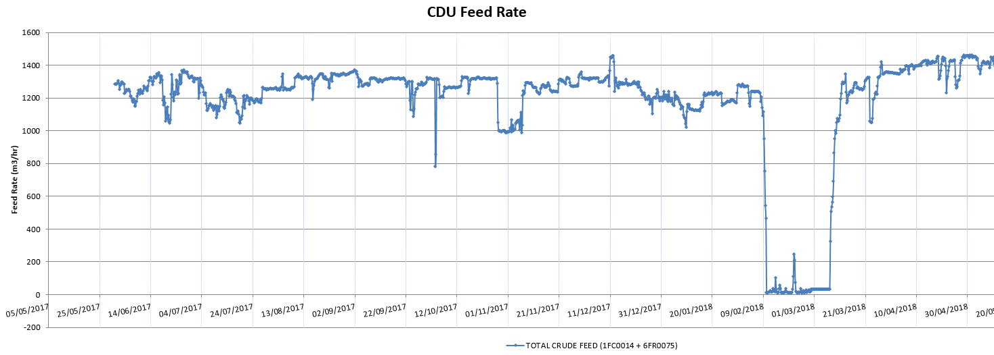
Feed rate up to 1389 m³/hr average
Initial feed rate 1241 m³/hr average
Chemical Cleaning
Graph 1 - Crude unit feed rate from 2018

References
Allied Pipefreezing Services Limited, 2019. Hot Tapping. [Online]
Available at: https://www.alliedpipefreezing.co.uk/services/hot-tapping/
[Accessed 6 November 2019].
Bagley, G., 2019. Hot tap manway procedure, Pembroke: Valero.
Dahlman, 2011. HCGO Filtration Coking. Dahlman Information, 3 May, p. 1.
Ferguson, T., 2019. Initial Project Plan. Pembroke: Primavera.
James, K., 2019. Checklist Risk Assessment Form, Pembroke: Valero.
Shell Global Solutions, 2007. C5 Fouling of Exchangers and Piping. In: GSRD, ed. Thermal Conversion Process Guide. Texas: SGSI, p. C5 page 5.
Shipping and bunker, 2020. World Bunker Prices. [Online]
Available at: https://shipandbunker.com/prices
[Accessed 23 January 2020].
U.S. Chemical Safety and Hazard Investigation Board, 2013. Williams Geismar Olefins Plant, Washington: CSB Publications.
Valero Engineering Drawing Office, 2019. Spool assembly - 02-EPI-DDG-0071,72,73,74 & 75. Pembroke: Valero.

Bibliography
Dahlman, 2011. HCGO Filtration Coking. Dahlman Informatio
Shell Global Solutions, 2007. C5 Fouling of Exchangers and Piping. In: GSRD, ed. Thermal Conversion Process Guide. Texas: SGSI
U.S. Chemical Safety and Hazard Investigation Board, 2013. Williams Geismar Olefins Plant, Washington: CSB Publications.

Appendices

Appendix 1 – CSB Williams Case Study (U.S. Chemical Safety and Hazard Investigation Board, 2013).

Appendix 2 – Criteria Analysis

Appendix 3 – Initial Project Plan (Ferguson, 2019)

Appendix 4 – Engineering drawings (Valero Engineering Drawing Office, 2019)

Appendix 5 – Hazard review, Risk assessment form. (James, 2019)

Appendix 6 – Project Plan Rev. 1 (Ferguson, 2019)

Appendix 7 – Specific Procedure (Bagley, 2019)

