ANISA KARIM 2407467

Task 1 – Concept Map
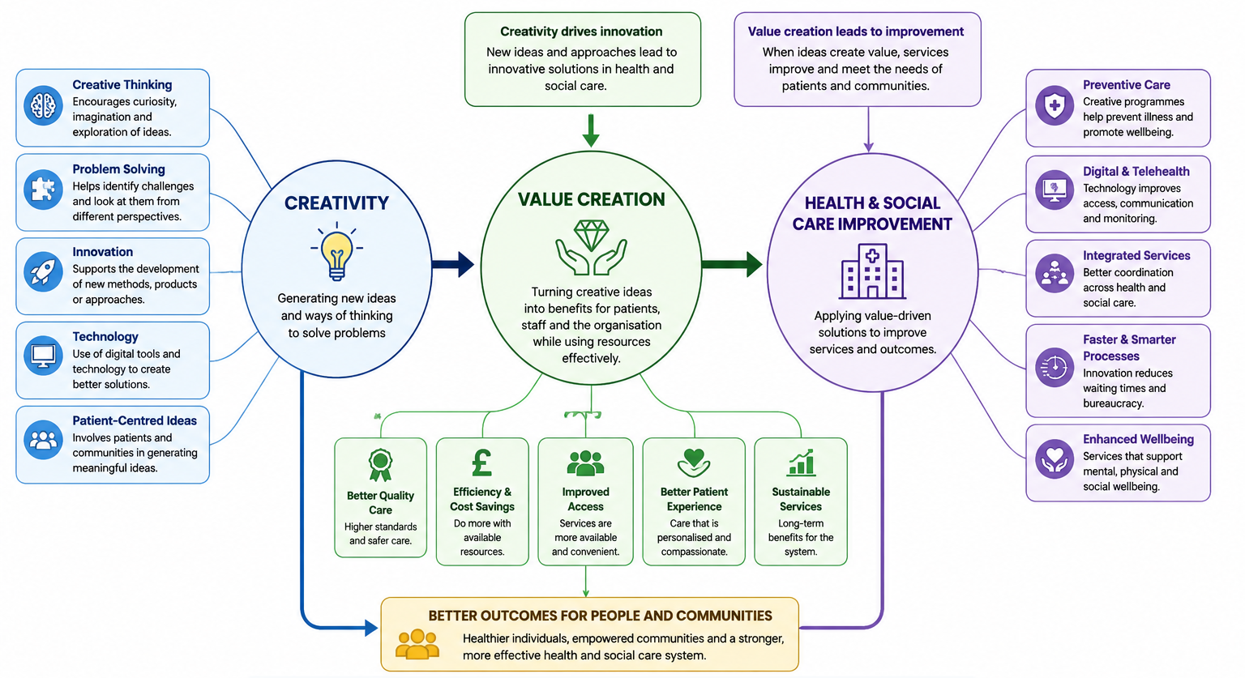
Figure 1: Concept Map
Source: Made on Canva

The concepts of creativity, value creation and health and social care improvement are related and facilitate the effective development of health and social care services. Creativity is defined as the ability to produce new and useful ideas which can lead to problem-solving and system enhancement (Mayndarto et al., 2026). In the health and social care sector, creativity spurs the workforce to think outside the box, drive improvements in patient care, communication and service delivery. Digital healthcare technologies like telehealth services have helped make healthcare more accessible and convenient for patients, whilst also easing hospitals (Citraro et al., 2022).
Creative thinking plays a role in the creation of values, in the use of resources and in the improvement of health care results. According to Oppert et al., (2023), the value in healthcare is doing the most with the least. This can be anything from minimizing waiting time to enhancing patient experience to encouraging preventative care. In addition, patient-centered approaches enable health care professionals to respond to individual patients' needs, resulting in better wellbeing and satisfaction (Sapta et al., 2020).
Innovation and creativity is also a factor which can help to drive continuous improvement in health and social care organizations. Collaboration, problem solving and new ideas can make health systems more efficient and sustainable (Snyder et al., 2019). In total, creativity adds value and contributes to innovative healthcare solutions, which enhance the quality, access and effectiveness of health and social care services.

Task 2 - Self-Reflection of Group Activity

Reflection on the Paperclip Activity – Driscoll’s Reflective Model (Driscoll, 2007)

What?
In the paperclip activity, our group had to think of as many ways as possible to use a paperclip in a short amount of time. The creativity, teamwork and divergent thinking were the main themes of the activity. I started focusing on sensible and work-related applications, like organising documents or resetting electronic gadgets, as opposed to the other group members. As the discussion proceeded, other students made up imaginative ideas, which stimulated broader thinking amongst the students.

So What?
This activity made I understand that sometimes creativity can be constrained and people do not want to assume risks when reaching out for the “right” answer. I realised that I was afraid of suggesting ideas that may be unusual since I seemed to worry about them not being understood. The positive group spirit, however, mitigated my anxiety and helped me to be more confident to participate.
The activity also emphasised the need for cooperation and communication amongst team members. Brainstorming ideas with others from different viewpoints was more effective than brainstorming alone. I discovered that divergent thinking allows for open-mindedness and convergent thinking allows for the assessment of the most practical ideas. These skills are very pertinent to health and social care because health and social workers are likely to encounter challenging situations that will demand flexible thinking and group decision-making.

Now What?
I will attempt to share ideas more freely during future group sessions, without overthinking whether they are correct or not. I will also prompt others to take part to ensure others feel involved in discussions. This gave me experience in a new way of thinking and added to my confidence, as well as being good practice in problem-solving and innovation in healthcare practice.

Task 3 - Case Study of a UK innovation

Introduction
The health and social care sectors are currently operating under an unprecedented pressure, with unprecedented demands and constraints in the systems currently in place (CQC, 2021; Serrano et al., 2023). For sustainability, organisations need to actively shift to strategic innovation in order to maintain the ability to care for increasingly complex needs. This case study is based on the remote monitoring framework called 'NHS at Home', implemented in the UK healthcare sector through the COVID Oximetry @home (CO@h) initiative as a leading example of digital process innovation.

The Case Study
The COW@h initiative was designed to reduce the risk of increased hospital admissions and extreme resource use during clinical surges by focusing on identifying "silent hypoxia" early. By shifting the clinical admission process from reactive acute care to proactive home placements, the project established the domestic environment as a new boundary for clinical supervision (Tomini et al., 2024). This intervention specifically worked on operational pressures at a fundamental level in the National Health Service (NHS), safely managing high-risk patients with respiratory issues at home, which optimised bed space when the system was in crisis.

The Creative Innovation
The creative drive behind this change lay in re-engineering the standard clinical process model, rather than simply introducing new hardware. The service creatively combined basic and readily available digital tools, including a smartphone application, automated text alerts, and home pulse oximeters, with virtual multidisciplinary review teams (MDRTs) (Shah et al., 2021). The Care Quality Commission (2021) says that adopting 'person-centred' and technologically enabled pathways enables health systems to stay highly responsive to the evolving patient profile. This model shifted patients from passive service recipients to active co-producers of their health data, fundamentally altering the organisational clinical environment. Consequently, this small, incremental technological restructuring successfully bypassed traditional capacity barriers (Serrano et al., 2023).

Value and Impact
This innovative service delivery model reimagined in a way that added significant clinical, human and operational value. In practice, the use of technology for remote monitoring was linked to a dramatic decrease in adverse patient outcomes, such as a significant reduction in both 30-day hospital mortality and the likelihood of prolonged hospital stays (over 7 to 14 days) (Boniface et al., 2022). Moreover, as an administrative issue, optimising digital data submission significantly streamlined the clinical burden, with more than 50% fewer provider phone interactions on average, and created significant operational time savings for front-line nursing teams (Shah et al., 2021).

Conclusion
Overall, the CO@h case study demonstrates that adapting the process of the creative work can improve health care infrastructure not only to increase patient safety but also to enhance clinical efficiency. The NHS most effectively delivered measurable system value by marrying up technology and a person-centred approach and created a scalable blueprint to manage chronic and acute diseases in today's health and social care landscapes.

Task 4 - Research Task

Identified Issue: Digital Inequalities and Access Barriers in Digitalised Healthcare
Digital health innovations, including telehealth and telemonitoring services, are rapidly adopted with the goal of maximising service delivery and improving patient independence. This transition has, however, inadvertently increased the "digital divide", meaning there are significant disparities in access to care for vulnerable, elderly and socioeconomically disadvantaged communities that do not have the digital literacy, stable internet infrastructure or suitable hardware to engage with these technologies.

Paraphrase of Academic Findings

Article 1: Emani et al. (2023)
In their study, Emani et al. (2023) examine patient-level systems-level factors that contribute to inequities in digital health portals and telehealth use. The researchers conclude that although digital health interventions are intended to create a more equal health care landscape, the access to these interventions is tightly regulated by socio-demographic factors, such as age, income and education levels. Lower digital health literacy rates amongst vulnerable populations contribute to anxiety and reluctance to new automated or application-based health care paths. Moreover, the study emphasizes that health care providers are not always providing personalised onboarding or technical assistance, which further normalises the exclusion of non-technical individuals, and contributes to health disparities.

Article 2: Honey et al. (2024)
Honey et al. (2024) discuss the operational difficulties of implementing remote health interventions, especially with regard to infrastructure and users' capabilities in these remote and marginalised communities. Their results illustrate that one of the key reasons for excluding these disparities from access and equity is the assumption of healthcare institutions that everyone has an equal digital space (e.g. high-speed broadband and privacy in their home setting for virtual consultations). In fact, many vulnerable people are constrained from funding their connectivity or have data poverty, as they are unable to afford consistent connectivity. If digital transformation is not proactively and equitably co-designed with these socioeconomic realities in mind, the result will be the continued unintended exclusion of the very patients that need the most intensive health care support.

Task 5 - Podcast
Record a two-minute Podcast introducing your idea for component 2 using https://www.rev.com/onlinevoicerecorder The MP3 audio must be downloaded and embedded as a file (see guidance video on how to do this here: https://www.youtube.com/watch?v=D21isId0agw) or an accessible OneDrive link if using a chromebook (make accessibility – anybody) before inserting into your portfolio. Check the accessibility of the link before submitting.
Please refer to week 4 & 6 content.

[please insert file or link here]

Task 6 - NHS Leadership Framework Analysis

Summary of Key Components
The NHS Leadership Framework provides a shared set of expectations of leadership capability across all health professions, and brings the message that the responsibility for leadership should not be confined to a specific position, but is more of an approach to doing things at work (Streeton et al., 2021). The framework is made up of seven core domains, to promote organisational excellence. The first five domains all apply across all staff members and are as follows: Demonstrating Personal Qualities conveys self-awareness alongside professional values; Working with Others entails the development of a network of people to work creatively with; Managing Services means planning services and optimising resources; Improving Services is about commitment to safety and innovation; and Setting Direction involves making informed, evidenced-based decisions (Health and Care Professions Council, 2023).
The other two domains are, on the other hand, specifically focused on the client professionals' role as senior, positional leaders (Monkhouse et al., 2018). Some of these top level components require executives to drive broader organisation systems change, to focus and prioritise long-term cultural change and to lead and drive complex systems change within overall organisation (NHS Confederation, 2023). These seven domains work together and make sure that the behaviour of leaders at all levels is aligned with operational NHS standards of clinical quality and care for patients.

Application of a Component: Improving Services
A leader can use the Improving Services element to promote digital creativity and to help to improve the quality of the care (Streeton et al., 2021). As an umbrella for this, it is anticipated that leaders will challenge, question, review and drive change in current practice. Focusing on paths of technology in practice, a clinical leader may promote a culture of continuous improvement by inviting frontline teams to co-design technological pathways with them, as with virtual ward projects (NHS England, 2023).
The leader as a positive role model for innovation makes sure that the patient perspective is taken up into new automated care paths, reducing digital access barriers (NHS Confederation, 2023). Moreover, the leader can be confident that they will have strong evaluation mechanisms in place to safely pilot new innovative and digital monitoring approaches, balancing resource constraints with patient safety, whilst adding to the value of the system in the long-term (NHS England 2023).

Task 7 - Self-Reflection Journal Entry
The module has entirely revolutionized
my understanding of the creative and value generation aspects of the health and social care service. At first I thought creativity was an artistic characteristic or just some type of “restless and reckless” activity inappropriate in narrowly controlled medical environments. From that experience, I learned that divergent thinking is indeed a powerful tool for effectively solving problems together whilst crossing institutional boundaries. I now recognize the value-creating opportunity is not just cost cutting, it's about creating maximum systemic results, optimizing patient-centered journey, and improving clinical efficiency.
All these changes in thinking have had a powerful impact on my professional development. To be a part of someone who takes the initiative in questioning the convention, instead becoming a silent entity forced to accept operational guidelines, to be someone who speaks out with innovative, tech-infused ideas to help those who lack access to technology and information. This module has helped me display my disposition of speaking my mind in a multidisciplinary group. In the future, I will embed values led practices into all actions taken and ensure that any future service changes that I initiate are co-designed with an inclusive approach and take into consideration, the socioeconomic reality of my diverse service users.

Reference List
Baldofski, S., Scheider, J., Kohls, E., Klemm, S.L., Koenig, J., Bauer, S., Moessner, M., Kaess, M., Eschenbeck, H., Lehner, L. and Becker, K., 2024. Intentions and barriers to help-seeking in adolescents and young adults differing in depression severity: cross-sectional results from a school-based mental health project. Child and Adolescent Psychiatry and Mental Health, 18(1), p.84.
Boniface, M., Burns, D., Duckworth, C., Ahmed, M., Duruiheoma, F., Armitage, H., Ratcliffe, N., Duffy, J., O’Keeffe, C. and Inada-Kim, M., 2022. COVID-19 Oximetry@ home: evaluation of patient outcomes. BMJ Open Quality, 11(1).
Care Quality Commission. (2021). Enabling innovation and adoption in health and social care: Developing a shared view. Accelerated Access Collaborative; NHS England. Available at: https://www.cqc.org.uk/publications/themed-work/enabling-innovation-adoption-health-social-care-developing-shared-view
Citraro, M., Carcano, C., Carpanzano, E., Puiatti, A., Sommaruga, L. and Vignati, S., 2022. From creativity to value creation. In Towards a new future in engineering education, new scenarios that european alliances of tech universities open up (pp. 1067-1075). Universitat Politècnica de Catalunya.
Driscoll, J., 2007. Practising Clinical Supervision: A Reflective Approach for Healthcare Professionals. 2nd ed. Edinburgh: Elsevier.
Health and Care Professions Council (HCPC). (2023). Leadership and the standards of proficiency: About the Clinical Leadership Competency Framework (CLCF). Education and Training Committee. Available at: https://www.hcpc-uk.org/standards/standards-of-proficiency/
Mayndarto, E.C., Suzuki, R. and Fujita, M., 2026. DIGITAL CREATIVITY AND SOCIAL VALUE CREATION: ENTREPRENEURIAL STRATEGIES IN TECHNOLOGY-DRIVEN COMMUNITIES. Journal of Social Entrepreneurship and Creative Technology, 3(2), pp.129-140.
NHS Confederation. (2023). Digital Boards programme: Lead with confidence in a digital NHS. NHS Confederation / Public Digital. Available at: https://thenhsalliance.org/digital-boards
NHS England. (2023). Supporting clinical leadership in virtual wards – A guide for integrated care system clinical leaders. NHS England Publications. Available at: https://www.england.nhs.uk/long-read/supporting-clinical-leadership-in-virtual-wards-a-guide-for-integrated-care-system-clinical-leaders/
NHS Leadership Academy. (2012). Leadership Framework: A summary. NHS Institute for Innovation and Improvement. Available at: https://www.leadershipacademy.nhs.uk/wp-content/uploads/2012/11/Leadership-Framework-A5-Handout.pdf
Oppert, M.L., O'Keeffe, V., Bensnes, M.S., Grecu, A.L. and Cropley, D.H., 2023. The value of creativity: A scoping review. Journal of creativity, 33(2), p.100059.
Pretorius, C., Chambers, D., Cowan, B. and Coyle, D., 2019. Young people seeking help online for mental health: cross-sectional survey study. JMIR Mental Health, 6(8), p.e13524.
Sapta, I.K.S., Landra, N., Supartha, I.W.G., Asih, D. and Setini, M., 2020. Public health welfare in digital-based resources transformation from social capital and information sharing: Creative industries from village. Systematic Reviews in Pharmacy, 11(6), pp.688-696.
Serrano, L.P., Maita, K.C., Avila, F.R., Torres-Guzman, R.A., Garcia, J.P., Eldaly, A.S., Haider, C.R., Felton, C.L., Paulson, M.R., Maniaci, M.J. and Forte, A.J., 2023. Benefits and challenges of remote patient monitoring as perceived by health care practitioners: a systematic review. The Permanente Journal, 27(4), p.100.
Shah, S.S., Gvozdanovic, A., Knight, M. and Gagnon, J., 2021. Mobile app–based remote patient monitoring in acute medical conditions: prospective feasibility study exploring digital health solutions on clinical workload during the COVID crisis. JMIR formative research, 5(1), p.e23190.
Snyder, H., Witell, L., Elg, M. and McColl-Kennedy, J.R., 2019. The influence of place on health-care customer creativity. European Journal of Marketing, 53(7), pp.1400-1422.
Tomini, S.M., Massou, E., Crellin, N.E., Fulop, N.J., Georghiou, T., Herlitz, L., Litchfield, I., Ng, P.L., Sherlaw-Johnson, C., Sidhu, M.S. and Walton, H., 2024. A cost evaluation of COVID-19 remote home monitoring services in England. PharmacoEconomics-Open, 8(5), pp.739-753.
Streeton, A.M., Kitsell, F., Gambles, N. and McCarthy, R., 2021. A qualitative analysis of vertical leadership development amongst NHS health-care workers in low to middle income country settings. Leadership in Health Services, 34(3), pp.296-312.
Monkhouse, A., Sadler, L., Boyd, A. and Kitsell, F., 2018. The improving global health fellowship: a qualitative analysis of innovative leadership development for NHS healthcare professionals. Globalization and health, 14(1), p.69.

