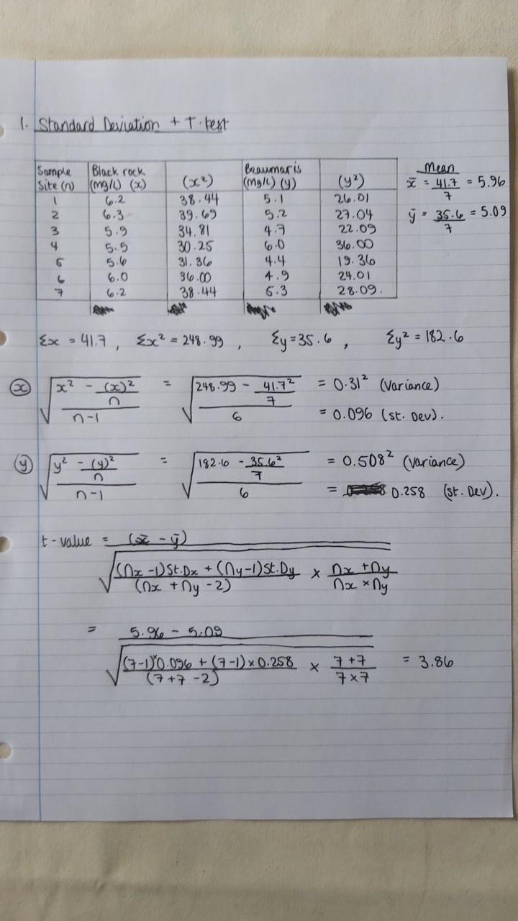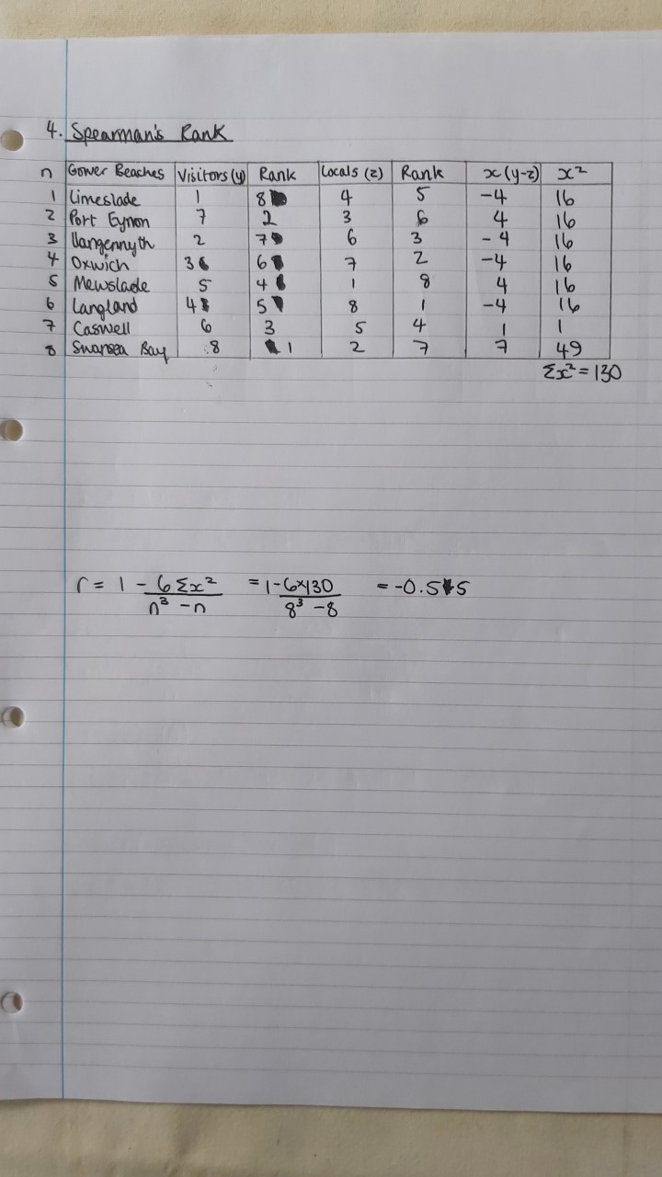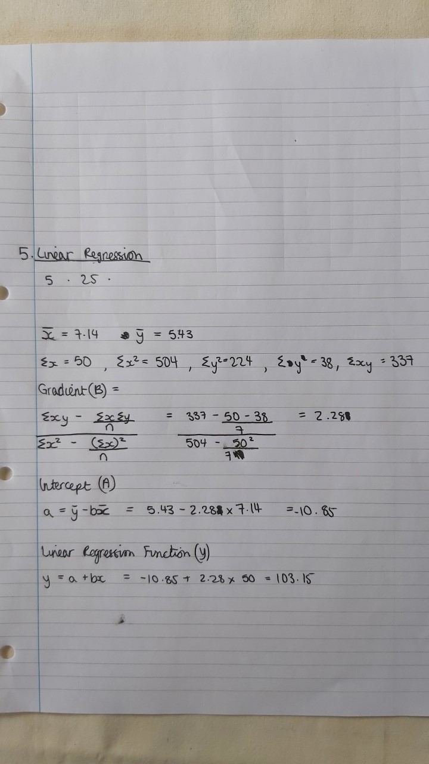
HERE ARE SOME RANDOM WORDS THAT TURNITIN NEEDS, PLEASE DON’T COUNT THIS STATEMENT IN THE EXAM PLEASE, THANK YOU!!
NAIM.

