Microsoft Access Database UNIVERSAL SPORTS

Executive Summary
The report has explained the concept of the Microsoft Access database. The report showed that in the MS Access desktop database, the major objects include queries, forms, reports, modules, macros, data macros, and tables. The report has also discussed foreign and primary key concept. It has examined the relationship between various tables that are created. The report explained relationships like one to one, one to many, and many to many. The report also showed a degree of relationship in the table using examples.

Table of Contents
Introduction 4
Task 1 5
Relationship among various tables created 5
Degree of relationship 6
E-R diagram 14
Conclusion 15

Introduction
The report determines the concept of the Microsoft Access database. It explains the relationship between various tables that are created. The report also shows the degree of relationship in the table using examples. The report also discusses the foreign and primary key concept.
Microsoft Access is regarded as the relational database management system that is mainly designed for the use of home and small business. MS Access is part of Microsoft Office Suite that is widely available on the PC version. MS Access is traditionally called a desktop database system as its functions run from the single computer in which database applications are installed in the server and are then accessed from several client machines across the network. MS Access also comprises a web solution that is mainly integrated with the SQL server- which is a powerful database product from Microsoft (Zygiaris, 2018). In the MS Access desktop database, the major objects include queries, forms, reports, modules, macros, data macros, and tables. If users have worked in other database systems on desktop computers then they may see the database as the file in which data is stored. In MS Access desktop database comprises all the essential objects that are related to storing data including the objects that are defined as automating the use of data.

Task 1

Relationship among various tables created
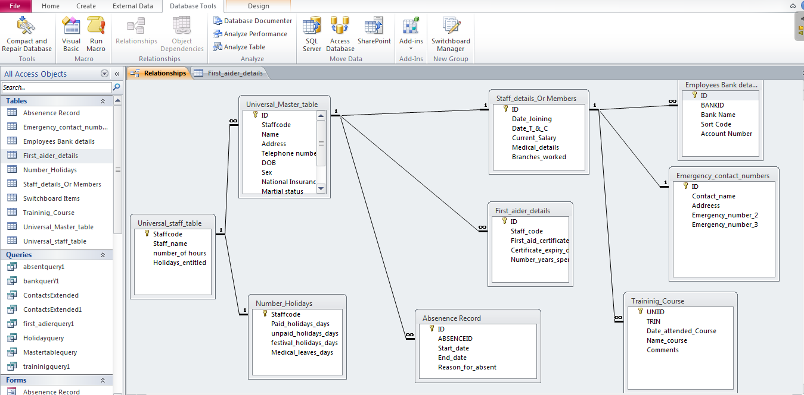

Relationship
Between two types of database tables as well as the foreign key there exists a relationship. A relational database is unique for each record that is termed as the primary key(Sharma, 2017).
The primary key in the database shows the existing column or record in a particular table. No repeated attributes are seen in the candidate key and from this primary key is selected(Szczęśniak, 2018). To ensure that candidate has unique features it compiles the automatically generated key using databases.
A foreign key is known as another candidate and it is not the primary key that is used for linking a record to the data in another table (Dimolikas et al., 2020).
By using a foreign key or any other candidate key, about three relationship types can be implemented by users that are as followed:
One-to-one: This is termed as the relationship in which there exists only one type of record in the other table. For instance, in the database of the school, one ID is held by a student and each ID is only assigned to a single person. This relationship does not comprise the use of a foreign key and can be only implemented in a particular single table. For example, each spouse has other spouses in the marriage database.
One-to-many: In this, one record in the particular table can relatively be associated or related to one or more than one record existed in the other table. For instance, customers as well as order tables are held by each business enterprise.
From single customers, multiple orders can be widely linked. The foreign key needs to be held or contained in the order table of the database with the primary key. There should not exist a foreign key in the customer table.
Many-to-many: Under this relationship, there exist multiple records that are associated with several records in the table. For instance, this relationship exists between products and customers. Several products can be purchased by many customers. This relationship involves a product table along with customers as well as order tables.

Degree of relationship
These are called several entity types that associate or participate in the relationship. By seeing the E-R diagram, we can simply tell the degree of relationship that is the several types of entity that is connected to a relationship is known as the degree of that relationship.
For instance, if there are two types of entities that are Account and Customers and that are linked by using the foreign and primary key (Sharma, 2017). We can now say that degree of relationship is 2 as two entities take part in the relationship.
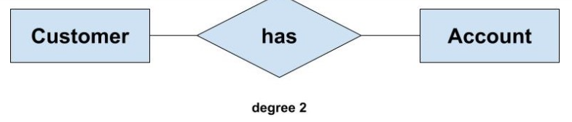
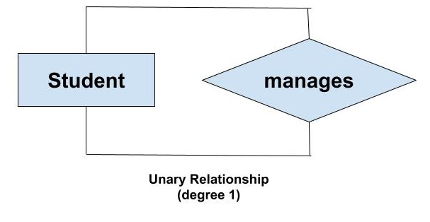
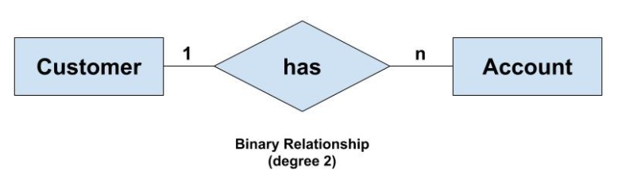
Below attached are the screenshots of the ms access database which has been created related to the case study given on Universal sports company. All the tables, reports, forms and opening menu form are all designs as per the requirements of the project and thus, makes it more versatile and more viable to use. In total 10 tables are created along with the forms and reports, these tables include universal master table, staff table, emergency contact number table, absent record table, training course table, first aid table, number of holidays, switchboard menu table and further queries are created on the basis of table relations and established foreign keys with the help of SQL which is the best used for the relational database management.

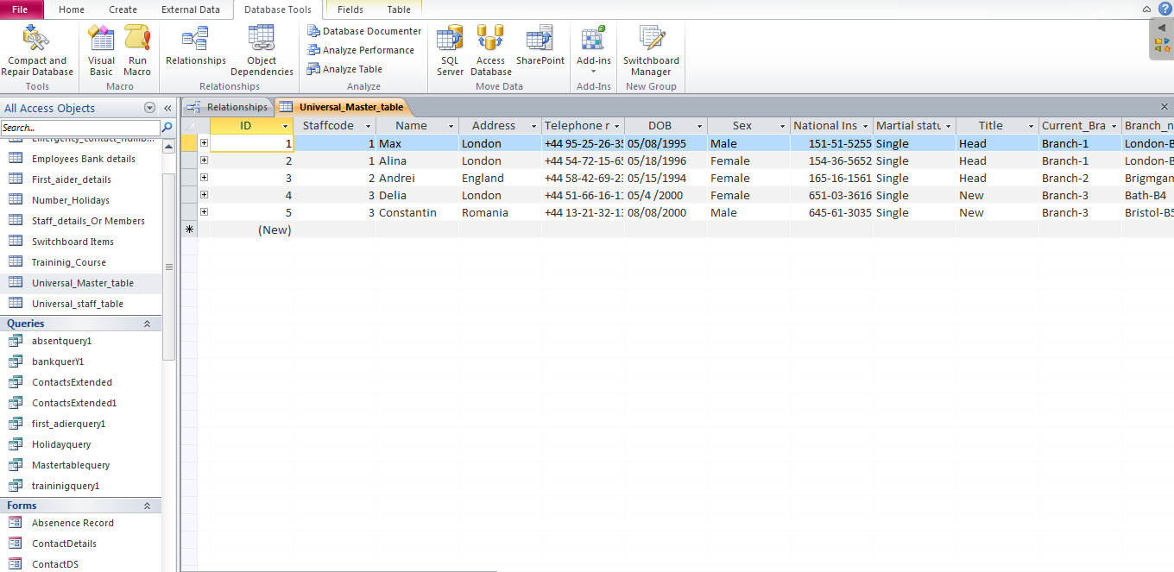
Above screen host is of universal master table which is basically has all the information of the members of the company or one can employees of the company, it is very important table in the database as it collects all the information of the employees through the form and consists curial data of the employees.

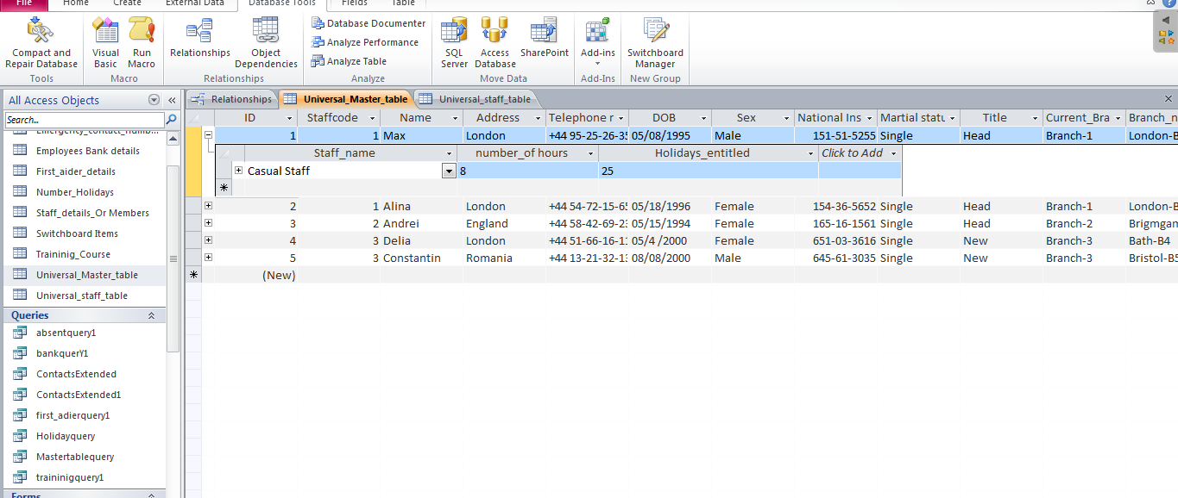

Above screenshot shows the data which is retrieving from the foreign key which connected it to the universal staff table which consist of the standard data of all the members such as swimming pool attendant, casual staff and last fitness instructor.
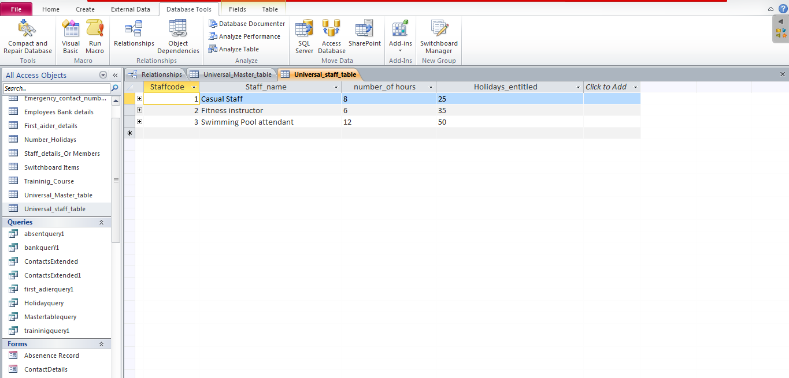
This is a staff table which consist of the fields such as primary key, staff name, number of hours and holidays entitled and which is further connected to master table through foreign key with the help of "one To many" relation which is the important cardinality in these two fields.

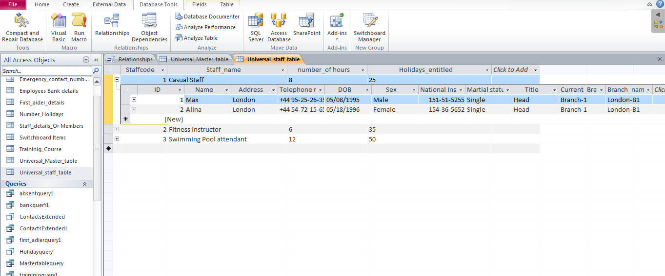
The staff universal table is connected to number of holidays, that is available for the all the members except the one called casual staff as per the requirement.

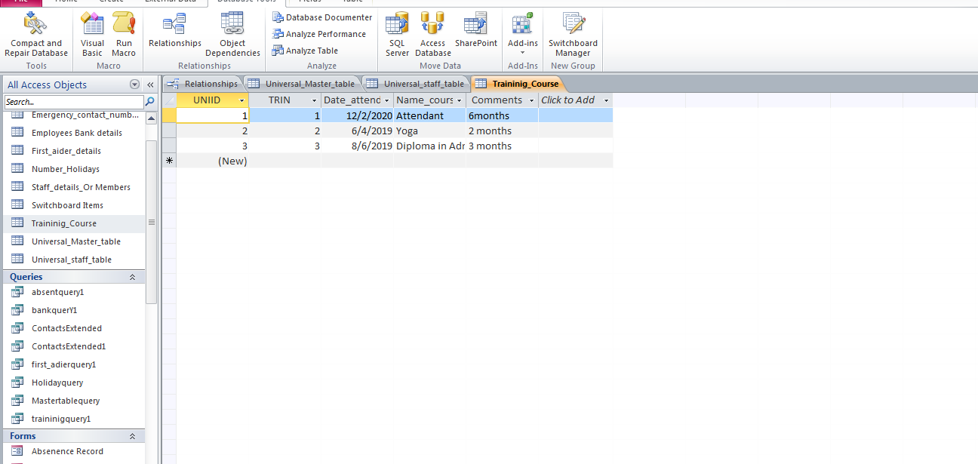
This is training table which consists of the fields called primary key, TRIN, date and number of hours attended by the member to certified in the course and even comments field is also given if needed.
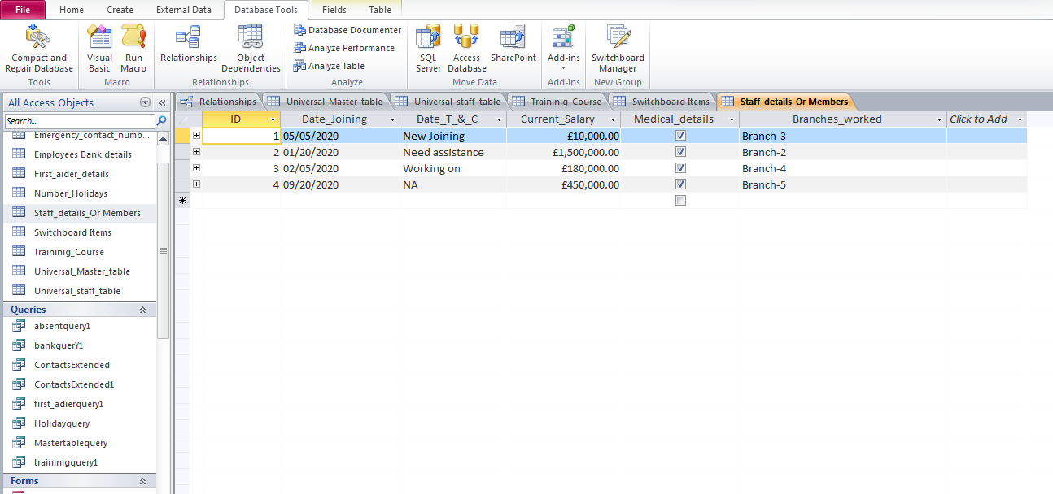
This table is connected to the universal master table which has data of the members thus this table extends the members data by collaborating with branch name, current salary, terms and conditions and date of joining, which makes the database more robust and healthy.

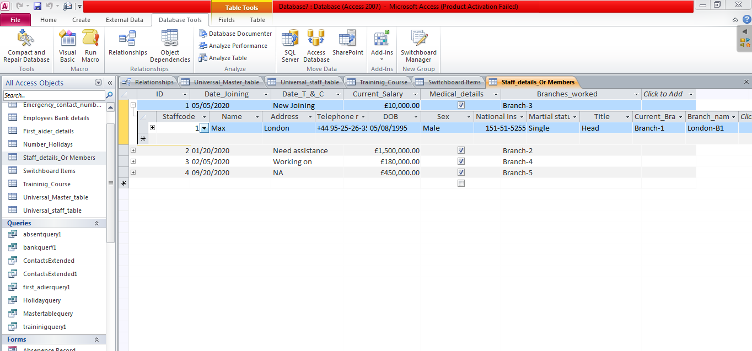

Above screenshot is the table staff member data but showing the foreign key with "many To one" relations with universal master table

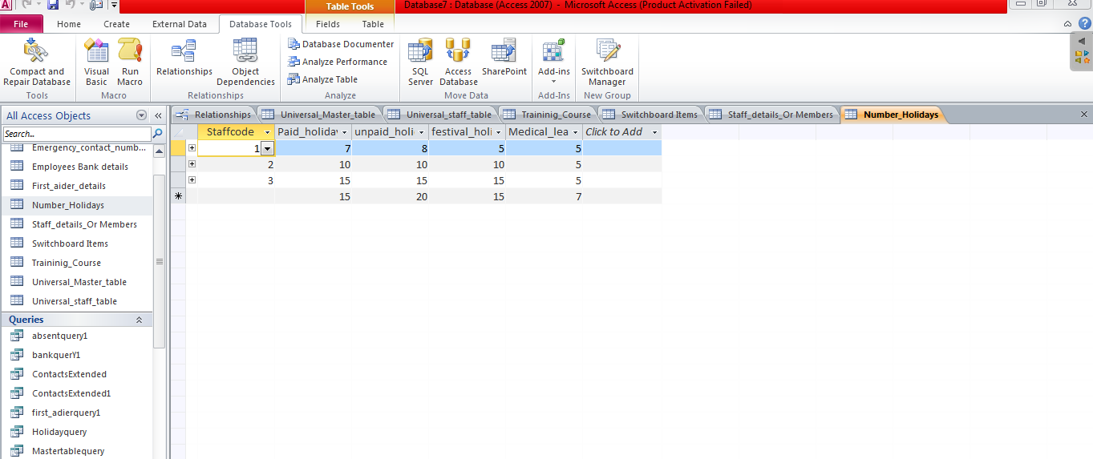
Above screenshot is the table of number of holidays consist of the fields such as paid leave, unpaid leave, medical leave. and primary key which is necessary.

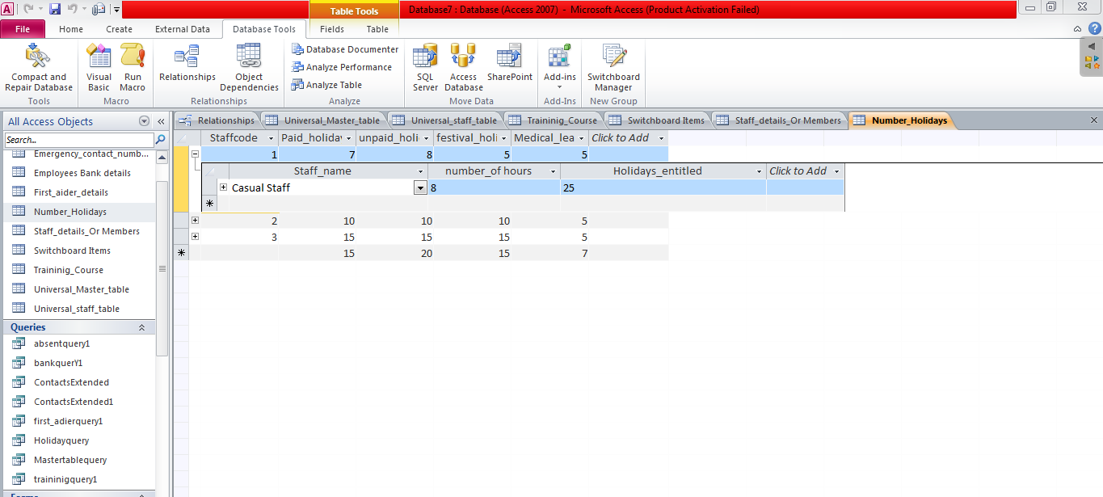
number of holidays further extended with the foreign key with the help of "one TO many relation" thus makes it more clear and justify the Third normal form.
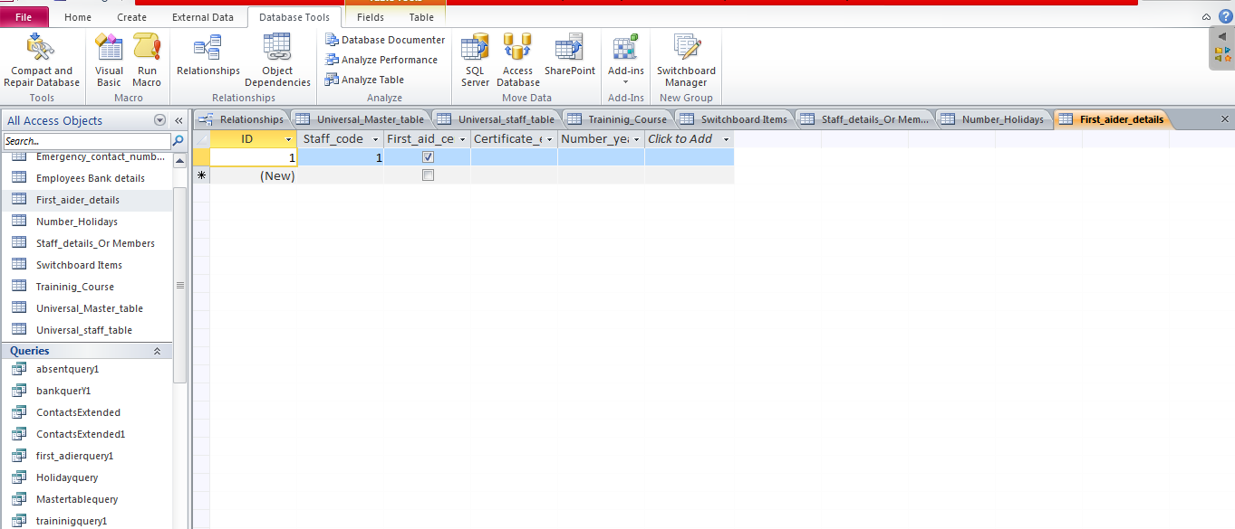
above screenshot is the first aider details which consist of the fields such as staff that behaves as the foreign key and further first aid on radio button, certificate and number of years of completion.
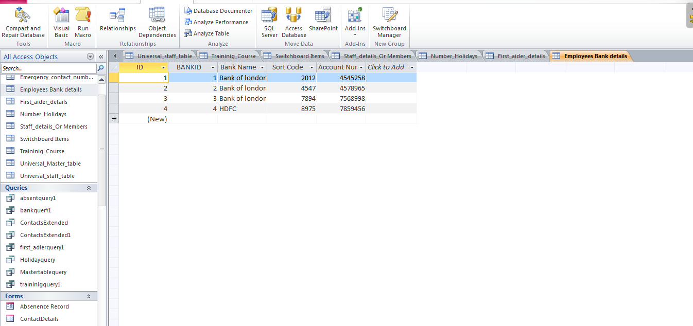
Bank details of the all the employees can be filled here with the fields such as bank name, sort code and account number with the help of foreign key which is bankid

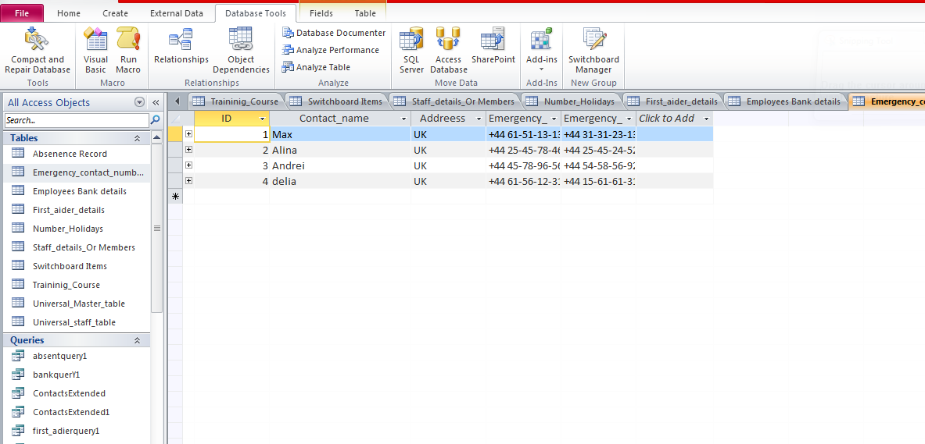
Foreign key with the help of one to many cardinality, further assist in the formation of emergency contact details consist of two emergency number fields along with address and name.

E-R diagram
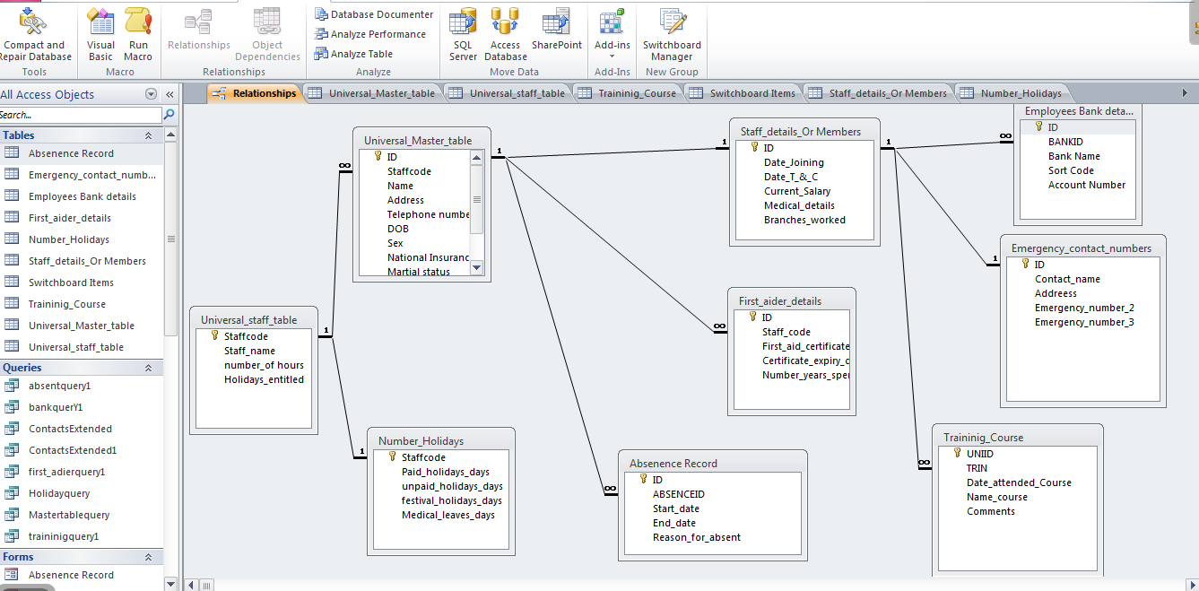
Above is the entity relationship diagram which has been established among all the tables together thus makes it easy and comfortable for the user while using or operating it. As one can see number of holiday and universal staff table are connected with one to one relations, makes the staff table to take all the data from number of hours table which however, would deliver only unquiet data which also the reason to use ONE TO OONE relation. further the staff table is connected to master table with the help of one to many relation as the staff code behaving as the foreign key. Master table is connected with absent record as one to many relation, with first aider as the one to many and one to one with staff member. Now, the staff member is connected with bank details as one to many, one to many with contact numbers table and lastly one to many with training course. All the tables follow the third form of RDBM rule which follows the first two normal form to reduce the duplicity and redundancy.

TASK2
TABLES
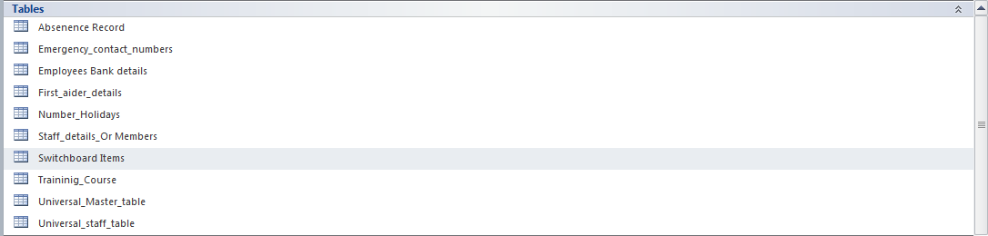

FORMS

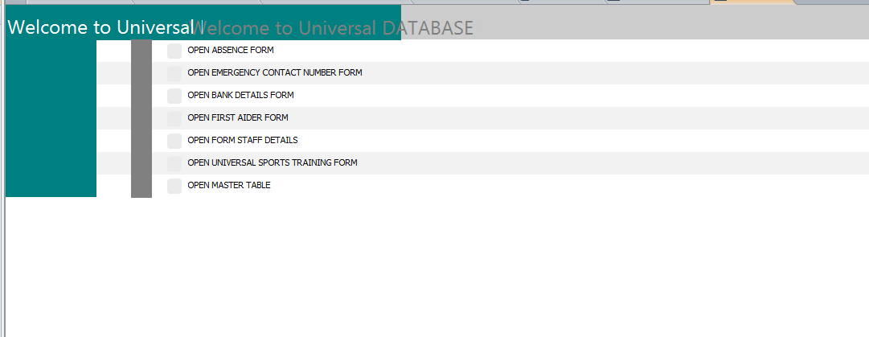

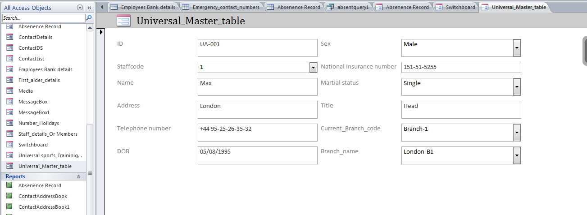

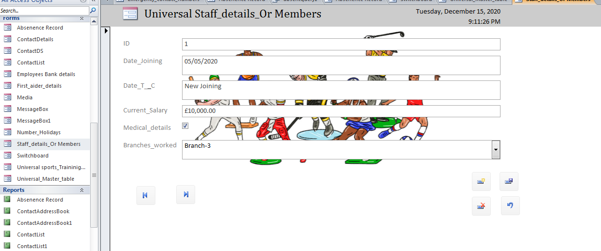

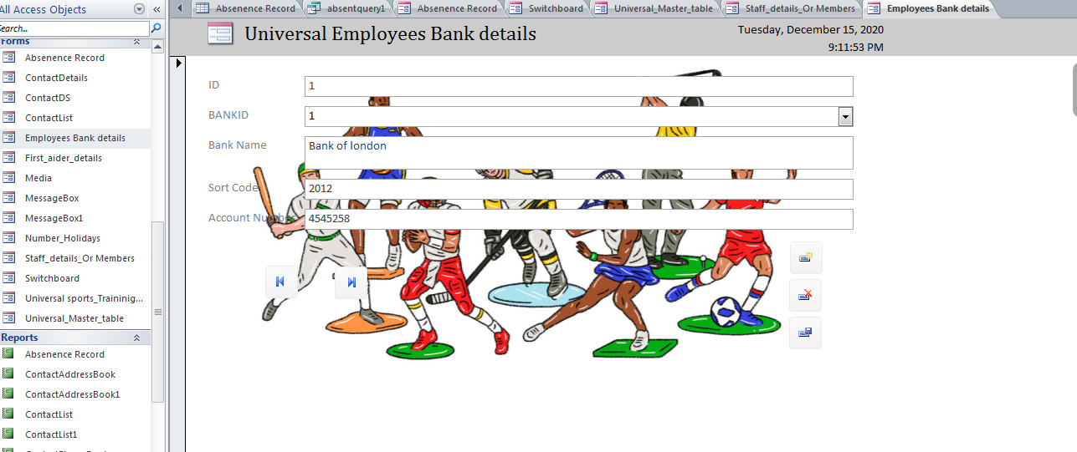

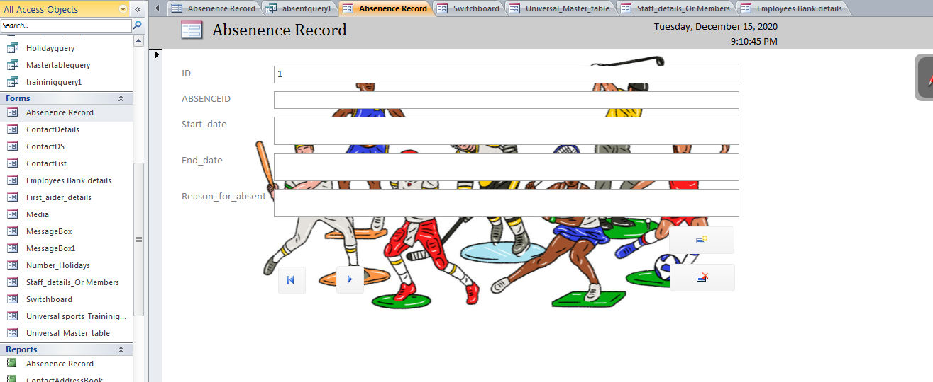

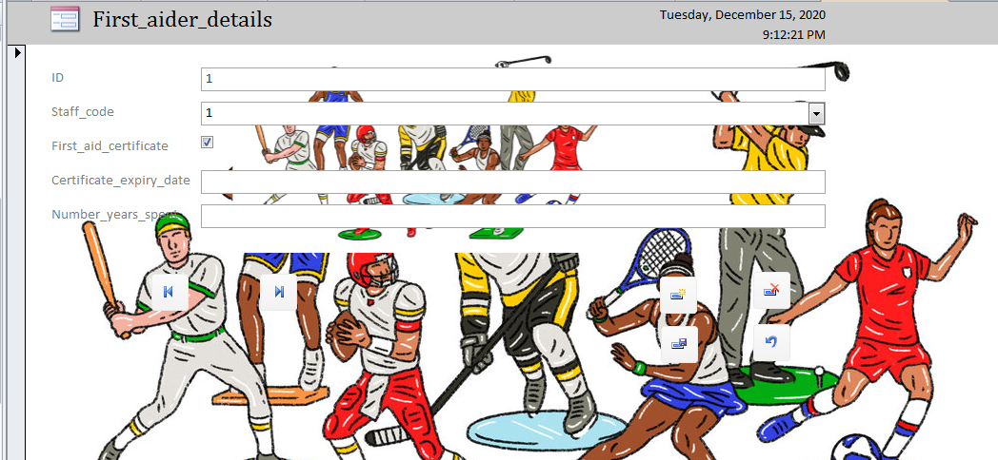

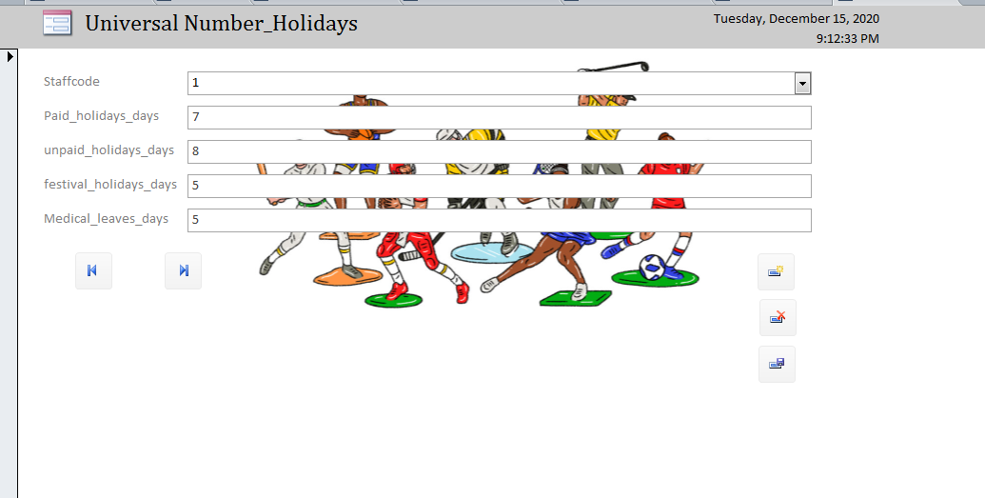

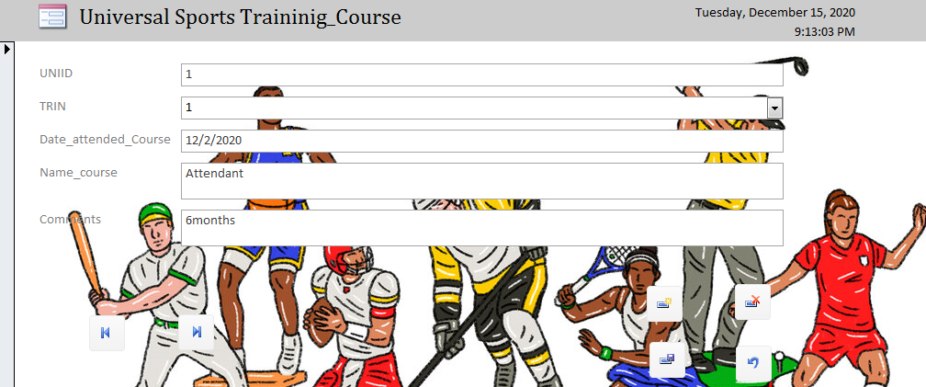

QUERIES
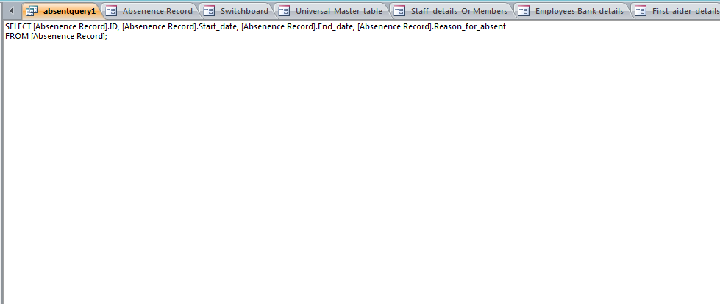

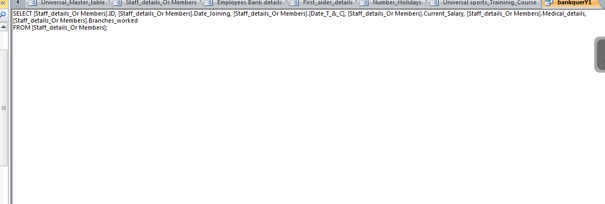

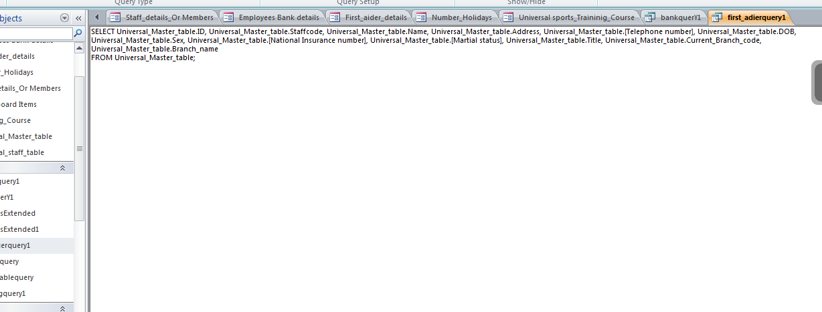

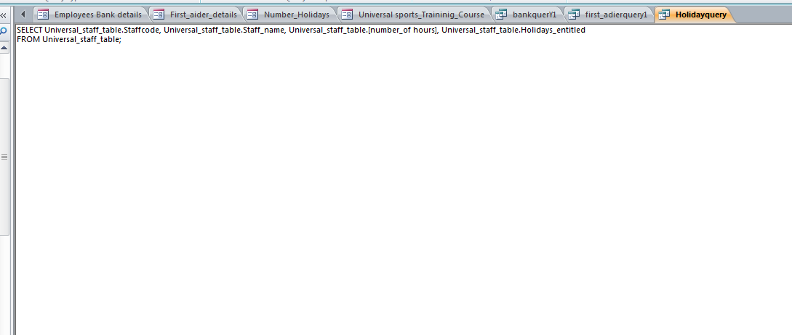

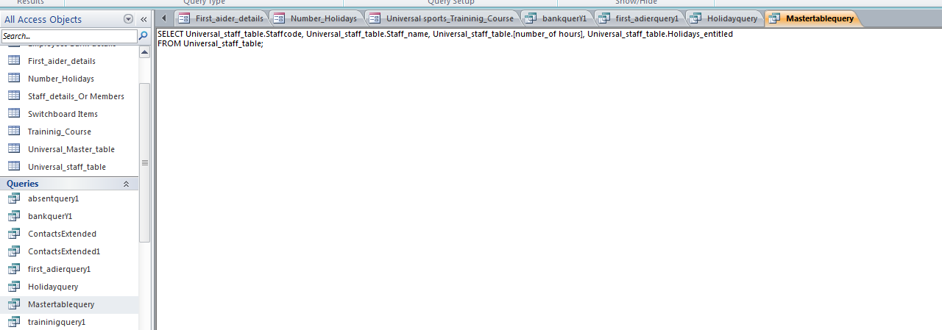
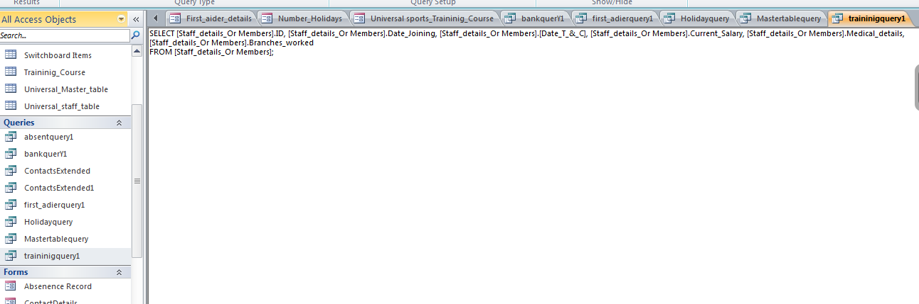
REPORTS
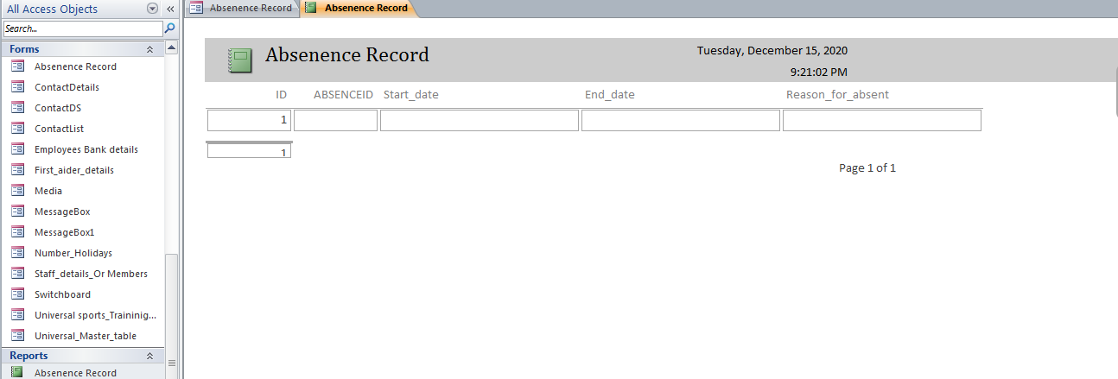

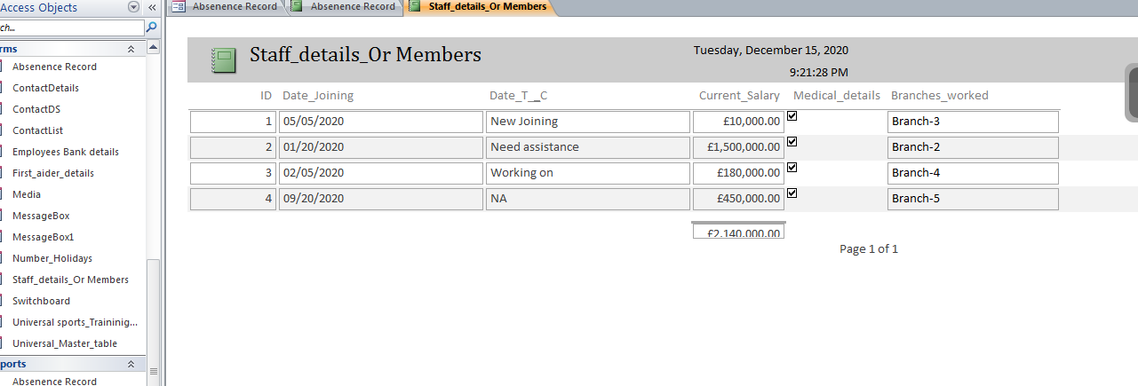

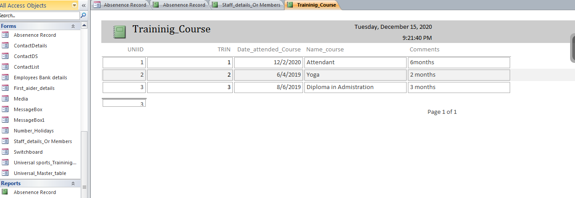

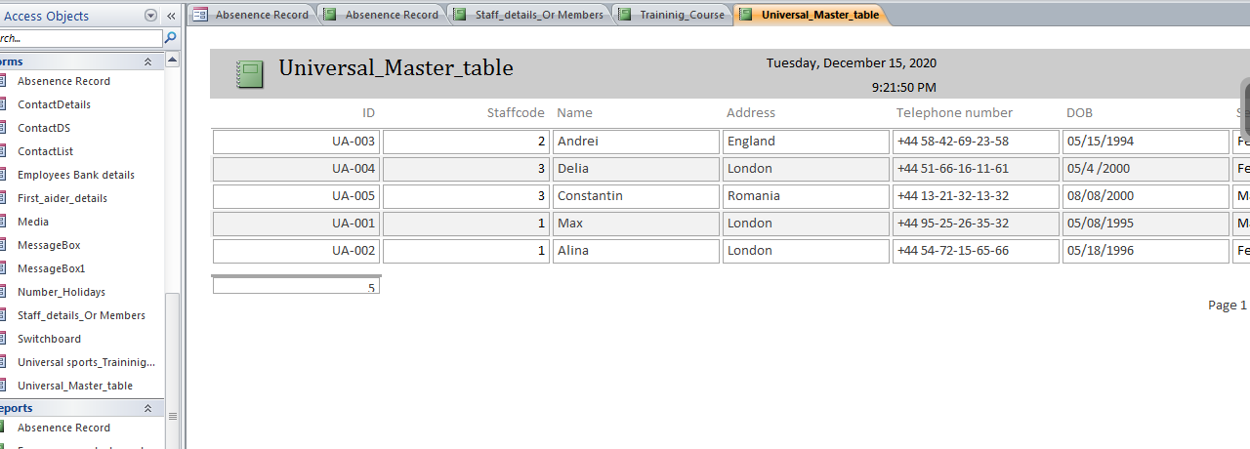

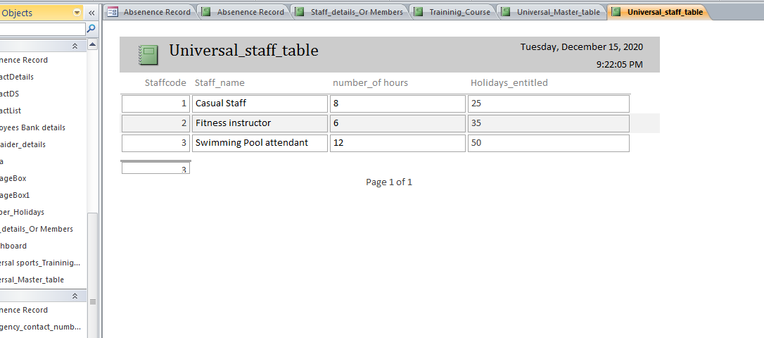
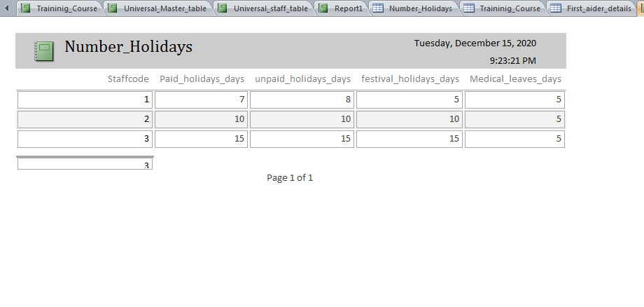
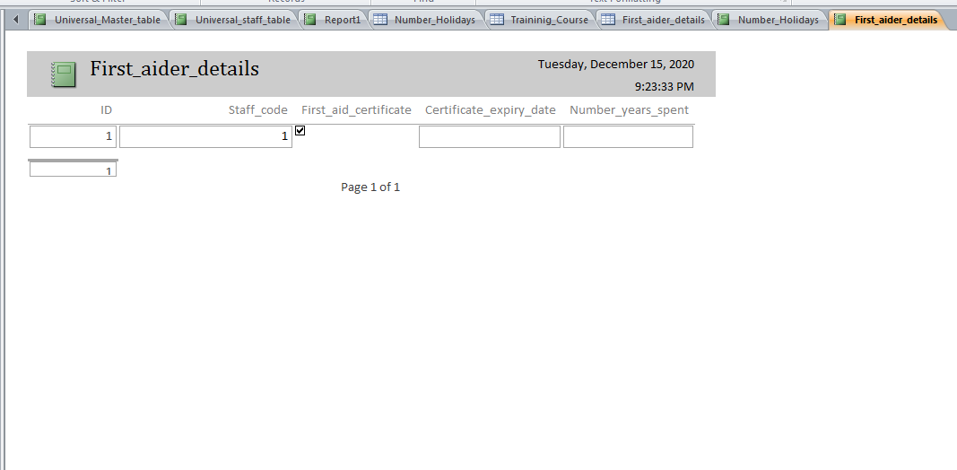
RELATIONSHIP
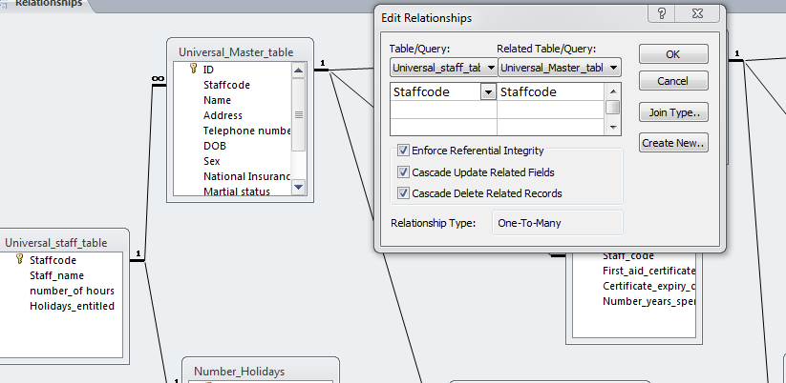

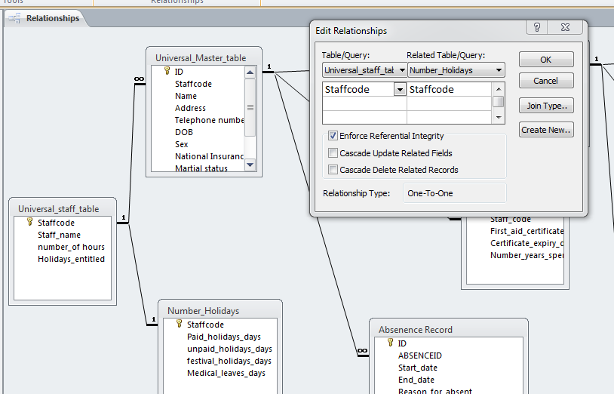

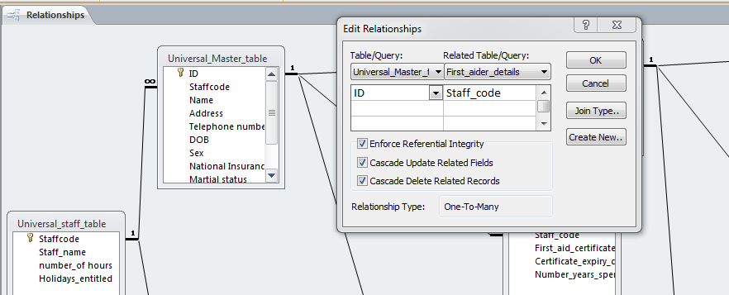
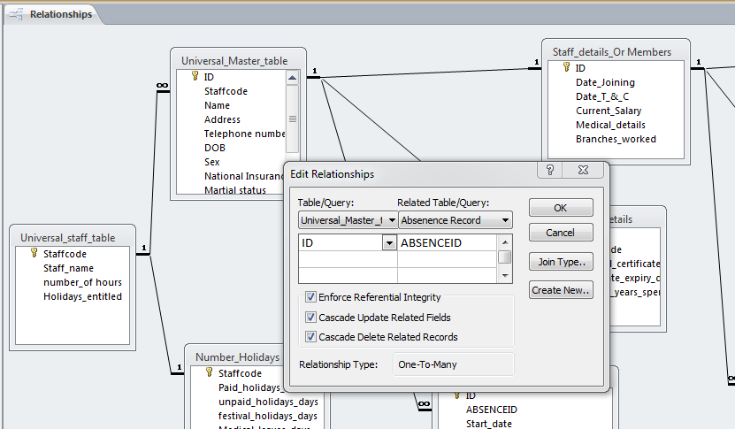

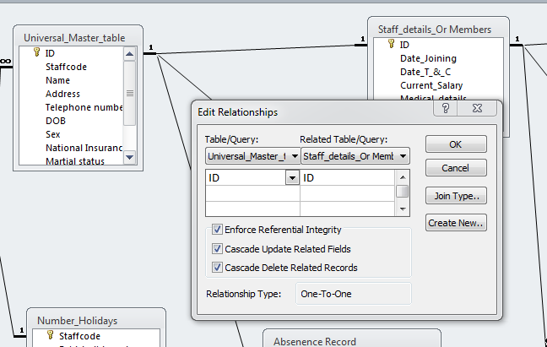
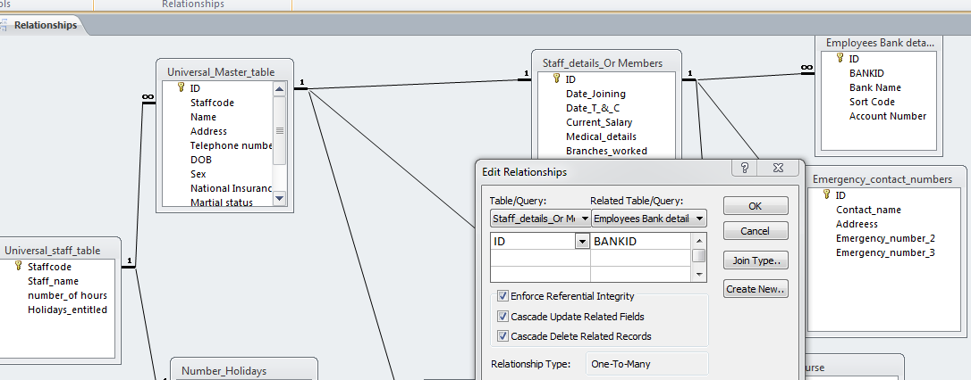
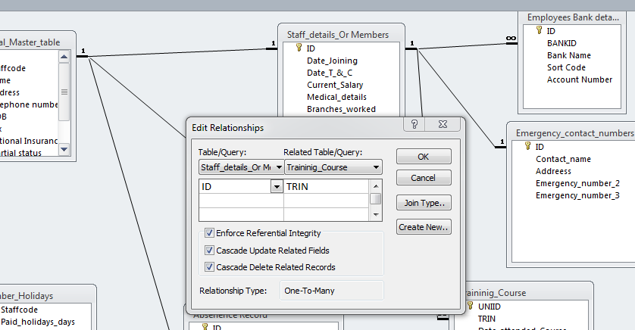
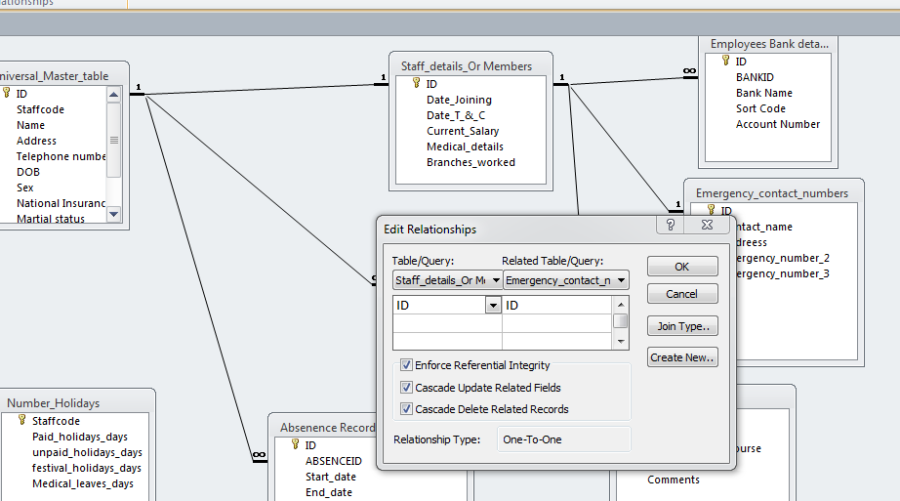
USER GUIDE
The user has to install the MS access software on the machine and after that user has to open the file of universal database which has all the files, and forms. User needs to use the form as the main source of managing database and further all the details of the employees can be filled easily with the buttons given on the form, likewise user can also change the fields or any changes if required , or if the user is unknown to operate ms access, then it's not suggested. The menu form opens up automatically thus, makes it easy and fast to use.

Conclusion
It can be concluded from the report that MS Access comprises a web solution that is mainly integrated with the SQL server- that is powerful database products from Microsoft. The report showed that In the MS Access desktop database, the major objects include queries, forms, reports, modules, macros, data macros, and tables. The report discussed the foreign and primary key concept. It has examined the relationship between various tables that are created. The report explained relationships like one to one, one to many, and many to many. The report also explained the degree of relationship in the table using examples.
The report showed that MS Access is mainly offered by Microsoft that enables users to link to data with the existing location and use it to view, update, query, and report. The report showed that MS Access is the application that is typically used to create, manage, and format data. The essential tools that are included in MS Access are a screen for data entry, producing reports, other operations, and running queries. MS Access is very popular as a skilled developer of MS Access createsa wide range of software functionality in a short timeframe than other development platforms. A simple database can be created quickly even through a novice access developer.

References
Dimolikas, K., Zarras, A.V., and Vassiliadis, P., 2020, November.A study on the effect of a table’s involvement in foreign keys to its schema evolution.In International Conference on Conceptual Modeling (pp. 456-470).Springer, Cham.
Sharma, N., 2017. Overview of the Database Management System. International Journal of Advanced Research in Computer Science, 8(4).
Stepanov, M.S., Koshliakova, I.G., Sorochkina, O.Y. and Kirimova, K.V., 2020, November.Database management systems application for the organization’s metrological support. In Journal of Physics: Conference Series (Vol. 1679, No. 5, p. 052056). IOP Publishing.
Szczęśniak, B., 2018. Microtools Based on the Relational Data Model–Conformity between Foreign and Primary Keys. Multidisciplinary Aspects of Production Engineering, 1(1), pp.491-497.
Zygiaris, S., 2018. Database Management Systems: A Business-Oriented Approach Using ORACLE, MySQL, and MS Access. Emerald Group Publishing.

