How do materials of the world shape people and how do people shape the materials of the world?
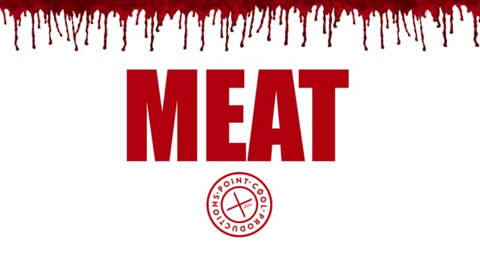
Introduction.
It is my intention within this essay to explore the problematic relationship humans have with meat as a food source. Is humanities relationship with this material object continuing to grow and adapt with the ever-changing world it is creating around itself or are humans clinging to outdated traditions and self-serving values that are now causing the materials of the world to shape humanities destruction?
A study will be made to examine exactly at what point the living animal is considered a food source. Is it before or after the animal is killed? I shall investigate who is demanding this food source and who is supplying it, (Geddes and Scott 2010). Consideration will be given to current methods of mass production and how it effects the local area (Lever & Milbourne 2015) and how its effecting climate change globally. Examining two newspaper articles created over a decade apart will highlight the shift in human accountability for creating climate change (The Independent 2006 & The Guardian 2018). Using Paul Horns theory to support my argument (inside climate news 2013) I will consider his viable solutions to help climate change via the meat farmers.
I shall briefly examine the new materialist approach to human relationships with food (Attala 2019) before concluding that maintaining a relationship with this material object is not only detrimental to the planet but is also a completely abusive relationship with no substantial health benefits for the body.

What is meat?
Meat is viewed by some people as a delicious treat that supports human dominance in this age of Anthropocene. However, an ever-increasing number of people consider meat a barbaric unsustainable food source. Why is this shift occurring?
After conducting a simple study with a small group of meat eaters the results highlighted some complex issues surrounding the relationship meat eaters have with their chosen food source.

The study asked ten participants to look at the three images below and define at what point they consider the image to be meat?
Ten adults participated and the results were as follows:
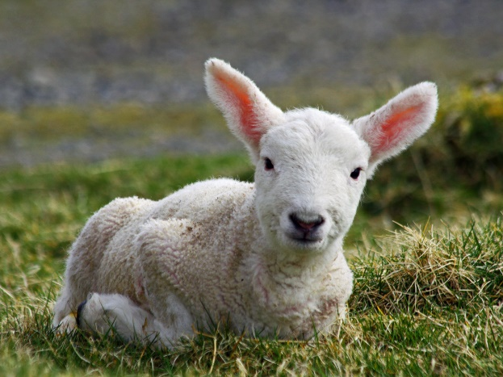 IMAGE A – 3 people
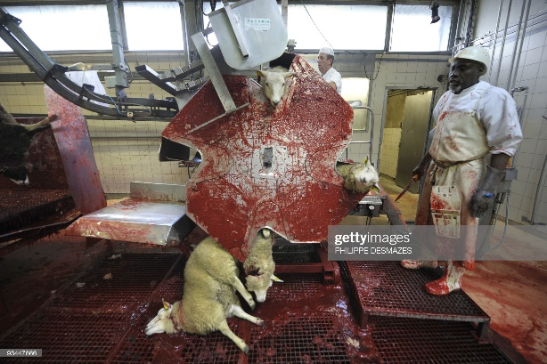 IMAGE B – 1-person

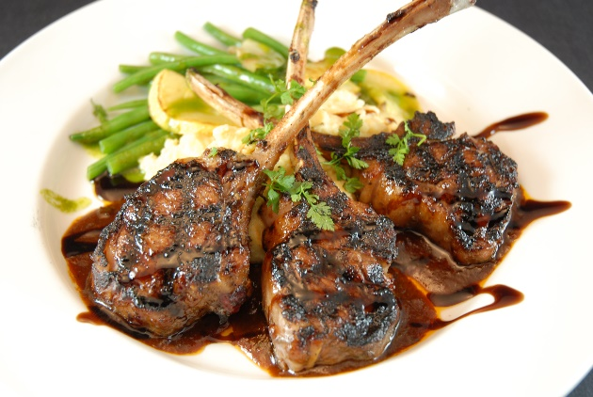 IMAGE C– 6 people.
Results:
The people that saw meat as an ‘essential’ part of their daily diet regarded IMAGE A as meat. They were all from the local farming community and revealed their chosen image as if revealing a guilty secret. They expressed a loyalty to local community and named family members that worked within the meat industry. As one participant explained, “it has always been a way of life round here and it always will be!” (farmer’s daughter, aged 63). The image of the lamb represented Welsh pride, family income and local culture. The defensive and almost apologetic response came after viewing IMAGE B. They did not want to acknowledge this part of the process and continued to point at the image of the living lamb when they referred to the meat industry. Choosing IMAGE A as a food source reflected not only cultural identity but social status. Choosing to eat a meat free diet would be a betrayal of the farming community they felt they belonged to. What I found interesting was their reluctance to share their identities. The biggest advocates of the mass-production of meat did not want to give their names just their ages and connection to the local area, e.g. ‘farmers daughter, age 63’ or ‘country lad, age 49.’ This would suggest an element of shame that refused to accept accountability. The remaining participants all gave their names willingly and were open to discussing the devastating effects eating meat has on the animals, the human body and the environment. In conclusion this short study reveals a shift in accountability. Whilst pride of local tradition is still in place it does not appear to be the case for the wider community. Perhaps the shift in media focus and growing number of environmental pressure groups has been a catalyst for this anonymity amongst meat producers. The Llanybidder meat processing plant (Dunbia) was incredibly guarded and refused to answer even the simple question, “when was the industrial plant built?” I received an email from Dunbia stating nothing more than, “we are leading experts in our field.”
The table below shows two newspaper reports about climate change published over a decade apart. These five quotes from each article reflects the shift in human accountability;

The Independent Geoffrey Lean 2006 | The Guardian Damian Carrington 2018
‘The worlds top destroyer of the environment is the cow.’ | ‘Food production causes great damage to the environment.’
‘Cows soak up vast amounts of water; 990litres of water = 1 litre of milk’ | ‘Deforestation and water shortages from farming.’
‘Livestock are responsible for 18% of greenhouse gasses that cause global warming’ | ‘Vast ocean dead zones from agricultural pollution.’
‘Antibiotics used to treat them get into drinking water and endanger human health’ | ‘UK & US citizens need to cut eating beef by 90%’
‘The massive damage done by livestock will more than double by 2050’ | ‘Profound changes in farming practices are needed’

Local and nonlocal impact.
The fastest growing community in the local area is the migrant workforce, most of whom work in the Meat processing Industry. Employment in these sectors has become less attractive to the UK work force, leading to labour shortages, (Geddes and Scott, 2010).
There has also been a rise in the incidence of low paid, irregular and non-unionised work in the meat processing sectors (Rogaly, 2008). The mass-production of this material is now creating cultural diversity within the local community. The relationship people have with this food source is also forcing dramatic changes in the climate which are now presenting horrifying consequences. In the hunter gatherer era meat was an essential part of daily life but this is no longer the case in the USA or China, so why are these countries producing more meat than anyone else?
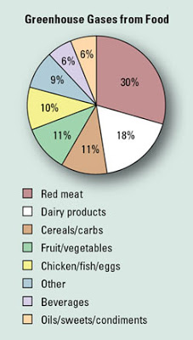
The chart on the left shows; meat and dairy consumption contribute to over half of the greenhouse gasses emitted. Wealth is now taking priority over health.
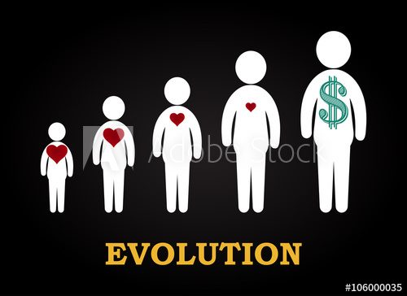
The media can no longer manipulate the public into believing they must eat meat to stay ‘big and strong.’ Meat is regarded more as a health hazard in contemporary society due to strong links with heart disease and cancer. 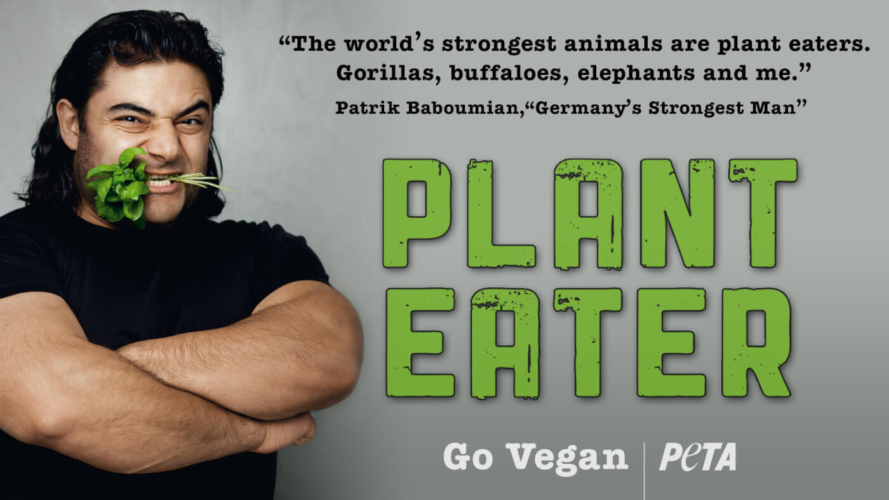 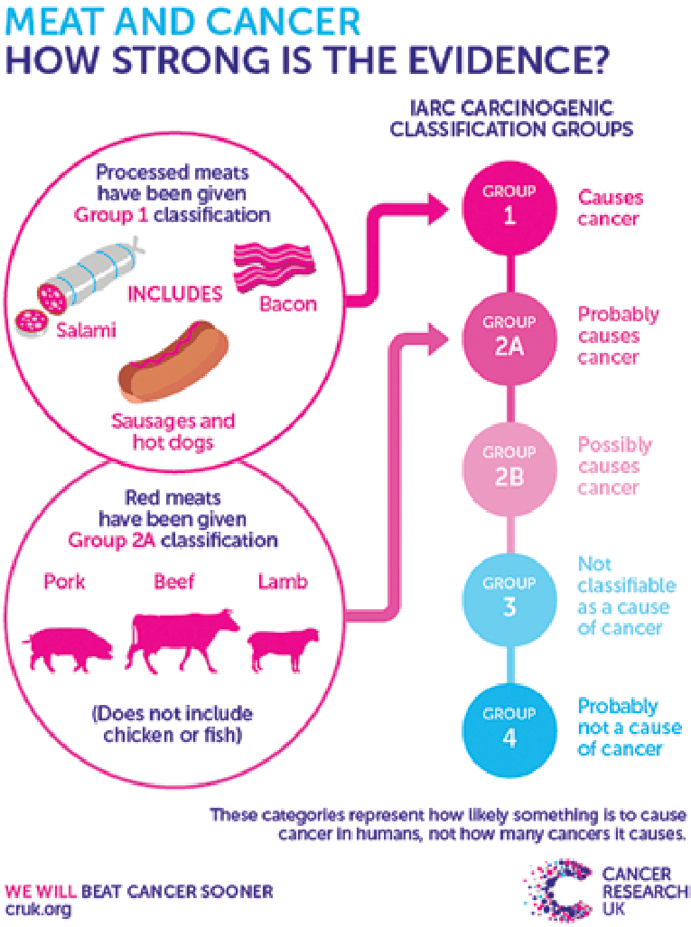
Viable solutions are offered by Paul Horne in his article for non-partisan, Pulitzer prize winning ‘Inside climate news.’ He offers hope for salvaging the self-destructive relationship humans have with meat by focusing on the part farmers can play in creating climate solutions. 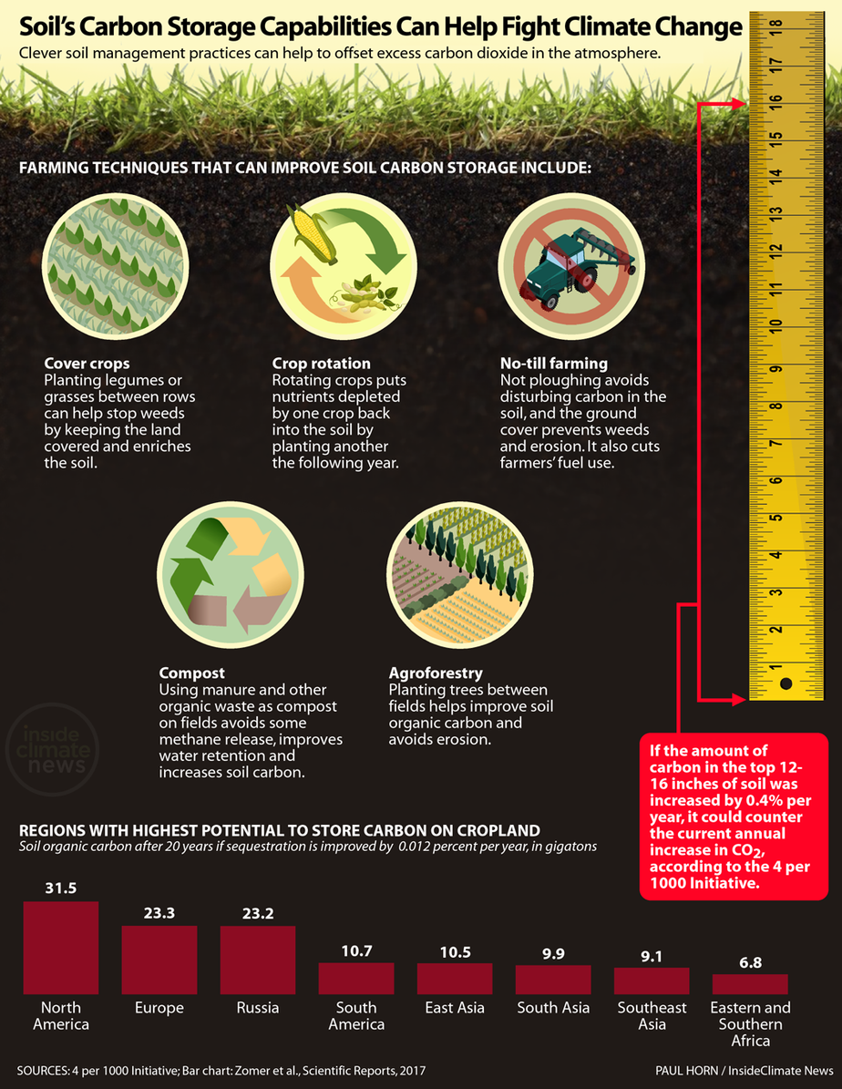

Conclusion
As with any relationship in the material world the person involved must constantly assess that relationship to monitor how it needs to grow or adapt in order to survive, e.g. a newly diagnosed diabetic must re-evaluate their relationship with sugar as a food source or a women in love must reassess her marriage if domestic violence enters the relationship. Luci Attala redefines eating as a mutually influential co-productive relationship. The new materialist framework argues that the material process of eating cannot successfully remain exclusively interested in the human consequences (Attala 2019). Human relationships with meat as a food source must change because in this age of Anthropocene the consequences are detrimental not only to the humans ingesting meat but to the entire living world. The current forest fires of Brazil are an example of the consequential effect the mass-production of meat is having on the environment. Examining the abusive symbiotic relationship humans have with meat raises the question, ‘why is this material still an object of choice within contemporary society?’
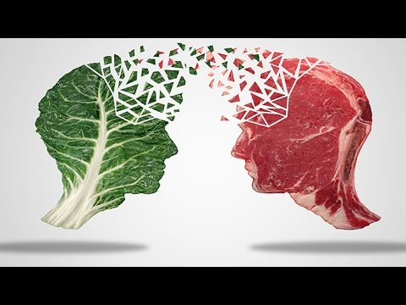
In conclusion the relationship humans have with meat as a food source is an example of how human relationships with material objects can shape the world and how material objects can shape peoples relationship with the world. The continuation of this self-destructive relationship with the objects we create in the material world will undoubtedly see the end of humanity, “we’re all doomed!” (Whisky Galore 1949).

