University of Wales Trinity Saint David



Student Name: Rumen Pavlov

Student Number:1902012

Module: Digital Marketing

Module Code: LCMB7010

Programme: MBA Marketing

Assignment: 1

Lecture: Amitave Banik

Table of contents:

Part 1
Introduction
Retail businesses sell items or services to customers for their consumption, use, or pleasure. They typically sell items and services in-store as well as online.
With a clear analysis of the global market, focus your research on one particular company and critically appraise and analyse how a retail business organisation is represented digitally and makes use of digital marketing within the media and wider social sphere.
Exhibit thorough analysis on digital assets the organisation owns, focusing on its website and provide an indication of the balance between internal and external communication structural flows; information architecture and effective strategies, including promotions for the product and services
Part 2
Introduction
Machine Learning (ML) is an essential component of Artificial Intelligence (AI) to know your customer.
Artificial Intelligence (AI) to know your customer.
From marketing intelligence and customer segmentation to forecasting decisions.
Details the applications of Machine Learning in digital marketing to Maximize ROI

Part 1
NYS Collection was established in America in 1996 by Marc Behar and Sal Babino. The company specialises in selling eyewear and sunglasses which offer different designs without the hefty price tag which are usually associated by customers with sunglasses from other high-end stores. Marc Behar and Sal Babino began this journey as a start-up business with only one retail outlet which was located within the World Trade Centre in New York. Over time, the company saw substantial growth and with that growth came more opportunities. The company now has over 10,000 locations all over the world.
Over the years that the company has been in this industry, they have earned a reputation which describes them as a prominent eyewear supplier. Their consistent annual sales growth which range between 50% and 30%, put them at the top as an industry leader. They expansion had a big part to play in regards to this title too. This success can be seen from the ongoing market leadership, strong track record and sales figures.
The quality of the items is maintained through high standards and every product comes with its own lifetime guarantee. NYS Collection implements a distribution model which includes retail outlets and franchises in order to sell its products. Overall the company has established itself as a leader within the market in the eyewear industry. They offer contemporary and stylish sunglasses at very reasonable prices while keeping up with the high quality standards.
Some of the key benefits of the retail industry are the variety of retail formats which can be seen as supermarkets, physical stores, online stores and shops. Another is the final consumer. Once the product has reached the consumer it means it has reached the end of its journey and it can be seen as a successful sale. Global reach is another benefit of retail. When establishing a business, especially in recent times, it always a good idea to be able to allow access to your products via an online website or to advertise your products via different social media platforms. This will ensure that your products will be reached by most people and customers wouldn’t need to wait for a physical store to open in order to visit. This also relates to convenience for customers and market expansion which another key benefit. Online stores allow sellers to expand their business beyond their local region. Consumers can be targeted in different cities and countries without the need for a physical store.
Having physical stores is also beneficial for those customers which prefer to try on items and physically inspect the goods they are about to purchase in order to avoid any disappointment and dissatisfaction. Another benefit is that there is not delivery charge or waiting time. They can have their item right with them as soon as they’ve purchased. It also has a much simpler returns procedure. With returning an online purchase, usually a label has to be printed, then taken to a local post office, whereas when returning something to a physical shop, it is all done there and then without any extra hassle.
The benefits of online sells
As of 2023, online sales are seen to grow continuously and are becoming a more and more powerful avenue for businesses in terms of their growth and success within the modern marketplace. The benefits mentioned above describe the potential companies have in order to leverage data, optimize marketing strategies and reach a more global audience to get better outcomes.

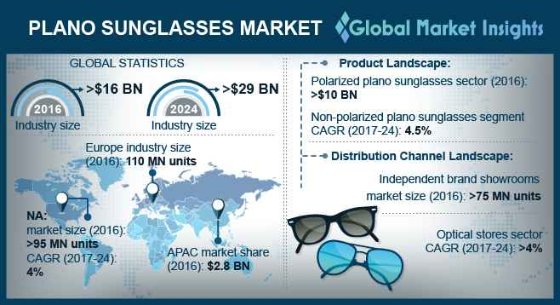
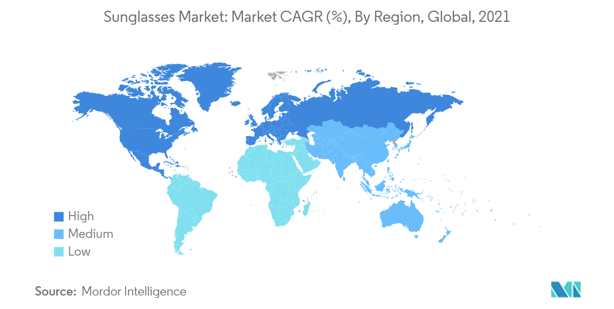
The global market is a system which enables trade which is known to be unrestricted. It also allows labour mobility and financial interactions across many different nations. This means that economic events within the country can have a ripple effect on others. This is seen as interdependence and it prevents economic isolation which in return encourages cooperation between political and commercial agreements. International labour standards also play their part in fostering said cooperation because they also promote the exchange of human capital between different companies. This cooperation contributes to the development for the business economically.
When looking at NYS Collection and their Market Segmentation, they product type consists of polarized and non-polarized sunglasses. This is the distinctions which are based on the different type of lens used within the sunglasses. End user is another part of the segmentation which means that the sunglasses are made for different target and age groups including women, men and other unisex wearers. This means that the company is able to cater to all needs and requirements of their customers. The sunglasses market also thinks about the different areas and regions which will be beneficial for the company. The market analysis report (2023) gives insights into the global sunglasses market. The analysis shows calculations of the market size and also predictions for each factor based on their values.
The international sunglasses market is very competitive as it features both international and domestic competitors. Some of the main names within this market are known brands such as Safilo Group SpA, LVMH and Essilor Luxottica. They have a very strong and stable market presence and are known for their wide-ranging product lines. Leading companies within this industry are focusing on the opportunities by the emerging markets in order to diversify their product offers and also to cater to the continuously changing demands of their customers. For example the athleisure trend which is mostly popular in China, Brazil, South Africa and India. These countries are investing into these markets in order to increase their revenue streams.
Companies such as Ray-Ban and Oakley are developing their online platforms in regards to branding and marketing purposes. Their platforms allow for a direct way to connect with the customers and show their products. The brands are seen to adapt to the shift in customer behaviour as more and more customers are noticed to take to the online platform to make their purchases.
NYS Collection has a deep focus on the sales strategy. In the United Kingdom, the brand is focusing on the kiosk sales, while in the United States it is following both kiosk sales and physical store presence. By implementing this strategy, the company is able to tailor their approach to the specific preferences and customer behaviour within the different markets.
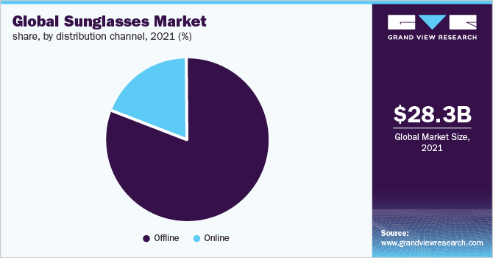

Insights Into Distribution Channels
In 2021, the sector dominated the market and was able to account for more than 80% of the overall sales. The strong tendency of the customers to try the items out before purchasing played a big role in the segment’s rise. In order to reach as many customers as possible, major competitors has to increase their offline distribution networks. Furthermore, the segment is also being driven by the wide range of sunglasses that already available to be tested onsight. In addition to this, having trained sales employees with experience increases sales.
From 2022 to 2030, the online market is said to grow at the fastest speed of CAGR 7.5%. expanding the market is also connected to the manufacturers’s heightened attention in regards to selling their products online. The internet mostly includes e-commerce websites, social media profiles and pages and brand websites. These online outlets are affordable and some are even free of charge. They also assist these companies in reaching a much larger base of customers. Emerging technologies have also been implemented such as the 3D feature where customers who are looking for sunglasses online are able to use this new feature in order to get a visual representation on how the glasses would look on them.
Customer Relationship Management is also known as CRM. It relates to the use of technology in order to look over and manage communications and interactions with existing and potential clients. There are many benefits of using CRM. Some of them are the enhanced profitability. It can result into better customer insights which in result of this will be able to provide more effective sales and implement better marketing strategies. It also improves customer service as it shows if a department of the store is lacking attention or there needs to me more communication within the business in general. It also builds stronger client connections as it builds that relationship between the customers and the brand which could then result in loyalty to the company.
Using CRM, it strengthens the company connections with its clients, service users, employees, partners, and suppliers. Building trusting connections and keeping track of prospects and customers are crucial for customer acquisition and retention, which is at the core of a CRM's function. You can view everything in one place with the help of a simple, configurable dashboard. It can provide information on your encounters with a client in the past, the progress of their orders, any open customer service tickets, and more.
As per Gartner, investing in CRM technology can be seen as a leading revenue sector. This indicates that the critical role that this plays in regards to business growth. This is crucial for business which are searching to have a strategy which is future orientated and to remain on the market.
CRM also its own benefits for the sales teams too. It enhances the pipeline understanding. This means that sales employees can have a much more clearer understanding of their sales pipeline and they can track their opportunities and leads more effectively. It also analyses their performance. Sales managers can have a representation of the performance of their sales teams and the different company campaigns. Integration of social media data can also be another benefit. CRM systems can analyse data from different social media platforms and see the interactions that have been had on there. CRM is a pivotal investment for companies which are striving to achieve revenue growth and also strategic sustainability. Some communications can be overlooked or lost within the str2eam if there isn’t a main platform put in place in order to be used for consumer interactions. It also allows companies and businesses to keep track of their meetings with business partners and vendors and document their requests and plan different follow ups.
NYS and ROI
The term "return on investment" (ROI) refers to the idea that each corporate expense should be used as efficiently as possible. ROI is crucial in marketing since one of the main objectives is to spend money in order to create money by acquiring paying consumers through convincing advertising strategies.
Marketing ROI, sometimes referred to as MROI and return on marketing investment (ROMI), is the particular return on investment a business experiences from the money it invests in corporate marketing. MROI analyses a marketing campaign's revenue gains to its total cost in an effort to determine the most economical strategies to boost profits. To document and evaluate the efficacy of a company's marketing techniques in relation to its cost, you may utilise the return on investment of a particular project or the total returns of all marketing activities.
To indicate the growth or loss that a marketing campaign causes within a firm, marketers use a percentage to calculate ROI. Each dollar invested on marketing results in increased income, according to a better ROI. A poor score, however a low revenue quantity relative to the expense of the marketing campaign is indicated by the ROI %.
Internal marketing strengthens the tie between your brand and your workforce while external marketing concentrates on forging connections with your customers. Internal marketing is equally crucial since it strengthens the bond between your brand and the people who work for you.

Internal communication occurs when individuals within a company send and receive information from one another. Only co-workers, associates, or other personnel employed by the firm have access to it. Public disclosure is not made of anything. There are a number of situations where internal communication is required. Information exchanges should never be taken for granted, even though some are more crucial than others. Effective communication may substantially change the result in any circumstance.

External communication is the exchange of information between a firm and a party outside the organisation. Despite being directed at a different audience, the message might still be understood by those who work for the organisation. The function of external communication in a marketing plan. The distribution of messaging is targeted at a certain audience in an effort to attract new customers and increase sales. You can employ marketing service providers to generate materials specifically for you or build the appropriate message in-house. By Mary Novak (2019)

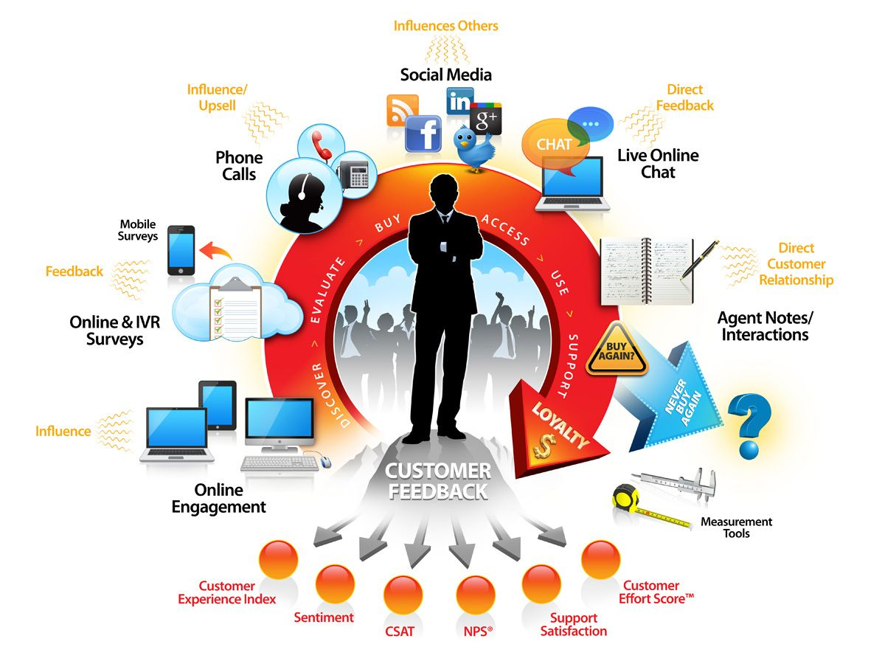



Promotion includes the utilization of the different marketing strategies in order to target specific markets and increase the company sales. The covers the launching of new products and implementing promotional activities with regards to enhancing sales and figures. Effective promotion also includes the understanding on how to leverage a number of different marketing tactics but to not only establish stronger company presence but to increase sales too. Product marketing is when the strategies and the techniques used to effectively promote goods. It is all about creating a narrative which is compelling to the customers.
When setting a price for an item there are a few factors which need to be considered. In first place, the business needs to know how much manufacturing costs will be for the product. They also need to keep up with the market value as if they price the item too high, customers will not buy it as they can get it cheaper elsewhere. However, if they price the item too low, customers still will not purchase it as it loses the trust value in the product. Customers are more likely to think that an item is of lesser quality if it is much cheaper than other competitors. This is why proper pricing is crucial to every business.

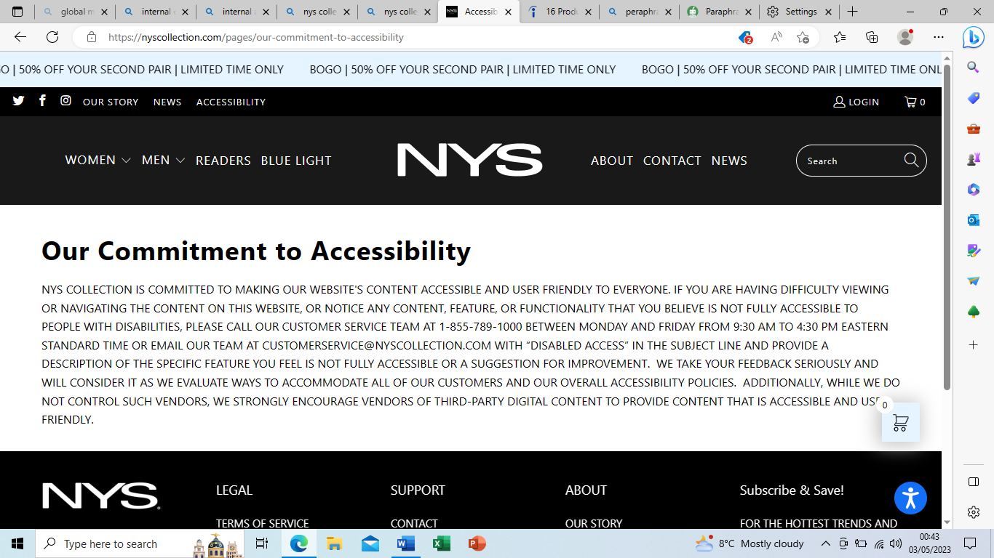
When it comes to social media platforms, NYS Collection use Twitter, Facebook and Instagram. There are many advantages and disadvantages when it comes to the use of social media in regards to companies and businesses. Social media allows for the engaging with the customers within the comfort of their own home. The company will have the ability to respond rapidly in regards to new market developments which can have an impact on how customers view the company all together. It is also significantly less expensive rather than traditional marketing and advertising on billboards, newspapers and radio stations. The cost of maintaining a social media presence is minimal. Your budget will determine how much or how little you may spend on sponsored advertising. (World Economic Forum. (2018).

Some of the disadvantages when using social media are the resources. The company would need to set aside money to keep up the internet presence, respond to comments, and produce new content. This could entail shelling out cash for paid advertising as well as the costs associated with creating video or photographic content. Evaluation could also be another disadvantage. Although it is easy to calculate the return on investment from social media advertising in terms of online sales, there are certain advantages that are less tangible. It could be hard to measure and put a monetary value on the brand visibility and reputation that social media may provide. Determining the impact of social media on in-store sales is difficult. Unfortunately some companies may be using social media to boost sales while avoiding communication with clients

Part 2
In recent times the majority of businesses are seen to be using the technology in order to improve their businesses and simplify their job. NYS Collection also use it to improve their company and their structure. In the second part of this report, the technological side of the business will be discussed and also how companies can implement it within their operations. It will also focus on marketing intelligence and also customer segmentation into forecasting decisions.

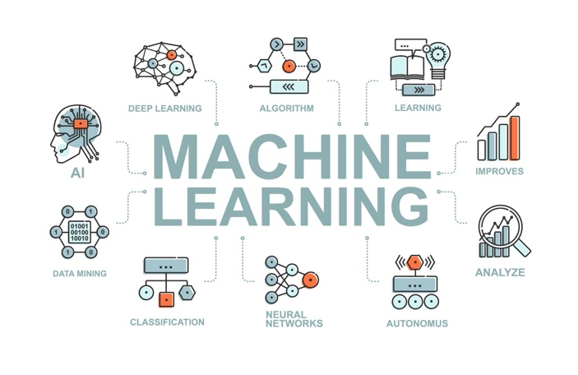

Machine learning is a subdivision of AI (Artificial Intelligence) which involves making different algorithms and models which let computers to predict without actually being programmed. The goal of machine learning is to allow computers to learn from data and also to be able to improve their performance over a certain amount of time. The first step is the data collection where relevant data is gathered. The data serves as the base for training the machine learning model. Raw data usually needs to be cleaned and then processed which is the next step of machine learning. This involves normalising data, handling missing values and changing categorical variables into numerical representations. The next step is the feature extraction where the most relevant features are selected in order to build a model. There are different types of models when it comes to machine learning. Some of them are clustering, classification and regression. Depending on the type of data and the nature of the problem, that is how the data is selected. (Mathur, G. (2023)
Machine learning is crucial as it allows for the making of new products and also gives organisations an understanding of the different customer behaviour trends and some of their operative patterns. Machine learning is crucial for companies such as Google, Uber, Facebook etc. In recent times, statistics show that machine learning has also become a very important point of competitive different for many different businesses.
There are three main types of machine learning. The first one is supervising learning where the model is trained on specific labelled data. The input data is paired with the corresponding factor or in other words the output values. This is done so that it can continue to make accurate predictions on brand new data. The second type is the unsupervised learning. This is when the model is trained on unlabelled data and there is no output values or target. The aim is for the model to find out patterns and relationships with the data. Finally, the third type of machine learning is the reinforcement learning. This is where a model which is in training is put through a trial and error type programme. The model then learn to perform actions in order to maximise the reward signal. This type of learning is used when an agent needs to make a specific set of decisions. (Artificial Intelligence)

The advantages of machine learning are the automation and the efficiency that it provides. It reduces human error and it allows for more repetitive tasks to be processed. It also allows for personalised recommendations and experiences for clients. Another advantage is that it is able to handle complex data such as texts, audio and images which means that it is able to carry out a more comprehensive analysis.
Other advantages of machine learning is the continuous on going learning. Some of the machine learning techniques such as the reinforcement learning allows the systems to learn from their experiences and interactions with the environment. Machine learning can also model non-linear relationships in terms of data. This makes them suitable for a great range of applications. It is very well proven that machine learning can also handle vast amounts of data and also process large datasets.
Some of the disadvantages are the overfitting. This means that models can become too familiar to the training data which in result can have poor performance on unseen data. Lack of domain knowledge is also another disadvantage as it doesn’t consider specific context and knowledge. It also has some ethical concerns such as invading of privacy and surveillance.
Other disadvantages include the lack of contextual understanding. This means that the machine learning models sometimes are not able to understand the context and often make decisions only based on the patterns they have gathered from the data collected. Just because machine learning has been implemented into a company, that does not mean that there wont be any human intervention needed. Human involvement will still be needed in order to validate, fine-tune and to correct the outputs.
Some big companies such as Microsoft, Google, Amazon etc. compete for customers by promoting platform services which mostly include data preparation, model building, training, data preparation and application deployment. More universal applications are what ongoing deep learning and AI research aims to produce.
Today's AI models require extensive training to produce an algorithm that is highly optimized to complete a single task. Some scientists, however, are investigating how to make models more flexible and are looking to discover techniques that will allow a machine to apply context learned from one task to subsequent, various tasks.

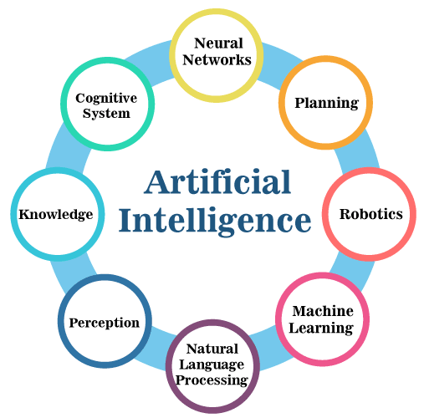
Companies are using artificial intelligence in order to increase the lead volume and to significantly enhance the overall sales performance of the company. This is done so that a big portion of the sales process can be enhanced by the artificial technology. It also allows sales employees to simply focus on what is important and what their tasks are which is simply to make sales. More and more innovative businesses are implementing this technologies into their day to day operations. Salesforce State of Sales research shows that sales leaders predict that artificial intelligence will be able to increase quicker than any other technology out there. (Machine Learning, statistics, and Data Analytics’ 2021)
Artificial intelligence also has a great impact on sales and their processes and strategies across many different industries. It can process high amounts of data quickly and more accurately. In result of this, it allows for the sales employees to gain a better insight into customer’s preferences, trends and their behaviours. It also allows for personalised communication between staff and customers. Chatbots can engage with clients in real time and they are able to answer any questions that the client may have. AI is also able to forecast sales. It uses historical data and also current trends in order to predict sales performance. Because of this, companies are able to allocate their resources into the right departments and also to plan their inventory more effectively.

Conclusion
Supervised learning is more suitable for when there is a smaller dataset with labelled data. The model then learns how forecast based on the given labels. Unsupervised learning is preferred for bigger datasets where the model sees structures or patterns without identifying labels beforehand. Deep learning techniques are considered when there is a high amount of available data. It includes neural networks and many layers which can learn hierarchical features on their own. Another factor which was mentioned in this report is reinforcement learning and deep reinforcement learning. It is where there the training agents make decisions in a certain environment in order to maximize rewards. Overall, there are challenges and barriers. The lack of high quality framework for machine learning is seen as a great obstacle. As the pilot studies progressed further, many more challenges connected to operationalization were discovered.
Finally, you considered the options for different programming languages, IDEs, and platforms when it comes to creating your own machine learning models. The following step is for you to begin studying and applying each machine learning approach. Although the subject is broad, which indicates that there is width, each topic can be learned in a short period of time due to its depth. Each subject stands alone from the others. You must think about one issue at a time, study it, put it into practice, and use your chosen language and algorithm(s) to build it. Platform for AI optimization to automate the whole development and deployment process for AI solutions. Our evolutionary methodology helps companies to create energy-efficient machine learning systems and make judgments that are optimized in complicated contexts. Although it is very convenient, online shopping also encourages careless consumption habits by encouraging customers to take advantage of free returns and expedited shipping. These further the list of environmental problems we already face, including global warming, waste generation, and pollution. (LeCun, Y., Bengio, Y., & Hinton, G. (2015).)
Different programming languages should be considered. Platforms for the machine learning models and Integrated Development Environments. Whatever the choice may be, it will still have an impact on the deployment and development of the machine learning training and solutions. The preferred approach to learning machine learning includes learning about each and every topic. Even though the topic may be broad, separate topics can be learnt quickly and in short periods as their depth is a lot lower. Learning has to involve practical application, implementation using the selected algorithms and languages and also a great understanding. Artificial Intelligence is analysed within this report which also describes the deployment and development of the Artificial Intelligence solutions.
NYS Collection should take into consideration opening their own retail store rather than being only available via the online website and the outlets. This will benefit the company as it will establish their position within this market industry even further. It will also develop their popularisation even further as an actual brand. Another reason as to why opening a retail store would be better is that they would be able to carry more goods. At current times, they are only able to order a few items at one time as their space is very limited and they must be very careful when analysing the monthly sales and inventory. The company should look into developing their website further as it could allow for more alternative options for its customers and could be made to be more appealing.
It is very crucial and essential for NYS Collection and also other companies to investigate opportunities provided by machine learning. Machine learning techniques are also very important for primary data is it shown in the machine learning position paper. Even though machine learning seems promising at first hand, statistics show that the quality and the transparency of results still needs to be resolved.

References:

Artificial Intelligence (2023) Encyclopædia Britannica. Available at: https://www.britannica.com/technology/artificial-intelligence (Accessed: 19 August 2023).
Artificial Intelligence (2023) NIST. Available at: https://www.nist.gov/artificial-intelligence (Accessed: 19 August 2023).
Abadi, M., Barham, P., Chen, J., Chen, Z., Davis, A., Dean, J., ... & Monga, R. (2016). TensorFlow: Large-scale machine learning on heterogeneous systems. GitHub. https://github.com/tensorflow/tensorflow
Deloitte Insights. (2018). How artificial intelligence could transform government. [online] Available at: https://www2.deloitte.com/insights/us/en/focus/cognitive-technologies/artificial-intelligence-government-summary.html
Etzioni, A. & Etzioni, O. (2017). Should artificial intelligence be regulated? Issues in Science & Technology, 33(4), 32-26. Retrieved from http://www.issues.org
Forbes.com. (2018). Five Ways AI Can Help Small Businesses. [online] Available at: https://www.forbes.com/sites/forbeschicagocouncil/2018/06/15/five-ways-ai-can-help-small-businesses/#75afa5e110d7
Gartner.com. (2018). Gartner Forecasts Worldwide Public Cloud Revenue to Grow 21.4 Percent in 2018. [online] Available at: https://www.gartner.com/newsroom/id/3871416
Goodfellow, I., Pouget-Abadie, J., Mirza, M., Xu, B., Warde-Farley, D., Ozair, S., ... & Bengio, Y. (2014). Generative adversarial nets. In Advances in Neural Information Processing Systems (pp. 2672-2680).
Olah, C., & Carter, S. (2016). Attention and Augmented Recurrent Neural Networks. Distill. https://distill.pub/2016/augmented-rnns/
Kak, S. (2018, February 7). Will robots take your job? Humans ignore the coming AI revolution at their peril. NBC News. Retrieved from https://www.nbcnews.com/think/opinion/will-robots-take-your-job-humans-ignore-coming-ai-revolution-ncna845366
LeCun, Y., Bengio, Y., & Hinton, G. (2015). Deep learning. Nature, 521(7553), 436-444.
Machine Learning, statistics, and Data Analytics’ 2021 Machine Learning [Preprint]. doi:10.7551/mitpress/13811.003.0005.
Mathur, G. (2023) Data Science vs. machine learning: What’s the difference?, IBM Blog. Available at: https://www.ibm.com/blog/data-science-vs-machine-learning-whats-the-difference/ (Accessed: 19 August 2023).
Mitchell, T. M. (1997). Machine Learning. McGraw-Hill.
Parnas, D.L. (2017). The real risks of artificial intelligence. Communications of the Association for Computing Machinery, 60(10), 27-31. doi:10.1145/3132724
Persons, T.M. (2018). Artificial intelligence: Emerging opportunities, challenges, and implications for policy and research (GAO Publication No. GAO-18-644T). Washington, DC: U.S. Government Accountability Office. Retrieved from https://www.gao.gov/products/GAO-18-644T
Petropoulos, G. (2018). The impact of artificial intelligence on employment. Retrieved from http://bruegel.org/2018/07/the-impact-of-artificial-intelligence-on-employment/
Silver, D. (2017). Mastering Chess and Shogi by Self-Play with a General Reinforcement Learning Algorithm. (published doctoral dissertation). University of Alberta.
Trappenberg, T.P. (2019) ‘Machine learning with sklearn’, Fundamentals of Machine Learning, pp. 38–65. doi:10.1093/oso/9780198828044.003.0003.
van Wynsberghe, A. (2021) ‘Sustainable AI: AI for Sustainability and the sustainability of ai’, AI and Ethics, 1(3), pp. 213–218. doi:10.1007/s43681-021-00043-6.
Uk.insight.com. (2018). 5 Ways Artificial Intelligence (AI) is Changing Our World | Insight UK. [online] Available at: https://www.uk.insight.com/en-gb/learn/articles/2017-06-14-5-ways-ai-is-changing-our-world
World Economic Forum. (2018). How the Internet of Things has evolved over the last 50 years. [online] Available at: https://www.weforum.org/agenda/2018/01/how-the-internet-of-things-has-evolved-over-the-last-50-years
Williams, A. and Williams, A. (2018). 5 Ways the Internet of Things Benefits Entrepreneurs. [online] TechCo. Available at: https://tech.co/internet-of-things-benefits-entrepreneurs-2016-05

