Cloud Administration /ACCA6025/
Valentin Latinov Miladinov /2024732/
Academic Report on Azure Portal

Contents
Introduction: 3
TCO Calculator: 3
Azure File Storage: 7
Azure SQL Databases: 13
Azure Site Recovery for GLI’s continuity: 17
Conclusion: 18
References: 19

Introduction:
The digital age consists of dynamic, revolutionary times. Tech changes faster than the light reflections from a disco ball; it changes so fast newer generations would barely have any time to feel any nostalgia towards their olden tech days, because what they have now they would probably just have it bettered in the future, but in contrast with previous generations that had to replace the typewriters with back then completely new machinery, further generations have a good technological base, when it comes both to knowledge and use; furthermore, they’d have already honed intuition on this matter. That said, nowadays, being even a day behind might prove to be more detrimental that one would ask for. This is exactly the case with GLI: as an educational institution they are amidst of financial technological chaos – what on-premises servers offer them is too expensive to be taken care of, on-premise servers are more prone to events that endanger their content, they have virtual limitations consisting of storage, processing capacity, scalability. However, GLI is open to the new ways of the new times, and this is what pushes the idea of this report – to showcase how one middle-sized educational business can transfer their on-premises servers to the cloud services Azure offers in attempt to lower their IT negatives and increase their IT positives.

TCO Calculator:
First and foremost, this task consists of two needs – IT and budget relief on a decent price. And a visual representation of the transition, with price information, is possible. Ideally, concrete information regarding GLI’s on-premises servers would be presented for this task to be executed in a more refined manner. As of now, for the completion of this project, making assumptions is necessary. What needs noting is that all assumptions here are made based on general industry knowledge mainly known in similar organizations. Even then, the accuracy might not be absolute, but it would give a clear picture of the whole idea behind the benefits of moving to cloud, finance-wise. Presented are few possible scenarios of GLI’s on-premises IT infrastructure:
- Bare minimum:
  - Servers:
    - A single server or a small number of servers would suffice as GLI’s starting point.
    - Modest specification of the servers (single quad-core CPU, 16GB of RAM, 500GB of storage capacity) are acceptable.
  - Storage:
    - Local storage or network-attached storage (NAS) device.
    - Initially, few terabytes would suffice, but this really depends on the volume of data.
  - Network:
    - Router.
    - Switch.
    - Firewall.
    - This would connect devices and it would give them internet access.
    - 50 Mbps would be good only for a small number of users.

  - Databases:
    - A single database server is enough to host GLI’s databases (user profiles and course materials).
    - Modest specifications, with few hundred gigabytes to a terabyte or two of storage capacity.
- Better specifications, which sound more reasonable for a growing medium-sized business, and which would be considered as GLI’s actual on-premises infrastructure:
  - Servers:
    - Approximately 10 physical servers.
    - Quad-core CPUs.
    - 64GB RAM.
    - 4TB storage capacity.
  - Storage:
    - Total storage capacity - 40TB.
    - Traditional hard disk drives (HDDs) spread across servers and network-attached storage (NAS) devices.
  - Network:
    - 100Mbps would be most common bandwidth usage.
    - 200Mbps at peak-time.
    - A probable forecast gives 1TB data transfer per month.
  - Databases:
    - Main database – 2TB storage capacity.
      - User profiles.
      - Course materials.
    - Supporting databases (distributed across other servers) – 1TB total storage capacity.
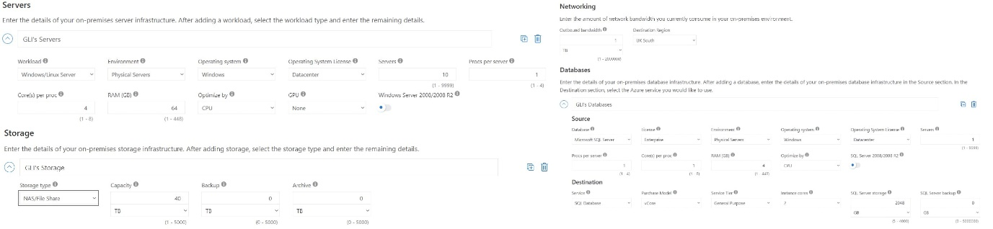
In order to evaluate the financial and operational benefit of moving to Cloud services, the help of a certain tool could be used. The tool in question is Total Cost of Ownership Calculator, or shortly – TCO Calculator. Once the workloads are defined (see figure 1.), the calculations may commence.
Figure 1
Pressing the blue “Next” button in TCO Calculator leads to assumptions adjustments. The only change to be considered there is the change of the currency to British pounds. Geo-redundant storage is optional, especially now, when the goal is to show the least costly possible service, but if one wants to bring more security, this option could be chosen, which would get all data replicated to a different far-away region just in case something goes wrong with the current one. At current times, this option won’t be used. Furthermore, in the same page, there are few assumptions, each with its numerical value – this is what Azure assumes as a possible cost in the given area. All the sections are up to the user to regulate to their judgment, although there are already values set by Azure beforehand.
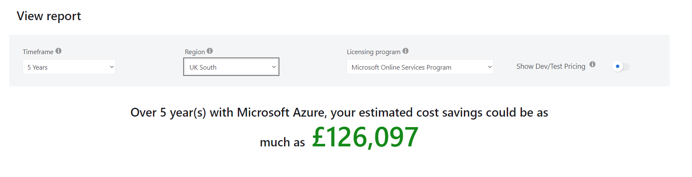
Once there is nothing else to configure, pressing the blue “Next” button would take the user to the final page, where the calculation is finally done. Another thing to configure is the region – in this task the demanded region would be UK South since it’s either the closest one or the second closest to the main building and potentially to GLI’s auditory, which means the connection is more stable and it is also faster (see Figure 3.). There will be other regions, where bigger financial savings are possible for the most of it, but it would be at the price of customer service, downtime, ease-of-access (see Figure 2.). Another thing that could be changed is the timeframe, but the bigger the timeframe, the more information is gathered. And if the timeframe is bigger, it has the information of smaller timeframes in itself (see Figure 4.).
Figure 2
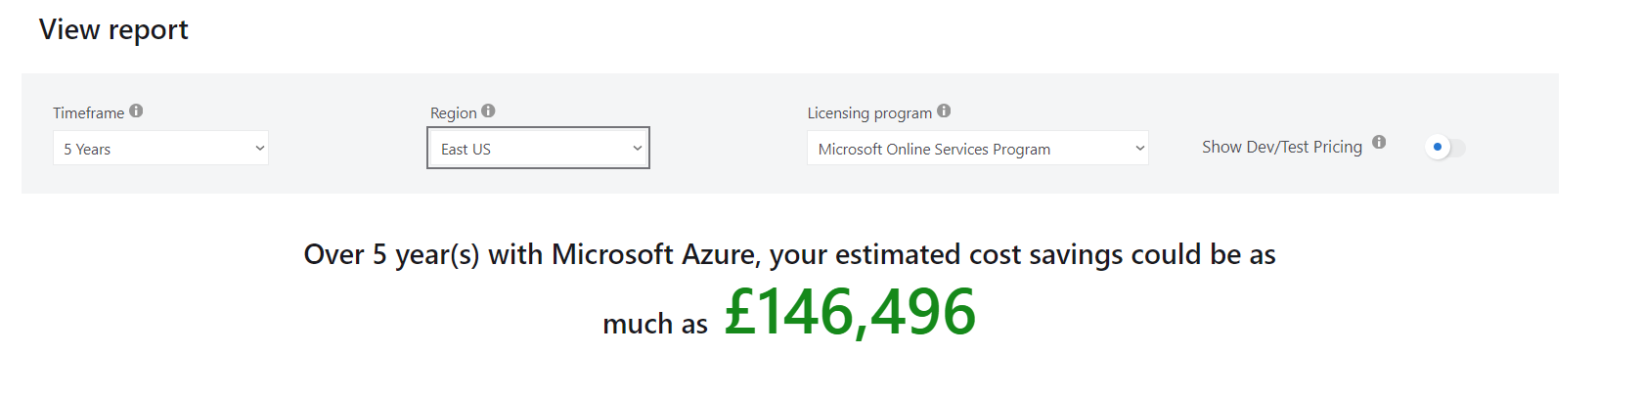
Figure 3
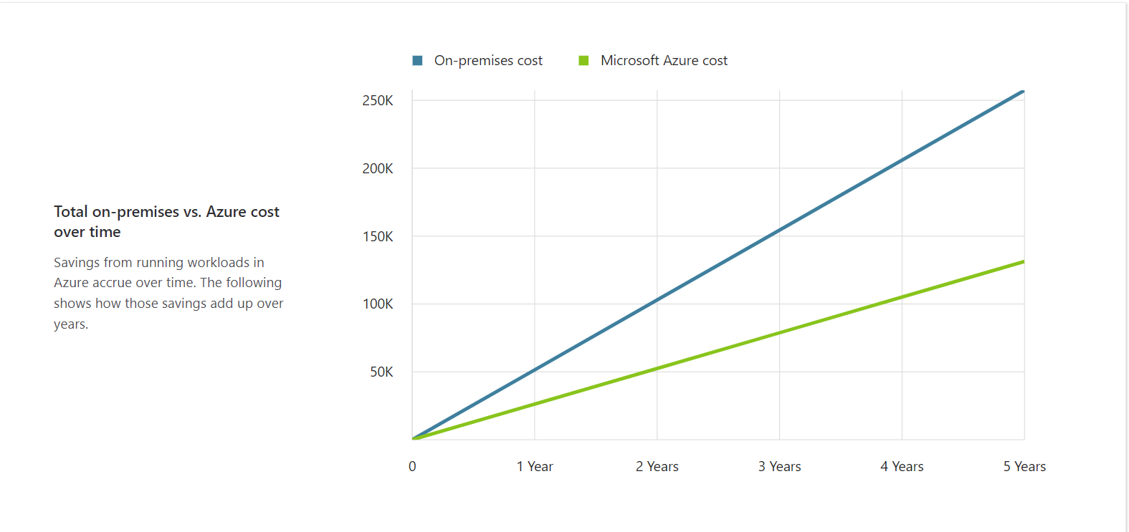
Figure 4
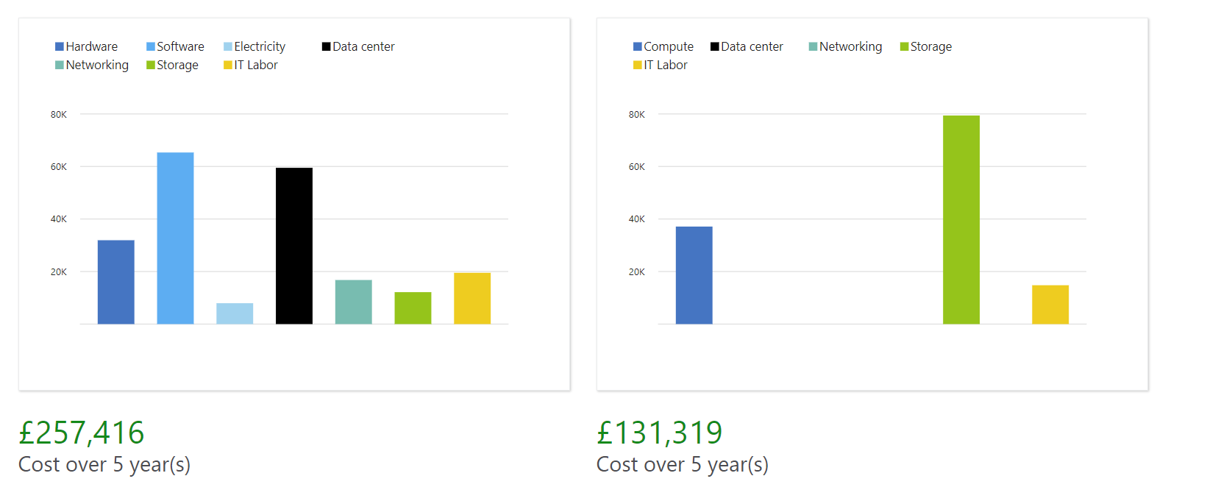
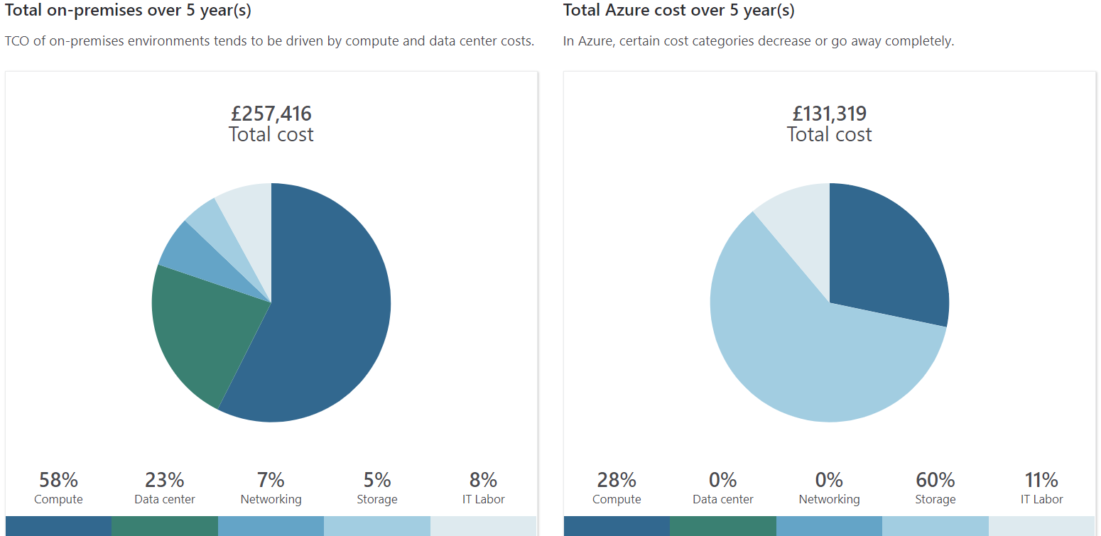
So, what happens if this keeps up for five years exactly? As shown in Figure 2. savings go up to £126 097. But how come? Why does it seem that effective? It literally cuts the costs almost by half, it sounds almost as a scam! While such statement could hold true in such cases, where such a massive chunk is bitten off the cost, the “secret” behind Azure’s actions is logical and in fact quite simple – changing the IT environment lowers the cost of a category or completely removes it (see Figure 5 and Figure 6). Basically, payment is made only for what’s used and that of course is where Azure’s strength is coming from.
Figure 6
Figure 5

Azure File Storage:
Another important point to view is how Azure File Storage and its associated features, security measures would be able to support GLI. Furthermore, a brief demonstration of the implementation of Azure Storage account for GLI will be presented with the contribution of appropriate screenshots.
Very evidently from the first point this report made, it is safe to conclude what challenges there are for GLI to overcome:
- Scalability is a slippery slope in on-premises environments, due to all the components that are required for it to exist in the first place, both physical-wise and technical-wise; this could prove to be of unnecessary cost both financial-wise and attention-wise in own infrastructure, but not in Azure with its automatic scaling that would meet the needs of GLI with full readiness for sudden increases in demand, cutting off the need for manual intervention completely; this will stultify the concern of hitting storage limits;
- Cost-effectiveness is a product of Azure’s pay-as-you-go model, which allows one to pay for nothing more than what they use; the cost of maintaining and upgrading physical servers is no more GLI’s problem due to Azure selling only the storage it wants to buy.
- Reliability and Availability is introduced by georedundancy – an option that allows geographical redundant storage (GRS) which stores data to secondary region, which evades regional failures (optional).
- Security measures, formed by encryption and access control; data security against unauthorized access is stronger due to Azure’s encryption; Azure Active Directory (Azure AD) gives GLI fine-grained access, meaning only authorized personnel would access sensitive data.
Now that the challenges and their solutions were mentioned, the next step would naturally be to go in detail about the whole matter, because the excitement doesn’t majorly come from the magic trick, but how the magic trick was performed.
- Scalability:
  - Flexibility in Storage Capacity – GLI’s storage needs could be dynamic and so Azure File Storage is, meaning that in time of high registration or new course releases storage capacity is automatically expanded in parallel; when times aren’t as dynamic, GLI won’t pay for unused resources, as Azure scales down accordingly and this elasticity optimizes costs so well and ensures availability.
  - Ease of management – this drops the need for an IT team to continuously monitor and manually adjust storage capacity; as long as Azure has predefined rules and usage patterns, it handles this task, automatically; lessens the administrative burden, meaning more time and attention on more strategic tasks; management simplicity enhanced by Azure’s comprehensive dashboard and management tools and this is what provides real-time information about usage patterns, keeping GLI informed which allows them to be more strategic.

  - Scalability without downtime – it is as it sounds – scalability won’t cause any downtime, matter of fact, it doesn’t even impact the availability or the performance of the storage services; this means there would be less reasons for GLI not to have its services going and being a hindrance to its users; this feature is even more important during exam periods or registration windows, when it is most crucial for the services to be not interrupted.
  - Supporting high demand and growth – this concludes the scalability point by solidifying that Azure allows one to expand its offerings and gather more people onto its services as it takes care of scalability needs in a cost-effective pay-as-you-go model of payment manner.
- Cost-Effectiveness:
  - Financial flexibility (pay-as-you-go model and its advantages):
    - Direct control over storage cots (paying for what’s used);
    - Substantial upfront investments in hardware is no more;
    - Reduced risk of over-provisioning.
    - Reduced risk of under-utilisation of resources.
    - Adjustable real-time expenditure allows tighter budget; summer or winter breaks, when usage is lower, costs decrease; this is not typical for fixed-cost storage solutions.
  - Budget predictability and planning:
    - Transparent pricing – Azure shows pricing in detail, which majorly supports cost forecasting; basically, TCO could be used, and there is already a proof of this in the current report.
    - Cost management tools – GLI is able to monitor and analyse spendings in real-time; GLI will be alerted if there is an unexpected increase in usage, which allows them to avoid budget overruns and keeps financial discipline.
  - Scaling economy:
    - No maintenance or replacement costs (already mentioned in scalability point).
    - Economies of scale – even with a rising usage, larger data volumes frequently translate into lower per-gigabyte costs; furthermore, Azure is in a constant optimization with its infrastructure, which potentially reduces costs.
  - Cost reduction through automated features:
    - Automated data lifecycle management – data that is rarely needed can be automatically transferred to less expensive storage classes (e.g. cool or archive tiers), lowering the cost, keeping the data accessible.
    - De-duplication and compression – by reducing the amount of data stored, storage requirements and costs are reduced accordingly; this is done by Azure, so GLI has nothing to worry about;

- Reliability and availability:
  - High availability:
    - Built-in redundancy:
      - Locally redundant storage (LRS) – ensures data gets replicated three times in a single physical location in the given Azure data centre; it protects data from hardware failures; even if one of the copies is burnt, there are two other chances to get back to business.
      - Zone-redundant storage (ZRS) – replicates data across three Azure availability zones in the same region; even if a zone fails, GLI’s data would be accessible, both as of educational materials and administrative records,
      - Geo-redundant storage (GRS) – the zenith of Azure’s data protection – GRS replicates data to a secondary region, hundreds of miles away from the first location; this way, there is disaster recovery scenario prepared, keeping GLI’s data accessible even if an entire geographic region suffers hardware damages.
    - Availability SLAs:
      - There is a 99.9% availability guaranteed for LRS users.
      - There is a 99.99% availability guaranteed for ZRS and GRS users.
      - Both of these options are industrial leaders.
      - The service level agreements (SLAs) ensure GLI’s critical application and data availability whenever needed, supporting their operational requirements seamlessly;
  - Data durability:
    - Data integrity checks:
      - Azure casually performs integrity checks on stored data; this way, if there is any corrupt data, it’d be automatically repaired; for this to happen, data from redundant copies is required; this way there is data accuracy and reliability, which is crucial for educational institutions where data integrity has massive effects on academic records, course materials and so on.
    - Automated failover:
      - Should a failure occur, Azure File Storage could automatically failover to a secondary replica and GLI wouldn’t have to do anything about it; this reduces the downtime, and the educational services remain undisturbed;
  - Disaster recovery:
    - Geo-replication:
      - In case of a disaster such as hurricanes or earthquakes in a region, causing one region worth of hardware to malfunction, the same datafiles would be gathered from another location (as long as it didn’t go through similar things), where it was previously copied in.
    - Rapid recovery:
      - Rapid recovery capabilities.
      - Tools that allow point-in-time restores.
      - Organization’s operations could resume quickly after any disruption.
  - Strategic advantage:
    - Continuous access – as students and faculty depend on it, Azure’s high availability ensures continuous access to learning materials and systems.
    - Compliance requirements – adhering to data protection regulations is vital for educational institutions, which Azure provides without even breaking a sweat whatsoever.
- Security Measures:
  - Encryption:
    - Encryption at Rest:
      - Azure Storage Service Encryption (SSE): all data is encrypted at rest using 256-bit AES encryption (one of the mightiest ones available); the encryption happens transparently.
      - Customer-managed keys (CMK): if an organisation requires control over their encryption keys, Azure presents the option of using customer-managed keys; this way GLI would fully control over the encryption and decryption of their own files.
    - Encryption in transit:
      - HTTPS and SMB 3.0: any data transfer between Azure data centres and GLI’s systems in automatically encrypted.
  - Access Control:
    - Azure active directory (Azure AD) integration:
      - Role-based access control (RBAC):
        - Fine-grained access control using roles.
        - GLI assigns specific permissions to users and groups with their role in the organization.
        - This way only authorized personnel is allowed to sensitive data;
      - Conditional access:
        - Multi-factor authentication (MFA);
        - Access to Azure File Storage is secure and compliant with organizational policies and procedures.
    - Shared access signatures (SAS):
      - Time-bounded access:
        - SAS tokens provide access to resources.
        - GLI grants limited access to files for a specified time period.
        - Useful when sharing materials with external partners or temporary staff.

  - Network security:
    - Virtual networks and firewalls:
      - Azure virtual network: GLI is able to restrict access to their Azure File Storage to their Azure Virtual Network (VNet), isolating their data and services from public internet access, which would reduce the risk of external attacks.
      - Firewall rules: configuration of network rules is possible; therefore, specifying which IPs are allowed or denied is possible too;
  - Advanced threat protection:
    - Azure security centre:
      - Threat detection and alerts: capable in advanced threat detection, continuously monitors for any suspicious activity and potential threats; GLI could benefit from this automated security assessor with actionable security alerts.
      - Unified security management: centralized view of security state of all Azure services is presented; it could potentially give GLI bird’s view over their infrastructure.

Implementation visualized:
In order to create a storage account, one naturally logs into their account in https://portal.azure.com. Then goes in the searching tab and writes: “Storage accounts”. They click on that and then “Create”. The screenshot 1.1 presents the screen that appears, but with the necessary modification for resource groups, name, etc. Then, they press on Networking – however, when they are to change options in network, they’d soon realize it is impossible as of the given moment. That’s why they need to go and create a virtual network first by writing: “Virtual Networks” in the search tab and fill the missing spaces as shown in 1.2. Then, they go back and do 1.1. Once they can actually modify Networking, they will find themselves choosing to deny public internet access and rely on private networks. Which opens the tab presented in 1.3. Once they fill the gaps, they can review and create their first storage account as presented in 1.4.

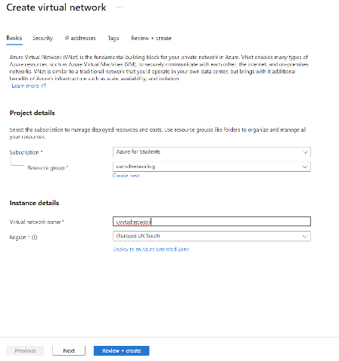
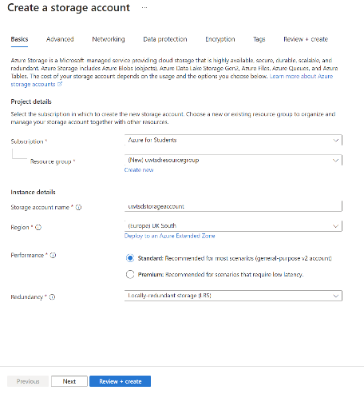
1.2. Create a Network
1.1. Create a storage account

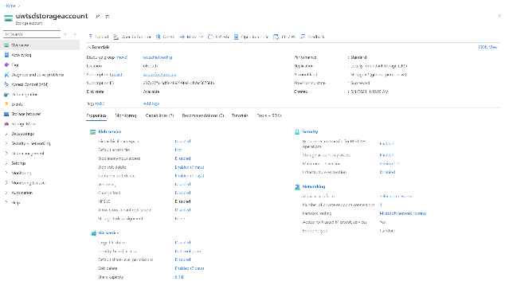
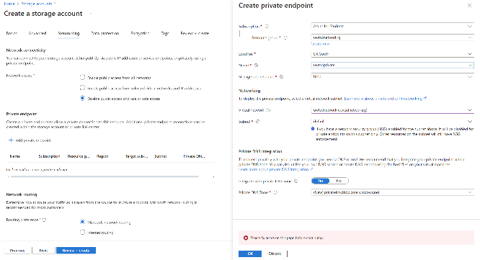
1.4. Finished storage account
1.3. Finalize creating storage account

Azure SQL Databases:
So much about Azure File Storage and its potential uses for GLI, next on the list is the evaluation of different Azure database options (Azure SQL Database, Azure Database for MySQL, Azure Database for PostgreSQL); then the most suitable one for storing using profiles will be suggested. This will be followed by showcasing the whole process of creating an Azure database using the Azure portal, supported by screenshots.
When deciding which Azure database option for storing user profiles would be benefit GLI the most, it is very important to first consider GLI’s needs, when it comes to user data. What guides this decision is a matter of scalability, security, cost and ease of management. This report will now proceed to explain the key features and advantages of the three Azure database services that were already proposed above.
An opener in this point will be Azure SQL Database with its features of fully managed SQL database engine that is based on the latest stable SQL server, integrated intelligence that grasps app patterns in order to optimize both performance and reliability, scalable with automated performance tuning and global scalability features. Its advantages are based on strong integration with other Microsoft services that GLI could potentially already be using; security that offers advanced data security features (e.g. Transparent Data Encryption and Azure Directory authentication); incredible performance when it comes to relational data, making it ideal for complex queries on user profiles.
Next in the queue is MySQL, which could be determined by its features of being fully managed MySQL community edition database service, integrated high availability without any additional costs, scalable performance that’s able to adjust compute or storage independently. It is advantageous with its open-source flexibility that supports open-source applications that use MySQL, cost-effectiveness that makes it less costly than Azure SQL Database, naturally better for budget-conscious environments, ease of use.
Last in the list is PostgreSQL which is known with its fully managed PostgreSQL database service, high availability, automatic backup, and scaling capabilities; it also supports PostgreSQL extensions and PostGIS, which would enhance its functionality. PostgreSQL shines in its rich set of features that support advanced indexing features and full-text search; this can be useful in querying user profiles; open source that promotes community-driven innovation which keeps the platform robust and up to date; customizability, which makes it perfect for specific use cases that require detailed database tuning. In short terms, PostgreSQL is highly specific user/community-driven SQL Database, meaning that users have more freedom with it, alongside with more configuring to do.

Before finalizing the decision of which one is the best to use, presented would be pros/cons table for all the contesters:
 | Azure SQL Database | Azure MySQL Database | PostgreSQL
Pros: | -high integration with other Azure Services  -advanced security options  -automated features such as performance tuning and threat detection | -lower cost  -familiar technology  -adequate for standard CRUD (Create, Read, Update, Delete) operations, which are typical of user profiles | -supports sophisticated SQL queries  - has strong extensibility  -good for complex data interactions  -good when using geographic data or custom procedures
Cons: | -Higher cost that scales with performance levels or advanced features enabled | -lack of advanced security  Lack of performance optimization features | -more expensive than MySQL, cheaper than Azure SQL at comparable performance levels

Facts are all these databases are a good pick, conditionally. Azure SQL Database, which is the most expensive of them all, could be beneficial as long as there is a careful planning and management being made in order to keep costs from damaging the budget excessively. However, as long as GLI does not require the advanced features offered by Azure SQL Database (Hyperscale, Automated Tuning, Zone Redundant Storage), then all the efforts would be in vain. GLI would by no means need anything too specific like PostgreSQL either, because they wouldn’t care about complex queries or extensive use of JSON data types for an instance. PostgreSQL, as useful as it is in other scenarios, it is just an unnecessary complexity in this case overall. Which leaves only Azure MySQL Database, which gives all that GLI needs with the budget available.

Creating Azure Database:

Once in home page, press “Create resource”, then write: “SQL Database”. Then find SQL Database and press on “Create”.
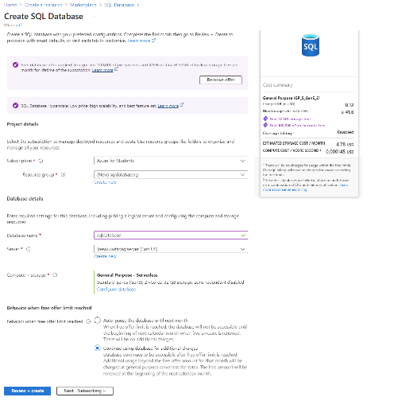
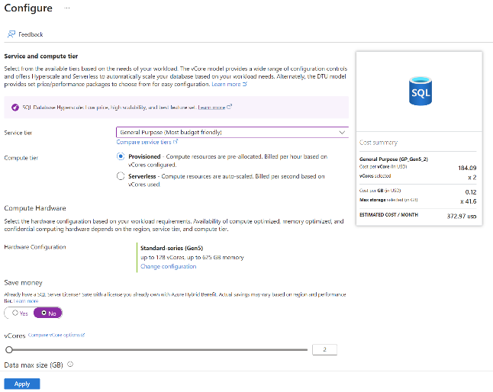
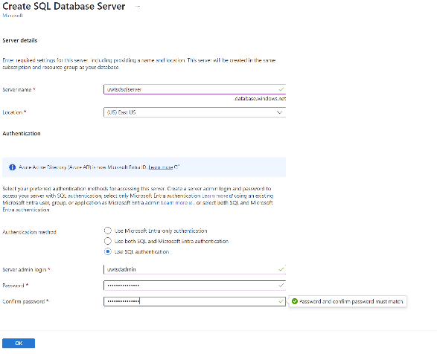
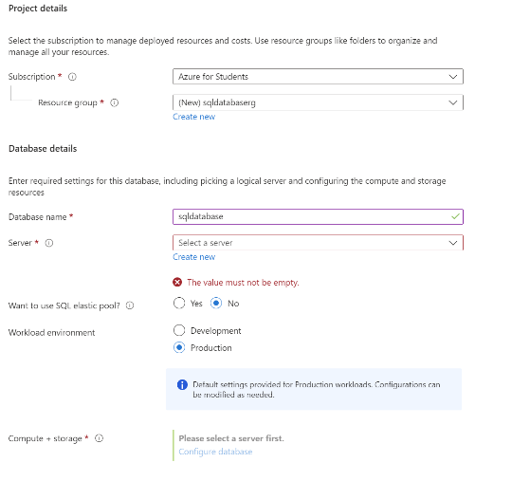
SQL 4. Use any given offer that would lower the costs, but don’t forget to choose the option that would keep the function going even when the offer ends, so no manual work needs to be done in the future, regarding this
SQL 3. Change Hyperscale with General Purpose to save on budget
SQL 2. Create Database Server
SQL 1. Fill the gaps.
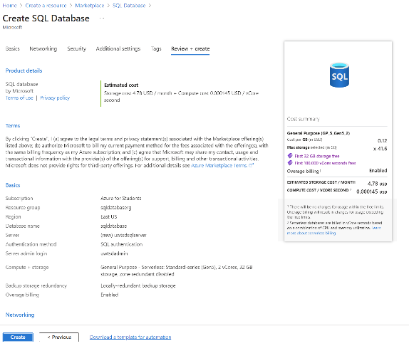
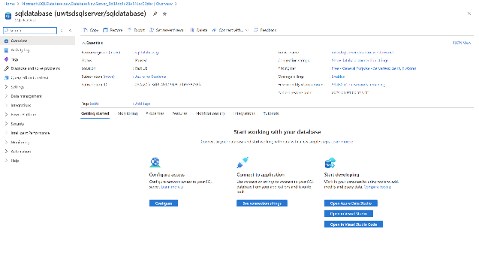
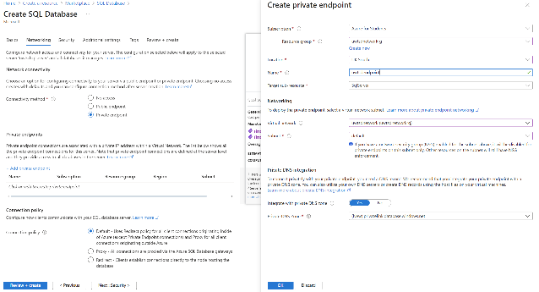
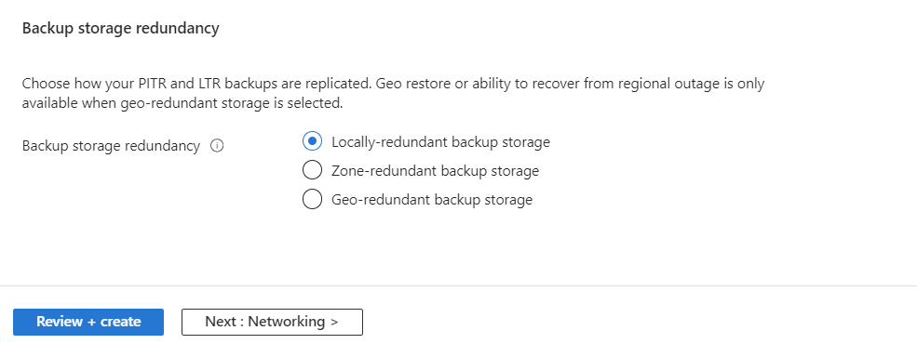
SQL 7. Review and create
SQL 8. Final result
SQL 6. In Networking, dealing with the same thing from the previous point, fill the gaps wherever necessary
SQL 5. Picking the lowest cost option

GLI Backup Schedules Video
https://www.youtube.com/watch?v=IxZb-LNa_DU

Azure Site Recovery for GLI’s continuity:
As GLI wants to ensure business continuity and minimize downtime in case of unexpected outages or disasters, an evaluation of how Azure Site Recovery (ASR) would assist GLI in disaster recovery to protect their storage and databases is to be presented in the following point.
ASR is a critical component of Azure Azure’s disaster recovery (DR) solutions. And it is here to ensure business continuity and minimize downtime if a disruption or a disaster hits. What’s next in the report is how ASR could assist GLI in protecting their cloud infrastructure.
Key features of ASR are:
      - Automated replication – continuous replication of data, workloads and applications; this replication is either between Azure regions or from an on-premise environment to Azure; meaning that in any case of an outage or disaster, GLI already has its data back-up available in a secondary location, ready to be activated on call;
      - Flexible recovery plans – ASR have customizable recovery plans; they can include not only the order in which machines are recovered, but the incorporate scripts to automate some processes, ensure compliance requirements and reduce overall recovery times as well;
      - Orchestrated disaster recovery – ASR allows one to automate the recovery of services in the proper sequence, which results in the restoration of application functionality faster;
      - Non-disruptive disaster recovery drills – the production environment won’t be affected by any DR plans testing GLI undergoes; the meaning of this is that GLI can fine-tune their DR processes and this wouldn’t cost in any downtime; test are formed of simulation of a failover process, which makes sure that performance would be as expected in real action.
But how do these features make the work of GLI easier, secure and qualitative? First thing to note is that ASR minimizes downtime. It enables quick failover to a secondary site, meaning that in an event of data failure (any damage), GLI can switch to that secondary location without a customer noticing it. This keeps the access to critical educational resources and administrative systems maintained. Second, ASR ensures data integrity by continuously replicating data, which keeps it up-to-date and consistent both in primary and secondary sites, which is a very crucial step for an educational institution where data integrity would impact all things from course management to student records. Third of all, it is cost-effective. GLI won’t have any need to invest in their own secondary disaster recovery site with ASR’s service and that’s a huge financial saving. It’s as stated for their primary data before – they pay only for what they use and only when they use it, especially during DR drills or real action. Fourth, it takes care of the compliance with data protection regulations, which is crucial for educational institutions. ASR provides robust DR capabilities, and they include data encryption, secure replication and comprehensive audit trails. Last, but not least, the geographical distribution, which is quite something, having in mind Azure’s global presence, allows GLI to select a DR site in any region that would maximize efficiency and compliance, but would be also geographically away enough to be not affected by any regional disasters that could influence the primary site.
There are some considerations to be made according with the implementation. GLI is to define their Recovery Point Objective and their Recovery Time Objective (RPO and RTO). This way, they can determine how often data has to be replicated and how rapidly systems are to be restored following an outage. Constant replication could require specific bandwidth. This is even more the case if GLI opts for frequent data syncs. It is of importance to estimate the network infrastructure that already exists. This way handling these loads without impacting normal operations would be ensured.

Conclusion:
In times of rapid changes adaptation is a blessing and probably a whole lot of labour. However, working smart is what makes working hard tremendously more meaningful. That is what this report had to present – how new times offer intelligent ease to masterful complexity. The possible financial effect of it was presented in the very beginning, alongside with bonuses like the growing lack of necessity of a constantly prepared IT team and huge amount of attention paid to day-to-day tasks. Introduced were Azure File Storage with many of its benefits, SQL Databases were inspected and then chosen from, backup schedules should present no surprise anymore and business continuity with almost complete lack of downtime is in GLI’s grasp now. Should GLI decide to take a step towards the future, they should step with confidence and dedication.

References:
/0/: https://azure.microsoft.com/en-us/ (Not a reference, but have used it in the first task)
[1] Microsoft, "Introduction to Azure Files," Microsoft Docs, 2023. Available: https://docs.microsoft.com/en-us/azure/storage/files/storage-files-introduction. (Accessed: 07/04).
[2] Microsoft, "Azure Storage Security Guide," Microsoft Docs, 2023. Available: https://docs.microsoft.com/en-us/azure/storage/common/storage-security-guide. (Accessed: 07/04)
[3] Microsoft, "What is Azure SQL Database?", Microsoft Docs. Available: https://docs.microsoft.com/en-us/azure/azure-sql/database/sql-database-paas-overview. (Accessed: 09/04)
[4] Microsoft, "Overview of Azure Site Recovery," Microsoft Docs. Available: https://docs.microsoft.com/en-us/azure/site-recovery/site-recovery-overview. (Accessed: 09/04)

