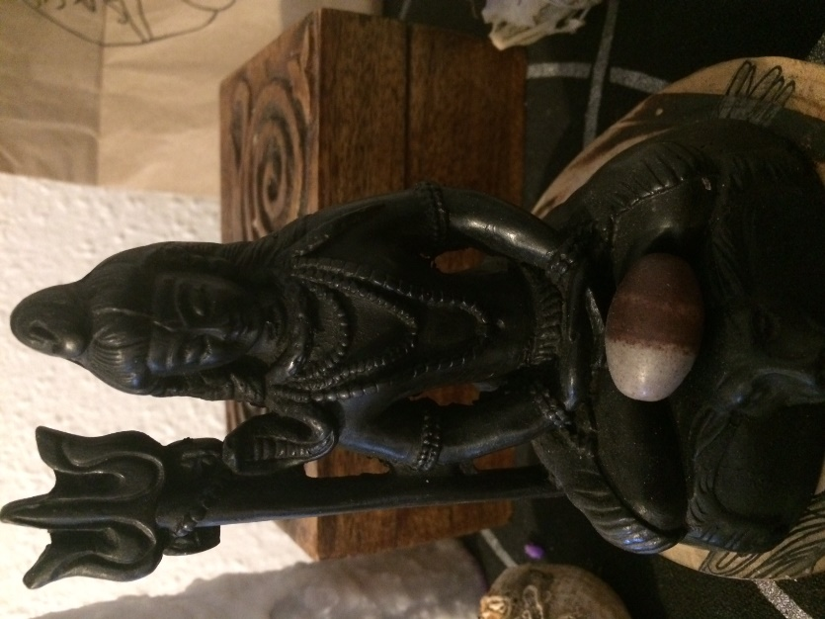
Name: Shiva
Height: 6 inches
Material: Resin
Origins: Nepal
Date of acquisition: 30 August 2018
Biography: This statuette is a representation of the god Shiva in his pashupati form, meaning Lord of animals in Sanskrit. Depicted in meditation and sitting on a wolf with his pet serpent, the god is peaceful. His trident, a power symbol, stand beside him. This object has been made in Nepal but was found somewhere in Canada by its current owner’s friend. It has been given to the current owner as a goodbye gift when she left Canada. Its main function is to sit on a home shrine altar where it can sometimes witness rituals and meditation sessions. It never moves from there and, although it looks peaceful, this little figure crossed the Atlantic sea by ship to arrive here in the UK with its owner in one piece. Besides being a representation of a strong spiritual archetype, it carries memories from the last day spent with friends from overseas. It also is a tool that lets its owner remember the person who gave it to her. Spiritual artefact, symbol of friendship and carrier of memories, it could have been made for different reasons at first. From Nepal to Canada to UK, it shows how a simple object can have a complex life and how love is sometimes shared and remembered by its presence.

