

Academic and Employability Skills
Term 2

Angie Vanesa Garcia Navarro
Student ID: 1906514

Module code: BMSW4001_LON.

Lecturer name: Sylvia Hoffmann

Contents
Introduction 3
Time Management 3
Why Do I need Time management? 3
How did I improve my time management? 3
Critical Thinking 4
Why do I need this? 4
How can I improve? 4
CV writing 4
Why do I need to improve my current CV? 5
What was the result? 6
Public Speaking Skill 7
Why do I need this Skill? 7
How did I improve it? 7
Conclusion 7
References 8

Introduction
Academic Employability Skills is the most useful module give me rights instruments to become a professional in my academic life and to be ready to get a better job. Skills more useful were Time Management and Critical Thinking, and in my career, as a Recruiter Students for British Universities have been helping me to improve my approach with students and achieve my job goals. Also, I will explain the CV writing and Speaking Public and that helped building new skills and reinforce that already have. This report aims to provide an analytic understanding of how these topics had been impacted my life.

Time Management
Time Management is a method where you can learn to the difference between important/urgent and not important/not urgent and manage your goals on time.
In an individual has proper time management could mean positive things about itself, an example that person is disciplined, punctuality, responsibility or capable.
The research Key Management tools and practices that will improve your business, the constant work in your organisation and time management until perfection offer to you as an individual or team to progress to act on your goals. There two factors you can combine inspiration and transpiration to provide your work efficiently. (Ten have et al. 2003)

Why Do I need Time management?
Before starting the Higher Certificate Skills for the workplace at University in London, I found many issues to organise mi personally life, job and studies I used to give the wrong priority to things were not relevant.
Starting the term 1, I was a quite surprise there was a Method where could improve my performance in my academic life and at the workplace that was Time Management.
At my workplace, this method helped me to avoid the rush, have a panoramic of the current and future situations, and I can find the best way to give up and follow my line to success, and as a Marketing Officer, is essential to achieve my target.

How did I improve my time management?
Currently, I work three days a week, and I re-set up my daily. In essence, in the mornings, I focus call my successful student, resolve any enquire they have, make sure they are going to class preparation and a reminder them goals, this contributes to keeping in constant touch with them. For me, this is important to give them the priority because they will build to achieve my target another thing essential but not urgent is complete all the applications for University and in the rest of the day, I keep finding news students.

I have a significant change in my life and is not just regard to my workplace but also in my academic life. When I must do the assignments and presentation for the University, this has my total priority, and I have minimum three days I focus entirely in this because my goal is to get a good grade and be proud of my self for my achievement.

Critical Thinking
Critical Thinking is the capacity that an individual has to collect all the information beyond creativity and research and use your ability through the process, on the other hand, is find up the best way to prove your critical thinking by accurately analysing. (Morgan, 2017)
In Critical Thinking, one of the most famous method is the Theory of Bloom Taxonomy is a system of learned behaviours during learning and understanding through three mains points:
The Analysis is an examination of the process besides reasons and consequences of the event. Evaluation is accurate studies all the knowledge and source I know and use it to find up the solution. The last one is Creating when you collected all these factors and created a new opinion. (Morgan, 2011, p81)

Why do I need this?
In my academic life, I applied The Theory of Bloom Taxonomy, I set up my goal, and that is taking first-class honours in this course. During the first semester I learnt, it is fundamental to collect all studies, evidence and the knowledge that are necessary to write any assignment but is easy to read this and paraphrase it. I tried to read handbooks, modules and use credibility sources, nevertheless after received the result of the assignment and read comments of my lectures beside was quite good. In the assignments, there was something I could not understand and after study this particular skills that are Critical Thinking I realized that I need to improve my creativity to design my idea and put all this in practice on a credible sample.

In all my preceding education, I learnt to memorize books, and my lectures had deprived me of having my ideas. I needed to change my mind, studying my weaknesses and strengths, open my mind and use my creativity because those are essential factors to develop my Critical Thinking, and are significant progress to my goal.
I work as a Student Advisor, and Critical Thinking skill is not something you can easily store. For example, during a discussion with one of my students, and I need to be accurate and responsibility to fix the problem. It is significant to find a credible source and does the right research, to find the solutions and provide to the student the best recommendations according to its request. (Tittle,2011)

How can I improve?
Using Critical Thinking also requires excellent listening skills, and however, it needs to work and academic life. This Skill is focused on research, have a panoramic of all perspectives about the arguments because that will make a difference in your performance in both areas.
Finalized, the understanding from which one is the purpose concerning Critical Thinking is essential to me, as a student and professional to rich my goal. I need to find up more credible source and carefully to avoid fake news that could compromise my job. I will obtain the opportunity to give logic and robust opinion about that argument or assignment to make sure I demonstrated all the knowledge I gained.

CV writing
CV is the abbreviation of Curriculum Vitae and is the most important document on you that will help to find a job. This document must cover all your detail, personal statement, job experience education, activities, skills section, is important work in the writing build with power words and on minimum detail to be successful in the job application. (Morgan, 2017)
The department of Human Resource takes a 7 second to view a CV and find up the potential candidate. Still, in some cases, a CV through a complex system of analysing whereby second could be considerate the CV adapt for that job position. (Moor, 2019) and more of three of the quarts of candidates are rejected if in the CV appears a picture of itself if the email address is not professional or found a grammar mistake. (Sundberg, 2012)

Why do I need to improve my current CV?
After an accurate analysis of cv writing, I decided to re-set my CV because I believe this was old, unprofessional and I realized I did not “write” my real potential using all the information found in Moodle and personal research. Regarding my job experiences, my key is a marketing tool and communication skills, and I want to grow professionally.
Previous CV:
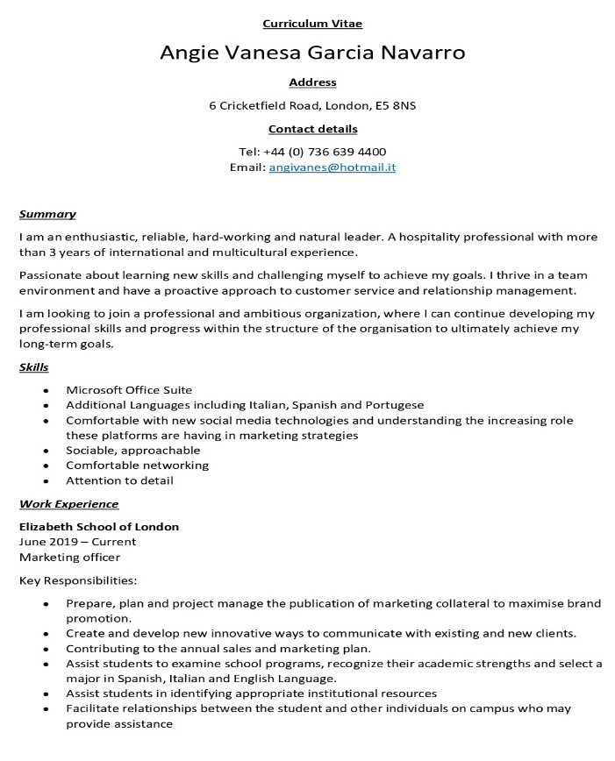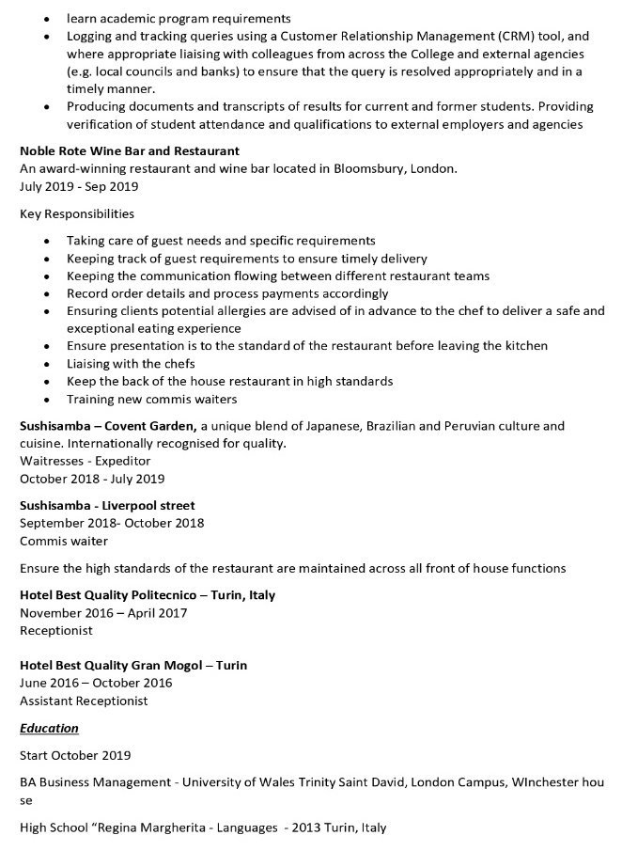
Source: by Autor
The lecture as can see this is my CV previous that I worked and make it better. I will explain step by step. In my details, look correct, but I updated with my LinkedIn profile and Skype account that are fundamental components of your overall professional presence and for the most relevant social media platform for job search.
The section most important of CV is the Summarising where I have to talk about me because the Job Seeker will decide if I am notable candidature or no. I used a power word, reduce the sentences and make more impressive to attract them and I improved with following summarising:

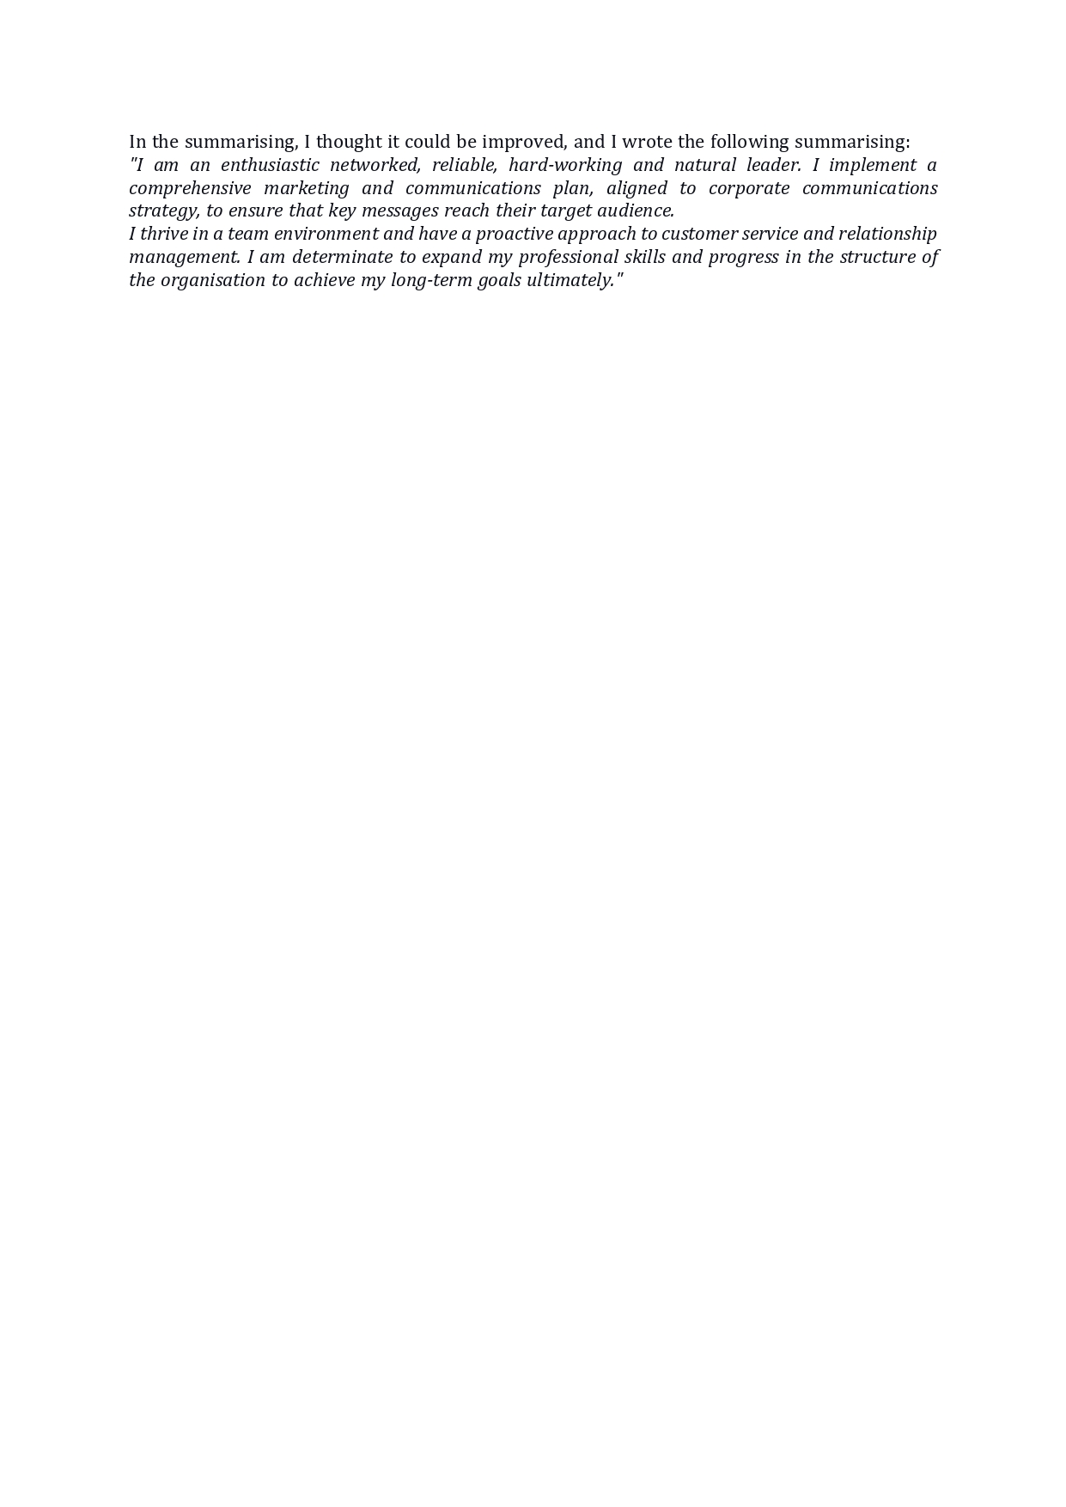

The next step is bout section skills following survey Job Outlook 2018 said the most skills research by jobseeker are problem-solving, teamworking, strong working ethic and communications ethics. (Gray, 2017) Having analysed these skills, I can reflect myself on it, and I decided to add these in my Key Skill. I had the experience, and I can demonstrate it besides, I need to work harder, especially in communication skills. The next section is Work Experience, I followed the rule in CV writing in Moddle. In the previous CV, there are many unnecessary bullets to describe my duties; in addition, I wrote what I did instead of what I achieved.
In Education, I edited some detail to look more professional and specific about the date and where I got my certificates.
Furthermore, the Hobbies section was irrelevant to me. However, for recruitments is considerate like a piece of evidence and give to you trust in your ability for that reason I added that I am part of ArtPerUk, is a Peruvian dance group sometimes, sometimes I enjoy participating.
To conclude my CV, I wrote in the end references available on request, I found who could give me their professional recommendations, because it is essential if one day I want to apply for a job. They will ask me the references that will provide me with more trust and more chances to get that job.

What was the result?
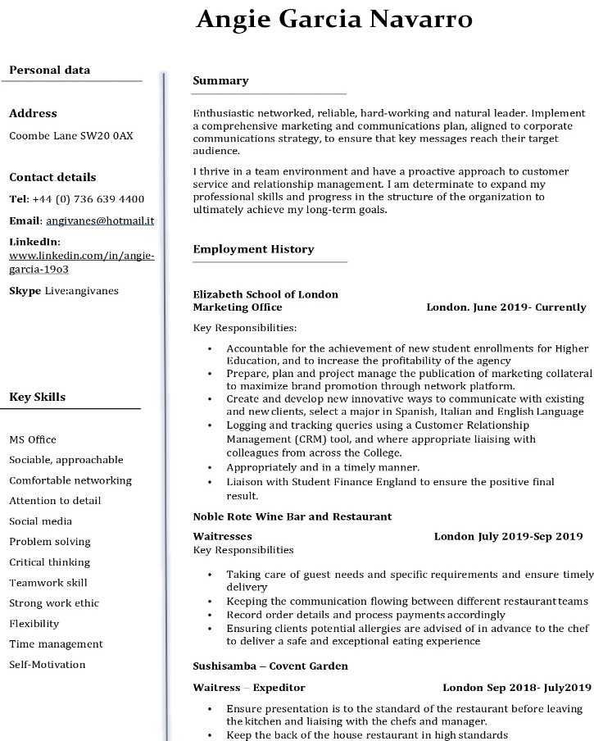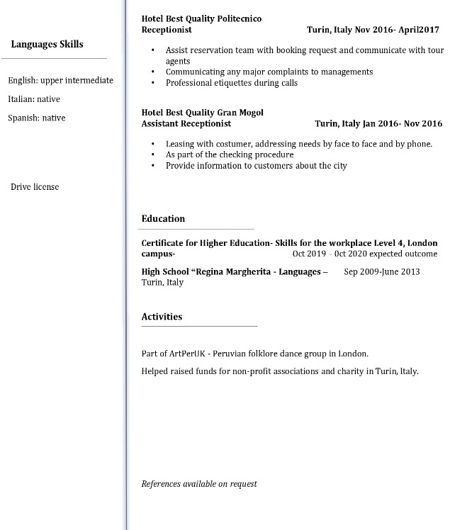
Source: by Autor
This analysing of my CV made me more transparent, and which is my goal, also I changed the style, and it looks modern and tidy.
In my opinion, I feel more confident in my knowledge and me what I learnt from this course that is Skills for the workplace and my next step. I am motivated to apply for a job. I am sure I will receive a positive response and improve my career in networking.
Have a professional Curriculum Vitae is the vital importance such as have excellent writing if the objective is getting a professional job. Needs be perseverant to progress in a project and attention to a minimum detail of your writing because the power word makes the difference.

Public Speaking Skill
Public Speaking is the most important skills for a person because wherever during a presentation for business, university or event is indispensable use all your strength to not lose the attention of spectators and achieve the objective of presentation with success. Conforming you improve your public speaking you will gain extra ones to increase your performance for the next presentation. (Becker and Edem, 2004)

Why do I need this Skill?
In previous education in Italy, in my class, we never used to do a presentation this experience could not help me a lot, to develop this skill and I regretted not having done it. However, nothing is too late, and since when I started this course, I felt everything was a challenge but in a positive way.
To be a good speaker in front of a public is essential as long as will improve your employable life and will come the day I want to be ready as much as is possible because will depend on my success as a professional and student.
It needs a hard preparation, manage anxiety, verbal and non-verbal communication, behaviours, confidence, creativity, accurate manage the project you present, reasonable conclusion and able to all the probable question from a public. (Morgan, 2017)

How did I improve it?
My first presentation in term 1, the result was quite good; first, I wear a formal dress because it gives you credibility in my performance. It is vital to control the level of anxiety because, during the presentation, the main objective is to convince the public about your project and do not forget any topic of it and keep your smiling. During the essays on class, the lecture told me to stay calm because if more I am anxious, I will speak faster, and this will not help and on the final presentation I keep my worry and remind myself to speak slowly.
I learnt that it needs to have strong communication and have an outstanding level of voice. Such any presentation needs an introduction is the point most important is where you capture the attention of the public, developing the topic through speak clearer and use a relevant example, anecdote or in some cases humour to interactive with them.
For further success does not read a lot of the slide of the presentation but keep the visual contact with the spectators. I was proud of what I did and has been an excellent opportunity to practice in front of my colleagues and become a more confident and the for next time I will get an excellent mark. I am aware, the way is not easy to become a good speaker, require time, and a lot of practice and the result you gained will help you to develop your performance. In the other hand, have a personal style will increase your confidence and achieve the message you want to convey to the public, even if you have to discuss with the manager or with your colleagues.

Conclusion
Each skill I described and analyzed have been a great impact on my life that I could try significant benefit. In my opinion, every skill I learnt from this course can be a success just if the student applies in real life. I started slow, and I was afraid because sometimes I found some difficult to manage the situations and that it could not be the right way. Still, in the end, the progress and results I saw since the first week has been excellent in my studies, especially in my workplace, and one of my Manager was satisfied with my job done. I could not feel happier with that, and this motivated to continue and get a better job and student.

References

Becker, L. and Edem, J. V. (2004) Presentation Skills for Students. New York: Macmillan Press.
Gray, K. (2017) The key attributes employers seek on student’s resumes. Available at https://www.naceweb.org/about-us/press/2017/the-key-attributes-employers-seek-on-students-resumes/ (Accessed 16th April 2020)
Morgan, P. (2017) The Business Student´s Guide to Study and Employability. London press, United Kingdom.
Moor, E. (2019) Your CV has 7 Seconds to Get a Recruiter’s Attention- Here’s How to Make It Count. Available at https://www.glassdoor.co.uk/blog/7-second-cv/ (Accessed 16th April 2020)
Ten Have, S. et al. (2003) Key Management tools and practices that will improve your business. Available at: https://books.google.co.uk/books?hl=it&lr=&id=GhLOrawtvMoC&oi=fnd&pg=PR7&dq=improve+time+management+&ots=Do9kQn2Zi1&sig=mRxvBVzAOxTCAgpIkvw7BZYz9Bs&redir_esc=y#v=onepage&q=improve%20time%20management&f=false (Accessed 12th April 2020)
Tittle, P. (2011) Critical thinking an appeal to reason thinking. Available at : https://books.google.co.uk/books?hl=it&lr=&id=3DdZBwAAQBAJ&oi=fnd&pg=PP1&dq=Tittle,+P.+(2011)+Critical+thinking+an+appeal+to+reason+thinking.+New+York:+Routledge+Press&ots=YOnkFIwykW&sig=d6I7X0PNsnEQCNOTNuN6F6tY75k#v=onepage&q=Tittle%2C%20P.%20(2011)%20Critical%20thinking%20an%20appeal%20to%20reason%20thinking.%20New%20York%3A%20Routledge%20Press&f=false. (Accessed 12th April 2020)
Sundberg, J. (2012) How Long Do Recruiters Spend Reading Your CV? Available at https://theundercoverrecruiter.com/infographic-recruiters-spend-5-7-seconds-reading-your-cv/ (Accessed 16th April 2020)

