
Programme: Master of Business Administration

Module: Marketing Management
Module code: LCMB7024

Assignment Title: Assessment component 2: Marketing Strategies Portfolio

Student Name: KHATIJABIBI MAHEBUBBHAI RADHANPURI
Student ID: 2420022
Table of Contents
1.0 Element 1: Brand Extension Poster Presentation 3
2.0 Element 2: Develop a Segmentation, Targeting, Differentiation, and Positioning (STDP) 4
2.1 Key market segments relevant to the brand extension using geographic, demographic, psychographic, and behavioural variables 4
2.2 Detailed explanation of your chosen target audience 6
2.3 Way brand will differentiate itself from competitors in the market 6
2.4 Positioning of the brand extension 7
3.0 Element 3: Marketing Mix (4Ps or 7Ps) 8
3.1 Way each element of the marketing mix will be applied and how it aligns with and supports the overall brand extension strategy 8
4.0 Element 4: Reflection 13
4.1 Reflection on my experience developing the brand extension 13
4.2 Reflection on the experience preparing and delivering the poster presentation 13
4.3 Key skills, knowledge, and insights you have gained throughout this process 13
4.4 Way these have contributed to my personal and professional development 14
4.5 Way I could further enhance my approach and performance in similar projects in the future 14
References 16

1.0 Element 1: Brand Extension Poster Presentation
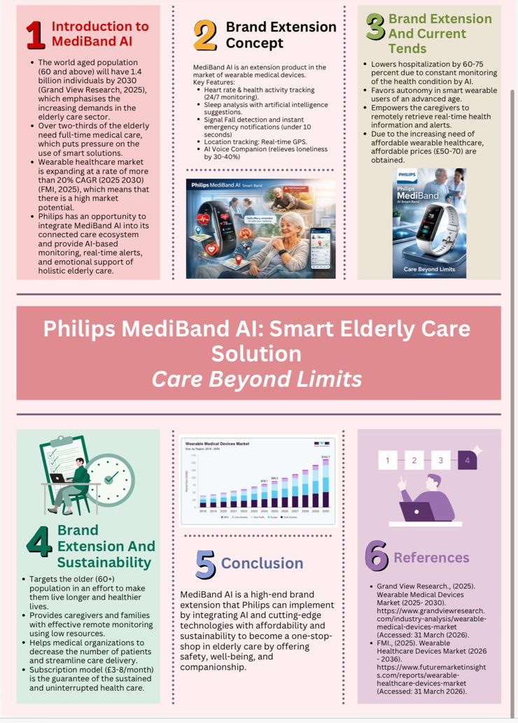

2.0 Element 2: Develop a Segmentation, Targeting, Differentiation, and Positioning (STDP)

2.1 Key market segments relevant to the brand extension using geographic, demographic, psychographic, and behavioural variables
Geographic Segmentation
Philips MediBand AI will focus on developed and emerging markets where the ageing population and uptake of digital healthcare are booming. The main market should be North America and Europe because of their well-developed healthcare facilities and a high rate of using wearable medical devices. The North American market, as an example, had a market share of about 45.7% of the global wearable medical device market in 2025 due to high penetration of technology and healthcare expenditure (Fortune Business Insights, 2025). Equally, the demand in Europe is also growing as a result of growing geriatric populations, and the prevalence of chronic diseases. The fast development of digital health market worldwide including over USD 1.19 trillion in 2032 with a CAGR of 16.7%, supporting the high geographic opportunities of Philips MediBand AI in the developed market regions, North America and Europe, and in the high potential Asia-Pacific markets.
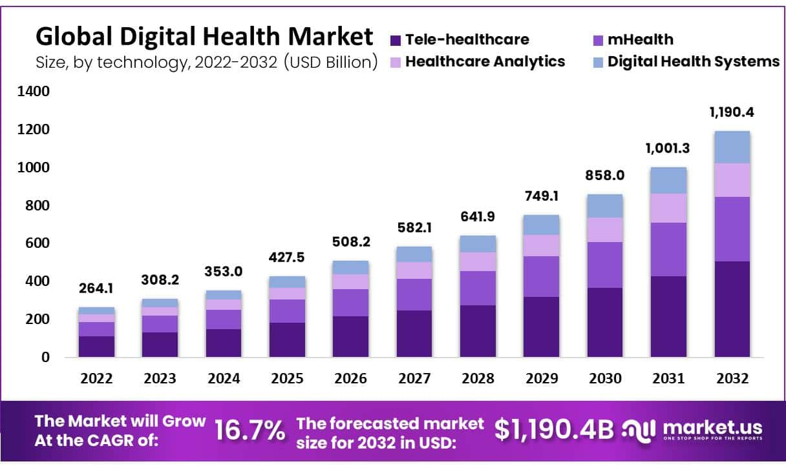
Fig 1: Global Digital Health Market
Source: (Market.us, 2025)
Demographic Segmentation
The main age group of the target population of Philips MediBand AI is 60 years and older because of the dynamic ageing process in the world. It has been estimated that by 2030, 1 out of 6 individuals will be over 60 years, which is going to pose a big burden on elderly healthcare solutions. The second group of demographics is that of caregivers and relatives, who are usually aged between 30 and 55 and are the ones who take care of the elderly (MarketsandMarkets, 2025). This segment is important in making purchases especially in the middle and high-income families. The income segmentation is also important. The product will be aimed at middle- to upper-income customers that can afford smart healthcare solutions, particularly in developed markets.
Psychographic Segmentation
Psychographic segmentation is based on lifestyle, values and attitudes on health and technology. Philips MediBand AI is aimed at health-concerned elderly people interested in independence, safety and quality of life. These consumers are moving towards preventive healthcare rather than reactive, in line with digital health uptake trends in the world. Also, the product targets families and caregivers, who consider peace of mind and emotional safety values (DelveInsight, 2025). Even though the older generations have always been considered to be conservative towards digital technologies, the trend is evolving fast. It is believed that within the next decade, up to 50% of those aged 55-60 will embrace wearable health technologies. This points to a big change in tech-enabled healthcare behaviours.
Behavioural Segmentation
Behavioural segmentation is based on the usage pattern, benefits targeted and customer readiness. Philips MediBand AI is mainly aimed at consumers who are interested in prevention healthcare and method of remote monitoring that is gaining importance because of increasing healthcare expenses and prevalence of chronic diseases (National Institutes of Health, 2025). A major behavioural segment consists of users who need to keep a constant check of their health, like heart patients or those with mobility problems. Real-time monitoring of vital signs with wearable healthcare devices is becoming more popular due to its ability to identify the threat of health conditions in time and decrease the number of hospital visits.

2.2 Detailed explanation of your chosen target audience
Philips MediBand AI is aimed at the following target audience: elderly people (60+ years old) who live independently but need constant health control and safety assistance. This population is growing at an alarming rate and by 2030, the world will be home to about 1.4 billion people aged 60 and above, which will strain the available healthcare and preventive measures. Such consumers are usually middle- and upper-income brackets, are becoming more willing to use wearable technology, and are motivated by independence, safety, and quality of life (LinkedIn, 2025). Moreover, another important secondary audience is the group of caregivers and family members (between 30 and 55) who make buying choices and demand the use of good remote monitoring equipment to guarantee the welfare of their older parents. This two-fold strategy can improve market penetration by answering the needs of users and concerns of decision-makers, which is why MediBand AI can be an extremely applicable solution that can be scaled to the expanding digital healthcare market.

2.3 Way brand will differentiate itself from competitors in the market
Philips MediBand AI can be distinguished by the fact that it targets elderly care, and not just overall fitness monitoring. It provides older users with AI-based health insights, real-time fall detection, and emergency alerts, unlike its competitors, including Apple Watch or Fitbit. One of the strengths is that it is holistic, both physically tracking health and providing emotional assistance in an AI companion (Global Market Insights, 2025). Moreover, the good reputation of Philips in healthcare contributes to trust and reliability, and its simplicity and low cost of subscription increases the accessibility. The care-centered, specialised positioning forms a distinct competitive edge in the wearable healthcare sector.

2.4 Positioning of the brand extension
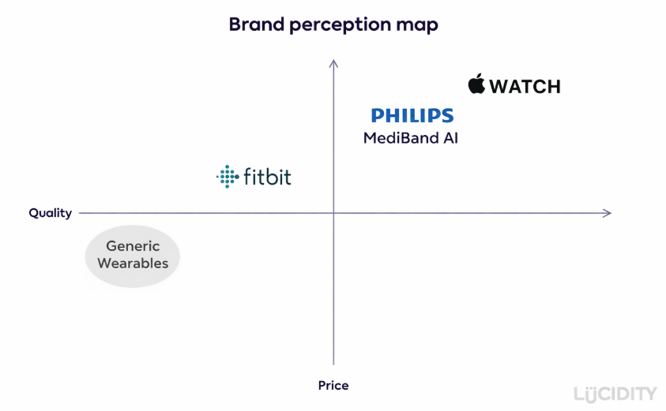
Fig 2: Positioning Map
Source: (Self-Created)

3.0 Element 3: Marketing Mix (4Ps or 7Ps)

3.1 Way each element of the marketing mix will be applied and how it aligns with and supports the overall brand extension strategy
Product Strategies
Philips MediBand AI is positioned as a premium and specialised healthcare wearable that is aimed at the needs of older users. The product continues to be at the premium quality level because it has clinically relevant attributes like continuous monitoring of the heart rate, fall detection, sleep tracking, and AI-based health insights. It is user-friendly with simplified interface, bigger display, and ergonomic design to make it easy to use by older adults who in most cases are challenged by technology. Its functionality has not only the physical monitoring of health but also AI companionship, which is relevant in loneliness, almost a quarter of older adults worldwide (InsightAce Analytic, 2025). Philips will be able to provide a 1-2 year warranty and continuous software updating, which guarantees the longevity and value. The wearable medical devices market expanding by 2030 to more than USD 162 billion, which validates the Philips MediBand AI premium product approach as the need to personalize high-quality healthcare wearables to meet the needs of elderly consumers is high.
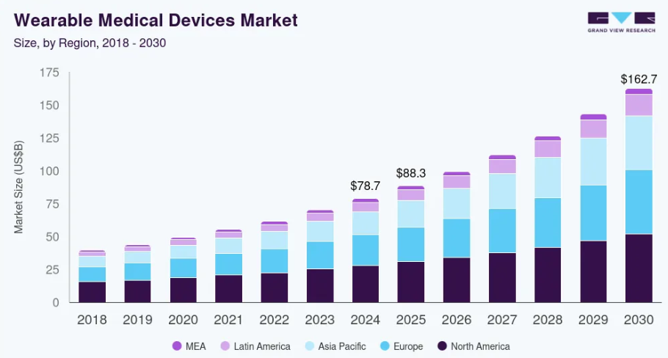
Fig 3: Global wearable healthcare market
Source: (Grand View Research, 2025)
Price Strategies
Philips MediBand AI supports value-based pricing, which is based on the high perceived value of safety, independence, and continuous monitoring of health. The product will be sold at prices of between £50-70 with an additional subscription model of about £8 per month which will make it affordable and also create a recurrent revenue. Cost-based pricing is also taken to be able to sustain a profitability by efficient production and economies of scale (World Health Organization, 2025a). In the case of new product development, the market penetration strategy is used to achieve a market share rapidly in the competitive wearable market. The segmented pricing will enable Philips to focus on various customer segments such as the elderly users, care givers, and healthcare institutions and perhaps execute bulk discounts. Psychological pricing, like pricing under £70, increases the perceived affordability. Such pricing mechanism is in line with the increasing global healthcare prices, as healthcare spending is over 10% of global GDP, and there is a need to find more affordable solutions, such as wearable monitoring devices (Grand View Research, 2025).
Place (Distribution) Strategies
Philips MediBand AI has a total distribution strategy incorporating direct, indirect, and multi-channel distribution channels to increase accessibility. Direct marketing media refers to the official site of Philips and the leading online shop websites through which one can easily make purchases (ScienceDirect, 2025). The partnership with pharmacies, hospitals, and healthcare providers are indirect channels, which increases the credibility and trust among older consumers. Multi-channel marketing is used to make the product available online and offline to the consumer with a variety of preferences.
Promotion Strategies
Philips MediBand AI promotion strategy revolves around the concept of an integrated marketing communications, addressing the needs of both elderly users and their caregivers. The advertisement targets the online segment including social media, search engines, and video advertising, highlighting the main advantages of safety, autonomy, and tranquility. Considering the fact that the volume of digital advertising will surpass USD 700 billion in 2025, this medium will be critical in accessing the contemporary consumers (World Health Organization, 2025b). Personal selling is carried out by the use of health practitioners and in store demonstrations that will generate a feeling of trust and credibility. Promotion strategies such as introductory offers and trial subscriptions are used to promote product uptake. Brand reputation is enhanced by the public relations activity, i.e., collaboration with healthcare organisations and campaigns about the wellbeing of the elderly.
People Strategies
Individuals are a key component in the MediBand AI value proposition delivery especially in a healthcare-centered product. Philips has made sure that employees are well trained in both technical expertise and sensitive communication that is vital in dealing with old people. Customer support services, like 24/7 telephone lines, chat, and support apps, improve customer experience and satisfaction (United Nations, 2023). High service quality and involvement of employees are guaranteed by employee motivation strategies, performance incentives, and continuous training programmes. Also, staff turnover reduction strategies like career development opportunities and favourable working environment helps in ensuring the provision of consistent service delivery. Service quality is especially relevant in healthcare, where the aspects of trust and reliability are critical points of customer satisfaction. Studies show that organizations that have employees who are highly engaged potentially enjoy increased profitability by up to 21%, and that proper people management is vital in ensuring business success (World Bank, 2025).
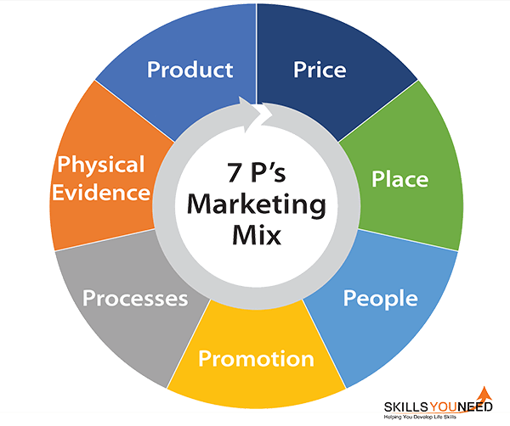
Fig 4: 7Ps of Marketing
Source: (SkillsYouNeed, 2025)
Process Strategies
Philips MediBand AI has its process strategy centered on the efficiency, reliability, and user-friendliness. The customer Relationship Management (CRM) systems help in gathering and analysing the user information, which allows it to offer personalised services and anticipate health insights. The key element is the use of the Information and Communication Technology (ICT), cloud-based systems, mobile apps, and AI analytics are used to facilitate real-time monitoring and notifications (McKinsey & Company, 2025). The onboarding is made easy and user-friendly to make sure that the elderly can easily adopt the system. Fully automated procedures, including health reports and fall detection alerts, enhance responsiveness and minimize manual actions. Service effectiveness is further improved with integration with healthcare providers. With the increased pace of digital transformation, more than 60% of healthcare organisations worldwide are investing in digital technologies, which emphasizes the need to have an efficient process (PwC, 2025).
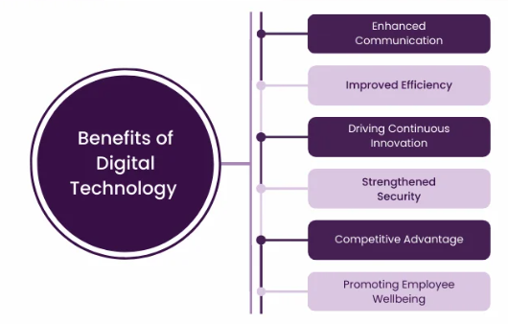
Fig 5: Benefits of Digital Technology
Source: (The Knowledge Academy, 2026)
Physical Evidence
Physical evidence is crucial in enhancing the credibility and perceived quality of the Philips MediBand AI. The packaging and branding of the product is meant to show professionalism, trust and innovation which are in line with the healthcare identity of Philips (Statista, 2025). Pharmacies and healthcare centres will have retail presence, which will increase visibility and customer experience. The physical appearance of the device also conveys the meaning of quality and reliability. A mobile application interface is a crucial digital touchpoint, which provides a transparent interface that is easy to use to track health information. Customer reviews, testimonials and case studies also enhance brand credibility and impact buying decisions (Kotler Impact, 2025).

4.0 Element 4: Reflection

4.1 Reflection on my experience developing the brand extension
The creation of the Philips MediBand AI brand extension was a learning experience that helped me improve my knowledge of innovation and strategic marketing. It needed to combine the theoretical models of segmentation, targeting, and positioning with the reality of the market dynamics. In the process, I was able to acquire skills to locate pertinent market opportunities by analysing trends like ageing population and rising demands of digital healthcare solutions.
Strength: Effective application of marketing theory to a real-world context.
Weakness: Limited critical evaluation of potential risks and challenges.

4.2 Reflection on the experience preparing and delivering the poster presentation
The process of the poster presentation creation and delivery helped me to improve my skills in explaining complicated concepts in a clear and succinct way. The design itself had to be thought of in regards to visual clarity such that important information be displayed in an interesting and unorganized manner (Harvard Business Review, 2025).
Strength: Strong ability to present complex ideas clearly and concisely.
Weakness: Limited time reduced depth of explanation during presentation.

4.3 Key skills, knowledge, and insights you have gained throughout this process
The problem-solving, creativity, and analytical thinking skills are critical skills that I gained in this project. It also helped me develop knowledge on major marketing models like STP and the 7Ps, and how they can be applied in a business situation. Also, I enhanced my research skills by applying market trends and statistical data to assist my analysis.
Strength: Strong development of analytical and research skills.
Weakness: Limited depth in applying critical evaluation to insights.

4.4 Way these have contributed to my personal and professional development
This project has provided me with skills and knowledge which have helped me in my personal and professional growth. It has boosted my self-assurance in translating the theoretical knowledge into practical application, which is critical in marketing and business consulting jobs. I have become better at communication and presentation, which enables me to communicate ideas better (IBM, 2025). My independent working and handling of complex tasks skills were also reinforced by the project and are relevant skills in the workplace.
Strength: Improved confidence in applying theory to practice.
Weakness: Limited real-world industry exposure to validate decisions.

4.5 Way I could further enhance my approach and performance in similar projects in the future
To become a more data-driven person in the future, I will include more credible sources and real-time statistics in my analysis to make it more robust. I will also be working on managing my time properly by devoting enough time to research, design and practice. Practicing my presentation skills by regularly presenting in front of others and providing feedback will enable me to present more confidently and effectively. I will also pay more attention to critical analysis through comparing other strategies and give more rational recommendations (Deloitte, 2025).
Strength: Clear focus on continuous improvement and skill development.
Weakness: Current approach lacks deeper comparative and critical analysis.

Conclusion
To sum up, the Philips MediBand AI brand extension proves the high level of correspondence between market requirements and the strategic marketing schemes with the help of STDP and the 7Ps. Its potential to meet the increasing needs of elderly healthcare solutions, as well as its mirror of the significance of customer-centric innovation and strategic decision-making in a competitive digital health market, are presented in the analysis.

References
Deloitte (2025) Life Sciences and Healthcare Industry Insights. Available at: https://www.deloitte.com/global/en/Industries/life-sciences-health-care.html
DelveInsight (2025) Wearable Medical Devices Market Insights and Forecast. Available at: https://www.delveinsight.com/report-store/wearable-medical-devices-market
Fortune Business Insights (2025) Wearable Medical Devices Market Size, Share & Industry Analysis. Available at: https://www.fortunebusinessinsights.com/industry-reports/wearable-medical-devices-market-101070
Global Market Insights (2025) Digital Health Market Size and Share Report. Available at: https://www.gminsights.com/industry-analysis/digital-health-market
Grand View Research (2025) India Digital Health Market Size & Trends Report. Available at: https://www.grandviewresearch.com/industry-analysis/india-digital-health-market-report
Grand View Research (2025) Wearable Medical Devices Market Size, Share & Trends Report. Available at: https://www.grandviewresearch.com/industry-analysis/wearable-medical-devices-market
Harvard Business Review (2025) Marketing Topic Collection. Available at: https://hbr.org/topic/marketing
IBM (2025) Digital Transformation Overview. Available at: https://www.ibm.com/topics/digital-transformation
InsightAce Analytic (2025) Digital Health Market Forecast 2025–2035. Available at: https://www.insightaceanalytic.com/report/digital-health-market/1596
Kotler Impact (2025) Marketing Strategy and Innovation Insights. Available at: https://www.kotlerimpact.com/marketing-strategy/
LinkedIn (2025) Smart Wearable Healthcare Devices Market Size and Trends. Available at: https://www.linkedin.com/pulse/smart-wearable-healthcare-devices-market-size-on7bc/
Market.us (2025) Digital Health Market Size, Share, Trends and Forecast. Available at: https://market.us/report/digital-health-market/
MarketsandMarkets (2025) Wearable Medical Device Market by Type and Region – Global Forecast. Available at: https://www.marketsandmarkets.com/Market-Reports/wearable-medical-device-market-81753973.html
McKinsey & Company (2025) The Future of Digital Health. Available at: https://www.mckinsey.com/industries/healthcare/our-insights/the-future-of-digital-health
National Institutes of Health (2025) Adoption of Wearable Health Technology Study. Available at: https://pmc.ncbi.nlm.nih.gov/articles/PMC11890132/
PwC (2025) Global Healthcare Trends Report. Available at: https://www.pwc.com/gx/en/industries/healthcare/publications/healthcare-trends.html
ScienceDirect (2025) Digital Healthcare Transformation Research Article. Available at: https://www.sciencedirect.com/science/article/pii/S2949866X24001229
SkillsYouNeed (2025) The 7 Ps of Marketing Mix. Available at: https://www.skillsyouneed.com/lead/7-marketing-ps.html
Statista (2025) Wearable Technology Statistics and Market Data. Available at: https://www.statista.com/topics/1556/wearable-technology/
The Knowledge Academy (2026) What is Digital Technology? Types, Benefits, and Examples. Available at: https://www.theknowledgeacademy.com/blog/what-is-digital-technology/
United Nations (2023) World Population Ageing Report. Available at: https://www.un.org/development/desa/pd/content/world-population-ageing-2023
World Bank (2025) Population Ageing Overview. Available at: https://www.worldbank.org/en/topic/population/brief/aging
World Health Organization (2025a) Ageing and Health Fact Sheet. Available at: https://www.who.int/news-room/fact-sheets/detail/ageing-and-health
World Health Organization (2025b) Digital Health. Available at: https://www.who.int/health-topics/digital-health

