
Swansea Business School
Institute of Management & Health

Bachelor of Arts in Applied Business
LEVEL 5

Module Name: Enterprise Development and Commercial Innovation
Module Code: BMSW5000
Assignment Name: Academic interview
Student Name: Adelina Georgiana Cozma
Student Number:2431275
Lecturer: Chris Wilkin
Deadline: Monday 12thOctober 23:59
AI Acknowledgement
I confirm that I have not present any AI generated materials as my own work.

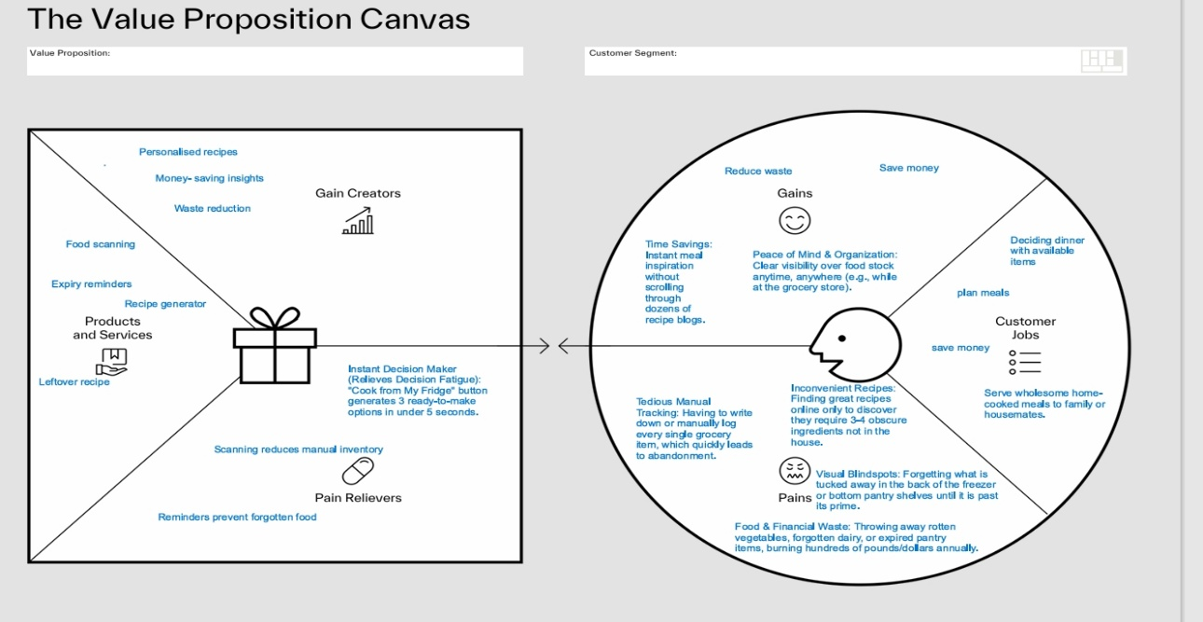

https://mm.tt/map/4090033527?t=3MbDzCygOa

References
1. Ananda, J., Karunasena, G.G., Kansal, M., Mitsis, A. and Pearson, D. (2023)
‘Quantifying the effects of food management routines on household food
waste’, Journal of Cleaner Production, 391, article 136230. doi:
10.1016/j.jclepro.2023.136230.
2. Barringer, B.R. and Ireland,R.D.(2021).Entrepreneurship : Successfully
Launching New Ventures. 6th ed. New York, Ny: Pearson changers,
and Challengers. Hoboken, New Jersey: Wiley.
3. CHATTERJEE, R.S., HAMEED, I., CHAUDHURI, R., VRONTIS, D.,
CHAUDHURI, S. and CHATTERJEE, S., 2025. Do food planner apps enhance
responsible food consumption? The impact of perceptual antecedents and
moderating effects on usage intention. British Food Journal, 127(8), pp.
2929.
4. Jagau, H.L., Vyrastekova, J., 2017. Behavioral approach to food waste: an
experiment. Br.Food J. 119, 882–894. https://doi.org/10.1108/BFJ-05-2016-
0213
5. Kummu, M., de Moel, H., Porkka, M., Siebert, S., Varis, O., Ward, P.J., 2012.
Lost food,wasted resources: global food supply chain losses and their
impacts on freshwater,cropland, and fertiliser use. Sci. Total Environ. 438,
477–489.https://doi.org/10.1016/J.SCITOTENV.2012.08.092
6. Leverenz, D., Moussawel, S., Maurer, C., Hafner, G., Schneider, F., Schmidt,
T., Kranert,M., 2019. Quantifying the prevention potential of avoidable food
waste in householdsusing a self-reporting approach. Resour. Conserv.
Recycl. 150, 104417. https://doi.org/10.1016/j.resconrec.2019.104417
7. Osterwalder, A. and Pigneur, Y. (2010). Business Model Generation: a
Handbook for visionaries, Game
8. Osterwalder, A., Pigneur, Y., Bernarda, G. and Smith, A. (2014) Value
proposition design: How to create products and services customers want.
Hoboken, NJ: John Wiley &amp; Sons.
9. Schanes, K., Dobernig, K. and Gözet, B. (2018) ‘Food waste matters: A
systematic review of household food waste practices and their policy
implications’, Journal of Cleaner Production, 182, pp. 978–991. doi:
10.1016/j.jclepro.2018.02.030.
10. Schanes, K., Dobernig, K., Gözet, B., 2018. Food waste matters - a
systematic review ofhousehold food waste practices and their policy implications. J. Clean. Prod. 182,978–991.
https://doi.org/10.1016/J.JCLEPRO.2018.02.030
11. Shepherd, D.A. and Patzelt, H. (2021). Entrepreneurial Strategy, Starting,
Managing, and scaling new ventures.Springer Nature.
12. Talwar, S., Kaur, P., Yadav, R., Sharma, R. and Dhir, A. (2023), “Food waste
and out-of-home-dining: antecedents and consequents of the decision to
take away leftovers after dining at restaurants”, Journal of Sustainable
Tourism, Vol. 31 No. 1, pp. 47-72, doi: 10.1080/09669582.2021.1953512.
13. Tonini, D., Albizzati, P.F., Astrup, T.F., 2018. Environmental impacts of food
waste:learnings and challenges from a case study on UK. Waste Manage
76, 744–766.https://doi.org/10.1016/J.WASMAN.2018.03.032
14. Troise, C., O&#39;Driscoll, A., Tani, M. and Prisco, A. (2021), “Online food
delivery services and behavioural intention – a test of an integrated TAM
and TPB framework”, British Food Journal, Vol. 123 No. 2, pp. 664-683, doi:
10.1108/bfj-05-2020-0418.
15. Wang, L., Filimonau, V. and Li, Y. (2021), “Exploring the patterns of food
waste generation by tourists in a popular destination”, Journal of Cleaner
Production, Vol. 279, 123890, doi: 10.1016/j.jclepro.2020.123890.
16. WRAP (2025) Understanding household food waste in the UK: The
Household Food Management Survey. Available from: WRAP. Accessed:12October 2026.

