Method to ensure Caribbean Coffee information security based on improved IT framework and models

Yizhen Wang
Abstract
With the continuous improvement of network infrastructure in various countries around the world, advanced network technology has been quickly popularized and applied, and many enterprises have embarked on the information highway of enterprise informatization and internationalization. What follows is that information security has become the company's top priority, and mature information security framework and models are urgently needed.This article refers to, uses and improves three types of network security models or framework, namely, the Information Technology Infrastructure Library, the Information Standardization Organization 27000, and Information Security Level Protection System(ISLPS) , to try to explore and solve the information security and management problems of Caribbean coffee.
Keywords: network technology , informatization , information security , the Information Technology Infrastructure Library , the Information Standardization Organization 27000 , Information Security Level Protection System.

- Introduction
With the rapid spread of the Internet around the world, people are increasingly dependent on the Internet. Daily life, work, study, entertainment, etc. are all closely related to the Internet. When the business and management of enterprises rely more and more on the Internet, decision makers must realize that the fate of the enterprise is closely linked with information security. Because the issue of enterprise information security is directly related to the survival and development of an enterprise, it should be the consensus of enterprise users at all levels to ensure enterprise information security so that the enterprise is not lost. Therefore, for companies to maintain healthy and sustainable development, information security is one of the basic guarantees. With the deteriorating network environment and the development of the enterprise itself accompanied by more and more commercial leaks, the issue of information security has gradually been put on the agenda, and enterprise managers have gradually stepped out of their previous misunderstandings, and the construction of information security has become The primary task of enterprises, some small and medium-sized enterprises have also joined this growing team. Virus and Trojan horses, hacker attacks, LAN internal ARP, overflow attacks, deliberate leaks by insiders, unintentional leaks by insiders, failures of data and information storage equipment, natural disasters, etc., all belong to information security issues. If it is business secret information, the loss to the enterprise will be even greater, and it will even affect the survival and development of the enterprise. Therefore, companies need to establish a safe, reasonable, and convenient information security architecture, so that all kinds of information can be fully protected. This is not only a guarantee for customers and employees, but also a care for the company's development prospects. This article will analyze and compare three safety frameworks or models in the following, and then use them to deal with the safety problems encountered by Caribbean coffee.
- Security Frameworks and Models
This article will list the basic information of three information security frameworks or models, namely, the Information Technology Infrastructure Library, the Information Standardization Organization 27000, and Information Security Level Protection System(ISLPS), and analyze their advantages and disadvantages and other differences from a personal perspective.
2.1 Information Technology Infrastructure Library (ITIL)
ITIL stands for IT Infrastructure Library (Information Technology Infrastructure Library) developed by the British government department CCTA (Central Computing and Telecommunications Agency) in the late 1980s and summarizes the best practices in IT service management in various industries in the UK. ITIL provides an objective, rigorous, and quantifiable standard and specification for enterprise IT service management (ITSM) practices[1].
The ITIL core process is shown in Figure 1.
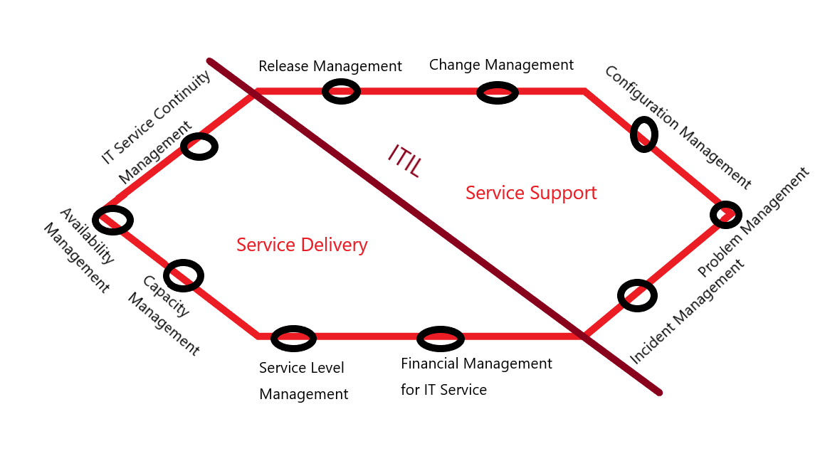
Fig 1. The core process of ITIL

In my opinion, ITIL core process can be divided into two categories, namely Service Delivery and Service Support. Service Delivery contains IT Service Continuity Management, Availability Management, Capacity Management, Service Level Management, Financial Management for IT Service, Service Support contains Release Management, Change Management, Configuration Management, Problem Management, Incident Management, which are shown above.
2.1.1 Service Strategy
Service Strategy is the core of ITIL life cycle. Its role includes but is not limited to: It has formulated a series of guidance programs to help IT service providers and their customers operate, help them develop long-term and establish a clear Service Strategy. Accurately understood as:
[1] Which services should be provided;
[2] To whom the service should be provided;
[3] How to develop internal and external markets for services;
[4] Existing and potential competition, the goal of value that can distinguish what to do and how to do;
[5] How will customers and stakeholders measure value and how value will be created;
[6] How do customers use different service providers to decide service resources;
[7] How to master and control value creation through financial management;
[8] How to create safe and strategic service assets and investment in service management capabilities under a strong business;
[9] How to allocate existing resources to best effect;
[10] Comprehensive service portfolio;
[11] How to measure service performance;
Service Strategy is the foundation of service design, service transformation, service operation and service improvement. Its themes include market development, internal and external service provision, service assets, service catalogs, and the implementation of strategies throughout the life cycle. The Service Strategy ensures that the organization can handle the costs and risks associated with the service portfolio, establish operational effectiveness and achieve outstanding performance. Decisions made in the Service Strategy will have a profound impact.
2.1.2 Service Design
Service Design is one of the stages of the service life cycle and an element in the business transformation process. The role of Service Design in the business transformation process can be defined as:
Appropriate IT service design and innovative IT service design, including designing their architecture, processes, policies and documents to meet current and future agreed business needs.
The main goals and objectives of service design are:
[1] Design services to meet agreed business results;
[2] Designed to support the service life cycle process;
[3] Risk identification and management;
[4] Design a secure and quickly recoverable IT architecture, environment, application, and data information resources and capabilities;
[5] Design measurement methods and indicators;
[6] Formulate and maintain plans, processes, policies, standards, structures, frameworks, and documents, etc., which are used to support the design of high-quality IT solutions;
[7] Develop IT skills and abilities;
[8] Comprehensively improve the quality of IT services;
2.1.3 Service Transition
Service Strategy needs are coded through Service Design and design, while Service Transition is about how to effectively introduce this code into the service operation system. At the same time, the risk of failure and service interruption should be controlled. It also guides how to transform changes into services and service management processes, and avoid undesirable results in the process of innovation. In addition, it provides guidance on service control during the transition between customers and service providers. The goals of Service Transition are:
[1] Set customer expectations when using new or changed services;
[2] Drive business change projects or customer integration releases into business processes and services;
[3] Reduce changes in estimates and actual performance of conversion services;
[4] Reduce known errors and risks when introducing new or changed services into the production environment;
[5] Ensure that service usage meets service requirements under special constraints.
Meanwhile, the Service Transition link involves the following management processes:
[1] Conversion planning and support;
[2] Configuration management;
[3] Release management;
[4] Change management;
[5] Evaluation Management;
[6] Service confirmation and testing;
[7] Knowledge management.
2.1.4 Service Operation
Service Operation provides guidance on how to achieve the effect and efficiency of service support and delivery to ensure the value of customers and service providers. The strategic goal ultimately needs to be achieved through Service Operations. Therefore, it is a very important capability. It provides guidance on how to maintain the stability of Service Operations in the context of changes in design, scale, and service levels. There are two main types of control for Service Operations: passive and active.
2.1.5 Service Improvement
The improvement stage is a process of improvement under the existing framework. After the four cycles mentioned above, companies and personnel will make further improvements in accordance with the results shown by the structure. The five life cycles are linked together. If you want to get a perfect result, the improvement phase is indispensable.
2.2 Information Organization for Standardization 27000 (ISO)
ISO 27000 originated from the BS 7799 standard series in the United Kingdom. ISO 27001 is the "Specification for Information Security Management Systems" , which is a set of specifications for establishing an information security management system (ISMS) within an organization. Explains the model and requirements for establishing, implementing, operating, monitoring, reviewing, maintaining and improving the information security management system, which can be used to guide relevant personnel to apply ISO 27002. Its ultimate goal is to establish information security that meets the actual requirements of the organization through a standardized process. Management system. ISO 27002 proposes guidelines and general principles for initiating, implementing, maintaining and improving information security management within an organization, including 11 elements, 39 control objectives and 133 control measures[2].
2.3 Information Security Level Protection System(ISLPS)
China issued the national standard GB17859 "Criteria for Classification of Computer Information Security Protection Levels" in 1999, which has become an important basic standard for establishing a security level protection system and implementing security level management. At present, more than 10 supporting standards such as GB/T22239, GB/T22240, GB/T20270, GB/T 20271, GB/T 20272 have been published, covering the grading guidelines, basic requirements, implementation guidelines, evaluation requirements and other aspects. The core idea of GB17859 is to build, manage and supervise the security of information systems, especially business application systems, according to standards. The state uses laws and technical regulations to step up supervision and management of information security level protection work to ensure the safety of important information resources and important information systems.
Information security graded protection refers to the hierarchical security protection of state secret information, legal persons or other organizations and citizens’ proprietary information, as well as public information, and information systems that store, transmit, and process such information. Hierarchical management is to respond to and handle information security incidents in the information system hierarchically.

Four levels:

Level 1 Autonomous protection level: (no need to file, no requirements for the evaluation cycle) If a certain information system is rated as level one, it means that this type of information system usually contains general information related to citizens, legal persons, etc. Once the information leakage of this kind of information system occurs, it will generally damage the legitimate rights and interests of citizens, will not cause a certain degree of impact on the security and stability of the entire society, and will not harm the stability of the entire country.

Level 2 Guidance and Protection level: (Recorded by the public security department, recommended to be evaluated once every two years) If an information system is rated as level two, it means that this type of information system usually contains important information related to citizens, legal persons, etc. Once information leakage occurs in this information system, it will not only seriously damage the legitimate rights and interests of citizens, but also affect the security and stability of the entire society to a certain extent, but it will not harm the stability of the entire country.

Level 3 Supervision and Protection level: (recorded by the public security department, required to be evaluated once a year) If an information system is rated as Level 3, it means that this type of information system usually contains a large amount of important information related to citizens, legal persons, etc. Once information leakage occurs in this kind of information system, it will generally damage the legitimate rights and interests of citizens very seriously, and will have a great impact on the security and stability of the entire society.
Level 4 Compulsory protection level: (Public security department filing, required once every six months) If an information system is rated as Level 4, it means that this type of information system usually contains extremely important information related to citizens, legal persons, etc. Once information leakage occurs in this information system, it will not only cause a devastating blow to the legitimate rights and interests of citizens, but also cause a lot of damage to the public order and national security of the society.
- Comparison
Different from the other two information security models mentioned in this article, ITIL is a security framework, and many other frameworks and concepts can be extended outwards based on ITIL. ITIL is widely used in IT service management, which is in line with the current situation of rapid development of information.
Information Security Level Protection System(ISLPS) and ISO27000 series standards are the two mainstream information security standard systems in my country. I think their differences can be divided into the following seven categories:
- Different oriented objects
The objects processed by ISLPS often come from outside the unit (country, society, and the public), and it is an information security maintenance process that starts from the outside and develops from the inside. ISO27000 is the reverse. It is an information security maintenance process that starts internally (specifically to the business of a certain unit) and develops to the outside.
2. Different final goals
The ultimate goal of ISLPS is to ensure the interests of the country, society and the public. It is a relatively large-scale security system that serves the public interest. The ultimate goal of ISO27000 is to be specific to the feasibility of a certain unit department's information business. The first thing is to reduce the risk of business information leakage.
3. Different grading standards
ISLPS will first put forward corresponding security requirements based on the level of security problems encountered. There are many factors that affect the classification, and the classification is ultimately based on the external influence of the organization. ISO27000 will first conduct a risk assessment of the company's overall situation, and conduct a quantitative or qualitative ranking. The classification is ultimately based on the internal influence of the organization.
4.Different difficulties
Because ISLPS is geared towards national information security, social information stability, and public information protection, it is inevitable that the details will not be so perfect, and there is still much room for improvement. It may not cover certain specific or special enterprises or industries, so it sometimes requires specific analysis of specific issues to achieve the effect of detailed macro classification. However, ISO27000 is faced with problems such as excessive time-consuming, high cost, difficult selection, and difficult implementation. Implementers need to pay attention to how to take key and targeted measures.This is the problem brought about by the more targeted ISO27000.
- Solve practical problems according to the framework or model listed above
Next in this article, I try to establish a security framework through the aforementioned ITIL, ISO27000 and ISLPS to solve the cyber security problems encountered by Caribbean Coffee and deal with some of their worries. The specific security framework I designed is shown in the figure below :
ISLPS

ISO
ISO
Quality System
IT Planning
Project Management
IT Security
Service Management

ITIL
IT Operations
Fig 2. The security framework proposed by me
4.1 Risk Management
Risk management refers to the management process of Caribbean Coffee to minimize risks in today's network and information age environment, which is definitely risky. The system designed in this paper is based on the ISO 27000 framework, based on ITIL, and takes a series of measures to protect the company’s employees or customers’ information, including ensuring asset safety, ensuring human resource safety, system development and maintenance, etc. I believe this approach can effectively reduce the risk.
4.2 Security Policies
The security policy is that the entire IT operation must be carried out under the ISLPS framework, because ISLPS can be applied in a wider range and more complex situation, and can provide enterprises with control over IT services by auditing various functions, reasonable allocation of resources and attributes, reasonable protection of information security. Specific operations, such as the establishment of a company’s internal information security protection agency.
4.3 Security Management Models and Practices
The security management model refers to the conceptual diagram of the model I designed in Figure 2 based on ITIL, ISO27000 and ISLPS to solve the concerns of Caribbean coffee information leakage. In China, there is a saying that practice is the only criterion for testing truth, so practice is definitely indispensable. You can test the model in Caribbean Coffee to verify whether the security of all kinds of information has reached the ideal index in your mind. It is conceivable that many problems will definitely be encountered during the test, and we can continue to improve to achieve the final satisfactory result. Some of these problems have already been listed and have not been well improved, and some may be newly exposed. We need to record them, think about improvement methods, and try our best to improve the designed safety management model.
- Conclusions
In this article, I have designed an information security framework that includes ITIL, ISO27000 and ISLPS based on the information security-related knowledge I have learned. I want to help solve the information security-related information leakage encountered by Caribbean Coffee. Guarantee and other issues. The article first introduced ITIL, ISO27000 and ISLPS respectively, then compared their differences, and finally designed an information security framework. Through the main assignments of this course, I learned a network security framework and two models, and tried to solve the problem of Caribbean coffee. To be honest, I am not very familiar with information security architecture, so I spent a lot of time in the process of completing the homework, and I also consulted some capable classmates and teachers. I hope that in the coming time, I can learn more network security architecture and related knowledge, solve more problems more maturely, and lay a good foundation for my future career planning.

Reference
- K. Begic and A. Tanovic, "Improvement of implementation of ISO-IEC 20000 Edition 2 standard in IT systems of Telecom operator through comparison with ITIL V3 best practices," 2012 20th Telecommunications Forum (TELFOR), 2012, pp. 32-35, doi: 10.1109/TELFOR.2012.6419140.
- K. Beckers, S. Faßbender, M. Heisel and H. Schmidt, "Using Security Requirements Engineering Approaches to Support ISO 27001 Information Security Management Systems Development and Documentation," 2012 Seventh International Conference on Availability, Reliability and Security, 2012, pp. 242-248, doi: 10.1109/ARES.2012.35.

