Module: Workplace Health & Professional and Career development BMSW 4005
Assignment Title: Mock interview
Student: Nabilla Nambiar
Student Number: 2122534
Lecturer: Farah Islam

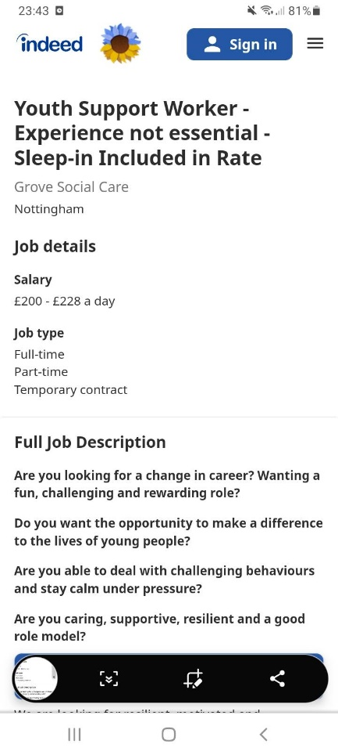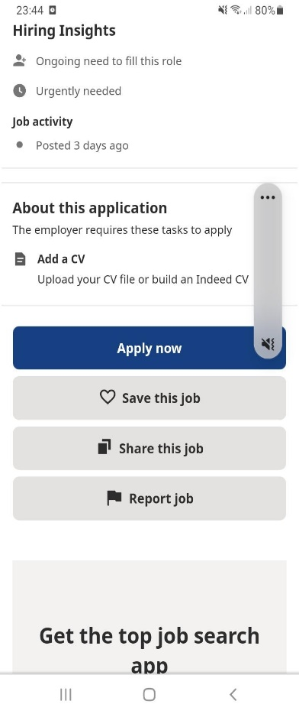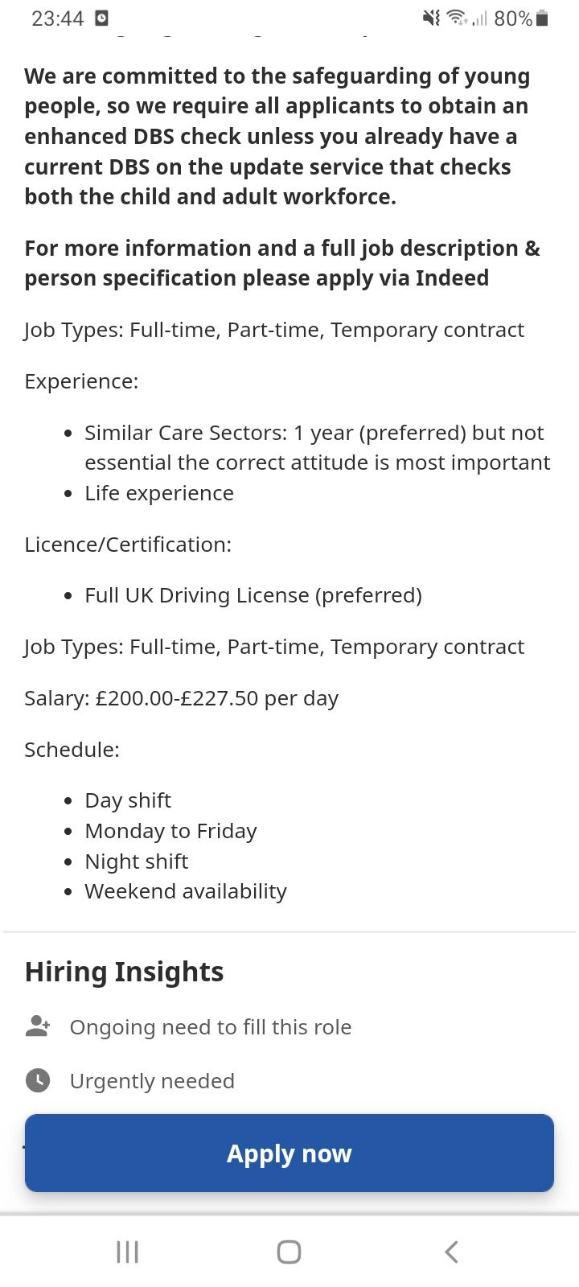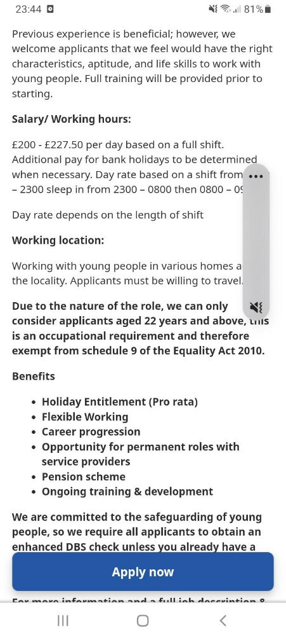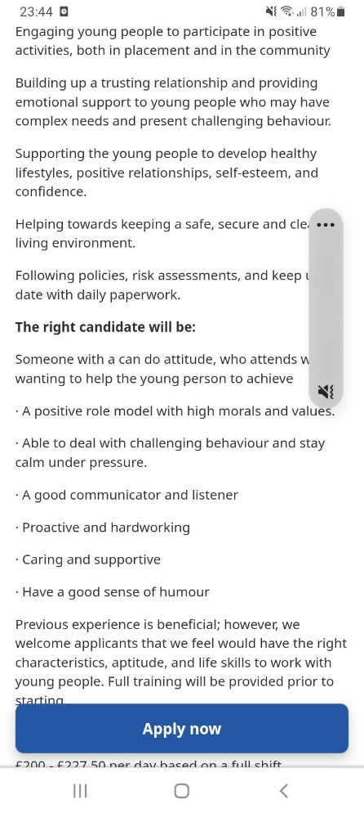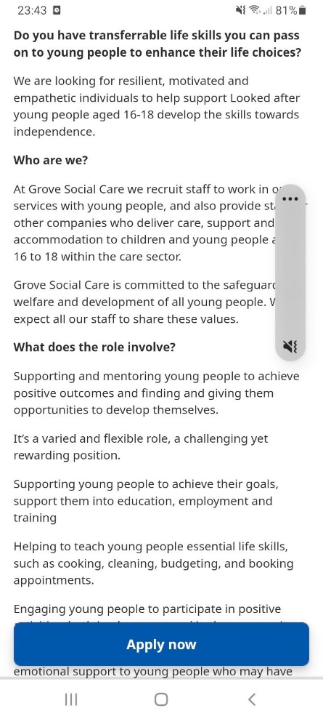
Nabilla Ravina
29, Brompton Pool Road
B28 0SJ Birmingham
West Midlands

To,
The HR Manager
Grove Social Care
14-16 Cowgate
Peterborough PE1 1NA
Nottingham
22-10-2022

Dear Sir/Madam
Application for the post of Youth Support Worker.
I wish to apply for the post of Copy Youth Support Worker which was advertised in Indeed.com this week.
Currently I am completing my Level 4 in Health and Social Care at the University of Wales Trinity Saint David.
Although I have no experience in working in this sector, I have quite a broad experience in dealing with people and handling tricky situations.
I have worked as a teacher before and have 23 years of experience as an English language journalist starting off as a reporter, before moving on to become a writer, an editor and eventually content editor-in-chief for coffee table books.
These past experiences have made me more experienced in dealing with people and in handling difficult situations as I had to manage children when I was teaching and went on to manage reporters when I was an editor.
Also, I am able to write proper reports and am flexible, motivated, and ready to learn as well as a keen team player.
I look forward to hearing from you.
Yours Faithfully
………………………….
Nabilla Ravina (Ms)
E-mail: nazrisonma@yahoo.com
Phone Number: 07400489832

Personal Profile
I have about 23 years of experience in Journalism with experience over a wide spectrum in this field such as writing and editing news and feature articles as well as producing coffee table books. I am meticulous, creative and flexible in executing my work. I am able to work independently, work as a team player and/or lead a team. I am able to meet deadlines, achieve company targets, and provide ideas and consultation for the purpose of marketing and development strategies.
Key Skills
• News writing and editing
• Travel and Tourism Feature Writing and Editing
• Translation Malay to English or English to Malay
• Coffee Table Books and Travel Magazines content production
Employment History
1989 – 1994 TOESL Teacher Education Department Malaysia
• Teaching English to pupils from Year 1 to Year 6
• To enable pupils with limited or no knowledge of English to achieve some form of communications skills on his language or at least to be able to use it as a second language

1994 – 2000 News Reporter The Sun Media Corporation
• Writing news stories sourced from attending events, special invites and press conferences.
• Sourcing breaking news stories, court news reporting, writing business news articles, tourism related news and feature articles
2000 – 2002 Features Writer The Sun Media Corporation
• Writer for tourism articles about Malaysia, fashion and personal products launches.

2003 -2005 Editor Venture Asia Sdn Bhd
• In charge of writing for the Malaysia Section of its Tourism Asia magazine which was internationally distributed
• Developed and wrote Tourism Malaysia's advertorials for this magazine as well as Silkwinds (the inflight magazine for Silk Air)
2006 -2007 Magazine Editor Kumpulan Karangkraf
• To revamp and revitalise the magazine and ensure it met international standards.
• Involved in magazine's sales and advertisements, promotional events, quality control, public relations with clients and marketing, apart from the normal Editorial duties
• Managing a team of reporters
• Creating new content for monthly issues
• Managing and directing photography for feature articles and front cover
• Directing layout for magazine
2006 -2008 Editor Virtual Malaysia
• Revamped and revitalised the magazine to ensure it met international standards
• Promote and assist magazine's sales and advertisements, promotional events, quality control, public relations with clients and marketing, apart from the normal Editorial duties
• Cover assignments and manage a team of writers and photographers
2009 -2015 English Language Editor Redz Communications
• Editor for English Section of State Government Newsletter Suara Perak
• Editor and writer for news portal Perak News
• Responsible for the production of coffee table books’ content
• Created ongoing tour company called Ipoh Secrets
• Translate news from Malay to English for print media and internet news scripts

Education
• Primary: King Edward VII, Taiping 1969- 1975
• Secondary: La Salle, Petaling Jaya 1976-1980, Buking Bintang School, Petaling Jaya 1981 - 1982
• College: Teachers Training College Seri Pinang, Pulau Pinang 1987 – 1989
• Level 1 Horticulture Birmingham Metropolitan College 2017 (March - April)
• Level 1 Retail Knowledge Birmingham Metropolitan College September 2017
Hobbies and Interests
• Gardening, Cooking, Travelling
References Available on Request

