Daniel Cooksley – 2008898- L4

Introduction to Web and Database Concepts

20th of April 2021

Contents
Daniel Cooksley - 2008898 1
L4 - Introduction to Web and Database Concepts 1
Abstract: 3
Requirements: 3
Implementation: 3
Validation: 6
Evaluation 7
References (IEEE) 8
Appendices – 9

Abstract:

My aim of this assignment is to design and code a user-friendly website given a chosen idea. I have chosen to design and code a website around the game called “The Division 2”. I will use HTML and CSS to code and style my website. I will be choosing a subcategory of the game called “factions” as their different factions, friendly and enemy. I will be choosing to design my website around the current enemy factions in The Division 2, giving a brief description of each enemy faction.

Requirements:

My website consists of a home page (index) and 4 links to the enemy factions within The Division 2, each page describes who the enemy factions are.
My website is based around the current standings of enemy factions within The Division 2. I believe this to be useful to the lore of the game as all factions, friendly and enemy have a back story. My targeting audience are those who would like to know more of the backstory of the enemy factions and the lore of them becoming enemies of The Division.

Implementation:

[1]index.html –
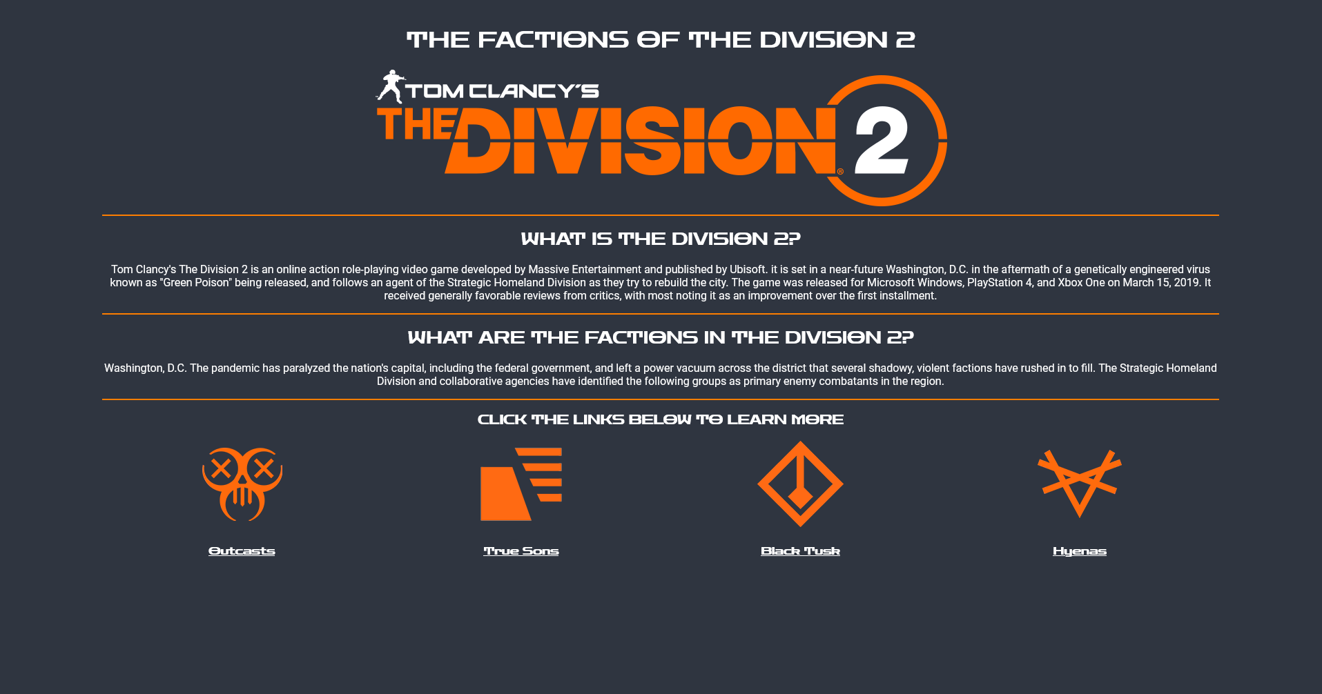

[4]Outcasts.html –
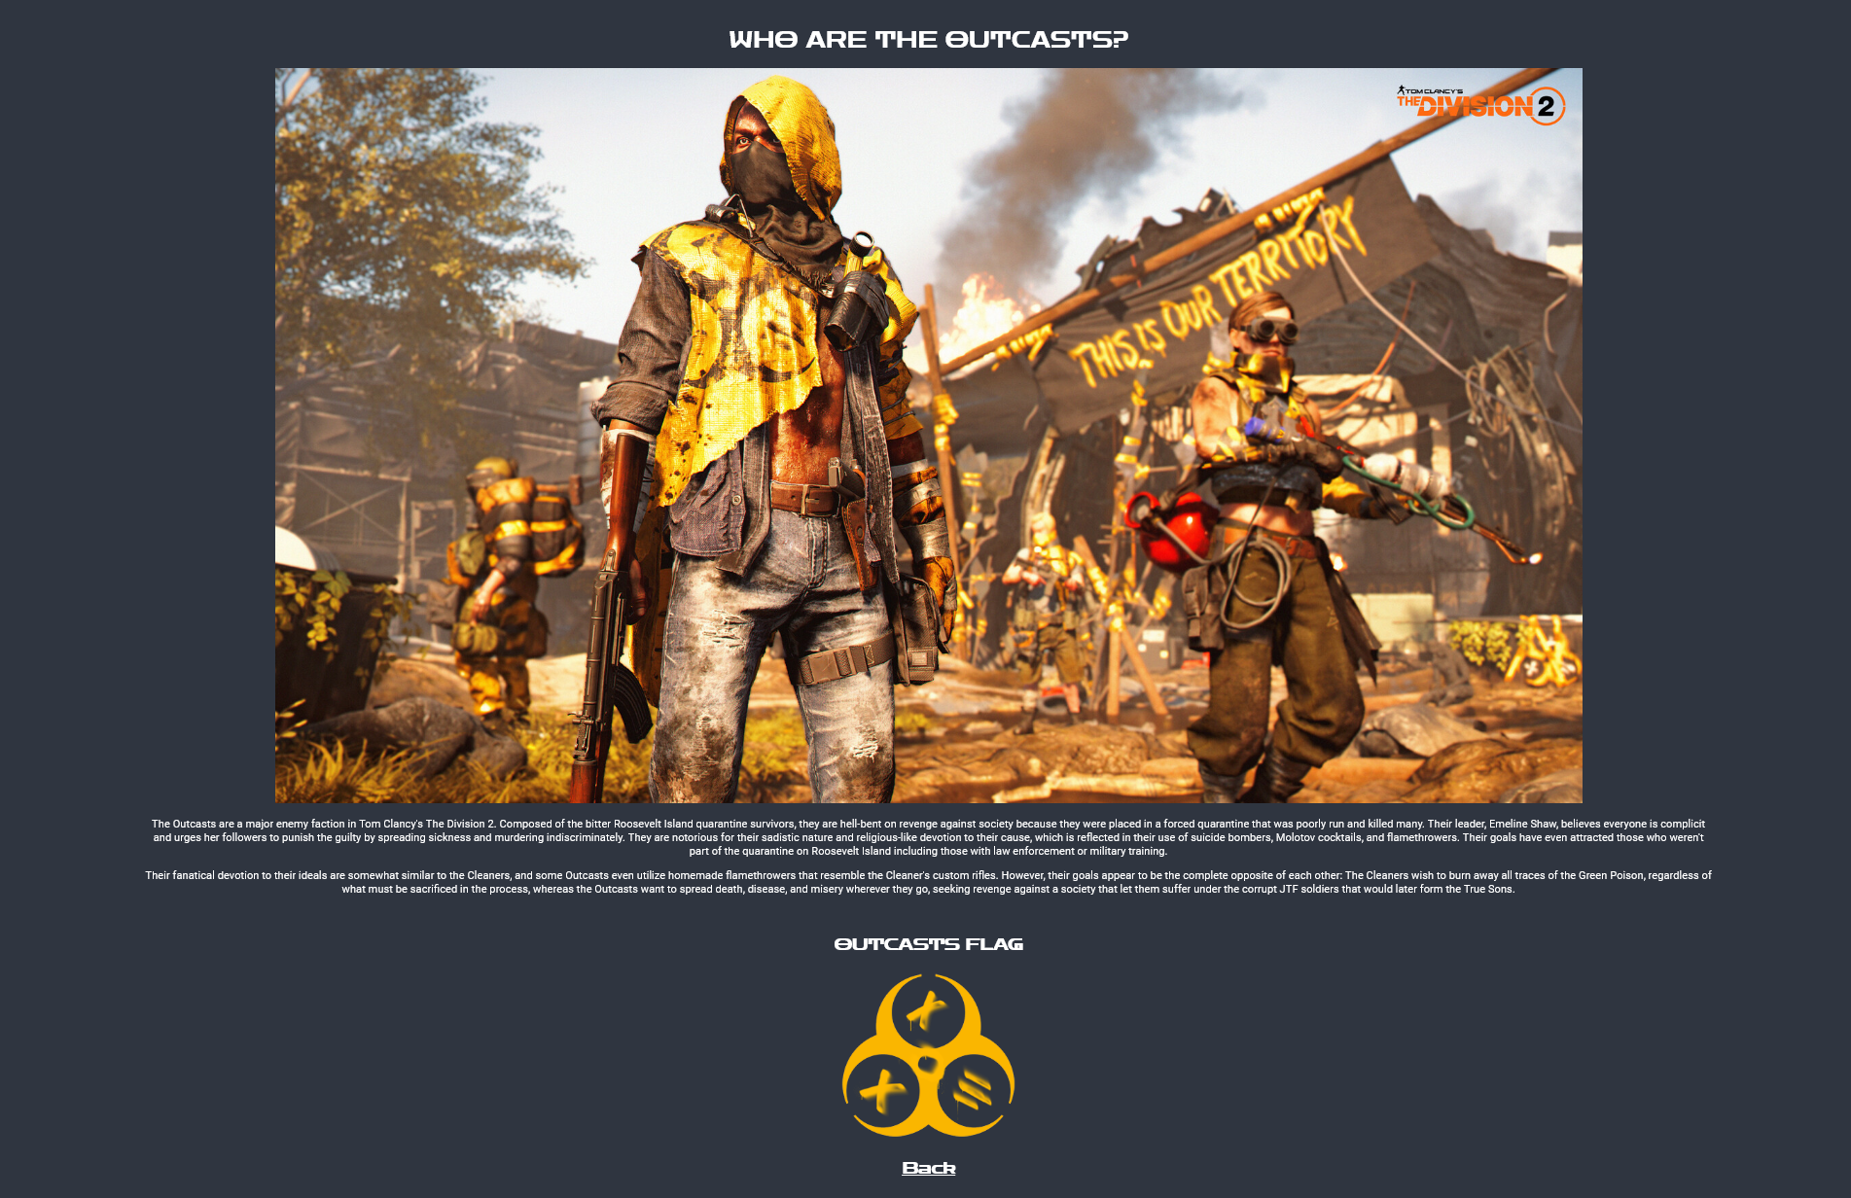
[5]truesons.html –
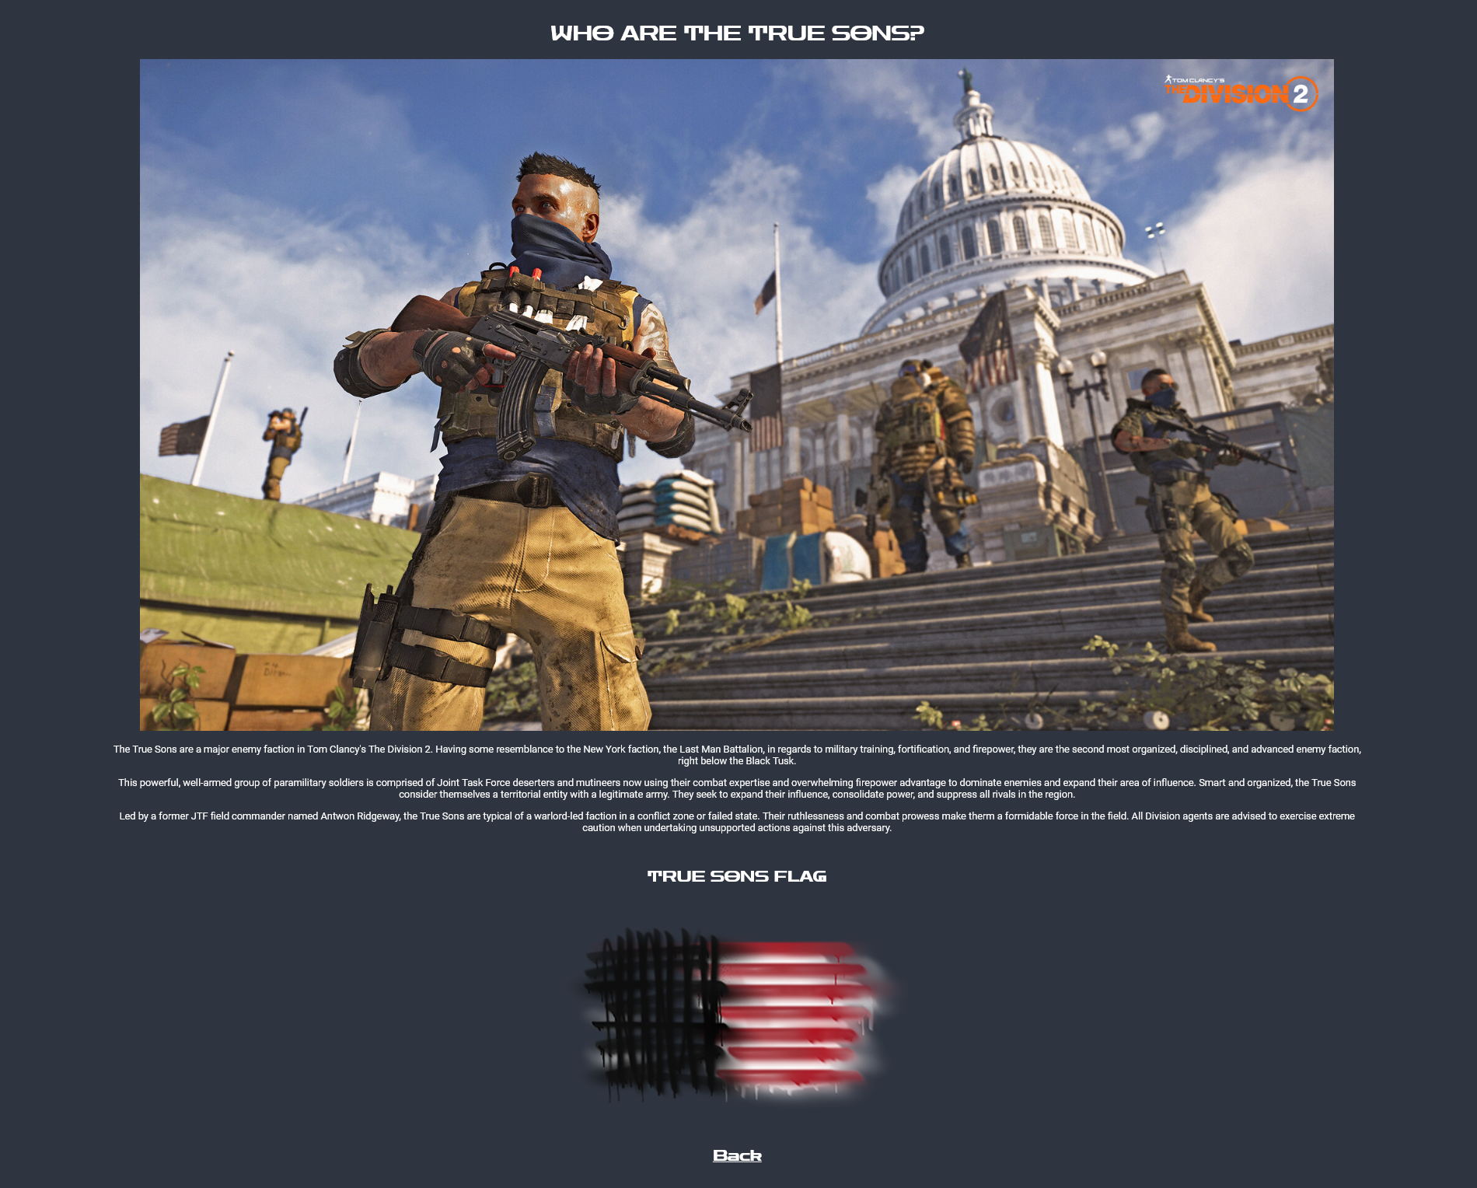

[2] blacktusk.html –
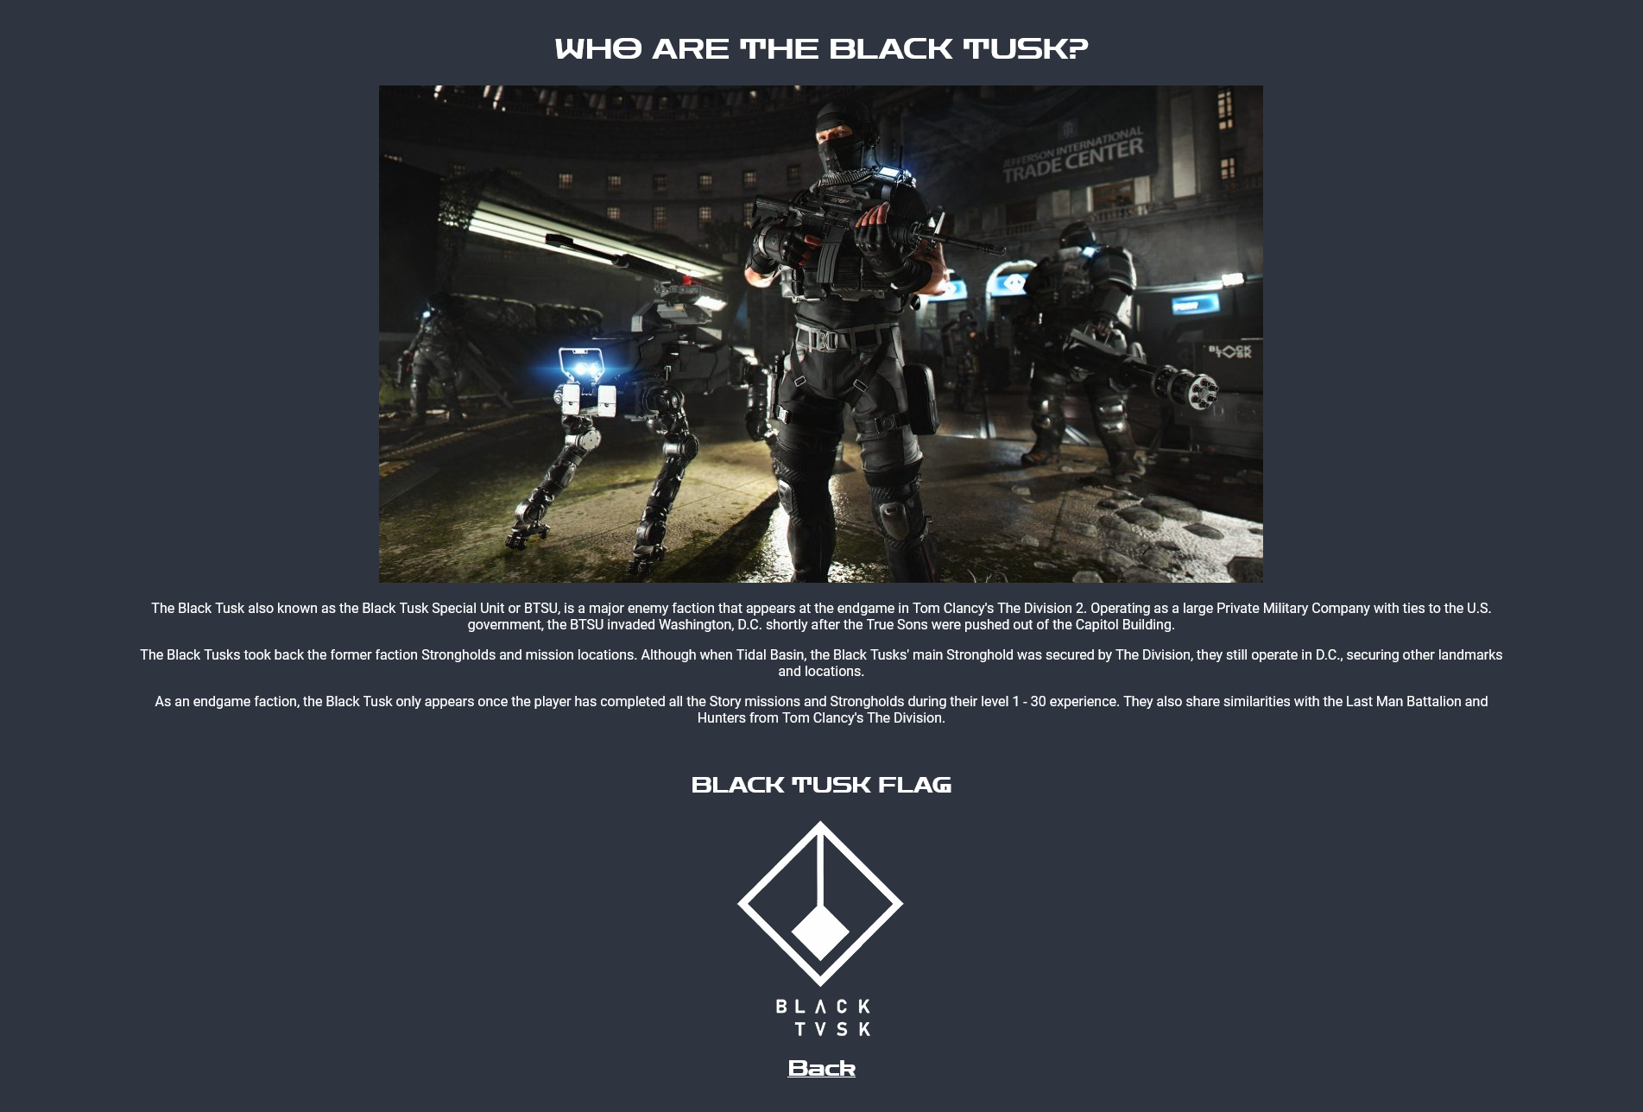
[3]hyenas.html –
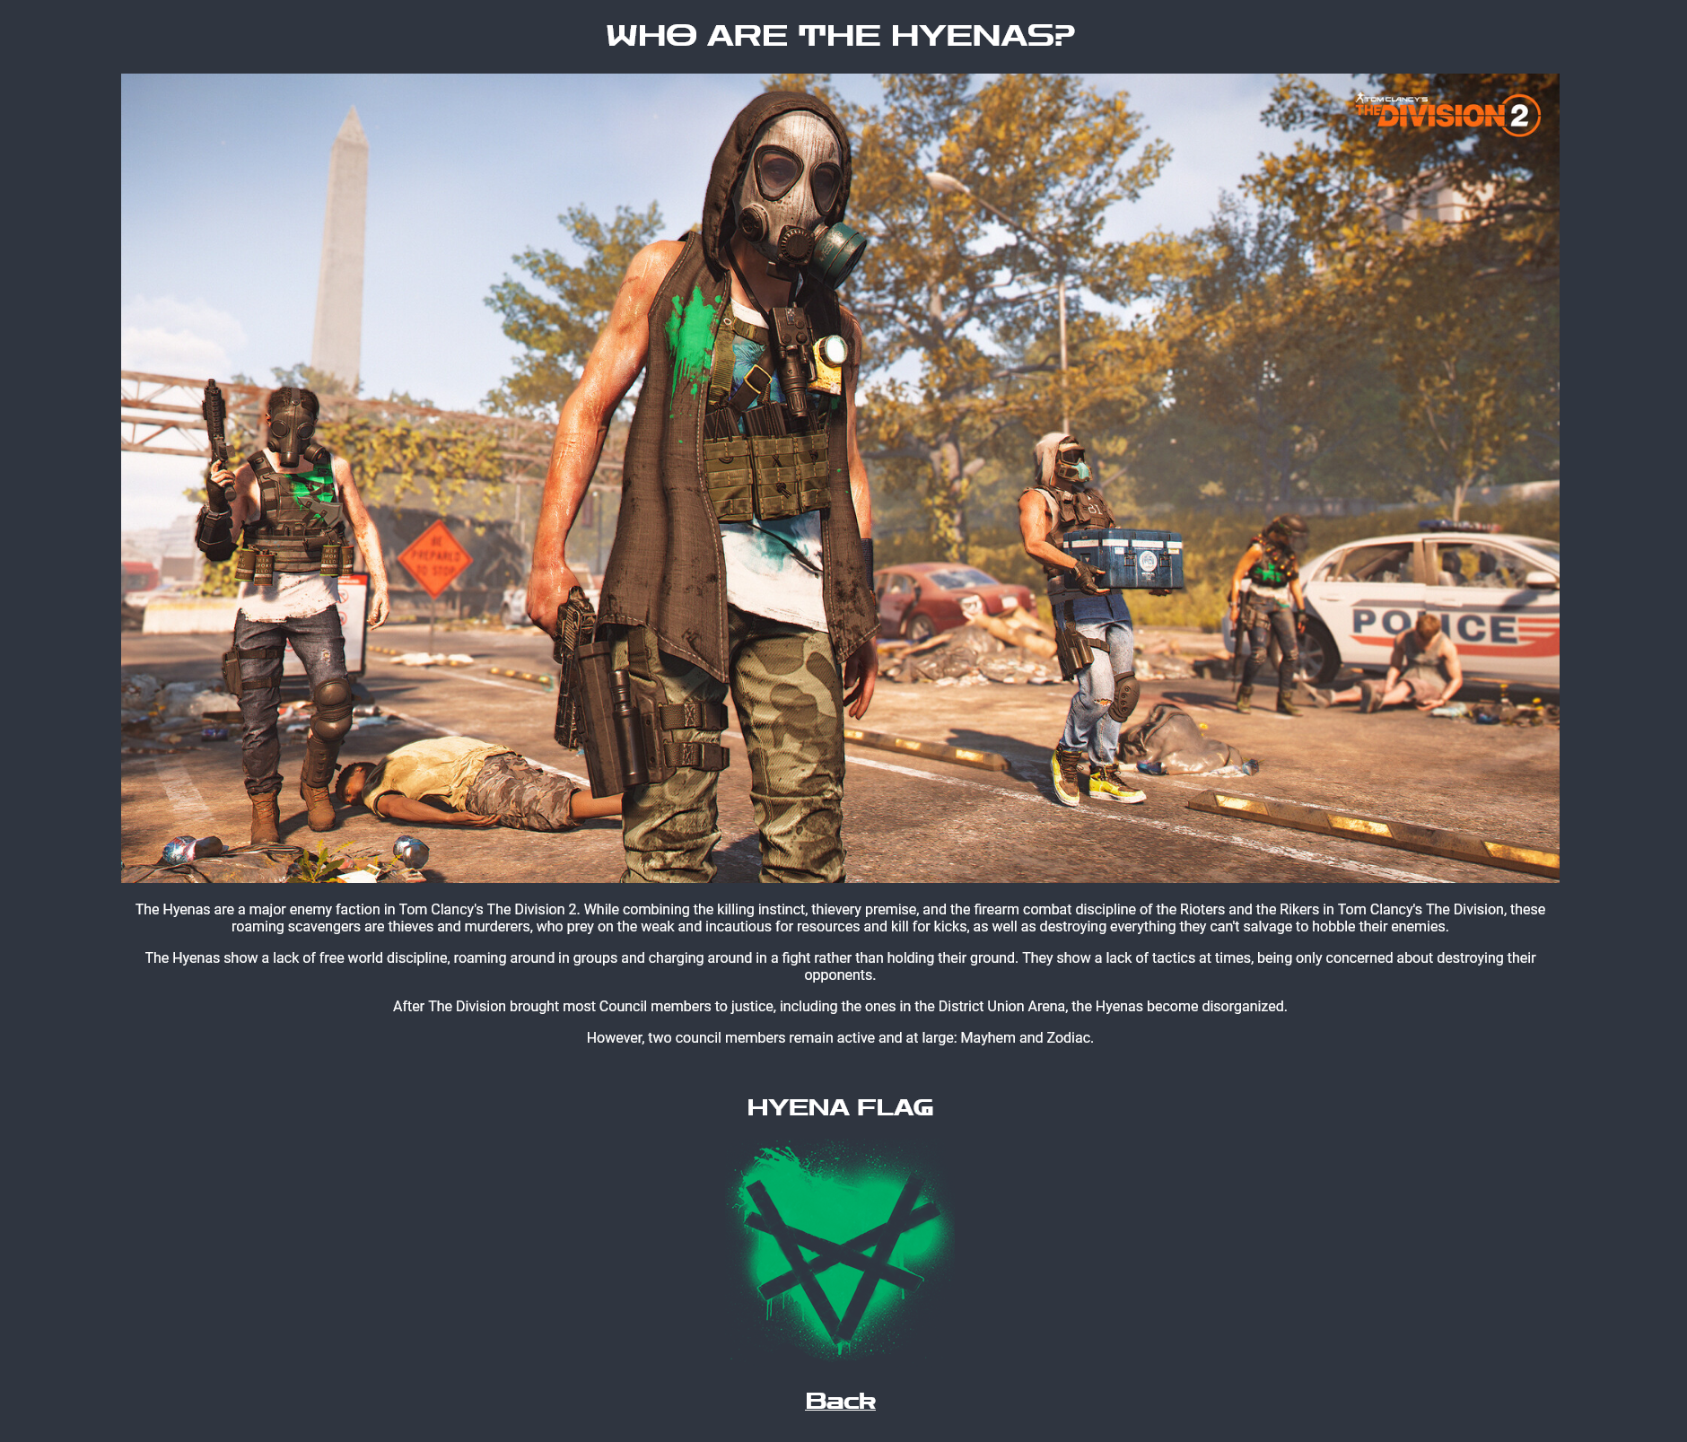

Validation:

Validating my HTML,
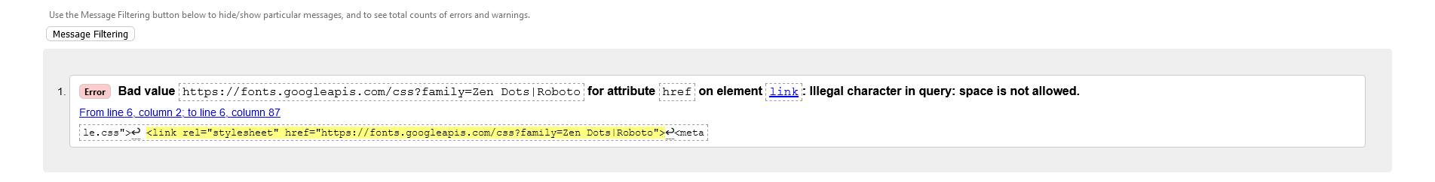
As you can see from the screenshot above of my index.html there has been one “Bad Value” I believe this to be a mistake as the naming convention of the google font must be implemented with the space between the Zen and the Dots. I tried to rectify this “Bad Value” by putting the HTML equivalent of space “%20” I do however get another bad value as shown below.
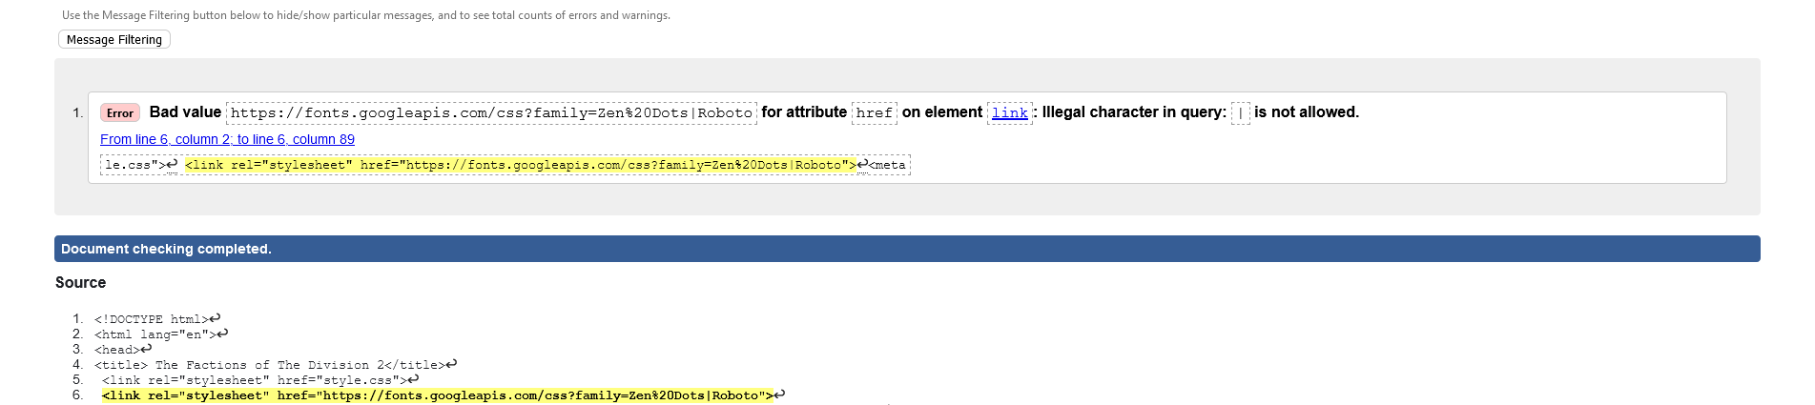

What the above screenshots do not show is two errors I had that were rectified using two lines of code. I had no language associated with my HTML, I added the line the code “<html lang="en">”
The second error that I had was defined as no alt text on the images placed with the website. The original code showed as follows “<img src="images/outcasts.jpg" class="images"”. To add ALT text to the images for use of accessibility I add the correct line of code which shows as “<img src="images/outcasts.jpg" class="images" alt="Outcasts Picture">” I applied this coding convention to every image within the code.

Validating my CSS,
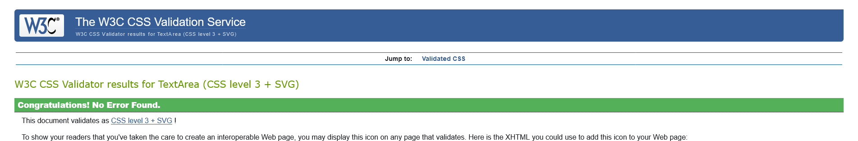
As you can see from the screen shot above, my CSS has no errors or warnings and is 100% accurate as per coding convention.

Evaluation

- Usefulness – I believe my website to be useful for specific information around the chosen target audience, the information is for education purposes and holds no weight of making you better at the video game. The target audience can get compressed information easily using the navigation tools and the short textual paragraphs based around each faction.
  - I would make the website more user friendly by reducing the size of the images on each page this allow the user not having to scroll down to find the information.

- [6] Search Engine Optimisation (SEO) – I have used two HTML tags that are included in the SEO therefore increasing my optimisation of my HTML these tags are as follows:
  - Title Tag – within my index.html I have the title tag as follow “<title> The Factions of The Division 2</title>” If someone were to search for factions of division 2 or division 2 factions the, they could find my website using the title tag that I have implemented.
  - Headings – within my code of the website I have multiple uses of title tags. I have listed some examples below:
    - <h1> THE FACTIONS OF THE DIVISION 2 </h1>
    - <h2> WHAT IS THE DIVISION 2? </h2>
    - <h3> CLICK THE LINKS BELOW TO LEARN MORE </h3>
    - <h1> WHO ARE THE OUTCASTS? </h1>

- Accessibility – to check my accessibility I used http://contrastchecker.com/ as per the image below, you can see that the contrast based around the colours of the foreground and background are high contrast creating a user-friendly interface and experience.
[7]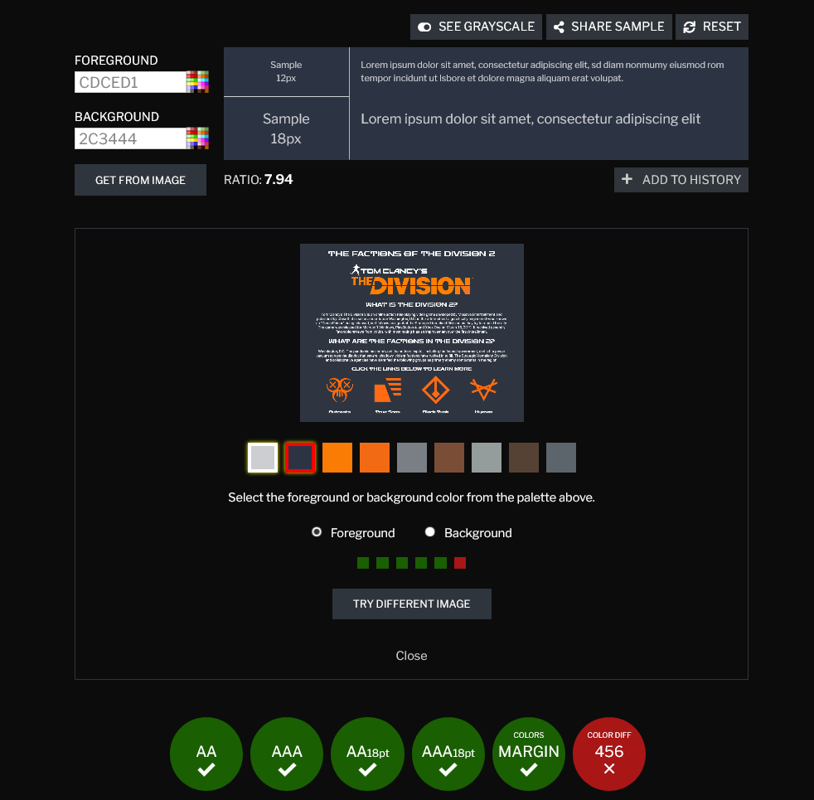

References (IEEE)

[1] The Division Wiki. 2021. Tom Clancy's The Division 2. [online] Available at: <https://thedivision.fandom.com/wiki/Tom_Clancy%27s_The_Division_2> [Accessed 26 April 2021].
[2] The Division Wiki. 2021. Black Tusk. [online] Available at: <https://thedivision.fandom.com/wiki/Black_Tusk> [Accessed 26 April 2021].
[3] The Division Wiki. 2021. Hyenas. [online] Available at: <https://thedivision.fandom.com/wiki/Hyenas?file=Abrar-khan-tctd2-screenshot-faction-hyenas.jpg> [Accessed 26 April 2021].
[4] The Division Wiki. 2021. Outcasts. [online] Available at: <https://thedivision.fandom.com/wiki/Outcasts?file=Abrar-khan-tctd2-screenshot-faction-outcasts.jpg> [Accessed 26 April 2021].
[5] The Division Wiki. 2021. True Sons. [online] Available at: <https://thedivision.fandom.com/wiki/True_Sons?file=Abrar-khan-tctd2-screenshot-faction-truesons.jpg> [Accessed 26 April 2021].
[6] Link-assistant.com. 2021. 8 HTML Tags Essential for SEO. [online] Available at: <https://www.link-assistant.com/news/html-tags-for-seo.html#anchor5> [Accessed 26 April 2021].
[7] Contrast Checker. 2021. WCAG - Contrast Checker. [online] Available at: <https://contrastchecker.com/> [Accessed 26 April 2021].

Appendices –

Index.html
<!DOCTYPE html>
<html lang="en">
<head>
<title> The Factions of The Division 2</title>
<link rel="stylesheet" href="style.css">
<link rel="stylesheet" href="https://fonts.googleapis.com/css?family=Zen%20Dots|Roboto">
<meta name="description" content="A website explaining the factions in the game called The Division 2">
</head>
<body>
<div class="main">

<h1> THE FACTIONS OF THE DIVISION 2 </h1>

<img src="images/logo.png" id="logo" alt="Main Logo">
<hr class="line">
<h2> WHAT IS THE DIVISION 2? </h2>

<p> Tom Clancy's The Division 2 is an online action role-playing video game developed by Massive Entertainment and published by Ubisoft.
it is set in a near-future Washington, D.C. in the aftermath of a genetically engineered virus known as "Green Poison" being released,
and follows an agent of the Strategic Homeland Division as they try to rebuild the city. The game was released for Microsoft Windows,
PlayStation 4, and Xbox One on March 15, 2019. It received generally favorable reviews from critics, with most noting it as an improvement
over the first installment.</p>

<hr class="line">
<h2> WHAT ARE THE FACTIONS IN THE DIVISION 2? </h2>

<p> Washington,
D.C. The pandemic has paralyzed the nation's capital, including
the federal government, and left a power vacuum across the district
that several shadowy, violent factions have rushed in to fill.
The Strategic Homeland Division and collaborative agencies have
identified the following groups as primary enemy combatants in the region.
</p>

<hr class="line">
<h3> CLICK THE LINKS BELOW TO LEARN MORE </h3>

<div class="container">

<div class="faction">
<a href="outcasts.html">
<img src="images/outcasts-logo.jpg" alt="Outcasts Logo" class="factionlogo">
<h4> Outcasts </h4>
</a>
</div>

<div class="faction">
<a href="truesons.html">
<img src="images/truesons-logo.png" alt="Truesons Logo" class="factionlogo">
<h4> True Sons </h4>
</a>
</div>

<div class="faction">
<a href="blacktusk.html">
<img src="images/blacktusk-logo.png" alt="Black Tusk Logo" class="factionlogo">
<h4> Black Tusk </h4>
</a>
</div>

<div class="faction">
<a href="hyenas.html">
<img src="images/hyenas-logo.png" alt="Hyenas Logo" class="factionlogo">
<h4> Hyenas </h4>
</a>
</div>

</div>

</div>

</body>
</html>

style.css
.main {
width: 85%;
margin: auto;
text-align: center;
padding: 10px;
}
body {
background-color:#2F3540;
color: #ffffff;
font-family: "Roboto", serif;
}
#logo {
max-width: 100%;
height: auto;
}
h1,h2,h3,h4 {
font-family: "Zen Dots", serif;
}
.container{
width:100%;
height:100%;
}
.faction {
width:25%;
height:100%;
float:left;
}
.images{
max-width: 100%;
}
a:link {
color: #ffffff;
}
a:visited {
color: #ffffff;
}
a:hover {
color: #FE7E00;
}
.factionlogo {
max-width: 65%;
height: auto;
}
.line {
border-top: 1px solid;
color: #FE7E00;
}

outcasts.html
<!DOCTYPE html>
<html lang="en">
<head>
<title> Outcasts</title>
<link rel="stylesheet" href="style.css">
<link rel="stylesheet" href="https://fonts.googleapis.com/css?family=Zen Dots|Roboto">

</head>
<body>
<div class="main">

<h1> WHO ARE THE OUTCASTS? </h1>

<img src="images/outcasts.jpg" class="images" alt="Outcasts Picture">

<p> The Outcasts are a major enemy faction in Tom Clancy's The Division 2.
Composed of the bitter Roosevelt Island quarantine survivors,
they are hell-bent on revenge against society because
they were placed in a forced quarantine that was poorly run and killed many. Their leader, Emeline Shaw, believes everyone is complicit and urges her followers to punish the guilty by spreading sickness and murdering indiscriminately. They are notorious for their sadistic nature and religious-like devotion to their cause, which is reflected in their use of suicide bombers, Molotov cocktails, and flamethrowers. Their goals have even attracted those who weren't part of the quarantine on Roosevelt Island including those with law enforcement or military training.
</p>
<p>
Their fanatical devotion to their ideals are somewhat
similar to the Cleaners, and some Outcasts
even utilize homemade flamethrowers that resemble
the Cleaner's custom rifles. However, their goals appear
to be the complete opposite of each other: The Cleaners
wish to burn away all traces of the Green Poison,
regardless of what must be sacrificed in the process,
whereas the Outcasts want to spread death, disease,
and misery wherever they go, seeking revenge against
a society that let them suffer under the corrupt JTF
soldiers that would later form the True Sons.
</p>

<br>
<h2> OUTCASTS FLAG </H2>
<img src="images/outcasts2.png" alt="Outcasts Flag">

<a href="index.html">
<h2>Back</h2>
</a>

</div>
</body>
</html>

truesons.html
<!DOCTYPE html>
<html lang="en">
<head>
<title> True Sons</title>
<link rel="stylesheet" href="style.css">
<link rel="stylesheet" href="https://fonts.googleapis.com/css?family=Zen Dots|Roboto">

</head>
<body>
<div class="main">

<h1> WHO ARE THE TRUE SONS? </h1>

<img src="images/truesons.jpg" class="images" alt="True Sons Picture">

<p> The True Sons are a major enemy faction in Tom Clancy's The Division 2. Having some resemblance to the New York faction, the Last Man Battalion, in regards to military training, fortification, and firepower, they are the second most organized, disciplined, and advanced enemy faction, right below the Black Tusk.
</p>
<p>
This powerful, well-armed group of paramilitary soldiers is comprised of Joint Task Force deserters and mutineers now using their combat expertise and overwhelming firepower advantage to dominate enemies and expand their area of influence. Smart and organized, the True Sons consider themselves a territorial entity with a legitimate army. They seek to expand their influence, consolidate power, and suppress all rivals in the region.
</p>
<p>
Led by a former JTF field commander named Antwon Ridgeway, the True Sons are typical of a warlord-led faction in a conflict zone or failed state. Their ruthlessness and combat prowess makes them a formidable force in the field. All Division agents are advised to exercise extreme caution when undertaking unsupported actions against this adversary.
</p>

<br>
<h2> TRUE SONS FLAG </H2>
<img src="images/truesons2.png" alt="True Sons Flag">

<a href="index.html">
<h2>Back</h2>
</a>

</div>
</body>
</html>

blacktusk.html
<!DOCTYPE html>
<html lang="en">
<head>
<title> Black Tusk</title>
<link rel="stylesheet" href="style.css">
<link rel="stylesheet" href="https://fonts.googleapis.com/css?family=Zen Dots|Roboto">

</head>
<body>
<div class="main">

<h1> WHO ARE THE BLACK TUSK? </h1>

<img src="images/blacktusk.jpg" class="images" alt="Black Tusk Picture">

<p> The Black Tusk also known as the Black Tusk Special Unit or BTSU, is a major enemy faction that appears at the endgame in Tom Clancy's The Division 2. Operating as a large Private Military Company with ties to the U.S. government, the BTSU invaded Washington, D.C. shortly after the True Sons were pushed out of the Capitol Building.
</p>
<p>
The Black Tusks took back the former faction Strongholds and mission locations. Although when Tidal Basin, the Black Tusks' main Stronghold was secured by The Division, they still operate in D.C., securing other landmarks and locations.
</p>
<p>
As an endgame faction, the Black Tusk only appears once the player has completed all the Story missions and Strongholds during their level 1 - 30 experience. They also share similarities with the Last Man Battalion and Hunters from Tom Clancy's The Division.
</p>

<br>
<h2> BLACK TUSK FLAG </H2>
<img src="images/blacktusk2.png" alt="Black Tusk Flag">

<a href="index.html">
<h2>Back</h2>
</a>

</div>
</body>
</html>

hyenas.html
<!DOCTYPE html>
<html lang="en">
<head>
<title> Hyenas</title>
<link rel="stylesheet" href="style.css">
<link rel="stylesheet" href="https://fonts.googleapis.com/css?family=Zen Dots|Roboto">

</head>
<body>
<div class="main">

<h1> WHO ARE THE HYENAS? </h1>

<img src="images/hyenas.jpg" class="images" alt="Hyenas Picture">

<p> The Hyenas are a major enemy faction in Tom Clancy's The Division 2. While combining the killing instinct, thievery premise, and the firearm combat discipline of the Rioters and the Rikers in Tom Clancy's The Division, these roaming scavengers are thieves and murderers, who prey on the weak and incautious for resources and kill for kicks, as well as destroying everything they can't salvage to hobble their enemies.
</p>
<p>
The Hyenas show a lack of free world discipline, roaming around in groups and charging around in a fight rather than holding their ground. They show a lack of tactics at times, being only concerned about destroying their opponents.
</p>
<p>
After The Division brought most Council members to justice, including the ones in the District Union Arena, the Hyenas become disorganized.
</p>
<p>
However, two council members remain active and at large: Mayhem and Zodiac.
</p>

<br>
<h2> HYENA FLAG </H2>
<img src="images/hyenas2.png" alt="Hyenas Flag">

<a href="index.html">
<h2>Back</h2>
</a>

</div>
</body>
</html>

