Workplace culture and its impact on organisation

Module code: BMSW 5105

Name: Jane Nakitto

Student ID: 2008466

Word count: 4200

Submission date: 06/05/22

Executive summary

This report is based on Primark, a renowned clothing brand that is running globally with its 392 stores. By choosing Primark as a case study, workplace culture of a business along with its impact on the organisational efficiency where various management models, theories and methods is demonstrated along with how it can impact the work culture and boost business efficiency. All the theories and model justified within this report also taken COVID-19 scenario into considerations where critical analysis are carried out adequately. Further, at the end of the report, a reflective essay is included to show learning and acquired skills of the module.

Table of Contents

Executive summary 2
1.0 Introduction 4
2.0 Main body 5
2.1 Chosen business for this report 6
2.2 Key analytical tool/framework 6
2.3 External factor of environment and PESTLE 7
2.4 External factors which can influence or affect the business 7
2.5 Applying PESTLE framework to Primark 8
2.6 Porters five forces of Primark 10
2.7 Workplace culture of Primark 11
2.8 Link between current workplace culture and its efficiency to achieve financial and non-financial performance 12
2.9 Ethical dilemma 13
2.10 Justification 14
3.0 Conclusion 14
Task 2 14
2.1 Reflective essay 14
4.0 REFERECNES 16
Appendices 18
Appendix one 18
Semi-structure interview questions 18
Respondents identity 18

1.0 Introduction

This report is based on the workplace culture of a business along with its impact on the organisational efficiency where various management models, theories and methods will be used to demonstrate how it can impact the work culture and boost business efficiency. On the other hand, this report was supported by a scenario where COVID-19 used as a background. The scenario is, due to pandemic various external environment elements has changed that has transformed corporate culture to adopt new strategies. As a result, workplaces tuned into work from home places, table meetings turned into Zoom call meeting which is still going on after the restriction. Therefore, many researcher’s analysis indicates this will last forever which hold challenges for corporate world along with opportunities (FCA, 2021)

Due to that “new normal” if adopted effectively leaders would be able to use these changes to build a resilient culture if not business would fail in a long run. Taking that into consideration the file dog study will choose an organisation where researcher have worked before and will answer “how the broader external environmental factors with COVID-19 and ethical dilemmas affect organisational culture and its performance”

Hitherto, to achieve the insight of the allocated task, the field of study has chosen Primark as a case study where researcher have worked before. The reason for choosing this business is researcher is well aware about the internal factors of the business and it would be easy to demonstrate and explain how the external factor have impacted the specially with COVID-19 affect the culture of business and its performances. All the information gathered within the report will be referenced accordingly by following university guidelines to avoid collusion.

2.0 Main body

2.1 Chosen business for this report

Primark is a global clothing retail brand that operating it business throughout UK, Ireland, Germany, Netherland, Portugal and Belgium with their more than 392 stores which is headquartered in Dublin, Ireland. That company was first started its operation back in 1969 by Arthur Ryan and spread its operation in England in 1973 and offering diverse range of products such as clothing, menswear, womenswear, homeware, footwear, confectionary and beauty products (Primark, 2022). The company is well-known for selling budget clothing and operation of business turned successful for sourcing cheaply, making cloth with simple design, bulking stock in huge bulk as a result, the company have developed itself a business that offer fashionable product with cutthroat process (BBC, 2021).
The business spread very quickly throughout the major locations due to it quick profit and income margin that led business to open store in regional and local areas. Due to the success of the business, soon Primark started to understand relevant consumers demand and global trends by developing effective management structure and business scheme. In 2010, the business has been awarded “Retailer of the year” and currently running nearly 400 stores in major locations (Primark, 2022).

2.2 Key analytical tool/framework

Environmental scanning meaning, gathering information from inside and out of the business such as internal and external environment through careful monitoring to identify future opportunity and threats (Van, 2022). It is basically the elements which can impact the operation of the business (Gheibi ET AL, 2018) Hitherto, to scrutinize the COVID-19 aftermath of Primark the field of study has chosen PESTLE analysis.
The term PESTLE stands for factors like, Political, Economic, Socio-logical, Technological, Environmental and Legal. This tool is adopted by many business in last 25 years and establishing its history is difficult (Van, 2022) The reason for choosing PESTLE analysis as a key analytical tool is, it is widely used by wide range of companies for business tactics such as marketing planning, strategic planning, product development and research reports. Adopting this tool a business can get into insight of business environment where they operate in as well as take advantages of the opportunities while reduce the potential threats effectively (Gheibi et al, 2018).
It also ought to be noted that, PESTLE analysis is an external environmental tool which can influence the internal element of business which eventually can guide business with strategic decision making. The main purpose of PESTLE is to audit the current environment as well as assess the potential changes through which business can place and position itself step ahead of the rivals to respond the changes quickly (Van, 2022) The PESTLE analysis considers as one of the most useful and effective environmental tool that se the bigger picture of the environment where business run its operation by understanding the possible risks, growth or decline. The PESTLE analysis is always been used as a generic orientation tool that figure out where does organization currently stand and what is happening externally could impact the business internally (Ahsan, 2021).

2.3 External factor of environment and PESTLE

The word environment indicates, the surrounding conditions and atmosphere for the business existence and it is very important for the organizational leaders to understand and know the environment before they start doing business operation. The external factor of the environment are sort of factor which are not under the control of the business and the factors incorporates political stability, social environment, government regulations, technological environment, rules and legislations, resources economy, culture and demographics of people (Raven, 2015).
The external environment incorporates, all the exterior elements which might hand an influence over the working condition of business. The external environment is also divided into two parts such as directly interactive and in-directly interactive (Grier D, 2014). Direct interactive is sort of environment which holds a firsthand and immediate impact towards the business whereas an in-direct interactive that holds secondary and distant impact towards the business. The factors of direct interactive environmental elements are owners, consumers, suppliers, employees and unions whereas factors of in-direct interactives are, socio-cultural forces, legal and political, economic and technological forces which might have impact on one business than another due to its operational nature (Kushwah 2018).

2.4 External factors which can influence or affect the business

Political: this comprises changes in government policies and legislation which may affect the business.
Economic: it indicates how the economic situation of a nation affect the business in regard to government spending, taxation, general demand, exchange rates, interest’s rates and global and economic factors that impact the economy (Ahsan, 2021).
Social: this indicates how the households, consumers and community’s beliefs and behaves (Van, 2022).
Technological: in indicates the way rapid pace of changes within innovation and operation take place (Van, 2022).
Legal: in indicates the national legislation which affect the business such as change sin employment laws (Van, 2022).
Environmental: It refers, what is happening with respect of environmental and ecological issues such as climate and weather changes (Van, 2022).

2.5 Applying PESTLE framework to Primark

When it comes to accessing the political, social, economic, environmental, legal, technological and legal external factors in the light of Primark different issues need to be taken into considerations. Its ought to be noted that, business firm need to conform towards set of regulations and policies enforced via government when developing their business policies as well as social responsibility also taken into social responsibilities as a global consciousness. Environmental, economic, technology and laws are also inseparable entities in which business operations can get impacted (Raven, 2015). It should be taken into consideration, the economic stability of a destination can contribute a lot to overall business conditions like Primark and technology on the other hand, technology brought huge effect to the business development status such as marketing and operational program (Grier, 2014).
Political factors: the overall business of Primark during the time of COVID-19 was severe towards the business-like Primark which includes shut down of business activities, cut-off supply chain, social distancing rules, few employee availability, fear if infection and death, delayed signing agreements etc. have impacted Primark negatively. During the first wave of pandemic, the government have announced the lockdown throughout the nation where, business like Primark prompted 40% slump where the business has lost estimated £2b in revenue where the global adjusted profit fall 63% (BBC, 2021). Apart from that, government have completely cut-off supply chain from different nations. Primark which sources its product largely from Bangladesh which was a red list country as a result due to the cut-off the business has failed miserably to boost its online sales. Further, when the restriction ease, the business have faced huge amount of sick call from its workers due to fear of infection and death that eventually put business at risks to run its operation effectively. On the other hand, the only positive impact which helped business is grants, reduction in taxes, abolished business rates, 80% wages payment to the Primark employees during coronavirus crisis (Correspondent, 2020).
Economic factors: before the pandemic Primark has double it operation since 2008 however sudden strike of the pandemic put business in greater risks which had major impact on their sales. During the pandemic, the business was left with unemployment where strategy to develop productivity also failed (Ahsan, 2021). The major economic aspects that impacted Primark are, inflation and hike in price, disruption of business activities. As a result, CMF chief executives indicated “getting consumers into stores need high encouragement from Primark to generate its footfall” (BBC, 2021).
Sociological factors: Primark has received various awards for being the best clothing retailer for many years (Primark, 2022) where they always think about the consumer’s affordability. However, social trends after the pandemic has change surprisingly where most of the shopper now tend to buy online rather than going to the store. However, Primark online shopping experiences is not like other rivals which has not been updated according to the trends (BBC, 2021). Ageing population is another factor, most of the aged consumers group were regular consumers of Primark and most of the moms but significant amount of them are not likely to buy online from Primark as a result decrease in profit generation was seen (Simpson, 2021). Apart from that, some of the major social impact that Primark encountered was shutdown of store during lockdown, compulsory observance of social distancing, self-isolation, evolving new ways of cultural and social interactions, restriction of social liberties, emergence of strange social interactions all these social aspects has very deep impact which is not quick to achieve (Ahsan, 2021).
Technological factors: during the time of lockdown and after lockdown the signification rise has seen of online shopping and the business refuse to go online which cost the business £1b loses. Almost 190 UK Primark stores had no online arm like it rivals but despite seeing 30% of fall which is £2b in first 16 weeks of COVID the business failed to set up its exiting online shop where its rivals like ASOS and Boohoo rose its sales online by 40% in the last 4 months of 2020 (Simpson, 2021).
Environmental factors: due to the restriction of COVID use of bags, transection, interaction become very strange which also hit Primark hard. On the other hand, several restrictions of government in terms of delayed shipments also impacted the business negatively. Some of the major environmental impact that the business have come across during the time of pandemic are; increased environmental awareness of consumers, high concern about personal hygiene, maximized use of disinfections an sanitizers, proliferations of dangerous substance within public domain etc. has put business operation of Primark at risks (Simpson, 2021).
Legal factors: this factors of PESTLE are also linked with government legislation and regulations. As discussed earlier, shut down of business activities, cut-off supply chain, social distancing rules, few employee availability, fear if infection and death, delayed signing agreements etc. have impacted Primark negatively where business lost estimated £2b in revenue where the global adjusted profit fall 63% (BBC, 2021). Apart from that, some the major legal factors that affect the business are, increased use of force towards people and business, due diligence aspects of business, business reformation such as social distancing, mandatory masks, hand sanitizing all these legal aspects raise fear among consumers of Primark (Ahsan, 2021).

2.6 Porters five forces of Primark

Porters five of forcers was first developed by Michael E Porter from Harvard Business School back in 1979 which was consider as an environmental audit element bus focus on strategic business unit rather than single product. That makes it highly relevant to identify broader environmental element of Primark. The elements of porters five forces are discussed below;
Threat of new entrants
The major threat of Primark is ASOS and BooHoo as after the pandemic restriction and during the restriction both rival went up to 40% within their online sales where Primark failed miserably to attract new online shopping experiences to boost their sales (BBC, 2021).
Power of suppliers
Primark source their product from different small suppliers based in Bangladesh, India and China however, due to the restriction set by government during COVID-19 most of the shipment being cancelled and delayed that impact the business to loss £836 millions (BBC, 2022).

Bargaining power of buyer
Bargaining power was relatively low before the pandemic as Primark was major player that dominate the market unimaginably however, during COVID business like Burton, BooHoo, Asos came up with exiting products in cheaper price which attract most of the consumers and all that customer later turned into loyal consumers to respective brand which put Primark to have less power on consumers (Desklib, 2022).
Threat of substitute
Threat of substitute is relatively low as the type of product Primark sale, other business would not be able to supply it as a result the business will grow gradually again after the pandemic however, due failure in e-commerce Primark will suffer in long run if necessary strategy has not been undertaken after such mistakes (Desklib, 2022).
Competitive rivalry
Competitive rivalry of the business is high as similar business in different size are available with same price but the reputation and infrastructure of Primark is strong in compare to its rivals but rival’s activity needs to take into consideration carefully as todays small rivals can dominate future with right set of strategy. (Desklib, 2022).

2.7 Workplace culture of Primark

Being an ex-employee of Primark the research has enough understanding regarding how does internal management and work culture about Primark. However as per the instruction given by the lecturer, the filed of study has carried out semi-structure interview towards a sample size of Primark where two existing management employees and one customer service assistant has been chosen to gather first hand data regarding communication, management behavior, staffing, training and development. To comply with ethical perspective of the report, respondent identify will be keep confidential and asked questions set will be added on the appendix.
When asked about the communication, respondent 1 replied, “the communication is not very effective due to the length of the department and shortage of staff. All the managers want use to work hard but the way the store get busy it is not possible to manage all work in same pace”. As per the behavior is concern respondent 2 replied, “the management have two hierarchy one is autocratic another one is democratic. The top management always set goal for department managers which is autocratic in nature and due to the pressure department managers get sometimes the struggle with set goals as even though they are democratic with colleagues but sourcing enough colleague is not easy which making workplace toxic”. When, researcher asked about staffing, respondent 3 replied “the staffing procedure is very poor due to less living wages, all the department you go now you will see they are struggling with staff”. Finally, as per training and development is concern “regular reviews and supervision is not there due to intension to save more however we have written training policies but impications of it just in the book not in reality”

2.8 Link between current workplace culture and its efficiency to achieve financial and non-financial performance

Organizational culture is something that can be defined as “specific collection of norms and values that shared via group or people within the organization as well as control the way they interact with each other” (Fanggidaw, 2018). as discussed earlier there are two types of leadership are followed by Primark, autocratic and democratic. Out of hierarchy, market, clan and adhocracy, Primark follow Market version of culture in order to drive performances. Hence, Primark has always been accused they are been autocratic in nature towards department manager and department manager always been democratic towards normal colleagues. Reason being, in the market based hierarchy culture Primark sense the stability and security through driven results (Schnedlitz et al, 2022). The work cycle of Primark within the store is first Store manager, Operation manager, department manager and colleagues. The operation manager to achieve the goal always push department manager with set goals as a result sometimes department manager fail due to understaff. One of the reason why, department manager are failing to achieve the goal is, in Primark wages for colleagues are relatively low as a result getting store full of colleagues are tough which put tremendous pressure on colleagues (Fanggidaw, 2018).

Its ought to be noted that, organizational workplace structure is directly linked with the performance of business as discussed by Denison (1984) the strength of corporate culture is directly linked with the level of profit within the company.

To achieve business goal which is to become trusted retailer ever, Primark should work on their workplace culture by creating a formal structure where all the employees will be working together by supporting each other. Hence, Primark here need to work on their weakness of low wages, pressurized working environment, autocratic leadership style, adequate training for managers which are some of the aspects that mitigating Primark to achieve its desired financial and non-financial performances (BBC, 2021).

2.9 Ethical dilemma

An ethical dilemma is sort of problem within the process of decision making in the field of corporate strategy. Basically, corporate strategy always focus on how to management risks, resources and return over the firm which is as opposed to looking at the competitive advantages within business strategy between two possible options, neither of which is truly acceptable from the viewpoint of ethical perspectives (Ilya Kiriya et al, 2020).
One of the major ethical dilemma of Primark is cheap sourcing. 90% of Primark clothing come from Bangladesh where worker are working 16-18 hours a day to meet the target set by owners who are official suppliers of Primark. Sadly, these workers only getting £70 pound a month which is heart-breaking. The facilities within the garments in Bangladesh is horrible with no labour laws and health and safety (Ethical Consumer, 2018).
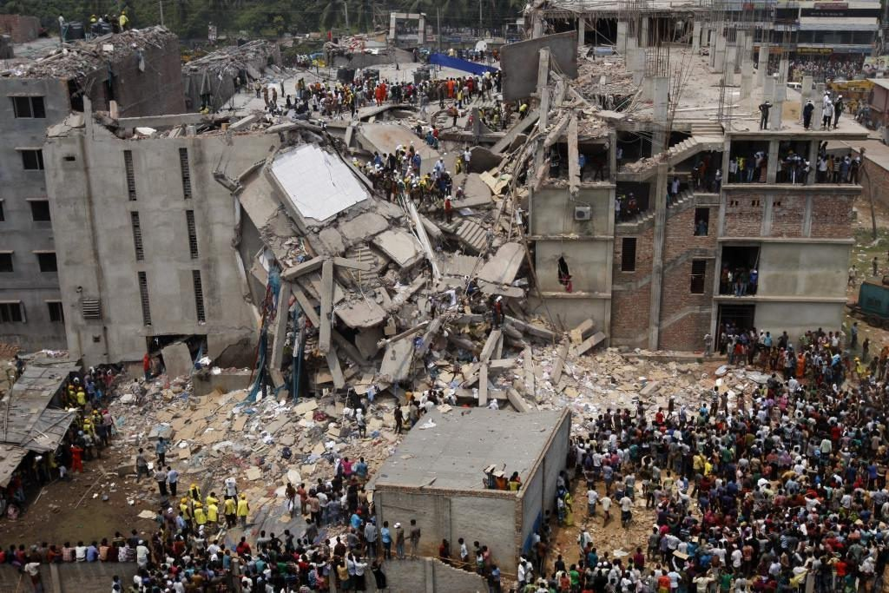
Source: Rivera, 2020
As a result, in 2009 Rana Plaza a garment in Bangladesh collapsed that killed 1138 workers and injured more than 2500 people where garments owner failed to follow the code of conduct set by Primark (Ethical Consumer, 2018).

During the time of COVID-19 many Bangladeshi garments being shut where Primark used to source their product but Primark never showed up to help them financially (Lizzie R. 2020).
The second ethical dilemma is, in Primark employees are always exploit where the global fashion brand still not paying the living wage of their workers. The research undertaken by Shenfield university this year identified Primark, Nike, and Adidas are duping business. Out of 20 fashion business investigated only these 3 identified as not committed to living ages (Lizzie R. 2020).

2.10 Justification

These two-ethical dilemma indicates the Primark is still putting ahead profits over the head of their people where the business as per their annual report, 2019 generated £7792m (BBC, 2021) with the profit of £919 million (Primark, 2021) Hence, this is high time for Primark to overcome their ethical dilemma by looking after their factory workers.

3.0 Conclusion

Primark is type of business that can easily give its competitors a competitive environment with their substantial financial power. However, due to recent impact on the business Primark should develop distinctive strategy with the consideration of PESTLE analysis, porters five forces tools. Further, this report is based on the workplace culture of a business along with its impact on the organisational efficiency where various management models, theories and methods are demonstrated as well as how it can impact the work culture and boost business efficiency showed. On the other hand, this report was supported by a scenario where COVID-19 used as a background and justifies PESTLE, Porters Five forces, Ethical dilemma etc. in regards to chosen business.

Task 2

2.1 Reflective essay

Reflective essay is analytical practices through which writer describes imaginary or real scene, interaction, event, memory and experiences (Bassot, 2016) Through this reflective I will outline my learning and acquired knowledge from the module with different example in regard to the workplace culture. To do that effectively Gibbs reflective cycle will be used which consist description, feelings, evaluation, analysis, conclusion and action plan (Gibbs, 1988).

Description: through this model and research I have experienced what critical analysis is. Even though this report was based on workplace culture however linking it with organization performance, COVID-19 situation, internal and external environment took my knowledge and understanding to a new height. Through this report, I have achieved knowledge about mini projects and dissertation as this report help me to understand how to do qualitative research method where I have carried out semi-structured interview towards three employees working within chosen business Primark. Now I am highly confident to undertaken dissertation by using this gathered knowledge from this module.

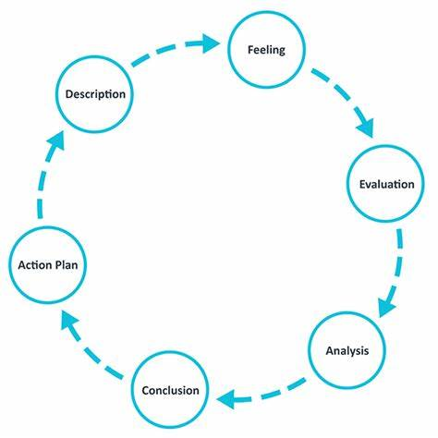
Source: Google Image

Feelings: the overall thought about this experience is mixed. At first, I was bit struggling with the topic as it was a scenario based report where I had to add various workplace variable by choosing a business. But, as my module lecturer progress, I have got richer understanding about this report and work by following step by step process where I have delegated my time to understand about PESTLE, Porter’s five forces, ethical dilemma, current organizational practices, impact of current organizational culture on business performances and finally how COVID has changed the overall business environment. the use of Gibbs cycle also helped me to evaluate what knowledge I have achieve which will help me in future to undertake more critical projects or reports.

Evaluation: the overall experiences by carrying out this report was good and bad. There are several times I have noticed I was drifting always from the research topic and writing unnecessary information. But with the help of my lecturers and Moodle I have made this report presentable where I had chance to interview my previous work organizations colleague about workplace culture and through that, I have identified how workplace change after pandemic.

Analysis: in order ensure this report make sense, I have thoroughly followed the instruction given by my lecturer. During week 7 my lecturer demonstrated, use about survey questionnaire where set of questionnaire has been discussed to gather first hand data. Even though, the questionnaire was based on quantitative research methods I have decided to choose qualitative research methodology where semi-structured interview is chosen to get satisfactory answer from respondent.

Conclusion: I have done this report from my personal interests and academic purpose by following the guidelines set by my university. All the informations are gathered here by following secondary sources such as books, e-books, journal and article and official website of chosen business. The data that sourced from secondary sources are PESTLE, Porters five forces, ethical dilemma, workplace culture and key driver of changes which has been referenced according to avoid collusion. The only part where primary data is used are task number 4 where semi-structured questionnaire has undertaken to gather information regarding current workplace situation. All the questions asked is added in appendix along with participant name and position within the chosen business.

Action plan: This was scenario based research was instruction was given about how to finish as per the guideline. If in future e.g. in final if I get chance to take this topic as a case study then I will expand this report with various aim and objectives as well as will adopt triangulation method where qualitative and quantitative research method will be adopted simultaneously to gather more first-hand data.

4.0 REFERECNES

Ahsan S. (2021). SWOT Analysis of Primark. [online] SWOT & PESTLE Analysis. Available at: https://swotandpestleanalysis.com/swot-analysis-of-primark/. (Accessed 01/05/2022).

Bassot, B. (2016). Reflective journal. London: Palgrave Macmillan.

Correspondent, R.P.E. (2020). UK government to pay 80% of wages for those not working in coronavirus crisis. The Guardian. [online] 20 Mar. Available at: https://www.theguardian.com/uk-news/2020/mar/20/government-pay-wages-jobs-coronavirus-rishi-sunak. (Accessed 01/05/2022).

Desklib.com. (2022). Porter Five Force Model of Primark Assignment. [online] Available at: https://desklib.com/document/porter-five-force-model-of-primark/#:~:text=Porter%20five%20force%20model%20to%20identify%20and%20analyse. (Accessed 03/05/2022).

Desklib.com. (2022). Porter Five Force Model of Primark Assignment. [online] Available at: https://desklib.com/document/porter-five-force-model-of-primark/#:~:text=Porter%20five%20force%20model%20to%20identify%20and%20analyse
(Accessed 01/05/2022).

Ethical Consumer (2018). Primark | Ethical Consumer. [online] Ethical Consumer. Available at: https://www.ethicalconsumer.org/company-profile/primark. (Accessed 02/05/2022).

Ethical Consumer (2018). Primark | Ethical Consumer. [online] Ethical Consumer. Available at: https://www.ethicalconsumer.org/company-profile/primark. (Accessed 02/05/2022).

Fanggidae, R.E. (2018). Organizational Culture and Spirituality Workplace: Empirical Study of Influence of Organizational Culture and Spirituality Workplace. E3S Web of Conferences, 73, p.11017. doi:10.1051/e3sconf/20187311017.

Grier, D.A. (2014). The External Environment. Computer, 47(11), pp.124–124.

Gheibi, M., Karrabi, M., Mohammadi, A. and Dadvar, A. (2018). Controlling air pollution in a city: A perspective from SOAR-PESTLE analysis. Integrated Environmental Assessment and Management, 14(4), pp.480–488.

Kushwah, R.K. (2018). Influence of an Approach to External Business Environment in Delhi. Journal of Advances and Scholarly Researches in Allied Education, 15(5), pp.145–148. doi:10.29070/15/57615.

Ilya Kiriya, Panos Kompatsiaris and Giannēs Mylōnas (2020). The industrialization of creativity and its limits values, politics and lifestyles of contemporary cultural economies. Cham, Switzerland Springer.

Primark (2021). About Us | Primark. [online] www.primark.com. Available at: https://www.primark.com/en-gb/about-us.

Rivera, L. (2020). Primark ethics: is Primark actually worse than other high street shops? [online] Live Frankly. Available at: https://livefrankly.co.uk/fashion/primark-ethics-is-it-really-better/.(Accessed 04/05/2022).

Raven, P.H. (2015). Environment. Hoboken: John Wiley & Sons.

Simpson, E. (2021). Primark refuses to go online despite £1bn lockdown loss. BBC News. [online] 14 Jan. Available at: https://www.bbc.co.uk/news/business-55661741. (Accessed 04/05/2022).

Schnedlitz, P., Morschett, D., Rudolph, T., Schramm-Klein, H., Bernhard Swoboda and Springerlink (Online Service (2022). European Retail Research. Wiesbaden: Gabler Verlag.

Van, N. (2022). Potions Mini Mortar And Pestle. S.L.: Running Pr Miniature Edit.

Appendices

Appendix one

Semi-structure interview questions

How long you are working within the business?

How good is level of communication within your store?

How is the management behaviour towards the workers?

What is the current situation of staffing within your store?

How effective is training and development within your store?

Respondents identity

Confidential | Manager, Primark
Confidential | Department Manager. Primark
Confidential | Trainee Supervisor. Primark

