BMIH6004 Hotel Placement –
Managing Hotel Administration
Placement: Village Hotel Swindon

Module lead: Julia Chifari
Student Name: Alina Elena Grigore
Student ID: 2127382

Table of Contents
Introduction 3
Section 1: Reflection on Experience and Personal Development 4
Section 2: Critical Analysis of Work-Based Skills and Technical Knowledge 6
Section 3: Reflection on Organisational Issues 7
Conclusion and Action Plan 8
References 9

Introduction
Overview of the hotel's administrative operation: At the Village Hotel Swindon, administrative duties include making sure the front office works well so that it can handle guests arriving and leaving, making bookings, and for help. The front office's most important jobs are handling guest requests and complaints and ensuring the business runs smoothly. Good communication between departments and the proper use of property management tools are necessary for activities to run smoothly.
- To learn the knowledge and skills I need to use hotel systems to handle orders, requests, and guests checking in.
- To be good at resolving conflicts and handling guest complaints well to ensure they are satisfied.

Section 1: Reflection on Experience and Personal Development
Gibbs Reflective Cycle
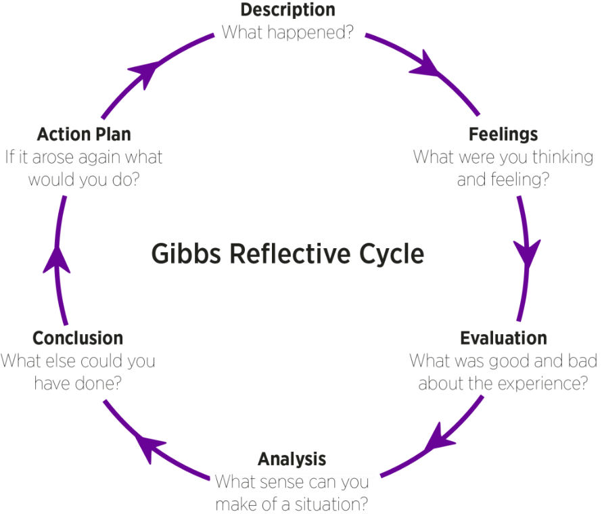
Figure 1: Gibbs Reflective Cycle (Tripathy, 2020)
Description: As part of my job at the Village Hotel Swindon, a guest one evening, I could tell they were annoyed that they had to wait so long for room service. Service delays at the hotel caused by many guests harmed the guests' experiences. The supervisor quickly resolved the guest's problem, reassured them, and promptly got the service back up and running.
Feelings: I was initially nervous because I knew providing prompt service was essential for making guests happy, but I did not see how the guests would respond. I admire the supervisor's calm and skill in dealing with the guest's anger (Baker and Kim, 2020). I felt encouraged and confident in my ability to improve how I handled complaints because she was calm and honest.
Evaluation: The guest had a better experience because the supervisor cared and understood, which made the hotel front office operations good. However, there was trouble communicating between departments because room service was late (ASET, 2017). The idea that this problem could have been avoided with better order prioritisation and coordination shows how important good communication and organisation are in running a hotel.
Analysis: The supervisor's answer clarified the importance of having great people skills and the ability to make quick decisions. Regarding my personal growth, I understood how important it is for departments to work together and improve at solving conflicts (Liddle, 2023). This taught me that adequately dealing with problems before they get worse and using a systematic approach to service delivery can make visitors much happier.
Conclusion: This event showed how important it is for departments to work together to meet customer needs. Improving communication methods could reduce service delays and prevent problems like this. From what I have seen, providing excellent customer service means putting the guests' needs first and ensuring they feel valued, affecting how the guest sees the hotel.
Action plan: One of my goals for future work situations is to improve my task management abilities. I will look for ways to work together more closely with other areas so that I can learn how they do things and talk to the front office (Fallon and Rutherford, 2010). Additionally, it would be helpful to set up a way for offices to prioritise visitor requests during busy times.

Section 2: Critical Analysis of Work-Based Skills and Technical Knowledge
Placement experience
I improved at customer service, working with others, managing tasks, and talking to people while in placement at the Village Hotel Swindon. Communication was an area where I made a lot of progress. The front office staff relied on clear and direct conversation to handle customers' needs, primarily when problems arose (Torres and Zhang, 2022). The guest's confusion about the breakfast policy shows how important it is to communicate orally and in writing. During my job, I got better at working with others. During busy check-in times, the hotel staff organised their work well to ensure everything ran smoothly. I regularly worked with the front office teams to quickly meet customers' needs and often talked to the front office to answer their questions (Hagg, 2013). Managing my tasks became more important as I took on more duties, such as making payments, answering customer questions, and watching over guest check-ins.
Work-based skills and technical knowledge
Through my placement, I have learnt how important it is to have academic and practical knowledge to provide excellent customer service. The hotel's reservation system helped me handle plans, cancellations, and upgrades quickly and easily, even during busy times (Johnston, Clark and Shulver, 2012). Managing room availability, taking care of guest check-ins and check-outs, and handling guest complaints are all complicated front-office tasks that require a deep understanding of technology systems and people skills, which I improved by learning more about operational proficiency (Kimani and Scott, 2023). Despite last-minute changes to reservations, I handled guest relations and the hotel's operational needs by staying calm, assessing the situation, and coming up with a quick answer.

Section 3: Reflection on Organisational Issues
Identifying the issue: There were problems when guests made last-minute changes or asked for rooms without clear information about what was available. Check-in hours were extended because it was unclear when customers' rooms would be ready. This problem mainly affected the people who worked at the front office. There was a problem because guests arrived earlier than planned, and the hotel was already entire during busy times (QAA, 2018). The people working at the front office were stressed as new guests arrived, and housekeeping had difficulty getting rooms ready on time. Hotel guests were naturally annoyed and unhappy because they had to wait long to check-in.
Impact on guest experience: Guests were unhappy because of delays and unclear information about whether their rooms were available, which significantly affected their visit. Some guests' irritation worsened the general atmosphere of the stay, especially for those who had asked to check in early or were looking forward to a smooth arrival. The delayed readiness of the room messed up the check-in process, making the Front Office staff stressed and overloaded as they dealt with waiting customers and constant questions (Wood, 2013). The situation made it hard for the hotel to run its business. Due to last-minute room preparations, the level of service went down as the front office staff fought to meet guests' needs.
Practical solutions: To solve this problem, I suggest a better way for the front office and housekeeping to talk to each other. A sharing platform or a more advanced property management system would help both groups know more about room conditions and availability in real-time (Walker, 2021). With this plan, the front office staff would not have to make false promises about early check-ins and could give guests more accurate information about room availability. If there were a period between check-in hours on days when there are a lot of guests, they would be better told about room availability and wait times. If departments had more training in how to work together and talk to each other, they would be better at dealing with these kinds of problems.

Conclusion and Action Plan
During my placement, I learnt how important it is to communicate clearly, work together, and handle my time well. I saw firsthand that more information given at check-in can help clear up misunderstandings, like the room availability problem. I also understood how important it was for departments to work together, especially during trouble. These experiences have taught me how important it is to quickly solve problems and answer guests' questions using my technical knowledge and work-based skills.
Action Plan:
SMART Goals | Resources | Expected Impact | Timeframe
Improve interdepartmental collaboration | Scheduled meetings and support from department managers | Reduced availability of services misunderstanding | 3-6 months
Creating detailed guests outline on available services | Digital guides approval from management | Higher guest satisfaction with fewer complaints about services | Within 2 months

References
ASET (2017) Good Practice Guide for Workbased and Placement Learning in Higher Education. Sheffield: ASET
Baker, M. A., and Kim, K. (2020) Dealing with customer incivility: The effects of managerial support on employee psychological well-being and quality-of-life. International Journal of Hospitality Management, 87, 102503. https://doi.org/10.1016/j.ijhm.2020.102503
Fallon, M. and Rutherford, D. (2010) Hotel Management and Operations. London: Wiley
Hagg, E. (2013) Internship Guide: Work Placements Step by Step. 5th Ed. The Hague: Eleven International Publishing.
Johnston, R., Clark, G. and Shulver, M. (2012) Service Operations Management: Improving Service Delivery. 5th Ed. London: Pearson.
Kimani, C. J., and Scott, J. (2023) Introduction to Front Office Operations and Administrations in Hospitality Management Diploma Level. Finstock Evarsity Publishers.
Liddle, D. (2023) Managing conflict: A practical guide to resolution in the workplace. Kogan Page Publishers.
QAA (2018) UK Quality Code, Advice and Guidance: Work-based Learning. London: QAA.
Torres, E. N., and Zhang, T. (2022) Customer Service Marketing: Managing the Customer Experience. Routledge.
Tripathy, M. (2020) Dimensions of critical thinking in workplace management & personal development: A conceptual analysis. Multidisciplinary Journal for Education, Social and Technological Sciences, 7(2), 1-19. https://doi.org/10.4995/muse.2020.12925
Walker, J. R. (2021) Introduction to hospitality. Pearson.
Wood, R.C. (2013) Key Concepts in Hospitality Management. London: SAGE Publications Ltd.

