Taguchi experiment – Catapult

Systems Engineering Assignment

David Tolhurst | 222916 | ACDA 2021 | Systems Engineering

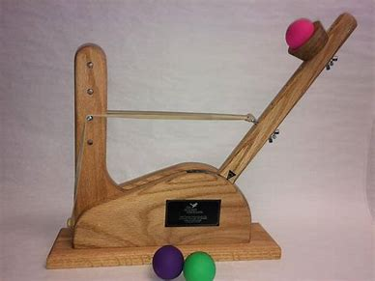

List of Contents
List of Figures 2
Objective 3
Apparatus and method 3
Apparatus 3
Method 3
Results 5
Discussion 6
Conclusion 6
Reflection 6

List of Figures
Figure 1 - Independent variables, levels and array 4
Figure 2 - Results for initial 8 runs 5
Figure 3 - Graphs 5
Figure 4 - Key control features results 6

Objective
The primary objective of this experiment was to carry out multiple test firings using a catapult to determine the key control factors that affect the output of the system. The experiment itself consisted of very simple and readily available items such as a small wooden catapult, G-clamp, measuring tape and a rubber ball. The catapult that was used for the experiment had multiple adjustable features that were changed throughout the experiment to help determine the key control factors.
The Taguchi methodology for capturing experimental data was utilised as it is designed to improve quality and consistency by minimizing variation and defects for a given system or design. It involves using orthogonal arrays which help determine the most prominent factors which effect the results of the experiment whilst also aiming to use the least number of trials as possible. The use of orthogonal arrays eliminates the need for repeated or similar trials for every possible combination of control factors and noise factors. [1] [2]

Apparatus and method

Apparatus
- Catapult
- Rubber band
- Flat surface (Table, floor etc)
- Rubber ball
- G-clamp
- Measuring tape
- Laptop
- Whiteboard marker (Not essential but can help mark distances)

Method
The above-mentioned apparatus was set up at one end of a row of tables that was approximately 5m long. The base of the catapult was secured to the table using a G-clamp so that it did not move at all during the experiment. Then the measuring tape was stretched out to its maximum length starting from the point where the ball would leave the catapult and towards the far end of the table. Where the measuring tape could not reach, a marker was used to add incremental points of measurements so that if the ball did go further than the length of the measuring tape then an accurate distance could still be captured.
The experiment consisted of 8 firings that offered different levels of variability. The 7 variables were band front position, band anchor position, 1,2 interactions, stop position, pull back angle, 2,4 interactions and operator. This can be observed in figure 1 below.
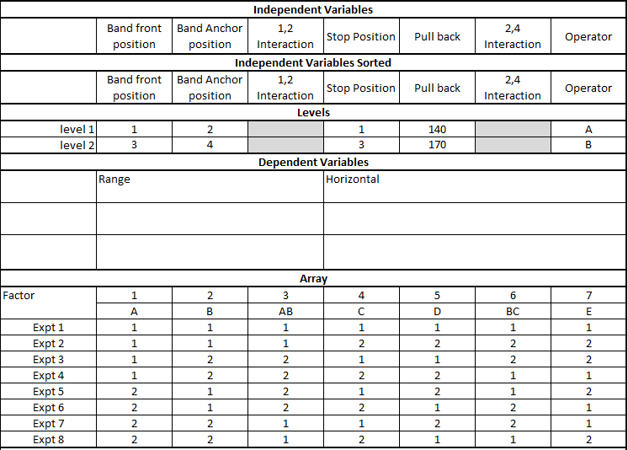
Figure 1 - Independent variables, levels and array
As shown above the Taguchi array was pre-populated with what each variable would be set at for each experiment. For example, experiment 1 was carried out by referring to the matrix which informed the user that the following steps were to be taken.
- Band front position – 1
- Band anchor position – 2
- Stop position – 1
- Pull back angle – 140 degrees
- Operator to carry out firing – A
Once all of this was in place, the operator A released the catapult allowing the ball to be fired whilst the remaining team members observed the exact distance where the ball initially landed on the table. The distance was then entered into the Taguchi matrix and the next experiment carried out using the same steps as before but with different variables set. This was repeated until all 8 experiments had been completed. If any obvious error occurred during the firing such as the wrong pull back angle been provided then that experiment was restarted until a satisfactory run was completed.
The variables that had results with the greatest inconsistencies were identified to be critical control features. The most obvious 2 key control features were noted, and a secondary set of experiments were carried out to further analyse why the 2 key control features were having that effect on the system as a whole. Similarly to before, the experiment was based off of 2 levels but instead this time it was the minimum and maximum setting used for each run which was identified from the first 8 runs.
The key control features were fired in the exact same manner as before to ensure that all the data captured was consistent and fair. Both key control features were tested against one another 3 times so that and average distances value could be derived. Now that an average distance value had been obtained for each key control factor, a mid-point was calculated for each and then tested to see how close the team could come to the theoretical value.

Results
The following data in figure 2 was captured from the initial 8 runs using the variables provided by the Taguchi method/matrix.
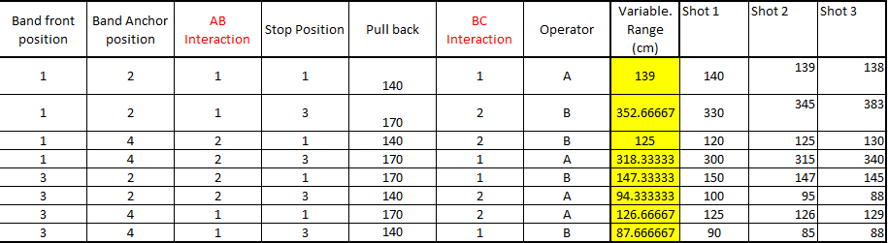
Figure 2 - Results for initial 8 runs
The data that was captured in figure 2 also generated multiple different graphs that provide insight into the difference between variables and levels. The graphs were used during the experiments to identify the key control factors, these ended up being band front position and pull back angle. These findings can be observed below in figure 3.
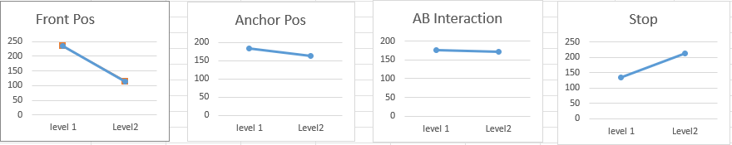
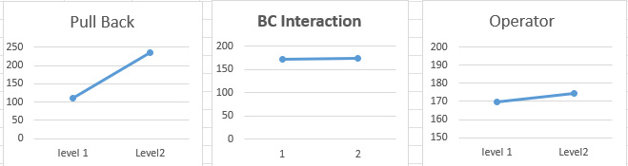
Figure 3 - Graphs
In figure 4 below, we can see the results from the runs where the 2 key control features that were obtained from the information gathered in figure 3 and also how the mid-points were calculated.
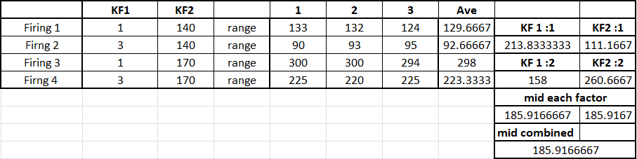
Figure 4 - Key control features results

Discussion
Figure 1 shows how the orthogonal array was used to analyse all of the variables without the need for any unnecessary or additional trial runs. Using this array also led to identifying the 2 key control factors which had the most effect on the overall flight trajectory of the rubber ball when fired from the catapult.
These were band front position and pull back angle. These findings make sense as the front band position is what effects how much tension that the rubber band is under and the moment of release. The same can be said for the pull back angle of the catapult as when the arm of the catapult was pulled back to its maximum angle of 170 degrees the user could physically feel a harder resistance which meant that the rubber band was under even more tension which would’ve sent the rubber ball further down range as more motive force would have been provided.
Another feature that should be mentioned but was not one if the 2 key control factors was the stop position. As shown in figure 3 it also effected the distance that the ball travelled greatly. This is because for the greatest distance to be achieved then the angle that the ball left the catapult at had to be as close to 45 degrees as possible.

Conclusion
In conclusion, the use of the Taguchi methodology is an excellent solution for building robustness within a system design as it provides extremely useful data whilst minimising the amount of testing that needs to be carried out for a given product or design. The method helps point out any areas that are prone to be affected by external noise factors which allows for mitigations to be put in place to avoid failure.

Reflection
If these experiments were to be carried out again then the following considerations should be made. A better way of loading the ball into its cup on the catapult could be introduced as I felt like it was possible to force the ball in too far which may have affected how easily it left the cup when the catapult reached its stop position. Also, a more accurate measuring technique could be introduced by coating the ball in something that would leave a visual mark upon contacting the table. This would have allowed us to get more accurate distance values and helped keep everything consistent.

References

[1] | “Taguchi Method,” Science Direct , [Online]. Available: https://www.sciencedirect.com/topics/materials-science/taguchi-method. [Accessed 7 April 2025].
[2] | Six Sigma, “The Guide to the Taguchi Method: A Robust Quality and Efficient Experimentation,” 8 October 2024. [Online]. Available: https://www.6sigma.us/process-design/taguchi-method/. [Accessed 7 April 2025].

